Software Design Specification
for
JBrick
Version 2.0
Prepared by Abhishek Shrestha, Hugo Pilco, & Victor Alvarez, &Corey Cooney
JBrickers
2010-11-11

Revision History
Name | Date | Reason For Changes | Version
Fall 2010 | 2010-11 | Fix some of the bugs in the system and understand the code | 1.0
Winter 2011 | 2011-01 | Fix some of the bugs in the system and understand the code | 2.0

Introduction
In the sections that follow, we provide an insight of the design decisions we faced when reverse engineering the current version of the software to fix some of its issues and to add some new features.

Goals and objectives
Our main goal is to add new features to JBrick while keeping the current set of features and without cluttering the code. Also there are a lot of functionalities that have already been implemented in the JBrick but some of them needs to be tested further and some also require few changes and bug fixing.

Statement of scope

A description of the software is presented in terms of the functionality that you are presenting the design for in this document.

Major constraints
Any constraints that will impact the manner in which the software is to be specified, designed, implemented or tested are noted here.

Definitions, acronyms, and abbreviations
SWT : Standard Widget Toolkit, an open source widget toolkit developed by IBM for the Eclipse project.
JFace : UI Toolkit that acts as a layer on top of SWT without hiding SWT from the developer, it contains common programming tasks and classes for developing SWT applications.

References
JFace at Eclipsepedia : http://wiki.eclipse.org/index.php/JFace
SWT at Eclipsepedia : http://wiki.eclipse.org/SWT

System Architecture

Overview
The application was rushed in every sense and the coupling is really high, that’s why we don’t have subsystems, but the features we’ve been working on have taken into consideration this fact and we’ve been trying to correct this issue slowly. Right now, the number of classes of the application has increased, compared to what we initially found, because of the refactoring applied to separate concerns.

- Fall 2010
  - Keywords
  - Save question
  - Minimize button
- Winter 2010
  - The JBrickEditor and MainWindow dependency
  - Compiling Empty Files
  - The colors
  - The line numbers
  - The tools
  - The dialog windows (Piano, Direct Controller, Joystick, and Find Brick)
  - Disable buttons based on Brick connection status (Piano, DirectController, Joystick)
  - Brick Connection Polling and Connection Centralization
  - Detection of Fantom Driver
  - FindBrick Dialog
  - Improving Undo & Redo
  - Stop Button Bug in the Help Content Browser
  - Multiple Windows for the Method Templates and the Help Browser
  - The Piano

Fall 2010

Class Diagram
The Following class diagrams shows the structural changes that have been done to the JBrick source code.In this document we are showing the before and the after of the class diagram:

Before
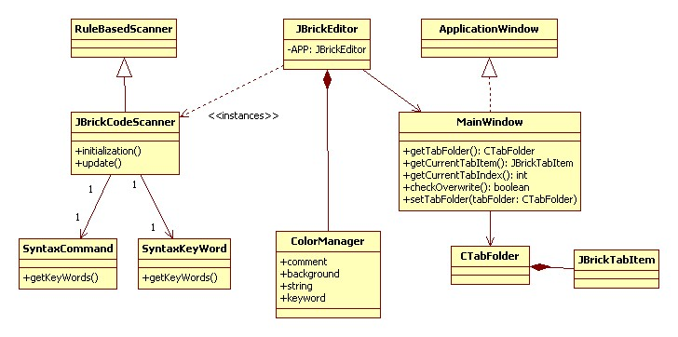

After
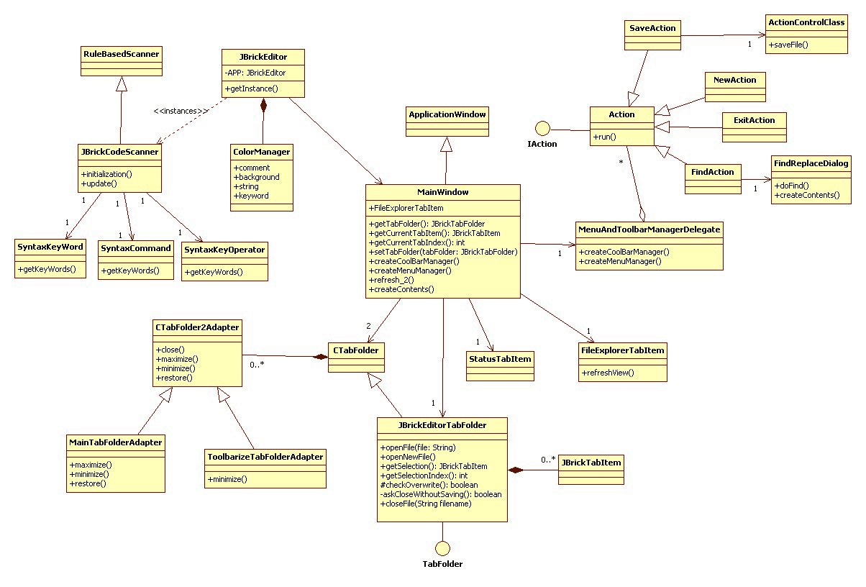
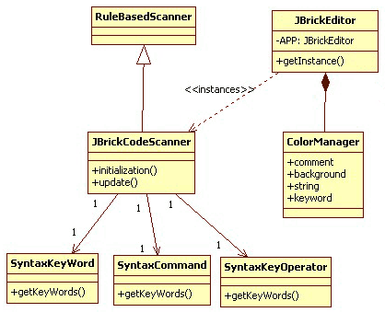

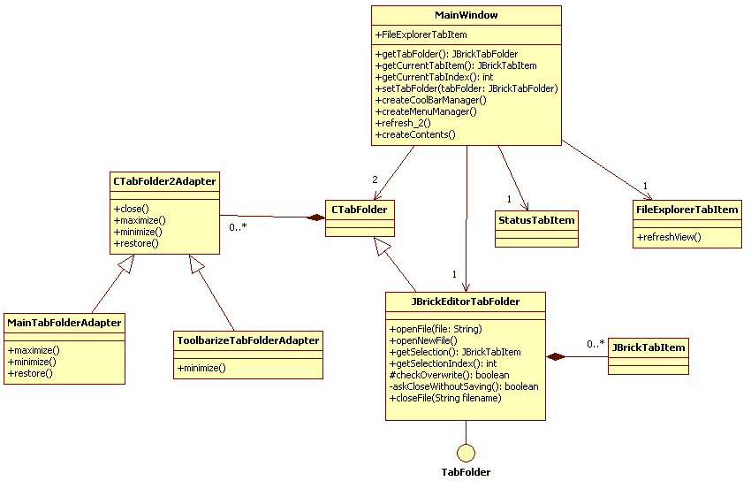
As shown in the following diagram, the class MenuAndToolbarManagerDelegate has been created to delegate the creation of both the MenuManager and the ToolbarManager. The Action classes don’t need any additional configuration because they invoke some methods in the JBrickEditor class, which is a Singleton.

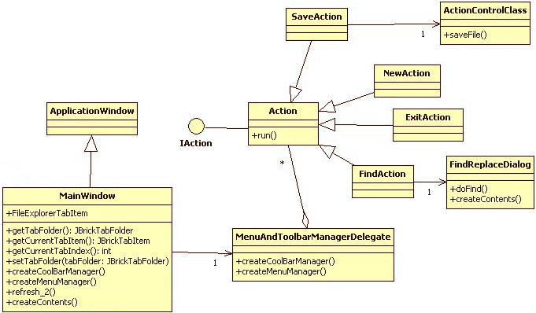
Winter 2010

The JBrickEditor and MainWindow dependency
The problem with the previous diagram is not obvious, but the Action classes are dependent of the JBrickEditor and some of them are dependent of the MainWindow class. This implies that JBrickEditor has some methods with low cohesion, i.e. they have nothing to do with what the JBrickEditor class is supposed to do, and also assumes that JBrickEditor has an instance of MainWindow, so that methods from the MainWindow class can be invoked by the Action classes.

To better illustrate the matter at hand, let’s see a class diagram with most of the methods for the MainWindow and JBrickEditor classes. As shown in the following diagram, the JBrickEditor class contains methods related to the operations of the editor tabs, such as undo(), redo(), cut(), copy(), and paste(). Moving these methods from the JBrickEditor class to the MainWindow class doesn’t necessarily help our cause because MainWindow also has methods related to the operations of the editor tabs, such as openNewFile(), getCurrentTabItem() and saveFile().

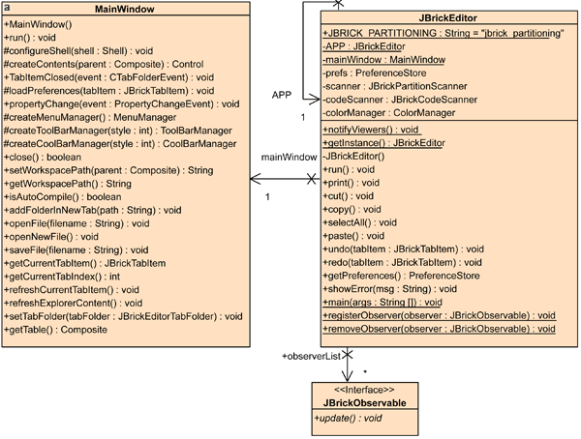

As an example of this behavior, the following sequence diagram shows how the SaveAction works.

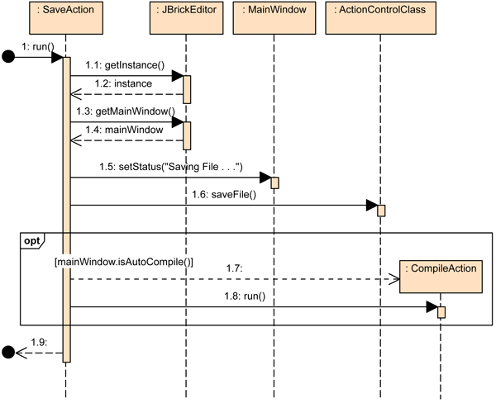
Most of the action classes had this issue of calling the JBrickEditor singleton, then get its MainWindow instance and finally, call one of the MainWindow’s methods. This makes the Action classes highly dependable on the behavior defined in the JBrickEditor and MainWindow classes.

Further refactoring should be able to address this issue, eliminating the dependencies to the JBrickEditor and MainWindow classes. A way of doing this is by adding interfaces to force a contract with the Action classes, and remove some of the methods that are currently in the JBrickEditor class.

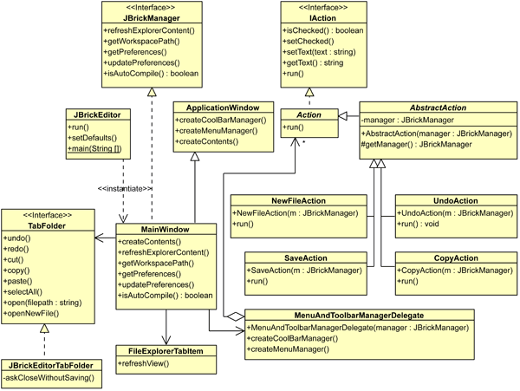

In the previous diagram, two Interfaces and an Abstract class where added to avoid the described dependency issue. The JBrickEditor class is now tidy, without any method involving tab related functionality. This functionality was moved to the TabFolder and JBrickManager interfaces and are implemented by the JBrickEditorTabFolder and MainWindow classes, respectively. The functionality related to the tabs that was part of MainWindow was removed and merged with TabFolder, giving us a cleaner MainWindow class.

The AbstractAction class was created with the purpose of eliminating the dependency to the JBrickEditor singleton in the Action classes and instead depend on the JBrickManager interface to perform the actions. An implementation of the JBrickManager interface is given as a constructor parameter to the AbstractAction class, forcing its subclasses to override this constructor if needed.

As a result, the previous sequence diagram for the SaveAction class is affected as follows:

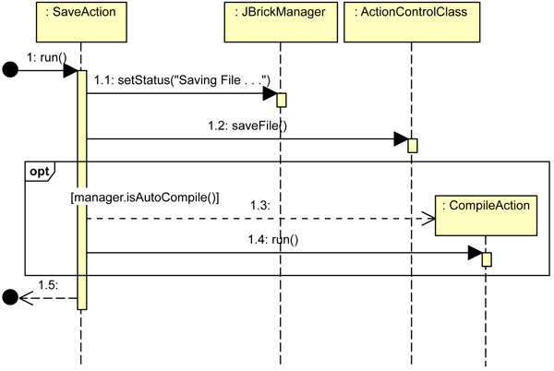
The dependency to the JBrickEditor and MainWindow classes is now replaced, as stated earlier, for a dependency to the JBrickManager interface, which is sent as a constructor argument.

Compiling Empty Files
One of the Action classes, the CompileAction class specifically, is responsible for compiling the source code in the editor. Regardless of the content of the editor, the compiler tries to compile the source. If an empty file is been displayed in the editor and the CompileAction is executed, a message will pop up stating that the compilation was successful. This is due to the underlying nxc compiler that accepts empty source code files as valid.

The following class diagram illustrates the CompileAction class after the refactoring process mentioned above.
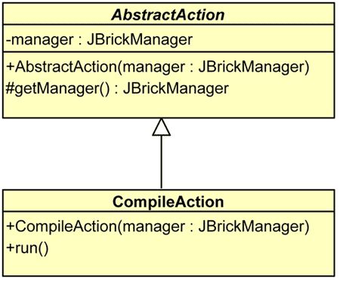
Inside the run() method, a condition has been included to validate whether or not at least one character has been written to the file before compiling it. If it has been determined that the file is not empty, then it proceeds with the source compiling.

The colors
Another area of the source code affected by the refactoring is the one concerning the color management in the Editor’s tabs. Before, CommentScanner and JBrickCodeScanner, the classes that bring color to the editor, were dependent of the ColorManager class which acts as a place to centralize constants relating to color values. Anytime the update method is invoked on the implementing classes, the preferences for the colors were read directly from the JBrickEditor singleton, but only a couple of colors were kept in the preferences. The previous version of the code is reflected in the following diagram:

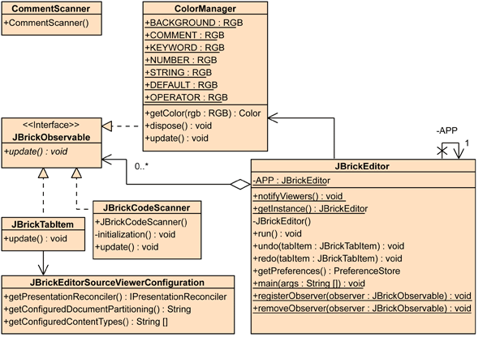

As demonstrated previously, the refactoring of JBrickEditor eliminates most of the methods in the class and makes it no longer a singleton. The ColorManager class is re-purposed to act as a central storage for the color values, not constants, i.e. instead of having constants with the color codes, a collection of variables would be used, giving us more control of the configured colors. An enumeration is used to distinguish between different colors, for example, comments’ color and keywords’ color. Now, JBrickCodeScanner and CommentScanner still depend on the ColorManager class, when their update() methods are invoked, they consult the color codes with the ColorManager. When the update() method is invoked on the ColorManager, it reads the preferences from the JBrickManager interface (implemented by MainWindow) and stores the color values for the other classes to get. These changes can be seen in the following diagram:

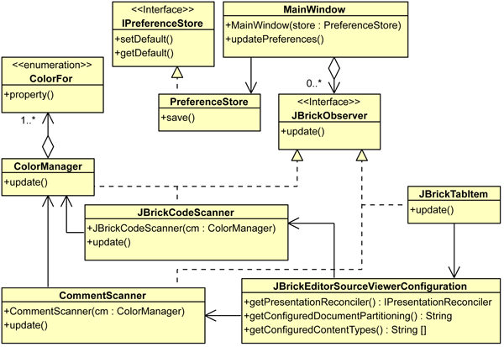

In this diagram, the JBrickObservable interface was renamed to JBrickObserver because that’s how it’s been taught. The JBrickCodeScanner and CommentScanner classes now have a ColorManager as a parameter in their constructors for the purpose described earlier. The PreferenceStore class comes from the JFace library, and implements the required methods to save the preferences to a properties file.

Having defined the class structure for the color management support, the only thing missing is to modify the GUI to support the colors that were previously defined as constants in the ColorManager class as follows:
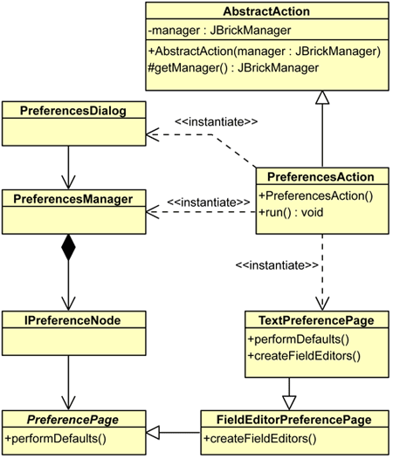

Most of the classes in the preceding diagram are part of the JFace library, the only classes implemented in the JBrick project are AbstractAction, PreferencesAction and TextPreferencePage. The run() method in the PreferencesAction class is responsible for creating the Preferences dialog. The TextPreferencePage is the class that contains the fields to edit the preferences; to create the fields, it must override the method createFieldEditors() from the superclass FieldEditorPreferencePage, and to implement the functionality of the “Restore Defaults” button, it must override the performDefaults() method. The only modified behavior added to the overridden method is to preserve the Workspace setting because otherwise clicking on the button would set it to blank.

The default settings for the colors are set in the setDefaults() methods in the JBrickEditor class. This method is executed only at the initialization of the application because the PreferenceStore class is responsible for keeping this information. Trying to set the color values in the performDefaults() method would create unnecessary overhead because the method would set all the colors to black, and the overridden functionality would invoke methods that are anyway called by the parent’s performDefaults().

This is a snapshot of the GUI for the preferences:

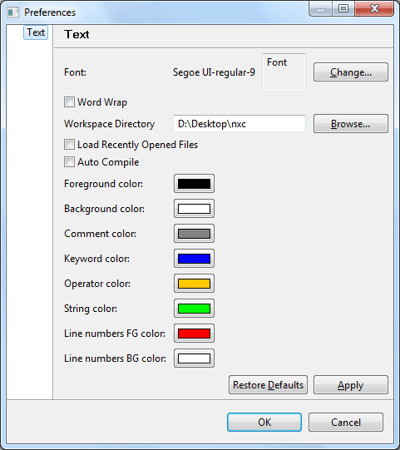

The color preferences pictured above are the ones defined by the ColorFor enumeration. Since the “update” messages for the JBrickObserver involves the classes that are part of the editor’s body, more features can be added as it’s the case for the line numbers which, as pictured above, are red with a white background.

The line numbers
An instance of the CompositeRuler class is employed by the editor’s tab items to display the line numbers on the left of the editing area. Since the colors for the editor are changed within the update() method in the JBrickTabItem class, it’s possible to change the colors and font for the ruler by invoking some of the available methods in the CompositeRuler class.
Class hierarchy for the tab items | Updates being passed
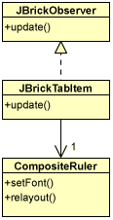 | 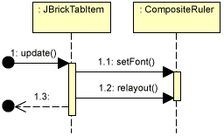
The only issue here is that if the font size changes to a bigger size, the ruler width will stay the same, and the line numbers would either get cut or disappear. This is resolved by invoking the relayout() method in Composite ruler, so the component would be redrawn to fit the new font size.

The tools
Based on the design of the color preferences, it’s possible to add another PreferencePage to contain the path for the tools used by JBrick, namely nbc, BrickTool, and NeXTTool. The purpose of this is to avoid having the paths for these tools as constants in the source code and have a chance for configuration. The following class diagram shows the creation of a new class for this task: BrickToolsPreferencePage.
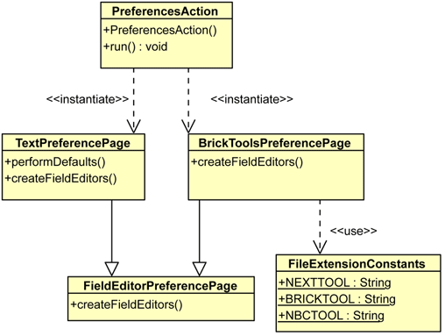
As seen in the class diagram for the color preferences, the createFieldEditors() method is used for creating the fields; the tools’ paths fields, in this case. The constants in the FileExtensionConstants class are used to name the properties in the preferences properties file, just as for the colors the enum ColorFor values are used to name the properties for the color in said file. Likewise, the setDefaults() method in the JBrickEditor class is used to set the default path for these tools when the application starts, so that when the “Restore Defaults” button is clicked, the fields for the paths will be filled with these default values.

The dialog windows (Piano, Direct Controller, Joystick, and Find Brick)
Based on the behavior of the preferences dialog, the decision has been made to modify the Piano, DirectController, Joystick and Find Brick dialogs. The current behavior is that these dialogs are independent of the application window, meaning that their behavior is not modal and we’re capable of playing around with the application window while one of these dialogs is opened. The behavior of the preferences dialog is modal, that is, it blocks the application window and it’s the only window capable of receiving the mouse and keyboard events.

The classes that are responsible for these dialog windows are inheriting from the JFace class ApplicationWindow, the same class MainWindow inherits from. This gives the dialog independence, but has the disadavantage of being able to initialize more than one of these dialogs at the same time. For example, we would be capable of having two Find Brick dialogs at the same time, if we don’t have a way of controlling the instantiations.

This issue is addressed by changing the parent class for the JoystickUIWindow, DirectControllerUIWindow, PianoUIWindow, and FindBrickUIWindow classes to TrayDialog, allowing only single instance to be opened. An overview of the changes involved for these classes is as follow:
Previous Implementation  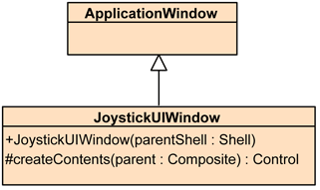 | Current Implementation  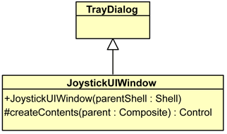
The other classes mentioned above followed/follows the same structure.

Disable buttons based on Brick connection status (Piano, DirectController, Joystick)
The Piano, DirectController, and Joystick depend on the status of the connection to the Brick. These functions require an active connection to the Brick, which is established in the GUI through the FindBrick dialog. Thus, it is desirable to enable/disable the state of these buttons according the the connection status of Brick.

An ideal way to achieve this functionality is through the use of Observer design pattern, as shown below:
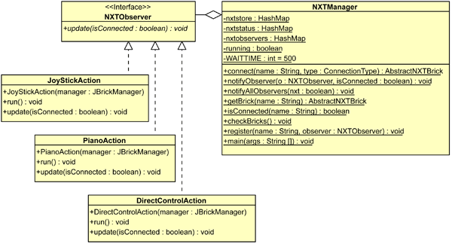

The NXTManager class is responsible for managing all the connection operations. In case of successful connection or failure, NXTManager notifies all the observers (PianoAction, JoyStickAction, DirectControlAction).

Also a minor change has been made to the NXTObserver Interface as shown in the figure below:
Previous Implementation  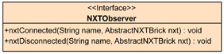 | Current Implementation  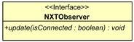

Instead of having two methods to represent the status of the connection a simple update() method can be used to represent the state.

Brick Connection Polling and Connection Centralization
In the previous design, the modules that depend on Brick connection (PainoComposite, JoystickComposite, DirectController) instantiated a connection to the brick individually. Thus each time any of these functionalities were invoked, a new connection instance was created. To overcome this problem and also to implement the polling functionality the following refactoring was made. The main idea is to have only a single instance of connection running at a time. This has been achieved by making the NXTManager class a singleton.

Now the NXTManager handles all the connection related functionality. Also a polling feature has been added. Initially, the user needs to initiate the FindBrick action to connect to the brick. Once it is connected, all the buttons related to connection (as discussed above) will be activated and polling is started. In case the user unplugs the brick, the polling detects it and disables all the associated buttons and polling will also stop; this will also notify all the observers regarding the disconnection and the observers like PianoUIWindow (UI for piano) will be notified about it so that some relevant action may be initiated, such as saving the played tones.

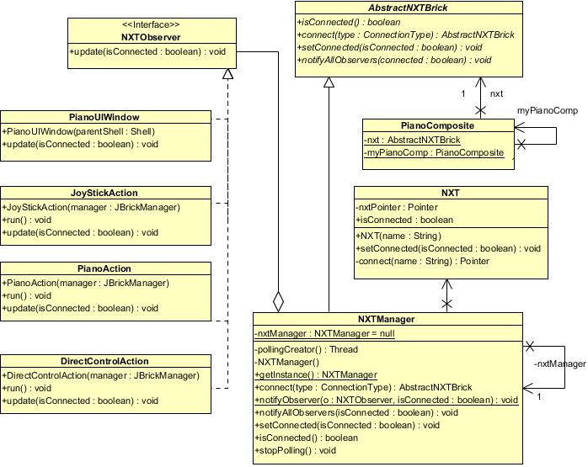

Detection of Fantom Driver
Fantom driver are required to connect the NXT Brick to a computer via USB. In the previous implementation the application did not detect if Brick was connected or not. The user had to explicitly make connection using the FindBrick dialog. To start polling when the application starts up first step that needs to be done is detecting whether the computer running the application has Fantom drivers installed or not.

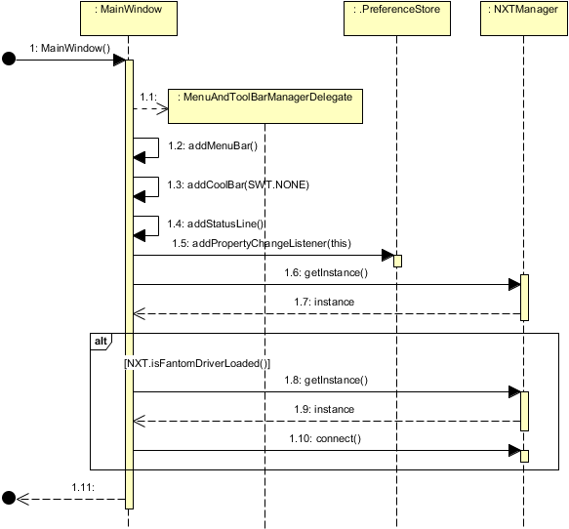

All the Fantom driver related operation has been defined in Fantom interface. The task of initializing Fantom driver has been ported to NXT class (on class load). When the application is launched if the driver is detected then the connection related buttons (Piano, DirectController, Joystick) are enabled and also the polling of Brick is also started. In case no brick is connected those three buttons are disabled but FindBrick is enabled. But in case the driver is missing these buttons are disabled including the FindBrick button.

*Note: Learn more about NXTFantom Driver

FindBrick Dialog
The FindBrick dialog allows the Brick to be connected via Bluetooth or USB and any one of these connection type preference can also be saved in a preference. Below is a snapshot of the FindBrick dialog:
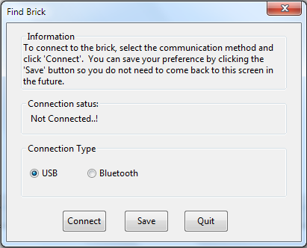

If the connection attempt made by the user is successful, the dialog dismisses and a sharp beep is produced but it case the connection attempt was failed then proper notification is displayed along with a flat beep.

Improving Undo & Redo
The previous version of the Undo & Redo functions in JBrick acted like a Wordpad Undo & Redo function, i.e. the user can create a new file and start writing many lines of code and if developer executes the undo function then all the written lines of code are deleted immediately because of the default timer used to capture the input. This Undo & Redo function should be controlled in a way that only the last lines should be deleted.

One way to do this is by generating a trace of the Undo actions for every Undo execution. Each time the next undo is executed, this will undo every single change after the previous one. The Undo Manager uses something like a memory to register for all the previous changes and undo actions executed. The idea is to generate a "new record" of changes every time a new single line of code is written. So each new line of code will be a new change and it will be registered in the "record of changes".

So the keystroke for "newline" is intercepted every time a new line is written. Every time the "Enter" key is pressed, a new record of change is created. As a consequence, every time the undo function is executed, it will not delete the complete code. It will delete just the last written line of code. So the user can undo and redo one line of code at a time.

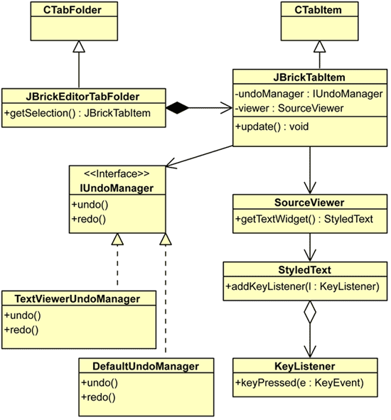

In order to solve these issue, the following classes have been modified JBrickTabItem and JBrickEditorTabFolder. The solution to this problem is intercepting the keypress method for the JBrickEditor class. This keypress method is inside of the JBrickTabItem. The keypress receives the key and if the key is an “enter” then it will execute and undo and redo execution. In that way a new trace of undo action and a new change is generated per each new line generated. Then the cursor is located in the next line. The next time the undo is executed, the last line of written code will be removed and in that way for all the written lines in the next undo executions. So every undo execution will undo the last written code after an Enter.

Stop Button Bug in the Help Content Browser
The class HelpBrowser is responsible for all the uses of the Help Content. The HelpBrowser contains a STOP button for interrupt the web navigation inside the browser. However this button only works the first time is used. This button calls a method .close() which is responsible of closing the internet connection. This method has been replaced for a setUrl(“”) method. This method will emulate the internet interruption calling to a unknown website. The HelpBrowser was the only class Modified.
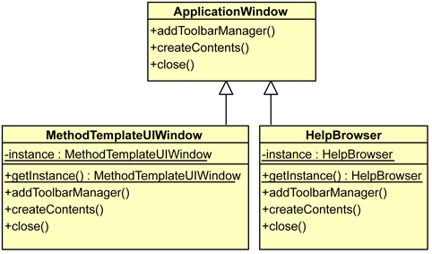

Multiple Windows for the Method Templates and the Help Browser
As shown in the previous diagram, MethodTemplateUIWindow and HelpBrowser inherit from the ApplicationWindow class. The issue was being possible to launch multiple instances of these windows. This was resolved by making these two classes singleton, so that whenever the buttons for launching them are clicked, only the same instance is returned.

The close() method is invoked whenever the selected window is closed [by the user] and it’s used to unset the current instance of the window (it’s the private static variable instance), so a new instance would be created the next time the window is launched and kept until it’s closed.

The Piano
To better understand the changes to the Piano, here is a snapshot of its current visual design:

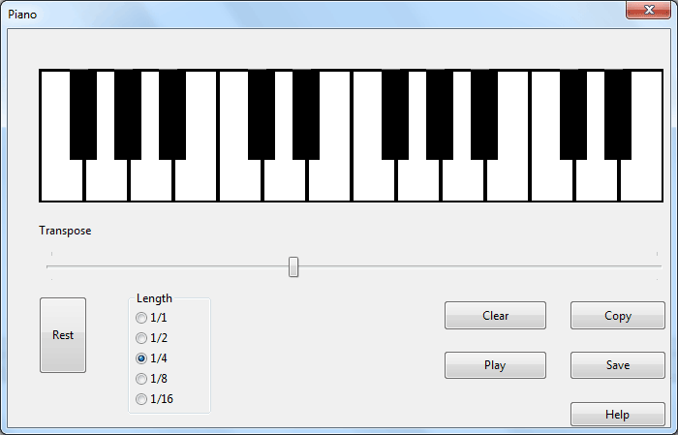

The features related to the Piano are:
1. The keywords
Following the structure to the PianoComposite class, there’s a method named pianoKeyPressed(). This method contains all the keywords for each and every of the sounds, and it has been modified to add the sound of some of the black keys. (s = KeyId 11; d = KeyId 12; z = KeyId 12; x = KeyId 13).

2. Piano Recording
This is recording class structure for the Piano:

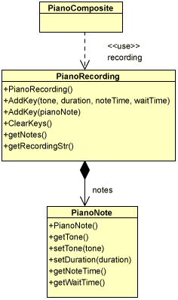

The PianoComposite class stores an instance of PianoRecording and calls AddKey() inside pianoClicked, ClearKeys() in clearButtonPressed, and getNotes() in playButtonPressed. The PianoRecording class stores the notes that have been pressed in the ArrayList of PianoNote in notes and modifies the datastructure appropriately in the various methods.

3. The Save, Rest, Help buttons
The PianoComposite class contains Save, Rest, and Help buttons which are instances of the Button class. The following class diagram illustrates better this association:

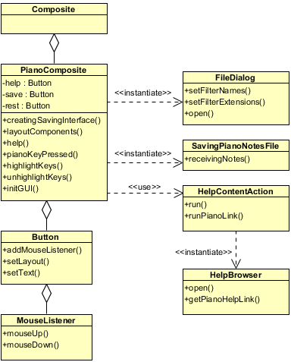

As shown in the previous diagram, the PianoComposite has the layoutComponents() method, inside of which the creation of all the buttons used in the piano interface takes place. The Button class has a collection of MouseListener, and since the three buttons are instances of the Button class, they also have a method called addMouseListener() to add mouse event listeners to their own collection. The three mouse listeners added to the buttons, one for each button, only implement the mouseDown() method which is triggered when the user clicks on the button. These are the details of the implementation:

- Save Button: When the user clicks on the save button, the mouseUp method will call creatingSavingInterface(). This method should instantiates FileDialog class. In that moment a saving dialog box will appear in front of the user. The user will select where he will save the file and the name of the file.The FileDialog class contains an open method. This last method will return the name of the file. If the file already exist, then the user will choose if he overwrites the file or not. When the user accepts, an instance of savingPianoNotesFile will be created, this instance will call the method receivingNotes and it will pass the arraylist of notes from PianoRecording and the name of the file.

- Help Button: executes the run() method in an instance of HelpContentAction, which is a property of the PianoComposite. The help button will call the help method, this method will call runPianoLink method inside of the HelpContentAction. This method creates an instance of HelpBrowser and this instance will call the getPianoHelpLink() method. This method will executes browser.setUrl and it will pass the absolutePath of the Piano Composer.html. This action will show the browser and it will show the Piano Help Link.

- Rest Button: sets the note to zero and uses the noteLengthDiv variable which sets a default value for the duration of the wait time. It also calls the AddKey() method inside the PianoRecording instance, this method will send two values the note with zero value and the duration. These values will be taken into account when the nxc file is generated.

Description for Subsystem 1..n
System decomposition describes the decomposition into class groupings/classes (depending on how many there are) and the responsibilities of each grouping/class. You can use a table to help you organize these.

Software Interface Description
The developed software should be able to connect to the Lego Mindstorm Bricks via USB or Bluetooth using the drivers provided with the Bricks.

The graphical user interface should provide enough information for Freedom Scientific’s JAWS, or any other software of that type for that matter, to be able to read said user interface to a blind or low vision user.

The application should be capable of running on any of the three widely used operating systems (Mac OS X, Windows and Linux).

Persistent data management
The system makes use of the persistent data storage basically for two purpose;
- for storing the properties of the system: For storing the properties a simple file format has been adopted that follows a key-value pair. The following files have been used to store the system properties:
  - JBconn.properties: it stores the connection type the user has selected for connecting to the brick.
  - JBrickEditor.properties: It stores the workspace path the user has selected and also the list of recent files
- for storing the configurations of the system: the application stores information that are required by the application like keywords, constants in an XML file format. The following files are used by the application:
  - keywords.xml: it stores the list of keywords
  - constants.xml: stores various constants that are used by the system
  - operators.xml: stores the operators like +, -, / etc.
A different color is rendered for the words that appear in any of these files. E.g. the keywords are rendered green, constants are rendered blue and operators are rendered orange.

Persistent data management describes the persistent data stored by the system and the data management infrastructure required for it. This section typically includes the description of data schemes, the selection of a database, and the description of the encapsulation of the database.

Access control and security
The design of the system does not requires different views for different users. Thus, the user of access control and security is not applicable to the system under consideration.

Global software control
In most cases the system does not need to interact with other external systems. Only in the case an NXC file needs to be transferred to the the brick, it is connected to the brick. Currently two connection types have been made to communicate with the brick; using the USB or via Bluetooth connection. Once the brick is connected to the computer (through any of these connection type), “Find Brick” action could be initiated to detect the connection before transferring the file.

Boundary conditions
Boundary conditions describe the start-up, shutdown, and error behavior of the system.

