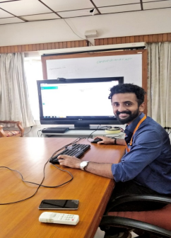

**www. 1 0 0 d ay s o fp y tho n. d ev**

**100 Days of Python Pledge**

*I Ritesh R Kapse am committed to completing the 100 days of Python challenge.*

*I hereby pledge to work for at least an hour on Python programming for 100 days.*

*I will keep myself on track, even though some days I might feel tired or frustrated.*

*I will keep myself accountable, even though I have lots of things to do, I will make this a priority in my* life.

*I will overcome difficulties and achieve my goal.*

*I will become a Python developer.*

*I believe in myself.*

***Signature:***  R.R. Kapse

Date Signed: 12-Nov-2020