Bigdata Assignment 1.3

Task 1:

Check whether /user/acadgild directory exists or not in the HDFS.

If it doesn't exist, then create this.

Create a directory /user/acadgild/hadoop.

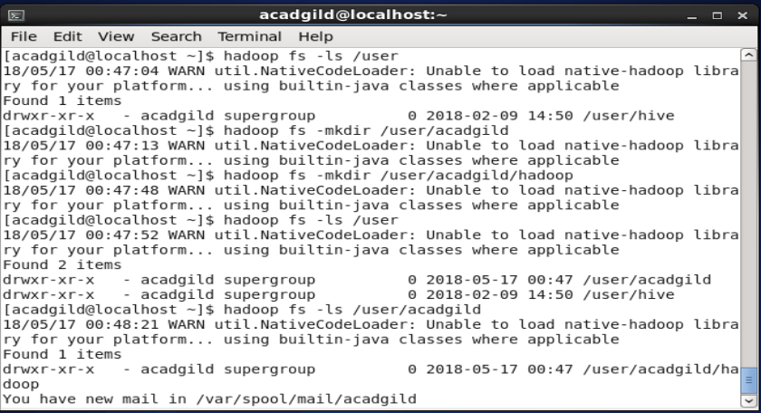

Ans – First I checked using **hadoop fs -ls /user** command to check if the directory /user/acadgild existed or not.

Then , created the directory /user/acadgild/hadoop using command **hadoop fs -mkdir /user/acadgild/hadoop**

Task 2:

Create a file in HDFS under directory /user/acadgild/hadoop, with name word-count.txt.

Whatever we type on screen should get appended to the file.

Try to type (on screen) few lines from any online article or textbook.

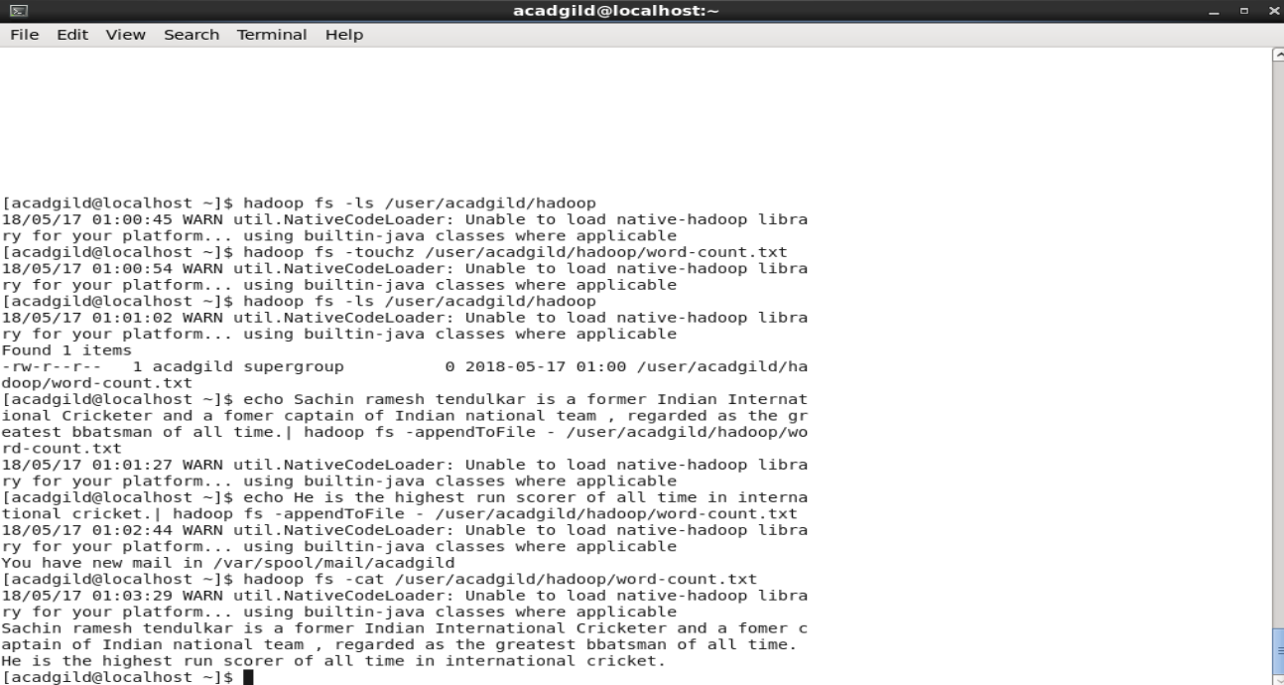

Ans – Created the file word-count.txt using command **hadoop fs -touchz /user/acadgild/hadoop/word-count.txt**

stored text in it using echo comand and **hadoop -fs -appendToFile - /user/acadgild/hadoop/word-count.txt**