Bigdata Assignment 1.6

We have a dataset of sales of different TV sets across different locations.
Records look like:
Samsung|Optima|14|Madhya Pradesh|132401|14200
The fields are arranged like:
Company Name|Product Name|Size in inches|State|Pin Code|Price
There are some invalid records which contain 'NA' in either Company Name or Product Name.
1. Write a Map Reduce program to filter out the invalid records. Map only job will fit for this
context.

Answer

Driver code-
package mapreduce.task.assignment;

import org.apache.hadoop.fs.Path;
import org.apache.hadoop.conf.*;
import org.apache.hadoop.mapreduce.Job;
import org.apache.hadoop.mapreduce.lib.input.FileInputFormat;
import org.apache.hadoop.mapreduce.lib.input.TextInputFormat;
import org.apache.hadoop.mapreduce.lib.output.FileOutputFormat;
import org.apache.hadoop.mapreduce.lib.output.TextOutputFormat;
import org.apache.hadoop.io.LongWritable;
import org.apache.hadoop.io.Text;

public class Task {
public static void main(String[] args) throws Exception {
Configuration conf = new Configuration();
Job job = new Job(conf, "Assignmnet1.6");
job.setJarByClass(Task.class);
//Key is LongWritable as it is the index
job.setMapOutputKeyClass(LongWritable.class);
//Value is Text as the whole string is required
job.setMapOutputValueClass(Text.class);

//Key is LongWritable as it is the index
job.setOutputKeyClass(LongWritable.class);
//Value is Text as the whole string is required
job.setOutputValueClass(Text.class);
job.setMapperClass(TaskMapper.class);

job.setInputFormatClass(TextInputFormat.class);
job.setOutputFormatClass(TextOutputFormat.class);

FileInputFormat.addInputPath(job, new Path(args[0]));
FileOutputFormat.setOutputPath(job,new Path(args[1]));

/*
Path out=new Path(args[1]);
out.getFileSystem(conf).delete(out);
*/

job.waitForCompletion(true);
}
}

Mapper Code -
package mapreduce.task.assignment;

import java.io.IOException;

import org.apache.hadoop.io.LongWritable;
import org.apache.hadoop.io.Text;
import org.apache.hadoop.mapreduce.*;

public class TaskMapper extends Mapper<LongWritable, Text,LongWritable,Text> {

@Override
public void map(LongWritable key, Text value, Context context)
throws IOException, InterruptedException {
String[] lineArray = value.toString().split("\\|");

String company = lineArray[0];
String product = lineArray[1];
//Checking if company name or product name must not equal to NA
if(!(company.equals("NA")||product.equals("NA")))
{
context.write(key,value);
}

}
}

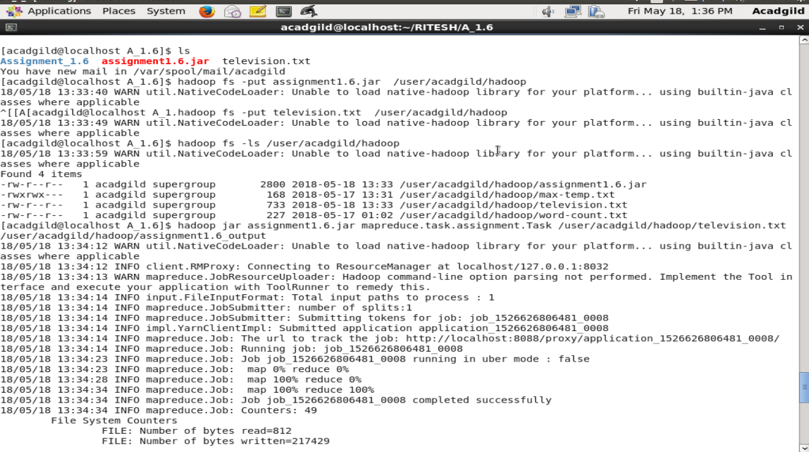
Execution Steps:-
- television.txt was put to hdfs.
- After the driver code and mapping code , a jar file of was generated.
- assignmen1.6.jar file(mapping code) was put to hdfs.
- Mapping task was performed by the following command – hadoop jar assignmen1.6.jar mapreduce.task.assignment.task /user/acadgild/hadoop/television.txt /user/acadgild/hadoop/assignment1.6_output
- To see the content of the output following command was used -
hadoop cat /user/acadgild//hadoop/assignment1.6_output/part-r-00000

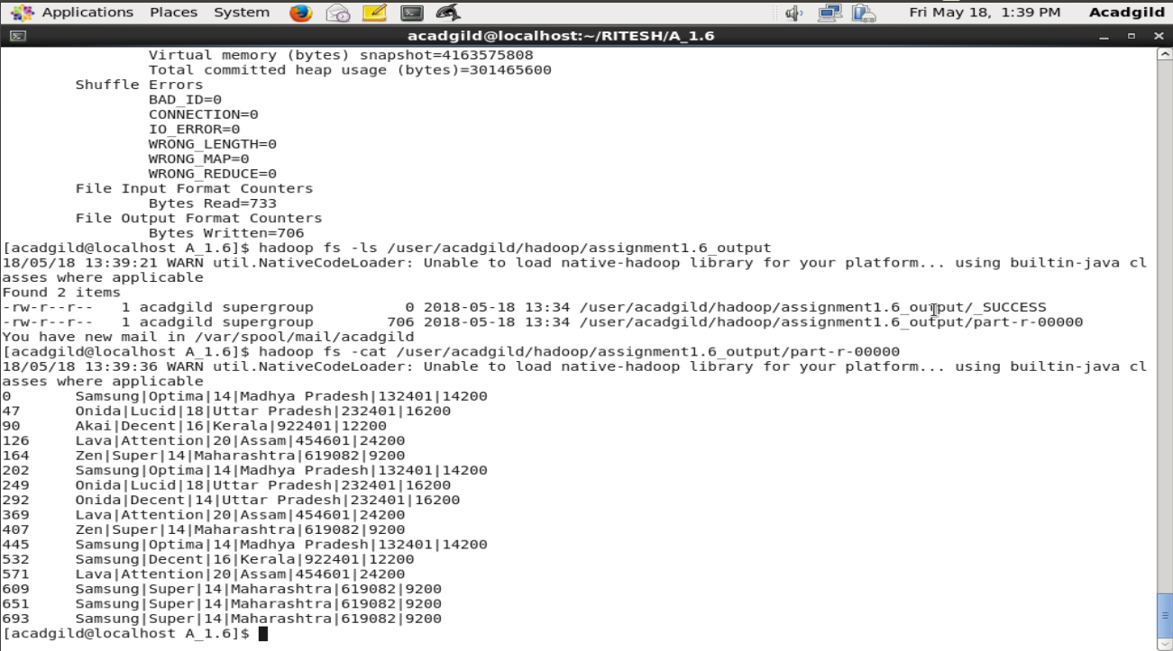
Output
As in the above screen shot ,it is evident that the content of the output file does not contain any records whose company name or product name equals “NA”.

