Bigdata Assignment 2.5

- We ran Pig in localmode - pig -x local

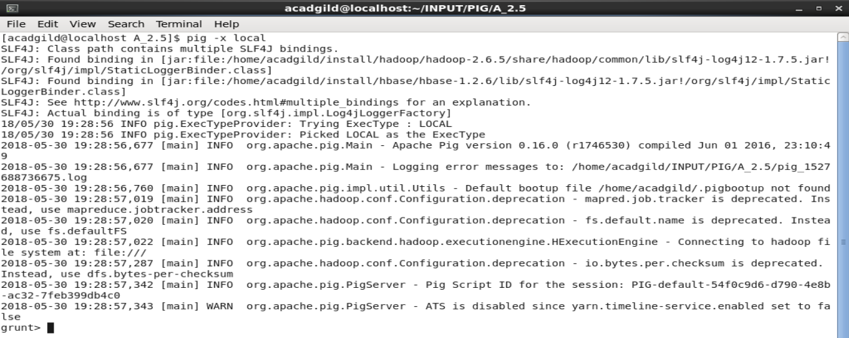

Problem Statement 1
Find out the top 5 most visited destinations.

Solution-
- piggybank jar is registered in order to use the CSVExcelStorage class.

REGISTER '/home/acadgild/install/pig/pig-0.16.0/lib/piggybank.jar';

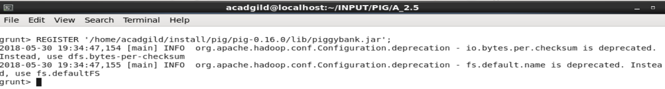

- delayed flight.csv file data is loaded into a relation
delayed_flight = load 'DelayedFlights.csv' USING org.apache.pig.piggybank.storage.CSVExcelStorage(',','NO_MULTILINE','UNIX','SKIP_INPUT_HEADER');

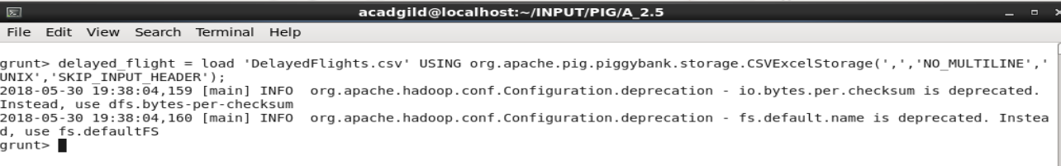
- generated columns that required and they are typecasted.

required_data = foreach delayed_flight generate (int)$1 as year, (int)$10 as flight_num, (chararray)$17 as origin,(chararray) $18 as dest;

- filtered out null values in the relation

filter_dest = filter required_data by dest is not null;

- Flitered data is grouped by destination .
group_dest = group filter_dest by dest;

- Each destination group's total count is calculated.
visit_dest = foreach group_dest generate group, COUNT(filter_dest.dest);

- Sorted the list in decreasing order.
desc_visit_dest = order visit_dest by $1 DESC;

- Top 5 are selected and stored in a relation
Result = LIMIT desc_visit_dest 5;

- airports.csv data is loaded into a relation
airport_data = load 'airports.csv' USING org.apache.pig.piggybank.storage.CSVExcelStorage(',','NO_MULTILINE','UNIX','SKIP_INPUT_HEADER');

- generated columns that required and they are typecasted.
airport = foreach airport_data generate (chararray)$0 as dest, (chararray)$2 as city, (chararray)$4 as country;

- result and airport joined on common column dest for complete details.
complete_details = join Result by $0, airport by dest;
dump complete_details;

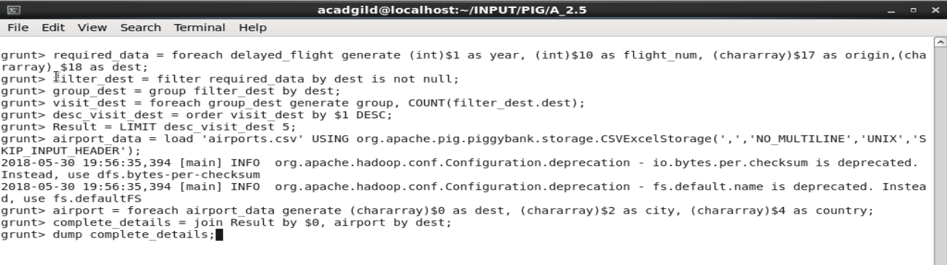
Output-
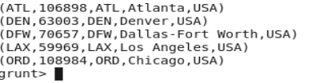

Problem Statement 2
Which month has seen the most number of cancellations due to bad weather?

Solution-
- piggybank jar is registered in order to use the CSVExcelStorage class.

REGISTER '/home/acadgild/install/pig/pig-0.16.0/lib/piggybank.jar';
delayed_flight = load 'DelayedFlights.csv' USING org.apache.pig.piggybank.storage.CSVExcelStorage(',','NO_MULTILINE','UNIX','SKIP_INPUT_HEADER');

- delayed flight.csv file data is loaded into a relation
cancelled_flight = foreach delayed_flight generate (int)$2 as month,(int)$10 as flight_num,(int)$22 as cancelled,(chararray)$23 as cancel_code;

- weather cancelled flight is stored in a relation.
weather_cancellation = filter cancelled_flight by cancelled == 1 AND cancel_code =='B';

- weather cancelled flights are grouped by month
wc_month = group weather_cancellation by month;

- In each month , no of flights are cancelled both these are columns are generated.
count_bymonth = foreach wc_month generate group, COUNT(weather_cancellation.cancelled);

- The list is sorted in descending order then top one is selected.
desc_count = order count_bymonth by $1 DESC;
Result = limit desc_count 1;
dump Result;
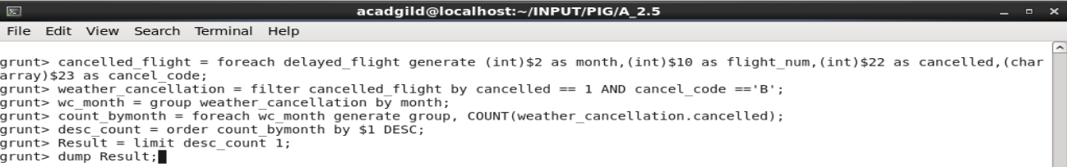

Output-:

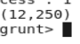

Problem Statement 3
Top ten origins with the highest AVG departure delay

Solution:-

- piggybank jar is registered in order to use the CSVExcelStorage class.
REGISTER '/home/acadgild/install/pig/pig-0.16.0/lib/piggybank.jar';

- delayed flight.csv file data is loaded into a relation
delayed_flight = load 'DelayedFlights.csv' USING org.apache.pig.piggybank.storage.CSVExcelStorage(',','NO_MULTILINE','UNIX','SKIP_INPUT_HEADER');

- Required columns such delay time and origin are generated into another relation.
delay_origin = foreach delayed_flight generate (int)$16 as dep_delay, (chararray)$17 as origin;

- The required columns data are filtered out if it contains null.
filter_delay_origin = filter delay_origin by (dep_delay is not null) AND (origin is not null);

- Flights details are grouped by common column origin.
group_origin = group filter_delay_origin by origin;

- List is generated with each group(origin) and its corresponding avg delay time .
list_origin = foreach group_origin generate group, AVG(filter_delay_origin.dep_delay);

- List is sorted in descending order and top 10 are stored in another relation.
Result = order list_origin by $1 DESC;
Top_ten = limit Result 10;
- Airport.csv data is loaded into a relation
airport_data = load 'airports.csv' USING org.apache.pig.piggybank.storage.CSVExcelStorage(',','NO_MULTILINE','UNIX','SKIP_INPUT_HEADER');

- Required columns of the relation such as the airport details are generated .
airport_req = foreach airport_data generate (chararray)$0 as origin, (chararray)$2 as city, (chararray)$4 as country;

- Airport relation and top_10 relation are joined by origin.
Joined = join airport_req by origin, Top_ten by $0;

- Airport details are generated and sorted in descending order , and hence result is displayed.
Final = foreach Joined generate $0,$1,$2,$4;
Final_Result = ORDER Final by $3 DESC;
dump Final_Result;

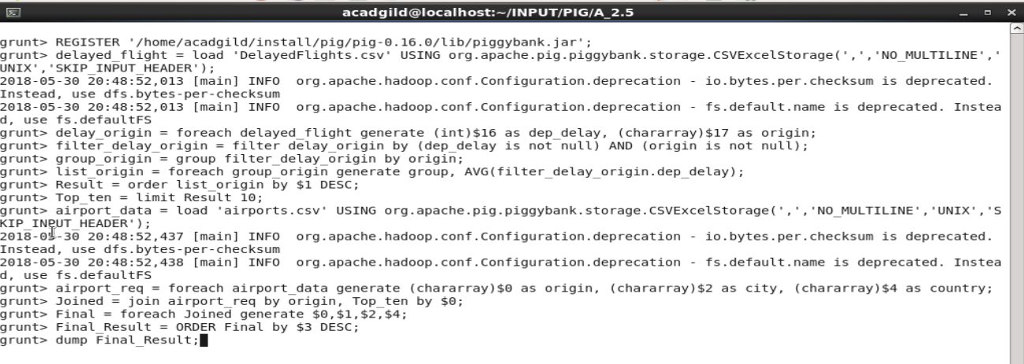

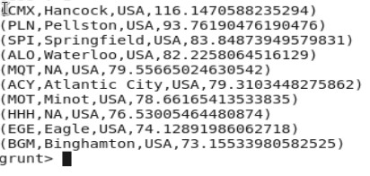
Output-

Problem Statement 4
Which route (origin & destination) has seen the maximum diversion?

Solution -

- piggybank jar is registered in order to use the CSVExcelStorage class.
REGISTER '/home/acadgild/install/pig/pig-0.16.0/lib/piggybank.jar';

- delayedflight.csv data is loaded into a relation.
delayed_flight = load 'DelayedFlights.csv' USING org.apache.pig.piggybank.storage.CSVExcelStorage(',','NO_MULTILINE','UNIX','SKIP_INPUT_HEADER');

- Created an another relation in which diverted filghts are considred.
diverted_flight = FOREACH delayed_flight GENERATE (chararray)$17 as origin, (chararray)$18 as dest, (int)$24 as diversion;

- Filtered the flights if origin or destination is null .
filter_diverted_flight = FILTER diverted_flight BY (origin is not null) AND (dest is not null) AND (diversion == 1);

- Grouped the data by origin and destination.
group_route = GROUP filter_diverted_flight by (origin,dest);

- For every group , its corresponding total count is calculated, hence a lsit is generate.
list_route = FOREACH group_route generate group, COUNT(filter_diverted_flight.diversion);

- The list is sorted in descending order and top 10 is calculated.
list_route_desc = ORDER list_route BY $1 DESC;
Result = limit list_route_desc 10;
dump Result;

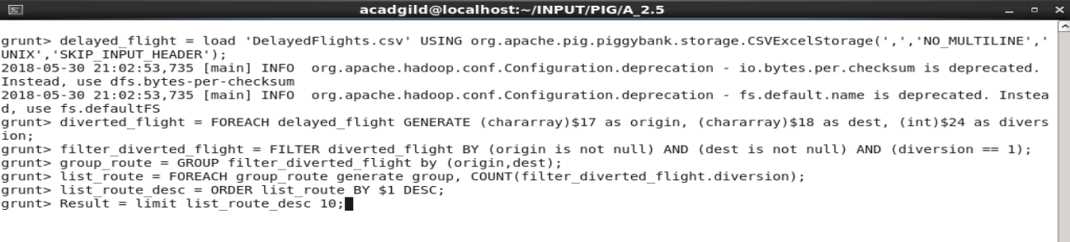

Output -
