Bigdata Assignment 2.6

Implement the use case present in below blog link and share the complete steps along with

screenshot(s) from your end.

<https://acadgild.com/blog/pig-use-case-pokemon-data-analysis/>

* Entered into pig shell by using command - **pig -x local**

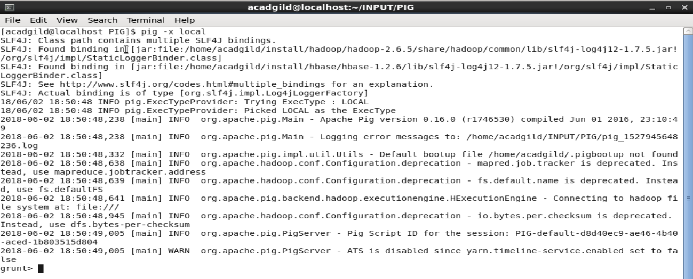

* Loaded the pokemon dataset into a relation - **Load_Data = LOAD 'Pokemon.csv' USING PigStorage(‘,’) AS(Sno:int,Name:chararray,Type1:chararray,Type2:chararray,Total:int,HP:int,Attack:int,Defense:int,SpAtk:int,SpDef:int,Speed:int);**

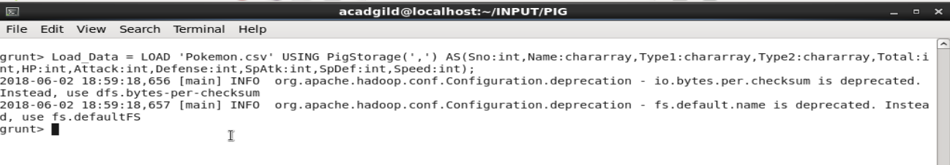

1. Find the list of players that have been selected in the qualifying round (DEFENCE>55).

**Ans -** Filtered the data where defence>55

**selected_list = FILTER Load_Data BY Defense>55;**

**dump selected_list;**

Output - 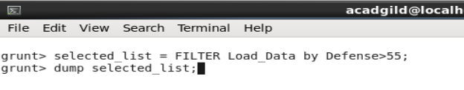

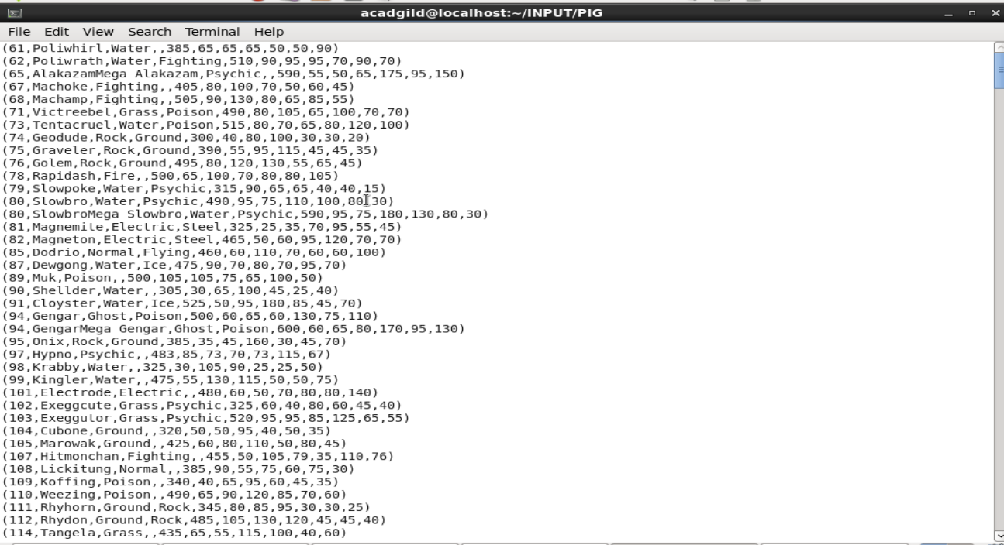

2. State the number of players taking part in the competition after getting selected in the qualifying round.

Ans -

First we grouped all the data into one then

**group_selected_list = Group selected_list All;**

**count_selected_list = foreach group_selected_list GENERATE COUNT(selected_list);**

**dump count_selected_list;**

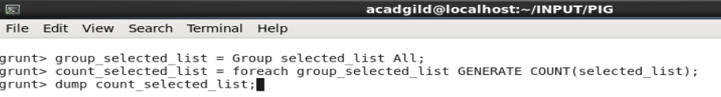

Output -



3. Using random() generate random numbers for each Pokémon on the selected list.

Ans -

From the selected list for each pokemon we assigned a random no by using RANDOM function.

**random_data = foreach selected_list GENERATE RANDOM(),Name,Type1,Type2,Total,HP,Attack,Defense,SpAtk,SpDef,Speed;**

**dump random_data;**



Output- 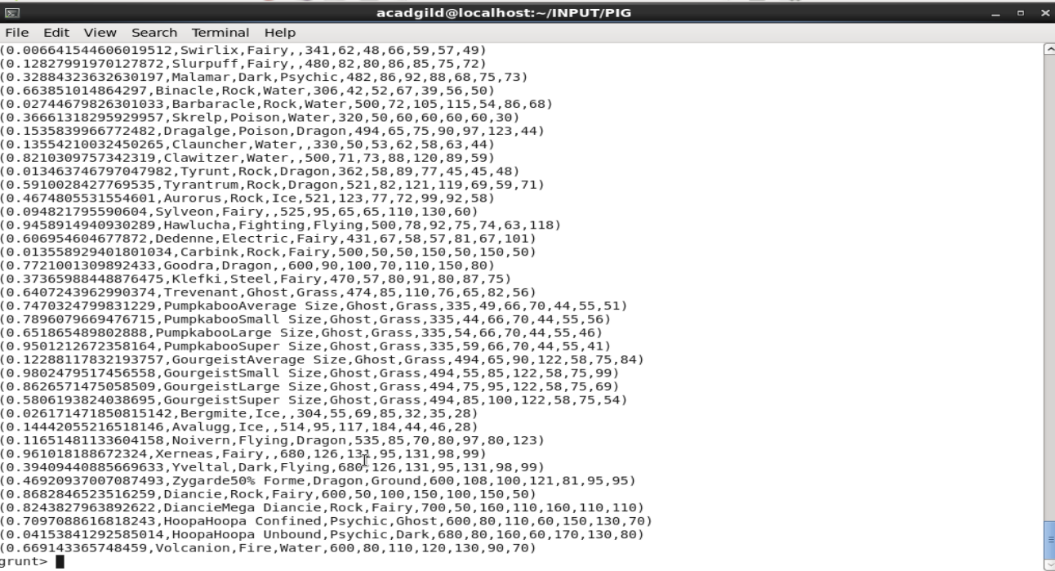

4.Arrange the new list in a descending order according to a column randomly.

Ans -

List is generated in the decreasing order by according to random no column

**random_descending = ORDER random_data BY $0 DESC;**

**dump random_descending;**

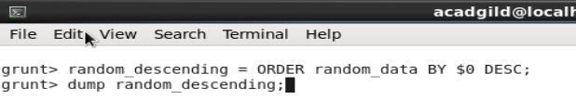

Output -

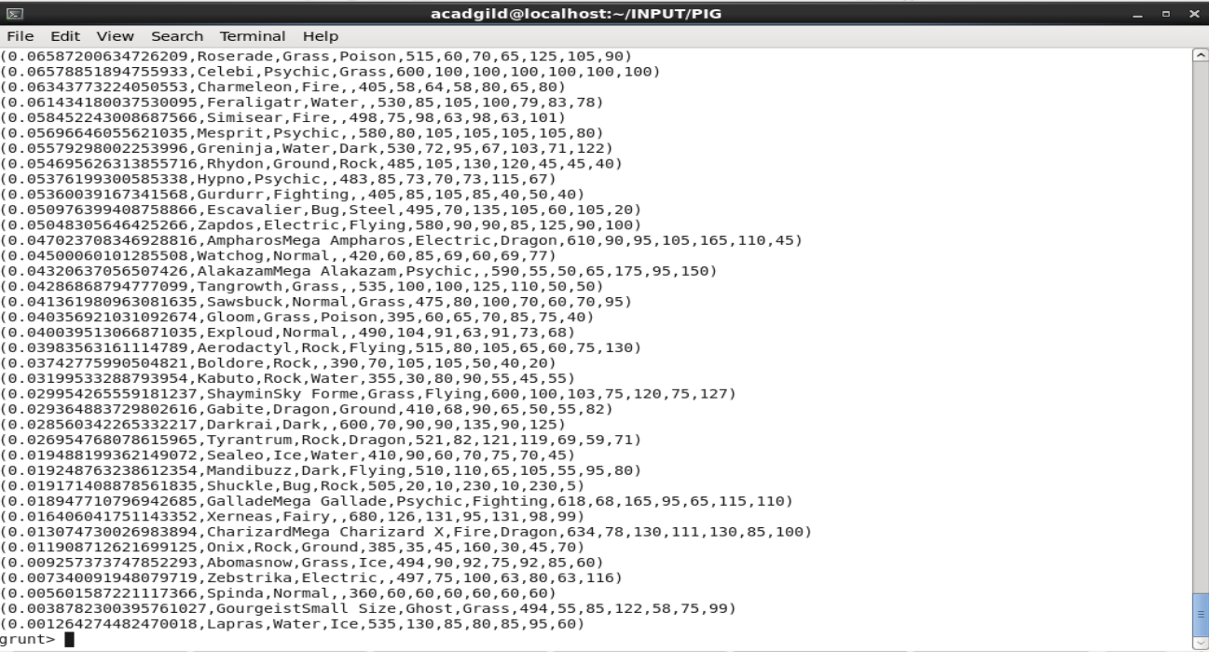

5. Now on a new relation again associate random numbers for each Pokémon and arrange in descending order according to column random.

Ans -

From the selected list for each pokemon we assigned a random no by using RANDOM function.

List is generated in the decreasing order by according to random no column

**random_data2 = foreach selected_list GENERATE RANDOM(),Name,Type1,Type2,Total,HP,Attack,Defense,SpAtk,SpDef,Speed;**

**random_desending2 = ORDER random_data2 BY $0 DESC;**

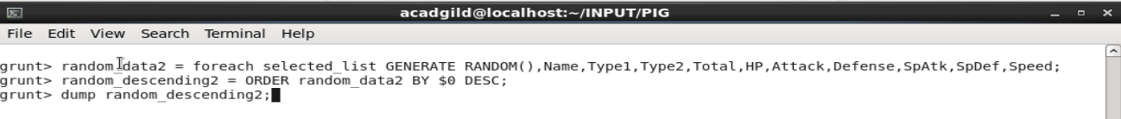

Output -

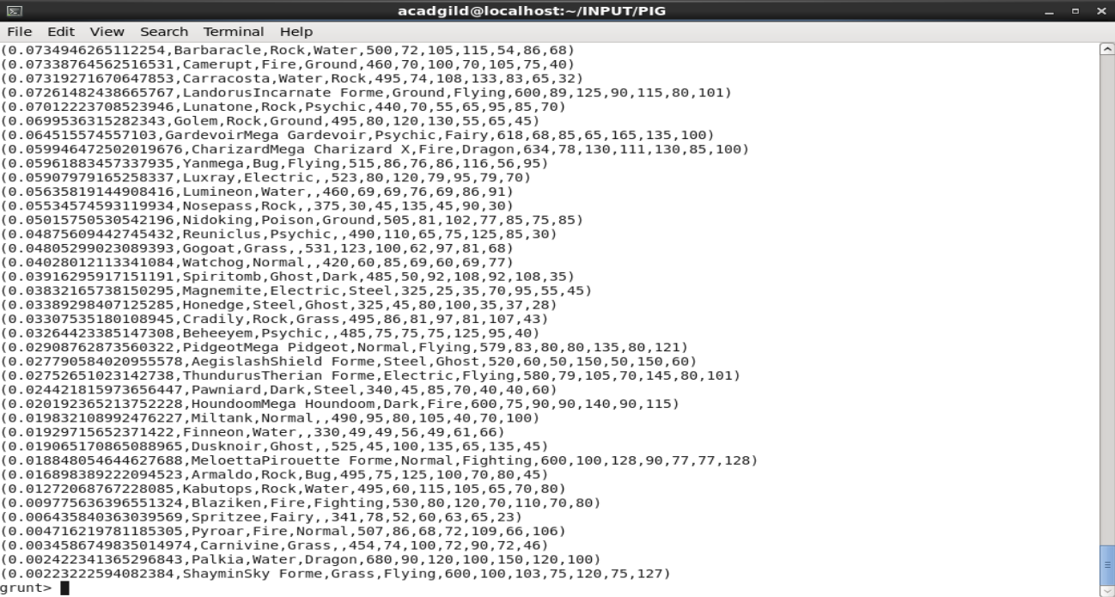

6. From the two different descending lists of random Pokémons, select the top 5 Pokémons for 2 different players.

Ans -

From the 2 descending list we selected the top5 by using LIMIT.

**limit_data_random_desending = LIMIT random_data 5 ;**

**dump limit_data_random_desending;**

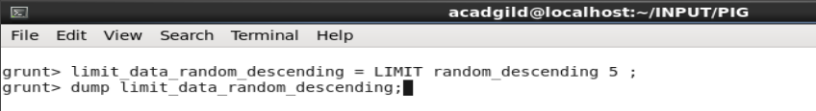

Output -

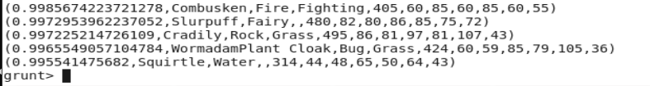

**limit_data_random_desending2 = LIMIT random_data2 5 ;**

**dump limit_data_random_desending2;**

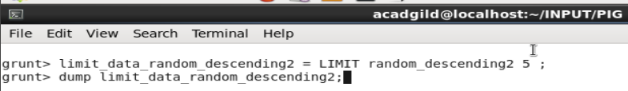

Output -

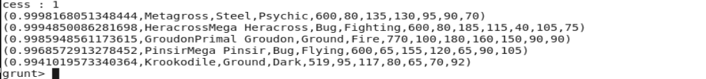

7. Store the data on a local drive to announce for the final match. By the name player1 and player2 (only show the NAME and HP).

Ans -

Using pre-defined functions we got 2 sets of 5 Pokémons, which got selected randomly.

**filter_only_name = foreach limit_data_random_descending Generate ($1,HP);**

**dump filter_only_name;**

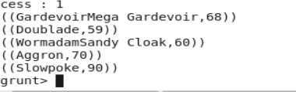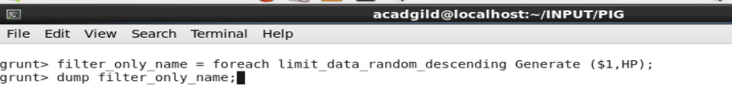

Output -

**filter_only_name2 = foreach limit_data_random_descending2 Generate ($1,HP);**

**dump filter_only_name2;**

Output - 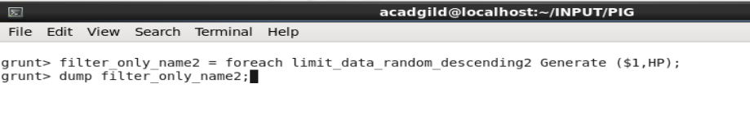

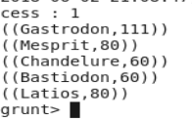

**STORE limit_data_random_desending INTO ‘/home/acadgild/player1.txt’;**

**STORE limit_data_random_desending2 INTO ‘/home/acadgild/player2.txt’;**

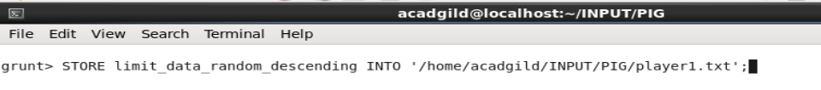

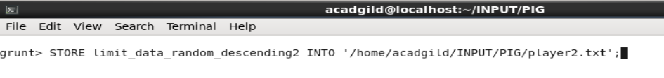

Output - 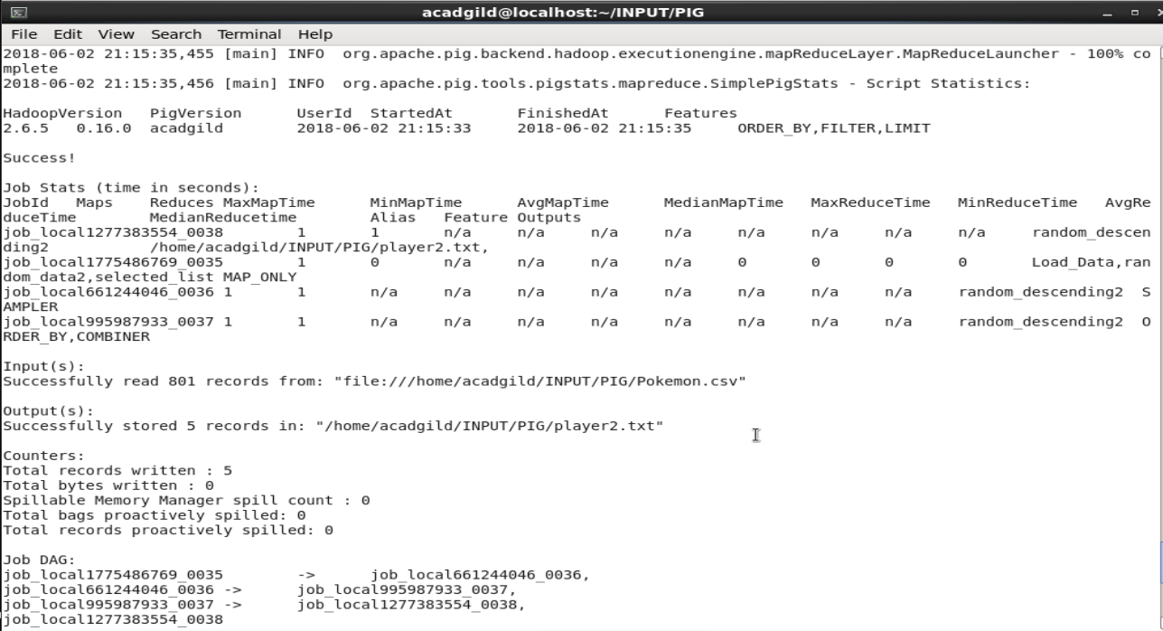

As in the below screenshot , both file are got stored in the local file system.

