Bigdata Assignemnt 2.7

Create a database named 'custom'.

Create a table named temperature_data inside custom having below fields:

1. date (mm-dd-yyyy) format

2. zip code

3. temperature

The table will be loaded from comma-delimited file.

Load the dataset.txt (which is ',' delimited) in the table.

Solution -

* entered into hive shell by using command -

**start-all.sh**

**hive**

* Checked the databases and then created a database named as 'custom' and then gain checked if it is created or not.

Command used :-

**show databases;**

**create database custom;**

**show databases;**

* Then 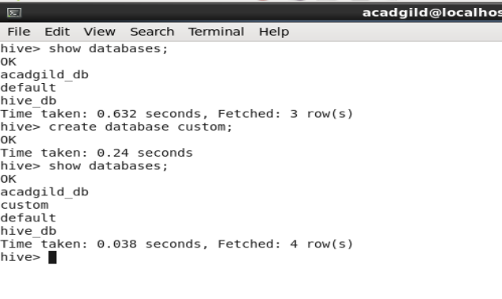in the 'custom' database , we created a external table named temp_table and loaded the data into the tablefrom the text file loacted in the local file system.

Command used -

**use custom;**

**CREATE EXTERNAL TABLE IF NOT EXISTS temp_table(full_date string,zipcode , temp int) ROW FORMAT DELIMITED FIELDS TERMIBATED BY ',' ;**

**LOAD data local inpath 'dataset_Session 14.txt' overwrite into table temp_table;**

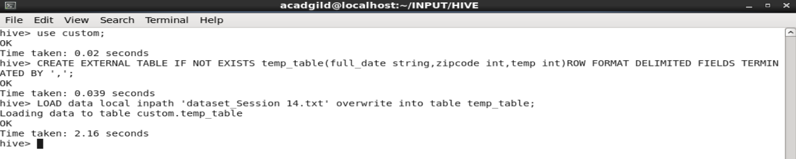

* Then we checked the contents of the table as it can be ssen inthe below screenshot the date format is dd-MM-yyyy.

**select * from temp_table;**

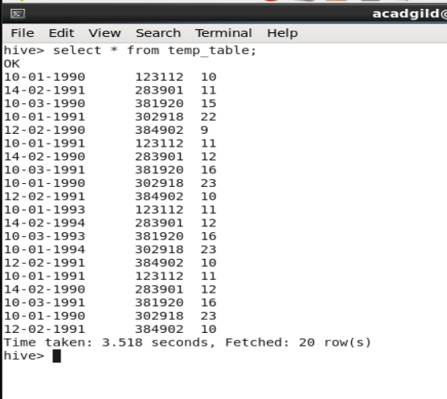

* We created another table to store the correct date format data .

**CREATE EXTERNAL TABLE IF NOT EXISTS temperature_data(full_date string, zipcode int, temp int) ROW FORMAT DELIMITED FIELDS TERMINATED BY ',' ;**

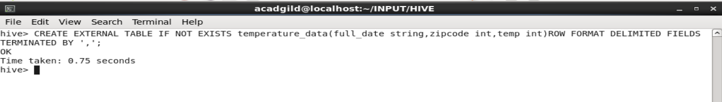

* Inserted the data into new table 'temperature_data' from the previous table temp_table with changed data format(MM-dd-YYYY) using unix_timestamp function.

**INSERT OVERWRITE TABLE temperature_data SELECT date_format(from_unixtime(unix_timestamp(full_date,'dd-MM-yyyy')),'MM-dd-YYYY'), zipcode , temp from temp_table;**



* After inserting the data , we checked the content of the table

**select * from temperature_data;**

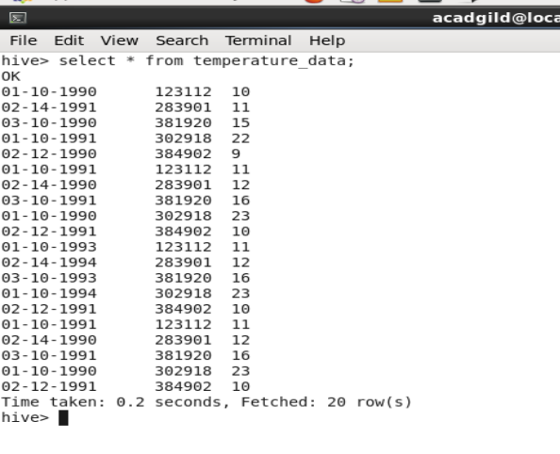

Conclusion -

As in the table's content we can see the date format changed to (MM-dd-YYYY) and the rest column as per the question