Bigdata Assignment 5.5

1.Write a simple program to show inheritance in scala.

2.Write a simple program to show multiple inheritance in scala.

Solution -

1. Inheritance.scala

**class Person {**

**var salary:Float = 100000**

**}**

**class Department extends Person{//Department class inherits Person class**

**var bonus:Int = 5000**

**println("Salary = "+salary) //As it inherits, able to access Salary**

**println("Bonus = "+bonus)**

**}**

**object MainObject{**

**def main(args:Array[String]){**

**new Department()**

**}**

**}**

Output – As in the below screenshot we can observe that in the console window wegot the output from the Department class which has inherited from another class due to which it is able to access “salary” variable in the Person class

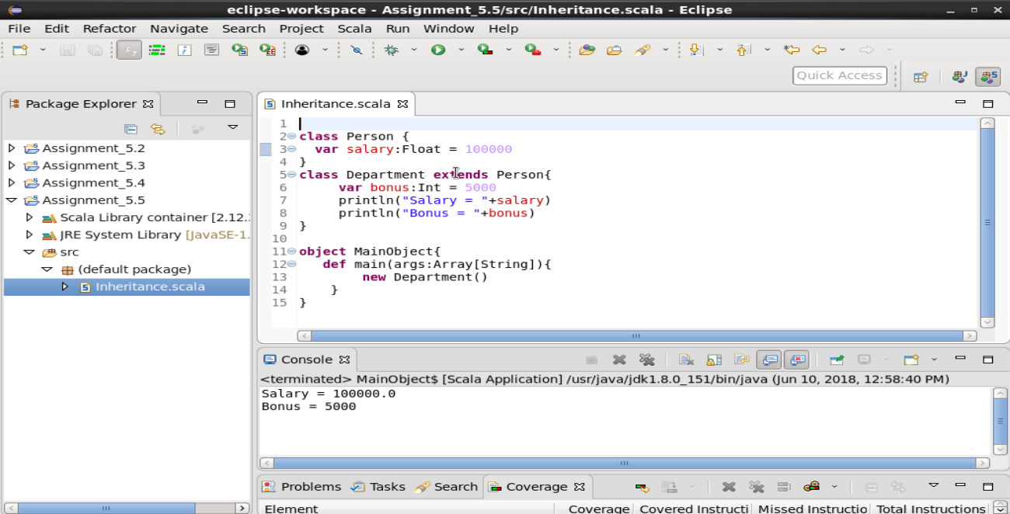

2. **MultipleInheritance.scala**

**object Example {**

**def main(args: Array[String]): Unit= {**

**trait A {**

**var x: Int = _**

**def action = {**

**x = x + 5**

**}**

**}**

**trait B {**

**var y: Int = _**

**def action = {**

**y = y + 1**

**}**

**}**

**class AB extends A with B {//AB class extending traits A and B**

**x = 4**

**y = 6**

**override def action = {**

**super[A].action//calling A trait's function action**

**super[B].action//calling B trait's function action**

**}**

**}**

**var ab = new AB**

**ab.action**

**println("x value = "+ab.x)**

**println("y value = "+ab.y)**

**}**

**}**

OUTPUT - Multiple inheritance of class is not possible in the case of scala but it can extend multiple traits. A trait encapsulates method and field definitions, which can then be reused by mixing them into classes.

In the following program we defined 2 traits having same variable and same function name. And one inherited both the traits.From that we override and using super keyword we can use it to access each trait's variable and function.

