Object Oriented Programming (CSEG1044)
Unit 06: Capstone Project — Phase 2
UML and Package Design
Project: Cafeteria Order and Billing System

1. Goal of This Phase
This phase converts the use cases from Phase 1 into a concrete class design and package structure. Every class is given a clear responsibility, relationships between classes are defined, and the architecture is split into four distinct layers: model, dao, service, and ui.

2. Package Structure
The project follows a four-layer architecture. Each package has a single, well-defined role. SQL never appears in UI code, and bill calculation logic never appears inside Swing event handlers.

Package | Layer | Responsibility
model | Data Layer | Plain Java classes (POJOs) representing real-world entities. No SQL, no Swing.
dao | Persistence Layer | All JDBC/SQL code lives here. One DAO class per entity. Returns model objects to callers.
service | Business Logic Layer | Validation, calculations, and workflow coordination. Calls DAO, returns results to UI.
ui | Presentation Layer | Swing screens only. Calls service layer. Contains zero SQL and zero business logic.
util | Utility Layer | Singleton DBConnection class manages the JDBC connection used by all DAO classes.

3. Folder Layout
The recommended folder layout inside the src directory is:

src/
cafeteria/
model/
User.java
MenuItem.java
Customer.java
Order.java
OrderItem.java
Bill.java
dao/
UserDao.java
MenuDao.java
OrderDao.java
service/
BillingService.java
MenuService.java
OrderService.java
ui/
LoginFrame.java
AdminDashboard.java
OperatorDashboard.java
MenuManagementPanel.java
PlaceOrderPanel.java
BillPanel.java
OrderHistoryPanel.java
SalesSummaryPanel.java
util/
DBConnection.java
Main.java

4. Class Responsibilities

4.1 Model Classes (package: cafeteria.model)
Class | Responsibility
User | Stores login credentials and role (Admin/Operator). Provides validatePassword() so password checking stays out of the UI.
MenuItem | Holds item name, category, price, and availability flag. No calculation logic.
Customer | Stores customer name and contact information linked to an order.
Order | Holds a list of OrderItem objects and a reference to Customer. Provides getTotal() to sum all line totals.
OrderItem | Joins a MenuItem to an Order with a quantity. Provides getLineTotal() = unitPrice × quantity.
Bill | Holds the computed subtotal, tax, and final total for one Order. Does NOT calculate — values are set by BillingService.

4.2 DAO Classes (package: cafeteria.dao)
Class | Responsibility
UserDao | Queries the users table. Provides findByUsername() used during login. All SQL is here, not in LoginFrame.
MenuDao | Full CRUD for the menu_items table. Validates uniqueness of item names before insert.
OrderDao | Persists orders, order_items, and bills to the database. Provides getByDate() for daily sales queries.

4.3 Service Classes (package: cafeteria.service)
Class | Responsibility
BillingService | Calculates subtotal, tax (5% GST), and total. Creates and returns a Bill object. Tax logic is never inside a Swing listener.
MenuService | Validates menu item fields before calling MenuDao. Ensures name uniqueness. Acts as gatekeeper between UI and DAO.
OrderService | Validates and places orders via OrderDao. Retrieves order history and computes daily sales summaries.

4.4 Utility Class (package: cafeteria.util)
Class | Responsibility
DBConnection | Singleton class that creates and returns a single shared JDBC Connection. All DAO classes call DBConnection.getInstance().getConnection() — never create their own Connection.

5. Key Relationships
From | To | Type | Meaning
Order | OrderItem | Composition (1 to 0..*) | An Order owns a list of OrderItems. Items cannot exist without an Order.
OrderItem | MenuItem | Association | Each OrderItem references one MenuItem for name and price.
Order | Customer | Association | Each Order is linked to one Customer.
Bill | Order | Composition | A Bill is generated from one Order and holds its calculated totals.
MenuService | MenuDao | Dependency | Service calls DAO to read/write menu items from the database.
OrderService | OrderDao | Dependency | Service calls DAO to persist and retrieve orders and bills.
BillingService | Bill | Dependency | Service creates and populates a Bill object after calculation.
All DAOs | DBConnection | Dependency | Every DAO gets the shared JDBC Connection from DBConnection.

6. UML Class Diagram
The diagram below shows all classes grouped by package, with fields, methods, and relationships. Green = model, Blue = dao, Red = service, Purple = util.

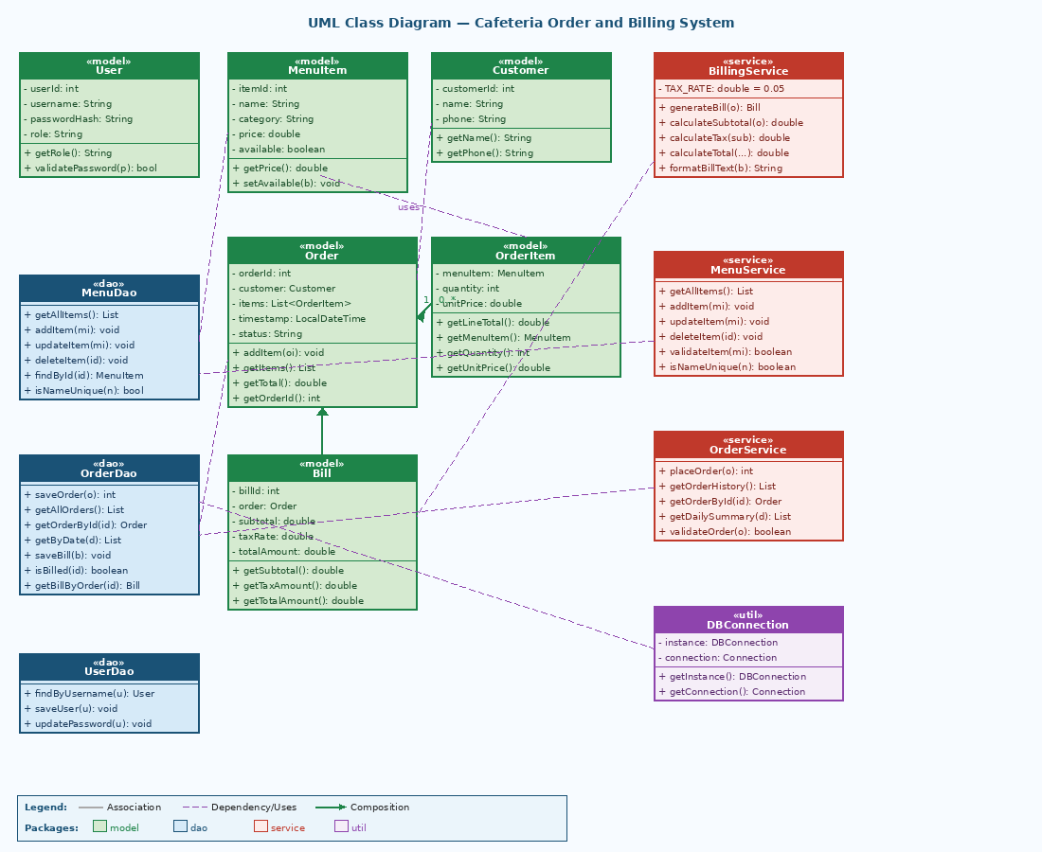

7. Design Warnings Addressed
Warning from Phase 2 PDF | How This Design Addresses It
Do not create one giant manager class | Responsibilities are split into BillingService, MenuService, and OrderService — no single God class.
Do not place SQL inside Swing event handlers | All SQL is in DAO classes. UI panels only call service methods.
Do not keep validation logic only in the UI | Validation is in service classes (e.g., MenuService.validateItem). UI may show errors but never decides rules.
Do not create classes with no real responsibility | Every class in this design has a clearly defined, unique role as shown in Section 4.

8. Review Checklist
 | Checklist Item
✓ | Every class has a clear, single role — no class does everything
✓ | Relationships (association, composition, dependency) are logically correct
✓ | Service and DAO responsibilities are separated — no SQL in service or UI classes
✓ | The UML diagram supports all 7 use cases from Phase 1
✓ | Bill calculation is in BillingService, not inside a Swing listener
✓ | DBConnection is a Singleton — only one connection is created
✓ | All model classes are plain Java objects with no SQL or Swing imports

