

SOFTWARE ENGINEERING

SUBMITTED TO: DR. SOBIN cc
SUBMITTED BY:
RITESH SIGH 590017034
ANURAG KUMAR 590011480
MOHIT VATS 590016048

SOFTWARE REQUIREMENTS SPECIFICATION (SRS)
Voice-Controlled Desktop Assistant

1. Introduction
1.1 Purpose
The purpose of this Software Requirements Specification (SRS) document is to provide a comprehensive, precise, and unambiguous description of the Voice-Controlled Desktop Assistant system. This document serves as a formal contract between stakeholders and developers and acts as the primary reference throughout the software development life cycle. It ensures that all parties have a common understanding of system requirements before implementation begins.

1.2 Document Conventions
This document uses standardized terminology as recommended by IEEE. The keyword SHALL denotes a mandatory requirement, SHOULD indicates a recommended feature, and MAY represents an optional capability. All diagrams included in this document follow standard UML and Data Flow Diagram (DFD) conventions.

1.3 Intended Audience
The intended audience for this document includes software engineers, system analysts, project managers, faculty evaluators, test engineers, and end users. This SRS is also useful for future developers who may extend or maintain the system.

1.4 Product Scope
The Voice-Controlled Desktop Assistant allows users to interact with their desktop system using spoken commands instead of traditional input devices. The system improves accessibility, enhances productivity, and provides hands-free interaction with the operating system.

1.5 Definitions, Acronyms, and Abbreviations
SRS – Software Requirements Specification
DFD – Data Flow Diagram
UML – Unified Modeling Language
OS – Operating System
TTS – Text to Speech

1.6 References
IEEE 830 Software Requirements Specification Standard
Microsoft Windows API Documentation
Speech Recognition System Documentation

2. Overall Description
2.1 Product Perspective
The Voice-Controlled Desktop Assistant is a standalone desktop application that interfaces with the operating system through system APIs. It consists of multiple modules such as voice capture, speech recognition, command processing, task execution, and response generation. The system operates as both a foreground and background service.

2.2 Product Functions
Major product functions include capturing voice input, converting speech to text, interpreting commands, executing system-level tasks, managing files and applications, controlling system settings, and providing voice or text-based feedback to users.

2.3 User Classes and Characteristics
Normal users possess basic computer knowledge and use the assistant for routine tasks. Advanced users rely on automation and efficiency for multitasking. Administrators manage system configuration, permissions, and security policies.

2.4 Operating Environment
The system operates on Windows 10 or higher with a minimum hardware configuration of a dual-core processor, 4 GB RAM, functional microphone, and speakers or headphones.

2.5 Design and Implementation Constraints
The system must comply with operating system security restrictions. It must not perform unauthorized actions or access restricted resources. Performance depends on hardware quality and environmental noise.

2.6 Assumptions and Dependencies
It is assumed that users speak clearly and grant microphone permissions. The system depends on speech recognition libraries, OS APIs, and audio drivers.

3. Functional Requirements
3.1 Functional Requirement 1
Description:
The system SHALL implement functional requirement 1 to ensure reliable operation of the Voice-Controlled Desktop Assistant. This requirement defines how the system responds to user input, processes commands, interacts with the operating system, and generates appropriate output.
Priority: High
Inputs:
User voice commands captured via microphone.
Processing:
Speech recognition, command parsing, validation, and execution.
Outputs:
System action and user feedback through voice or display.

3.2 Functional Requirement 2
Description:
The system SHALL implement functional requirement 2 to ensure reliable operation of the Voice-Controlled Desktop Assistant. This requirement defines how the system responds to user input, processes commands, interacts with the operating system, and generates appropriate output.
Priority: High
Inputs:
User voice commands captured via microphone.
Processing:
Speech recognition, command parsing, validation, and execution.
Outputs:
System action and user feedback through voice or display.

3.3 Functional Requirement 3
Description:
The system SHALL implement functional requirement 3 to ensure reliable operation of the Voice-Controlled Desktop Assistant. This requirement defines how the system responds to user input, processes commands, interacts with the operating system, and generates appropriate output.
Priority: High
Inputs:
User voice commands captured via microphone.
Processing:
Speech recognition, command parsing, validation, and execution.
Outputs:
System action and user feedback through voice or display.

3.4 Functional Requirement 4
Description:
The system SHALL implement functional requirement 4 to ensure reliable operation of the Voice-Controlled Desktop Assistant. This requirement defines how the system responds to user input, processes commands, interacts with the operating system, and generates appropriate output.
Priority: High
Inputs:
User voice commands captured via microphone.
Processing:
Speech recognition, command parsing, validation, and execution.
Outputs:
System action and user feedback through voice or display.

3.5 Functional Requirement 5
Description:
The system SHALL implement functional requirement 5 to ensure reliable operation of the Voice-Controlled Desktop Assistant. This requirement defines how the system responds to user input, processes commands, interacts with the operating system, and generates appropriate output.
Priority: High
Inputs:
User voice commands captured via microphone.
Processing:
Speech recognition, command parsing, validation, and execution.
Outputs:
System action and user feedback through voice or display.

3.6 Functional Requirement 6
Description:
The system SHALL implement functional requirement 6 to ensure reliable operation of the Voice-Controlled Desktop Assistant. This requirement defines how the system responds to user input, processes commands, interacts with the operating system, and generates appropriate output.
Priority: High
Inputs:
User voice commands captured via microphone.
Processing:
Speech recognition, command parsing, validation, and execution.
Outputs:
System action and user feedback through voice or display.

3.7 Functional Requirement 7
Description:
The system SHALL implement functional requirement 7 to ensure reliable operation of the Voice-Controlled Desktop Assistant. This requirement defines how the system responds to user input, processes commands, interacts with the operating system, and generates appropriate output.
Priority: High
Inputs:
User voice commands captured via microphone.
Processing:
Speech recognition, command parsing, validation, and execution.
Outputs:
System action and user feedback through voice or display.

3.8 Functional Requirement 8
Description:
The system SHALL implement functional requirement 8 to ensure reliable operation of the Voice-Controlled Desktop Assistant. This requirement defines how the system responds to user input, processes commands, interacts with the operating system, and generates appropriate output.
Priority: High
Inputs:
User voice commands captured via microphone.
Processing:
Speech recognition, command parsing, validation, and execution.
Outputs:
System action and user feedback through voice or display.

3.9 Functional Requirement 9
Description:
The system SHALL implement functional requirement 9 to ensure reliable operation of the Voice-Controlled Desktop Assistant. This requirement defines how the system responds to user input, processes commands, interacts with the operating system, and generates appropriate output.
Priority: High
Inputs:
User voice commands captured via microphone.
Processing:
Speech recognition, command parsing, validation, and execution.
Outputs:
System action and user feedback through voice or display.

3.10 Functional Requirement 10
Description:
The system SHALL implement functional requirement 10 to ensure reliable operation of the Voice-Controlled Desktop Assistant. This requirement defines how the system responds to user input, processes commands, interacts with the operating system, and generates appropriate output.
Priority: High
Inputs:
User voice commands captured via microphone.
Processing:
Speech recognition, command parsing, validation, and execution.
Outputs:
System action and user feedback through voice or display.

4. External Interface Requirements
4.1 User Interface
The system provides a simple and intuitive user interface with visual indicators for listening status, command recognition, and execution feedback.

4.2 Hardware Interface
The system interfaces with audio input devices such as microphones and audio output devices such as speakers.

4.3 Software Interface
The system interacts with the operating system through system APIs and third-party speech recognition libraries.

4.4 Communication Interface
The system does not require network communication for basic functionality.

5. Non-Functional Requirements
5.1 Performance Requirements
The system shall respond to commands within two seconds under normal operating conditions.

5.2 Security Requirements
Sensitive operations shall require authentication and voice data shall not be stored without consent.

5.3 Reliability Requirements
The system shall operate with 99% uptime and recover gracefully from failures.

5.4 Usability Requirements
The system shall be easy to use by non-technical users and provide help commands.

5.5 Maintainability Requirements
The system shall follow modular design principles for easy maintenance.

5.6 Portability Requirements
The system shall be portable across future versions of the operating system.

6. System Models
This section includes
Data Flow Diagrams (DFD):
LEVEL 0:
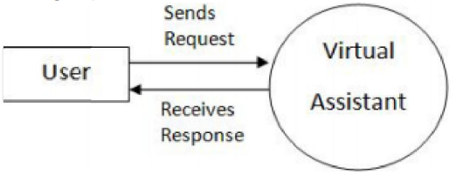
LEVEL 1:
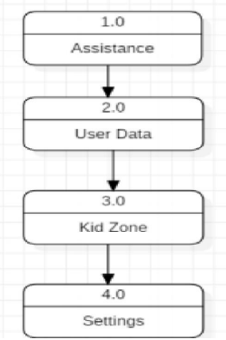
LEVEL 2:
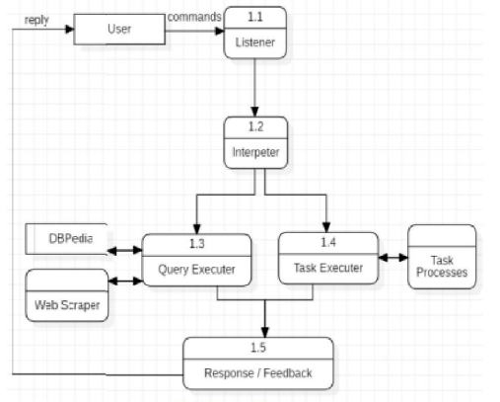
Use Case Diagram:
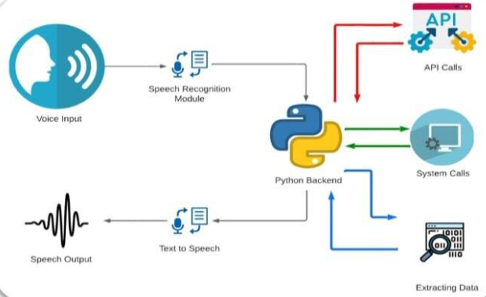

Entity Relationship (ER) Diagram:
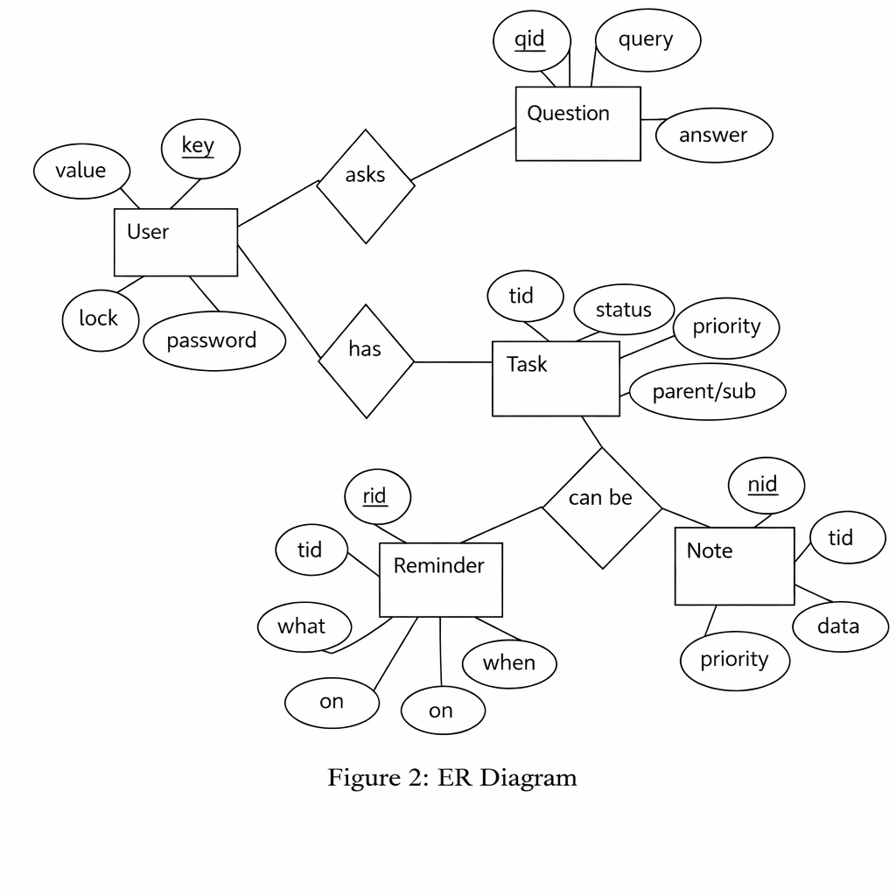

7. Future Enhancements
Support for multiple languages and accents.
Integration with cloud-based services.
AI-based learning for personalized commands.

8. Conclusion
This Software Requirements Specification document provides a complete and detailed description of the Voice-Controlled Desktop Assistant. It defines system behavior, constraints, and expectations and serves as a solid foundation for development, testing, and evaluation.

