Q.19. Write a program to create an array L1 with n values. Create two user defined functions even () - to create an array which store only even values from L1 and Odd () - to create an array which store only odd values from the L1.

#include<iostream.h>

#include<conio.h>

void even(int arr[],int size)

{int dup[100],z=0,k=0;

for(int i=0;i<size;i++)

{if(arr[i]%2==0)

{k=k+1;

dup[z++]=arr[i];

}

}

cout<<"\nThe even values are: ";

for(int i=0;i<k;i++)

cout<<dup[i]<<" ";

}

void odd(int arr[],int size)

{int dup[100],k=0,z=0;

for(int i=0;i<size;i++)

{if(arr[i]%2!=0)

{k=k+1;

dup[z++]=arr[i];

}

}

cout<<"\nThe following are the odd values: ";

for(int i=0;i<k;i++)

cout<<dup[i]<<" ";

}

void main()

{int a[100],n;

cout<<"enter the size: ";

cin>>n;

cout<<"enter the array: ";

for(int i=0;i<n;i++)

cin>>a[i];

even(a,n);

odd(a,n);

getch();

}

**Output:**

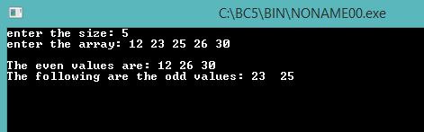

Q.20. Write a program to remove all adjacent duplicate elements from the given array. The program should contain a function del_adjacent_dups to delete duplicate elements.

#include<iostream.h>

#include<conio.h>

void del_adjacent_dups(int arro[],int n1);

void main()

{int n,arr[100];

cout<<"enter the size: ";

cin>>n;

cout<<"enter the array: ";

for(int i=0;i<n;i++)

cin>>arr[i];

del_adjacent_dups(arr,n);

getch();

}

void del_adjacent_dups(int arro[],int n1)

{for(int i=0;i<n1;i++)

{for(int j=i+1;j<n1;j++)

{if(arro[i]==arro[j])

{for(int a=j;j<n1-1;j++)

arro[a]=arro[a+1];

n1--;

j--;

}

}

}

cout<<"\nthe new array is: ";

for(int i=0;i<n1;i++)

cout<<arro[i]<<" ";

}

**Output:**

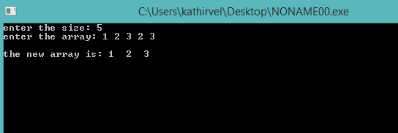

Q.21. Write a menu driven program to read a numeric array and do the following using functions:

(i) To get the position and insert an element.

(ii) To delete an element from the array.

(iii) To search for an element.

(iv) To sort the given array.

#include<iostream.h>

#include<conio.h>

void main()

{ int a[100],n;

char ch;

cout<<"enter the size: ";

cin>>n;

cout<<endl;

cout<<"enter the elements: ";

for(int i=0;i<n;i++)

cin>>a[i];

cout<<"\na.enter the given elemnet in a given position";

cout<<"\nb.delete an element for the array";

cout<<"\nc.search for an element";

cout<<"\nd.to sort the given array";

cout<<endl;

cout<<"enter your choice: ";

cin>>ch;

if(ch=='a')

{ int pos, val;

cout<<"enter the position and value: ";

cin>>pos>>val;

for(int j=n;j>=pos;j--)

a[j]=a[j-1];

n++;

a[pos-1]=val;

cout<<"the new array is: ";

for( int i=0;i<n;i++)

cout<<" "<<a[i];

}

else if(ch=='b')

{ int val,pos,flag;

cout<<"enter the value to be deleted: ";

cin>>val;

for(int i=0;i<n;i++)

{if(val==a[i])

{pos=i;

flag=1;

break;

}

}

if(flag==1)

{for(int j=pos;j<n;j++)

a[j]=a[j+1];

n--;

cout<<" the new array is: ";

for(int i=0;i<n;i++)

cout<<" "<<a[i];

}

else

cout<<"value not found";

}

else if(ch=='c')

{int val,pos,flag=0;

cout<<"enter the val to be searched: ";

cin>>val;

for(int i=0;i<n;i++)

{if(a[i]==val)

{pos=i+1;

flag=1;

}

}

if(flag==1)

cout<<"the elemet is found in position: "<<pos;

if(flag==0)

cout<<"not found";

}

else if(ch=='d')

{for (int i = 0; i < n; i++)

{

for (int j = i+1; j < n; j++)

{

if (a[j]<a[i])

{

int tmp = a[i];

a[i] = a[j];

a[j] = tmp;

}

}

}

cout<<"the array is asending order is: ";

for(int i=0;i<n;i++)

cout<<a[i]<<" ";

}

getch();

}

**Output:**

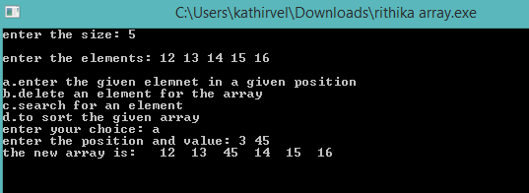

Q.22. Write a function which accept 2D array of integers and its size as arguments and displays the sum of elements which lie on diagonals. Assuming the 2D list to be a square matrix with odd dimension [i.e. 3 x 3]

Example of the list content is

5 4 3

6 7 8

1 2 9

Output through the function should be

Diagonal One Sum: 21

Diagonal Two Sum: 11

#include<iostream.h>

#include<conio.h>

void sumdiagonals(int arr[][100],int m1,int n1);

void main()

{int arr[100][100],m,n;

cout<<"enter the dimensions: ";

cin>>m>>n;

cout<<"enter the elements: "<<endl;

for(int i=0;i<m;i++)

{for(int j=0;j<n;j++)

cin>>arr[i][j];

cout<<'\n';

}

sumdiagonals(arr,m,n);

getch();

}

void sumdiagonals(int a[][100],int m1,int n1)

{int summajor=0,summinor=0;

for(int i=0;i<m1;i++)

{for(int j=0;j<n1;j++)

if(i==j)

summajor=summajor+a[i][j];

}

for(int i=0;i<m1;i++)

{for(int j=0;j<n1;j++)

if((i+j)==(n1-1))

summinor=summinor+a[i][j];

}

cout<<"\nthe sum of major diagonal: "<<summajor;

cout<<"\nthe sum of minor diagonal: "<<summinor;

}

**Output:**

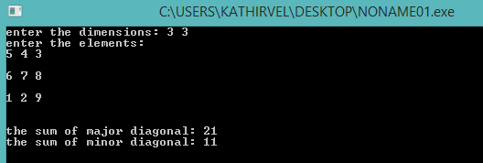

Q.23. Write a program to display the upper and

lower triangular matrix.

#include<iostream.h>

#include<conio.h>

void main()

{int a[100][100],m,n;

cout<<"enter the dimensions: ";

cin>>m>>n;

cout<<"enter the elements: "<<endl;

for(int i=0;i<m;i++)

{for(int j=0;j<n;j++)

cin>>a[i][j];

cout<<'\n';

}

cout<<"\nthe upper triangular matrix is: "<<endl;

for(int i=0;i<m;i++)

{for(int j=0;j<n;j++)

if(i<=j)

cout<<a[i][j]<" ";

cout<<endl;

}

cout<<"\nthe lower triangular matrix is: "<<endl;;

for(int i=0;i<m;i++)

{for(int j=0;j<n;j++)

if(i>=j)

cout<<a[i][j]<" ";

cout<<endl;

}

getch();

}

**Output:**

