Q5. An electronic shop has announced the following seasonal discounts on the purchase of certain items.

|  |  |  |
| --- | --- | --- |
| Amount purchased | Discount on TV system | Discount on music system |
| 0-25000 | 5% | 10% |
| 25001-50000 | 10% | 20% |
| More than 50000 | 15% | 30% |

Develop a program based on the above criteria, to input amount of purchase and the type of purchase (T /M) by a customer. Compute and print the net amount to be paid by a customer.

[Hint: Discount = (Discount rate /100) * Amount of purchase Net amount = amount of purchase - discount).]

#include<iostream.h>

#include<conio.h>

void main()

{ int a;

float b;

char ch;

cout<<"\n\n\n***************T. TYPE OF PURCHASE: TV***************";

cout<<"\n\n\n**********M. TYPE OF PURCHASE: MUSIC SYSTEM**********";

cout<<"\n\n\n**********ENTER THE DERISED TYPE OF PURCHASE: ";

cin>>ch;

if(ch=='T')

{cout<<"\n\n\nenter the amount purchased: ";

cin>>a;

if(a>0 && a<=25000)

{b= 0.05*a;

cout<<"\n\n\nyour discount is "<<b;

cout<<"\n\n\nthe net amount is "<<a-

b;

}

else if(a>=25001 && a<=50000)

{ b= 0.1*a;

cout<<"\n\n\nyour discout is: "<<b;

cout<<"\n\n\nThe net amount is: "<<a-b;

}

else if(a>50000)

{b=0.15*a;

cout<<"\n\n\nyour discount is: "<<b;

cout<<"\n\n\nThe net amount is: "<<a-b;

}

}

else if(ch=='M')

{cout<<"\n\n\nenter the amount purchased: ";

cin>>a;

if(a>0 && a<=25000)

{b= 0.1*a;

cout<<"\n\n\nyour discount is "<<b;

cout<<"\n\n\nThe net amount is "<<a-b;

}

else if(a>=25001 && a<=50000)

{ b= 0.2*a;

cout<<"\n\n\nyour discout is: "<<b;

cout<<"\n\n\nThe net amount is: "<<a-b;

}

else if(a>50000)

{b=0.3*a;

cout<<"\n\n\nyour discount is: "<<b;

cout<<"\n\n\nThe net amount is: "<<a-b;

}

}

else

cout<<"\n\n\ninvalid character";

getch ( );

}

**OUTPUT:**

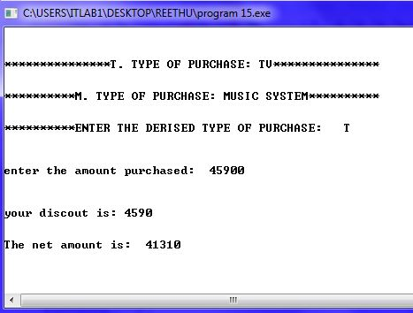

6. Write a program to convert time entered in seconds into its equivalent hours, minutes and seconds.

#include<iostream.h>

#include<conio.h>

void main()

{ int x;

cout<<"enter the time in seconds: ";

cin>>x;

cout<<"equivalent time: "<<x/(60*60)<<" hours "<<(x%(60*60))/60<<" mins "<<(x%(60*60))%60<<" secs";

getch();

}

Output:

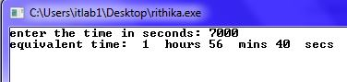

Write a program to accept electricity bill details (i.e.,) customer number, customer name, previous month meter reading and current month reading and then find no, of units consumed by the customer and amount payable to electricity department by performing following checks:

First 100 units cost per unit is Rs. 4.00

Next 500 units cost per unit is Rs. 5.00

Beyond 600 units cost per unit is Rs. 6.00

#include<iostream.h>

#include<conio.h>

void main()

{ int x, y, z, u;

cout<<"enter the customer number: ";

cin>>x;

cout<<"enter the previous month reading: ";

cin>>y;

cout<<"enter the current month reading: ";

cin>>z;

u=z-y;

if(u<=100)

{cout<<"net payable amount is: ";

cout<<u*4;

}

else if(100<u<=600)

{cout<<"net payable amount is: ";

cout<<(u*4)+((u-100)*5);

}

else if(u>600)

{cout<<"net payable amount is: ";

cout<<(u*4)+((u-100)*5)+((u-600)*6);

}

getch();

}

Output:

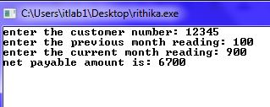

Write a program in C++ for area calculation of circle, square, rectangle and triangle using switch construct

#include<iostream.h>

#include<conio.h>

void main()

{ char x;

cout<<"c. area of circle";

cout<<"\ns.area of square";

cout<<"\nr.area of rectangle";

cout<<"\nt.area of triangle";

cout<<"\nenter your choice: ";

cin>>x;

switch(x)

{case'c': {float x1;

const float pi=3.14;

cout<<"enter the radius of the circle: ";

cin>>x1;

cout<<"area of the circle "<<(pi*x1*x1);

}

break;

case's': {float x1;

cout<<"enter the side of the square: ";

cin>>x1;

cout<<"area of square "<<(x1*x1);

}

break;

case'r':{float x1, x2;

cout<<"enter the sides of the rectangle: ";

cin>>x1>>x2;

cout<<"area of the rectangle is "<<(x1*x2);

}

break;

case't':{float x1, x2;

cout<<"enter the height and base of the triangle: ";

cin>>x1>>x2;

cout<<"area of the triangle is: "<<(0.5*x1*x2);

}

break;

default: cout<<"invalid";

}

getch();

}

Output:

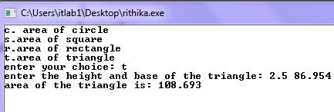

Write a menu driven program using functions to do the following on a given number.

a. Reverse the number and display both the numbers.

b. Find the sum of digits of the number.

c. Count the no. of odd and even digits present in it.