**HTML**

* HTML stands for HyperText Markup Language.
* HTML is used to create web pages and web applications.
* HTML is widely used language on the web.
* We can create a static website by HTML only.
* Technically, HTML is a Markup language rather than a programming language

Basic structure of an html page

<!DOCTYPE html>

<html lang="en">

<head>

    <title>New Website</title>

</head>

<body>

    Hi!!!!! This is a basic structure of a webpage

</body>

</html>

**output**

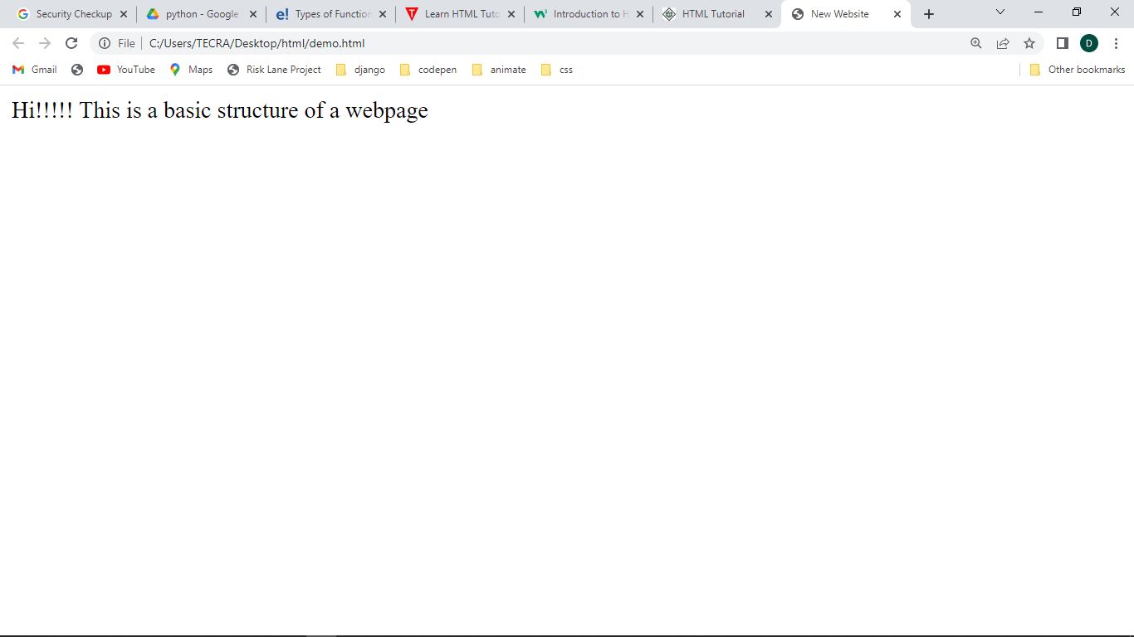

The <p> tag defines a paragraph. Browsers automatically add a single blank line before and after each <p> element.

Heading tags

**HTML headings** are titles or subtitles that you want to display on a webpage.

<!DOCTYPE html>

<html lang="en">

<head>

    <title>New Website</title>

</head>

<body>

    <p>This is some text in a paragraph.</p>

    <h1>This is heading 1</h1>

    <h2>This is heading 2</h2>

    <h3>This is heading 3</h3>

    <h4>This is heading 4</h4>

    <h5>This is heading 5</h5>

    <h6>This is heading 6</h6>

</body>

</html>

**Output**

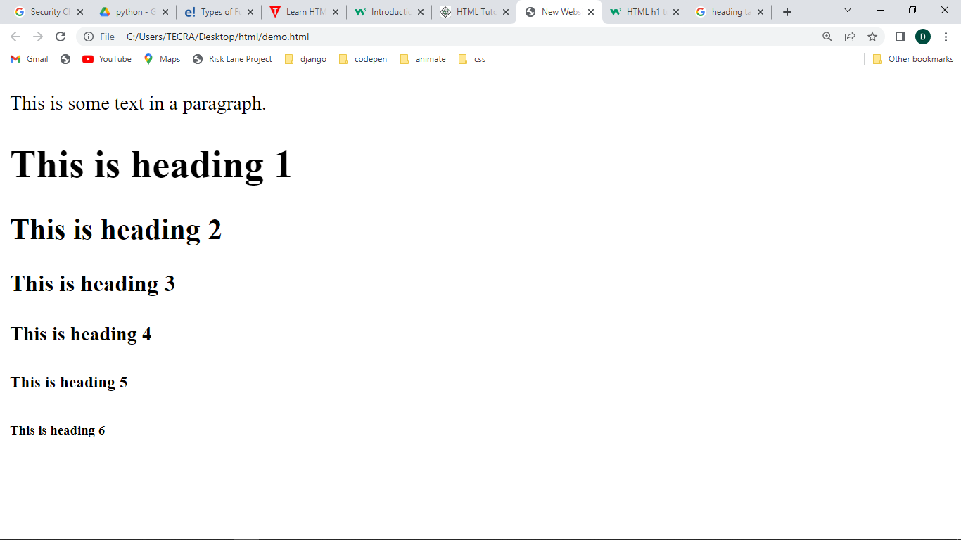

Line Break Tag

Whenever you use the **<br />** element, anything following it starts from the next line.

<!DOCTYPE html>

<html lang="en">

<head>

    <title>New Website</title>

</head>

<body>

    <p>Hello<br />

        You delivered your assignment ontime.<br />

        Thanks<br />

        Mahnaz</p>

</body>

</html>

**Output**

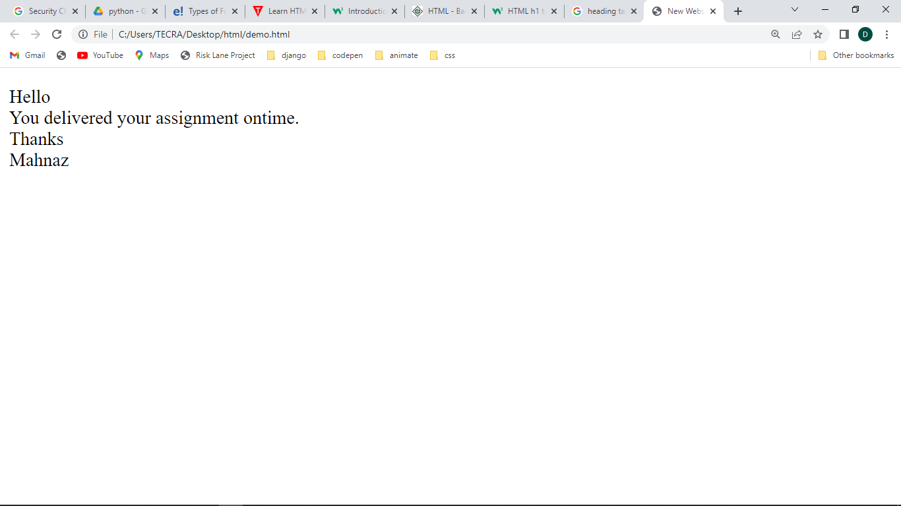

## Centering Content

You can use **<center>** tag to put any content in the center of the page or any table cell.

<!DOCTYPE html>

<html lang="en">

<head>

    <title>New Website</title>

</head>

<body>

    <p>This text is not in the center.</p>

      <center> <p>This text is in the center</p></center>

</body>

</html>

**Output**

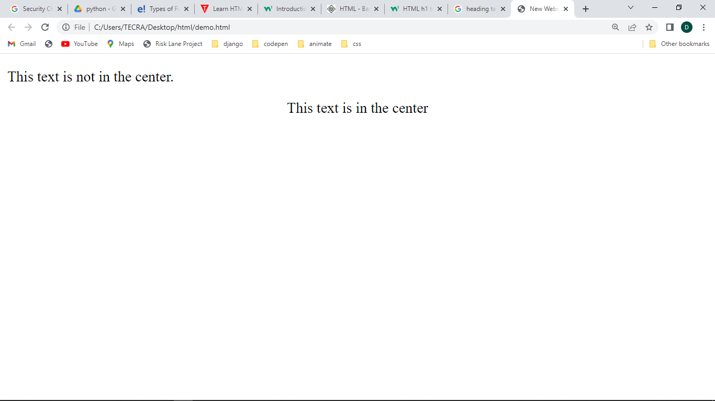

## Horizontal Lines

Horizontal lines are used to visually break-up sections of a document. The **<hr>** tag creates a line from the current position in the document to the right margin and breaks the line accordingly.

<!DOCTYPE html>

<html>

<head>

    <title>New Website</title>

</head>

<body>

    <p>This is paragraph one and should be on top</p>

    <hr />

    <p>This is paragraph two and should be at bottom</p>

</body>

</html>

**Output**

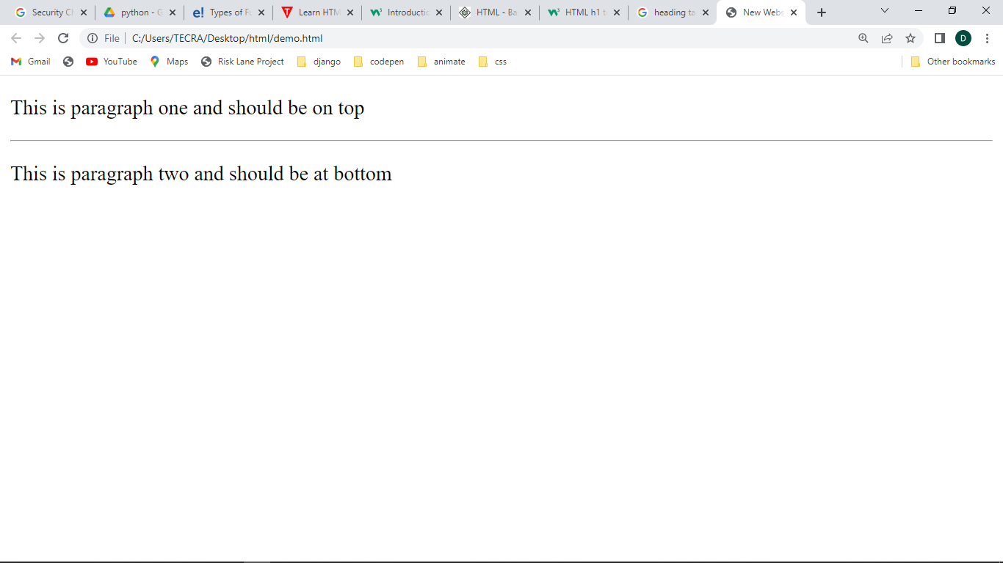

# Text Formatting

* <b> - Bold text
* <strong> - Important text
* <i> - Italic text
* <em> - Emphasized text
* <mark> - Marked text
* <small> - Smaller text
* <del> - Deleted text
* <ins> - Inserted text
* <sub> - Subscript text
* <sup> - Superscript text

<!DOCTYPE html>

<html>

<head>

    <title>New Website</title>

</head>

<body>

    <b>This text is bold</b> <br>

    <strong>This text is important!</strong>  <br>

    <i>This text is italic</i> <br>

    <em>This text is emphasized</em> <br>

    <small>This is some smaller text.</small>

    <p>Do not forget to buy <mark>milk</mark> today.</p>

    <p>My favorite color is <del>blue</del> red.</p>

    <p>My favorite color is <del>blue</del> <ins>red</ins>.</p>

    <p>This is <sub>subscripted</sub> text.</p>

    <p>This is <sup>superscripted</sup> text.</p>

    <p>This is some <u>mispeled</u> text.</p>

</body>

</html>

Output

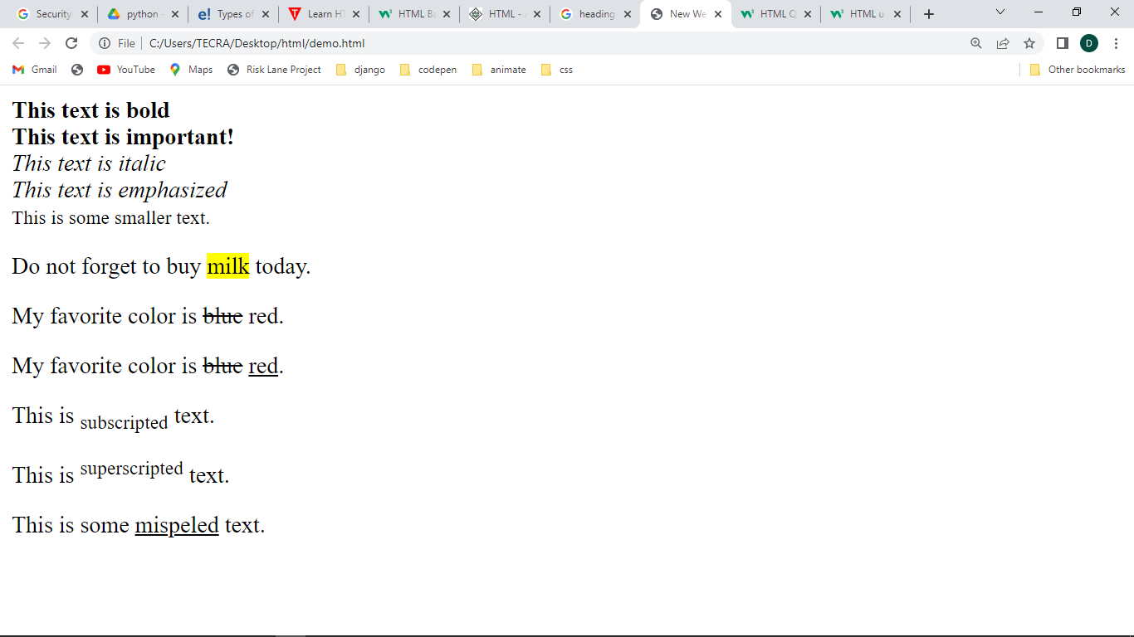

# Lists

## Unordered HTML List

An unordered list starts with the <ul> tag. Each list item starts with the <li> tag.

The list items will be marked with bullets (small black circles) by default:

allow web developers to group a set of related items in lists.

<!DOCTYPE html>

<html>

<body>

<h2>An unordered HTML list</h2>

<ul>

  <li>Coffee</li>

  <li>Tea</li>

  <li>Milk</li>

</ul>

</body>

</html>

Output

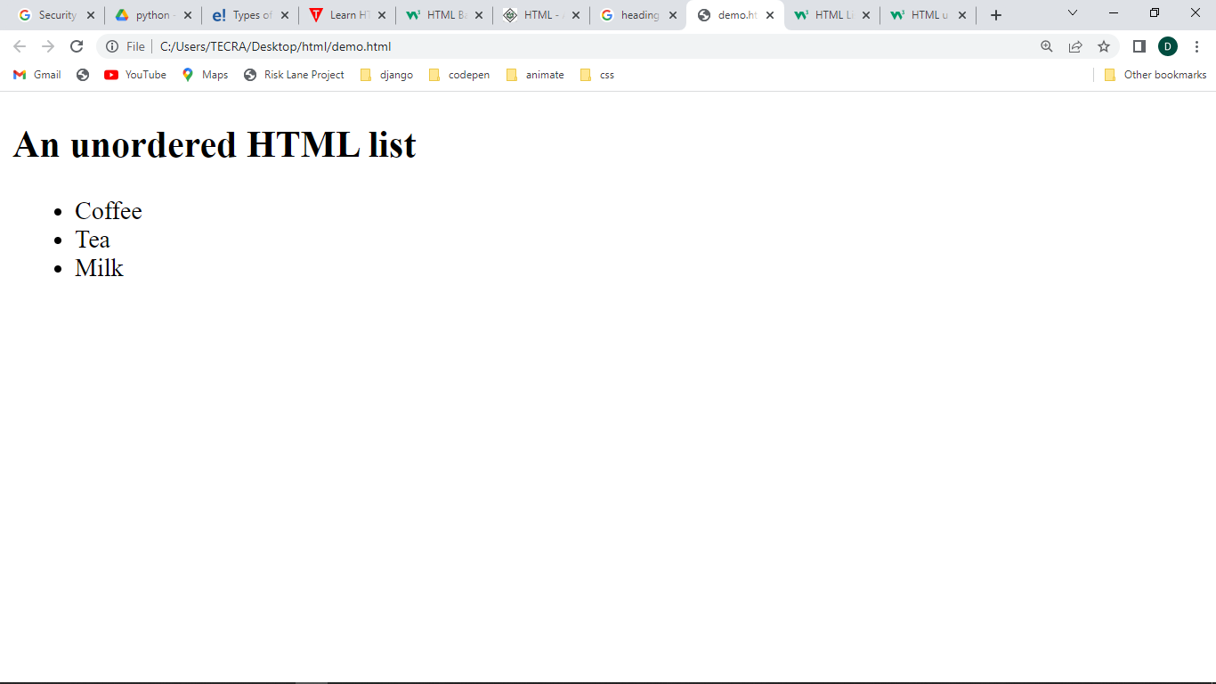

## Ordered HTML List

An ordered list starts with the <ol> tag. Each list item starts with the <li> tag.

The list items will be marked with numbers by default:

<!DOCTYPE html>

<html>

<body>

<h2>An ordered HTML list</h2>

<ol>

  <li>Coffee</li>

  <li>Tea</li>

  <li>Milk</li>

</ol>

</body>

</html>

Output

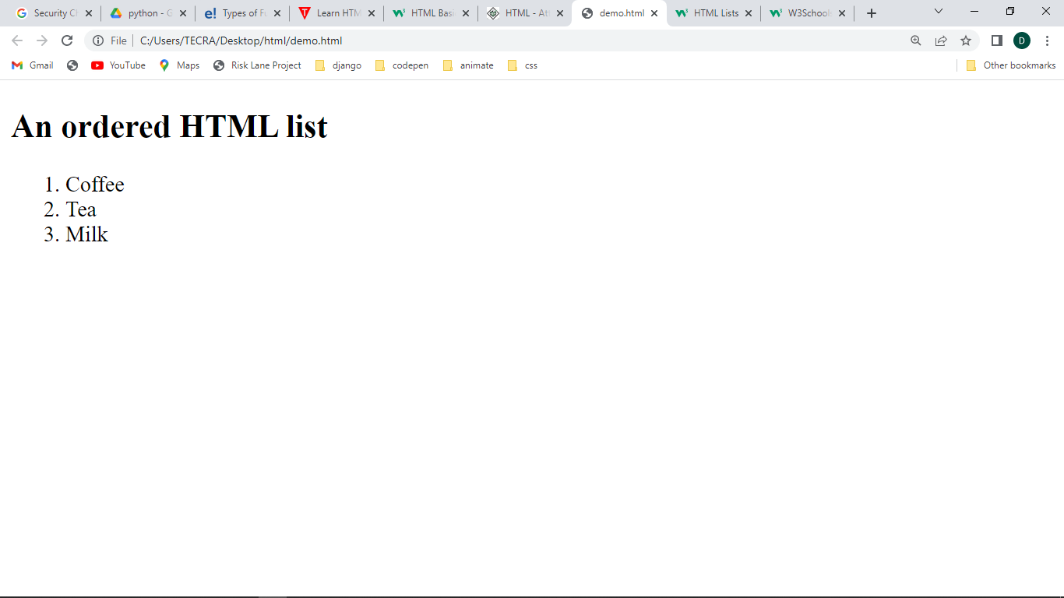

## Description Lists

HTML also supports description lists.

A description list is a list of terms, with a description of each term.

The <dl> tag defines the description list, the <dt> tag defines the term (name), and the <dd> tag describes each term:

<!DOCTYPE html>

<html>

<body>

<h2>A Description List</h2>

<dl>

  <dt>Coffee</dt>

  <dd>- black hot drink</dd>

  <dt>Milk</dt>

  <dd>- white cold drink</dd>

</dl>

</body>

</html>

Output

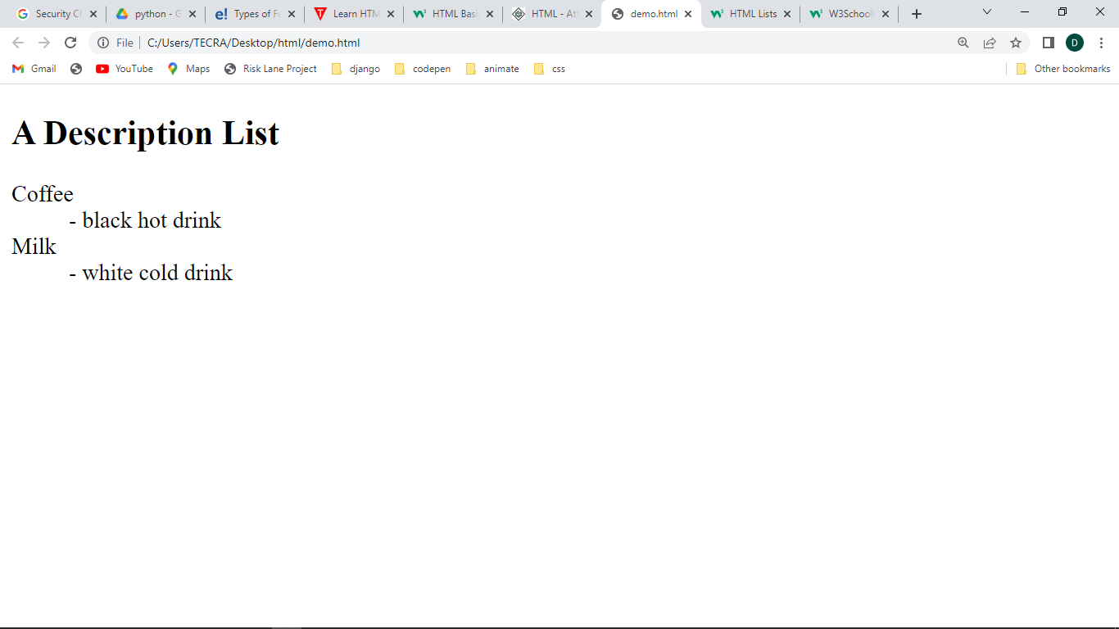

## Links

HTML links are defined with the <a> tag:

The link's destination is specified in the href attribute.

<!DOCTYPE html>

<html>

<body>

<h2>HTML Links</h2>

<p>HTML links are defined with the a tag:</p>

<a href="https://www.google.com">This is a link</a> <br>

<a href="home.html"> Home </a>  <br>

<a href="about.html"> About </a>  <br>

<a href="services.html"> Services </a>  <br>

<a href="gallery.html"> Gallery </a>  <br>

<a href="contact.html"> Contact </a>

</body>

</html>

## Output

## 

## Images

HTML images are defined with the <img> tag.

The source file (src), alternative text (alt), width, and height are provided as attributes:

<!DOCTYPE html>

<html>

<body>

<h2>HTML Images</h2>

<p>HTML images are defined with the img tag:</p>

<img src="car1.jpg" alt="car" width="300" height="250">

<img src="car2.webp" alt="car" width="300" height="250">

</body>

</html>

Output

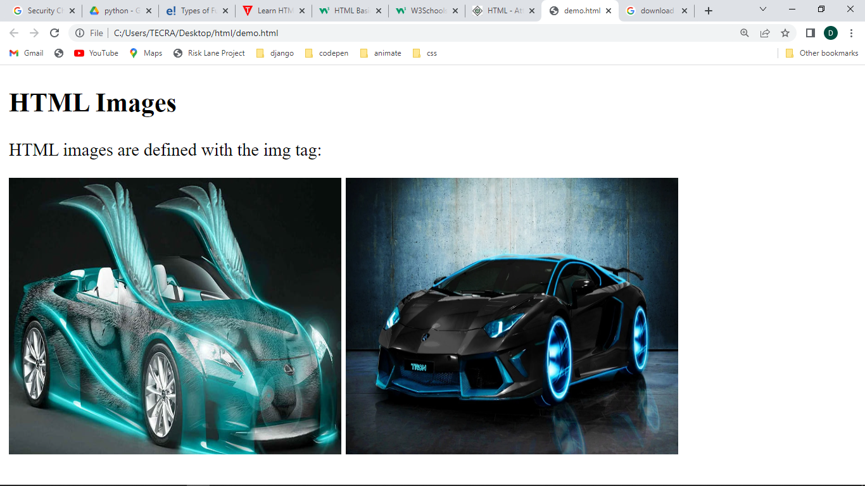

# Span  Tag

The <span> tag is an inline container used to mark up a part of a text, or a part of a document.

The <span> tag is easily styled by CSS or manipulated with JavaScript using the class or id attribute.

### Example

A <span> element which is used to color a part of a text:

    <p>My mother has <span style="color:blue">blue</span> eyes.</p>

Output

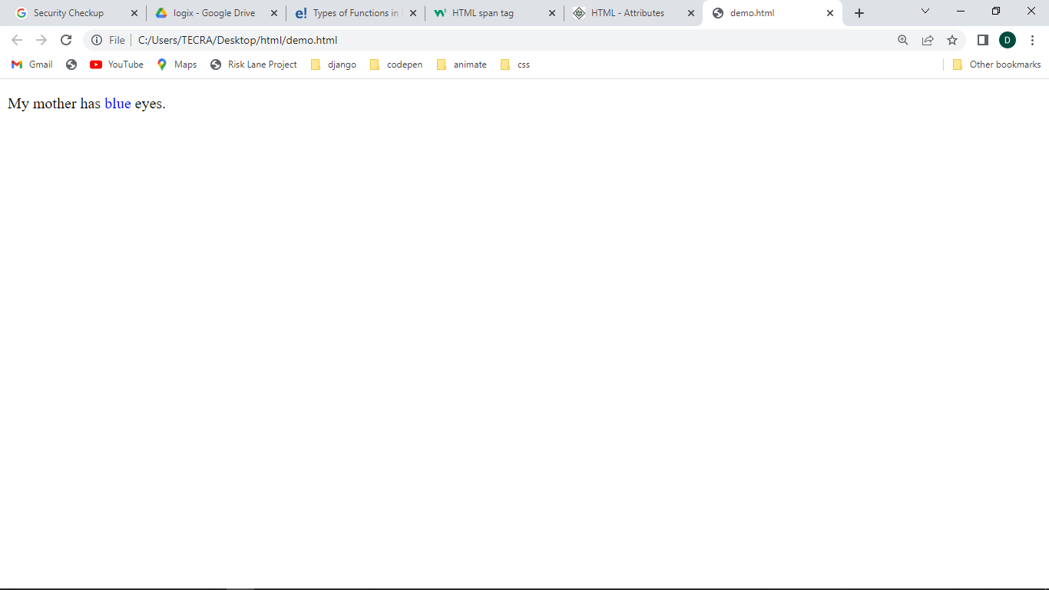

# HTML Video

The HTML <video> element is used to show a video on a web page.

    <video width="320" height="240" controls>

        <source src="movie.mp4" type="video/mp4">

        <source src="movie.ogg" type="video/ogg">

      Your browser does not support the video tag.

      </video>

To start a video automatically, use the autoplay attribute:

    <video width="320" height="240" autoplay>

        <source src="movie.mp4" type="video/mp4">

        <source src="movie.ogg" type="video/ogg">

      Your browser does not support the video tag.

      </video>

Add muted after autoplay to let your video start playing automatically (but muted):

    <video width="320" height="240" autoplay muted>

        <source src="movie.mp4" type="video/mp4">

        <source src="movie.ogg" type="video/ogg">

      Your browser does not support the video tag.

      </video>

# HTML Audio

The HTML <audio> element is used to play an audio file on a web page.

    <audio controls>

        <source src="horse.ogg" type="audio/ogg">

        <source src="horse.mp3" type="audio/mpeg">

      Your browser does not support the audio element.

      </audio>

To start an audio file automatically, use the autoplay attribute:

    <audio controls autoplay>

        <source src="horse.ogg" type="audio/ogg">

        <source src="horse.mp3" type="audio/mpeg">

      Your browser does not support the audio element.

      </audio>

# Tables

HTML tables allow web developers to arrange data into rows and columns.

## Table Cells

Each table cell is defined by a <td> and a </td> tag.

td stands for table data.

Everything between <td> and </td> are the content of the table cell.

## Table Rows

Each table row starts with a <tr> and ends with a </tr> tag.

tr stands for table row.

## Table Headers

Sometimes you want your cells to be table header cells. In those cases use the <th> tag instead of the <td> tag:

th stands for table header.

<!DOCTYPE html>

<html>

<body>

<h1>person table</h1>

<table border="2">

  <tr>

    <th>Person 1</th>

    <th>Person 2</th>

    <th>Person 3</th>

  </tr>

  <tr>

    <td>Emil</td>

    <td>Tobias</td>

    <td>Linus</td>

  </tr>

  <tr>

    <td>16</td>

    <td>14</td>

    <td>10</td>

  </tr>

</table>

<p>To understand the example better, we have added borders to the table.</p>

</body>

</html>

Output

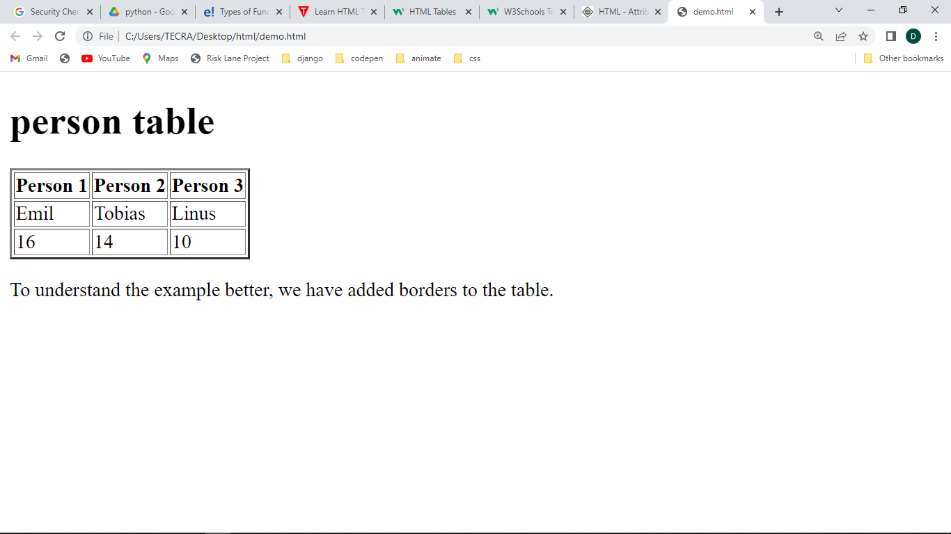

## Colspan

To make a cell span over multiple columns, use the colspan attribute:

<!DOCTYPE html>

<html>

<body>

    <body>

        <h2>Cell that spans two columns</h2>

        <p>To make a cell span more than one column, use the colspan attribute.</p>

        <table border="1">

          <tr>

            <th colspan="2">Name</th>

            <th>Age</th>

          </tr>

          <tr>

            <td>Jill</td>

            <td>Smith</td>

            <td>43</td>

          </tr>

          <tr>

            <td>Eve</td>

            <td>Jackson</td>

            <td>57</td>

          </tr>

        </table>

</body>

</html>

Output

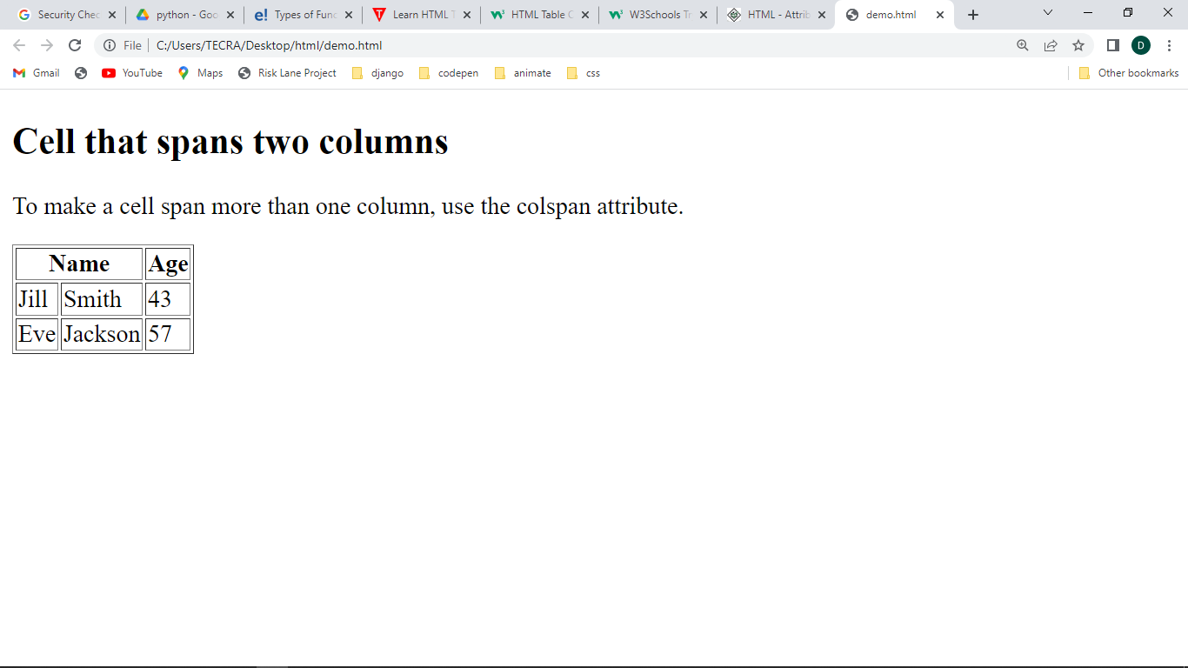

## Rowspan

To make a cell span over multiple rows, use the rowspan attribute:

<!DOCTYPE html>

<html>

<body>

    <body>

        <h2>Cell that spans two rows</h2>

        <p>To make a cell span more than one row, use the rowspan attribute.</p>

        <table border="1">

          <tr>

            <th>Name</th>

            <td>Jill</td>

          </tr>

          <tr>

            <th rowspan="2">Phone</th>

            <td>555-1234</td>

          </tr>

          <tr>

            <td>555-8745</td>

          </tr>

        </table>

</body>

</html>

Output

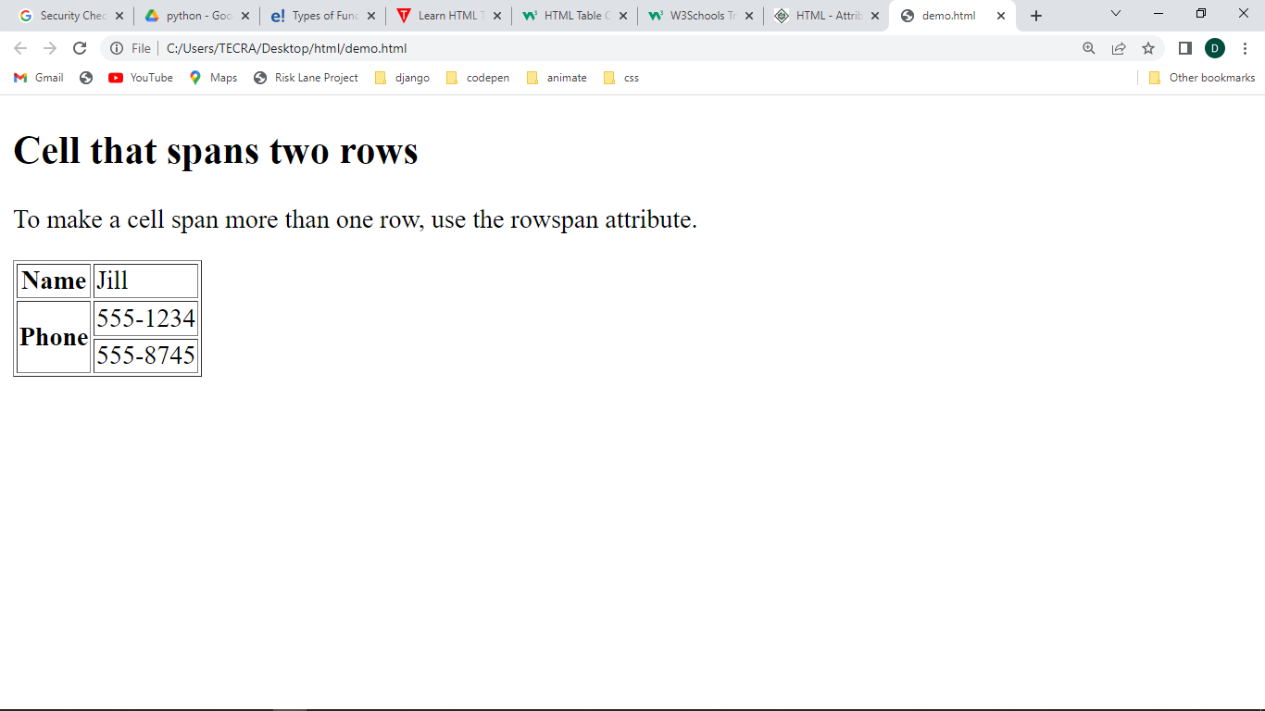

# Iframes

An HTML iframe is used to display a web page within a web page. An inline frame is used to embed another document within the current HTML document.

<!DOCTYPE html>

<html>

<body>

  <body>

    <iframe src="hello.html" height="200" width="300" title="Iframe Example"> </iframe>

    <iframe src="https://www.youtube.com/embed/qz0aGYrrlhU" height="200" width="300" title="Iframe Example"> </iframe>

  </body>

</html>

**Output**

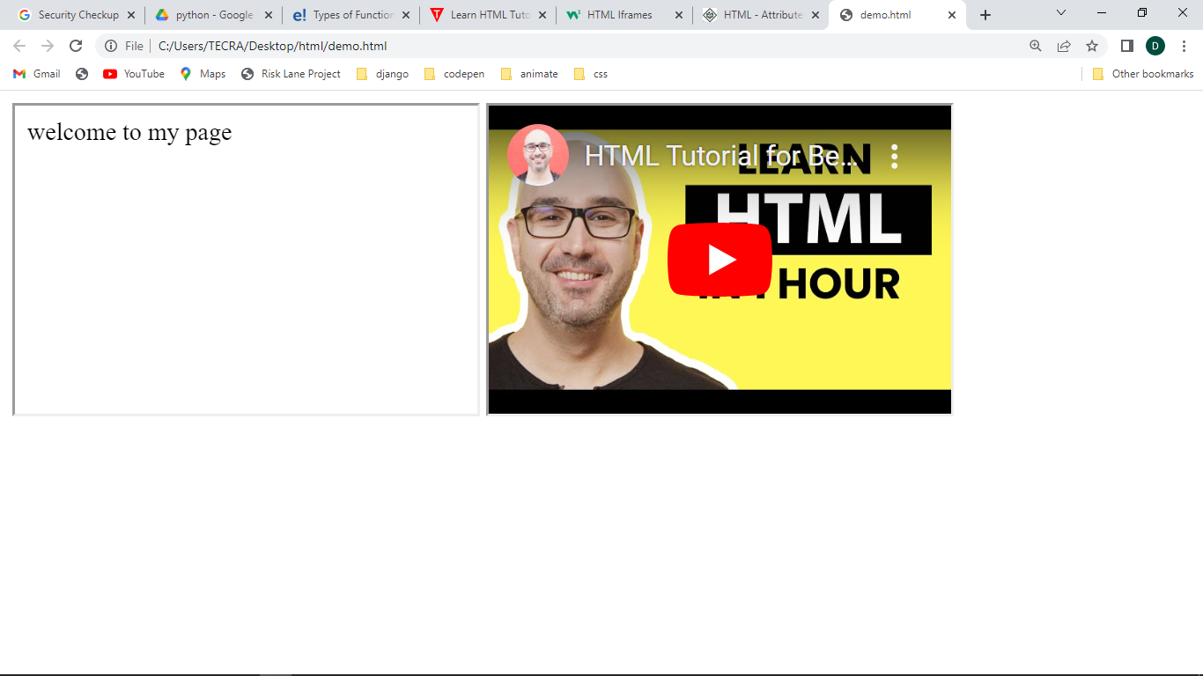

# HTML Forms

An HTML form is used to collect user input. The user input is most often sent to a server for processing.

The <form> element is a container for different types of input elements, such as: text fields, checkboxes, radio buttons, submit buttons, etc.

## Text Fields

The <input type="text"> defines a single-line input field for text input.

## Radio Buttons

The <input type="radio"> defines a radio button.

Radio buttons let a user select ONE of a limited number of choices.

## Checkboxes

The <input type="checkbox"> defines a **checkbox**.

Checkboxes let a user select ZERO or MORE options of a limited number of choices.

## The Submit Button

The <input type="submit"> defines a button for submitting the form data to a form-handler.

The form-handler is typically a file on the server with a script for processing input data.

The form-handler is specified in the form's action attribute.

## The Name Attribute for <input>

Notice that each input field must have a name attribute to be submitted.

If the name attribute is omitted, the value of the input field will not be sent at all.

<!DOCTYPE html>

<html>

<body>

<form action="" method="">

    First Name: <input type="text" name="firstname"/> <br/>  <br/>

    Last Name:  <input type="text" name="lastname"/> <br/>  <br/>

    Address:<textarea ></textarea> <br/>   <br/>

    Date of birth:<input type="date" id="dob" name="dob"> <br/>   <br/>

    Password:<input type="password" id="password" name="password"> <br/>   <br/>

    Mobile:<input type="number" id="phn" name="phn"> <br/>   <br/>

    Email:<input type="email" id="pwd" name="email"> <br/>   <br/>

    Photo:<input type="file" id="myfile" name="myfile">  <br/>   <br/>

   Select language: <input type="radio" id="html" name="fav_language" value="HTML">HTML

<input type="radio" id="css" name="fav_language" value="CSS">CSS

<input type="radio" id="javascript" name="fav_language" value="JavaScript">JavaScript  <br/>   <br/>

Select language: <input type="checkbox" id="html" name="fav_language" value="HTML">HTML

<input type="checkbox" id="css" name="fav_language" value="CSS">CSS

<input type="checkbox" id="javascript" name="fav_language" value="JavaScript">JavaScript  <br/>   <br/>

Choose a car:

<select name="cars" id="cars">

  <option value="volvo">Volvo</option>

  <option value="saab">Saab</option>

  <option value="mercedes">Mercedes</option>

  <option value="audi">Audi</option>

</select><br>

<input type="button" value="Click me">

</form>

  </body>

</html>

**Output**

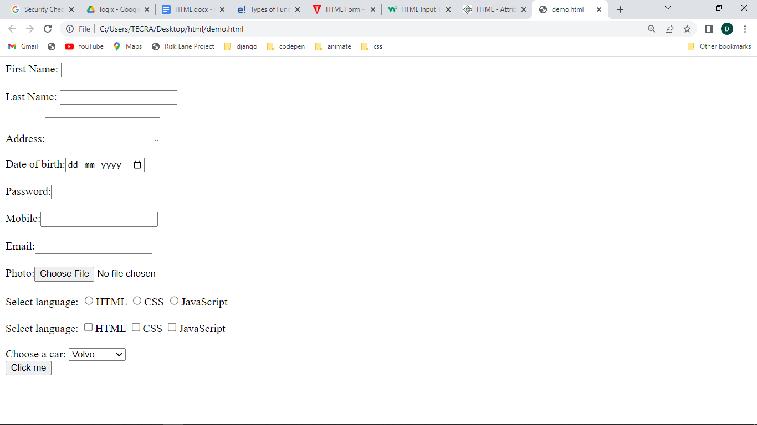

**Example of form using table:**

**<!DOCTYPE html>**

**<html>**

**<body>**

**<center>**

**<h1>Registration Form</h1>**

**<form action="" method="">**

**<table >**

**<tr>**

**<td> First Name:</td>**

**<td><input type="text" name="firstname"/></td>**

**</tr>**

**<tr>**

**<td> Last Name: </td>**

**<td><input type="text" name="lastname"/> </td>**

**</tr>**

**<tr>**

**<td> Address:</td>**

**<td><textarea ></textarea> </td>**

**</tr>**

**<tr>**

**<td> Date of birth:</td>**

**<td><input type="date" id="dob" name="dob"></td>**

**</tr>**

**<tr>**

**<td> Password:</td>**

**<td><input type="password" id="password" name="password"></td>**

**</tr>**

**<tr>**

**<td>Mobile:</td>**

**<td><input type="number" id="phn" name="phn"></td>**

**</tr>**

**<tr>**

**<td> Email:</td>**

**<td><input type="email" id="pwd" name="email"> </td>**

**</tr>**

**<tr>**

**<td> Photo:</td>**

**<td> <input type="file" id="myfile" name="myfile"> </td>**

**</tr>**

**<tr>**

**<td >Select language:</td>**

**<td> <input type="radio" id="male" name="gender"**

**value="male">male</td>**

**</tr>**

**<tr>**

**<td></td>**

**<td><input type="radio" id="female" name="gender"**

**value="female">female </td>**

**</tr>**

**<tr>**

**<td>Select language: </td>**

**<td><input type="checkbox" id="html" name="fav_language"**

**value="HTML">HTML</td>**

**</tr>**

**<tr>**

**<td></td>**

**<td><input type="checkbox" id="css" name="fav_language"**

**value="CSS">CSS </td>**

**</tr>**

**<tr>**

**<td></td>**

**<td><input type="checkbox" id="javascript" name="fav_language"**

**value="JavaScript">JavaScript </td>**

**</tr>**

**<tr>**

**<td>Choose a car:</td>**

**<td>**

**<select name="cars" id="cars">**

**<option value="volvo">Volvo</option>**

**<option value="saab">Saab</option>**

**<option value="mercedes">Mercedes Benz</option>**

**<option value="audi">Audi</option>**

**</select></td>**

**</tr>**

**<tr>**

**<td colspan="2">**

**<br><center><input type="button" value="Click me"></center>**

**</td>**

**</tr>**

**</table>**

**</form>**

**</center>**

**</body>**

**</html>**

**output**

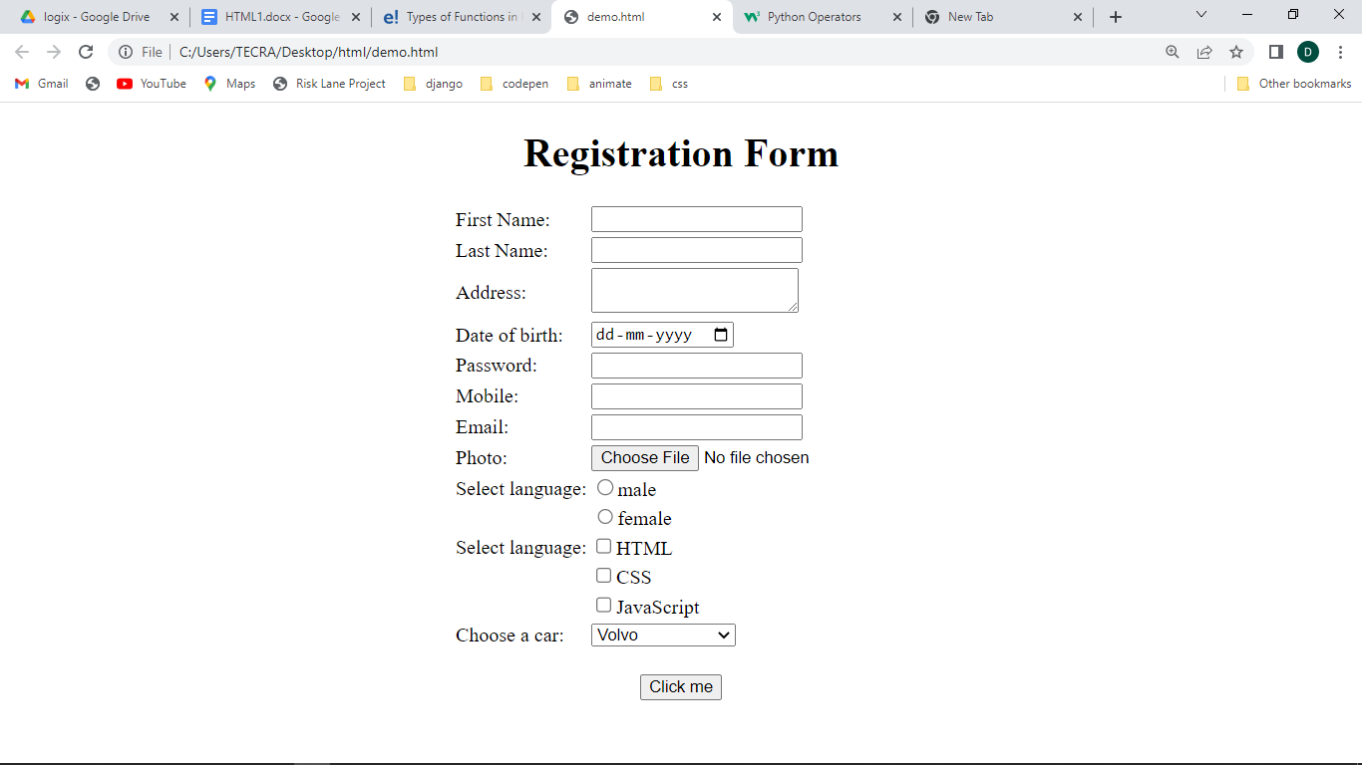

# HTML <div> Tag

The <div> tag defines a division or a section in an HTML document.

The <div> tag is used as a container for HTML elements - which is then styled with CSS or manipulated with JavaScript.

The <div> tag is easily styled by using the class or id attribute.

Any sort of content can be put inside the <div> tag!

    <html>

        <head>

        <style>

        .myDiv {

          border: 5px outset red;

          background-color: lightblue;

          text-align: center;

        }

        </style>

        </head>

        <body>

        <div class="myDiv">

          <h2>This is a heading in a div element</h2>

          <p>This is some text in a div element.</p>

        </div>

        </body>

        </html>

**Output**

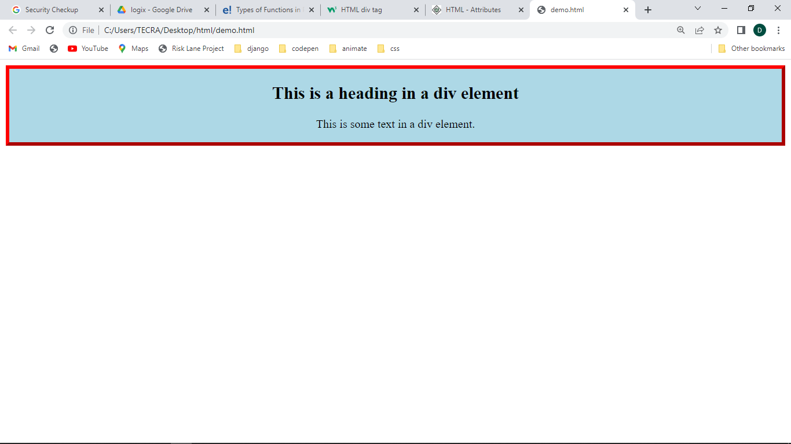

**Example2**

    <html>

        <head>

        <style>

        .div1{

          width:100px;

          background-color: red;

         height:100px;

        }

        #div2{

            width:100px;

          background-color: purple;

          height:100px;

        }

        </style>

        </head>

        <body>

        <div class="div1">

          <p>div1</p>

        </div>

        <div id="div2">

            <p>div2</p>

          </div>

        </body>

        </html>

**Output**

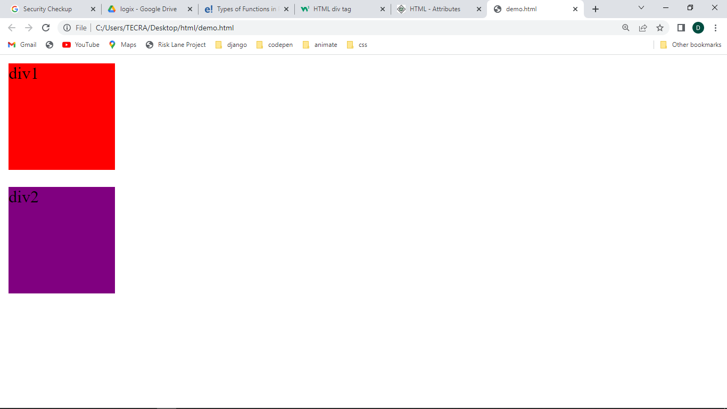

# HTML id Attribute

The HTML id attribute is used to specify a unique id for an HTML element.

You cannot have more than one element with the same id in an HTML document.

The id attribute is used to point to a specific style declaration in a style sheet. It is also used by JavaScript to access and manipulate the element with the specific id.

The syntax for id is: write a hash character (#), followed by an id name. Then, define the CSS properties within curly braces {}.

<!DOCTYPE html>

<html>

<head>

<style>

#myHeader {

color: black;

text-align: center;

}

</style>

</head>

<body>

<h2>The id Attribute</h2>

<p>Use CSS to style an element with the id "myHeader":</p>

<h1 id="myHeader">My Header</h1>

</body>

</html>

output

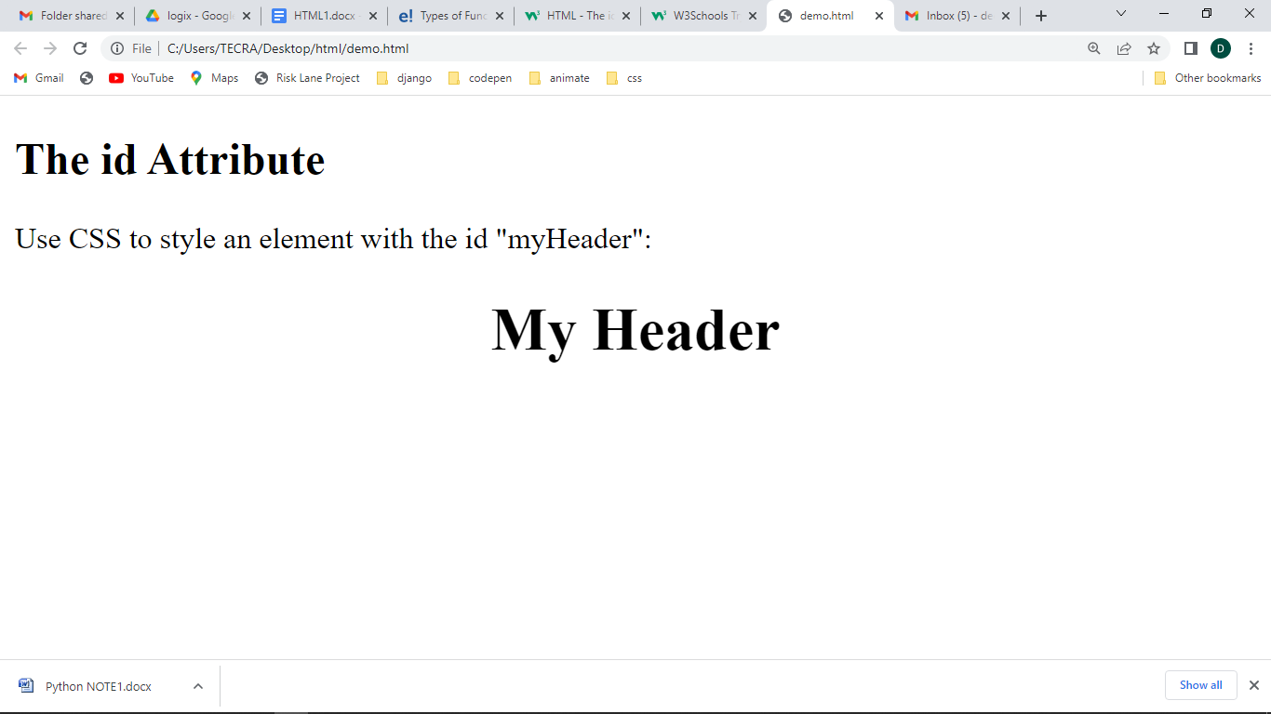

# HTML class Attribute

The HTML class attribute is used to specify a class for an HTML element.

Multiple HTML elements can share the same class.

The class attribute is often used to point to a class name in a style sheet. It can also be used by a JavaScript to access and manipulate elements with the specific class name.

<!DOCTYPE html>

<html>

<head>

<style>

.myClass {

color: black;

text-align: center;

}

</style>

</head>

<body>

<h2>The class Attribute</h2>

<p>Use CSS to style an element with the class "myClass":</p>

<h1 class="myClass">My Class</h1>

</body>

</html>

output

