Motion Graphics Services Agreement

PARTIES
This 3D Motion Graphics Services Agreement (the “Agreement”) is made on 14-06-2025 (the “Effective Date”) by and between:
- Designer (Freelancer): Ritik kharya , with address : Near chaurasiya hospital,naka chandravadhni,Gwalior-474009,MP
- Client: ________________________, with address ____________________________
Together referred to as the “Parties.”

PROJECT SCOPE
The Designer agrees to create and deliver a custom 2D/3D(mix) motion graphics video or product animation using software such as Blender, After effects, or similar tools. The scope includes:
- Designing and animating a product showcase video.
- 3D modeling, simulations, lighting, texturing, rendering, and post-processing.
- Motion graphics and visual effects integration as per the creative brief.
- Final deliverable in: MOV / Mp4 / Mkv format, duration approximately 90 sec .
Optional: Specific delivery specs can be attached as Exhibit A.

TIMELINE
- Project Start Date: 15-06-2025
- Estimated Delivery Date: 30-06-2025
- Revisions (up to 2 rounds) to be completed within 5 days post-delivery.

PAYMENT TERMS
- Total Project Fee: ₹ 20,000 .
- 30% advance (₹ 6,000 ) due before work begins.
- 70% balance (₹ 14,000 ) due upon delivery of final approved animation.
Work will not commence until the advance is received.
Final files will be shared only after full payment.
- Preferred payment method: UPI (UPI, PayPal, Bank Transfer, etc.)

CLIENT RESPONSIBILITIES
The Client agrees to:
- Provide all necessary references, materials, branding guidelines, and product information by [date:15-06-2025] .
- Give timely feedback and approvals.

REVISIONS
- 5 free revisions included.
- Additional changes beyond this will be charged at ₹ 1000 /revision.

RIGHTS & USAGE
- Full rights to the final animation are transferred to the Client upon full payment.
- Designer may use parts of the project in portfolio unless the Client requests NDA in writing.

CANCELLATION & TERMINATION
- If the Client cancels the project after commencement, the 30% advance is non-refundable.
- Either party may terminate the agreement with written notice. Any completed work will be billed accordingly.

CONFIDENTIALITY
Any proprietary or confidential information shared will be kept private and used solely for the project.

DISPUTES & GOVERNING LAW
Any disputes will be resolved via [Arbitration / Mediation] under the laws of India . with proceedings held in Bhopal, Madhya Pradesh.

ENTIRE AGREEMENT
This document constitutes the entire agreement between the Parties.

SIGNATURES
Freelancer/designer :
Name: Ritik kharya .
Signature: (as following)
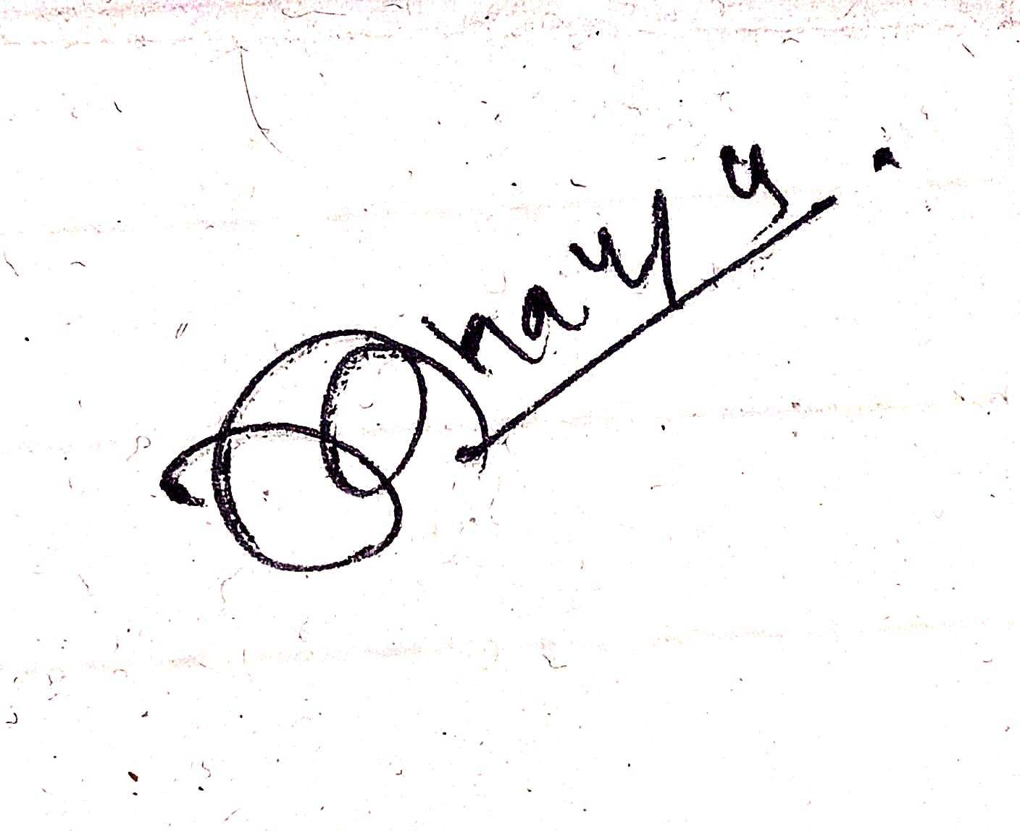
Date: 14-05-2025 .
CLIENT
Name: ____________________
Signature: ________________
Date: _____________________

