Experiment2: Develop a LSTM-based model for time series data forecasting.

Dataset used: tarit21/electricity-transformer-dataset-etdataset

Where the data set attributes are as following:
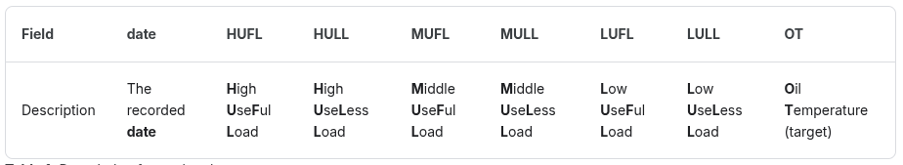

Here the Goal is to predict the Oil Temperature. The train, test, validation splits 70 : 15 : 15.

The oil temperature graph is shown with the split.
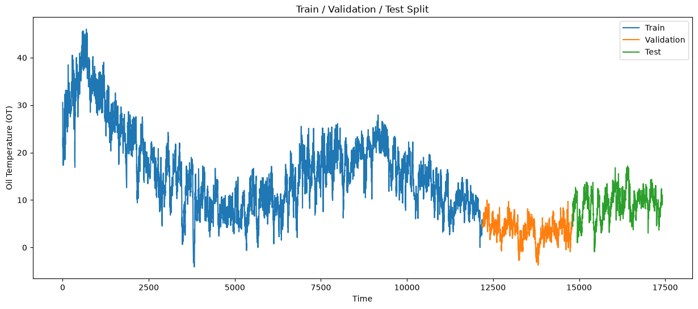

Where the hyperparameters used in the tuning is as following:
- Sequence length = 128
- Batch size = 40
- Learning rate = 0.0001
- Number of epochs = 20
- Dropout = 0.2

Where the model structure is:
model = LSTMModel(
input_size=7,
hidden_size=64,
num_layers=2,
output_size=1
)

Training vs validation loss Graph
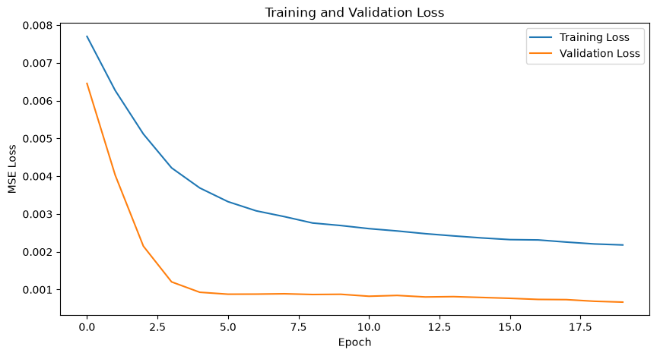

Mean Square error = 0.8522347211837769

Oil temperature Graph actual vs predicted are as following
