Experiment4: Implement an LSTM-based sentiment analysis system with an Attention layer for US Airline Tweets Dataset (with model saving).
Dataset used: crowdflower/twitter-airline-sentiment (Tweets.csv), downloaded from Kaggle with kagglehub
Where the data set attributes used are as following:
Field | Description
text | Raw tweet written by the customer about a US airline
airline_sentiment | Sentiment label (target): negative / neutral / positive

After removing missing values and empty tweets, 14,640 tweets remain (negative 9,178, neutral 3,099, positive 2,363). Here the Goal is to classify each tweet as negative, neutral or positive. The train, validation, test splits 60 : 20 : 20 (stratified by class).
Split | Number of tweets
Train | 8,784
Validation | 2,928
Test | 2,928

The following preprocessing is applied to each tweet:
- Stripping leading / trailing whitespace and dropping empty tweets
- One-hot encoding of the sentiment labels in the fixed order negative, neutral, positive
- Hashing each word to an integer id with Keras one_hot (vocabulary size 10000)
- Padding and truncating every tweet to a fixed length of 35 (post)

Where the hyperparameters used in the tuning is as following:
- Vocabulary size = 10000
- Sequence length = 35
- Embedding dimension = 100
- LSTM units = 64 (return_sequences=True)
- Attention = single learnable weight vector and bias (tanh scoring)
- Dense units = 64 (ReLU)
- Dropout = 0.4 (after attention), 0.3 (after dense layer)
- Batch size = 64
- Optimizer = Adam, Learning rate = 0.0005
- Number of epochs = 20 (EarlyStopping on val_loss, patience 4, best weights restored)

Attention layer: the LSTM returns its output at every timestep (35 x 64). The attention layer gives each timestep a score, score_t = tanh(h_t · W + b). The scores are turned into weights with softmax over the 35 timesteps, and the context vector is the weighted sum of the LSTM outputs, so the model can focus on the words that matter most for the sentiment.
Where the attention layer is:
class AttentionLayer(Layer):
def build(self, input_shape):
self.W = self.add_weight(name='attention_weight',
shape=(input_shape[-1], 1),
initializer='glorot_uniform')
self.b = self.add_weight(name='attention_bias',
shape=(1,), initializer='zeros')
def call(self, inputs):
scores = tf.tanh(tf.matmul(inputs, self.W) + self.b)
scores = tf.squeeze(scores, axis=-1)
weights = tf.nn.softmax(scores, axis=1)
weights = tf.expand_dims(weights, axis=-1)
return tf.reduce_sum(inputs * weights, axis=1)
Where the model structure is:
inputs = Input(shape=(35,))
x = Embedding(input_dim=10000, output_dim=100)(inputs)
x = LSTM(64, return_sequences=True)(x)
x = AttentionLayer()(x)
x = Dropout(0.4)(x)
x = Dense(64, activation='relu')(x)
x = Dropout(0.3)(x)
outputs = Dense(3, activation='softmax')(x)
model = Model(inputs, outputs)
model.compile(optimizer=Adam(learning_rate=0.0005),
loss='categorical_crossentropy',
metrics=['accuracy'])
Total parameters = 1,046,660 (all trainable; the attention layer adds 65)

Training vs validation accuracy and loss Graph
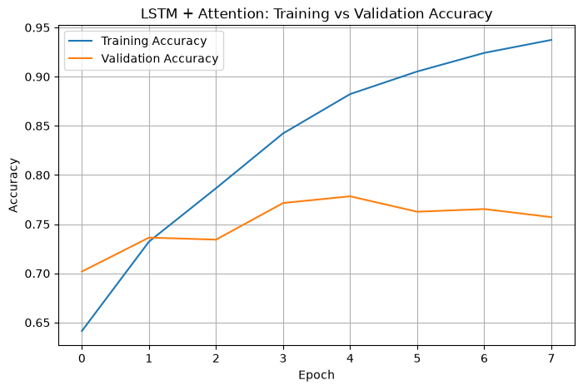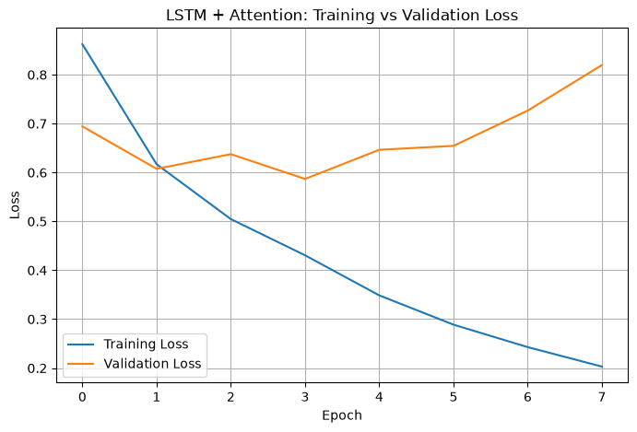
Training stopped at epoch 8; the best epoch was epoch 4 (lowest validation loss = 0.5869, validation accuracy = 0.7715), whose weights were restored for testing.

Test Loss = 0.5871
Test Accuracy = 0.7783 (77.83 %)

Classification report on the test set:
Class | Precision | Recall | F1-score | Support
negative | 0.85 | 0.88 | 0.87 | 1835
neutral | 0.58 | 0.64 | 0.61 | 620
positive | 0.77 | 0.57 | 0.66 | 473
accuracy |  |  | 0.78 | 2928
macro avg | 0.73 | 0.70 | 0.71 | 2928
weighted avg | 0.78 | 0.78 | 0.78 | 2928

Confusion matrix on the test set is as following
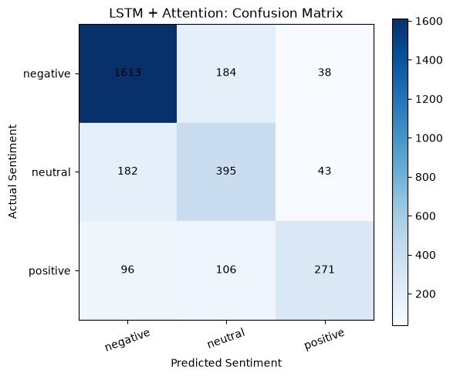
1,613 of 1,835 negative tweets are classified correctly. Most of the errors are between negative and neutral (184 negative tweets predicted as neutral and 182 neutral tweets predicted as negative), and 106 positive tweets are predicted as neutral.

Prediction on a new sample tweet:
Tweet | Predicted | Probabilities (neg / neu / pos)
The flight was amazing and the staff were very helpful | positive | 0.008 / 0.047 / 0.945

Saving the trained model: the model is saved to output/LSTM_Attention_Sentiment.keras only if its validation accuracy is better than the best validation accuracy stored in output/LSTM_Attention_Sentiment_best.json. In this run the validation accuracy improved from 0.7442 to 0.7715, so the model was saved. It was then loaded back with the custom AttentionLayer and evaluated again on the test set:
Metric | Trained model | Saved & loaded model
Test Loss | 0.5871 | 0.5871
Test Accuracy | 0.7783 | 0.7783
Macro F1 | 0.71 | 0.71

Comparison with the previous run of this model (before hyperparameter tuning):
Metric | Before tuning | After tuning
Vocabulary size | 500 | 10000
Sequence length | 50 | 35
Embedding / LSTM units | 128 / 128 | 100 / 64
Dropout (after attention) | 0.5 | 0.4
Learning rate / patience | 0.001 / 3 | 0.0005 / 4
Validation Accuracy | 0.7442 | 0.7715
Test Accuracy | 0.7483 | 0.7783
Test Loss | 0.6178 | 0.5871
Macro F1 | 0.67 | 0.71
Weighted F1 | 0.74 | 0.78
Neutral recall | 0.56 | 0.64
Positive recall | 0.53 | 0.57
Best epoch (val_loss) | 6 (0.6234) | 4 (0.5869)
Total parameters | 204,164 | 1,046,660

Conclusion: Tuning the hyperparameters raised the test accuracy from 74.83 % to 77.83 % and the macro F1 from 0.67 to 0.71. The biggest gain comes from the larger vocabulary: one_hot hashes words into vocab_size slots, so with only 500 slots many different words shared the same id. With 10000 slots most words keep their own id and the model can tell them apart. Negative tweets are classified well (F1 0.87), while neutral and positive tweets are still the hardest classes (F1 0.61 and 0.66), mostly confused with each other and with negative. The model overfits after epoch 4 (training accuracy reaches 0.94 while validation loss rises), so early stopping with restored best weights is important. The saved model gives exactly the same test results after loading, which confirms the model saving and loading works correctly.

