Experiment3: Implement an LSTM-based sentiment analysis system with an Attention layer for US Airline Tweets Dataset.

Dataset used: crowdflower/twitter-airline-sentiment (Tweets.csv)

Where the data set attributes used are as following:
Field | Description
text | Raw tweet written by the customer about a US airline
airline_sentiment | Sentiment label (target): negative / neutral / positive

After removing missing values and duplicate tweets, 14,427 tweets remain. Here the Goal is to classify each tweet as negative, neutral or positive. The train, validation, test splits 60 : 20 : 20 (stratified by class).
Split | Number of tweets
Train | 8,655
Validation | 2,886
Test | 2,886

The following preprocessing is applied to each tweet:
- Lower-casing
- Removing @mentions and URLs
- Expanding negations (didn't -> did not)
- Keeping ! and ? as separate tokens, removing other non-letters
- Tokenizing (fit on training set only, <OOV> token) and padding to a fixed length

Where the hyperparameters used in the tuning is as following:
- Vocabulary size = 10000
- Sequence length = 40
- Embedding dimension = 128
- LSTM units = 64 (Bidirectional, return_sequences=True)
- Attention units = 64 (additive / Bahdanau-style attention pooling)
- Spatial dropout = 0.3
- Dropout = 0.5
- Batch size = 10
- Optimizer = Adam, Learning rate = 0.001 (halved by ReduceLROnPlateau, patience 2)
- Number of epochs = 50 (EarlyStopping on val_loss, patience 4, best weights restored)

Attention layer: the Bidirectional LSTM returns its output at every timestep (40 x 128). The attention layer gives each timestep a score, score_t = v · tanh(W·h_t + b). Padding positions are masked out, and a softmax over time turns the scores into weights α_t that sum to 1. The tweet is then represented by the weighted sum Σ α_t·h_t (a 128-dim vector), which goes to the classifier. So instead of using only the last LSTM state, the model learns which words matter most for the sentiment.

Where the attention layer is:
class AttentionPooling(layers.Layer):
def __init__(self, units=64, **kwargs):
super().__init__(**kwargs)
self.supports_masking = True
self.score_dense = Dense(units, activation='tanh')
self.score_out = Dense(1, use_bias=False)

def attention_weights(self, inputs, mask=None):
scores = self.score_out(self.score_dense(inputs))
if mask is not None:
mask = tf.cast(mask, scores.dtype)[..., tf.newaxis]
scores += (1.0 - mask) * -1e9
return tf.nn.softmax(scores, axis=1)

def call(self, inputs, mask=None):
weights = self.attention_weights(inputs, mask)
return tf.reduce_sum(weights * inputs, axis=1)

Where the model structure is:
inputs = Input(shape=(40,))
x = Embedding(input_dim=10000, output_dim=128, mask_zero=True)(inputs)
x = SpatialDropout1D(0.3)(x)
x = Bidirectional(LSTM(64, return_sequences=True))(x)
x = AttentionPooling(64)(x)
x = Dropout(0.5)(x)
outputs = Dense(3, activation='softmax')(x)
model = Model(inputs, outputs)
model.compile(optimizer='adam',
loss='categorical_crossentropy',
metrics=['accuracy'])

Total parameters = 1,387,523 (all trainable; the attention layer adds 8,320)

Training vs validation accuracy and loss Graph
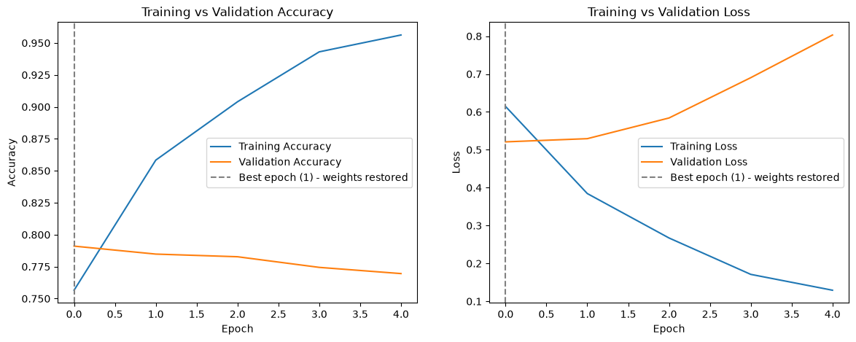
Training stopped at epoch 5; the best epoch was epoch 1 (lowest validation loss = 0.5210), whose weights were restored for testing.

Test Loss = 0.5127
Test Accuracy = 0.7970 (79.70 %)

Classification report on the test set:
Class | Precision | Recall | F1-score | Support
negative | 0.83 | 0.93 | 0.88 | 1816
neutral | 0.73 | 0.46 | 0.57 | 612
positive | 0.71 | 0.71 | 0.71 | 458
accuracy |  |  | 0.80 | 2886
macro avg | 0.76 | 0.70 | 0.72 | 2886
weighted avg | 0.79 | 0.80 | 0.78 | 2886

Confusion matrix on the test set is as following
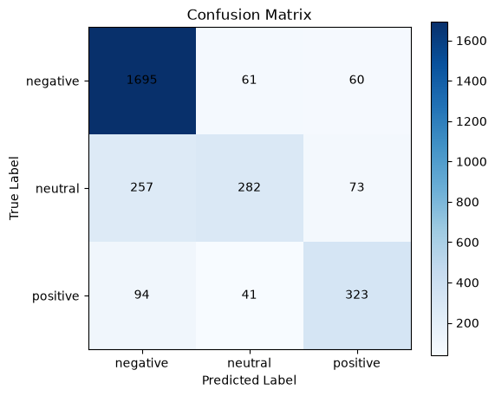

Predictions on new sample tweets:
Tweet | Predicted | Probabilities (neg / neu / pos)
The flight was amazing and the staff were very helpful | positive | 0.058 / 0.021 / 0.921
Worst airline ever, my luggage was lost and nobody helped | negative | 0.987 / 0.004 / 0.009
What time does the flight to Denver depart? | neutral | 0.465 / 0.491 / 0.044

Attention weights on the sample tweets (darker = more attention):
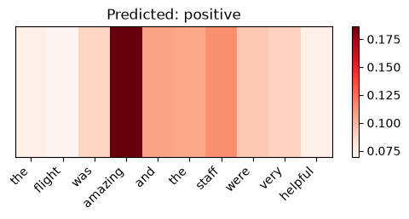
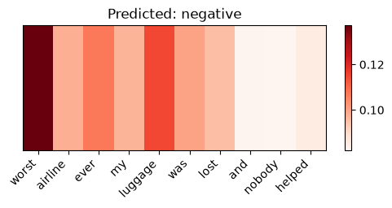
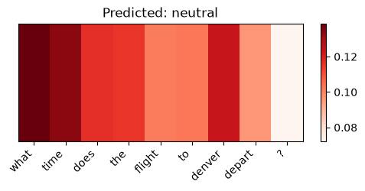
For the negative tweet, the model puts the most weight on "worst", followed by "luggage" and "ever", which are the words that carry the complaint.

Comparison with the plain BiLSTM model (Experiment 3 without attention):
Metric | BiLSTM | BiLSTM + Attention
Test Accuracy | 0.8011 | 0.7970
Test Loss | 0.5149 | 0.5127
Macro F1 | 0.73 | 0.72
Weighted F1 | 0.79 | 0.78
Neutral recall | 0.50 | 0.46
Best epoch (val_loss) | 2 (0.5190) | 1 (0.5210)
Total parameters | 1,379,203 | 1,387,523

Conclusion: Adding attention gives about the same performance as the plain BiLSTM on this dataset: test loss is slightly lower (0.5127 vs 0.5149) and accuracy is slightly lower (79.70 % vs 80.11 %). These differences are within run-to-run noise. Tweets are short (at most 40 tokens), so the final LSTM state already captures most of the sentence and attention has little room to help. The main benefit of the attention layer is interpretability: the attention weights show which words drove each prediction. Neutral tweets are still the hardest class (recall 0.46), and the model overfits quickly (best epoch 1), so early stopping is important.

