Experiment2: Develop a LSTM-based model for time series data forecasting.

Dataset used: tarit21/electricity-transformer-dataset-etdataset

Where the data set attributes are as following:
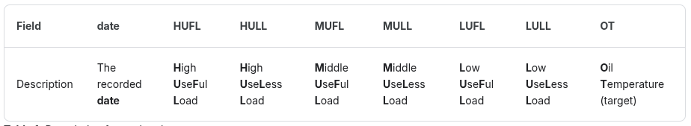

Here the Goal is to predict the Oil Temperature. The train, test, validation splits 60 : 20 : 20.

The following feature is used to predict OT: HUFL
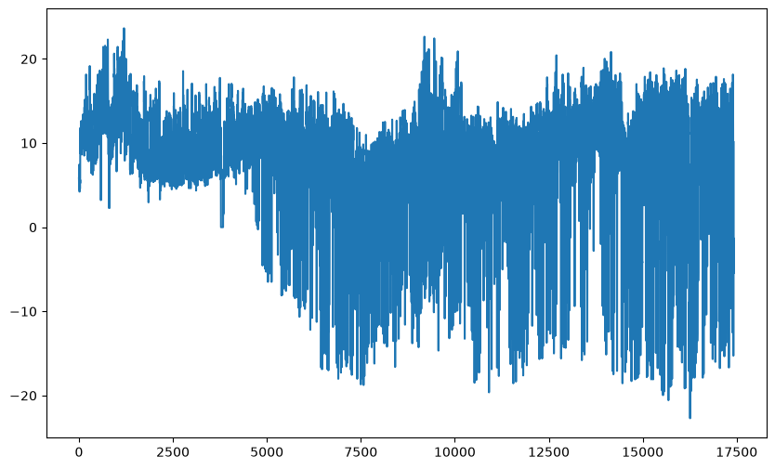

The oil temperature graph is shown with the split.
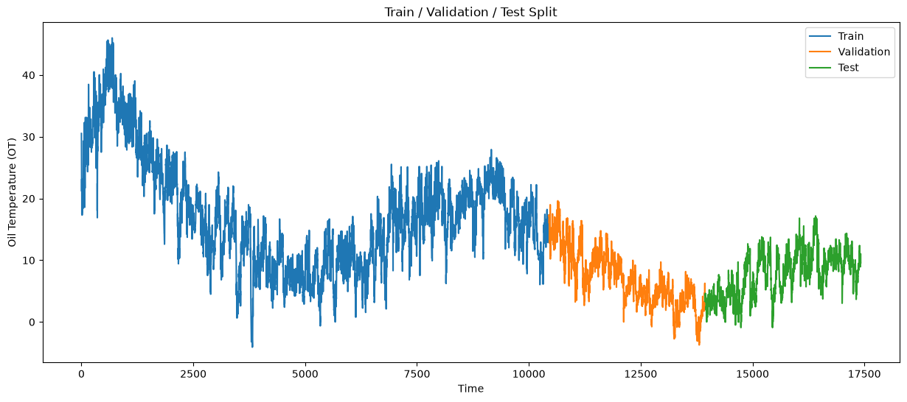

Where the hyperparameters used in the tuning is as following:
- Sequence length = 48
- Batch size = 5
- Learning rate = 0.0001
- Number of epochs = 100
- Dropout = 0.2

Where the model structure is:
model = LSTMModel(
input_size=1,
hidden_size=6,
num_layers=1,
output_size=1
)

Training vs validation loss Graph
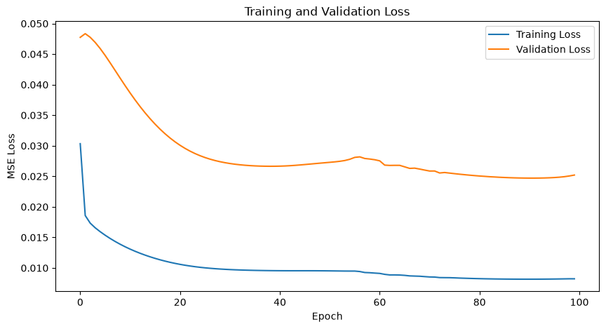

Mean Absolute Error = 6.451078414916992

Oil temperature Graph actual vs predicted are as following
