Experiment3: Implement an LSTM-based sentiment analysis system for US Airline Tweets Dataset.

Dataset used: crowdflower/twitter-airline-sentiment (Tweets.csv)

Where the data set attributes used are as following:
Field | text | airline_sentiment
Description | Raw tweet written by the customer about a US airline | Sentiment label (target): negative / neutral / positive

After removing missing values and duplicate tweets, 14,427 tweets remain. Here the Goal is to classify each tweet as negative, neutral or positive. The train, validation, test splits 60 : 20 : 20 (stratified by class).
Split | Number of tweets
Train | 8,655
Validation | 2,886
Test | 2,886

The following preprocessing is applied to each tweet:
- Lower-casing
- Removing @mentions and URLs
- Expanding negations (didn't -> did not)
- Keeping ! and ? as separate tokens, removing other non-letters
- Tokenizing (fit on training set only, <OOV> token) and padding to a fixed length

Where the hyperparameters used in the tuning is as following:
- Vocabulary size = 10000
- Sequence length = 40
- Embedding dimension = 128
- LSTM units = 64 (Bidirectional)
- Spatial dropout = 0.3
- Dropout = 0.7
- Batch size = 10
- Optimizer = Adam, Learning rate = 0.001 (halved by ReduceLROnPlateau, patience 2)
- Number of epochs = 50 (EarlyStopping on val_loss, patience 4, best weights restored)

Where the model structure is:
model = Sequential([
Input(shape=(40,)),
Embedding(input_dim=10000, output_dim=128, mask_zero=True),
SpatialDropout1D(0.3),
Bidirectional(LSTM(64)),
Dropout(0.7),
Dense(3, activation='softmax')
])
model.compile(optimizer='adam',
loss='categorical_crossentropy',
metrics=['accuracy'])

Total parameters = 1,379,203 (all trainable)

Training vs validation accuracy and loss Graph
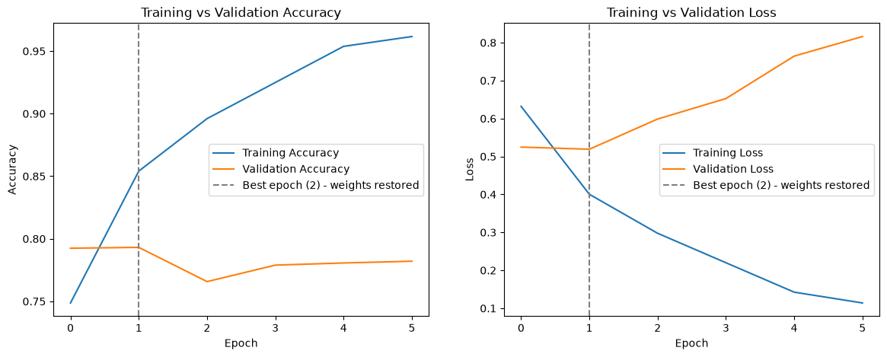
Training stopped at epoch 6; the best epoch was epoch 2 (lowest validation loss = 0.5190), whose weights were restored for testing.

Test Loss = 0.5149
Test Accuracy = 0.8011 (80.11 %)

Classification report on the test set:
Class | Precision | Recall | F1-score | Support
negative | 0.85 | 0.91 | 0.88 | 1816
neutral | 0.71 | 0.50 | 0.59 | 612
positive | 0.71 | 0.75 | 0.73 | 458
accuracy |  |  | 0.80 | 2886
macro avg | 0.75 | 0.72 | 0.73 | 2886
weighted avg | 0.79 | 0.80 | 0.79 | 2886

Confusion matrix on the test set is as following
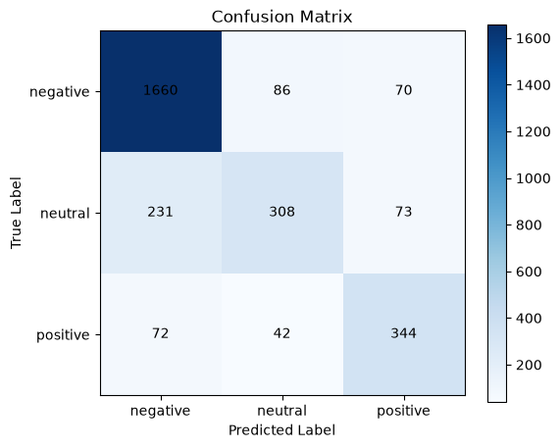

Predictions on new sample tweets:
Tweet | Predicted | Probabilities (neg / neu / pos)
The flight was amazing and the staff were very helpful | positive | 0.012 / 0.003 / 0.985
Worst airline ever, my luggage was lost and nobody helped | negative | 0.999 / 0.001 / 0.000
What time does the flight to Denver depart? | neutral | 0.436 / 0.548 / 0.016

