Effect of Shading on Solar Panel Output in Series and Parallel Configurations

AIM:-
To study the effect of shading on the output power of solar panels connected in series and parallel configurations, and to analyze how partial shading impacts the voltage, current, and overall efficiency in each case.

APPARATUS REQUIRED:-
- Solar Panel
- Multimeter
- Connecting Wires

BLOCK DIAGRAM:-
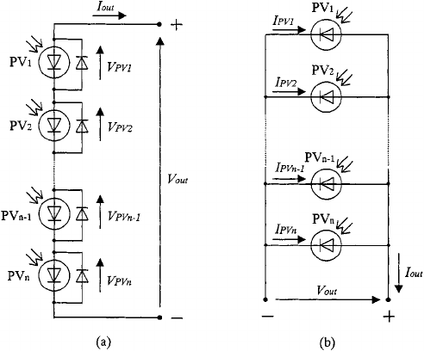

Unshaded

Shaded

OBSERVATION:-
S. No | Condition | Connection Type | Voltage  (V) | Current  (A) | Power  (W)
1. | Unshaded | Series
2. | Unshaded | Parallel
3. | Shaded | Series
4. | Shaded | Parallel

MODEL CALCULATION:-

MODEL GRAPH:-
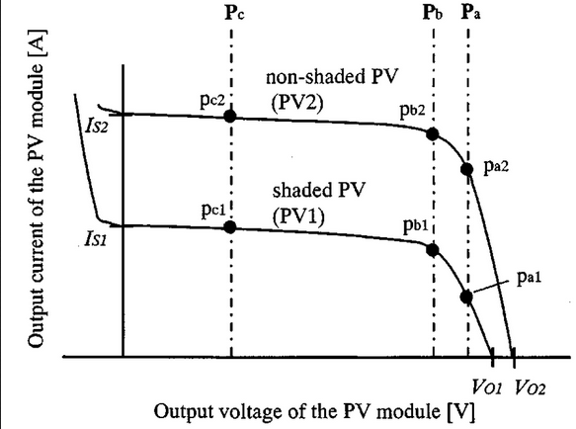
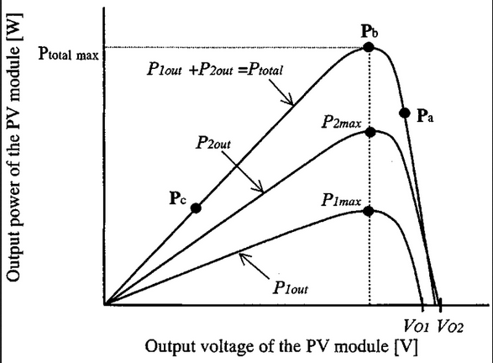

RESULT

