Load Test on PV Solar System under Varying Load Conditions

AIM:-
To study the performance of a photovoltaic (PV) solar system by measuring the voltage, current, and power output under different load conditions.

APPARATUS REQUIRED:-
- SolarPV Panel
- Voltmeter
- Ammeter
- Lamp Load
- Connecting Wires

CIRCUIT DIAGRAM:-

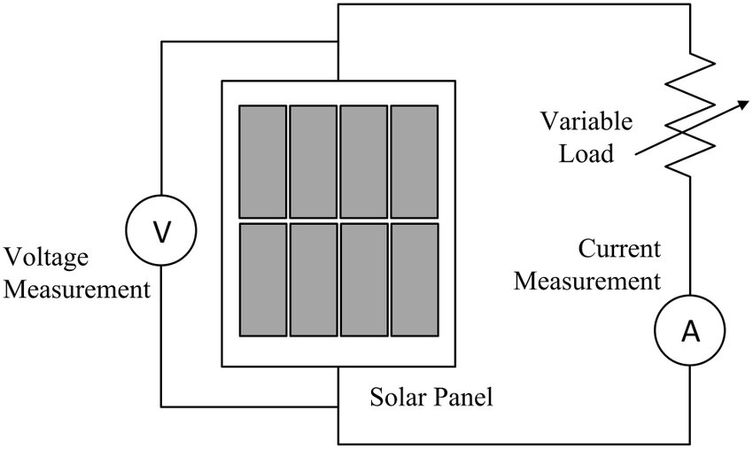

OBSERVATION:-
S. No | Load Condition | Voltage  (V) | Current  (A) | Power  (W)
1. | No Load
2. | 200W
3. | 400W
4. | 1000W

MODEL CALCULATION:-

MODEL GRAPH:-
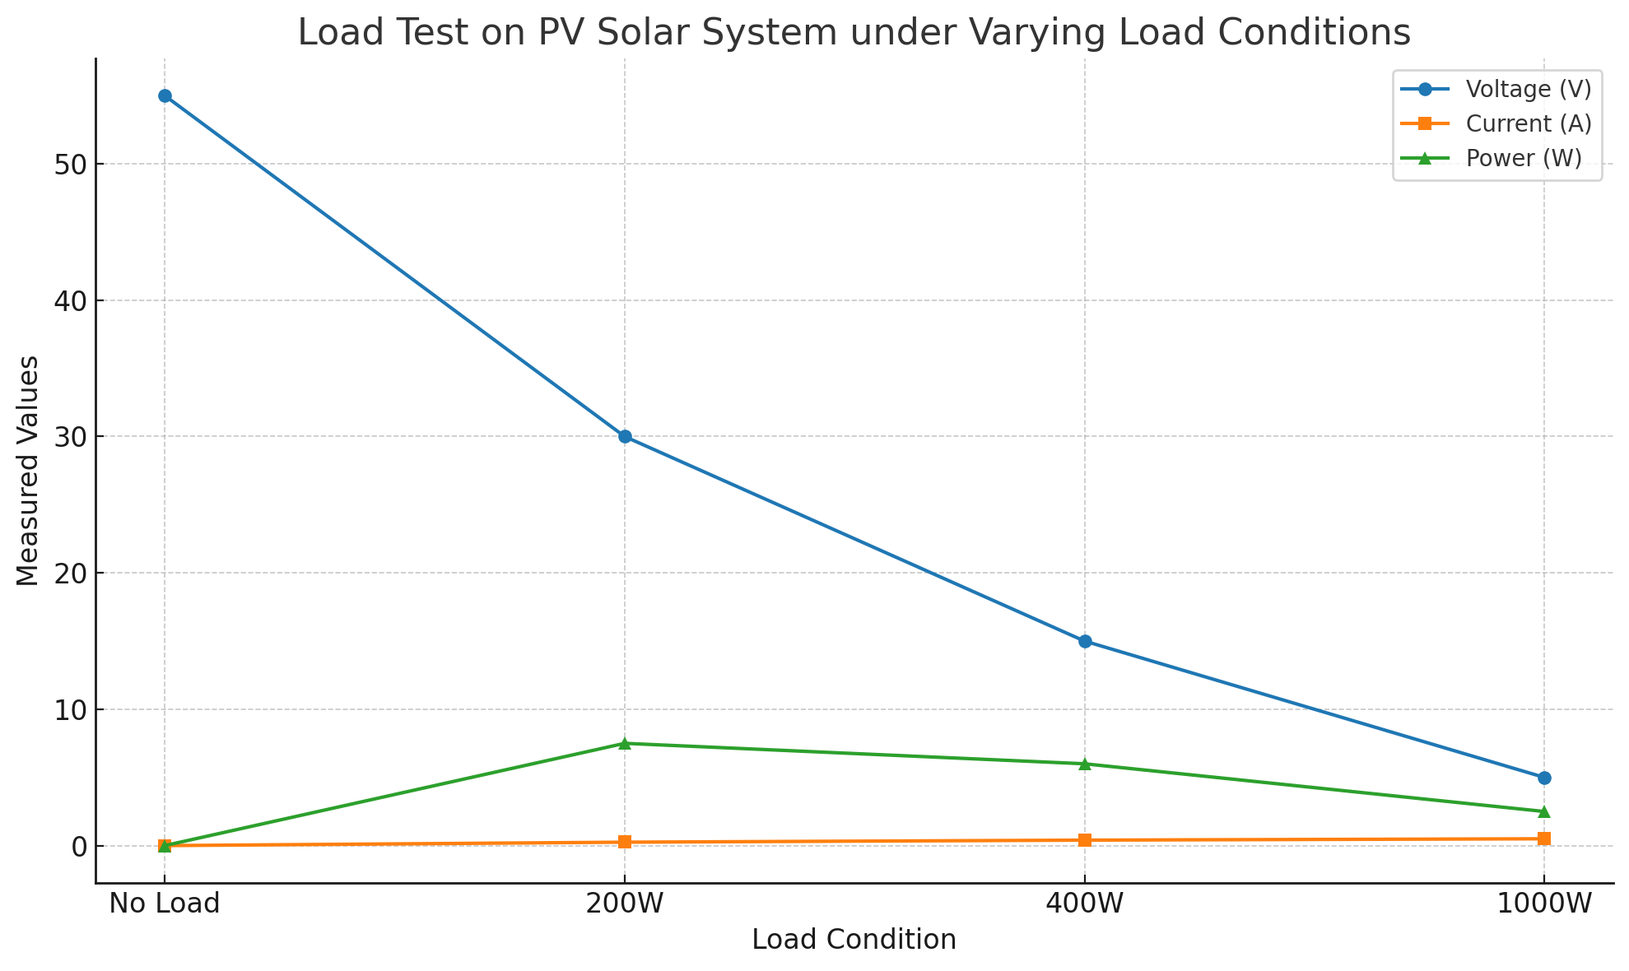

RESULT:-

