**AIObtuse**

A SYNOPSIS REPORT ON

Submitted in Partial fulfillment for the award of Degree of

Bachelor of Engineering in Computer Science &Engineering

Submitted to

**Rajiv Gandhi Proudyogiki Vishwavidyalaya, Bhopal(M.P.)**



MINOR PROJECT REPORT

Submitted by

**Riya Jain [0176CS181134] Vikas Kumar Lavaniya [0176CS181184]**

**Ritik Nakra [0176CS181130] Saubhagya Agrawal [0176CS181146]**

Under the supervision of

**Mr. Sugan Patel**

Asst. Professor, DEPARTMENT OF COMPUTER SCIENCE& ENGINEERING

LAKSHMI NARAIN COLLEGE OF TECHNOLOGY EXCELLENCE, BHOPAL



Department of Computer Science & Engineering

Lakshmi Narain College of Technology Excellence, Bhopal (M.P.)

Session: April 2020 - 21

CERTIFICATE

This is to certify that the dissertation entitled “AIObtuse” is the bonafide research work carried out independently by Riya Jain(0176CS181134) , Ritik Nakra(0176CS181130), Saubhagya Agrawal(0176CS181146), Vikas Lavaniya(0176Cs181184), student of Bachelor of Technology, Department of Computer Science & Engineering from Rajiv Gandhi Prodyogiki Vishwavidyalaya, Bhopal.

In the partial fulfillment of the requirement for the award of the degree of Bachelor of Technology, and this dissertation has not formed previously the basis for the award of any degree, diploma, associate ship, fellowship or any other similar title according to our knowledge.

**SUPERVISED BY:**

**Mr. Sugan Patel**

(Asst. Professor, Department of CSE)

LNCTE, Bhopal

**APPROVED BY:**

**Dr. Megha Kamble**

(Head, Department of CSE)

LNCTE, Bhopal

**FORWARDED BY:**

**Dr. V.K. Sahu**

**Principal**

LNCTE, Bhopal

DECLARATION

We, Ritik Nakra(0176CS181130) ,Vikas Lavaniya(0176CS181184) , Riya Jain(0176CS181134), Saubhagya Agrawal(0176CS181146) student of “**Bachelor of Technology in Computer science & engineering**”, session: 2020-21, **Lakshmi Narain College of Technology Excellence, Bhopal (M.P.),** hereby declare that the work presented in this project entitled "AIObtuse” is the outcome of our own work, is bonafide and correct to the best of our knowledge and this work has been carried out taking care of Engineering Ethics. The work presented does not infringe any patented work and has not been submitted to any other University or anywhere else for the award of any degree or any professional diploma.

……………………………. …………………………

Saubhagya Agrawal Riya Jain

(0176CS181146) (0176CS181134)

……………………….. ……………………………..

Vikas Lavaniya Ritik Nakra

(0176CS181184) (0176CS181130)

Bhopal:

Date:

ACKNOWLEDGEMENT

At the outset, we would like to link to thank the almighty who made all the things possible. Writing this project report would not have been possible without the support of several people whom we need to wholeheartedly thank. A special thanks to “Dr. Megha Kamble ” Professor and Head, Department of Computer Science and Engineering, LNCTE, Bhopal who helped us in completing the research and exchanged his interesting ideas thoughts and made this research easy accurate .

We are equally grateful to Dr. V.K. Sahu, principal, LNCTE for providing all the necessary resources to carry out this project work. We would like to thank all staff members of CSE, L.N.C.T.E. and friends, for their moral and psychological support.

Saubhagya Agrawal

(0176CS181146)

# ABSTRACT

AIObtuse is a smart talking camera which uses Artificial Intelligence to help individual by describing world to Obtuse (blind) people. This application mainly targets the specially abled persons (blind persons) to help them in some of their routine activities to identity the objects, persons and the activities proceeding around them. It could be the complete game changer to the blind person.

CONTENT

* What is AIObtuse?
* How it works?
* Data Flow Diagram
* Technology Used
  + Python
  + Artificial Intelligence
  + OpenCV
  + Object Detection
* Features
* Working and Methodology
* LIVE Detection sample
* Source code
* Conclusion
* Reference

What’s AIObtuse

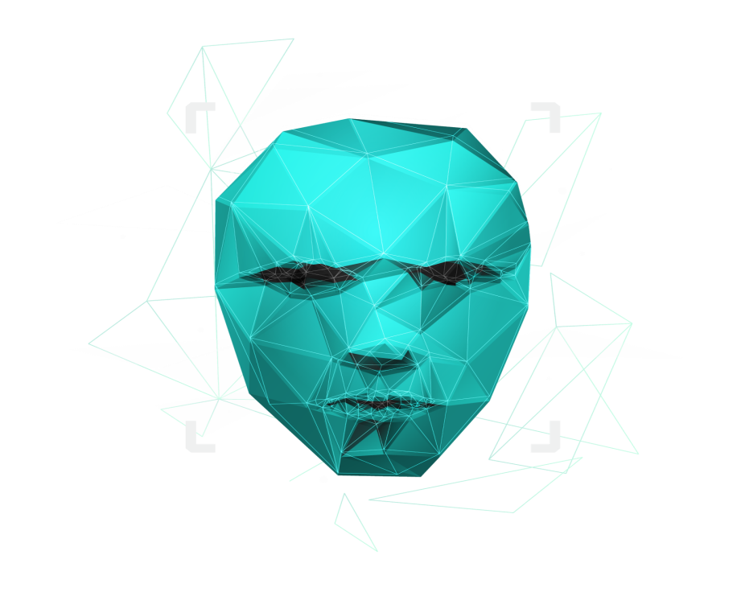

AIObtuse is an application which basically serves as a helping hand to the blinds by automatically narrating them the activities going around. What needs to be done is just keep the smartphone camera peeking out and connected earphones. This application uses the device camera to recognize the surroundings and with the help of artificial intelligence it will tell the prime persons what's going around them.

How it works?

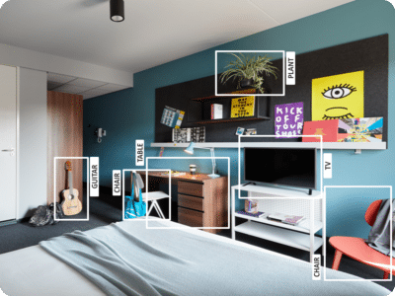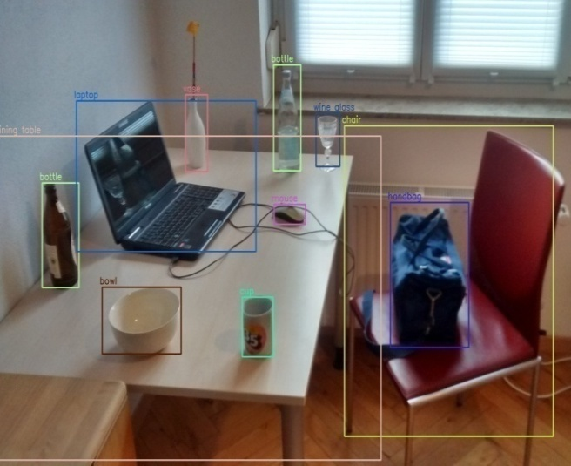

In first image: some objects in a room like Guitar, TV, Flower Pot are detected using the smart camera. Same as in second image : Laptop , Bag , Cup, Bottle etc. are detected using the camera and represent it by a rectangular box.

But for blind persons we are going to add voice note functionality in our project. As soon as the object detected by the camera , the name of the object will also be announce either by using speakers or earphones like a Google assistant .

Data Flow Diagram

User

Login

Permission

Gathering

Camera

Access

Data

Analysis

01

Detection

Updation of

logs

02

Data

Retrival

03

Fetching

data

Natural Language Processing of data

Audio Translation

Technology used

Python

Python is an [interpreted](https://en.wikipedia.org/wiki/Interpreted_language), [high-level](https://en.wikipedia.org/wiki/High-level_programming_language) and [general-purpose programming language](https://en.wikipedia.org/wiki/General-purpose_programming_language). Python's design philosophy emphasizes [code readability](https://en.wikipedia.org/wiki/Code_readability) with its notable use of [significant whitespace](https://en.wikipedia.org/wiki/Off-side_rule). Its [language constructs](https://en.wikipedia.org/wiki/Language_construct) and [object-oriented](https://en.wikipedia.org/wiki/Object-oriented_programming) approach aim to help [programmers](https://en.wikipedia.org/wiki/Programmers) write clear, logical code for small and large-scale projects. Python is [dynamically typed](https://en.wikipedia.org/wiki/Dynamic_programming_language) and [garbage-collected](https://en.wikipedia.org/wiki/Garbage_collection_(computer_science)). It supports multiple [programming paradigms](https://en.wikipedia.org/wiki/Programming_paradigms), including [structured](https://en.wikipedia.org/wiki/Structured_programming) (particularly, [procedural](https://en.wikipedia.org/wiki/Procedural_programming)), [object-oriented](https://en.wikipedia.org/wiki/Object-oriented_programming), and [functional programming](https://en.wikipedia.org/wiki/Functional_programming). Python is often described as a "batteries included" language due to its comprehensive [standard library](https://en.wikipedia.org/wiki/Standard_library).

Artificial intelligence (AI)

Artificial intelligence (AI), is [intelligence](https://en.wikipedia.org/wiki/Intelligence) demonstrated by [machines](https://en.wikipedia.org/wiki/Machine), unlike the natural intelligence [displayed by humans](https://en.wikipedia.org/wiki/Human_intelligence) and [animals](https://en.wikipedia.org/wiki/Animal_cognition). Leading AI textbooks define the field as the study of "[intelligent agents](https://en.wikipedia.org/wiki/Intelligent_agent)": any device that perceives its environment and takes actions that maximize its chance of successfully achieving its goals.[[3]](https://en.wikipedia.org/wiki/Artificial_intelligence#cite_note-Definition_of_AI-3) Colloquially, the term "artificial intelligence" is often used to describe machines (or computers) that mimic "cognitive" functions that humans associate with the [human mind](https://en.wikipedia.org/wiki/Human_mind), such as "learning" and "problem solving".

OpenCV

OpenCV (*Open Source Computer Vision Library*) is a [library of programming functions](https://en.wikipedia.org/wiki/Library_(computing)) mainly aimed at real-time [computer vision](https://en.wikipedia.org/wiki/Computer_vision).[[1]](https://en.wikipedia.org/wiki/OpenCV#cite_note-1) Originally developed by [Intel](https://en.wikipedia.org/wiki/Intel_Corporation), it was later supported by [Willow Garage](https://en.wikipedia.org/wiki/Willow_Garage) then Itseez (which was later acquired by Intel[[2]](https://en.wikipedia.org/wiki/OpenCV#cite_note-2)). The library is [cross-platform](https://en.wikipedia.org/wiki/Cross-platform) and free for use under the [open-source](https://en.wikipedia.org/wiki/Open-source_software) [Apache 2 License](https://en.wikipedia.org/wiki/Apache_License). Starting with 2011, OpenCV features GPU acceleration for real-time operations.

Object detection

Object detection is a computer vision technique that allows us to identify and locate objects in an image or video. With this kind of identification and localization, object detection can be used to count objects in a scene and determine and track their precise locations, all while accurately labeling them.

# Features

* Detects Object.
* Draws rectangular box around them.
* Call out the names of Object.
* Detects multiple objects simultaneously.

WORKING AND METHODOLOGY

AIObtuse is an application which basically serves as a helping hand to the blinds by automatically narrating them the activities going around. What needs to be done is just keep the smartphone camera peeking out and connected headphones. This application uses the device camera to recognize the surroundings and with the help of artificial intelligence it will tell the prime persons what's going around them.

It basically uses device camera and recognizes objects in the vision, it smartly draws a rectangular box around it and narrates the name of the object identified by the camera. The main Agenda behind the project Ai Obtuse is to make the daily challenges easy going to the specially abled persons.

Live Detection Sample

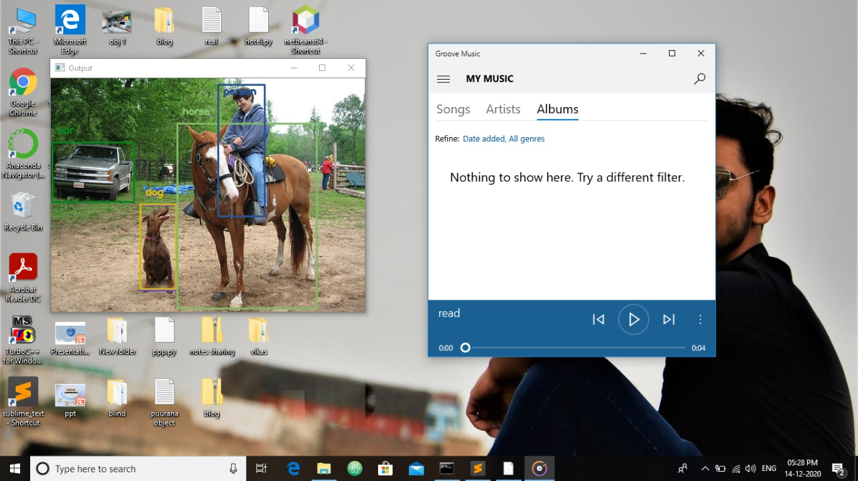

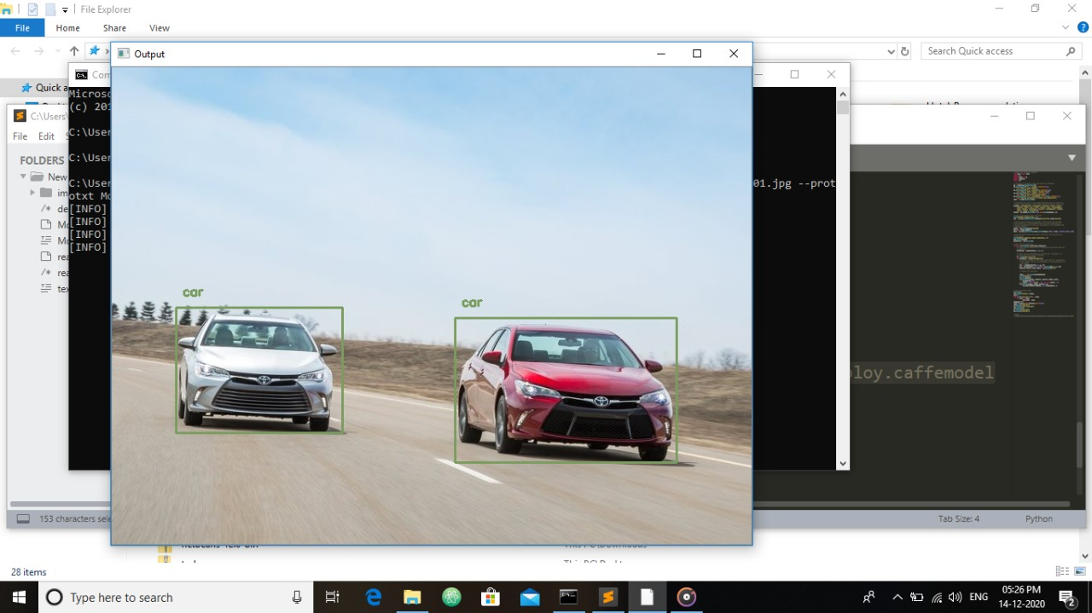

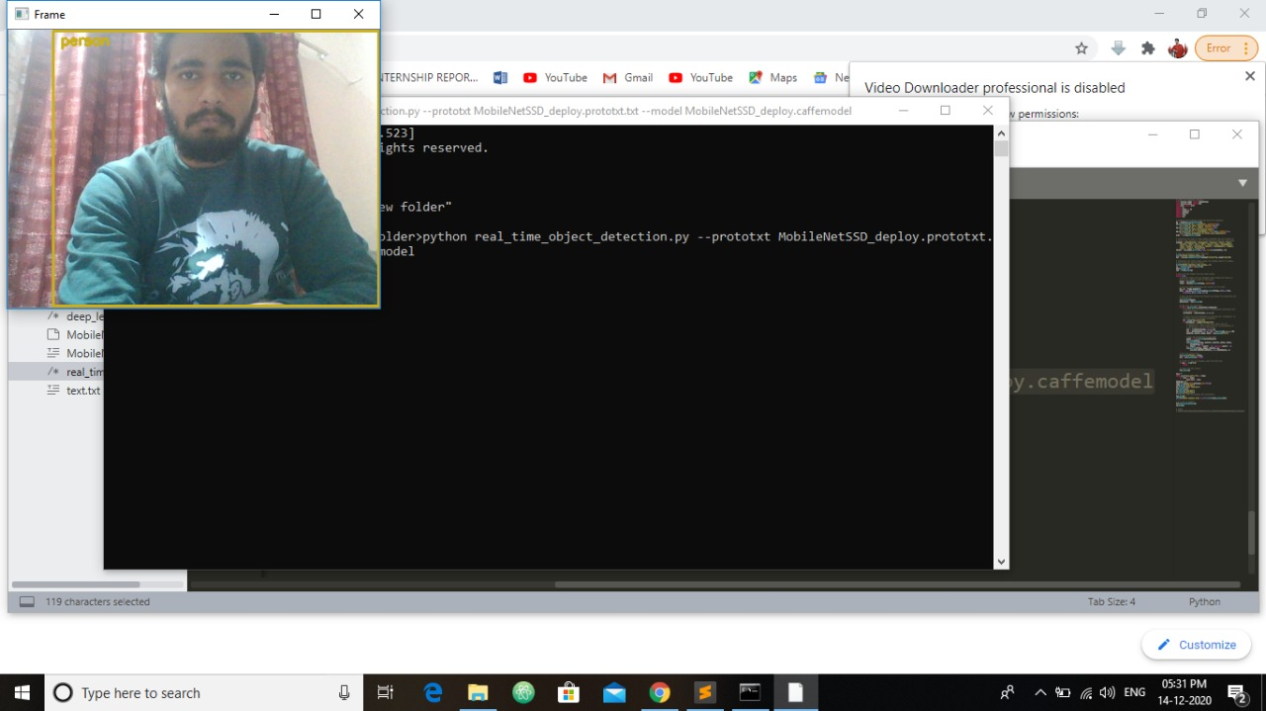

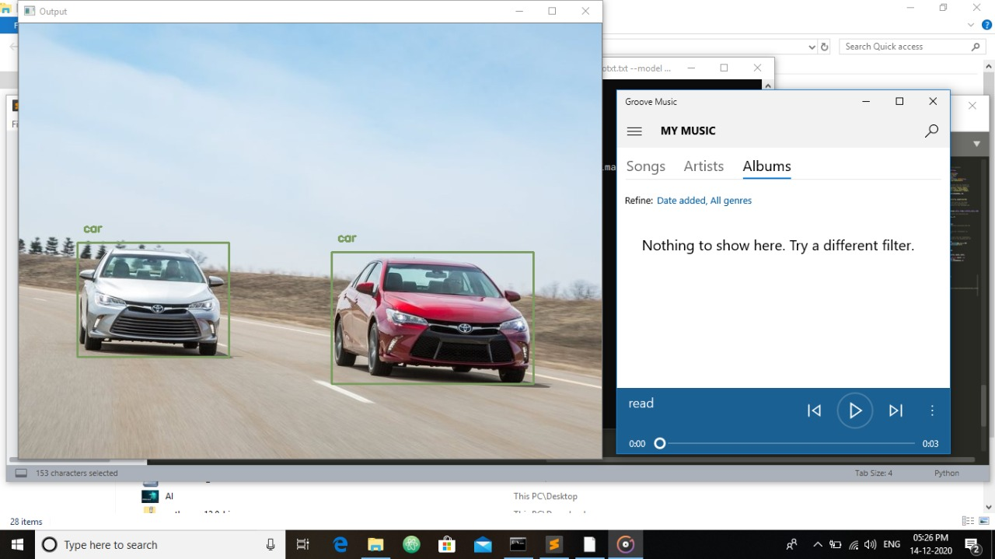

Source Code

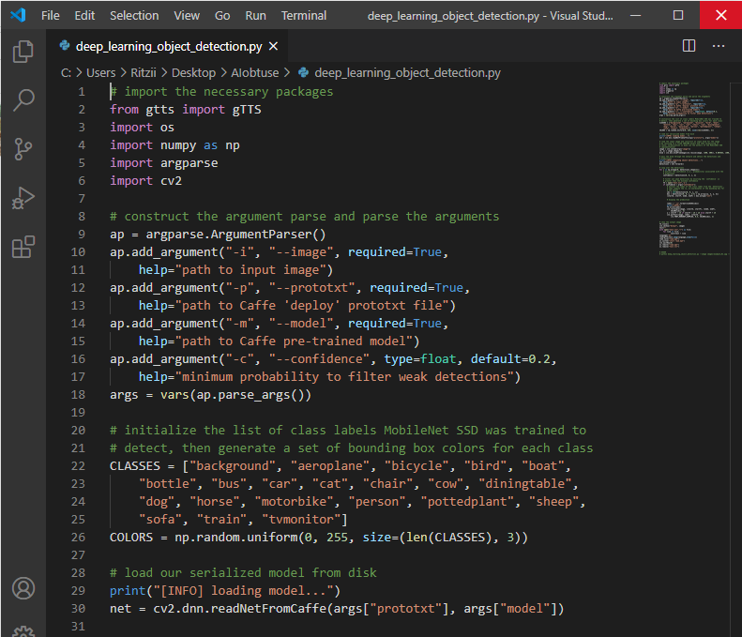

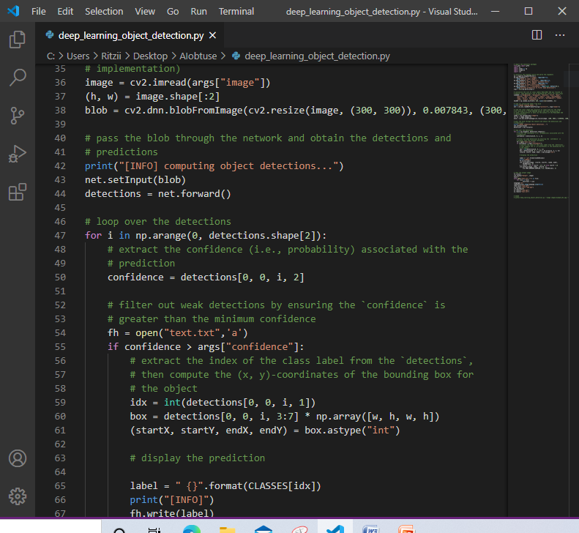

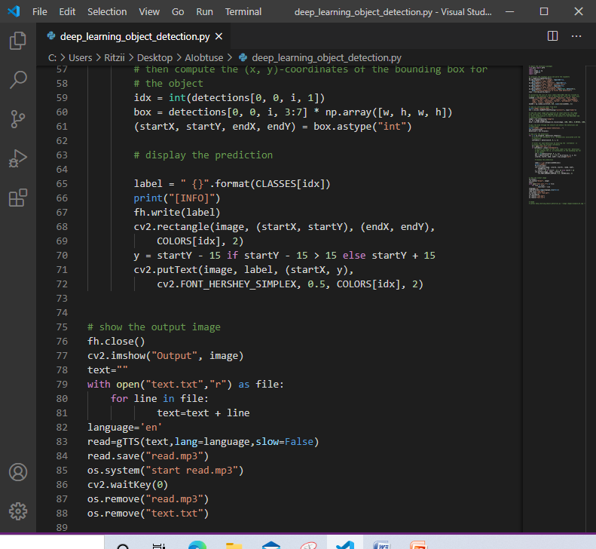

Conclusion

We tend to build an application which would directly help differently abled or specificly blind people in performing their daily routine work easily and most importantly without any help of other. If 100% working is achieved user would not need any assistance or anyone’s help for his/her work.

This application would increase self esteem of individual as a person and would definitely make him self dependent.

# References

* <https://code.visualstudio.com/download>
* <https://www.python.org/downloads/>
* <https://docs.opencv.org/>