Flow builder :

1. Create a screen flow and debug it:
Create opportunity using screen flow ; you have to include the required fields.Drag and drop screen icon from the elements.
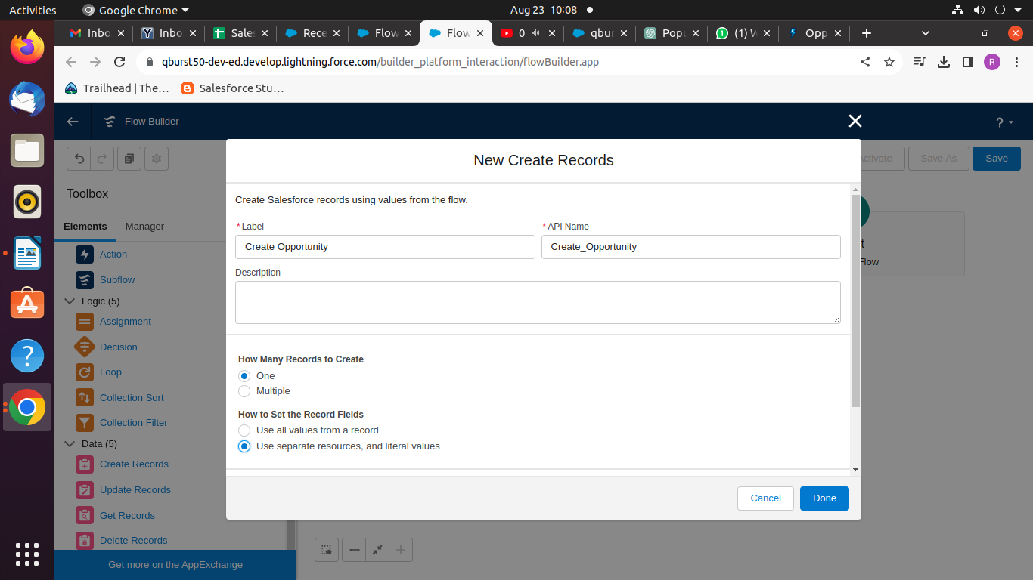
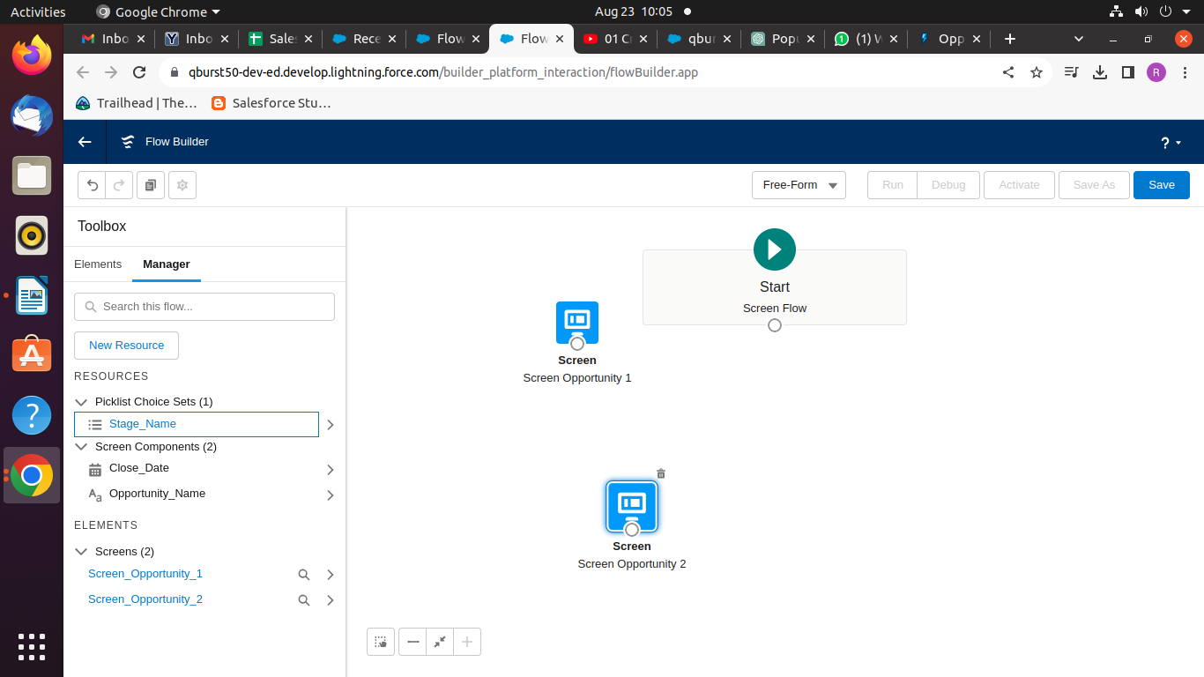
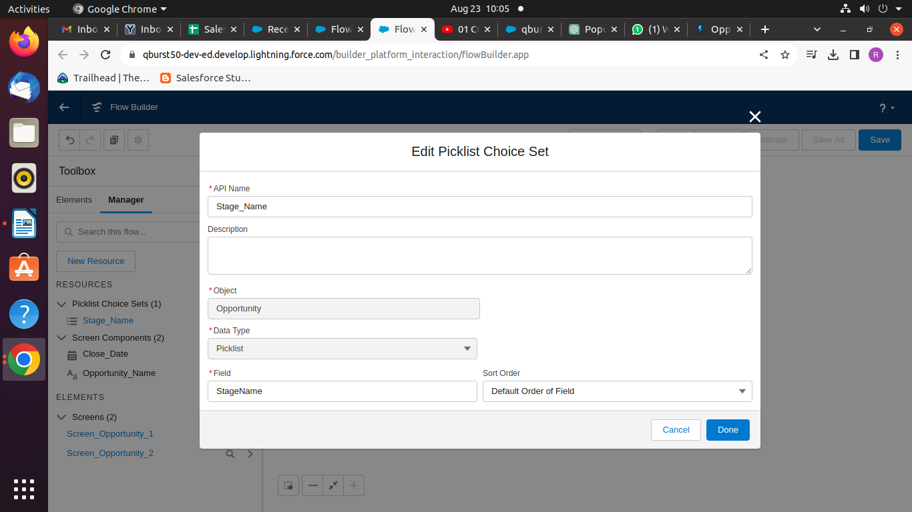
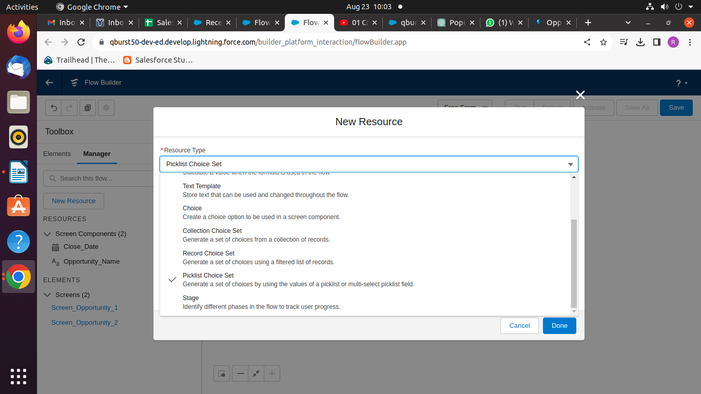
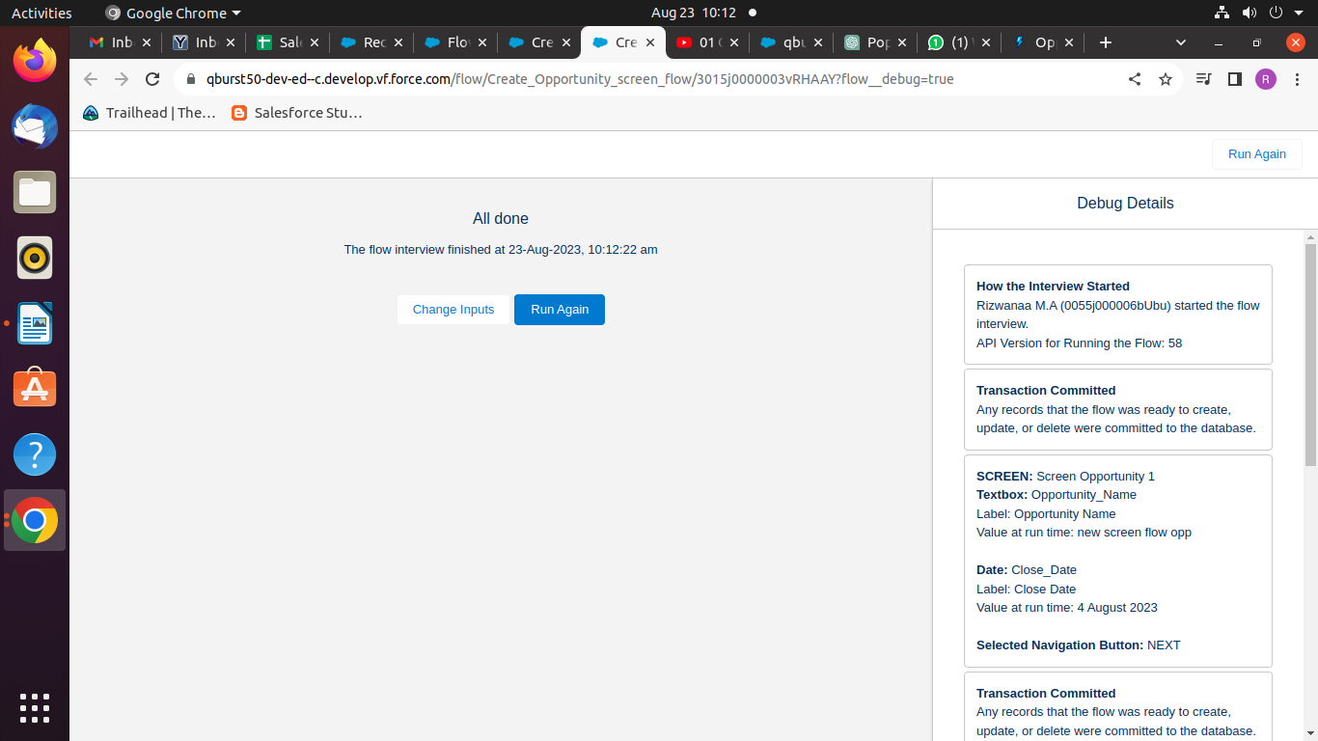
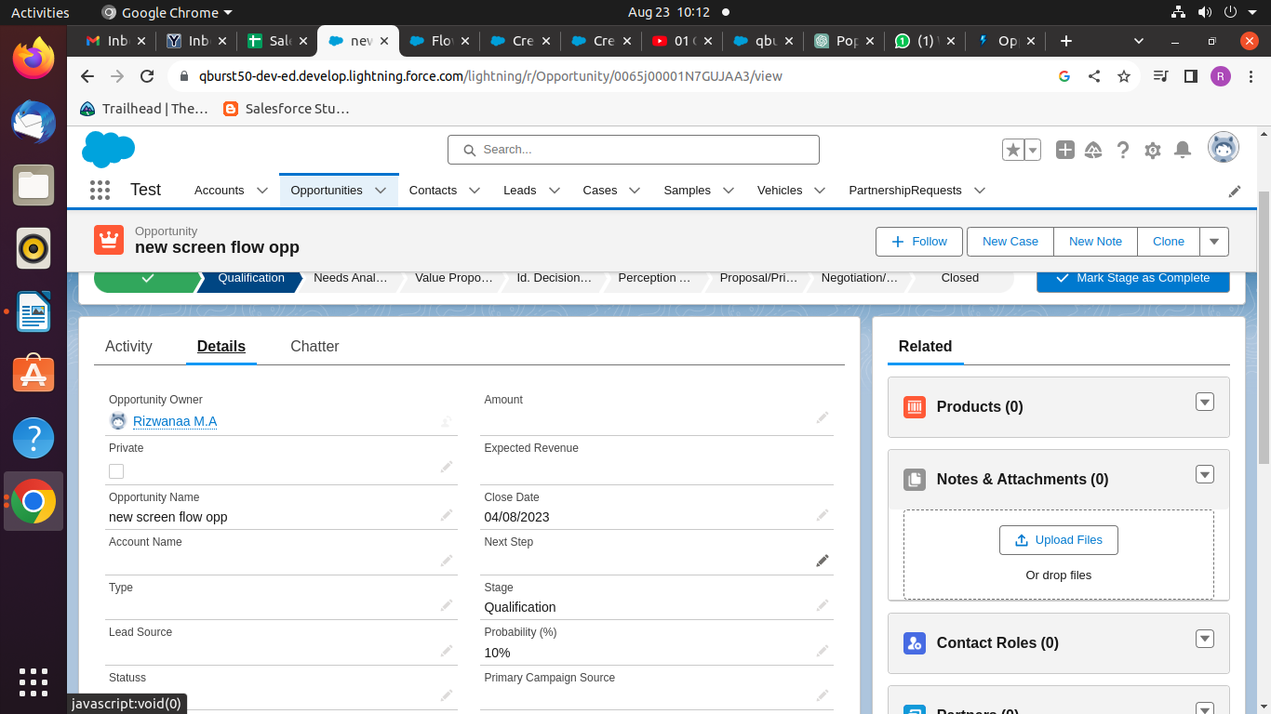
To create a picklist choose Manager-> New resource . And the add the picklist.

Save the flow and activate, use debug to check.

2. what happens when screen flow fails :
CloseDate is required, but in screen flow I have not mentioned as required, so when not entered data for required fields then screen throws error. Aso you”ll recieve an email.
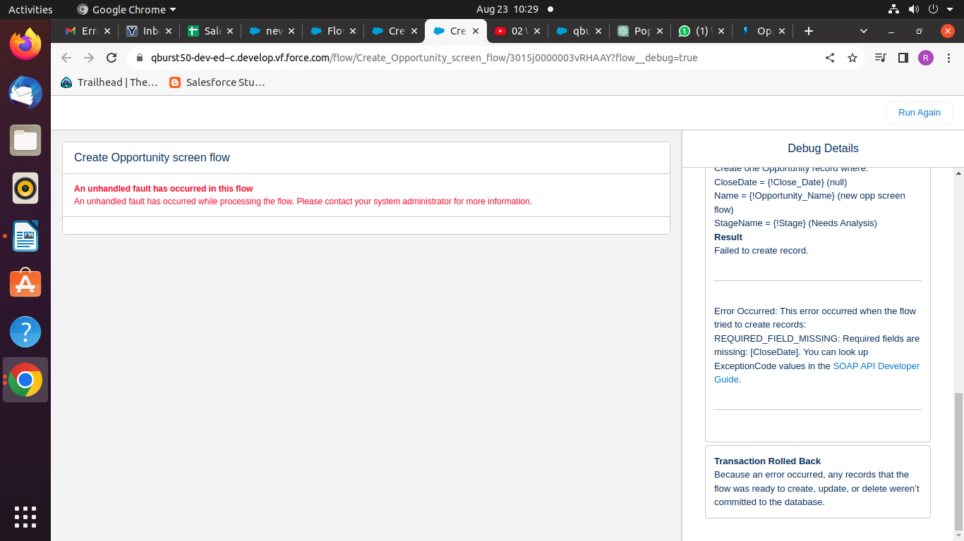
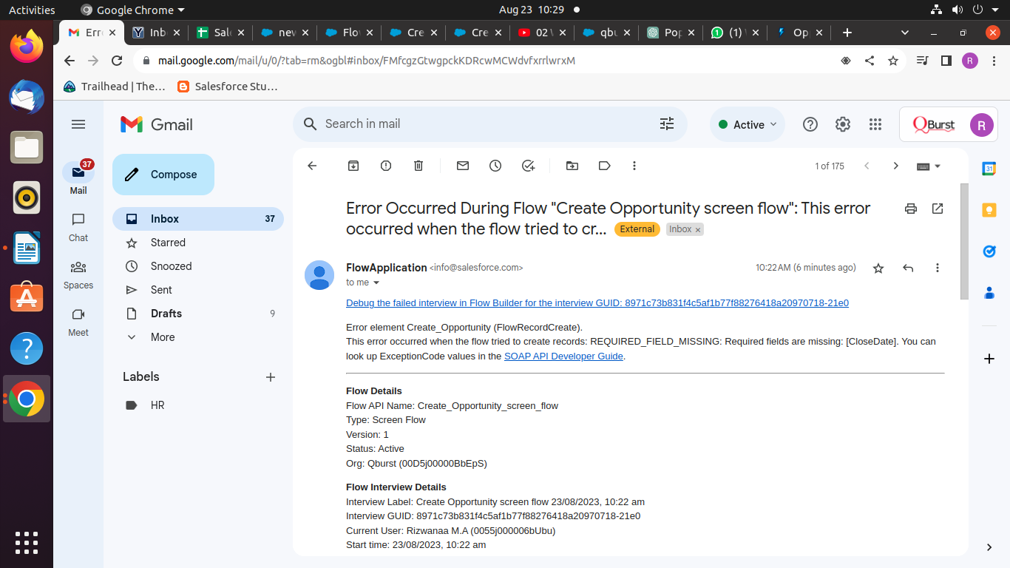

3. To place screen flow on record page: So you can create an opportunity being in account detail page and an opportunity gets created.

Note to consider: used the same 1st task screen but add one more variable as recordId
To link opportunity to an account:
Add new resource -> Resource type (variable) - > Api Name (MUST BE recordId) -
>data type(Text) ->Availability outside the flow (Available for input)

In Create record element add a field called: AccountId – recordId.

4. Flow resources:
Picklist Choice set – Already done
Record Choice set
Formula

Record Choice set -

5. Use of Assignment, Decision and loop elements in flow builder.
When deadline date on account is updated then populate it on close date on related opportunites whose stage is other than close lost or won.

