**Week -10**

**1.Time Series Analysis**

**# Get the data points in form of a R vector.**

rainfall <- c(799,1174.8,865.1,560.6,635.4,1054.5,1600.5,890.6,784.2,985,882.8,1071)

**# Convert it to a time series object.**

rainfall. timeseries <- ts(rainfall, start = c(2012,1),frequency = 12)

**# Print the timeseries data.**

Print (rainfall. timeseries)

**# Give the chart file a name.**

png(file = "rainfall.png")

**# Plot a graph of the time series.**

plot(rainfall.timeseries)

**output:**

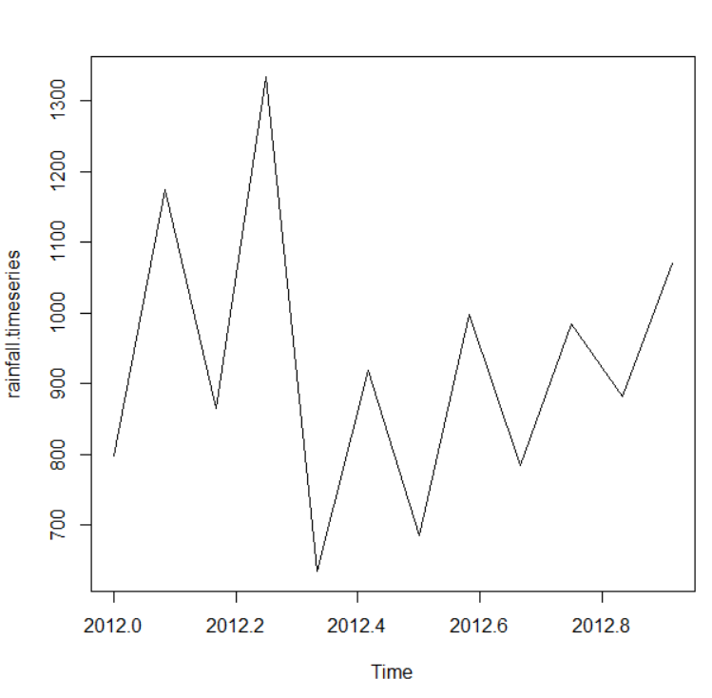

**2.Network data:**

**Library(igraph)**

**Install.packages(“igraph”)**

|  |  |
| --- | --- |
|  | |
|  | | |
|  | | # Create undirected graphs  g <- graph_from_literal (1-2, 1-3, 1-7, 3-4, 2-3, 2-4, 3-5, 4-5, 4-6, 4-7, 5-6, 5-8, 6-7, 7-8)  plot(g) | | |
|  | |  | | |

V(g)

Vcount(g)

E(g)

**Output:**

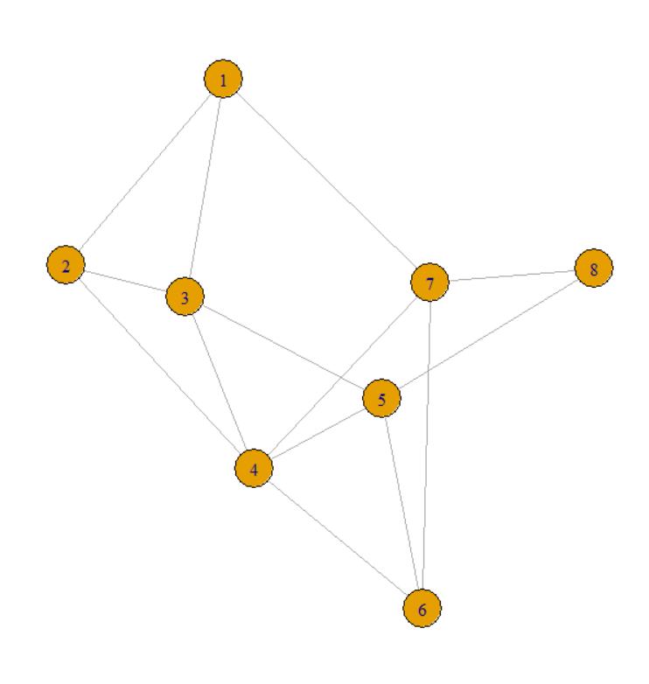

**3.Date operations:**

**The most basic function we use while dealing with the dates is as.Date() function.**

dv=as.Date(“2022-05-30”)

print(dv)

Sys.Date()

Sys.time()

**#to know about the current system date and time**

install.packages(“lubridate”)

library(lubridate)

now()

## #Extraction and Manipulation of the Parts of the Date

## 

## x=c("2020-01-10","2021-05-15","1990-07-07")

## month(x)

## year(x)

## mday(x)

## month(x,label=TRUE)

## wday(x,label=TRUE)

**5.String parsing:**

rs <- ("This is First R String Example")

strsplit(rs, split = " ")

rs <- ("This&is&First&R&String&Example")

strsplit(rs, split = "&")

rs <- ("This12is3First4R5String6Example")

strsplit(rs, split = "[0-9]+")