**Отчёт по 10 лабораторной**

**Код лабораторной**

Код Form1

using System;

using System.Collections.Generic;

using System.ComponentModel;

using System.Data;

using System.Drawing;

using System.Linq;

using System.Text;

using System.Threading.Tasks;

using System.Windows.Forms;

using System.Configuration;

using System.Data.OleDb;

using NLog.Internal;

namespace Lab8

{

public partial class Form1 : Form

{

public OleDbConnection Connection = null;

public Form1()

{

InitializeComponent();

}

public void Form1_Load(object sender, EventArgs e)

{

}

public Form1(string text)

{

InitializeComponent();

textBox1.Text = text;

}

public void button1_Click(object sender, EventArgs e)

{

Form2 f = new Form2();

f.Owner = this;

f.ShowDialog();

}

}

}

Код Form2

using System;

using System.Collections.Generic;

using System.ComponentModel;

using System.Configuration;

using System.Data;

using System.Data.OleDb;

using System.Drawing;

using System.Linq;

using System.Text;

using System.Threading.Tasks;

using System.Windows.Forms;

namespace Lab8

{

public partial class Form2 : Form

{

public Form2()

{

InitializeComponent();

}

public void Form2_Load(object sender, EventArgs e)

{

Form1 main = this.Owner as Form1;

string s = main.textBox1.Text;

RequestOutput requestOutput = new RequestOutput();

dataGridView1.DataSource = requestOutput.request(s).Tables[0];

}

}

}

Код ReguesOutput

using System;

using System.Collections.Generic;

using System.Configuration;

using System.Data;

using System.Data.OleDb;

using System.Linq;

using System.Text;

using System.Threading.Tasks;

using System.Windows.Forms;

namespace Lab8

{

internal class RequestOutput

{

private OleDbConnection Connection = null;

public DataSet request(string req)

{

OpenFileDialog openFileDialog1 = new OpenFileDialog();

openFileDialog1.ShowDialog();

string connectionString = "provider=Microsoft.Jet.OLEDB.4.0;data source=" + System.IO.Path.Combine(Application.StartupPath, openFileDialog1.FileName.ToString());

OleDbConnection conn = new OleDbConnection(connectionString);

Connection = new OleDbConnection(connectionString);

Connection.Open();

try

{

OleDbDataAdapter adapter = new OleDbDataAdapter(req, Connection);

DataSet ds = new DataSet();

adapter.Fill(ds);

Connection.Close();

return ds;

}

catch (Exception )

{

DataSet ds = new DataSet();

DataTable customers = ds.Tables.Add("Error");

customers.Columns.Add("Error");

customers.Rows.Add("Запрос не корректен");

conn.Close();

return ds;

}

}

}

}

Работа программы

Первая бд

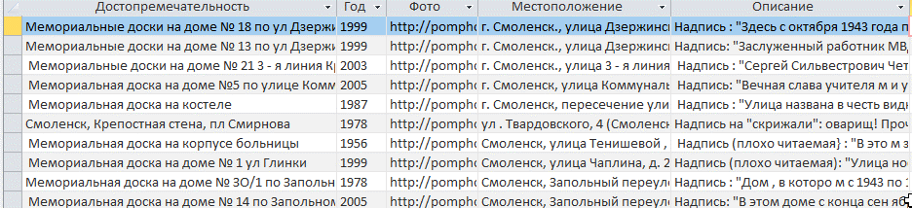

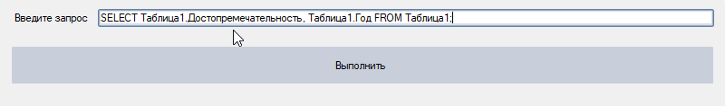

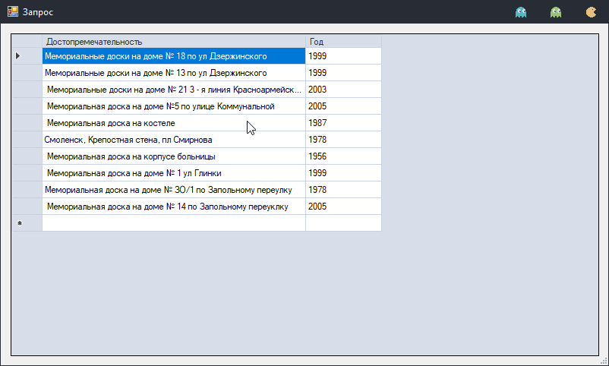

Вторая бд

