EECE5554 – Robotics Sensing and Navigation

Ruchik Jani (NUID – 002825482)

Lab1 Report

Stationary Data:

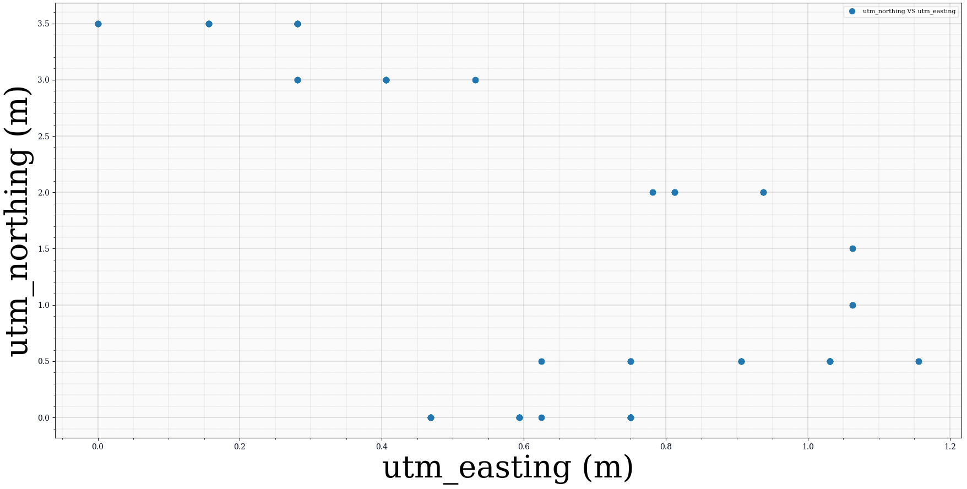
Figure 1: Northing vs Easting Scatter Plot

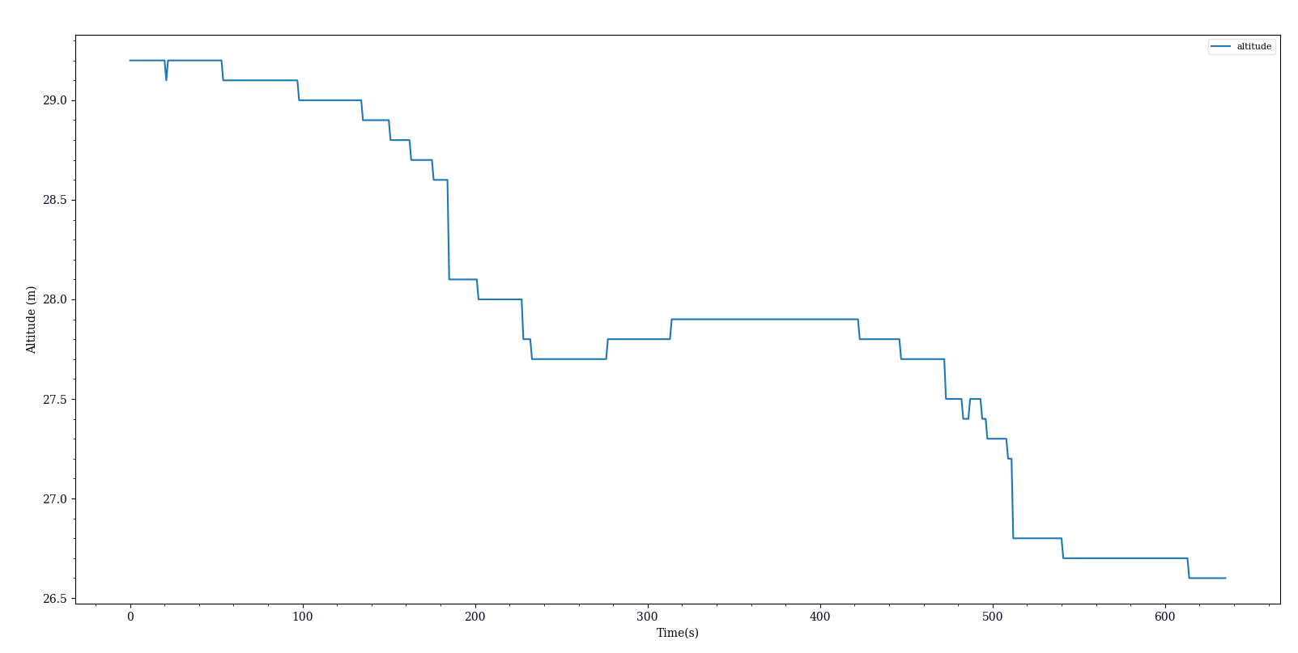
Figure 2: Altitude vs Time Line Plot

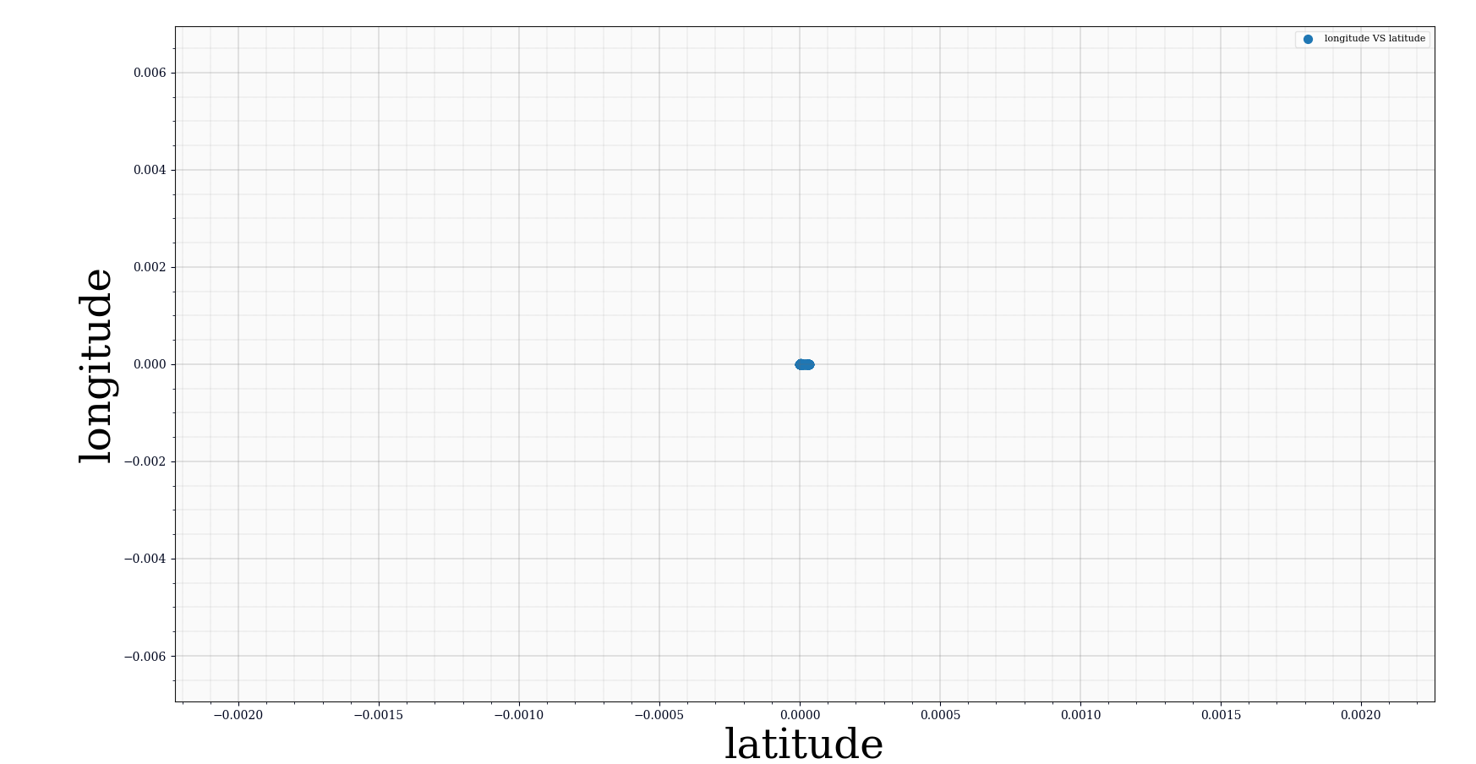
Figure 3: Longitude vs Latitude Scatter Plot

These readings were taken sitting in a bench outside my house which is near to Northeastern University. The weather conditions were sunny and a little breezy. The location was in a area surrounded partially by trees and townhouses.

Figure 1 gives us the Easting and Northing data in stationary condition. The data has been plotted relative to the minimum of the Easting and Northing values obtained from the GPS puck:
Minimum Easting: 327279.8125
Minimum Northing: 4688996.0
There is a deviation of 1.15 m in the Easting value and 3.5m in the Northing value even though the GPS sensor was stationary. This error arises due to obstructions like trees and walls around the bench as the signal bounces off these objects before reaching the GPS sensor.

Figure 2 gives us the Altitude vs Time data in stationary condition. The actual altitude of the location is about 14 m. We can observe that the error in altitude is huge. The altitude value from the sensor peaks at 29.3 m and settles down at 26.6 m. There is such a huge difference in readings because GPS sensors have a poor measurement in the vertical plane due to the angle between the line of sight to the various GPS satellites, and the ground.

Figure 3 gives us the Longitude vs Latitude data in stationary condition. The data has been plotted relative to the minimum of the Longitude and Latitude values obtained from the GPS puck:
Minimum Longitude: -71.09650421142578
Minimum Latitude: 42.33405685424805
There is no deviation in the values which is expected since the GPS sensor was stationary.
The actual co-ordinates of the location are: 42.334079 latitude, -71.096441 longitude.

Walking Data:

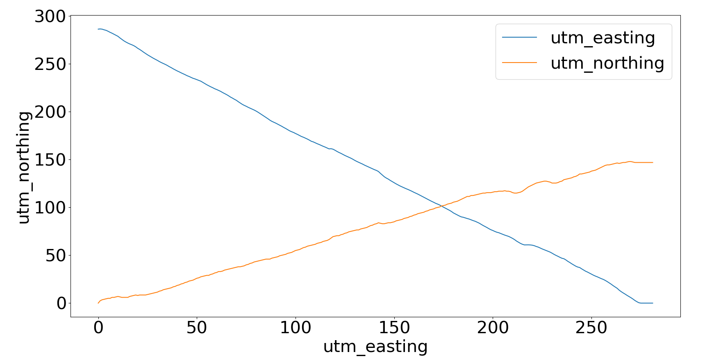
Figure 1: Northing vs Easting Line Plot

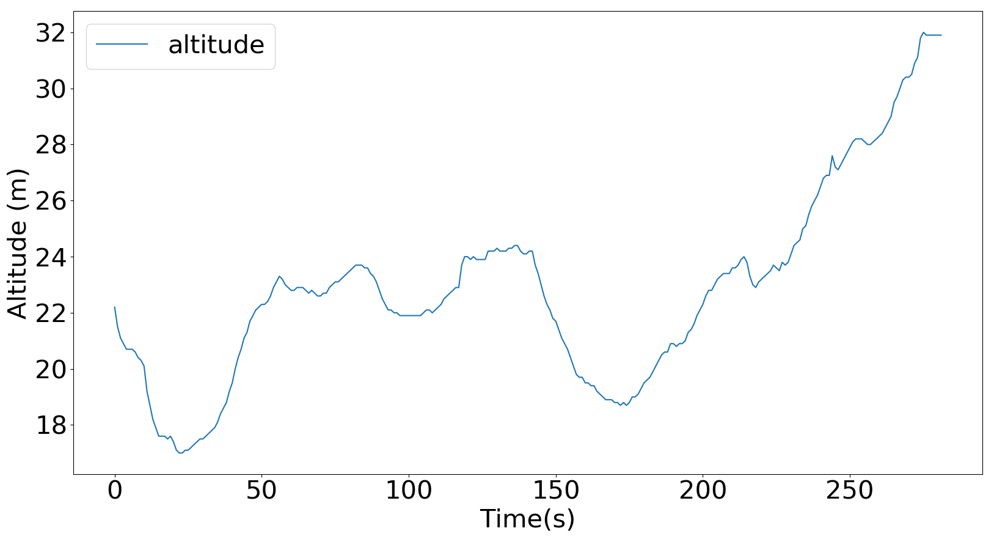
Figure 2: Altitude vs Time Line Plot

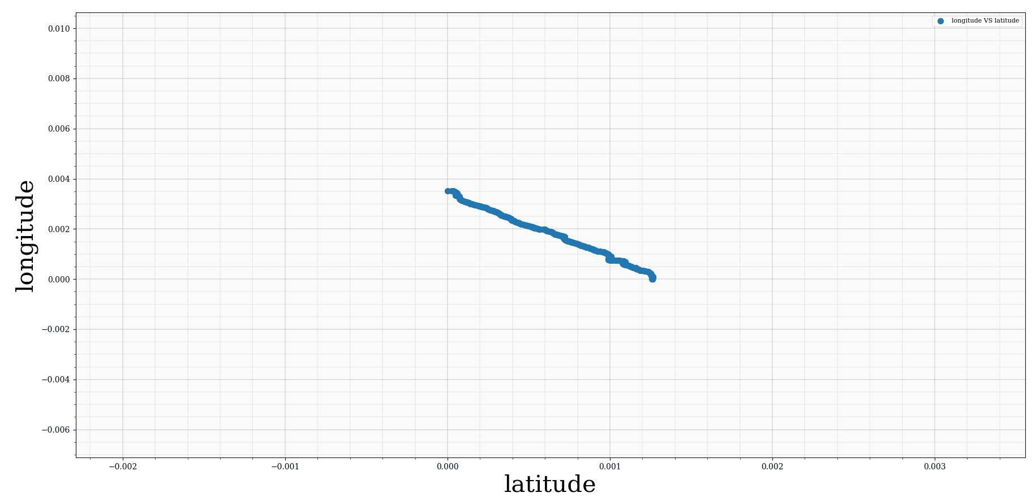
Figure 3: Longitude vs Latitude Scatter Plot

These readings were taken walking on a street in a straight line for almost 300 metres near my house. The weather conditions were sunny and a little breezy. The street was occupied by cars on the sides and there were trees on the foot-walk. The elevation also changed at some places. Due to approaching vehicles, I had to swerve to the foot-walk twice.

Figure 1 gives us the Easting and Northing data in walking condition. The data has been plotted relative to the minimum of the Easting and Northing values obtained from the GPS puck:
Minimum Easting: 327063.5
Minimum Northing: 4689006.0
The Easting value is steadily decreasing and the Northing value is steadily increasing. This is because I was walking in the North-West direction. The value of the Easting co-ordinate decreases as we move east to west, and the value of the Northing co-ordinate increases from south to north.

Figure 2 gives us the Altitude vs Time data in walking condition. The actual altitude of the straight line path varies from 13 – 14m. The altitude value from the sensor has a minimum value of almost 14 m, before it settles at 32m. The error value is expected because of the properties of the GPS sensor as described in the Stationary Data Section. The altitude curve is changing at multiple points which is consistent with the elevation of the terrain.

Figure 3 gives us the Longitude vs Latitude data in walking condition. The data has been plotted relative to the minimum of the Longitude and Latitude values obtained from the GPS puck:
Minimum Longitude: -71.09917449951172
Minimum Latitude: 42.33416366577149
The actual co-ordinates of the starting and end point are:
Start Point: 42.334111 lat, -71.095678 long
End Point: 42.335455 lat, -71.099123 long

The longitude is decreasing w.r.t. the latitude as seen in the scatter plot above. This is in line with the actual co-ordinates of the start and end points, and also the fact that I was walking in the North-West direction.

The accuracy of GPS Sensor is very high in case of walking condition as compared to the stationary condition.

