Automated Log Analyzer
REVA B. BONDE
ML AUTOMATION

Automated CyberSecurity Log Analyzer Agent
This is a ML based CyberSecurity Agent that automates tasks of a Log Analyzer. This is built in COLAB and coded entirely in Python. This agent automates the process of:
- Collecting logs: from APIs, files, servers or monitoring tools.
- Cleaning and parsing them: convert messy raw logs into structured form.
- Detecting anomalies: using rules and machine learning.
- Creating alerts & HTML reports: no need for manual analyzing.

Importance of this project:
- Automated Log analysis is a core SOC(Security Operations Center) Task:
Companies generate GBs or TBs of logs everyday due to security breaches behind login attempts, system events, network requests, errors, etc. Manually reading them is impossible.
- SOC analysts rely on automated agents:
Tools like Splunk, Wazuh, ELK Stack, SIEM Solutions, Crowd Strike, MS Sentinel (tools used for threat detection and log analysis) follow the pipeline:

Collect Parse Analyze Detect Alert

This pipeline is also used in the project.

Technologies used:
✔ API integration
✔ Data cleaning
✔ Cybersecurity event understanding
✔ Machine learning for anomaly detection
✔ Automation (agent behavior)
✔ HTML reporting (Jinja2 templates)
✔ Practical SOC workflow

Architecture:
- Define Metadata:
A dictionary with details used to understand the project.
- Import required libraries:
Standard libraries – os, json, tempfile, datetime and csv.
Third –party libraries – pandas, scikit-learn, requests, matplotlib, and jinja2.
- Fetch logs from API:
requests.get() fetches logs from external API endpoint. (API Endpoint is the URL where a client( browser, app, script) sends requests to access data or service from a server). Companies often send requests to SIEM Endpoints, REST APIs , etc.
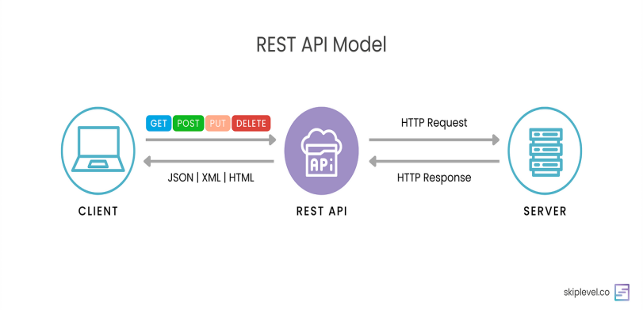
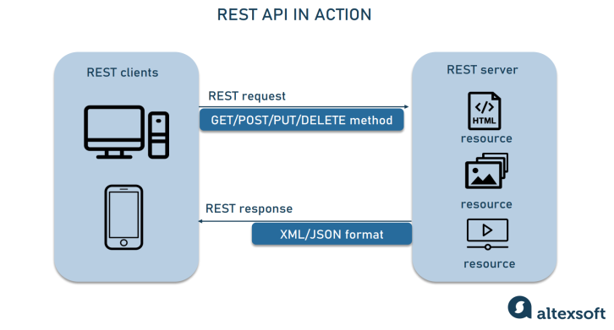
- Clean and preprocess logs:
Using pandas remove missing values, convert timestamps, filter noise and extract fields.
- Detect anomalies:
Algorithms such as Isolation Forest(works by isolating anomalies instead of profiling normal data) detect unusual activities in logs.
- Create HTML reports and send alerts:
Jinja2 summarizes findings and display charts mimicking SOC Dashboards. Slack API sends alerts to the admin.

CODE
- The project begins with metadata used for version tracking, consistent documentation, and updates and for the report to use the project name. Industrial tools have metadata such as SIEM tools, open-source libraries, docker containers and APIs. Metadata helps reporting , integration and CI/CD Development.
- Installing Dependencies:

!pip install -q scikit-learn pandas matplotlib jinja2 requests

! : Is used to run a shell command.
-q flag : Quiet mode. Hides long pip installation logs
Libraries installed: import

Sr. | Libraries installed | Purpose
1. | Pandas | Dataframe, csv reading, log preprocessing(read, clean, filter)
2. | Scikit-learn | ML Models, anomaly detection
3. | Matplotlib (.pyplot) | Charts, embed into HTML reports, plot anomaly scores
4. | Jinja2 | Templating engine, generates HTML reports
5. | requests | Send http requests, fetch logs via API(GET,POST) , send authentication logs, download json logs
6. | os | Handle file path, env variables, read/write log files, check existence of folders
7. | csv | Read raw comma separated values, write processed files
8. | tempfile | Temporary logs storage , temporary reports, temporary testing
9. | datetime | Convert strings to datetime, sort chronologically
10. | json | Read logs from API, convert Python dict to json, export logs
11. | Isolation Forest (from ensemble) | Unsupervised algorithm for anomaly detection(isolates rare/unusual points), fast, handles high dimensional data
12. | Standard Scaler (from preprocessing) | Normalize features( convert all values on a similar scale so that model treats each feature fairly)
13. | Template (from jinja2) | Dynamic HTML reports, mimics professional SIEM that generates pdfs/reports

- Fetching logs + loading data + Preprocessing :

def fetch_logs(api_url):
response = requests.get(api_url) -GET request to logging API
if response.status_code == 200: -checks status of request
return response.json() -converts json to dict/list
else:
return []

Why APIs for logs?
To simulate real SOC scenario. Modern systems don’t log onto local disks anymore. Logs are received from Firewalls, Cloud servers(AWS,AZURE), Authentication systems(OAuth,IAM), SIEM tools(Splunk , Sentinel), Application monitoring devices.

API response is turned to pd Dataframe:
[//example api response {
"timestamp": "2025-11-26T10:15:23",
"ip": "192.168.1.45",
"event": "LOGIN_FAILED",
"attempts": 3
}]

df = pd.read_csv("synthetic_logs.csv")

Companies export logs in csv format

Preprocessing:
Convert timestamp strings to datetime objects(for ML’s understanding):

pd.to_datetime()

missing values can create crashes during execution, NaN poisoning scaler, false anomalies

df.dropna()

Feature engineering:

Model uses signal patterns instead of raw logs.

Features normalize feed to ML

Derived features:
Feature | Meaning | Importance | Threats
failed_logins | No. of failed attempts | Detect brute force | Brute force
requests_per_min | Request spikes | Detect DDoS | DDoS
unique_ips | Count of ip addresses | Detect lateral movement | Intrusion
response_time | Latency | Detect backend overload | Exploitation attempt

Stages of data processing:

- Using ML model:
Isolation Forest algorithm:
Unsupervised(no labels required) anomaly detection (isolates anomalies rather than normal points) tree based(builds random trees) algorithm . This engine detects threats in logs.
Used in Cybersecurity intrusion detection, fraud detection, system monitoring, API usage anomaly detection.
Why we are using Isolation Forest?
This algorithm:
✔ learns normal patterns on its own
✔ flags deviations as anomalies
✔ handles numerical logs very well
Isolation Forest:
- randomly splits feature space
- isolates points using cuts
- anomalies get isolated quickly
(they are few and different)
- normal points require more splits

model = IsolationForest(contamination=0.05, random_state=42)
model.fit(scaled_features)
df['anomaly'] = model.predict(scaled_features)

contamination : tells what % of logs are anomalies
lower value = stricter model
higher value = more anomalies
.fit() : trains the model
.predict(): returns output -1(normal) and 1(anomaly)

Anomaly score:

df['score'] = model.decision_function(scaled_features)

higher score = normal
lower score = suspicious

- Report generation , visualization and alerts:

from jinja2 import Template
import matplotlib.pyplot as plt
import tempfile

A clean report allows faster incident response
Jinja2 is a templating engine that allows dynamic HTML reports used by Flask, Ansible and Django like renderers
{{ variable }} → placeholder that gets replaced by actual values.

Why charts?
Humans detect patterns visually faster than numerically.

Matplotlib plotting:

plt.figure() start new chart
plt.plot(df['timestamp'], df['score']) draw / plot
plt.title("Anomaly Scores Over Time")
plt.savefig("anomaly_plot.png") save plot , embed in html .png file

charts are saved temporarily by using tempfile
html = template.render() Injects data into html to create report

then file is written:
with open("report.html", "w") as f:
f.write(html)

Email , slack alerts:
def send_alert(message, webhook_url):
requests.post(webhook_url, json={"text": message})

this helps like a real monitoring agent.

End – to – end pipeline:

Fetch logs → Clean logs → Extract features → Normalize → Train ML model → Detect anomalies → Generate report → (Optional) Send alerts
- Industry impact:
Skill | Value
Python automation | core SOC workflows
Log parsing | used in security jobs
ML anomaly detection | Modern threat hunting
Reporting | Needed for audit & compliance
API consumption | Connects to real systems

Summary:
Stage | What Happens | Why It Matters
Log ingestion | Fetch logs via API / read CSV | Real-world log sources
Preprocessing | Clean, parse timestamps, extract fields | Prepare structured signals
Feature engineering | Convert raw events into ML-ready numeric features | Helps model learn patterns
Normalization | Standardize values | Prevents biased ML decisions
Isolation Forest | Detect outliers / anomalies | Identifies suspicious behavior
Report generation | HTML + charts | Makes findings human-readable
Alerts (optional) | Slack/Webhook notifications | Real-time incident response

