**PROJECT TITLE:**

**STOCK PRICE PREDICTION**

**PROBLEM DEFINITION:**

* Stock market prediction is the act of trying to determine the future value of a company stock or other financial instrument traded on an exchange. The successful prediction of a stock's future price could yield significant profit. The efficient-market hypothesis suggests that stock prices reflect all currently available information and any price changes that are not based on newly revealed information thus are inherently unpredictable. Others disagree and those with this viewpoint possess myriad methods and technologies which purportedly allow them to gain future price information.

**PRE-PROCESSING:**

**STEPS:**

1. **DATA CLEANING**
2. **HANDLE MISSING VALUES**
3. **CATEGORICAL TO NUMERICAL REPRESENTATIONS.**

**DATA CLEANING:**

Data cleaning is the process of fixing or removing incorrect, corrupted, incorrectly formatted, duplicate, or incomplete data within a dataset. When combining multiple data sources, there are many opportunities for data to be duplicated or mislabeled.

**HANDLE MISSING VALUES:**

1. Deleting Rows with missing values
2. Impute missing values for continuous variable
3. Impute missing values for categorical variable
4. Other Imputation Methods
5. Using Algorithms that support missing values
6. Prediction of missing values
7. Imputation using Deep Learning Library — Datawig

**CATEGORICAL TO NUMERICAL REPRESENTATIONS:**

1. cat.codes Attribute
2. replace
3. Label Encoder

**ALGORITHM:**

1. DEEP LEARNING TECHNIQUE : CNN-LSTM
2. ATTENTION MECHANISMS

**CNN-LSTM:**

 CNN-LSTM network use convolutional and LSTM layers to learn from the training data. To train a CNN-LSTM network with audio data, you extract auditory-based spectrograms from the raw audio data and then train the network using the spectrograms.

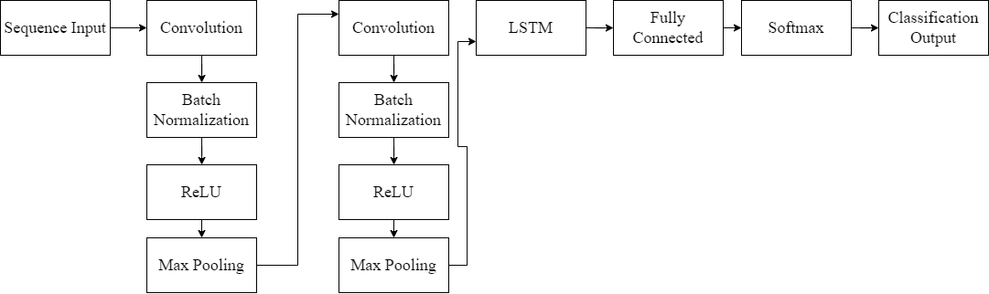

**ATTENTION MECHANISM:**

An attention mechanism is an Encoder-Decoder kind of neural network architecture that allows the model to focus on specific sections of the input while executing a task. It dynamically assigns weights to different elements in the input, indicating their relative importance or relevance.

**PROJECT WORKFLOW:**

