**PROJECT TITLE:**

**STOCK PRICE PREDICTION**

**PROBLEM DEFINITION:**

* Stock price prediction is the act of trying to determine the future value of a company stock or other financial instrument traded on an exchange. The successful prediction of a stock's future price could yield significant profit. The efficient-market hypothesis suggests that stock prices reflect all currently available information and any price changes that are not based on newly revealed information thus are inherently unpredictable. Others disagree and those with this viewpoint possess myriad methods and technologies which purportedly allow them to gain future price information.

**DESIGN THINKING:**

**.** The existing system fails while there are uncommon consequences or predictors.

**.** The former outcomes indicate that the stock price is changeable when the use of the traditional classifier

**.**  The actuality of the device stated in large part prophetic values, opting a relevant term for their enjoy with a purpose to benefit in large part prophetic rankings.

**.** It would not concentrate on outside occasions within the terrain, similar as modern-day occasions or social media.

**Proposed system:**

. On this proposed system, we focus on vaticination of stock request values the usage of gadget literacy algorithms comparable as Random Forest and aid Vector Machines

. We proposed We used the pandas Python library for facts processing, which mixed more than one dataset into one data block.

**PRE-PROCESSING:**

**STEPS:**

1. **DATA CLEANING**
2. **HANDLE MISSING VALUES**
3. **CATEGORICAL TO NUMERICAL REPRESENTATIONS.**

**DATA CLEANING:**

Data cleaning is the process of fixing or removing incorrect, corrupted, incorrectly formatted, duplicate, or incomplete data within a dataset. When combining multiple data sources, there are many opportunities for data to be duplicated or mislabeled.

**HANDLE MISSING VALUES:**

1. Deleting Rows with missing values
2. Impute missing values for continuous variable
3. Impute missing values for categorical variable
4. Other Imputation Methods
5. Using Algorithms that support missing values
6. Prediction of missing values
7. Imputation using Deep Learning Library — Datawig

**CATEGORICAL TO NUMERICAL REPRESENTATIONS:**

1. cat.codes Attribute
2. replace
3. Label Encoder

**ALGORITHM:**

1. DEEP LEARNING TECHNIQUE : CNN-LSTM
2. ATTENTION MECHANISMS

**CNN-LSTM:**

 CNN-LSTM network use convolutional and LSTM layers to learn from the training data. To train a CNN-LSTM network with audio data, you extract auditory-based spectrograms from the raw audio data and then train the network using the spectrograms.

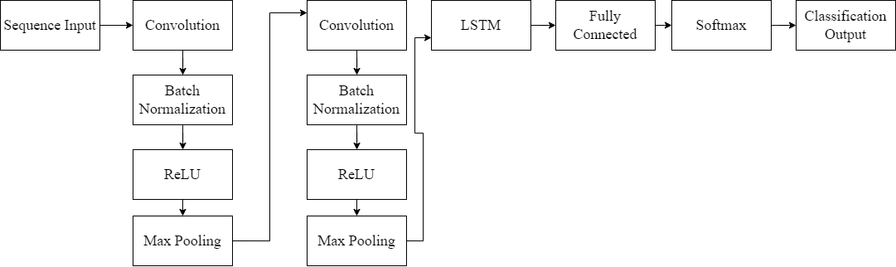

**ATTENTION MECHANISM:**

An attention mechanism is an Encoder-Decoder kind of neural network architecture that allows the model to focus on specific sections of the input while executing a task. It dynamically assigns weights to different elements in the input, indicating their relative importance or relevance.

**PROJECT WORKFLOW:**

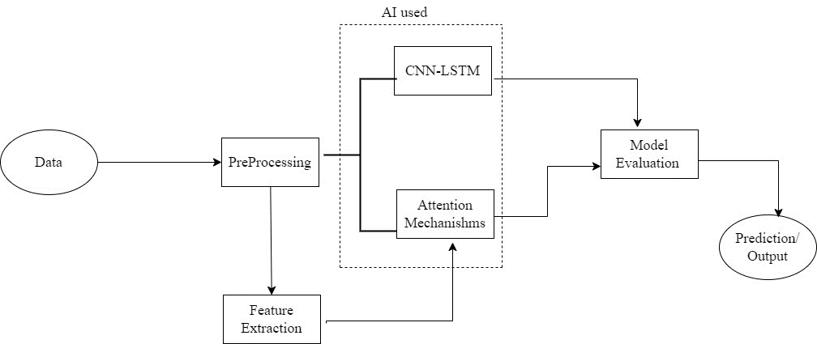

LSTM:

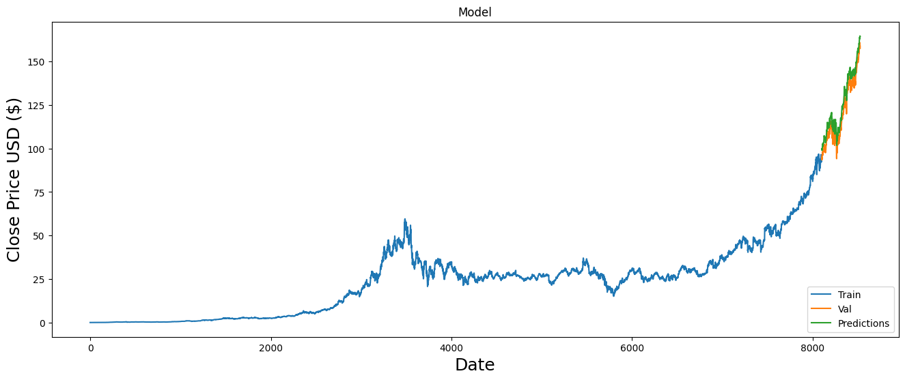

**ATTENTION MECHANISM:**

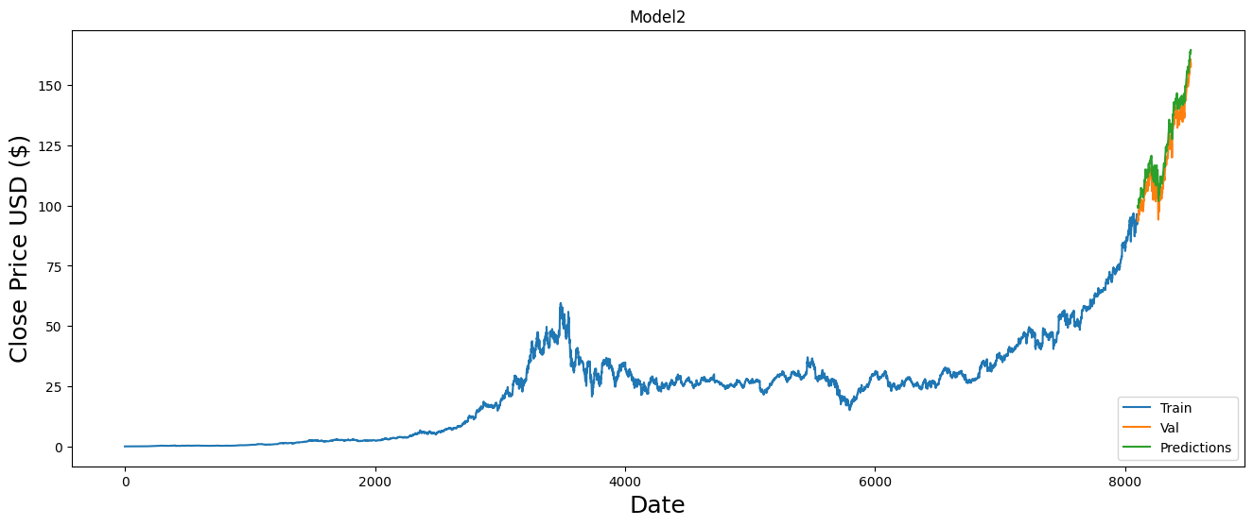

**CONCLUSION:**

The application of LSTM (Long Short-Term Memory) and attention mechanisms in stock price prediction has yielded promising results. Both of these machine learning models have demonstrated their effectiveness in capturing intricate patterns and dependencies within financial time series data. The similarity in forecasting accuracy between LSTM and attention mechanisms suggests that they are capable of handling the complexities of stock market prediction equally well.

The introduction of attention mechanisms has further enhanced the performance of these models by allowing them to focus on specific data points or time periods that are more relevant for forecasting. This adaptive mechanism helps the model allocate its attention to critical features, ultimately improving prediction accuracy.

In summary, LSTM and attention mechanisms have emerged as valuable tools for stock price prediction, offering a powerful means to extract valuable insights from financial time series data. Continued research and development in this field will likely lead to further improvements in forecasting accuracy, ultimately benefiting investors, traders, and financial institutions in making informed decisions in the dynamic world of stock markets.

**REFERENCES:**

1. Stock Market Prediction Using Machine Learning,panelAbdulhamit Subasi, Faria Amir, Kholoud Bagedo, Asmaa Shams, Akila Sarirete <https://www.sciencedirect.com/science/article/pii/S1877050921021128>
2. A Survey on Stock Market Prediction Using Machine Learning Techniques Polamuri Subba Rao1(&) , K. Srinivas2 , and A. Krishna Mohan3 1 Department of CSE, KIET, Korangi, India psr.subbu546@gmail.com 2 Department of CSE, VR Siddhartha Engineering College, Vijayawada, AP, India vrdrks@gmail.com 3 Department of CSE, UCEK, JNTUK, Kakinada, AP, India [krishna.ankala@gmail.com](mailto:krishna.ankala@gmail.com)

<https://www.researchgate.net/publication/341482418_A_Survey_on_Stock_Market_Prediction_Using_Machine_Learning_Techniques/link/5ff3fc01299bf140887028e4>

1. Short-term stock market price trend prediction using a comprehensive deep learning system

Jingyi Shen & M. Omair Shafiq Journal of Big Data <https://journalofbigdata.springeropen.com/articles/10.1186/s40537-020-00333-6>-