Rhythm 1.2 GUI user guide

by Roman Pryamonosov, Alexander Zolotarev, Roman Syunyaev

# Getting Started

Be sure that you have Matlab version 2017 or greater.

Download Rhythm 1.2 to your project directory from GitHub via link: https://github.com/optocardiography/Rhythm-1.2

Open rhythm.m with Matlab and go to Home -> Set Path. Add your project directory via “Add with Subfolders …”, then “Save” and “Close”.

Run rhythm.m.

# GUI

Main window of Rhythm consists of 3 parts (see figure 1):

1. Toolbars on the left
2. Four movie screens on the center
3. Signal windows on the right

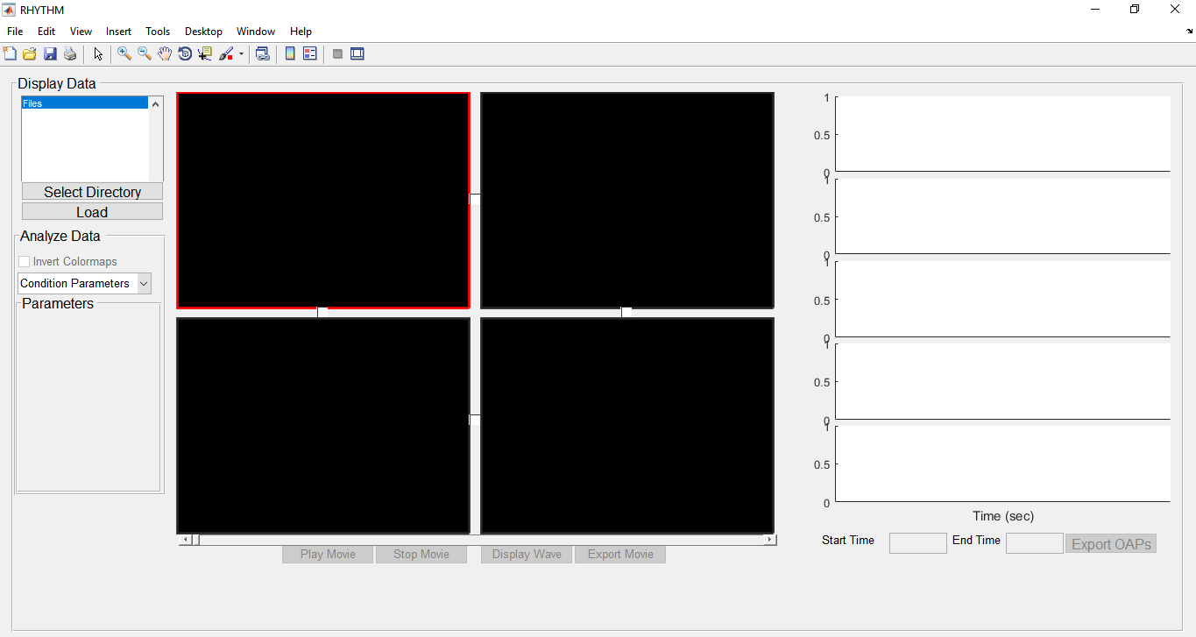

Figure 1. Start interface of Rhythm. Toolbars on the right, four movie screens on the center, signal screens on the right.

# Toolbars

Use button “Select Directory” on the top of toolbar menu to set path with your experimental data. You will see the list of available files in the current directory. Select an experiment and click “Load” to load experiment data and visualize it on the selected movie screen (with red boundaries). Reload data to any movie screen if it is necessary.

Menu “Analyze Data” on the bottom has popup menu containing add-ons for signal processing (Condition Parameters, Conduction Velocity, Activation Map, etc.). Once any data is loaded to movie screen(s) you can select signal processing method, that you interested in. After that you will see parameters for selected processing method. See several examples on figure 2. “Save” icon allows user to export analysis result as a matlab figure.

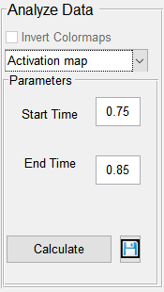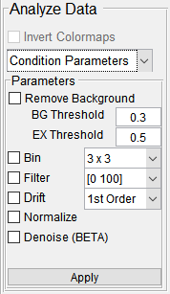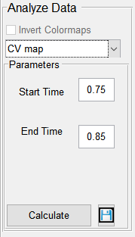

Figure 2. Examples of “Analyze Data” menu.

# Movie screens

Four movie screens allow to upload several experiments independently. One can select a screen by a single-click. The selected screen has red boundaries. Double click may be used to zoom in the selected screen.

Note that different experiments may contain different camera frames number, but all loaded data must have a common frame rate.

Once any data is loaded, buttons Play Movie, Stop Movie, Display Wave and Export Movie become unfrozen. Play movie and Stop Movie is used to play signal data with the respect to time. Time is shown on the movie slider.

Use “Display Wave” button to set marker on desirable point of loaded data. You can set up to 5 different markers. After setting 5 markers, new Display Wave calls will overwrite old markers. Each movie screen contains its own markers. Figure 3 shows three datasets with 3, 2 and 4 markers correspondingly. Signals waves are shown for a selected movie screen. Markers can be grabbed by single-click and dragged to different position of its movie screen.

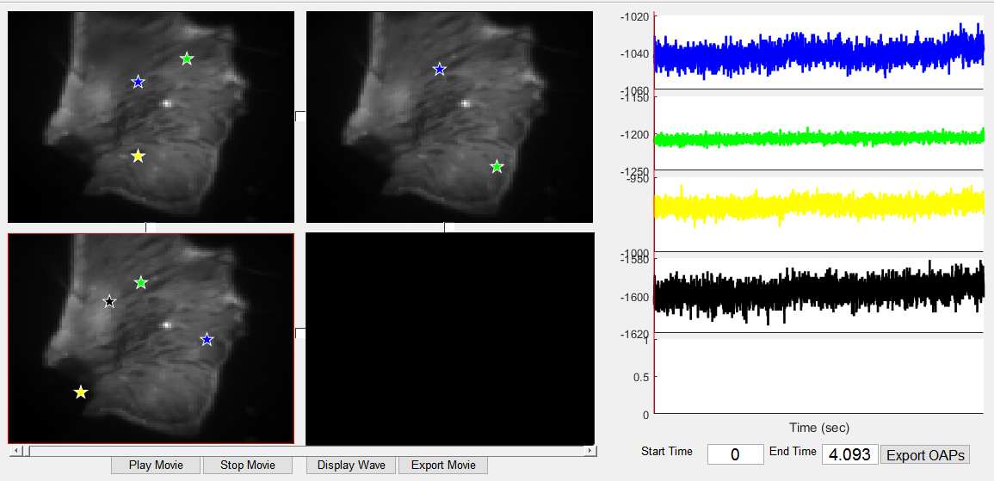

Figure 3. Several markers are set on different screens. Signal waves in marker points are shown on the signal screens for selected screen.

Screen synchronization

Several experiment files obtained with the same camera position may be synchronized. User can synchronize uploaded data with setting checkboxes between the movie screens. Once several movie screens are synchronized, they share group markers. Marker placed on one of synchronized screens, applied to all the screens from that group. Group markers can be dragged to a different position as usual. Figure 4 shows two synchronized movie screens 1 and 2, and one separate screen 3. Screens 1 and 2 have two group markers, while screen 3 has its own markers. Signal waves are drawn for a selected group of synchronized screens or for a selected screen if it is not in any synchronized group.

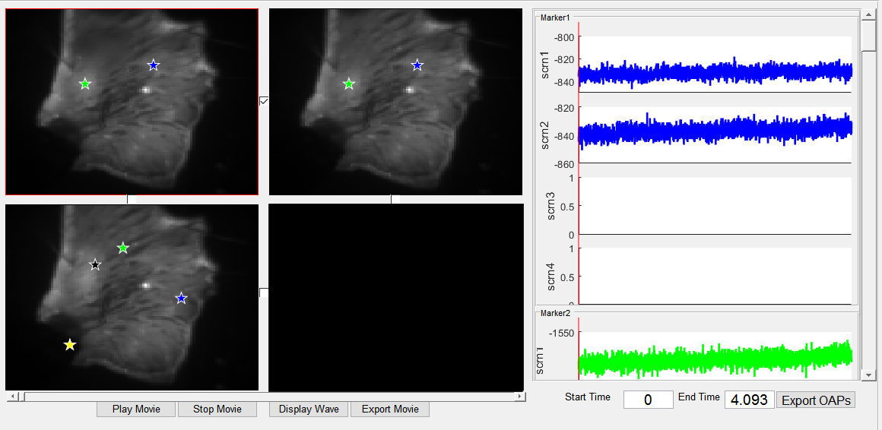

Figure 4. Example of the two synchronized movie screens and one screen with no group. Signals on the right are shown for the screen group, that contains the selected screen.

# Signal screens

Signal screens on the right show time-dependent signal waves, probed in the position of markers. Signal waves have the same colors as their markers.

Signal screens display signal waves in two modes: waves of a signal screen and waves of all the screens in one synchronized group. In the first case (see figure 3) there are 5 signal screens for each marker. In the second case (see figure 4) there are 5 signal groups for each group marker. A signal group is a four signal screens for each movie screen. Since a number of screens in the group mode is large, one can use vertical slider to see all signals.

Red vertical line represents the current time. User can zoom in/out in time, specifying “Start Time” and “End time”. Note that start time is non-negative value.

Button “Export OAPS” exports signal waves to a new window that can be used to save data as image. In synchronized movie screen mode, the new window organized as follows: columns stand for screens, rows for markers (see figure 5).

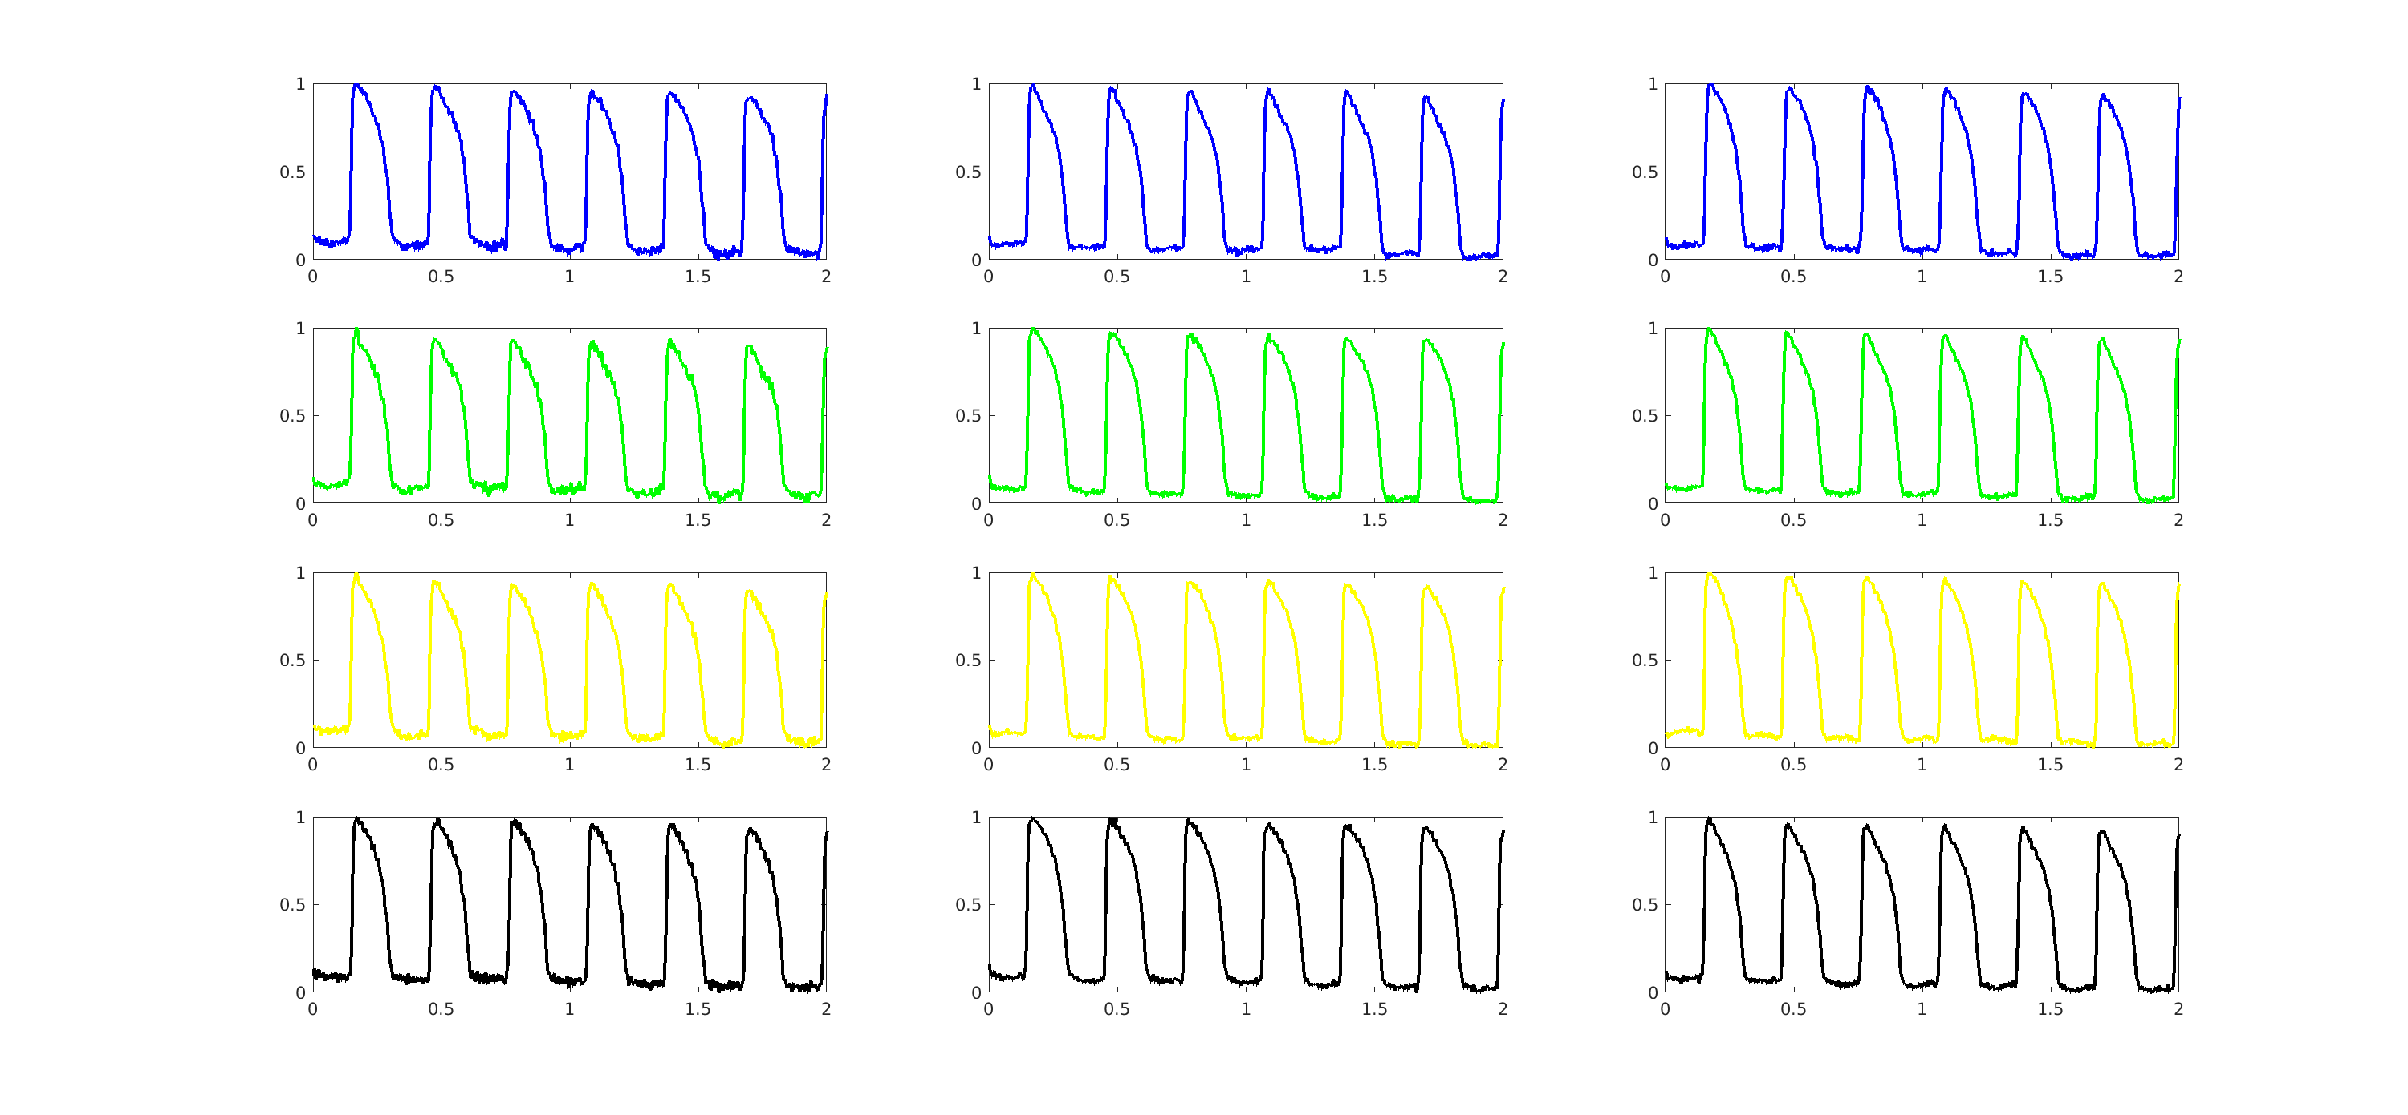

Figure 5. Export OAPs window. Example for 3 linked movie screens with 4 markers on them.

# Using signal conditioning and analysis functions

## Signal conditioning

The Condition Signals panel consists of five check boxes (Remove Background, Bin, Filter, Remove Drift, and Normalize) and one Apply button. The check boxes may be selected in any combination, but the conditions will be applied in the order they appear after *Apply* is clicked. Only the original data will be processed.

#### Remove Background

This function segments the black and white image of the tissue taken by the CMOS camera and detects pixels below the BG Threshold value. It then uses the EX Threshold to remove groups of pixels less than EX of the total image size. EX Threshold and BG Threshold values are set to values between 0 and 1. The figures below demonstrate the effect of removing the background of the original signal.

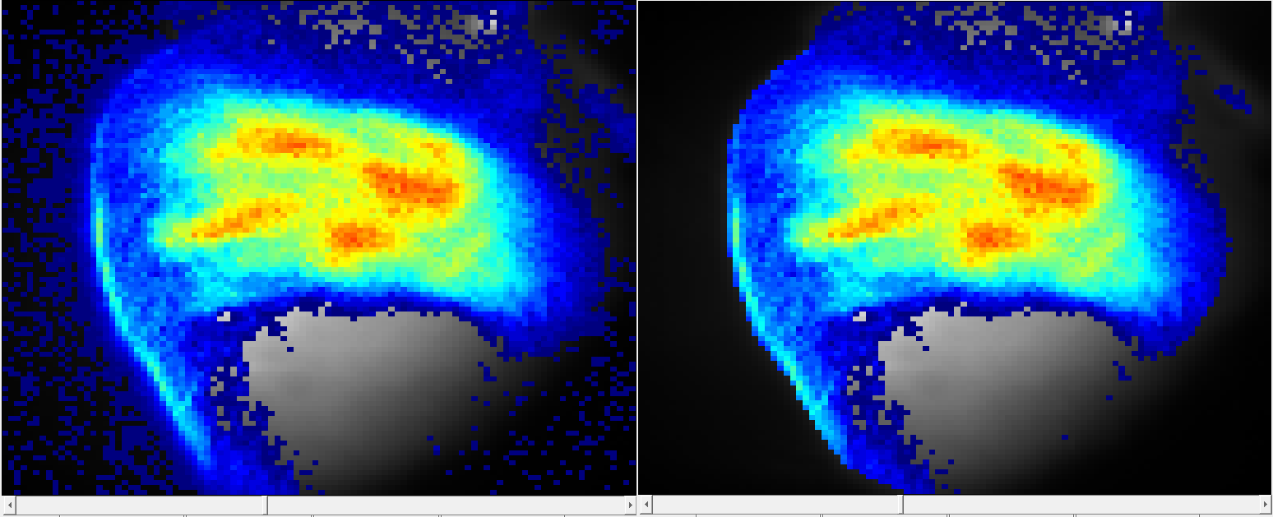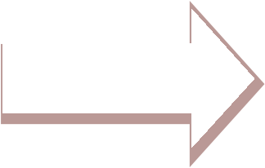

Figure 6. Remove Background

#### Bin

The Bin function sums the amplitudes of adjacent pixels, divides the sum by the number of pixels, and puts the average value in the center pixel. Increasing the bin size increases the smoothness. Decreasing the bin size increases sharpness.

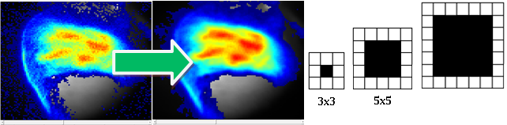

Figure 7. Binning

#### Filter

The Filter function operates zero-­‐phase forward and reverse digital filtering with an nth order band pass filter between a low and high passband threshold frequency. The default Filter is set at a 50th order band pass filter between 2/Fs and 100/Fs. By clicking the drop-­‐down menu next to Filter, the high band of the filter can be adjusted to 50, 75, 100 and 150 Hz. The figures below demonstrate the effect of a [0 100] bandpass filter. All filters are implemented with the Parks-McClellan-Remez Exchange algorithm and made to be zero-­‐phase.

#### Remove drift

The Remove Drift function adjusts a slanted waveform to level off the baseline.

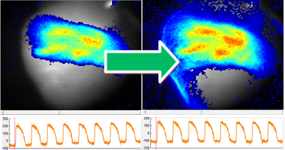

Figure 8. Drift removal

#### Normalize

The Normalize function adjusts the data set to normalize data points to be within 0 and 1. Normalization should be performed once the background noise pixels are removed. Below is an example.

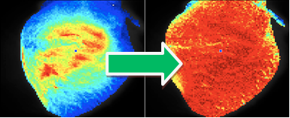



Figure 9. Normalize signal.

## Activation map.

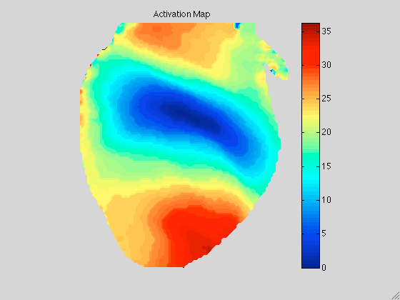

Figure 10. Activation map.

The Activation Map function plots the activation map for the time duration as specified in the Start Time and End Time entries. This interval is restricted by green sweep bars in the signal Screens. In order to save this map, click on the “Save” icon.

## Action potential duration map.

The Start Time and End Time entries restrict the data into a specific time interval, reflected by sweep bars in the Signal Screen. The Min APD and Max APD entries allow the user to control the range of action potential duration in milliseconds, based on the data being analyzed. The entries must be numeric values greater than zero. The %APD button allows control over analysis of the time duration, from the maximum upstroke velocity to the first point that is a specified percentage of the maximum value after the peak as depicted in figure 11. Upon click on the “Mapping” button APD map appears on the selected screen. Pop-up figure is a histogram of APDs displayed in the map. In order to export this map as a Matlab figure, click “Save” icon.

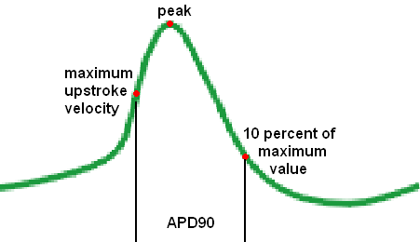

Figure 11. The %APD entry allows control over analysis of the time duration. For example, 0.9 value in the entry results in APD90 calculation as depicted in the figure.

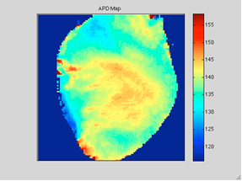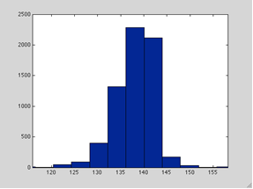

Figure 12. APD map.

Upon clicking “Regional APD” select rectangular region of interest on the selected screen with the cursor. Two variables are displayed in the Matlab Command Window and in the Statistics panel. There are APD mean(apd_mean) and the standard deviation of the action potential (apd_std).

## Conduction velocity map.

The function calculates conduction velocity (CV). Edit start and end times entries to define the time interval. This interval is reflected by blue sweep bars in the signal Screens. After clicking “Calculate”, select a rectangular region of interest on the selected screen with the cursor. CV is calculated as local gradient of activation time. Activation map and vector map of CV is depicted on the screen afterwards. Click “Save” icon in order to export CV map as a Matlab figure.

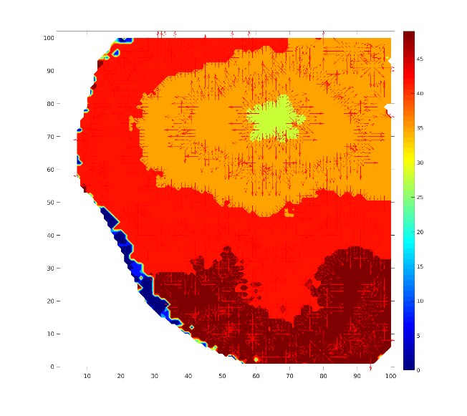

Figure 13. CV map.

If you want to calculate CV along one direction (e.g. longitudinal or transverse CV), you should click “Draw Line”. Then you should left-click on the starting point of the direction of interest, right-click on the ending point afterwards. “Calculate CV” calculates average CV in a rectangle within 5 pixels of the line and with CV direction within 15° of the selected line direction. Five numbers are printed in Statistics panel. There are median conduction velocity, mean conduction velocity, standard deviation of the CV, the total number of vectors included in calculation and mean vector angle.

## Rise time.

The function calculates depolarization time. The Start Time and End Time entries restrict the data into a specific time interval. The RiseTime is calculated as a time from the %Start entry to the %End entry of depolarization. Click “Calculate” button and select the rectangular region of interest on the screen. RiseTime distribution within region of interest and histogram are displayed. “Save” button exports the RiseTime map as a Matlab figure.

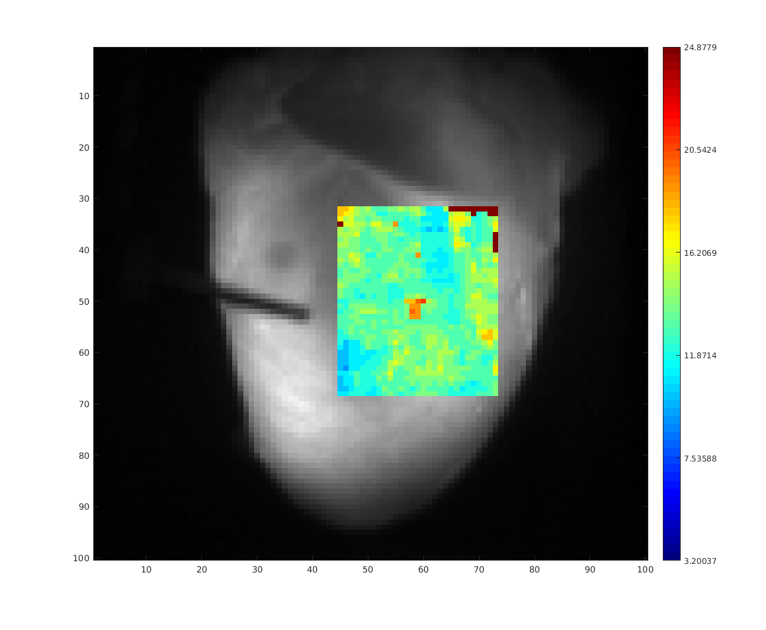

Figure 13. RiseTime map.

## Calcium decay.

This function calculates the relaxation time of calcium transients. The Start Time and End Time entries restrict the data into a specific time interval. Calcium transients from the time specified by %split entry to the 10% of calcium transients amplitude are fitted with exponential functions. Click on “Calculate Tau” button and select the rectangular region of interest. Relaxation time distribution is depicted on the screen afterwards. “Save” button exports the Calcium decay map as a Matlab figure.

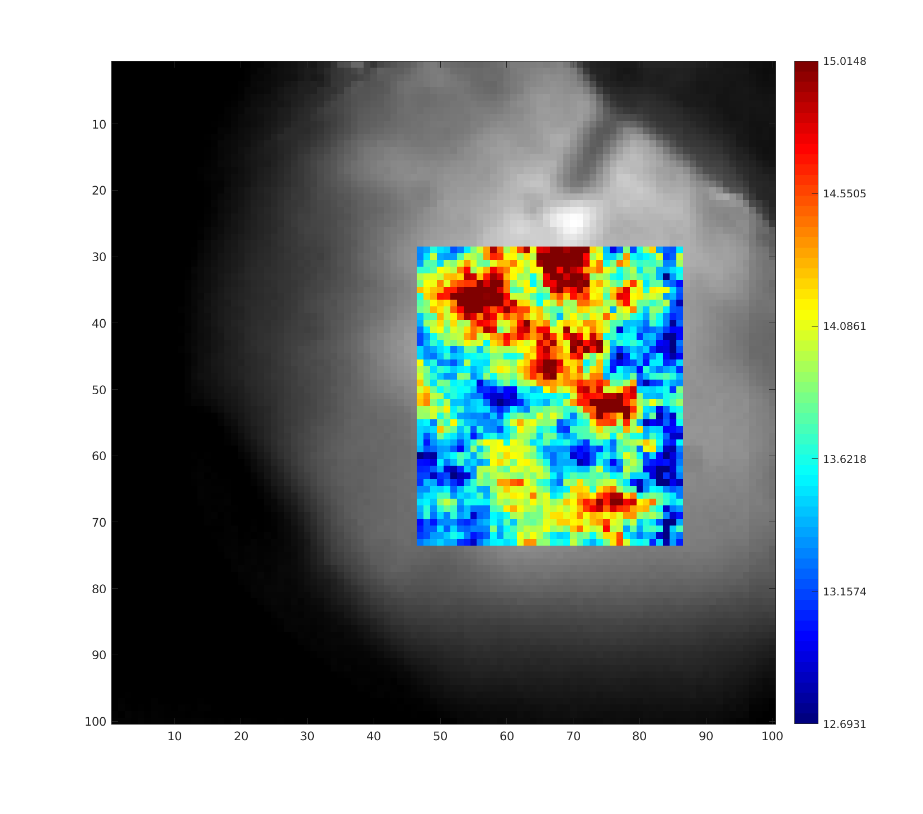

Figure 14. Calcium decay map.

# Add new user-implemented analysis functions

You can add new functional with the minimal interaction with rhythm.m, following next steps.

1. in rhythm.m find initialization of popup menu of toolbars:

map_popup = uicontrol('Parent',anal_data,'Style','popupmenu','FontSize',10,...

'String',{'Condition Parameters','CV map', 'Activation map', 'APD\CaT map', 'Rise Time', 'Calcium Decay'},...

'Position',[3 320 140 25], 'Callback',{@mapPopUp_callback});

Add new string into popup menu, for instance 'Example Function'. It will allow you to see new line in popup menu:

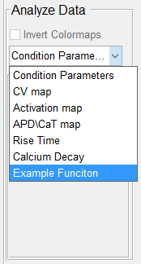

1. find function mapPopUp_callback(~,~) and add a corresponding case, for instance:

switch get(map_popup,'Value')

...

case 7

GUI_ExampleFunction (map, handles, f);

end

All GUI functions share at least 3 common arguments. The first argument map stands for a panel to draw on. The second argument handles of main rhythm.m program (for more details see the handles class implemented in rhythmHandles.m). The third argument f is main figure of rhymth main window.

1. Write GUI functional using the template GUI_example.m. Copy everything from GUI_example.m into your own function GUI_ExampleFunction.m. You can add any kind of matlab GUI structures, specifying the ‘Parent’ field as the first argument map. It is strongly recommended to use normalized coordinates.

Use handles.activeCamData to get the data depicted on the active screen. Use handles.activeCamData.screen to get the screen itself. Use handles.activeCamData.cmosData to get the camera data you preprocessed before and handles.activeCamData.rawData to get the raw camera data. See the handles class camData.m for more details.

After you draw your map on the active screen, set handles.activeCamData.drawMap to 1 to provide a correct map drawing.

You can find other GUI examples already implemented in rhythm. See m-files started with “GUI_”. Please, do not modify them.