Software Requirement and Design

Specifications

[DIGITAL ART GALLERY]

Course Code :
Instructor
MISS RUBAB JAFFAR
Project Team
ANAKSHA JANKI [22K-4293]
RAFIA JAMIL [22K-4397]

Submission Date : 6-DEC-2024

Table of Contents
1. INTRODUCTION.....................................................................................................................................................5
1.1. Purpose of Document.........................................................................................................................5 1.2. Intended Audience ..............................................................................................................................5 2. OVERALL SYSTEM DESCRIPTION ............................................................................................................................6
2.1. Project Background.............................................................................................................................6 2.2. Project Scope ......................................................................................................................................6 2.3. Not In Scope ........................................................................................................................................6 2.4. Project Objectives ...............................................................................................................................6 2.5. Stakeholders ........................................................................................................................................6 2.6. Operating Environment ......................................................................................................................6 2.7. System Constraints.............................................................................................................................6 2.8. Assumptions & Dependencies ..........................................................................................................6 3. EXTERNAL INTERFACE REQUIREMENTS..................................................................................................................7
3.1. Hardware Interfaces ...........................................................................................................................7 3.2. Software Interfaces.............................................................................................................................7 3.3. Communications Interfaces ...............................................................................................................7 4. FUNCTIONAL REQUIREMENTS................................................................................................................................8
4.1. FUNCTIONAL HIERARCHY .............................................................................................................................8
4.2. Use Cases............................................................................................................................................8 4.2.1. [Title of use case] ...........................................................................................................................8 5. NON-FUNCTIONAL REQUIREMENTS........................................................................................................................9
5.1. Performance Requirements...............................................................................................................9 5.2. Safety Requirements ..........................................................................................................................9 5.3. Security Requirements .......................................................................................................................9 5.4. User Documentation...........................................................................................................................9 SDS .........................................................................................................................................................................10
6. SYSTEM ARCHITECTURE ............................................................................................................................11 6.1. SYSTEM LEVEL ARCHITECTURE ...................................................................................................................11 7. APPLICATION DESIGN .........................................................................................................................................12 8 REFERENCES ......................................................................................................................................................13 9 APPENDICES.......................................................................................................................................................14

1. Introduction
1.1. Purpose of Document
This document serves as the Software Requirements and Design Specification for the Digital Art Gallery system. It outlines the design, architecture, and functional specifications of the system, providing the necessary details to guide developers, stakeholders, and testers in the implementation and understanding of the project.
1.2. Intended Audience
This document is intended for:
- Project Stakeholders: Art gallery owners, curators, and system administrators who will use the platform.
- Development Team: Software developers, testers, and database administrators involved in building and deploying the system.
- End Users: Artists, customers, and auction participants who interact with the system.
- Project Managers: Individuals overseeing the project’s progress, ensuring that it meets deadlines, scope, and quality standards.
1.3. Definition of Terms, Acronyms, and Abbreviations
- UML: Unified Modeling Language
- API: Application Programming Interface
- CRUD: Create, Read, Update, Delete (basic database operations)
- NFT: Non-Fungible Token (digital ownership of artwork)
- Admin Panel: A back-end interface for managing artworks, users, bids,and auctions.
Term | Description
User: | A person interacting with the system, either as an artist, customer, or administrator,curator.
Gallery | :A collection of artworks available for display or sale.
1.4. Document Convention
The document will use the following conventions:
- Font: Arial
- Font Size: 12 pt for body text, 14 pt for headings
- Bold: Used for section titles and important terms
- Italics: Used for technical terms or code-related content
- Color: Text in blue for hyperlinks and references

2. Overall System Description
2.1. Project Background
The Digital Art Gallery is designed to provide a platform where artists can upload, showcase, and sell their artwork, while customers can browse, bid, and purchase artworks. The increasing demand for online art sales, especially NFTs (Non-Fungible Tokens), has created the need for a robust platform that connects buyers and sellers in a secure, seamless, and engaging environment.
2.2. Project Scope
The system will include the following core functionalities:
- User Management: Artists and customers can register, log in, and manage their profiles.
- Artwork Management: Artists can upload, edit, and delete their artwork listings.
- Bidding and Auctions: Customers can place bids on artworks during live auctions.
- Payment Integration: Secure payment gateways for purchasing artworks.
- Admin Panel: Administrators can manage users, artworks, and monitor auction activities.
Out of Scope:
- The system will not support the sale of physical artworks, only digital pieces or NFTs.
- Mobile application development is out of scope for this project.
2.3. Not In Scope
- Third-party Integrations: Other external systems, such as social media platforms or external payment processors, are not part of the scope.
- Physical Artwork Handling: The system will focus on digital artwork and associated NFTs, excluding logistics for physical artwork delivery.
2.4. Project Objectives
The Digital Art Gallery aims to:
- Create a user-friendly platform for both artists and buyers.
- Provide secure transactions for purchasing artwork.
- Enable artists to showcase and monetize their digital artworks.
- Implement a bidding system for auction-style sales of digital art.
2.5. Stakeholders
- Artists: Upload and manage their artwork listings.
- Customers: Browse, bid on, and purchase artworks.
- Administrators: Manage user accounts, artworks, and auctions.
- System Developers: Build, test, and maintain the platform.
- Payment Processors: Handle secure transactions for purchases.
2.6. Operating Environment
The system will operate:
- Frontend: Web-based interface (React/Angular)
- Backend: Python-based framework (Django or Flask)
- Database: MySQL or PostgreSQL
- Payment Gateway: Integration with third-party services like PayPal, Stripe for secure transactions.
2.7. System Constraints
- Software Constraints: The system must support modern browsers (Chrome, Firefox, Safari).
- Hardware Constraints: The system will be hosted on cloud infrastructure and should support up to 10,000 concurrent users.
- Legal Constraints: not applicable .
- User Constraints: The platform will be designed for art collectors and casual buyers, with features tailored for easy browsing and purchasing.
2.8. Assumptions & Dependencies
- The platform assumes a stable internet connection for browsing and purchasing artwork.
- The system will rely on third-party services (payment gateway, email services) for certain functionalities.

3. External Interface Requirements
3.1. Hardware Interfaces
The system will be accessed through personal computers and mobile devices with internet access. It does not have any direct hardware dependencies, but must support devices with standard browsers.
3.2. Software Interfaces
- Frontend: html,css,js web interface
- Backend: Flask-based connectivity
- Database: MySQL for storing user, artwork, and auction and other data
- Payment Gateway: Integration with services like Stripe for secure transactions
- Authentication: database for user login and account management
3.3. Communications Interfaces
- The system will use HTTPS for secure communication between the client and server.
- In app Notifications: For account registration, auction updates, and purchase confirmations.
- WebSocket: For real-time updates on active bids during auctions.

Thank you for the clarification! Here's an updated version of the functional requirements, where Bidding is treated as a separate functionality within the Auction Management section:

4. Functional Requirements
4.1. Functional Hierarchy
The core functionalities of the Digital Art Gallery system include:
- User Management
  - Register/Login/Logout
  - Profile Management (for Artists, Curators, Admins, and Customers)
- Artwork Management
  - Upload Artworks
  - Edit/Delete Artworks
  - View Artwork Listings
- Auction Management
  - Monitor Auction Status
  - View Bidding History
- Bidding
  - Real-Time Bidding: Allow multiple customers to place bids in real-time during live auctions.
  - Automatic Bid Updates: Display real-time updates of the current highest bid as it changes with new bids from customers.
  - Bid Placement: Allow customers to place bids on artworks, with the system validating bid amounts and ensuring that the bidding is done according to auction rules.
- Payment Processing
  - Secure Payment Gateway Integration
  - Transaction History
- Admin Panel
  - Manage Users
  - Monitor Auctions
  - Approve/Reject Bids
4.2. Use Cases
4.2.1. Digital Art Gallery Use Case
Use Case Name: Digital Art Gallery System
Use Case Description:
The Digital Art Gallery system provides an online platform for artists, customers, and curators to interact, allowing customers to browse, purchase, bid on auctions, and review artworks. Artists can upload and manage their artworks, while curators organize auctions and categories. Admins oversee the platform's operations and ensure smooth functioning of all processes.
Primary Actor: Customer
Other Actors: Artist, Admin, Curator, System
Stakeholders:
• Customers: To browse, purchase, bid, and review artworks conveniently.
• Artists: To showcase and sell their artworks.
• Admins: To monitor platform operations and manage users/content.
• Curators: To manage auctions and organize artworks into categories.
• System: To automate notifications, monitor analytics, and manage transactions.
Relationships:
• Includes:
o Browsing and filtering artworks.
o Managing wish lists and purchases.
o Uploading and updating artworks.
o Scheduling auctions.
o Generating notifications and reports.
• Extends:
o Advanced search filters for browsing artworks.
o Auction result notifications for customers and artists.
o Analytics tracking for admins.
Pre-conditions:
• Customers, artists, and admins are registered and logged into the system.
• Artworks are available in the database.
• Auction schedules are predefined by curators.
Flow of Events:
1. The customer logs into the system and selects a feature (e.g., browse, purchase, bid).
2. The system displays available options based on the customer’s selection.
3. Artists upload new artworks with details (title, description, price, category, and image).
4. Curators organize artworks into categories and schedule auctions.
5. Customers apply filters to search for artworks or place bids in auctions.
6. Admins monitor flagged content, approve uploads, and generate analytics reports.
7. The system notifies users of auction updates, purchases, and approvals.
Alternative and Exceptional Flows:
4.1 If an artist fails to provide mandatory details during upload, the system prompts them to complete the missing fields.
5.1 If no artworks match the filters, the system displays a "No Results Found" message with suggestions.
6.1 If an admin notices policy violations, the system disables the respective content or user account.
7.1 If the system encounters a transaction failure, it notifies the customer and logs the issue for admin review.
Post-conditions:
• Customers can view, purchase, or bid on artworks seamlessly.
• Artists’ artworks are displayed and sold on the platform.
• Auctions are completed, and winners are notified.
• Admins have access to reports and can maintain platform integrity.

5. Non-functional Requirements

5.1. Performance Requirements
The Digital Art Gallery system should meet the following performance criteria to ensure a smooth and responsive user experience:
- Speed:
  - The system should load the homepage within 2 seconds under normal conditions.
  - Search results for artworks should be displayed within 1 second of submitting the query.
  - Bidding updates should reflect in real-time without noticeable delays.
- Concurrency:
  - The system should support at least 100 concurrent users browsing and bidding at the same time during an auction without degradation in performance.
  - The system should support simultaneous interactions from multiple users during auctions without affecting performance or data integrity.
- Capacity:
  - The system should be able to handle at least 100 artwork listings and 50 registered users in the database, with easy scalability to support future growth.
- Reliability:
  - The system should be operational 99.9% of the time, with a maximum allowable downtime of 8 hours per year for maintenance and upgrades.

5.2. Safety Requirements
The system should ensure that no harm or loss occurs to users or data during usage:
- User Safety:
  - Personal data, such as payment information, should be protected from unauthorized access.
  - The system should provide confirmation prompts for important actions, such as placing bids or making payments, to avoid accidental actions.
- Data Protection:
  - Ensure that all transactions are processed securely, and any sensitive data (such as payment information) is encrypted during transmission.
- Error Handling:
  - The system should handle errors gracefully, providing informative messages without exposing sensitive system information.

5.3. Security Requirements
Security is critical for maintaining the integrity of the system, especially since transactions and personal data are involved:
- User Authentication:
  - Implement a secure user authentication mechanism that supports username/email and password login.
  - Use two-factor authentication (2FA) for admin users..
- Data Encryption:
  - Ensure end-to-end encryption for sensitive data, such as passwords, user profiles, and payment information.
- Authorization and Roles:
  - Define roles for users (Admin, Artist, Curator, Customer) with appropriate permissions. Admins should have full access to system functionalities, while Artists and Curators have limited access to manage artworks and auctions.
- Privacy Protection:
  - Ensure that personal user data (e.g., email addresses, transaction details) are stored securely and are not shared without user consent, in accordance with data protection regulations.

5.4. User Documentation
Not applicable

SDS

6. System Architecture

6.1. System Level Architecture
The architecture of the Digital Art Gallery is designed to facilitate a seamless user experience while ensuring robust management of artworks, auctions, user interactions, and secure transactions. This section outlines the high-level design of the system, including its major components, relationships, external interfaces, and deployment considerations.

System Decomposition
The Digital Art Gallery system is composed of the following main subsystems:
- User Management Subsystem
  - Responsible for handling user registration, login/logout, and profile management. It manages different user roles (Admin, Artist, Curator, Customer) and their respective permissions.
- Artwork Management Subsystem
  - Allows artists to upload, view, edit, and delete their artworks. Customers and curators can view the artworks, filter by categories, and participate in auctions.
- Auction Management Subsystem
  - Manages the creation and monitoring of auctions. This subsystem supports real-time bidding and provides users with auction status updates and bidding history.
- Payment Processing Subsystem
  - Handles secure payment processing for purchasing artworks and placing bids. Integrates with third-party payment gateways to ensure safe transactions.
- Admin Panel Subsystem
  - Provides the administrators with the tools to manage users, monitor auctions, handle disputes, and view transaction histories. Admins can also manage artwork approvals and user bans.
- Notification Subsystem
  - Sends real-time notifications to users about bidding status, new artworks, auction wins, and payment confirmations.
- Bid Subsystem
  - Allow multiple customers to place bids in real-time during live auctions.

Relationship Between the Elements
The system elements are interconnected to ensure smooth operation and data flow:
- User Management interacts with Artwork Management to ensure that artists and customers can manage their profiles and artworks.
- Artwork Management is linked to Auction Management for artwork listings in auctions.
- Auction Management and Payment Processing are integrated for seamless transaction handling when a bid is placed or artwork is purchased.
- Admin Panel is connected to all subsystems for system-wide management and oversight.
- Notification Subsystem communicates with all modules to send real-time alerts to users based on their actions, such as winning an auction or placing a bid.
- Bids management interacts with auction management where the curator needs to arrange auctions to make bids.

Interfaces to External Systems
- Payment Gateway Integration: The system interfaces with external payment providers (such as PayPal or Stripe) to securely process payments.
- Email Service: The system sends email notifications for registration, auction updates, and transaction confirmations.

Major Physical Design Issues
- Web Hosting: The system is deployed on a cloud-based platform (AWS, Azure, etc.) to ensure scalability and reliability.
- Database Server: The database hosting will be centralized on a secure server with high availability to store user data, artworks, bids, and payment records.

Global Design Strategies
- Error Handling: The system should be designed to handle errors gracefully by providing users with clear messages and options for retrying actions (e.g., payment failures, failed bid attempts). For backend issues, logging should be implemented to track and resolve issues effectively.
- Scalability: The architecture is designed to scale both horizontally and vertically, allowing the system to handle increased traffic during high-demand periods (e.g., auction events).
- Security: The system ensures secure transactions through encryption, strong user authentication mechanisms, and strict role-based access control.

System-Level Architecture Diagrams
To represent the overall architecture, UML diagrams such as Deployment Diagrams and Component Diagrams can be used. Below is a brief description of each diagram:
- Deployment Diagram:
This diagram shows how the system's components are deployed on the hardware infrastructure. It will include the application server, the database server, the web server, and how they interact with client workstations.
- Component Diagram:
This diagram represents the major components (e.g., BId Management, Artwork Management, Payment Processing,customer user ) and their relationships within the system. It shows how the components interact with their interfaces to interact with other components.all components are interdependent on each other as they share common interfaces at some point or other. At one point one component is proving its interface to other components (bids,artwork,sales to customer) and (curator to auction)and many more.

7. Application Design

7.1Sequence Diagram

- Sequence 1: Adding an Artwork to a Wish List
- 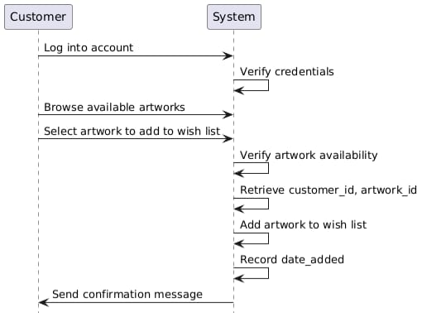
Actors: Customer, System
1. Customer logs into their account.
2. Browses available artworks and selects one to add to the wish list.
3. System verifies the artwork's availability and retrieves customer_id and artwork_id.
4. System adds the selected artwork to the wish list and records date_added.
5. Customer receives a confirmation message.
- Sequence 2: Placing a Bid in an Auction
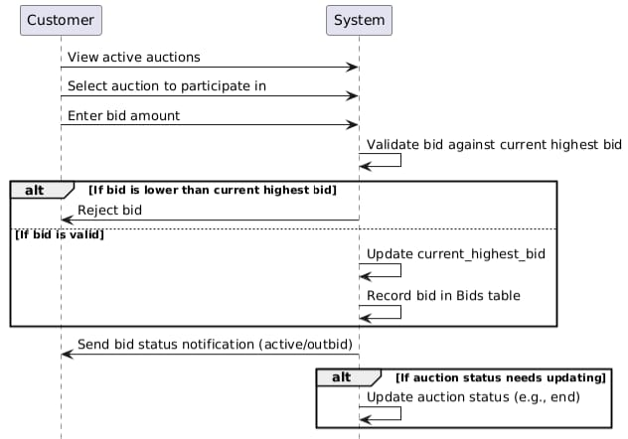

Actors: Customer, System
1. Customer views active auctions and selects an auction to participate in.
2. Customer enters a bid amount.
3. System validates the bid against the current highest bid for the auction_id.If the bid is lower than the current highest bid, the system rejects it.If the bid is valid, the system updates current_highest_bid and records the bid in the Bids table.
4. System sends a notification to the customer indicating the bid status (active or outbid).
5. Auction status is updated if applicable (e.g., if it ends).

- Sequence 3:Purchasing an Artwork
- 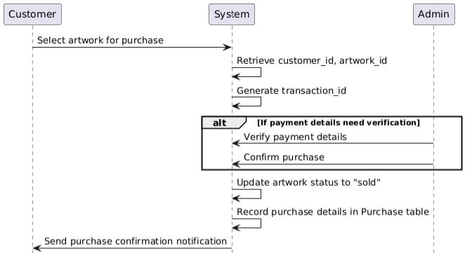
Actors: Customer, Admin, System
1. Customer selects an available artwork for purchase.
2. System retrieves customer_id and artwork_id and generates a transaction_id.
3. Admin verifies the payment details and confirms the purchase.
4. System updates the status of the artwork to "sold."
5. Purchase details (e.g., purchase_date, amount, payment_method) are recorded in the Purchase table.
6. System generates a notification confirming the purchase.
- Sequence 4: Submitting a Review for an Artwork
- 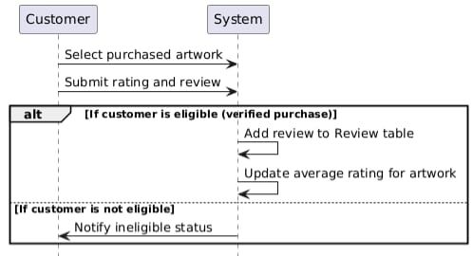
Actors: Customer, System
1. Customer selects an artwork they have purchased.
2. Customer submits a rating and review.
3. System verifies the customer's purchase history to ensure eligibility.
4. Review details (review_id, customer_id, artwork_id, rating, review_text, review_date) are added to the Review table.
5. System updates the average rating for the artwork.

- Sequence 5: Scheduling an Auction
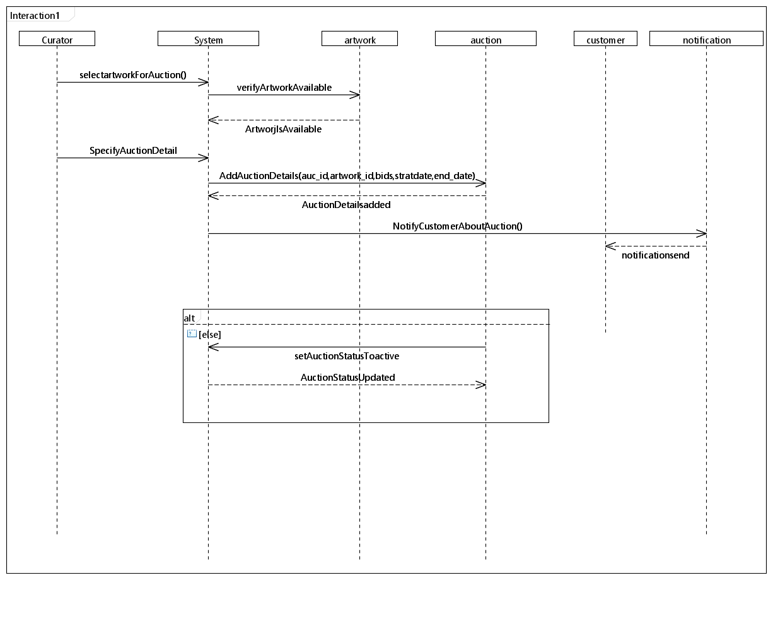
Actors: Curator, System
1. Curator selects an artwork to auction and specifies details (start_date, end_date, starting_bid).
2. System verifies the artwork's availability.
3. Auction details (auction_id, artwork_id, start_date, end_date, starting_bid) are added to the Auction table.
4. System notifies interested customers about the new auction.
5. Auction status is set to "active" upon reaching the start date.
- Sequence 6: Managing Artist Profiles
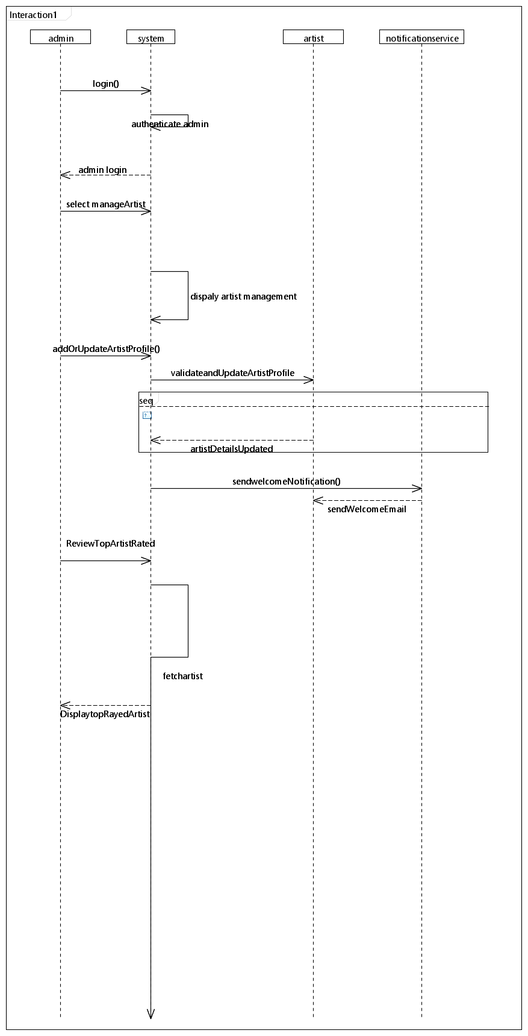
Actors: Admin, System
1. Admin logs into the system and selects "Manage Artists."
2. Admin adds a new artist profile or updates details (e.g., name, biography, email).
3. System validates and updates the Artist table.
4. If a new artist is added, the system sends a welcome notification to the artist.
5. Admin reviews top-rated or featured artists for potential promotions.
- Sequence 7: Category-Based Artwork Display
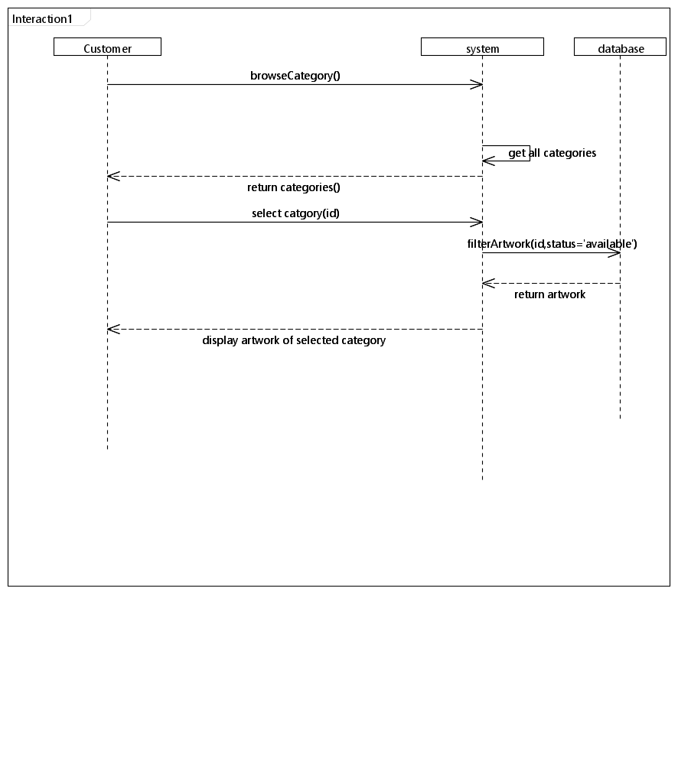
Actors: Customer, System
1. Customer browses the "Categories" section.
2. System retrieves all categories with name and description from the Category table.
3. Customer selects a category to view related artworks.
4. System filters artworks based on the selected category_id and their status (e.g., "available").
5. Customer views the filtered artworks, including details like title, price, and image_url.

- Sequence 8: Admin Approving Artwork Submission
- 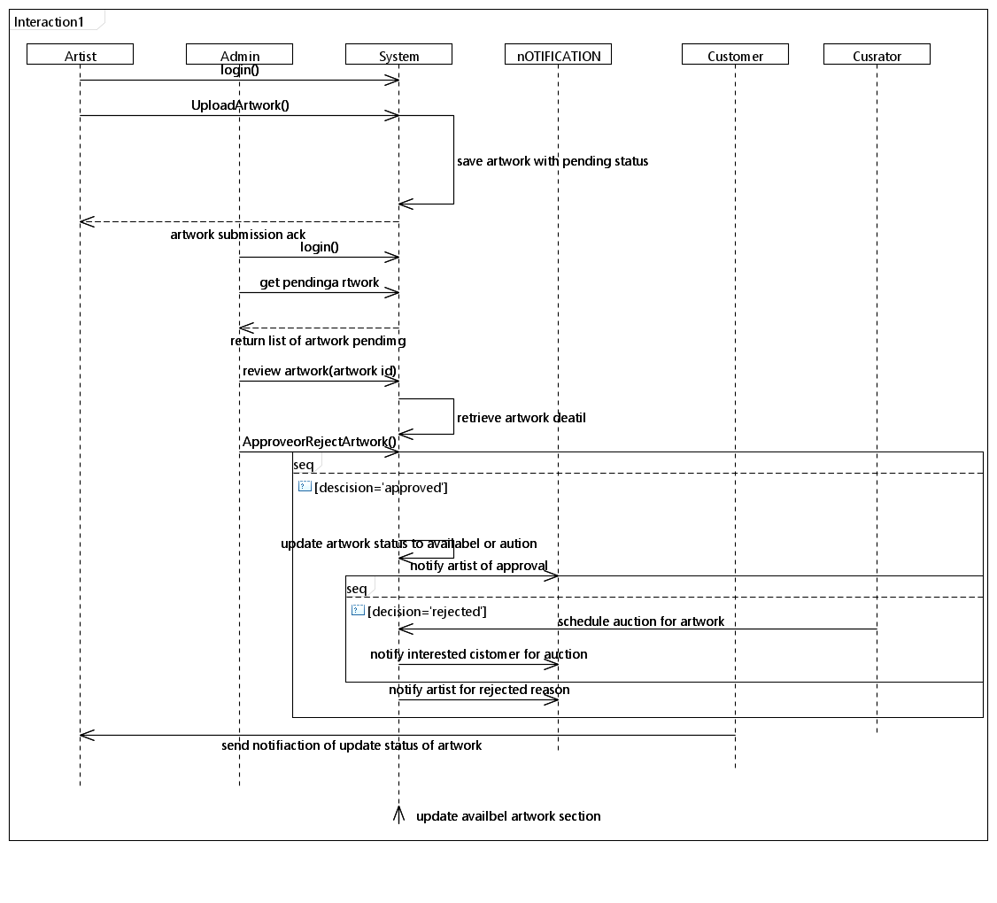
Actors: Artist, Admin, System’
1. Artwork Submission:An artist logs into their account and uploads a new artwork by providing details (title, description, category_id, price, and image_url).he artwork status is set to "pending approval."
2. Admin Review:Admin logs into the system and navigates to the "Pending Artworks" section.Admin reviews the submitted details and optionally requests revisions or provides feedback to the artist.
3. Approval or Rejection:If approved, the system updates the artwork status to "available" or "auctioned" based on admin input.If rejected, the system sends a notification to the artist with reasons for rejection.
4. Post-Approval Notifications:The system notifies the artist of approval and updates the "available artworks" section for customers.If the artwork is scheduled for auction, the system schedules it automatically, notifying both the artist and interested customers.

- Sequence 9:Managing Customer Notifications
- 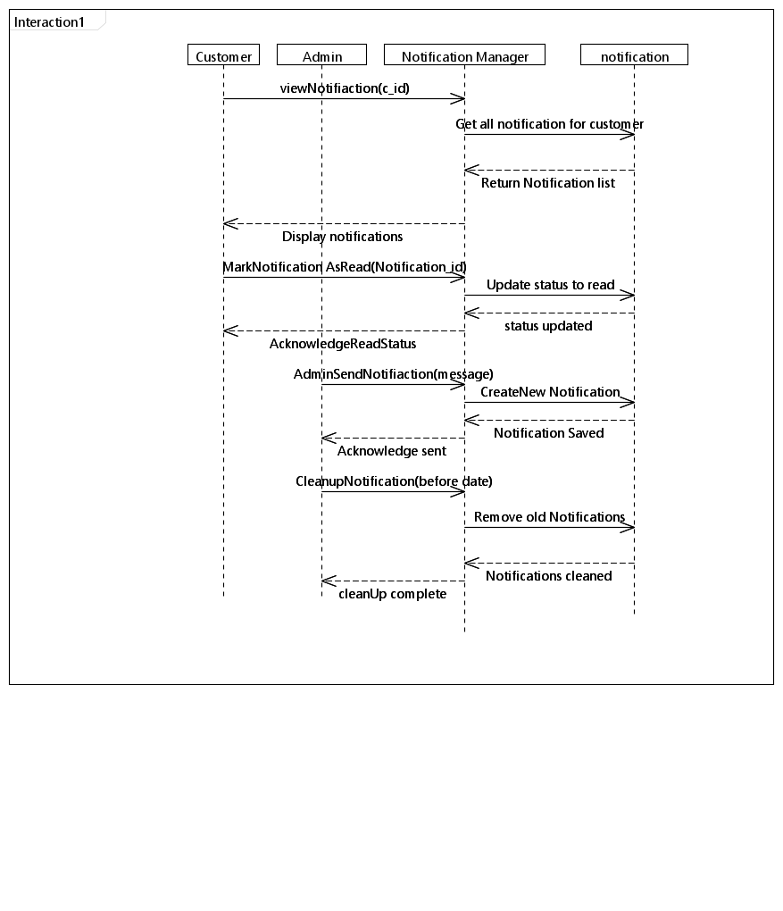
Actors: Customer, Admin, System
1. Event Trigger:The system triggers a notification event based on specific actions (e.g., a new bid placed, auction results, artwork purchased, or admin announcements).
2. Notification Generation:The system generates a notification message containing relevant details (e.g., "Your bid has been outbid," "Congratulations, you won the auction for Artwork X," or "Artwork Y has been added to your wish list").The notification is linked to the specific customer_id and assigned a status of "unread."
3. Admin-Sent Notifications (Optional):Admin logs in and manually sends a broadcast or targeted notification to customers (e.g., promotional messages or account warnings).System records admin-sent notifications in the Notification table.
4. Customer View and Interaction:Customer logs into their account and navigates to the "Notifications" section.The system displays all notifications sorted by date, highlighting unread ones.Customer clicks on a notification to view details.
5. Updating Notification Status:Once a notification is read, the system updates its status to "read."The system tracks read/unread status for analytics (e.g., engagement rates).6. Notification Cleanup (Admin):Admin periodically reviews older notifications and clears outdated ones, ensuring the database remains optimized.
- Sequence 10: Customer Participating in an Auction
- 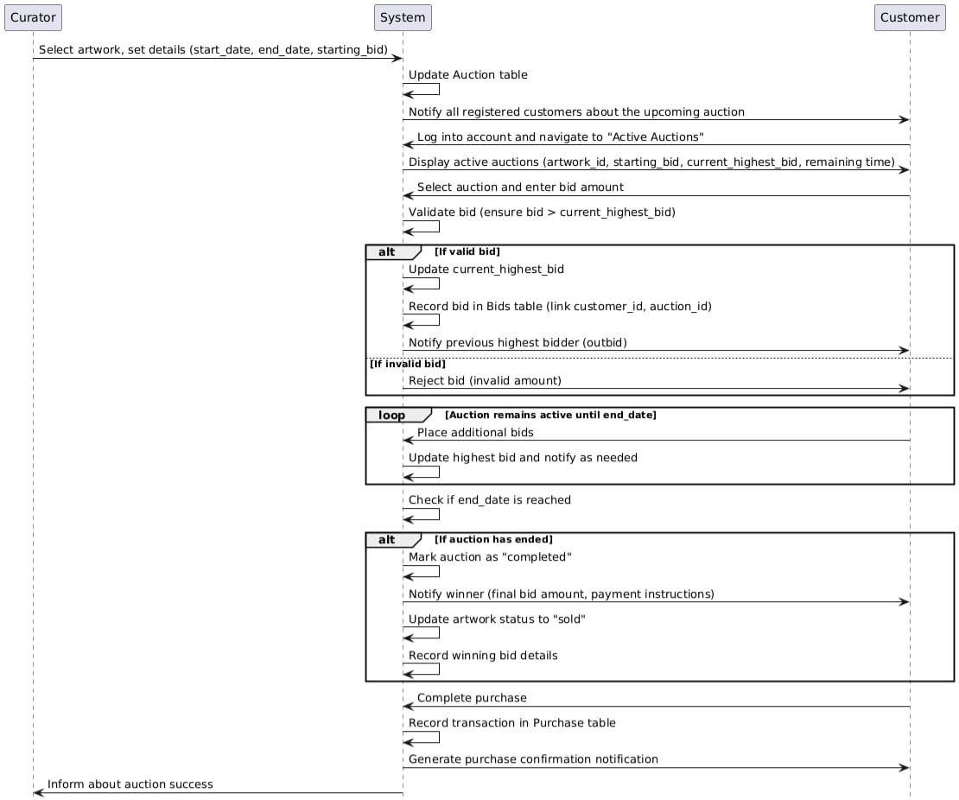

Actors: Customer, System, Curator
1. Auction Announcement:Curator schedules an auction by selecting an artwork and specifying details (start_date, end_date, starting_bid).The system updates the Auction table and notifies all registered customers about the upcoming auction.
2. Customer Browsing Auctions:Customer logs into their account and navigates to the "Active Auctions" section.System displays all active auctions with details such as artwork_id, starting_bid, current_highest_bid, and remaining time.
3. Placing a Bid:Customer selects an auction and enters a bid amount.System validates the bid to ensure it is higher than the current_highest_bid.If valid, the system updates the current_highest_bid and records the bid in the Bids table, linking it to the customer_id and auction_id.System notifies the previous highest bidder that they have been outbid.
4. Auction Progression:The auction remains active until the end_date.Customers can place additional bids, with the system continually updating the highest bid and sending notifications as needed.
5. Auction Closure:On reaching the end_date, the system marks the auction as "completed" and notifies the winner.The system generates a notification for the winning customer with details (e.g., final bid amount and payment instructions).The artwork status is updated to "sold," and the winning bid details are recorded.
6. Post-Auction Follow-Up:The winner completes the purchase, and the system records the transaction in the Purchase table.System generates a confirmation notification for the winner and informs the curator about the auction's success.
7.2 State Diagram
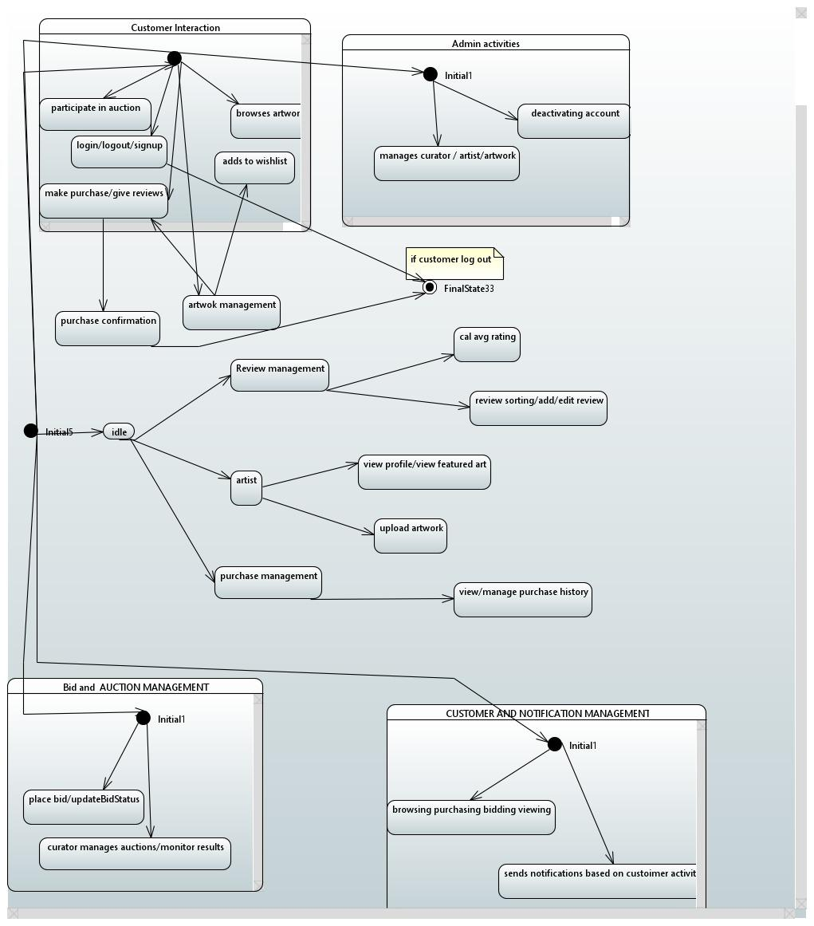
1. Customer Interaction
When a customer accesses the gallery, they begin by either logging in or creating a new account through the signup process. Once logged in, they are free to explore the gallery.

Customers can browse the available artwork to discover pieces they like. If they find something appealing but aren’t ready to purchase, they can add it to their wishlist for later.

If a customer finds an artwork they wish to own, they have two main options:

Purchase it directly through a checkout process.
Participate in an auction if the artwork is part of a bidding event.
After completing a purchase, the system confirms the transaction and allows the customer to leave a review for the artwork. Reviews help future customers make informed decisions. These reviews are managed through a system that sorts them, calculates average ratings, and allows editing by customers.

Additionally, the customer can access their purchase history and manage previously bought artworks through the platform.

When finished, the customer can log out, which transitions their session to the system's final state.

2. Artist Interaction
Artists play a crucial role in the gallery by contributing artwork to the platform. After logging in, an artist can manage their profile to display personal information and showcase their featured art.

Artists can also upload new artworks, making them available for customers to browse, purchase, or bid on through auctions. This helps artists maintain their portfolio and attract buyers.

3. Admin Activities
Admins oversee the smooth operation of the gallery. Their responsibilities include:

Managing curators, artists, and artworks: Admins ensure that the artworks are appropriately categorized and the artist profiles are well-maintained.
Deactivating accounts: If any user violates the platform’s policies, admins can deactivate their account to maintain a safe and professional environment.
Admins primarily operate in the background to keep the gallery functional and user-friendly.

4. Bid and Auction Management
The system offers a dynamic auction feature where customers can bid for artworks. Customers place or update their bids during the auction period.

Behind the scenes, curators monitor the auction process and oversee the results to ensure fairness. This creates a competitive and engaging experience for customers.

5. Customer and Notification Management
To enhance user engagement, the system tracks customer activities like:

Browsing through the gallery.
Purchasing artworks.
Bidding in auctions.
Based on these activities, the system sends notifications to customers. For example:

A reminder about an upcoming auction.
Updates on bids placed by the customer.
Confirmation of purchases or other account activities.
These notifications ensure that customers are well-informed and stay connected to the gallery.

6. Overall System Behavior
The system starts in an idle state, waiting for any user interaction. As soon as a customer, artist, or admin interacts with the platform, the system transitions into the appropriate state (e.g., browsing, bidding, or management).

Once a customer logs out or an admin completes their session, the system transitions to a final state.

7.3 Activity Diagram
Same 10 scenarios as sequence diagram.

- 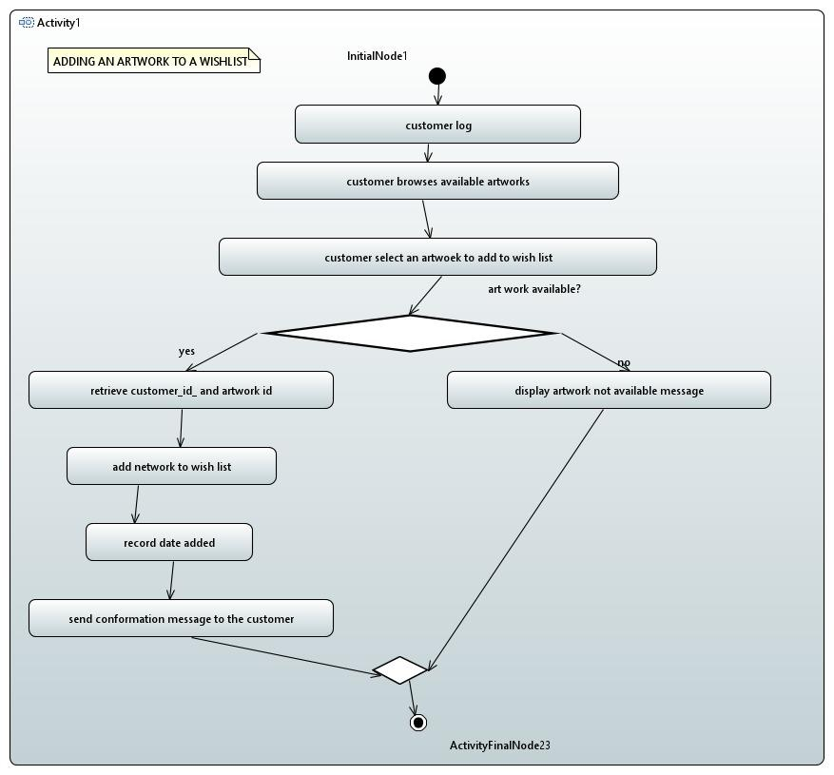
- 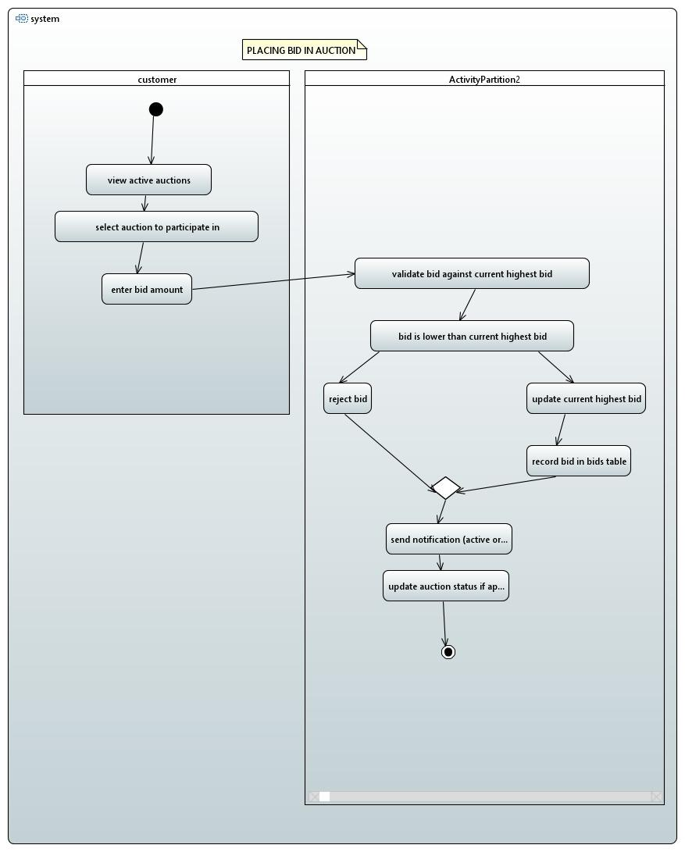
- 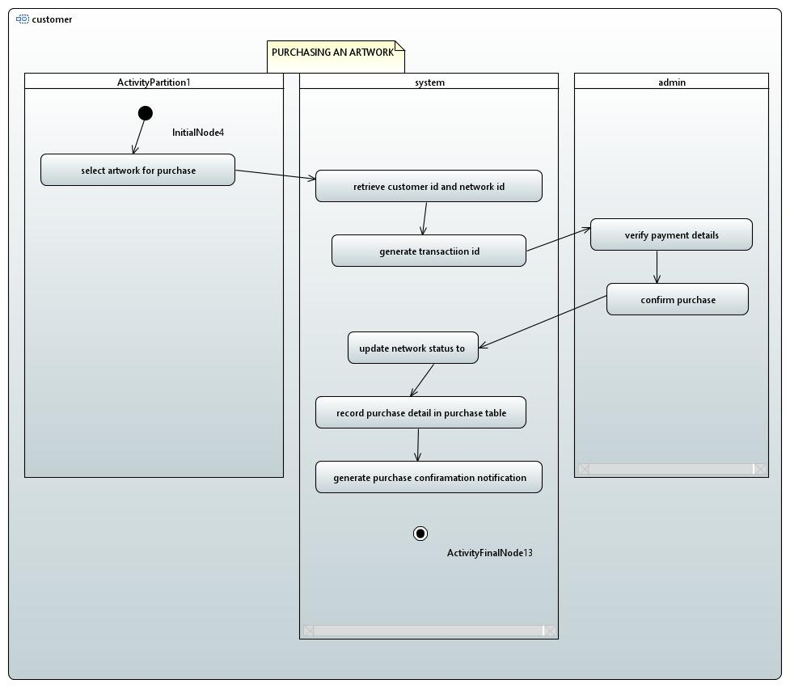
- 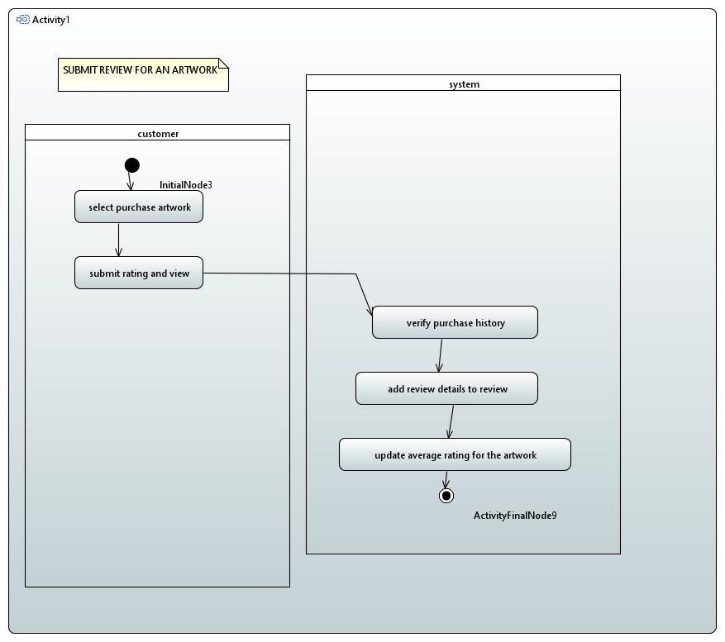
- 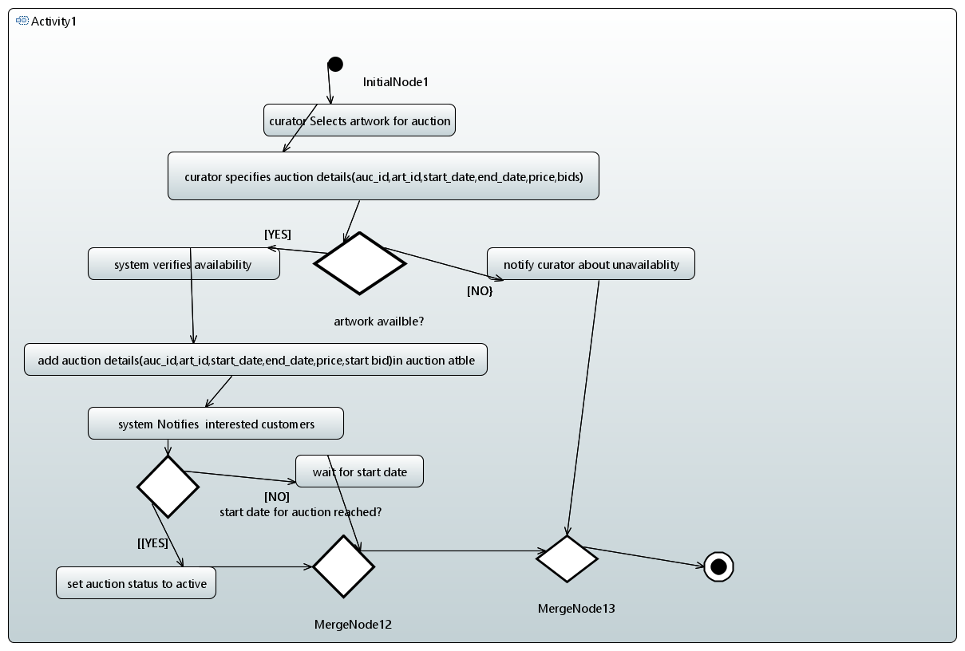
- 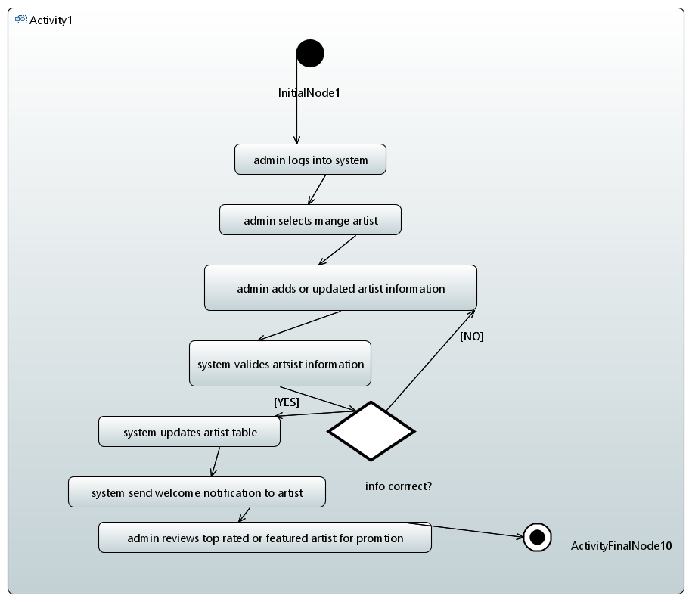
- 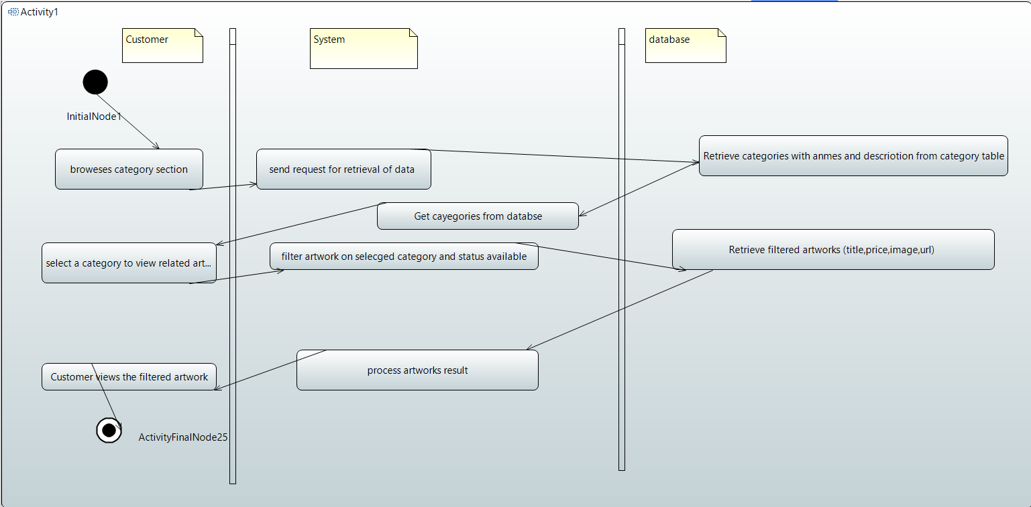
- 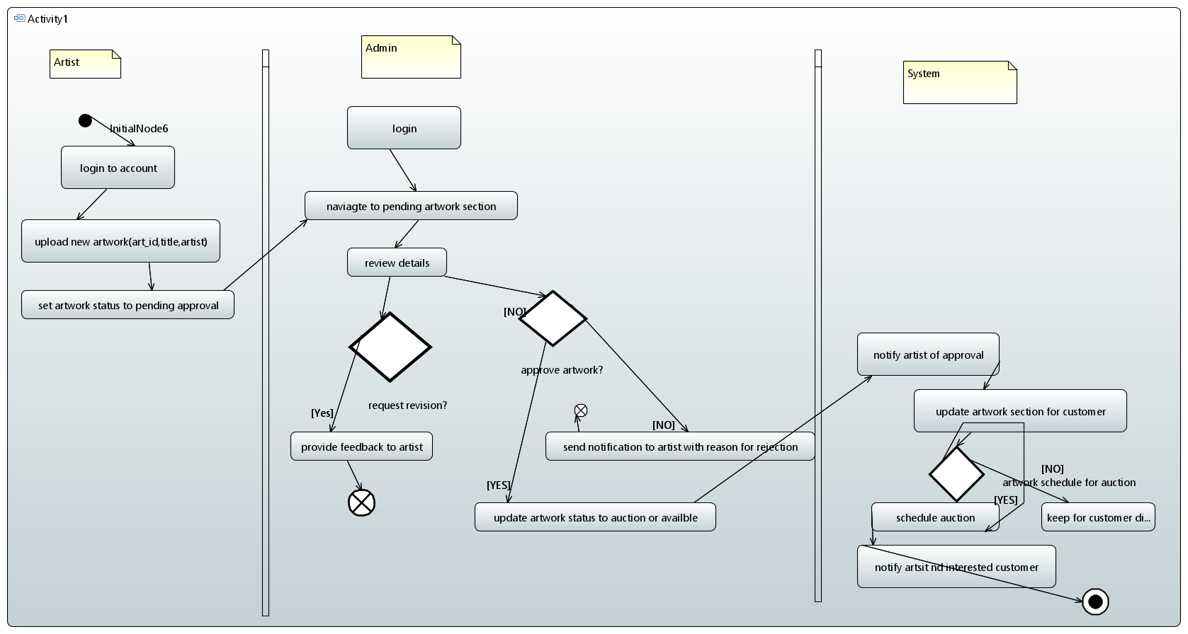
- 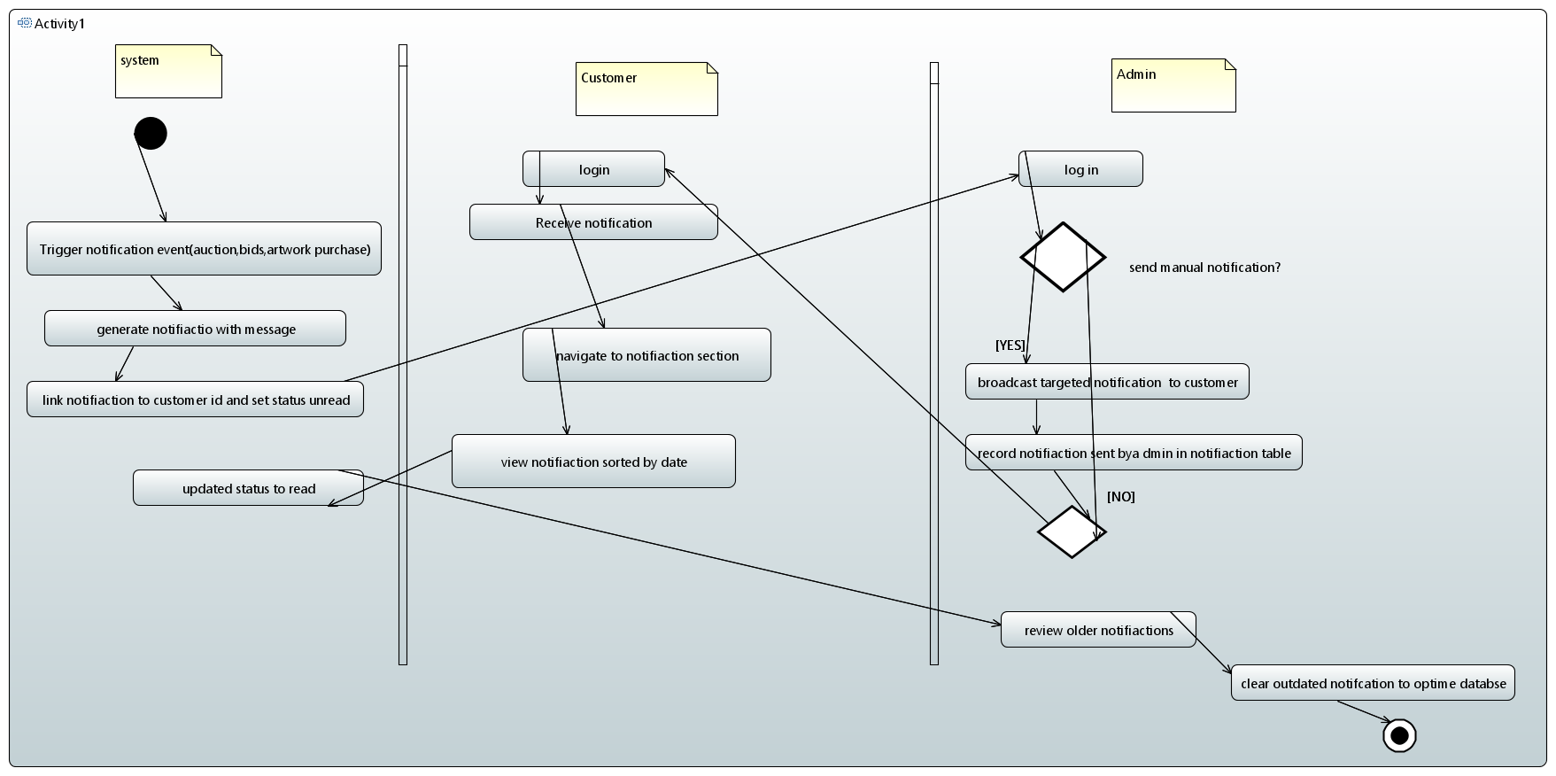
- 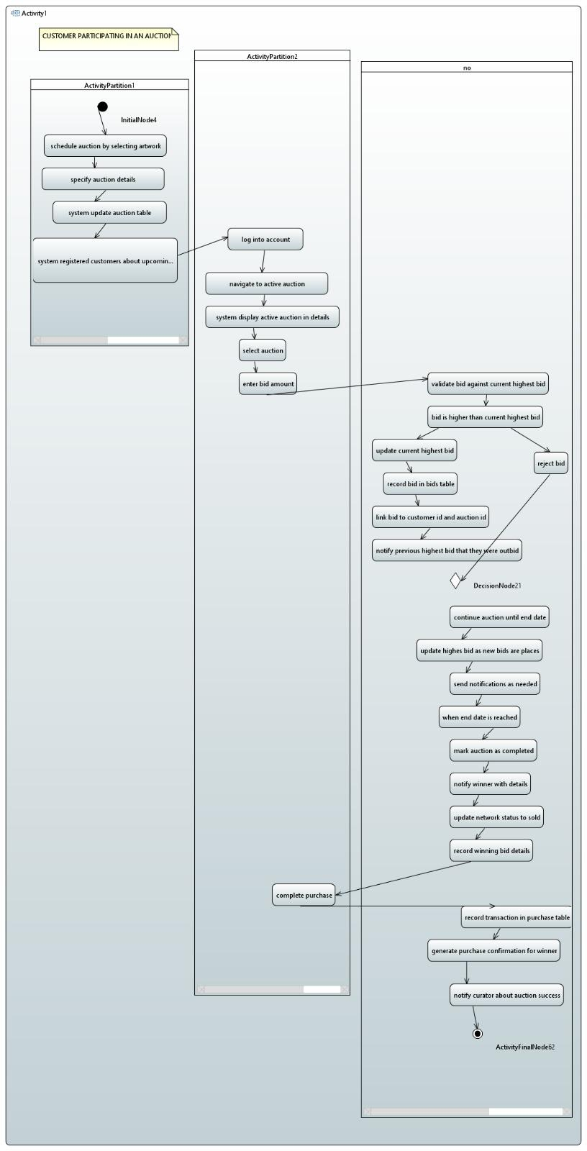

7. References
- UML 2.0 Specification
Title: Unified Modeling Language (UML) 2.0 Specification
Report Number: [Specify Report Number, if applicable]
Date: [Date of publication]
Publishing Organization: Object Management Group (OMG)
Available from: [Link or publisher details]
- Design Patterns: Elements of Reusable Object-Oriented Software
Title: Design Patterns: Elements of Reusable Object-Oriented Software
Authors: Erich Gamma, Richard Helm, Ralph Johnson, John Vlissides
Date: 1994
Publishing Organization: Addison-Wesley
Available from: [Link or publisher details]
- AWS Cloud Architecture Best Practices
Title: AWS Cloud Architecture Best Practices
Date: [Date of publication]
Publishing Organization: Amazon Web Services (AWS)
Available from: https://aws.amazon.com/architecture/
- Stripe API Documentation
Title: Stripe API Documentation
Date: [Date of publication]
Publishing Organization: Stripe
Available from: https://stripe.com/docs/api
- MySQL Database Design and Optimization
Title: MySQL Database Design and Optimization
Author: David R. Luebke
Date: [Date of publication]
Publishing Organization: O'Reilly Media
Available from: [Link or publisher details]
- "The Art of Secure Coding"
Title: The Art of Secure Coding
Author: [Author Name]
Date: [Date of publication]
Publishing Organization: [Publisher]
Available from: [Link or publisher details]
- Web Application Security
Title: Web Application Security: A Beginner's Guide
Author: Bryan Sullivan, Vincent Liu
Date: 2011
Publishing Organization: McGraw-Hill
Available from: [Link or publisher details]
- Payment Gateway Integration Best Practices
Title: Payment Gateway Integration Best Practices
Date: [Date of publication]
Publishing Organization: [Payment Gateway Provider]
Available from: [Link or publisher details]
- Digital Art Gallery System - Initial Design Proposal
Title: Digital Art Gallery System - Initial Design Proposal
Date: [Date of proposal]
Publishing Organization: [Your Organization or University Name]
Available from: [Link or publisher details]
- MySQL Workbench Documentation
Title: MySQL Workbench Documentation
Date: [Date of publication]
Publishing Organization: Oracle
Available from: https://dev.mysql.com/doc/workbench/en/

8. Appendices
Appendix A: System Use Case Diagrams
- Use Case Diagram for Art Auction
This diagram depicts the different use cases involved in the auctioning process within the Digital Art Gallery, including actions like placing a bid, viewing auctions, and accepting bids by the curator.
- Use Case Diagram for User Registration and Authentication
Describes the flow for new users (artists, curators, or customers) registering and logging into the system.

Appendix B: Sequence Diagrams
- Sequence Diagram for Placing a Bid
This diagram illustrates the interactions between the Customer, Auction, and Database to place a bid for an artwork in real-time.
- Sequence Diagram for Artwork Upload
Describes the flow of uploading an artwork from the artist’s end to the system, including image upload, metadata entry, and confirmation.

