Software Requirements Specification

For

Task Allocation System

Version 1.0 approved

Prepared by:

Ruturaj Jadhav, Nilesh Swami, Prashant Yadav,

Amardeep Kate, Ashwini Hawaldar, Prabha Ranjane, Pooja Jadhav

(Macdyssa)

September 14, 2016

Revision History

|  |  |  |  |
| --- | --- | --- | --- |
| **Author(s)** | **Date** | **Reason For Changes** | **Version** |
| Ruturaj Jadhav, Nilesh Swami,  Prashant Yadav,  Amardeep Kate,  Ashwini Hawaldar,  Prabha Ranjane,’  Pooja Jadhav | 14/09/2016 | This is first version of SRS. | 1.0 |
|  |  |  |  |

# Introduction

This Software Requirements Specification, SRS, will provide a description for a task management system. In the following sections we will define the document purpose, the scope of the task management product, and the intended audience for this document. Additional sections will define acronyms and abbreviations, and explain any document conventions. We will end the SRS with a section for references and acknowledgments.

* 1. **Purpose**

This Software Requirements Specification will describe the processes and functions of the Task Management System. The intended audience for this document will be the designers of this system, Sir Dnyaneshwar Suryawanshi and his assistant, and managers and their workers. The major portion of the product will be described within this documentation, with a possible upgrade to the system available in the future which may include a point’s reward system redeemable for avatars and avatar upgrades**.**

## Document Conventions

1. All text contained in this document is 16pt Times New Roman font.

2. Section titles are 16pt Times New Roman font.

3. Subsection titles are 14pt Times New Roman font.

4. Any further subsection breakdown is 12pt Times New Roman font.

5. All sections and subsection are numbered using the X.X… format, where X represents numbers.

6. Document text will be single-spaced and maintain 1.0” margins

## Intended Audience and Reading Suggestions

Task Management 1.0 SRS is derived from communication between the authors, and their product customers. Our Sir Dnyaneshwar Suryawanshi as a requirement for the MacDyssa has requested this SRS. Therefore, our intended audience consists of the clients, the developers.

## Product Scope

The Task Management System provides an interface for both managers and workers to use to track their daily tasks. Each user, manager or worker, will have a different user interface. The manager will have a traditional manager user interface, with the worker having a traditional worker interface. The manager interface will allow for entering of new tasks, editing tasks, deleting tasks, and searching of tasks. The manager interface will also allow for creating and deleting of users. Lastly, this interface will have the permission to reset passwords. The worker interface will allow them to search tasks and mark tasks that they have completed. The system will also provide a history of previous tasks assigned or completed.

## References

At this time this SRS does not reference any outside resources.

# Overall Description

## Product Perspective

The Task Management System will be a new self-contained product. Communication will be done via a HTML interface to a server that will connect with the SQL database that stores the Task Management information.

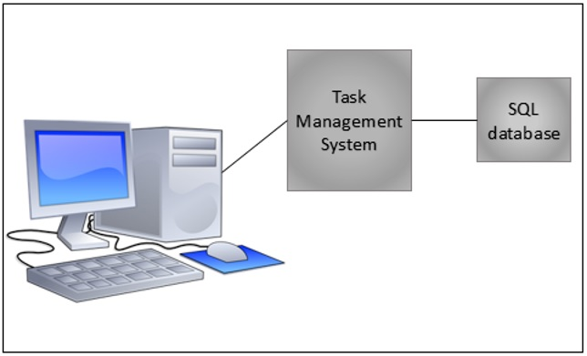

## Product Functions

### Login interface UI01

* The system will allow the management personnel to login to their module only.
* The system will allow the employee to login to their module only.
* The system will allow the client to login to their module only.
* The system will allow the administrator to login to their module only and manage system.

### Admin interface UI02

* The system will allow creating new logins for employee, client, management personnel and administrator itself.
* The system will allow to create the quotations, bills and receipts
* The system will allow managing statuses of employee, client, management personnel and administrator itself

### Manager interface UI03

* The system will allow adding project.
* The system will allow allocating client to particular project.
* The system will allow creating modules on particular project.
* The system will allow defining and creating tasks.
* The system will allow allocating tasks to developers/teams.
* The system will allow maintaining client interaction.

### Employee interface UI04

* Employee interface is divided into sub interfaces related to the department of the employee.

#### Software developer interface UI04.1

* The system will allow collecting SRS.
* The system will allow understanding tasks.
* The system will allow developing tasks/module.
* The system will allow maintaining management and client interaction.
* The system will allow updating status related to task.

#### Software tester interface UI04.2

* The system will allow collecting SRS.
* The system will allow creating test cases.
* The system will allow managing status about testing.
* The system will allow maintaining management interactions

#### Software Marketing Interface UI04.3

* The system will allow analyzing features about particular product.
* The system will allow designing advertisement, plan/method.
* The system will allow sale management and purchase management.
* The system will allow maintaining management and client interaction.

### Client interface UI05

* The system will allow checking progress of the particular project.
* The system will allow maintaining management and administration interaction through emails and messages.

## User Classes and Characteristics