Spring 5

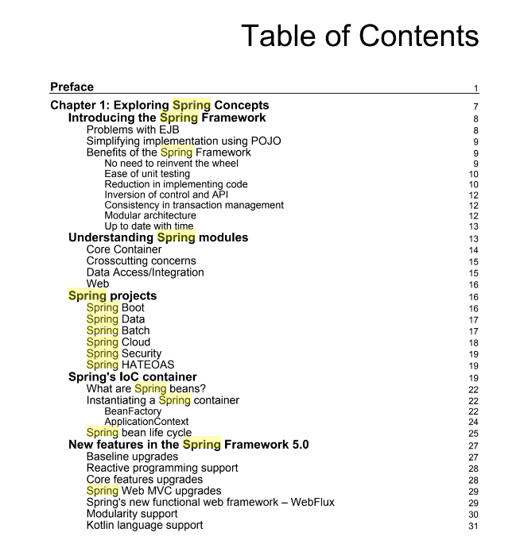
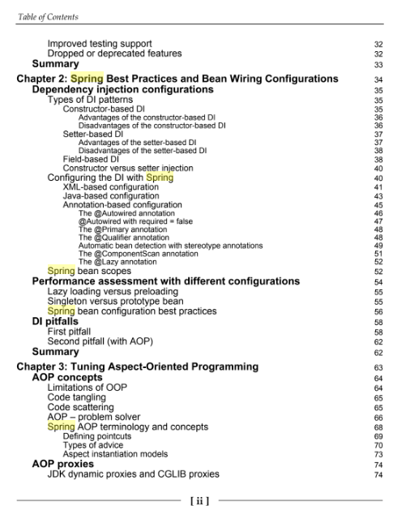
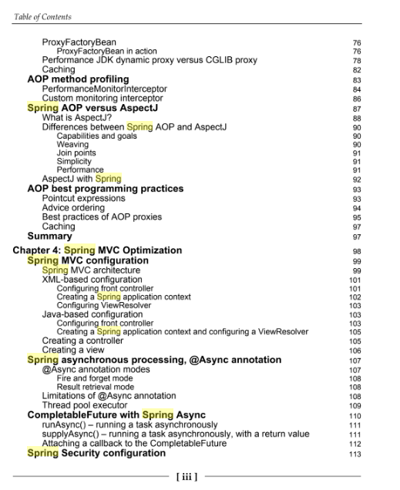
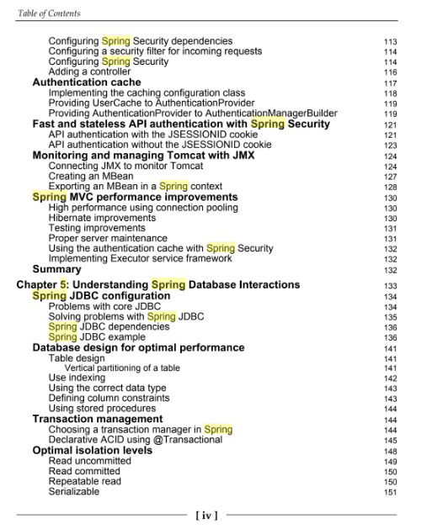
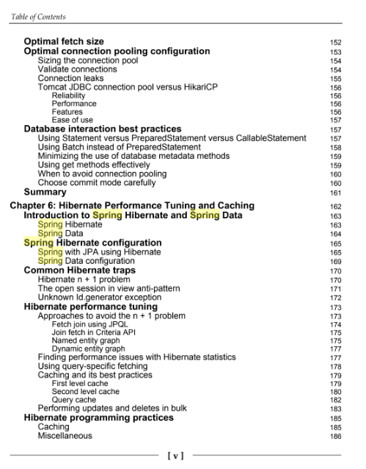
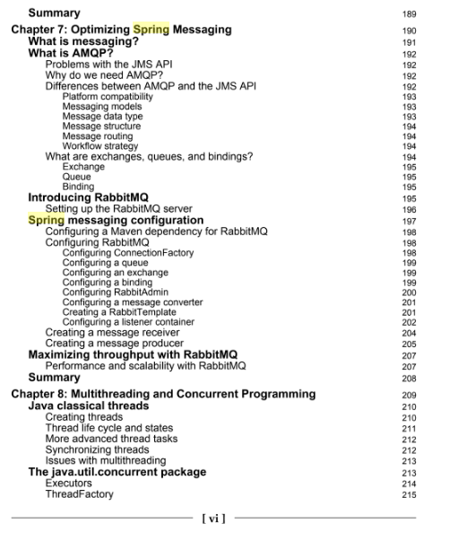
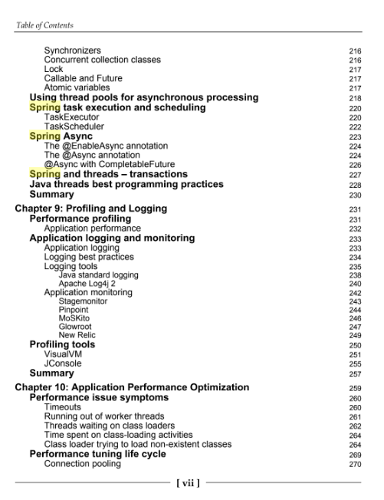
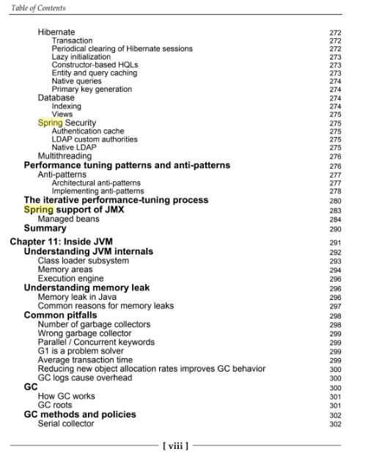
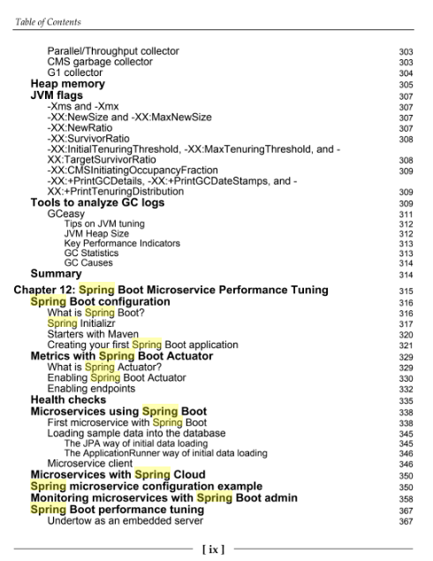

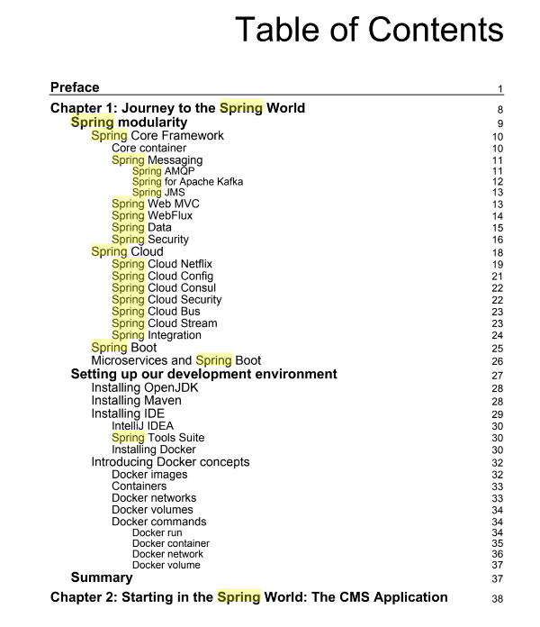
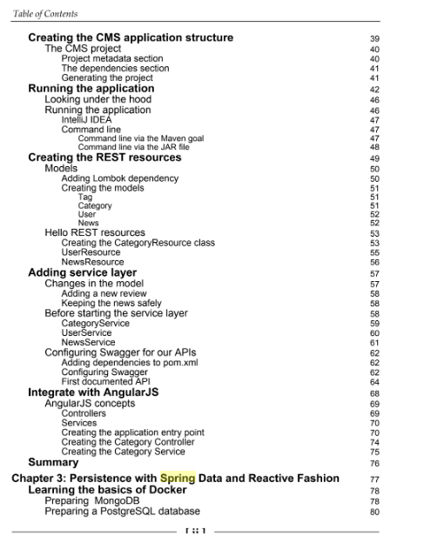
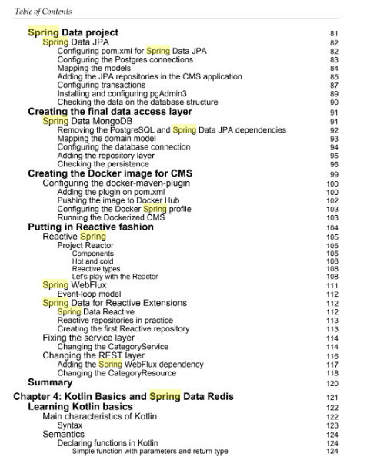
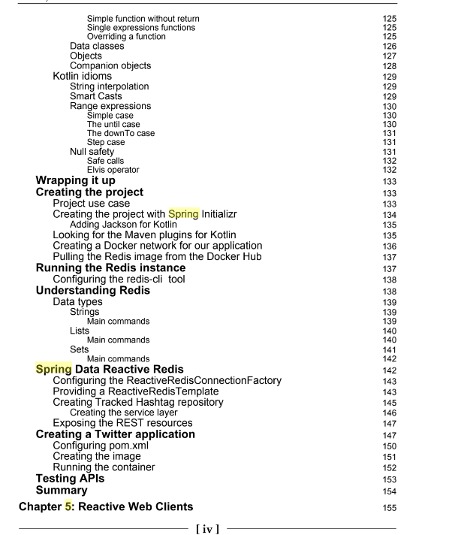
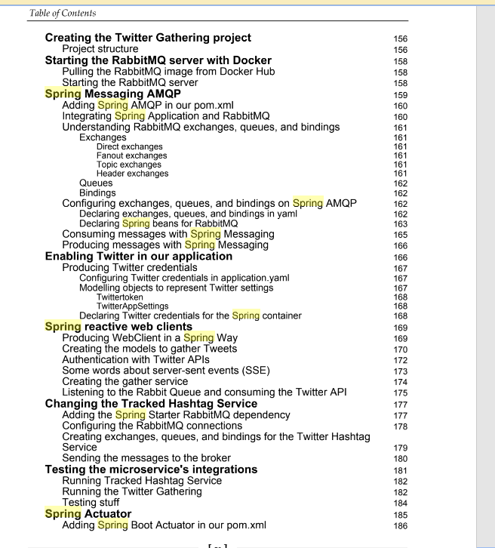
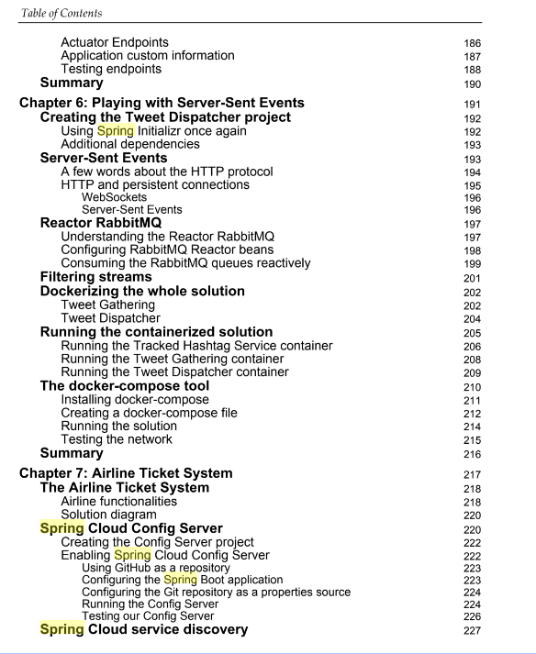
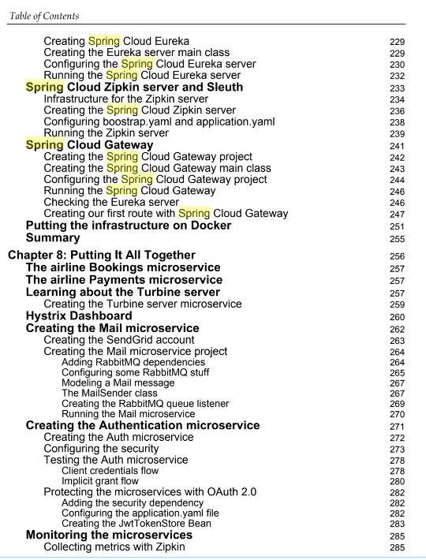
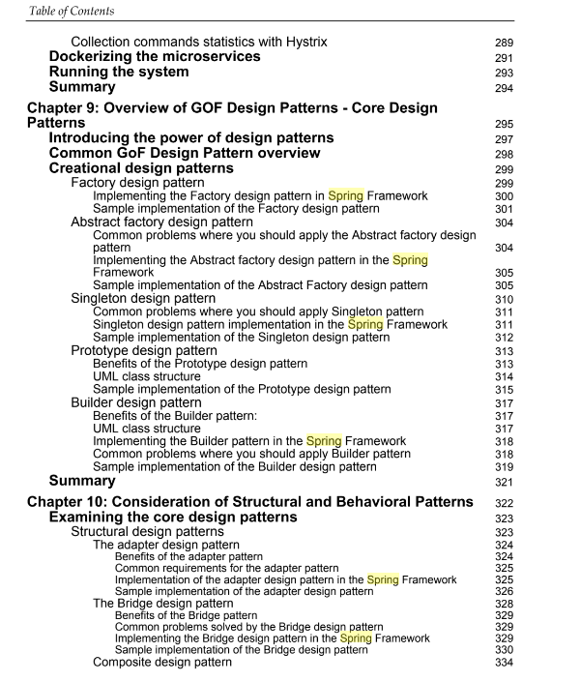
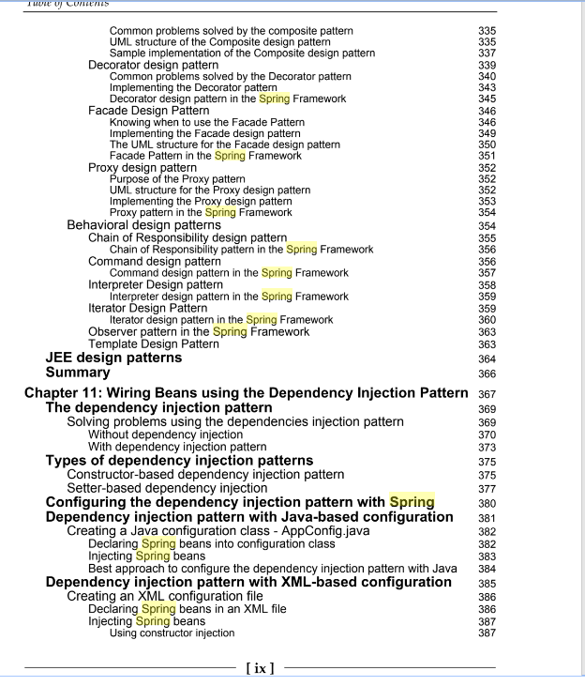
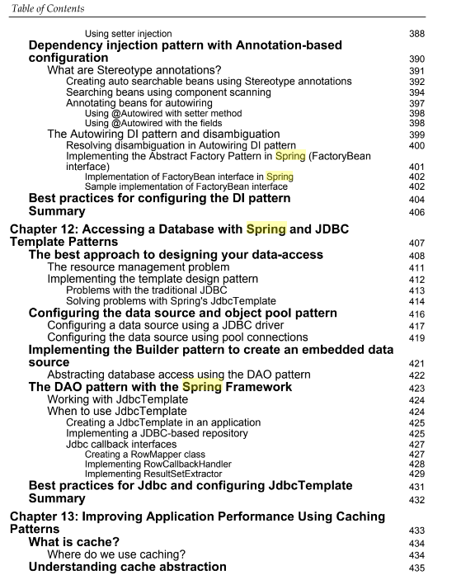

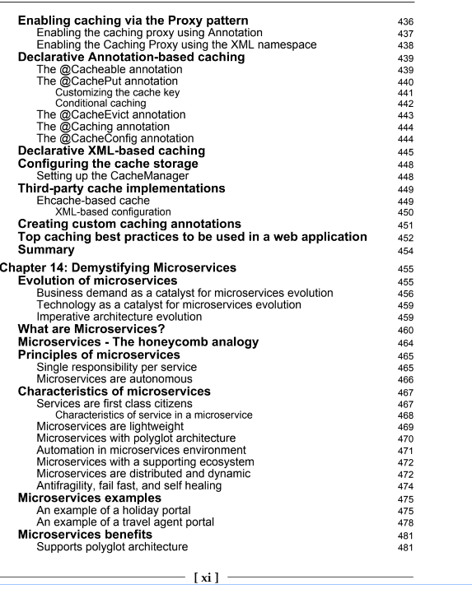
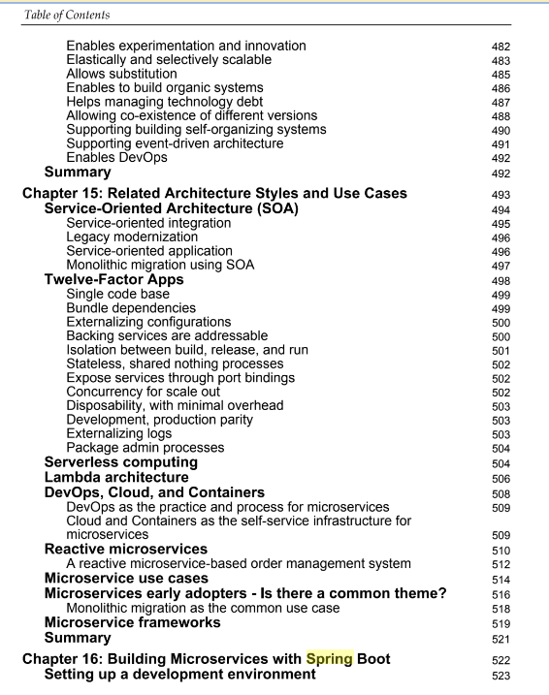
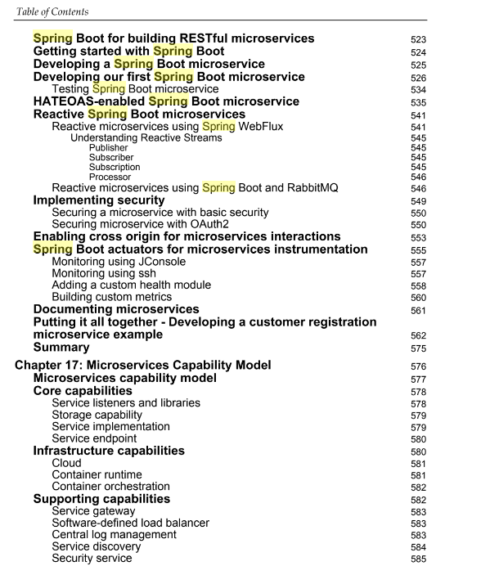
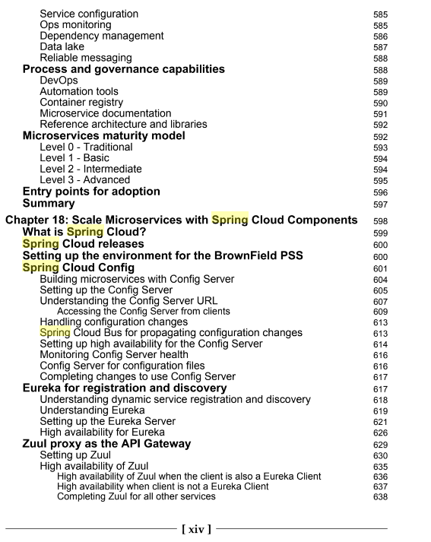
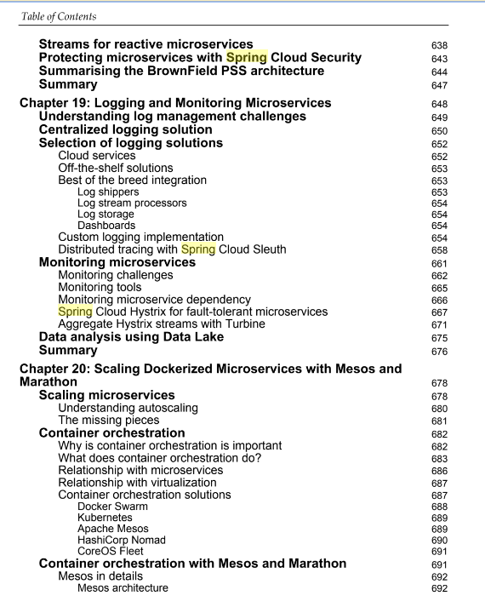

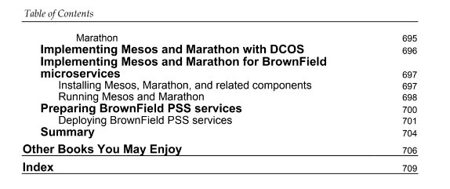

SpringBoot

Spring Boot is Spring's convention-over-configuration solution for creating stand-alone, production-grade Spring-based Applications that you can "just run".^{[22]} It is preconfigured with the Spring team's "opinionated view" of the best configuration and use of the Spring platform and third-party libraries so you can get started with minimum fuss. Most Spring Boot applications need very little Spring configuration. Features:
- Create stand-alone Spring applications
- Embed Tomcat or Jetty directly (no need to deploy WAR files)
- Provide opinionated 'starter' Project Object Models (POMs) to simplify your Maven configuration
- Automatically configure Spring whenever possible
- Provide production-ready features such as metrics, health checks and externalized configuration
- Absolutely no code generation and no requirement for XML configuration
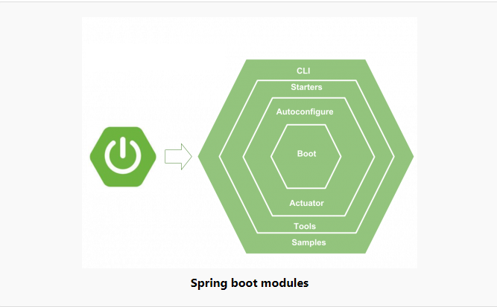

1. What is starter template?
Spring Boot starters are templates that contain a collection of all the relevant transitive dependencies that are needed to start a particular functionality. For example, If you want to create a Spring WebMVC application then in a traditional setup, you would have included all required dependencies yourself. It leaves the chances of version conflict which ultimately result in more runtime exceptions.
With Spring boot, to create MVC application all you need to import is spring-boot-starter-webdependency.
pom.xml
<!-- Parent pom is mandatory to control versions of child dependencies -->
<parent>
<groupId>org.springframework.boot</groupId>
<artifactId>spring-boot-starter-parent</artifactId>
<version>2.1.6.RELEASE</version>
<relativePath />
</parent>

<!-- Spring web brings all required dependencies to build web application. -->
<dependency>
<groupId>org.springframework.boot</groupId>
<artifactId>spring-boot-starter-web</artifactId>
</dependency>
Above spring-boot-starter-web dependency, internally imports all given dependencies and add to your project. Notice how some dependencies are direct, and some dependencies further refer to other starter templates which transitively downloads more dependencies.
Also, notice that you do not need to provide version information into child dependencies. All versions are resolved in relation to version of parent starter (in our example it’s 2.0.4.RELEASE).
Dependencies brought in by webmvc starter template
<dependencies>
<dependency>
<groupId>org.springframework.boot</groupId>
<artifactId>spring-boot-starter</artifactId>
</dependency>
<dependency>
<groupId>org.springframework.boot</groupId>
<artifactId>spring-boot-starter-json</artifactId>
</dependency>
<dependency>
<groupId>org.springframework.boot</groupId>
<artifactId>spring-boot-starter-tomcat</artifactId>
</dependency>
<dependency>
<groupId>org.hibernate.validator</groupId>
<artifactId>hibernate-validator</artifactId>
</dependency>
<dependency>
<groupId>org.springframework</groupId>
<artifactId>spring-web</artifactId>
</dependency>
<dependency>
<groupId>org.springframework</groupId>
<artifactId>spring-webmvc</artifactId>
</dependency>
</dependencies>
Read More : Spring boot starter templates list

2. Spring boot autoconfiguration
Autoconfiguration is enabled with @EnableAutoConfiguration annotation. Spring boot auto configuration scans the classpath, finds the libraries in the classpath and then attempt to guess the best configuration for them, and finally configure all such beans.
Auto-configuration tries to be as intelligent as possible and will back-away as you define more of your own configuration.
Auto-configuration is always applied after user-defined beans have been registered.
Spring boot auto-configuration logic is implemented in spring-boot-autoconfigure.jar. Yoy can verify the list of packages here.
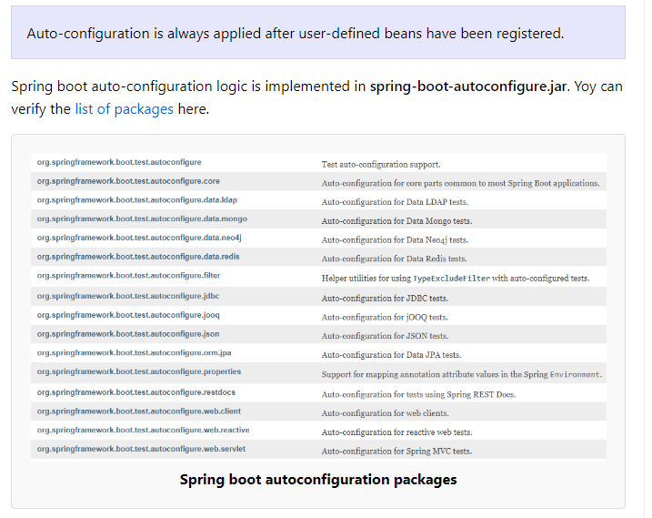Spring boot autoconfiguration packages
For example, look at auto-configuration for Spring AOP. It does the followings-
- Scan classpath to see if EnableAspectJAutoProxy, Aspect, Advice and AnnotatedElementclasses are present.
- If classes are not present, no autoconfiguration will be made for Spring AOP.
- If classes are found then AOP is configured with Java config annotation @EnableAspectJAutoProxy.
- It checks for property spring.aop which value can be true or false.
- Based on the value of property, proxyTargetClass attribute is set.
AopAutoConfiguration.java
@Configuration
@ConditionalOnClass({ EnableAspectJAutoProxy.class, Aspect.class, Advice.class,
AnnotatedElement.class })
@ConditionalOnProperty(prefix = "spring.aop", name = "auto", havingValue = "true", matchIfMissing = true)
public class AopAutoConfiguration
{

@Configuration
@EnableAspectJAutoProxy(proxyTargetClass = false)
@ConditionalOnProperty(prefix = "spring.aop", name = "proxy-target-class", havingValue = "false", matchIfMissing = false)
public static class JdkDynamicAutoProxyConfiguration {

}

@Configuration
@EnableAspectJAutoProxy(proxyTargetClass = true)
@ConditionalOnProperty(prefix = "spring.aop", name = "proxy-target-class", havingValue = "true", matchIfMissing = true)
public static class CglibAutoProxyConfiguration {

}

}

3. Embedded server
Spring boot applications always include tomcat as embedded server dependency. It means you can run the Spring boot applications from the command prompt without needling complex server infrastructure.
You can exclude tomcat and include any other embedded server if you want. Or you can make exclude server environment altogether. It’s all configuration based.
For example, below configuration exclude tomcat and include jetty as embedded server.
pom.xml
<dependency>
<groupId>org.springframework.boot</groupId>
<artifactId>spring-boot-starter-web</artifactId>
<exclusions>
<exclusion>
<groupId>org.springframework.boot</groupId>
<artifactId>spring-boot-starter-tomcat</artifactId>
</exclusion>
</exclusions>
</dependency>

<dependency>
<groupId>org.springframework.boot</groupId>
<artifactId>spring-boot-starter-jetty</artifactId>
</dependency>

4. Bootstrap the application
To run the application, we need to use @SpringBootApplication annotation. Behind the scenes, that’s equivalent to @Configuration, @EnableAutoConfiguration, and @ComponentScan together.
It enables the scanning of config classes, files and load them into spring context. In below example, execution start with main() method. It start loading all the config files, configure them and bootstrap the application based on application properties in application.properties file in /resources folder.
MyApplication.java
@SpringBootApplication
public class MyApplication
{
public static void main(String[] args)
{
SpringApplication.run(Application.class, args);
}
}

application.properties
### Server port #########
server.port=8080

### Context root ########
server.contextPath=/home
To execute the application, you can run the main() method from IDE such eclipse, or you can build the jar file and execute from command prompt.
Console
$ java -jar spring-boot-demo.jar

5. Advantages of Spring boot
- Spring boot helps in resolving dependency conflict. It identifies required dependencies and import them for you.
- It has information of compatible version for all dependencies. It minimizes the runtime classloader issues.
- It’s “opinionated defaults configuration” approach helps you in configuring most important pieces behind the scene. Override them only when you need. Otherwise everything just works, perfectly. It helps in avoiding boilerplate code, annotations and XML configurations.
- It provides embedded HTTP server Tomcat so that you can develop and test quickly.
- It has excellent integration with IDEs like eclipse and intelliJ idea.

Spring Boot CLI
The Spring Boot CLI is a command line tool and it allows us to run the Groovy scripts. This is the easiest way to create a Spring Boot application by using the Spring Boot Command Line Interface. You can create, run and test the application in command prompt itself.
This section explains you the steps involved in manual installation of Spring Boot CLI. For further help, you can use the following link: https://docs.spring.io/springboot/ docs/current-SNAPSHOT/reference/htmlsingle/#getting-started-installing-springboot
You can also download the Spring CLI distribution from the Spring Software repository at: https://docs.spring.io/spring-boot/docs/current-SNAPSHOT/reference/htmlsingle/#getting-started-manual-cli-installation
For manual installation, you need to use the following two folders −
- spring-boot-cli-2.0.0.BUILD-SNAPSHOT-bin.zip
- spring-boot-cli-2.0.0.BUILD-SNAPSHOT-bin.tar.gz
After the download, unpack the archive file and follow the steps given in the install.txt file. Not that it does not require any environment setup.
In Windows, go to the Spring Boot CLI bin directory in the command prompt and run the command spring –-version to make sure spring CLI is installed correctly. After executing the command, you can see the spring CLI version as shown below −

Run Hello World with Groovy
Create a simple groovy file which contains the Rest Endpoint script and run the groovy file with spring boot CLI. Observe the code shown here for this purpose −
@Controller
class Example {
@RequestMapping("/")
@ResponseBody
public String hello() {
"Hello Spring Boot"
}
}
Now, save the groovy file with the name hello.groovy. Note that in this example, we saved the groovy file inside the Spring Boot CLI bin directory. Now run the application by using the command spring run hello.groovy as shown in the screenshot given below −
Once you run the groovy file, required dependencies will download automatically and it will start the application in Tomcat 8080 port as shown in the screenshot given below −
Once Tomcat starts, go to the web browser and hit the URL http://localhost:8080/ and you can see the output as shown.
next →← prev

Spring Boot Actuator
Spring Boot provides actuator to monitor and manage our application. Actuator is a tool which has HTTP endpoints. when application is pushed to production, you can choose to manage and monitor your application using HTTP endpoints.
To get production-ready features, we should use spring-boot-actuator module. We can enable this feature by adding it to the pom.xml file.
- <dependencies>
- <dependency>
- <groupId>org.springframework.boot</groupId>
- <artifactId>spring-boot-starter-actuator</artifactId>
- </dependency>
- </dependencies>

6. Spring Boot Configuration
- Spring boot annotations
- A Guide to Logging in Spring Boot
- Spring Boot – Spring Boot starter templates
- Spring Boot – Starter Parent Dependency
- Spring Boot – Get all loaded beans
- Spring Boot – @SpringBootApplication and Auto Configuration
- Spring Boot – Change Application Root
- Spring Boot – Configure Jetty Server
- Spring Boot – Tomcat Default Port
- Spring Boot – WAR Packaging Example
- Spring Boot – Logging yml Config
- Spring Boot – Logging property Config
- Spring Boot – SSL [https]
- Spring Boot – CommandLineRunner
- Spring Boot – Developer Tools Module Tutorial
- Spring Boot – Inject Application Arguments in @Bean and @Compoment
- Spring boot embedded server logs
- Spring boot embedded tomcat configuration

7. Developing REST APIs and SOAP Webservices
- Spring Boot – REST APIs
- Spring Boot – Jersey
- Spring Boot – Spring HATEOAS Example
- Spring Boot – Request validation of REST APIs
- Spring Boot – Role Based Security
- Spring Boot – SOAP Webservice
- Spring Boot – SOAP Client
- Spring boot 2 and ehcache 3 example

8. Other Useful Topics
- Disable banner at startup
- Spring Boot – JSP View
- Spring Boot – Custom PropertyEditor
- Spring Boot – @EnableScheduling
- Spring Boot – JMSTemplate
- Spring Boot – RSS / ATOM Feed
- Spring boot read file from resources folder

Spring Boot Annotations

1. @SpringBootApplication
Spring boot is mostly about auto-configuration. This auto-configuration is done by component scanning i.e. finding all classes in classspath for @Component annotation. It also involve scanning of @Configuration annotation and initialize some extra beans.
@SpringBootApplication annotation enable all able things in one step. It enables the three features:
- @EnableAutoConfiguration : enable auto-configuration mechanism
- @ComponentScan : enable @Component scan
- @SpringBootConfiguration : register extra beans in the context
The java class annotated with @SpringBootApplication is the main class of a Spring Boot application and application starts from here.
import org.springframework.boot.SpringApplication;
import org.springframework.boot.autoconfigure.SpringBootApplication;

@SpringBootApplication
public class Application {

public static void main(String[] args) {
SpringApplication.run(Application.class, args);
}

}

2 Spring Boot : How does @EnableAutoConfiguration annotation works?
Spring Boot framework allows to create spring based applications with minimizing the effort of doing manual spring configurations. Spring Boot automatically do the configuration on behalf of the developer. You might be wonder how does the spring boot framework do the configuration automatically.
This is done with the @EnableAutoConfiguration annotation available in the Spring framework. @EnableAutoConfiguration will automatically do the spring configurations. it will create, register and load the Spring configuration beans required by the applications from the classes available in the class path.
e.g:- For example if JpaRepository class is present on the class path, then the RabbitAutoConfiguration will be enabled.
Spring Boot is designed so that you can gradually replaced the auto-configuration as needed. To exclude an auto configuration, use the exclude attribute of the @EnableAutoConfiguration annotation as below:
@EnableAutoConfiguration(exclude={DataSourceAutoConfiguration.class})

Auto-configuration classes are regular Spring Configuration beans. They are located using the SpringFactoriesLoader mechanism (keyed against this class). Generally auto-configuration beans are @Conditional beans (most often using @ConditionalOnClass and @ConditionalOnMissingBean annotations).

3. @SpringBootConfiguration
It indicates that a class provides Spring Boot application configuration. It can be used as an alternative to the Spring’s standard @Configuration annotation so that configuration can be found automatically.
Application should only ever include one @SpringBootConfiguration and most idiomatic Spring Boot applications will inherit it from @SpringBootApplication.
The main difference is both annotations is that @SpringBootConfiguration allows configuration to be automatically located. This can be especially useful for unit or integration tests.
Most Spring Boot use @SpringBootConfiguration via @SpringBootApplication, an annotation that inherits from it. If an application uses @SpringBootApplication, it is already using @SpringBootConfiguration.
Let’s look at @SpringBootConfiguration’s usage in an application.
First, we create an application class that contains our configuration:
1  2  3  4  5  6  7  8  9  10  11  12 | @SpringBootConfiguration  public class Application {  public static void main(String[] args) {  SpringApplication.run(Application.class, args);  }  @Bean  public PersonService personService() {  return new PersonServiceImpl();  }  }
The @SpringBootConfiguration annotation annotates the Application class. This indicates to the Spring container that the class has @Bean definition methods. In other words, it contains methods that instantiate and configure our dependencies.
For example, the Application class contains the bean definition method for the PersonService bean.
Furthermore, the container processes the configuration class. This, in turn, generates beans for the application. As a result, we can now use Dependency Injection annotations like @Autowired or @Inject.

2.2. @SpringBootConfiguration vs @Configuration
@SpringBootConfiguration is an alternative to the @Configuration annotation. The main difference is that @SpringBootConfiguration allows configuration to be automatically located. This can be especially useful for unit or integration tests.
The recommendation is to only have one @SpringBootConfiguration or @SpringBootApplication for your application. Most applications will simply use @SpringBootApplication.

4. @ImportAutoConfiguration
It import and apply only the specified auto-configuration classes. The difference between @ImportAutoConfiguration and @EnableAutoConfiguration is that later attempts to configure beans that are found in the classpath during scanning, whereas @ImportAutoConfiguration only runs the configuration classes that we provide in the annotation.
We should use @ImportAutoConfiguration when we don’t want to enable the default auto-configuration.
@ImportAutoConfiguration example
@ComponentScan("path.to.your.controllers")
@ImportAutoConfiguration({WebMvcAutoConfiguration.class
,DispatcherServletAutoConfiguration.class
,EmbeddedServletContainerAutoConfiguration.class
,ServerPropertiesAutoConfiguration.class
,HttpMessageConvertersAutoConfiguration.class})
public class App
{
public static void main(String[] args)
{
SpringApplication.run(App.class, args);
}
}

5. @AutoConfigureBefore, @AutoConfigureAfter, @AutoConfigureOrder
We can use the @AutoConfigureAfter or @AutoConfigureBefore annotations if our configuration needs to be applied in a specific order (before of after).
If we want to order certain auto-configurations that should not have any direct knowledge of each other, we can also use @AutoConfigureOrder. That annotation has the same semantic as the regular @Order annotation but provides a dedicated order for auto-configuration classes.
@AutoConfigureAfter Example
@Configuration
@AutoConfigureAfter(CacheAutoConfiguration.class)
@ConditionalOnBean(CacheManager.class)
@ConditionalOnClass(CacheStatisticsProvider.class)
public class RedissonCacheStatisticsAutoConfiguration
{
@Bean
public RedissonCacheStatisticsProvider redissonCacheStatisticsProvider(){
return new RedissonCacheStatisticsProvider();
}
}

5. Condition Annotations
All auto-configuration classes generally have one or more @Conditional annotations. It allow to register a bean only when the condition meets. Following are some useful conditional annotations to use.

5.1. @ConditionalOnBean and @ConditionalOnMissingBean
These annotations let a bean be included based on the presence or absence of specific beans.
It’s value attribute is used to specify beans by type or by name. Also the search attribute lets us limit the ApplicationContext hierarchy that should be considered when searching for beans.
Using these annotations at the class level prevents registration of the @Configuration class as a bean if the condition does not match.
In below example, bean JpaTransactionManager will only be loaded if a bean of type JpaTransactionManager is not already defined in the application context.
@Bean
@ConditionalOnMissingBean(type = "JpaTransactionManager")
JpaTransactionManager transactionManager(EntityManagerFactory entityManagerFactory)
{
JpaTransactionManager transactionManager = new JpaTransactionManager();
transactionManager.setEntityManagerFactory(entityManagerFactory);
return transactionManager;
}

5.2. @ConditionalOnClass and @ConditionalOnMissingClass
These annotations let configuration classes be included based on the presence or absence of specific classes. Notice that annotation metadata is parsed by using spring ASM module, and even if a class might not be present in runtime – you can still refer to the class in annotation.
We can also use value attribute to refer the real class or the name attribute to specify the class name by using a String value.
Below configuration will create EmbeddedAcmeService only if this class is available in runtime and no other bean with same name is present in application context.
@Configuration
@ConditionalOnClass(EmbeddedAcmeService.class)
static class EmbeddedConfiguration
{

@Bean
@ConditionalOnMissingBean
public EmbeddedAcmeService embeddedAcmeService() { ... }

}

5.3. @ConditionalOnNotWebApplication and @ConditionalOnWebApplication
These annotations let configuration be included depending on whether the application is a “web application” or not. In Spring, a web application is one which meets at least one of below three requirements:
- uses a Spring WebApplicationContext
- defines a session scope
- has a StandardServletEnvironment

5.4. @ConditionalOnProperty
This annotation lets configuration be included based on the presence and value of a Spring Environment property.
For example, if we have different datasource definitions for different environments, we can use this annotation.
@Bean
@ConditionalOnProperty(name = "env", havingValue = "local")
DataSource dataSource()
{
// ...
}

@Bean
@ConditionalOnProperty(name = "env", havingValue = "prod")
DataSource dataSource()
{
// ...
}

5.5. @ConditionalOnResource
This annotation lets configuration be included only when a specific resource is present in the classpath. Resources can be specified by using the usual Spring conventions.
@ConditionalOnResource(resources = "classpath:vendor.properties")
Properties additionalProperties()
{
// ...
}

5.6. @ConditionalOnExpression
This annotation lets configuration be included based on the result of a SpEL expression. Use this annotation when condition to evaluate is complex one and shall be evaluated as one condition.
@Bean
@ConditionalOnExpression("${env} && ${havingValue == 'local'}")
DataSource dataSource()
{
// ...
}

5.7. @ConditionalOnCloudPlatform
This annotation lets configuration be included when the specified cloud platform is active.
@Configuration
@ConditionalOnCloudPlatform(CloudPlatform.CLOUD_FOUNDRY)
public class CloudConfigurationExample
{
@Bean
public MyBean myBean(MyProperties properties)
{
return new MyBean(properties.getParam);
}
}

Spring Boot2 @SpringBootApplication Auto Configuration
By Lokesh Gupta | Filed Under: Spring Boot, Spring Boot 2
Spring boot is very easy to use and it does a lot of things under the hood, you might not be aware of. In future, a good developer will be who will know exactly what is going on behind spring boot auto configuration, how to use it in your favor and how to disable certain sections which you do not want into your project.
To understand most basic things behind spring boot, we will create a minimum boot application with single dependency and single launch class file. We will then analyze the startup logs to get the insights.

Create Spring boot application with launch class
- Create a new maven project in eclipse with archtype “maven-archetype-quickstart“.
- Update pom.xml file with spring-boot-starter-web dependency and plugin information.
<project xmlns="http://maven.apache.org/POM/4.0.0"xmlns:xsi="http://www.w3.org/2001/XMLSchema-instance"
xsi:schemaLocation="http://maven.apache.org/POM/4.0.0http://maven.apache.org/xsd/maven-4.0.0.xsd;
<modelVersion>4.0.0</modelVersion>

<groupId>com.howtodoinjava</groupId>
<artifactId>springbootdemo</artifactId>
<version>0.0.1-SNAPSHOT</version>
<packaging>jar</packaging>

<name>springbootdemo</name>
<url>http://maven.apache.org</url>

<parent>
<groupId>org.springframework.boot</groupId>
<artifactId>spring-boot-starter-parent</artifactId>
<version>2.0.0.RELEASE</version>
</parent>

<properties>
<java.version>1.8</java.version>
<project.build.sourceEncoding>UTF-8</project.build.sourceEncoding>
</properties>

<dependencies>
<dependency>
<groupId>org.springframework.boot</groupId>
<artifactId>spring-boot-starter-web</artifactId>
</dependency>
</dependencies>

<build>
<plugins>
<plugin>
<groupId>org.springframework.boot</groupId>
<artifactId>spring-boot-maven-plugin</artifactId>
</plugin>
</plugins>
</build>

<repositories>
<repository>
<id>repository.spring.release</id>
<name>Spring GA Repository</name>
<url>http://repo.spring.io/release</url>
</repository>
</repositories>
</project>
- Create launch application.
package com.howtodoinjava.demo;

import org.springframework.boot.SpringApplication;
import org.springframework.boot.autoconfigure.SpringBootApplication;
import org.springframework.context.ApplicationContext;

@SpringBootApplication
public class App
{
public static void main(String[] args)
{
ApplicationContext ctx = SpringApplication.run(App.class, args);
}
}

What this launch class does?
- Above class is called spring boot application launch class. It used to Bootstrap and launch a Spring application from a Java main() method. It typically does following things –
  - Create an instance of Spring’s ApplicationContext.
  - Enable the functionality to accept command-line arguments and expose them as Spring properties.
  - Load all the Spring beans as per the configuration. You can do other operations as well as per project need arises.

@SpringBootApplication Annotation
This annotation is a shortcut of applying 3 annotations in one statement –

@SpringBootConfiguration
@SpringBootConfiguration is new annotation in Spring boot 2. Previously, we have been using @Configuration annotation. You can use @Configuration in place of this. Both are same thing.
It indicates that a class provides Spring Boot application @Configuration. It simply means that annotated class is a configuration class and shall be scanned for further configurations and bean definitions.

@EnableAutoConfiguration
This annotation is used to enable auto-configuration of the Spring Application Context, attempting to guess and configure beans that you are likely to need. Auto-configuration classes are usually applied based on your classpath and what beans you have defined.
Auto-configuration tries to be as intelligent as possible and will back-away as you define more of your own configuration. You can always manually exclude any configuration that you never want to apply using two methods –
i) Use excludeName()
ii) Using the spring.autoconfigure.exclude property in properties file. e.g.
@EnableAutoConfiguration(excludeName = {"multipartResolver","mbeanServer"})
Auto-configuration is always applied after user-defined beans have been registered.

@ComponentScan
This annotation provides support parallel with Spring XML’s context:component-scanelement.
Either basePackageClasses() or basePackages() may be specified to define specific packages to scan. If specific packages are not defined, scanning will occur from the package of the class that declares this annotation.

Run the launch application and check logs
Let’s start running it with the simplest option–running as a Java application. In your IDE, right-click on the application class and run it as Java Application. For getting insight of registered beans, I have added modified the launch application as below.
@SpringBootApplication
public class App
{
public static void main(String[] args)
{
ApplicationContext ctx = SpringApplication.run(App.class, args);

String[] beanNames = ctx.getBeanDefinitionNames();

Arrays.sort(beanNames);

for (String beanName : beanNames) {
System.out.println(beanName);
}
}
}
Now see the logs –
. ____ _ __ _ _
/\\ / ___'_ __ _ _(_)_ __ __ _ \ \ \ \
( ( )\___ | '_ | '_| | '_ \/ _` | \ \ \ \
\\/ ___)| |_)| | | | | || (_| | ) ) ) )
' |____| .__|_| |_|_| |_\__, | / / / /
=========|_|==============|___/=/_/_/_/
:: Spring Boot :: (v2.0.0.RELEASE)

2018-04-02 13:09:41.100 INFO 11452 --- [ main] com.howtodoinjava.demo.App : Starting App on FFC15B4E9C5AA with PID 11452(C:\Users\zkpkhua\IDPPaymentTransfers_Integrated\springbootdemo\target\classes started by zkpkhua in C:\Users\zkpkhua\IDPPaymentTransfers_Integrated\springbootdemo)
2018-04-02 13:09:41.108 INFO 11452 --- [ main] com.howtodoinjava.demo.App : No active profile set, falling back to defaultprofiles: default
2018-04-02 13:09:41.222 INFO 11452 --- [ main] ConfigServletWebServerApplicationContext : Refreshing org.springframework.boot.web.servlet.context.AnnotationConfigServletWebServerApplicationContext@4450d156: startup date [Mon Apr 02 13:09:41 IST 2018]; root of context hierarchy
2018-04-02 13:09:43.474 INFO 11452 --- [ main] o.s.b.w.embedded.tomcat.TomcatWebServer : Tomcat initialized with port(s): 8080 (http)
2018-04-02 13:09:43.526 INFO 11452 --- [ main] o.apache.catalina.core.StandardService : Starting service [Tomcat]
2018-04-02 13:09:43.526 INFO 11452 --- [ main] org.apache.catalina.core.StandardEngine : Starting Servlet Engine: Apache Tomcat/8.5.28
2018-04-02 13:09:43.748 INFO 11452 --- [ost-startStop-1] o.a.c.c.C.[Tomcat].[localhost].[/] : Initializing Spring embedded WebApplicationContext
2018-04-02 13:09:43.748 INFO 11452 --- [ost-startStop-1] o.s.web.context.ContextLoader : Root WebApplicationContext: initialization completed in 2531 ms
2018-04-02 13:09:43.964 INFO 11452 --- [ost-startStop-1] o.s.b.w.servlet.ServletRegistrationBean : Servlet dispatcherServlet mapped to [/]
2018-04-02 13:09:43.969 INFO 11452 --- [ost-startStop-1] o.s.b.w.servlet.FilterRegistrationBean : Mapping filter: 'characterEncodingFilter' to: [/*]
2018-04-02 13:09:43.970 INFO 11452 --- [ost-startStop-1] o.s.b.w.servlet.FilterRegistrationBean : Mapping filter: 'hiddenHttpMethodFilter' to: [/*]
2018-04-02 13:09:43.970 INFO 11452 --- [ost-startStop-1] o.s.b.w.servlet.FilterRegistrationBean : Mapping filter: 'httpPutFormContentFilter' to: [/*]
2018-04-02 13:09:43.970 INFO 11452 --- [ost-startStop-1] o.s.b.w.servlet.FilterRegistrationBean : Mapping filter: 'requestContextFilter' to: [/*]
2018-04-02 13:09:44.480 INFO 11452 --- [ main] s.w.s.m.m.a.RequestMappingHandlerAdapter : Looking for @ControllerAdvice: org.springframework.boot.web.servlet.context.AnnotationConfigServletWebServerApplicationContext@4450d156: startup date [Mon Apr 02 13:09:41 IST 2018]; root of context hierarchy
2018-04-02 13:09:44.627 INFO 11452 --- [ main] s.w.s.m.m.a.RequestMappingHandlerMapping : Mapped "{[/error]}" onto public org.springframework.http.ResponseEntity<java.util.Map<java.lang.String, java.lang.Object>> org.springframework.boot.autoconfigure.web.servlet.error.BasicErrorController.error(javax.servlet.http.HttpServletRequest)
2018-04-02 13:09:44.630 INFO 11452 --- [ main] s.w.s.m.m.a.RequestMappingHandlerMapping : Mapped "{[/error],produces=}" onto public org.springframework.web.servlet.ModelAndView org.springframework.boot.autoconfigure.web.servlet.error.BasicErrorController.errorHtml(javax.servlet.http.HttpServletRequest,javax.servlet.http.HttpServletResponse)
2018-04-02 13:09:44.681 INFO 11452 --- [ main] o.s.w.s.handler.SimpleUrlHandlerMapping : Mapped URL path [/webjars/**] onto handler of type [class org.springframework.web.servlet.resource.ResourceHttpRequestHandler]
2018-04-02 13:09:44.682 INFO 11452 --- [ main] o.s.w.s.handler.SimpleUrlHandlerMapping : Mapped URL path [/**] onto handler of type [class org.springframework.web.servlet.resource.ResourceHttpRequestHandler]
2018-04-02 13:09:44.747 INFO 11452 --- [ main] o.s.w.s.handler.SimpleUrlHandlerMapping : Mapped URL path [/**/favicon.ico] onto handler of type [class org.springframework.web.servlet.resource.ResourceHttpRequestHandler]
2018-04-02 13:09:45.002 INFO 11452 --- [ main] o.s.j.e.a.AnnotationMBeanExporter : Registering beans for JMX exposure on startup
2018-04-02 13:09:45.070 INFO 11452 --- [ main] o.s.b.w.embedded.tomcat.TomcatWebServer : Tomcat started on port(s): 8080 (http) with context path ''
2018-04-02 13:09:45.076 INFO 11452 --- [ main] com.howtodoinjava.demo.App : Started App in 4.609 seconds (JVM running for5.263)
app
basicErrorController
beanNameHandlerMapping
beanNameViewResolver
characterEncodingFilter
conventionErrorViewResolver
defaultServletHandlerMapping
defaultValidator
defaultViewResolver
dispatcherServlet
dispatcherServletRegistration
error
errorAttributes
errorPageCustomizer
errorPageRegistrarBeanPostProcessor
faviconHandlerMapping
faviconRequestHandler
handlerExceptionResolver
hiddenHttpMethodFilter
httpPutFormContentFilter
httpRequestHandlerAdapter
jacksonCodecCustomizer
jacksonObjectMapper
jacksonObjectMapperBuilder
jsonComponentModule
localeCharsetMappingsCustomizer
mappingJackson2HttpMessageConverter
mbeanExporter
mbeanServer
messageConverters
methodValidationPostProcessor
multipartConfigElement
multipartResolver
mvcContentNegotiationManager
mvcConversionService
mvcHandlerMappingIntrospector
mvcPathMatcher
mvcResourceUrlProvider
mvcUriComponentsContributor
mvcUrlPathHelper
mvcValidator
mvcViewResolver
objectNamingStrategy
org.springframework.boot.autoconfigure.AutoConfigurationPackages
org.springframework.boot.autoconfigure.condition.BeanTypeRegistry
org.springframework.boot.autoconfigure.context.ConfigurationPropertiesAutoConfiguration
org.springframework.boot.autoconfigure.context.PropertyPlaceholderAutoConfiguration
org.springframework.boot.autoconfigure.http.HttpMessageConvertersAutoConfiguration
org.springframework.boot.autoconfigure.http.HttpMessageConvertersAutoConfiguration$StringHttpMessageConverterConfiguration
org.springframework.boot.autoconfigure.http.JacksonHttpMessageConvertersConfiguration
org.springframework.boot.autoconfigure.http.JacksonHttpMessageConvertersConfiguration$MappingJackson2HttpMessageConverterConfiguration
org.springframework.boot.autoconfigure.http.codec.CodecsAutoConfiguration
org.springframework.boot.autoconfigure.http.codec.CodecsAutoConfiguration$JacksonCodecConfiguration
org.springframework.boot.autoconfigure.info.ProjectInfoAutoConfiguration
org.springframework.boot.autoconfigure.internalCachingMetadataReaderFactory
org.springframework.boot.autoconfigure.jackson.JacksonAutoConfiguration
org.springframework.boot.autoconfigure.jackson.JacksonAutoConfiguration$Jackson2ObjectMapperBuilderCustomizerConfiguration
org.springframework.boot.autoconfigure.jackson.JacksonAutoConfiguration$JacksonObjectMapperBuilderConfiguration
org.springframework.boot.autoconfigure.jackson.JacksonAutoConfiguration$JacksonObjectMapperConfiguration
org.springframework.boot.autoconfigure.jackson.JacksonAutoConfiguration$ParameterNamesModuleConfiguration
org.springframework.boot.autoconfigure.jmx.JmxAutoConfiguration
org.springframework.boot.autoconfigure.security.reactive.ReactiveSecurityAutoConfiguration
org.springframework.boot.autoconfigure.validation.ValidationAutoConfiguration
org.springframework.boot.autoconfigure.web.client.RestTemplateAutoConfiguration
org.springframework.boot.autoconfigure.web.embedded.EmbeddedWebServerFactoryCustomizerAutoConfiguration
org.springframework.boot.autoconfigure.web.embedded.EmbeddedWebServerFactoryCustomizerAutoConfiguration$TomcatWebServerFactoryCustomizerConfiguration
org.springframework.boot.autoconfigure.web.servlet.DispatcherServletAutoConfiguration
org.springframework.boot.autoconfigure.web.servlet.DispatcherServletAutoConfiguration$DispatcherServletConfiguration
org.springframework.boot.autoconfigure.web.servlet.DispatcherServletAutoConfiguration$DispatcherServletRegistrationConfiguration
org.springframework.boot.autoconfigure.web.servlet.HttpEncodingAutoConfiguration
org.springframework.boot.autoconfigure.web.servlet.MultipartAutoConfiguration
org.springframework.boot.autoconfigure.web.servlet.ServletWebServerFactoryAutoConfiguration
org.springframework.boot.autoconfigure.web.servlet.ServletWebServerFactoryConfiguration$EmbeddedTomcat
org.springframework.boot.autoconfigure.web.servlet.WebMvcAutoConfiguration
org.springframework.boot.autoconfigure.web.servlet.WebMvcAutoConfiguration$EnableWebMvcConfiguration
org.springframework.boot.autoconfigure.web.servlet.WebMvcAutoConfiguration$WebMvcAutoConfigurationAdapter
org.springframework.boot.autoconfigure.web.servlet.WebMvcAutoConfiguration$WebMvcAutoConfigurationAdapter$FaviconConfiguration
org.springframework.boot.autoconfigure.web.servlet.error.ErrorMvcAutoConfiguration
org.springframework.boot.autoconfigure.web.servlet.error.ErrorMvcAutoConfiguration$DefaultErrorViewResolverConfiguration
org.springframework.boot.autoconfigure.web.servlet.error.ErrorMvcAutoConfiguration$WhitelabelErrorViewConfiguration
org.springframework.boot.autoconfigure.websocket.servlet.WebSocketServletAutoConfiguration
org.springframework.boot.autoconfigure.websocket.servlet.WebSocketServletAutoConfiguration$TomcatWebSocketConfiguration
org.springframework.boot.context.properties.ConfigurationBeanFactoryMetadata
org.springframework.boot.context.properties.ConfigurationPropertiesBindingPostProcessor
org.springframework.context.annotation.internalAutowiredAnnotationProcessor
org.springframework.context.annotation.internalCommonAnnotationProcessor
org.springframework.context.annotation.internalConfigurationAnnotationProcessor
org.springframework.context.annotation.internalRequiredAnnotationProcessor
org.springframework.context.event.internalEventListenerFactory
org.springframework.context.event.internalEventListenerProcessor
parameterNamesModule
preserveErrorControllerTargetClassPostProcessor
propertySourcesPlaceholderConfigurer
requestContextFilter
requestMappingHandlerAdapter
requestMappingHandlerMapping
resourceHandlerMapping
restTemplateBuilder
server-org.springframework.boot.autoconfigure.web.ServerProperties
servletWebServerFactoryCustomizer
simpleControllerHandlerAdapter
spring.http.encoding-org.springframework.boot.autoconfigure.http.HttpEncodingProperties
spring.info-org.springframework.boot.autoconfigure.info.ProjectInfoProperties
spring.jackson-org.springframework.boot.autoconfigure.jackson.JacksonProperties
spring.mvc-org.springframework.boot.autoconfigure.web.servlet.WebMvcProperties
spring.resources-org.springframework.boot.autoconfigure.web.ResourceProperties
spring.security-org.springframework.boot.autoconfigure.security.SecurityProperties
spring.servlet.multipart-org.springframework.boot.autoconfigure.web.servlet.MultipartProperties
standardJacksonObjectMapperBuilderCustomizer
stringHttpMessageConverter
tomcatServletWebServerFactory
tomcatServletWebServerFactoryCustomizer
tomcatWebServerFactoryCustomizer
viewControllerHandlerMapping
viewResolver
webServerFactoryCustomizerBeanPostProcessor
websocketContainerCustomizer
welcomePageHandlerMapping
You see how many beans got registered automatically. That’s beauty of spring boot. If you want to dig deeper into why any partivular bean got registered? You can see that by putting a debug flag at application startup.
Simply pass -Ddebug=true as VM argument.
Now when you run the application, you will get lots of debug logs having similar information :
CodecsAutoConfiguration.JacksonCodecConfiguration matched:
- @ConditionalOnClass found required class'com.fasterxml.jackson.databind.ObjectMapper'; @ConditionalOnMissingClass did not find unwanted class (OnClassCondition)

CodecsAutoConfiguration.JacksonCodecConfiguration#jacksonCodecCustomizer matched:
- @ConditionalOnBean (types: com.fasterxml.jackson.databind.ObjectMapper; SearchStrategy: all) found bean 'jacksonObjectMapper' (OnBeanCondition)

DispatcherServletAutoConfiguration.DispatcherServletConfiguration matched:
- @ConditionalOnClass found required class 'javax.servlet.ServletRegistration';@ConditionalOnMissingClass did not find unwanted class (OnClassCondition)
- Default DispatcherServlet did not find dispatcher servlet beans (DispatcherServletAutoConfiguration.DefaultDispatcherServletCondition)

DispatcherServletAutoConfiguration.DispatcherServletRegistrationConfiguration matched:
- @ConditionalOnClass found required class 'javax.servlet.ServletRegistration';@ConditionalOnMissingClass did not find unwanted class (OnClassCondition)
- DispatcherServlet Registration did not find servlet registration bean (DispatcherServletAutoConfiguration.DispatcherServletRegistrationCondition)

...
...
...
Above logs tell why a particular bean was registered into spring context. This information is very useful when you debug the issues with auto configutation.
Similarily, everytime we add a new dependency to a Spring Boot project, Spring Boot auto-configuration automatically tries to configure the beans based on the dependency.

Spring Boot Logging with application.yml
By Lokesh Gupta | Filed Under: Spring Boot
Learn spring boot logging configuration via application.yml file in simple and easy to follow instructions. In the default structure of a Spring Boot web application, you can locate the application.yml file under the resources folder.
Read More: Spring Boot Logging with application.properties
Table of Contents

Understand default spring boot logging
Set logging level
Set logging pattern
Set logging output to file
Using active profiles to load environment specific logging configuration
Color-coded logging output

Understand default spring boot logging
To understand default spring boot logging, lets put logs in spring boot hello world example. Just to mention, there is no logging related configuration in application.yml file. If you see any configuration in downloaded application, please remove it.
private final Logger LOGGER = LoggerFactory.getLogger(this.getClass());

@RequestMapping("/")
public String home(Map<String, Object> model) {

LOGGER.debug("This is a debug message");
LOGGER.info("This is an info message");
LOGGER.warn("This is a warn message");
LOGGER.error("This is an error message");

model.put("message", "HowToDoInJava Reader !!");
return "index";
}
Start the application. Access application at browser and verify log messages in console.
2017-03-02 23:33:51.318 INFO 3060 --- [nio-8080-exec-1] c.h.app.controller.IndexController : info log statement printed
2017-03-02 23:33:51.319 WARN 3060 --- [nio-8080-exec-1] c.h.app.controller.IndexController : warn log statement printed
2017-03-02 23:33:51.319 ERROR 3060 --- [nio-8080-exec-1] c.h.app.controller.IndexController : error log statement printed
Note down the observation that Default logging level is INFO – because debug log message is not present.
There is fixed default log message pattern which is configured in different base configuration files.
%clr{%d{yyyy-MM-dd HH:mm:ss.SSS}}{faint} %clr{${LOG_LEVEL_PATTERN}} %clr{${sys:PID}}{magenta}
%clr{---}{faint} %clr{[%15.15t]}{faint} %clr{%-40.40c{1.}}{cyan}
%clr{:}{faint} %m%n${sys:LOG_EXCEPTION_CONVERSION_WORD}
The above pattern print these listed log message parts with respective color coding applied:
- Date and Time — Millisecond precision.
- Log Level — ERROR, WARN, INFO, DEBUG or TRACE.
- Process ID.
- A — separator to distinguish the start of actual log messages.
- Thread name — Enclosed in square brackets (may be truncated for console output).
- Logger name — This is usually the source class name (often abbreviated).
- The log message

Set logging level
When a message is logged via a Logger it is logged with a certain log level. In the application.yml file, you can define log levels of Spring Boot loggers, application loggers, Hibernate loggers, Thymeleaf loggers, and more. To set the logging level for any logger, add keys starting with logging.level.
Logging level can be one of one of TRACE, DEBUG, INFO, WARN, ERROR, FATAL, OFF. The root logger can be configured using logging.level.root.
logging:
level:
root: ERROR
org.springframework.web: ERROR
com.howtodoinjava: DEBUG
org.hibernate: ERROR
In above configuration, I upgraded log level for application classes to DEBUG (from default INFO). Now observe the logs:
2017-03-02 23:57:14.966 DEBUG 4092 --- [nio-8080-exec-1] c.h.app.controller.IndexController : debug log statement printed
2017-03-02 23:57:14.967 INFO 4092 --- [nio-8080-exec-1] c.h.app.controller.IndexController : info log statement printed
2017-03-02 23:57:14.967 WARN 4092 --- [nio-8080-exec-1] c.h.app.controller.IndexController : warn log statement printed
2017-03-02 23:57:14.967 ERROR 4092 --- [nio-8080-exec-1] c.h.app.controller.IndexController : error log statement printed

Set logging pattern
To change the loging patterns, use logging.pattern.console and logging.pattern.file keys.
logging:
pattern:
console: %d{yyyy-MM-dd HH:mm:ss} - %msg%n
file: %d{yyyy-MM-dd HH:mm:ss} [%thread] %-5level %logger{36} - %msg%n
After changing console logging pattern in application, log statements are printed as below:
2017-03-03 12:59:13 - This is a debug message
2017-03-03 12:59:13 - This is an info message
2017-03-03 12:59:13 - This is a warn message
2017-03-03 12:59:13 - This is an error message

Set logging output to file
To print the logs in file, use logging.file or logging.path key.
logging:
file: /logs/application-debug.log
Verify the logs in file.
2017-03-03 13:02:50.608 DEBUG 10424 --- [http-nio-8080-exec-1] c.h.app.controller.IndexController : This is a debug message
2017-03-03 13:02:50.608 INFO 10424 --- [http-nio-8080-exec-1] c.h.app.controller.IndexController : This is an info message
2017-03-03 13:02:50.608 WARN 10424 --- [http-nio-8080-exec-1] c.h.app.controller.IndexController : This is a warn message
2017-03-03 13:02:50.609 ERROR 10424 --- [http-nio-8080-exec-1] c.h.app.controller.IndexController : This is an error message

Using active profiles to load environment specific logging configuration
It is desirable to have multiple configurations for any application – where each configuration is specific to a particular runtime environment. In spring boot, you can achieve this by creating multiple application-{profile}.yml files in same location as application.yml file.
Profile specific keys always override the non-profile specific ones. If several profiles are specified, a last wins strategy applies.
If I have two environments for my application i.e. prod and dev. Then I will create two profile specific yml files.
application-dev.yml
logging:
file: logs/application-debug.log
pattern:
console: "%d %-5level %logger : %msg%n"
file: "%d %-5level [%thread] %logger : %msg%n"
level:
org.springframework.web: ERROR
com.howtodoinjava: DEBUG
org.hibernate: ERROR
application-prod.yml
logging:
file: logs/application-debug.log
pattern:
console: "%d %-5level %logger : %msg%n"
file: "%d %-5level [%thread] %logger : %msg%n"
level:
org.springframework.web: ERROR
com.howtodoinjava: INFO
org.hibernate: ERROR
To supply profile information to application, key spring.profiles.active is passed to runtime.
$ java -jar -Dspring.profiles.active=prod spring-boot-demo.jar

Color-coded logging output
If your terminal supports ANSI, color output will be used to aid readability. You can set spring.output.ansi.enabled value to either ALWAYS, NEVER or DETECT.
spring:
output:
ansi:
enabled: DETECT
Color coding is configured using the %clr conversion word. In its simplest form the converter will color the output according to the log level.
FATAL and ERROR – Red
WARN – Yellow
INFO, DEBUG and TRACE – Green

0. Developer Tools
Spring Boot includes an additional set of tools that can make the application development experience a little more pleasant. The spring-boot-devtools module can be included in any project to provide additional development-time features. To include devtools support, add the module dependency to your build, as shown in the following listings for Maven and Gradle:
Maven.
<dependencies>
<dependency>
<groupId>org.springframework.boot</groupId>
<artifactId>spring-boot-devtools</artifactId>
<optional>true</optional>
</dependency>
</dependencies>
Gradle.
configurations {
developmentOnly
runtimeClasspath {
extendsFrom developmentOnly
}
}
dependencies {
developmentOnly("org.springframework.boot:spring-boot-devtools")
}
Developer tools are automatically disabled when running a fully packaged application. If your application is launched from java -jar or if it is started from a special classloader, then it is considered a “production application”. If that does not apply to you (i.e. if you run your application from a container), consider excluding devtools or set the -Dspring.devtools.restart.enabled=false system property.

Flagging the dependency as optional in Maven or using a custom`developmentOnly` configuration in Gradle (as shown above) is a best practice that prevents devtools from being transitively applied to other modules that use your project.

Repackaged archives do not contain devtools by default. If you want to use a certain remote devtools feature, you need to disable the excludeDevtoolsbuild property to include it. The property is supported with both the Maven and Gradle plugins.

20.1 Property Defaults
Several of the libraries supported by Spring Boot use caches to improve performance. For example, template engines cache compiled templates to avoid repeatedly parsing template files. Also, Spring MVC can add HTTP caching headers to responses when serving static resources.
While caching is very beneficial in production, it can be counter-productive during development, preventing you from seeing the changes you just made in your application. For this reason, spring-boot-devtools disables the caching options by default.
Cache options are usually configured by settings in your application.properties file. For example, Thymeleaf offers the spring.thymeleaf.cache property. Rather than needing to set these properties manually, the spring-boot-devtools module automatically applies sensible development-time configuration.
Because you need more information about web requests while developing Spring MVC and Spring WebFlux applications, developer tools will enable DEBUG logging for the web logging group. This will give you information about the incoming request, which handler is processing it, the response outcome, etc. If you wish to log all request details (including potentially sensitive information), you can turn on the spring.http.log-request-details configuration property.
If you don’t want property defaults to be applied you can set spring.devtools.add-properties to false in your application.properties.

For a complete list of the properties that are applied by the devtools, see DevToolsPropertyDefaultsPostProcessor.

20.2 Automatic Restart
Applications that use spring-boot-devtools automatically restart whenever files on the classpath change. This can be a useful feature when working in an IDE, as it gives a very fast feedback loop for code changes. By default, any entry on the classpath that points to a folder is monitored for changes. Note that certain resources, such as static assets and view templates, do not need to restart the application.

Triggering a restart
As DevTools monitors classpath resources, the only way to trigger a restart is to update the classpath. The way in which you cause the classpath to be updated depends on the IDE that you are using. In Eclipse, saving a modified file causes the classpath to be updated and triggers a restart. In IntelliJ IDEA, building the project (Build -> Build Project) has the same effect.
As long as forking is enabled, you can also start your application by using the supported build plugins (Maven and Gradle), since DevTools needs an isolated application classloader to operate properly. By default, Gradle and Maven do that when they detect DevTools on the classpath.

Automatic restart works very well when used with LiveReload. See the LiveReload section for details. If you use JRebel, automatic restarts are disabled in favor of dynamic class reloading. Other devtools features (such as LiveReload and property overrides) can still be used.

DevTools relies on the application context’s shutdown hook to close it during a restart. It does not work correctly if you have disabled the shutdown hook (SpringApplication.setRegisterShutdownHook(false)).

When deciding if an entry on the classpath should trigger a restart when it changes, DevTools automatically ignores projects named spring-boot,spring-boot-devtools, spring-boot-autoconfigure, spring-boot-actuator, and spring-boot-starter.

DevTools needs to customize the ResourceLoader used by the ApplicationContext. If your application provides one already, it is going to be wrapped. Direct override of the getResource method on the ApplicationContext is not supported.

Restart vs Reload
The restart technology provided by Spring Boot works by using two classloaders. Classes that do not change (for example, those from third-party jars) are loaded into a base classloader. Classes that you are actively developing are loaded into a restart classloader. When the application is restarted, the restart classloader is thrown away and a new one is created. This approach means that application restarts are typically much faster than “cold starts”, since the base classloader is already available and populated.
If you find that restarts are not quick enough for your applications or you encounter classloading issues, you could consider reloading technologies such as JRebelfrom ZeroTurnaround. These work by rewriting classes as they are loaded to make them more amenable to reloading.

20.2.1 Logging changes in condition evaluation
By default, each time your application restarts, a report showing the condition evaluation delta is logged. The report shows the changes to your application’s auto-configuration as you make changes such as adding or removing beans and setting configuration properties.
To disable the logging of the report, set the following property:
spring.devtools.restart.log-condition-evaluation-delta=false

20.2.2 Excluding Resources
Certain resources do not necessarily need to trigger a restart when they are changed. For example, Thymeleaf templates can be edited in-place. By default, changing resources in /META-INF/maven, /META-INF/resources, /resources, /static, /public, or /templates does not trigger a restart but does trigger a live reload. If you want to customize these exclusions, you can use the spring.devtools.restart.exclude property. For example, to exclude only /static and /public you would set the following property:
spring.devtools.restart.exclude=static/**,public/**
If you want to keep those defaults and add additional exclusions, use the spring.devtools.restart.additional-exclude property instead.

20.2.3 Watching Additional Paths
You may want your application to be restarted or reloaded when you make changes to files that are not on the classpath. To do so, use thespring.devtools.restart.additional-paths property to configure additional paths to watch for changes. You can use the spring.devtools.restart.excludeproperty described earlier to control whether changes beneath the additional paths trigger a full restart or a live reload.

20.2.4 Disabling Restart
If you do not want to use the restart feature, you can disable it by using the spring.devtools.restart.enabled property. In most cases, you can set this property in your application.properties (doing so still initializes the restart classloader, but it does not watch for file changes).
If you need to completely disable restart support (for example, because it does not work with a specific library), you need to set the spring.devtools.restart.enabled System property to false before calling SpringApplication.run(…​), as shown in the following example:
public static void main(String[] args) {
System.setProperty("spring.devtools.restart.enabled", "false");
SpringApplication.run(MyApp.class, args);
}

20.2.5 Using a Trigger File
If you work with an IDE that continuously compiles changed files, you might prefer to trigger restarts only at specific times. To do so, you can use a “trigger file”, which is a special file that must be modified when you want to actually trigger a restart check. Changing the file only triggers the check and the restart only occurs if Devtools has detected it has to do something. The trigger file can be updated manually or with an IDE plugin.
To use a trigger file, set the spring.devtools.restart.trigger-file property to the path of your trigger file.
You might want to set spring.devtools.restart.trigger-file as a global setting, so that all your projects behave in the same way.

20.2.6 Customizing the Restart Classloader
As described earlier in the Restart vs Reload section, restart functionality is implemented by using two classloaders. For most applications, this approach works well. However, it can sometimes cause classloading issues.
By default, any open project in your IDE is loaded with the “restart” classloader, and any regular .jar file is loaded with the “base” classloader. If you work on a multi-module project, and not every module is imported into your IDE, you may need to customize things. To do so, you can create a META-INF/spring-devtools.properties file.
The spring-devtools.properties file can contain properties prefixed with restart.exclude and restart.include. The include elements are items that should be pulled up into the “restart” classloader, and the exclude elements are items that should be pushed down into the “base” classloader. The value of the property is a regex pattern that is applied to the classpath, as shown in the following example:
restart.exclude.companycommonlibs=/mycorp-common-[\\w\\d-\.]+\.jar
restart.include.projectcommon=/mycorp-myproj-[\\w\\d-\.]+\.jar
All property keys must be unique. As long as a property starts with restart.include. or restart.exclude. it is considered.

All META-INF/spring-devtools.properties from the classpath are loaded. You can package files inside your project, or in the libraries that the project consumes.

20.2.7 Known Limitations
Restart functionality does not work well with objects that are deserialized by using a standard ObjectInputStream. If you need to deserialize data, you may need to use Spring’s ConfigurableObjectInputStream in combination with Thread.currentThread().getContextClassLoader().
Unfortunately, several third-party libraries deserialize without considering the context classloader. If you find such a problem, you need to request a fix with the original authors.

20.3 LiveReload
The spring-boot-devtools module includes an embedded LiveReload server that can be used to trigger a browser refresh when a resource is changed. LiveReload browser extensions are freely available for Chrome, Firefox and Safari from livereload.com.
If you do not want to start the LiveReload server when your application runs, you can set the spring.devtools.livereload.enabled property to false.
You can only run one LiveReload server at a time. Before starting your application, ensure that no other LiveReload servers are running. If you start multiple applications from your IDE, only the first has LiveReload support.

20.4 Global Settings
You can configure global devtools settings by adding a file named .spring-boot-devtools.properties to your $HOME folder (note that the filename starts with “.”). Any properties added to this file apply to all Spring Boot applications on your machine that use devtools. For example, to configure restart to always use a trigger file, you would add the following property:
~/.spring-boot-devtools.properties.
spring.devtools.reload.trigger-file=.reloadtrigger
Profiles activated in .spring-boot-devtools.properties will not affect the loading of profile-specific configuration files.

20.5 Remote Applications
The Spring Boot developer tools are not limited to local development. You can also use several features when running applications remotely. Remote support is opt-in. To enable it, you need to make sure that devtools is included in the repackaged archive, as shown in the following listing:
<build>
<plugins>
<plugin>
<groupId>org.springframework.boot</groupId>
<artifactId>spring-boot-maven-plugin</artifactId>
<configuration>
<excludeDevtools>false</excludeDevtools>
</configuration>
</plugin>
</plugins>
</build>
Then you need to set a spring.devtools.remote.secret property, as shown in the following example:
spring.devtools.remote.secret=mysecret
Enabling spring-boot-devtools on a remote application is a security risk. You should never enable support on a production deployment.
Remote devtools support is provided in two parts: a server-side endpoint that accepts connections and a client application that you run in your IDE. The server component is automatically enabled when the spring.devtools.remote.secret property is set. The client component must be launched manually.

20.5.1 Running the Remote Client Application
The remote client application is designed to be run from within your IDE. You need to run org.springframework.boot.devtools.RemoteSpringApplication with the same classpath as the remote project that you connect to. The application’s single required argument is the remote URL to which it connects.
For example, if you are using Eclipse or STS and you have a project named my-app that you have deployed to Cloud Foundry, you would do the following:
- Select Run Configurations…​ from the Run menu.
- Create a new Java Application “launch configuration”.
- Browse for the my-app project.
- Use org.springframework.boot.devtools.RemoteSpringApplication as the main class.
- Add https://myapp.cfapps.io to the Program arguments (or whatever your remote URL is).
A running remote client might resemble the following listing:
. ____ _ __ _ _
/\\ / ___'_ __ _ _(_)_ __ __ _ ___ _ \ \ \ \
( ( )\___ | '_ | '_| | '_ \/ _` | | _ \___ _ __ ___| |_ ___ \ \ \ \
\\/ ___)| |_)| | | | | || (_| []::::::[] / -_) ' \/ _ \ _/ -_) ) ) ) )
' |____| .__|_| |_|_| |_\__, | |_|_\___|_|_|_\___/\__\___|/ / / /
=========|_|==============|___/===================================/_/_/_/
:: Spring Boot Remote :: 2.1.7.RELEASE

2015-06-10 18:25:06.632 INFO 14938 --- [ main] o.s.b.devtools.RemoteSpringApplication : Starting RemoteSpringApplication on pwmbp with PID 14938 (/Users/pwebb/projects/spring-boot/code/spring-boot-devtools/target/classes started by pwebb in /Users/pwebb/projects/spring-boot/code/spring-boot-samples/spring-boot-sample-devtools)
2015-06-10 18:25:06.671 INFO 14938 --- [ main] s.c.a.AnnotationConfigApplicationContext : Refreshing org.springframework.context.annotation.AnnotationConfigApplicationContext@2a17b7b6: startup date [Wed Jun 10 18:25:06 PDT 2015]; root of context hierarchy
2015-06-10 18:25:07.043 WARN 14938 --- [ main] o.s.b.d.r.c.RemoteClientConfiguration : The connection to http://localhost:8080 is insecure. You should use a URL starting with 'https://'.
2015-06-10 18:25:07.074 INFO 14938 --- [ main] o.s.b.d.a.OptionalLiveReloadServer : LiveReload server is running on port 35729
2015-06-10 18:25:07.130 INFO 14938 --- [ main] o.s.b.devtools.RemoteSpringApplication : Started RemoteSpringApplication in 0.74 seconds (JVM running for 1.105)
Because the remote client is using the same classpath as the real application it can directly read application properties. This is how the spring.devtools.remote.secret property is read and passed to the server for authentication.

It is always advisable to use https:// as the connection protocol, so that traffic is encrypted and passwords cannot be intercepted.

If you need to use a proxy to access the remote application, configure the spring.devtools.remote.proxy.host and spring.devtools.remote.proxy.port properties.

20.5.2 Remote Update
The remote client monitors your application classpath for changes in the same way as the local restart. Any updated resource is pushed to the remote application and (if required) triggers a restart. This can be helpful if you iterate on a feature that uses a cloud service that you do not have locally. Generally, remote updates and restarts are much quicker than a full rebuild and deploy cycle.

