Core Java:-

History:-
→Java is a programming language created by James Gosling from Sun Microsystems (Sun) in 1991. The first publicly available version of Java (Java 1.0) was released in 1995.
Sun Microsystems was acquired by the Oracle Corporation in 2010. Oracle has now the steermn+anship for Java.

1.1.JAVA STEP BY STEP
January 15, 1991
"Stealth Project" (as named by Scott McNealy) brainstorming meeting in Aspen with Bill Joy, Andy Bechtolsheim, Wayne Rosing, Mike Sheridan, James Gosling and Patrick Naughton.
February 1, 1991
Gosling, Sheridan, and Naughton begin work in earnest. Naughton focuses on "Aspen" graphics system, Gosling on programming language ideas, Sheridan on business development.
June 1991
Gosling starts working on the "Oak" interpreter, which, several years later (following a trademark search), is renamed "Java."
August 19, 1991
Green team demonstrates basic user interface ideas and graphics system to Sun co-founders Scott McNealy and Bill Joy.
Summer 1992
Massive amounts of hacking on Oak, and related components.
October 1, 1992
Wayne Rosing joins from SunLabs (which had formed in July 1990) and assumes management of the team.
March 15, 1993
The development team, now incorporated as FirstPerson, focuses on interactive television after learning about Time Warner's RFP for its interactive cable TV trial in Orlando, FL.
April, 1993
NCSA Mosaic 1.0, the first graphical browser for the Internet, is released.
June 14, 1993
Time Warner goes with SGI for its interactive cable TV trial, despite acknowledged superiority of Sun technology and assurances in mid-April that Sun won the deal.
Summer, 1993
Naughton flies 300,000 miles selling Oak to anyone involved in consumer electronics and interactive television; meanwhile, the rate at which people are gaining access to the Internet reaches breakneck speed.
August, 1993
After months of promising negotiations with 3DO to provide set-top box OS, 3DO president Trip Hawkins offers to buy the technology outright. McNealy refuses, and deal falls through.
September, 1993
Arthur Van Hoff joins team, originally to do application development environment aimed at interactive television; ends up doing mostly language design.
February 17, 1994
Alternative FirstPerson business plan for doing CD-ROM/online multimedia platform based on Oak presented to Sun executives to very mixed reviews.
April 25, 1994
Sun Interactive created, half of FirstPerson employees leave to join it.
June, 1994
"Liveoak" project started. Designed by Bill Joy to use Oak for a big small operating system project.
July, 1994
Naughton reduces the "Liveoak" project's scope to simply retargeting Oak at the Internet after writing a throwaway implementation of a Web browser in a long weekend hack.
September 16, 1994
Jonathon Payne and Naughton start writing "WebRunner," a Mosaic-like browser later renamed "HotJava"
September 29, 1994
HotJava prototype is first demonstrated to Sun executives.
Autumn, 1994
Van Hoff implements Java compiler in Java. (Gosling had previously implemented it in C.)
May 23, 1995
Sun formally announces Java and HotJava at SunWorld '95.
May 23, 1995
Netscape announces its intention to license Java for use in Netscape browser.
September 21, 1995
Sun-sponsored Java development conference held in New York City.
September 25, 1995
Sun announces expanded alliance with Toshiba and a joint project to develop remote information retrieval products which incorporate Java.
September 26, 1995
Sunsoft announces suite of business-oriented development products incorporating Java.
October 30, 1995
Oracle announces its WebSystem suite of WWW software which includes a Java-compatible browser.
October 30, 1995
At the Internet World Conference in Boston, Lotus Development Corp., Intuit Inc., Borland International Inc., Macromedia Inc.,and Spyglass Inc. announce plans to license Java.
December 4, 1995
Sun and Netscape announce Javascript, a scripting language based on the Java language which is designed to be accessible to non-programmers.
December 4, 1995
Sun, Netscape and Silicon Graphics announce new software alliance to develop Internet interactivity tools.
December 4, 1995
Borland, Mitsubishi Electronics, Sybase and Symatec annouce plans to license Java.
December 6, 1995
IBM and Adobe announce licensing agreement with Sun for use of Java.
December 7, 1995
Microsoft announces plans to license Java during announcement of suite of new Internet products, including Visual Basic Script.

This account of the history of Java is based on an outline put together by Patrick Naughton, co-author ofthe HotJava browser and current VP of technology at Starwave Corp.

1.2.WHO WAS WHO
This are the people who belong to the Green Team , listed alphabetically:
Lisa Friendly -- FirstPerson employee, original member of the Java Products Group
John Gage -- Director of the Science Office, Sun Microsystems
James Gosling -- Green Team original, FirstPerson employee, original member Java Products Group, lead engineer and key architect of Java technology
Bill Joy -- Cofounder and vice president, Sun Microsystems, Inc., principal designer of the University of California, Berkeley, version of the UNIX® operating system
Jonni Kanerva -- Original Java Products Group employee, author of The Java FAQ
Tim Lindholm -- FirstPerson employee, original member Java Products Group
Scott McNealy -- chairman, president, and CEO of Sun Microsystems
Patrick Naughton -- Green Team member, FirstPerson cofounder
George Paolini -- Director of corporate marketing, Sun's Java Software Division
Kim Polese -- FirstPerson product marketing/P>
Lisa Poulson -- Original director of public relations for Java technology (Burson-Marsteller)
Wayne Rosing -- FirstPerson president
Eric Schmidt -- Former Sun Microsystems chief technical officer
Mike Sheridan -- Green Team member

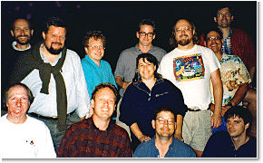
This is a snapshot taken at a barbecue that James Gosling threw for some of the folks associated with the Green Team. From left to right they are: Al Frazier, Joe Palrang, Mike Sheridan, Ed Frank, Don Jackson, Faye Baxter, Patrick Naughton, Chris Warth, James Gosling, Bob Weisblatt, David Lavallee, and Jon Payne.


History of Java
- Brief history of Java
- Java Version History
Java history is interesting to know. Java team members (also known as Green Team), initiated a revolutionary task to develop a language for digital devices such as set-top boxes, televisions etc.
For the green team members, it was an advance concept at that time. But, it was suited for internet programming. Later, Java technology as incorporated by Netscape.

James Gosling
Currently, Java is used in internet programming, mobile devices, games, e-business solutions etc. There are given the major points that describes the history of java.
1) James Gosling, Mike Sheridan, and Patrick Naughton initiated the Java language project in June 1991. The small team of sun engineers called Green Team.
2) Originally designed for small, embedded systems in electronic appliances like set-top boxes.
3) Firstly, it was called "Greentalk" by James Gosling and file extension was .gt.
4) After that, it was called Oak and was developed as a part of the Green project.
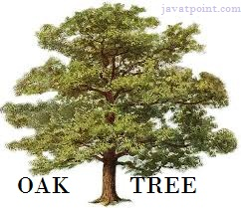

Why Oak name for java language?
5) Why Oak? Oak is a symbol of strength and choosen as a national tree of many countries like U.S.A., France, Germany, Romania etc.
6) In 1995, Oak was renamed as "Java" because it was already a trademark by Oak Technologies.

Why Java name for java language?
7) Why they choosed java name for java language? The team gathered to choose a new name. The suggested words were "dynamic", "revolutionary", "Silk", "jolt", "DNA" etc. They wanted something that reflected the essence of the technology: revolutionary, dynamic, lively, cool, unique, and easy to spell and fun to say.
According to James Gosling "Java was one of the top choices along with Silk". Since java was so unique, most of the team members preferred java.
8) Java is an island of Indonesia where first coffee was produced (called java coffee).
9) Notice that Java is just a name not an acronym.
10) Originally developed by James Gosling at Sun Microsystems (which is now a subsidiary of Oracle Corporation) and released in 1995.
11) In 1995, Time magazine called Java one of the Ten Best Products of 1995.
12) JDK 1.0 released in(January 23, 1996).

Java Version History
There are many java versions that has been released.
- JDK Alpha and Beta (1995)
- JDK 1.0 (23rd Jan, 1996)
- JDK 1.1 (19th Feb, 1997)
- J2SE 1.2 (8th Dec, 1998)
- J2SE 1.3 (8th May, 2000)
- J2SE 1.4 (6th Feb, 2002)
- J2SE 5.0 (30th Sep, 2004)
- Java SE 6 (11th Dec, 2006)
- Java SE 7 (28th July, 2011)

What is Java ? Why we need to Use?
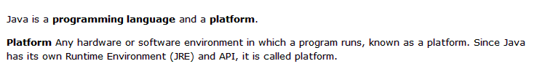
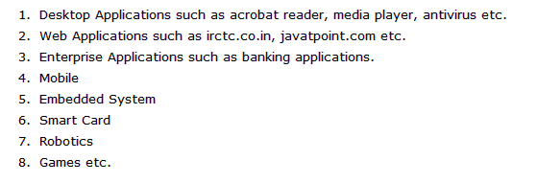

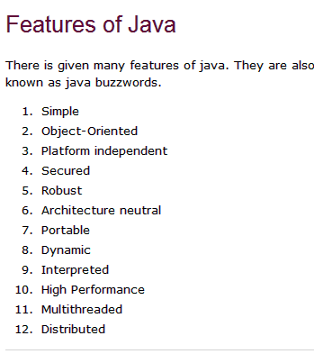Simple
According to Sun, Java language is simple because:
syntax is based on C++ (so easier for programmers to learn it after C++).
removed many confusing and/or rarely-used features e.g., explicit pointers, operator overloading etc.
No need to remove unreferenced objects because there is Automatic Garbage Collection in java.

Object-oriented
Object-oriented means we organize our software as a combination of different types of objects that incorporates both data and behaviour.
Object-oriented programming(OOPs) is a methodology that simplify software development and maintenance by providing some rules.
Basic concepts of OOPs are:
- Object
- Class
- Inheritance
- Polymorphism
- Abstraction
- Encapsulation

Platform Independent
A platform is the hardware or software environment in which a program runs. There are two types of platforms software-based and hardware-based. Java provides software-based platform. The Java platform differs from most other platforms in the sense that it's a software-based platform that runs on top of other hardware-based platforms.It has two components:
- Runtime Environment
- API(Application Programming Interface)

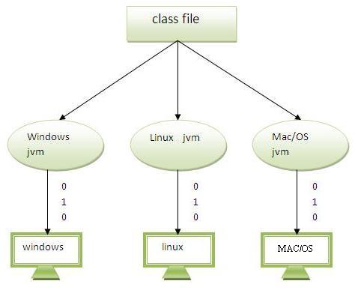Java code can be run on multiple platforms e.g.Windows,Linux,Sun Solaris,Mac/OS etc. Java code is compiled by the compiler and converted into bytecode.This bytecode is a platform independent code because it can be run on multiple platforms i.e. Write Once and Run Anywhere(WORA).

Secured
Java is secured because:
- No explicit pointer
- Programs run inside virtual machine sandbox.

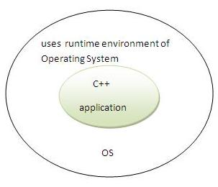 | 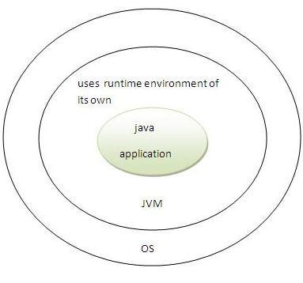

- Classloader- adds security by separating the package for the classes of the local file system from those that are imported from network sources.
- Bytecode Verifier- checks the code fragments for illegal code that can violate access right to objects.
- Security Manager- determines what resources a class can access such as reading and writing to the local disk.
These security are provided by java language. Some security can also be provided by application developer through SSL,JAAS,cryptography etc.

Robust
Robust simply means strong. Java uses strong memory management. There are lack of pointers that avoids security problem. There is automatic garbage collection in java. There is exception handling and type checking mechanism in java. All these points makes java robust.

Architecture-neutral
There is no implementation dependent features e.g. size of primitive types is set.

Portable
We may carry the java bytecode to any platform.

High-performance
Java is faster than traditional interpretation since byte code is "close" to native code still somewhat slower than a compiled language (e.g., C++)

Distributed
We can create distributed applications in java. RMI and EJB are used for creating distributed applications. We may access files by calling the methods from any machine on the internet.

Multi-threaded
A thread is like a separate program, executing concurrently. We can write Java programs that deal with many tasks at once by defining multiple threads. The main advantage of multi-threading is that it shares the same memory. Threads are important for multi-media, Web applications etc.

How the Way Java Works:-
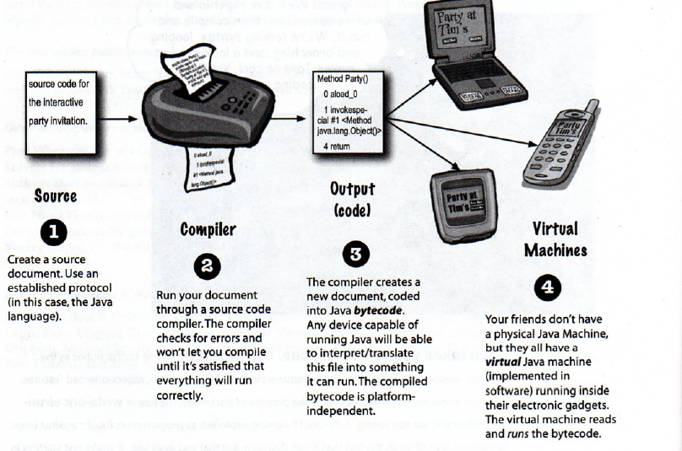
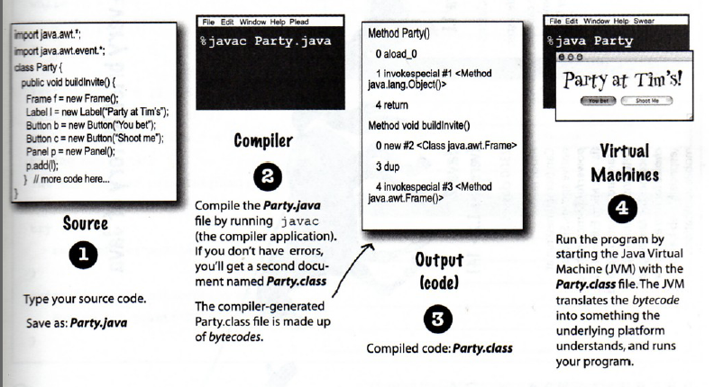
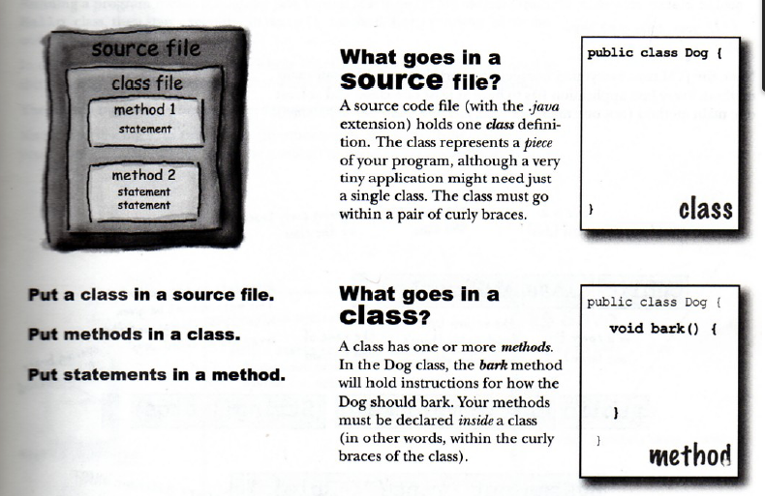
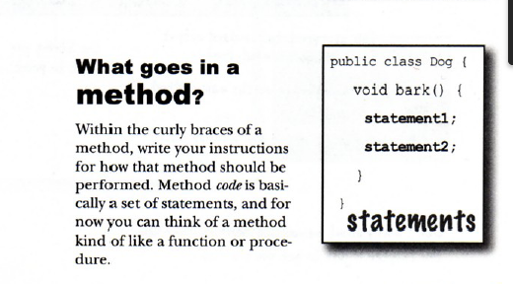
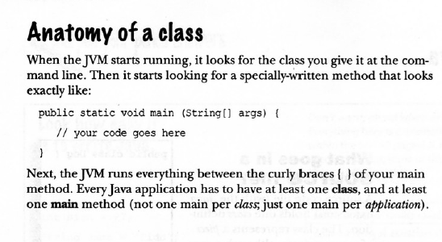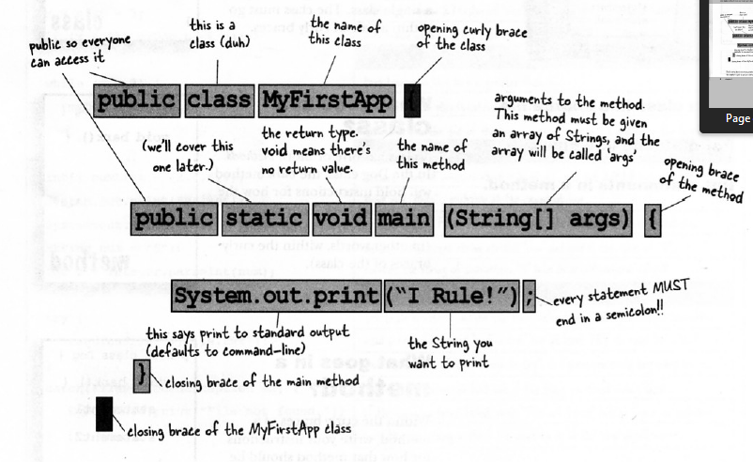
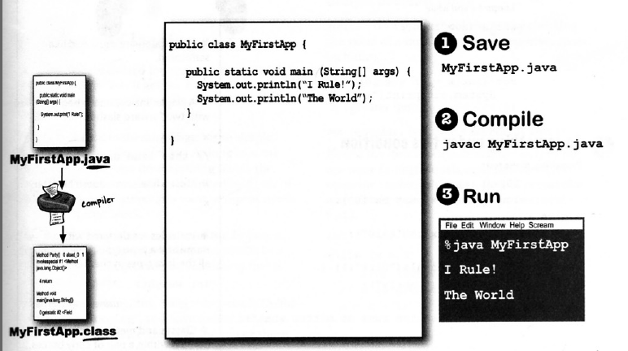
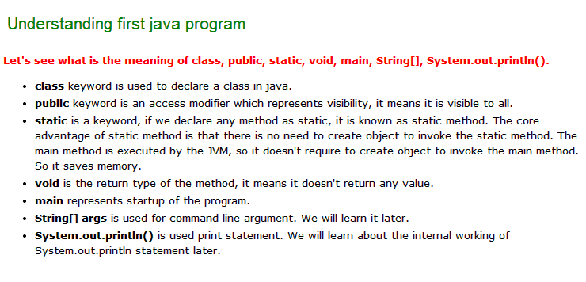
To compile and run the above program, go to your current directory first; my current directory is c:\new . Write here:

To compile: | javac Simple.java
To execute: | java Simple

How many ways, we can write a java program?
There are many ways to write a java program. The modifications that can be done in a java program are given below:
1)By changing sequence of the modifiers, method prototype is not changed.
Let's see the simple code of main method.
- static public void main(String args[])
2)subscript notation in java array can be used after type, before variable or after variable.
Let's see the different codes to write the main method.
- public static void main(String[] args)
- public static void main(String []args)
- public static void main(String args[])
3)You can provide var-args support to main method by passing 3 ellipses (dots)
Let's see the simple code of using var-args in main method. We will learn about var-args later in Java New Features chapter.
- public static void main(String... args)
4)Having semicolon at the end of class in java is optional.
Let's see the simple code.
- class A{
- static public void main(String... args){
- System.out.println("hello java4");
- }
- };
- 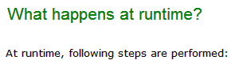
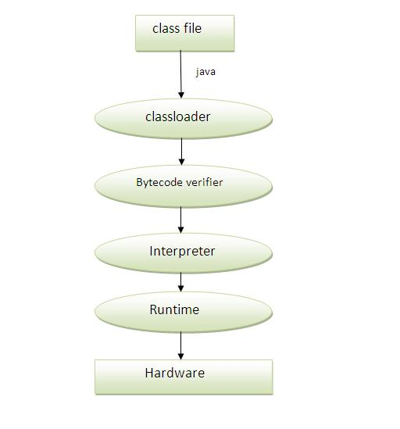

JVM:-
→JVM is the main component of Java architecture and it is the part of the JRE (Java Runtime Enviroment) . It provides the cross platform functionality to java.
→This is a software process that converts the compiled Java byte code to machine code. Byte code is an intermediary language between Java source and the host system. Most programming language like C and Pascal converts the source code into machine code for one specific type of machine as the machine language vary from system to system .
→ Mostly compiler produce code for a particular system but Java compiler produce code for a virtual machine . JVM provides security to java.
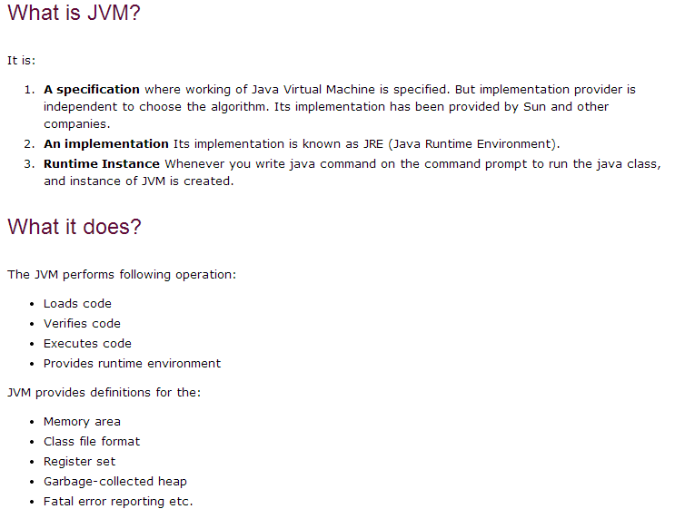

The JVM is not platform independent

The key here is that the JVM depends on the operating system – so if you are running Mac OS X you will have a different JVM than if you are running Windows or some other operating system.

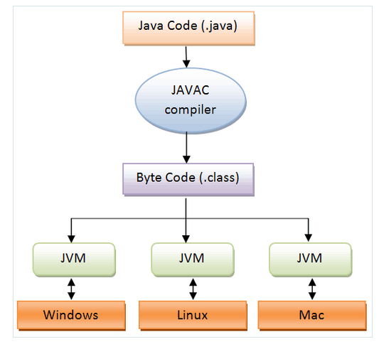
JVM Specification = Java programming language + Java Virtual Machine architecture + Java class-file format.
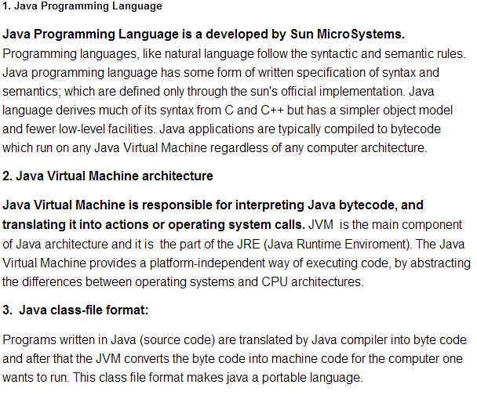
JRE[Java Runtime Environment]
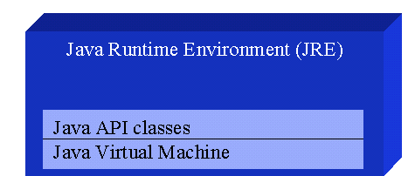

JVM Runtime Environment contains the two parts such as:
Java API classes: Java API classes are the predefined classes required for the program compilation and interpretation.
Java Virtual Machine: JVM is also a part of the JRE. The Java Virtual Machine is responsible for interpreting Java bytecode, and translating this into actions or operating system calls .

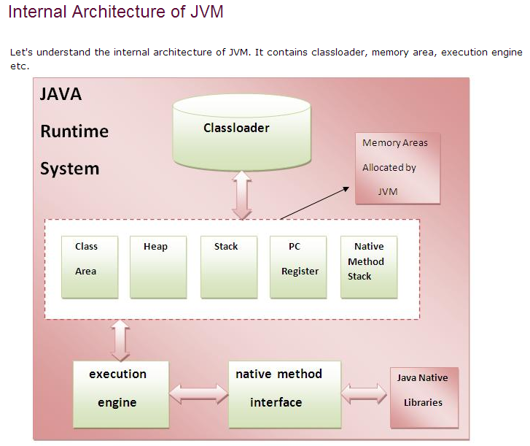

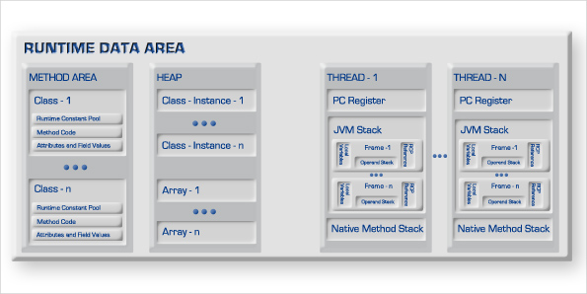

1) Classloader:
Classloader is a subsystem of JVM that is used to load class files.

2) Class(Method) Area:
Class(Method) Area stores per-class structures such as the runtime constant pool, field and method data, the code for methods.
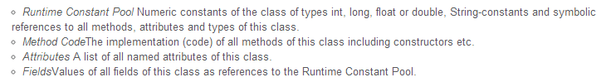

3) Heap:
→ It is the runtime data area in which objects are allocated.
→ Class instances and arrays are stored in heap memory. Heap memory is also called as shared memory. As this is the place where multiple threads will share the same data.
→The heap is created on virtual machine start-up. Heap storage for objects is reclaimed by an automatic storage management system (known as a garbage collector);

4) Java Stacks or Frames
→ Stack or Frames is used to store data and partial results, as well as to perform dynamic linking, return values for methods, and dispatch exceptions.
- Java stacks are created private to a thread.
→Each thread has a private JVM stack, created at the same time as thread.

→A new frame is created each time a method is invoked. A frame is destroyed when its method invocation completes

1) Local Variables
Each frame (§2.6) contains an array of variables known as its local variables. The length of the local variable array of a frame is determined at compile-time and supplied in the binary representation of a class or interface along with the code for the method associated with the frame (§4.7.3).
A single local variable can hold a value of type boolean, byte, char, short, int, float, reference, or returnAddress. A pair of local variables can hold a value of type long ordouble.

2) Operand Stacks
Each frame (§2.6) contains a last-in-first-out (LIFO) stack known as its operand stack. The maximum depth of the operand stack of a frame is determined at compile-time and is supplied along with the code for the method associated with the frame (§4.7.3).

3) Dynamic Linking
Each frame (§2.6) contains a reference to the run-time constant pool (§2.5.5) for the type of the current method to support dynamic linking of the method code. The class file code for a method refers to methods to be invoked and variables to be accessed via symbolic references. Dynamic linking translates these symbolic method references into concrete method references, loading classes as necessary to resolve as-yet-undefined symbols, and translates variable accesses into appropriate offsets in storage structures associated with the run-time location of these variables.
This late binding of the methods and variables makes changes in other classes that a method uses less likely to break this code.

5) The pc Register

→ PC (program counter) register. It contains the address of the Java virtual machine instruction currently being executed.
→ The Java Virtual Machine can support many threads of execution at once (JLS §17). Each Java Virtual Machine thread has its own pc (program counter) register. At any point, each Java Virtual Machine thread is executing the code of a single method, namely the current method (§2.6) for that thread. If that method is not native, the pc register contains the address of the Java Virtual Machine instruction currently being executed. If the method currently being executed by the thread is native, the value of the Java Virtual Machine's pcregister is undefined. The Java Virtual Machine's pc register is wide enough to hold a returnAddress or a native pointer on the specific platform.

6) Native Method Stack:
→ It contains all the native methods used in the application.
→ An implementation of the Java Virtual Machine may use conventional stacks, colloquially called "C stacks," to support native methods (methods written in a language other than the Java programming language).
→ This specification permits native method stacks either to be of a fixed size or to dynamically expand and contract as required by the computation. If the native method stacks are of a fixed size, the size of each native method stack may be chosen independently when that stack is created.
→ The following exceptional conditions are associated with native method stacks:
- If the computation in a thread requires a larger native method stack than is permitted, the Java Virtual Machine throws a StackOverflowError.
- If native method stacks can be dynamically expanded and native method stack expansion is attempted but insufficient memory can be made available, or if insufficient memory can be made available to create the initial native method stack for a new thread, the Java Virtual Machine throws an OutOfMemoryError.
7) Execution Engine:
It contains:
1) A virtual processor
2) Interpreter:Read bytecode stream then execute the instructions.
3) Just-In-Time(JIT) compiler:It is used to improve the performance.JIT compiles parts of the byte code that have similar functionality at the same time, and hence reduces the amount of time needed for compilation.Here the term ?compiler? refers to a translator from the instruction set of a Java virtual machine (JVM) to the instruction set of a specific CPU.
- The JIT compiler has been introduced to compensate for the disadvantages of the interpreter. The execution engine runs as an interpreter first, and at the appropriate time, the JIT compiler compiles the entire bytecode to change it to native code. After that, the execution engine no longer interprets the method, but directly executes using native code. Execution in native code is much faster than interpreting instructions one by one. The compiled code can be executed quickly since the native code is stored in the cache.
However, it takes more time for JIT compiler to compile the code than for the interpreter to interpret the code one by one. Therefore, if the code is to be executed just once, it is better to interpret it instead of compiling. Therefore, the JVMs that use the JIT compiler internally check how frequently the method is executed and compile the method only when the frequency is higher than a certain level.
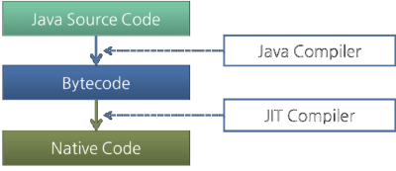

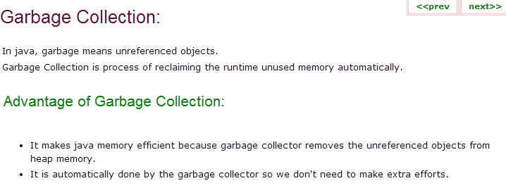
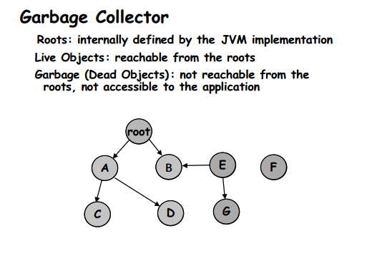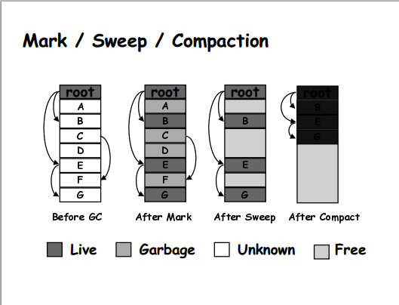
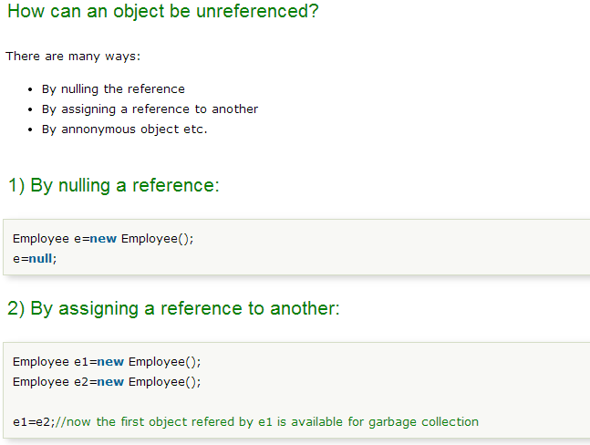
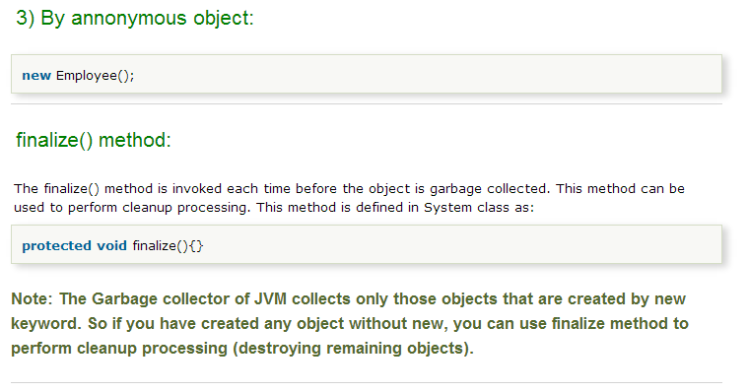
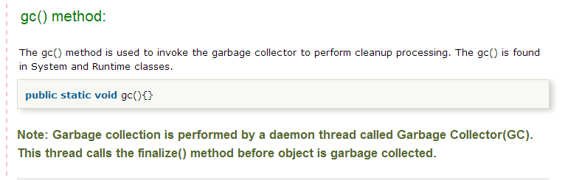
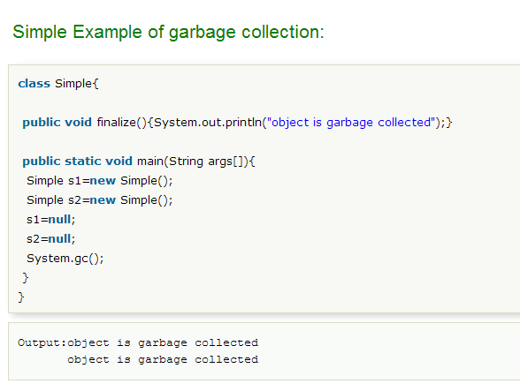

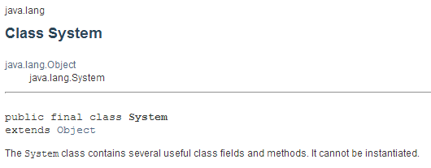
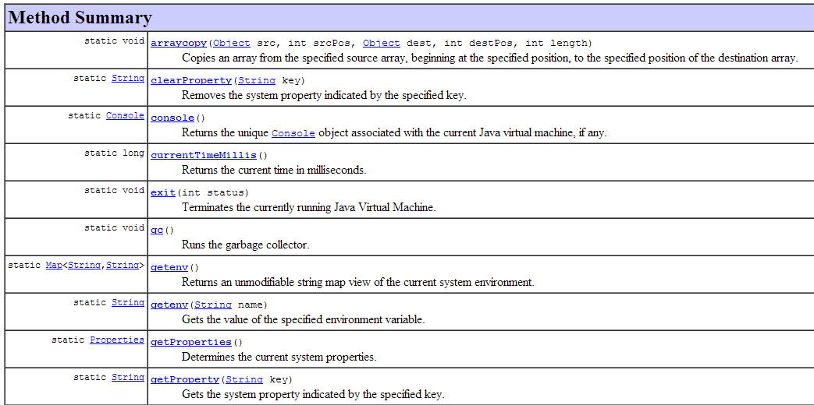
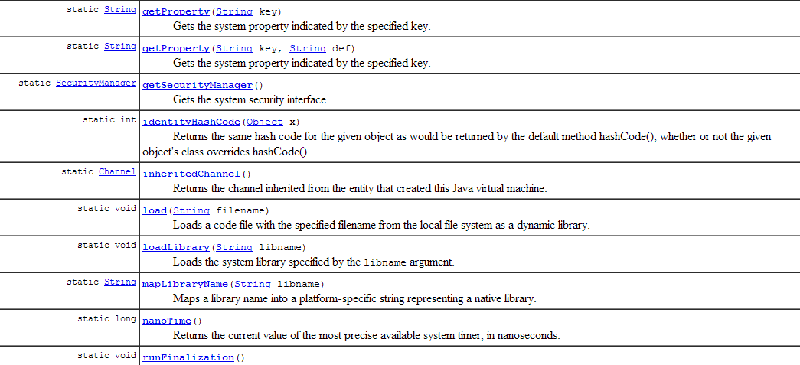

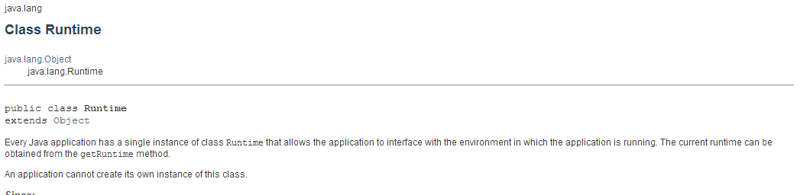
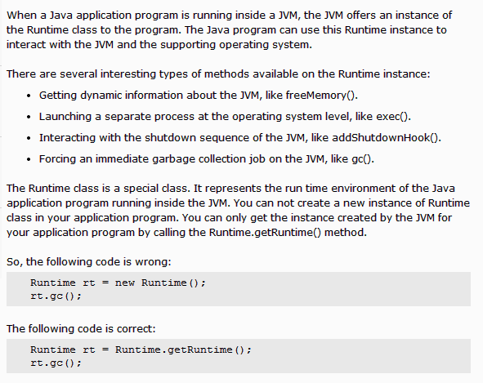

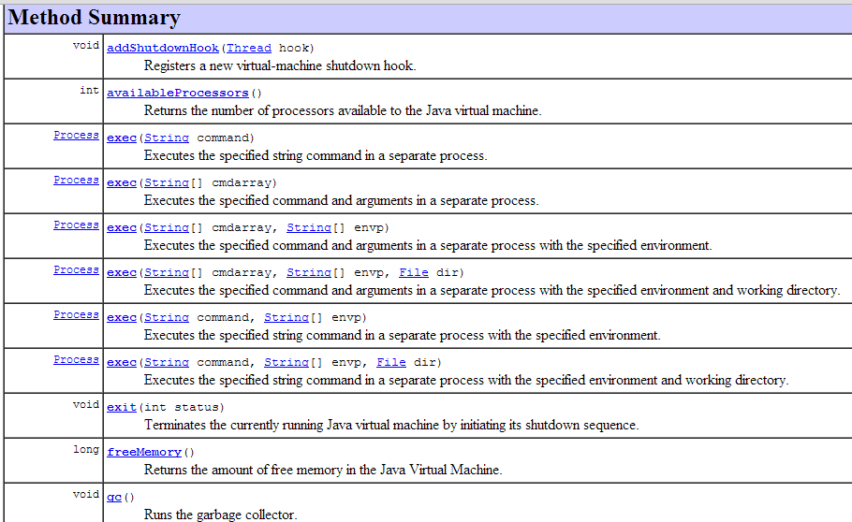
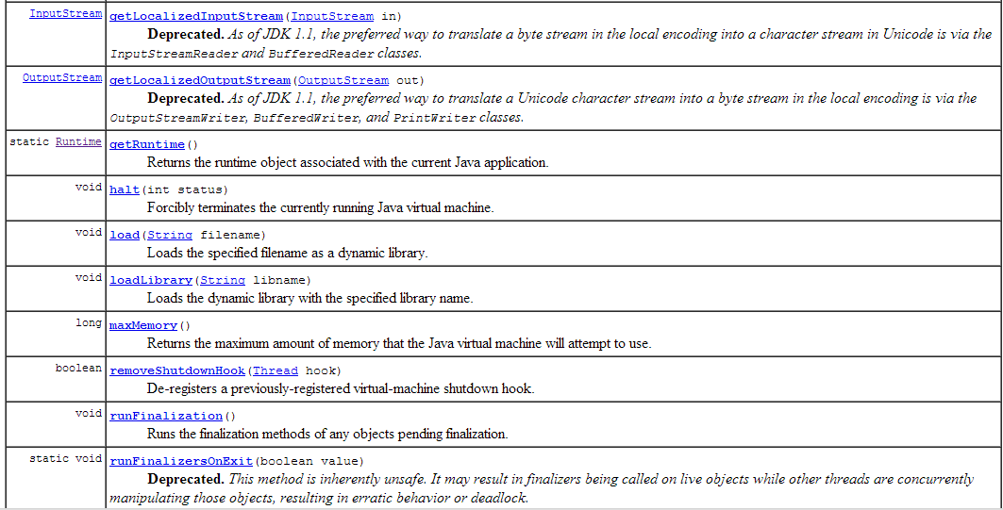

Difference between the JDK,JRE,JVM
JDK = JRE + development tools.
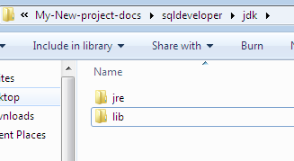
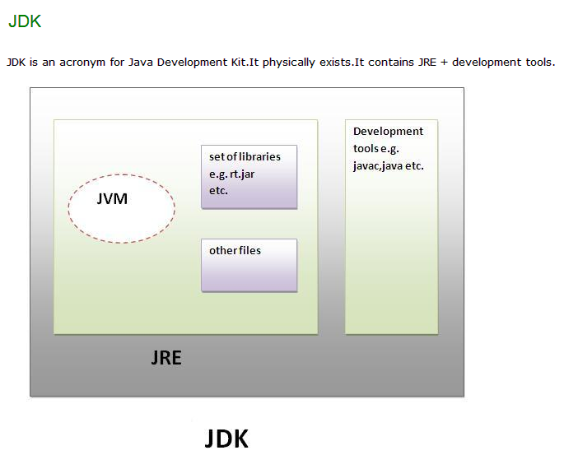
JRE=It contains set of libraries + other files that JVM uses at runtime.
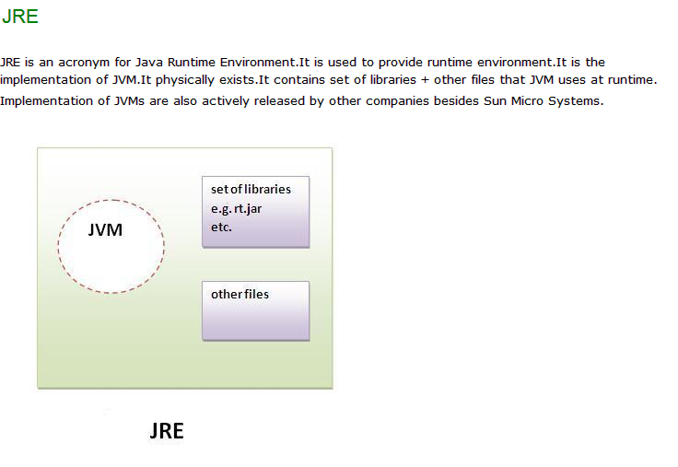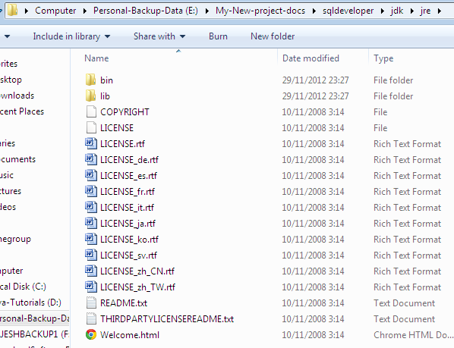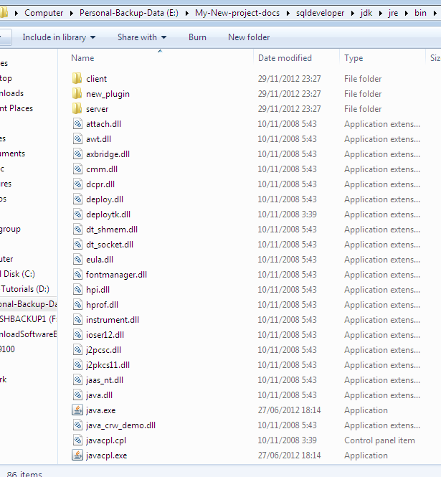
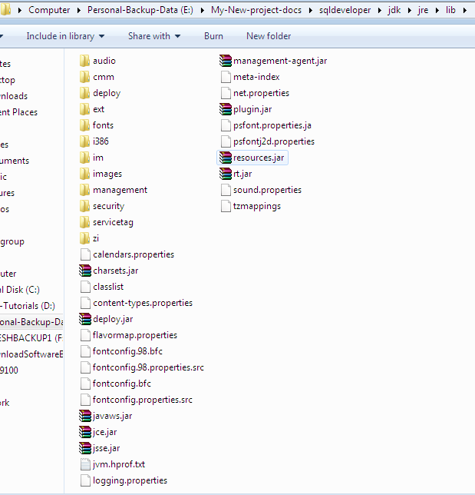

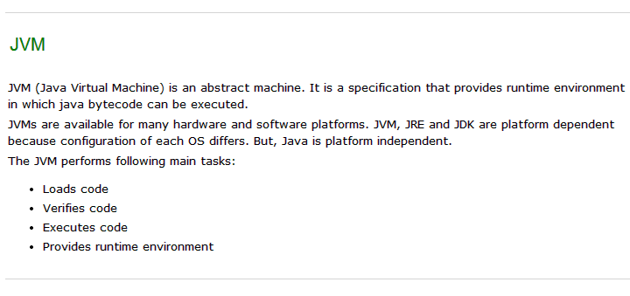
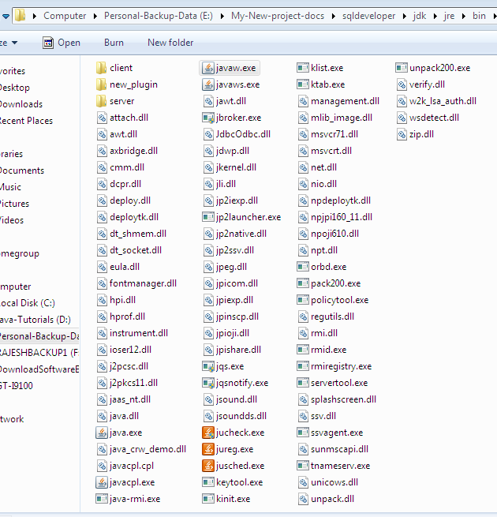

Variable and Datatype in Java:-
- Variable is a name of memory location
- There are three types of variables: local, instance and static.
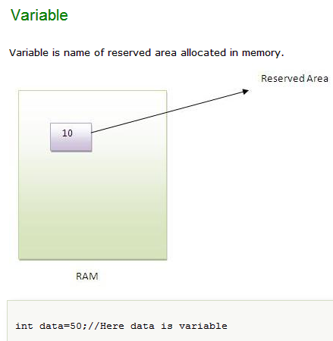
Types of Variable
There are three types of variables in java
- local variable
- instance variable
- static variable

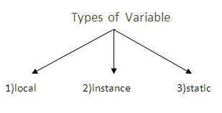

Local Variable
- A variable that is declared inside the method is called local variable.

Instance Variable
- A variable that is declared inside the class but outside the method is called instance variable. It is not declared as static.

Static variable
A variable that is declared as static is called static variable. It cannot be local.
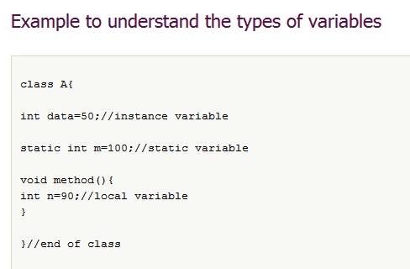

Data Types in Java
In java, there are two types of data types
- primitive data types
- non-primitive data types
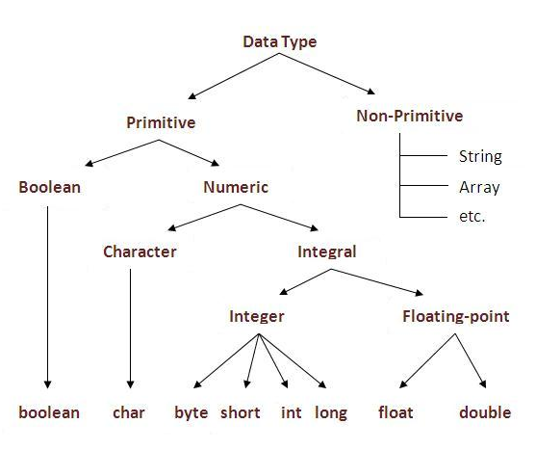

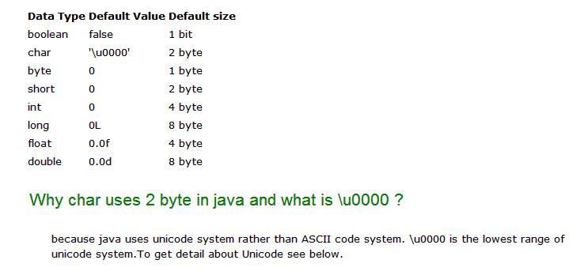

Object and Class in Java
In this page, we will learn about java objects and classes. In object-oriented programming technique, we design a program using objects and classes.
Object is the physical as well as logical entity whereas class is the logical entity only.

Object in Java
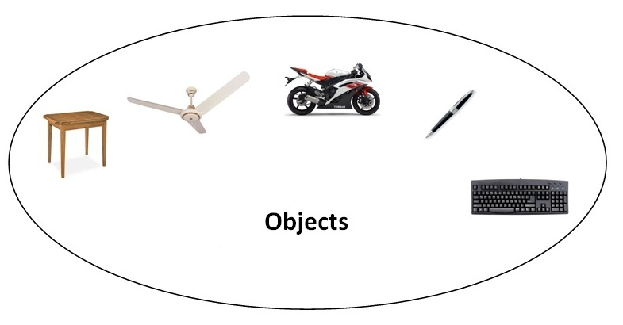
An entity that has state and behavior is known as an object e.g. chair, bike, marker, pen, table, car etc. It can be physical or logical (tangible and intangible). The example of intangible object is banking system.
An object has three characteristics:
- state: represents data (value) of an object.
- behavior: represents the behavior (functionality) of an object such as deposit, withdraw etc.
- identity: Object identity is typically implemented via a unique ID. The value of the ID is not visible to the external user. But, it is used internally by the JVM to identify each object uniquely.
For Example: Pen is an object. Its name is Reynolds, color is white etc. known as its state. It is used to write, so writing is its behavior.
Object is an instance of a class. Class is a template or blueprint from which objects are created. So object is the instance(result) of a class.
Object Definitions:
- Object is a real world entity.
- Object is a run time entity.
- Object is an entity which has state and behavior.
- Object is an instance of a class.

Class Object
- java.lang.Object

public class Object
Class Object is the root of the class hierarchy. Every class has Object as a superclass. All objects, including arrays, implement the methods of this class.
Since:
JDK1.0
See Also:
Class

Constructor Summary
Constructors
Constructor and Description
Object()

Method Summary
All MethodsInstance MethodsConcrete Methods
Modifier and Type | Method and Description
protected Object | clone()  Creates and returns a copy of this object.
boolean | equals(Object obj)  Indicates whether some other object is "equal to" this one.
protected void | finalize()  Called by the garbage collector on an object when garbage collection determines that there are no more references to the object.
Class<?> | getClass()  Returns the runtime class of this Object.
int | hashCode()  Returns a hash code value for the object.
void | notify()  Wakes up a single thread that is waiting on this object's monitor.
void | notifyAll()  Wakes up all threads that are waiting on this object's monitor.
String | toString()  Returns a string representation of the object.
void | wait()  Causes the current thread to wait until another thread invokes the notify() method or thenotifyAll() method for this object.
void | wait(long timeout)  Causes the current thread to wait until either another thread invokes the notify() method or thenotifyAll() method for this object, or a specified amount of time has elapsed.
void | wait(long timeout, int nanos)  Causes the current thread to wait until another thread invokes the notify() method or thenotifyAll() method for this object, or some other thread interrupts the current thread, or a certain amount of real time has elapsed.

Constructor Detail

Object
public Object()

5 Different Ways to Create Objects in Java
followed by bytecode of the line which is creating the object.
Using new keyword | } → constructor gets called
Using newInstance() method of Class class | } → constructor gets called
Using newInstance() method of Constructor class | } → constructor gets called
Using clone() method | } → no constructor call
Using deserialization | } → no constructor call
1. Using new keywords: It is the most common and regular way to create an object and a very simple one also. By using this method we can call whichever constructor we want to call (no-arg constructor as well as parameterized).
Employee emp1 = new Employee();

0: new #19 // class org/programming/mitra/exercises/Employee
3: dup
4: invokespecial #21 // Method org/programming/mitra/exercises/Employee."":()V
2. Using newInstance() method of Class class: We can also use the newInstance() method of a Class class to create an object. This newInstance() method calls the no-arg constructor to create the object.
We can create an object by newInstance() in the following way:
Employee emp2 = (Employee) Class.forName("org.programming.mitra.exercises.Employee").newInstance();
Or:
Employee emp2 = Employee.class.newInstance();

51: invokevirtual #70 // Method java/lang/Class.newInstance:()Ljava/lang/Object;
3. Using newInstance() method of Constructor class: Similar to the newInstance() method of a Class, there is one newInstance() method in the java.lang.reflect.Constructor class, which we can use to create objects. We can also call a parameterized constructor and private constructor by using this newInstance() method.
Constructor<Employee> constructor = Employee.class.getConstructor();
Employee emp3 = constructor.newInstance();

111: invokevirtual #80 // Method java/lang/reflect/Constructor.newInstance:([Ljava/lang/Object;)Ljava/lang/Object;
Both these newInstance() methods are known as reflective ways to create objects. In fact, the newInstance() method of a Class internally uses the newInstance() method of the Constructor class. That's why the latter is prefered and used by different frameworks like Spring, Hibernate, Struts, etc. To understand the differences between these two newInstance() methods, read Creating objects through Reflection in Java with Example.
4. Using clone() method: Whenever we call clone() on any object, the JVM actually creates a new object for us and copies all content of the previous object into it. Creating an object using the clone method does not invoke any constructor.
To use clone() method on an object we need to implement Cloneable and define the clone() method in it.
Employee emp4 = (Employee) emp3.clone();

162: invokevirtual #87 // Method org/programming/mitra/exercises/Employee.clone ()Ljava/lang/Object;
5. Using deserialization: Whenever we serialize and deserialize an object, the JVM creates a separate object for us. In deserialization, the JVM doesn’t use any constructor to create the object.
To deserialize an object we need to implement a Serializable interface in our class.
ObjectInputStream in = new ObjectInputStream(new FileInputStream("data.obj"));
Employee emp5 = (Employee) in.readObject();

261: invokevirtual #118 // Method java/io/ObjectInputStream.readObject:()Ljava/lang/Object;
As we can see in the above bytecode snippets, all 4 methods are called and get converted to invokevirtual (object creation is directly handled by these methods) except the first one, which got converted to two calls: one is new and other is invokespecial (call to constructor).

Class in Java
A class is a group of objects which have common properties. It is a template or blueprint from which objects are created. It is a logical entity. It can't be physical.
A class in Java can contain:
- fields
- methods
- constructors
- blocks
- nested class and interface

Syntax to declare a class:
- class <class_name>{
- field;
- method;
- }

Instance variable in Java
A variable which is created inside the class but outside the method, is known as instance variable. Instance variable doesn't get memory at compile time. It gets memory at run time when object(instance) is created. That is why, it is known as instance variable.

Method in Java
In java, a method is like function i.e. used to expose behavior of an object.

Advantage of Method
- Code Reusability
- Code Optimization

new keyword in Java
The new keyword is used to allocate memory at run time. All objects get memory in Heap memory area.

Object and Class Example: main within class
In this example, we have created a Student class that have two data members id and name. We are creating the object of the Student class by new keyword and printing the objects value.
Here, we are creating main() method inside the class.
File: Student.java
- class Student{
- int id;//field or data member or instance variable
- String name;

- public static void main(String args[]){
- Student s1=new Student();//creating an object of Student
- System.out.println(s1.id);//accessing member through reference variable
- System.out.println(s1.name);
- }
- }
Test it Now
Output:
0
null

Object and Class Example: main outside class
In real time development, we create classes and use it from another class. It is a better approach than previous one. Let's see a simple example, where we are having main() method in another class.
We can have multiple classes in different java files or single java file. If you define multiple classes in a single java source file, it is a good idea to save the file name with the class name which has main() method.
File: TestStudent1.java
- class Student{
- int id;
- String name;
- }
- class TestStudent1{
- public static void main(String args[]){
- Student s1=new Student();
- System.out.println(s1.id);
- System.out.println(s1.name);
- }
- }
Test it Now
Output:
0
null

3 Ways to initialize object
There are 3 ways to initialize object in java.
- By reference variable
- By method
- By constructor

1) Object and Class Example: Initialization through reference
Initializing object simply means storing data into object. Let's see a simple example where we are going to initialize object through reference variable.
File: TestStudent2.java
- class Student{
- int id;
- String name;
- }
- class TestStudent2{
- public static void main(String args[]){
- Student s1=new Student();
- s1.id=101;
- s1.name="Sonoo";
- System.out.println(s1.id+" "+s1.name);//printing members with a white space
- }
- }
Test it Now
Output:
101 Sonoo
We can also create multiple objects and store information in it through reference variable.
File: TestStudent3.java
- class Student{
- int id;
- String name;
- }
- class TestStudent3{
- public static void main(String args[]){
- //Creating objects
- Student s1=new Student();
- Student s2=new Student();
- //Initializing objects
- s1.id=101;
- s1.name="Sonoo";
- s2.id=102;
- s2.name="Amit";
- //Printing data
- System.out.println(s1.id+" "+s1.name);
- System.out.println(s2.id+" "+s2.name);
- }
- }
Test it Now
Output:
101 Sonoo
102 Amit

2) Object and Class Example: Initialization through method
In this example, we are creating the two objects of Student class and initializing the value to these objects by invoking the insertRecord method. Here, we are displaying the state (data) of the objects by invoking the displayInformation() method.
File: TestStudent4.java
- class Student{
- int rollno;
- String name;
- void insertRecord(int r, String n){
- rollno=r;
- name=n;
- }
- void displayInformation(){System.out.println(rollno+" "+name);}
- }
- class TestStudent4{
- public static void main(String args[]){
- Student s1=new Student();
- Student s2=new Student();
- s1.insertRecord(111,"Karan");
- s2.insertRecord(222,"Aryan");
- s1.displayInformation();
- s2.displayInformation();
- }
- }
Test it Now
Output:
111 Karan
222 Aryan
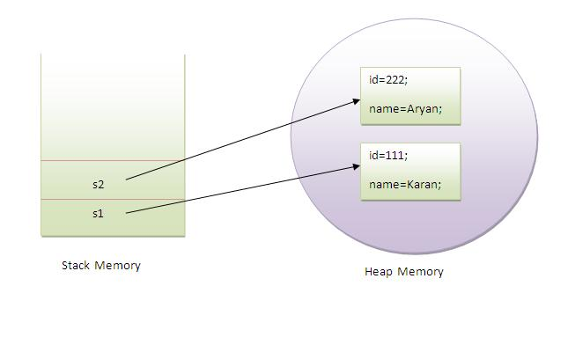
As you can see in the above figure, object gets the memory in heap memory area. The reference variable refers to the object allocated in the heap memory area. Here, s1 and s2 both are reference variables that refer to the objects allocated in memory.

3) Object and Class Example: Initialization through constructor
We will learn about constructors in java later.

Object and Class Example: Employee
Let's see an example where we are maintaining records of employees.
File: TestEmployee.java
- class Employee{
- int id;
- String name;
- float salary;
- void insert(int i, String n, float s) {
- id=i;
- name=n;
- salary=s;
- }
- void display(){System.out.println(id+" "+name+" "+salary);}
- }
- public class TestEmployee {
- public static void main(String[] args) {
- Employee e1=new Employee();
- Employee e2=new Employee();
- Employee e3=new Employee();
- e1.insert(101,"ajeet",45000);
- e2.insert(102,"irfan",25000);
- e3.insert(103,"nakul",55000);
- e1.display();
- e2.display();
- e3.display();
- }
- }
Test it Now
Output:
101 ajeet 45000.0
102 irfan 25000.0
103 nakul 55000.0

Object and Class Example: Rectangle
There is given another example that maintains the records of Rectangle class.
File: TestRectangle1.java
- class Rectangle{
- int length;
- int width;
- void insert(int l, int w){
- length=l;
- width=w;
- }
- void calculateArea(){System.out.println(length*width);}
- }
- class TestRectangle1{
- public static void main(String args[]){
- Rectangle r1=new Rectangle();
- Rectangle r2=new Rectangle();
- r1.insert(11,5);
- r2.insert(3,15);
- r1.calculateArea();
- r2.calculateArea();
- }
- }
Test it Now
Output:
55
45

What are the different ways to create an object in Java?
There are many ways to create an object in java. They are:
- By new keyword
- By newInstance() method
- By clone() method
- By deserialization
- By factory method etc.
We will learn these ways to create object later.

Anonymous object
Anonymous simply means nameless. An object which has no reference is known as anonymous object. It can be used at the time of object creation only.
If you have to use an object only once, anonymous object is a good approach. For example:
- new Calculation();//anonymous object
Calling method through reference:
- Calculation c=new Calculation();
- c.fact(5);
Calling method through anonymous object
- new Calculation().fact(5);
Let's see the full example of anonymous object in java.
- class Calculation{
- void fact(int n){
- int fact=1;
- for(int i=1;i<=n;i++){
- fact=fact*i;
- }
- System.out.println("factorial is "+fact);
- }
- public static void main(String args[]){
- new Calculation().fact(5);//calling method with anonymous object
- }
- }
Output:
Factorial is 120

Creating multiple objects by one type only
We can create multiple objects by one type only as we do in case of primitives.
Initialization of primitive variables:
- int a=10, b=20;
Initialization of refernce variables:
- Rectangle r1=new Rectangle(), r2=new Rectangle();//creating two objects
Let's see the example:
- class Rectangle{
- int length;
- int width;
- void insert(int l,int w){
- length=l;
- width=w;
- }
- void calculateArea(){System.out.println(length*width);}
- }
- class TestRectangle2{
- public static void main(String args[]){
- Rectangle r1=new Rectangle(),r2=new Rectangle();//creating two objects
- r1.insert(11,5);
- r2.insert(3,15);
- r1.calculateArea();
- r2.calculateArea();
- }
- }
Test it Now
Output:
55
45

Real World Example: Account
File: TestAccount.java
- class Account{
- int acc_no;
- String name;
- float amount;
- void insert(int a,String n,float amt){
- acc_no=a;
- name=n;
- amount=amt;
- }
- void deposit(float amt){
- amount=amount+amt;
- System.out.println(amt+" deposited");
- }
- void withdraw(float amt){
- if(amount<amt){
- System.out.println("Insufficient Balance");
- }else{
- amount=amount-amt;
- System.out.println(amt+" withdrawn");
- }
- }
- void checkBalance(){System.out.println("Balance is: "+amount);}
- void display(){System.out.println(acc_no+" "+name+" "+amount);}
- }

- class TestAccount{
- public static void main(String[] args){
- Account a1=new Account();
- a1.insert(832345,"Ankit",1000);
- a1.display();
- a1.checkBalance();
- a1.deposit(40000);
- a1.checkBalance();
- a1.withdraw(15000);
- a1.checkBalance();
- }}
Test it Now
Output:
832345 Ankit 1000.0
Balance is: 1000.0
40000.0 deposited
Balance is: 41000.0
15000.0 withdrawn
Balance is: 26000.0

