Exceptions:-

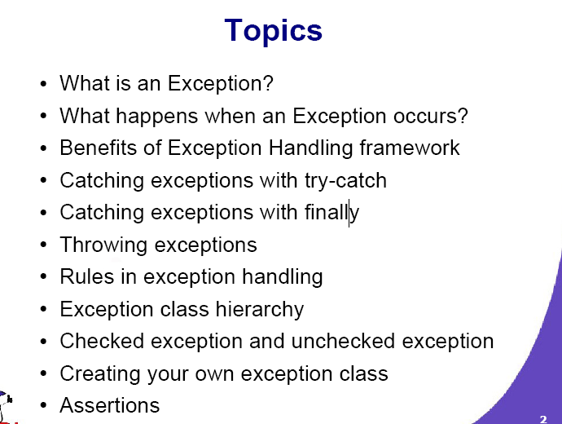

1.What is and EXCEPTION:-
Exceptions in java are any abnormal, unexpected events or extraordinary conditions that may occur at runtime.
including the following:
- A user has entered invalid data.
- A file that needs to be opened cannot be found.
- A network connection has been lost in the middle of communications, or the JVM has run out of memory.
Java Exceptions are basically Java objects.
What is an Exception?
● Exceptional event
● Error that occurs during runtime
● Cause normal program flow to be disrupted
● Examples
– Divide by zero errors
– Accessing the elements of an array beyond its range
– Invalid input
– Hard disk crash
– Opening a non-existent file
– Heap memory exhausted

java.lang.Object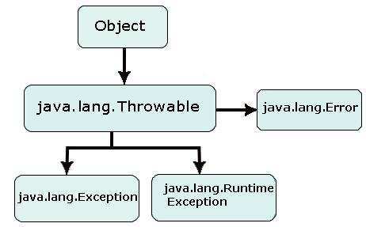
------------------ java.lang .Throwable

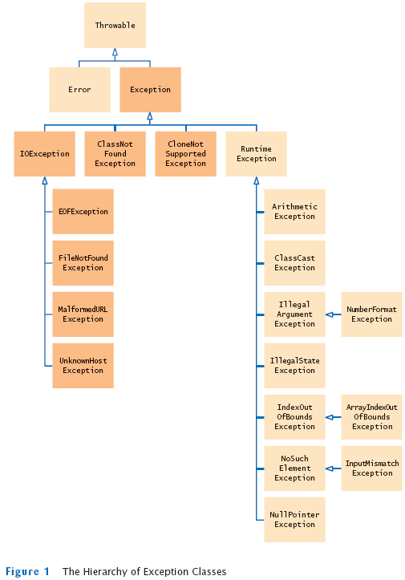
To understand how exception handling works in Java, you need to understand the three categories of exceptions:
- Checked exceptions: A checked exception is an exception that is typically a user error or a problem that cannot be foreseen by the programmer. For example, if a file is to be opened, but the file cannot be found, an exception occurs. These exceptions cannot simply be ignored at the time of compilation.
- Runtime exceptions: A runtime exception is an exception that occurs that probably could have been avoided by the programmer. As opposed to checked exceptions, runtime exceptions are ignored at the time of compliation.
- Errors: These are not exceptions at all, but problems that arise beyond the control of the user or the programmer. Errors are typically ignored in your code because you can rarely do anything about an error. For example, if a stack overflow occurs, an error will arise. They are also ignored at the time of compilation.

java.lang . Error
- java.lang.Object
- java.lang.Throwable
- java.lang.Error
- All Implemented Interfaces:
- Serializable
- Direct Known Subclasses:
- AssertionError, AWTError, CoderMalfunctionError, FactoryConfigurationError, LinkageError, ThreadDeath, TransformerFactoryConfigurationError, VirtualMachineError

java.lang
Class Exception
- java.lang.Object
- java.lang.Throwable
- java.lang.Exception
- All Implemented Interfaces:
- Serializable
- Direct Known Subclasses:
- AclNotFoundException, ActivationException, AlreadyBoundException, ApplicationException, AWTException, BackingStoreException, BadAttributeValueExpException, BadBinaryOpValueExpException, BadLocationException, BadStringOperationException, BrokenBarrierException, CertificateException, ClassNotFoundException, CloneNotSupportedException, DataFormatException, DatatypeConfigurationException, DestroyFailedException, ExecutionException, ExpandVetoException, FontFormatException, GeneralSecurityException, GSSException, IllegalAccessException, IllegalClassFormatException, InstantiationException, InterruptedException, IntrospectionException, InvalidApplicationException, InvalidMidiDataException, InvalidPreferencesFormatException, InvalidTargetObjectTypeException, InvocationTargetException, IOException, JAXBException, JMException, KeySelectorException, LastOwnerException, LineUnavailableException, MarshalException, MidiUnavailableException, MimeTypeParseException, MimeTypeParseException, NamingException, NoninvertibleTransformException, NoSuchFieldException, NoSuchMethodException, NotBoundException, NotOwnerException, ParseException, ParserConfigurationException, PrinterException, PrintException, PrivilegedActionException, PropertyVetoException, RefreshFailedException, RemarshalException, RuntimeException, SAXException, ScriptException, ServerNotActiveException, SOAPException, SQLException, TimeoutException, TooManyListenersException, TransformerException, TransformException, UnmodifiableClassException, UnsupportedAudioFileException, UnsupportedCallbackException, UnsupportedFlavorException, UnsupportedLookAndFeelException, URIReferenceException, URISyntaxException, UserException, XAException, XMLParseException, XMLSignatureException, XMLStreamException, XPathException

Exceptions Methods:
Following is the list of important medthods available in the Throwable class.
SN | Methods with Description
1 | public String getMessage()  Returns a detailed message about the exception that has occurred. This message is initialized in the Throwable constructor.
2 | public Throwable getCause()  Returns the cause of the exception as represented by a Throwable object.
3 | public String toString()  Returns the name of the class concatenated with the result of getMessage()
4 | public void printStackTrace()  Prints the result of toString() along with the stack trace to System.err, the error output stream.
5 | public StackTraceElement [] getStackTrace()  Returns an array containing each element on the stack trace. The element at index 0 represents the top of the call stack, and the last element in the array represents the method at the bottom of the call stack.
6 | public Throwable fillInStackTrace()  Fills the stack trace of this Throwable object with the current stack trace, adding to any previous information in the stack trace.

Example:
The following is an array is declared with 2 elements. Then the code tries to access the 3rd element of the array which throws an exception.
// File Name : ExcepTest.java
import java.io.*;
public class ExcepTest{

public static void main(String args[]){
try{
int a[] = new int[2];
System.out.println("Access element three :" + a[3]);
}catch(ArrayIndexOutOfBoundsException e){
System.out.println("Exception thrown :" + e);
}
System.out.println("Out of the block");
}
}
This would produce following result:
Exception thrown :java.lang.ArrayIndexOutOfBoundsException: 3
Out of the block

Catching Exceptions with try-catch:-
------------------------------------------------------.
Catching Exceptions:
The try-catch Statements
● Syntax:
try {
<code to be monitored for exceptions>
} catch (<ExceptionType1> <ObjName>) {
<handler if ExceptionType1 occurs>
} ...
} catch (<ExceptionTypeN> <ObjName>) {
<handler if ExceptionTypeN occurs>
}

