java.io
Interfaces
Closeable
DataInput
DataOutput
Externalizable
FileFilter
FilenameFilter
Flushable
ObjectInput
ObjectInputValidation
ObjectOutput
ObjectStreamConstants
Serializable

Classes
BufferedInputStream
BufferedOutputStream
BufferedReader
BufferedWriter
ByteArrayInputStream
ByteArrayOutputStream
CharArrayReader
CharArrayWriter
Console
DataInputStream
DataOutputStream
File
FileDescriptor
FileInputStream
FileOutputStream
FilePermission
FileReader
FileWriter
FilterInputStream
FilterOutputStream
FilterReader
FilterWriter
InputStream
InputStreamReader
LineNumberInputStream
LineNumberReader
ObjectInputStream
ObjectInputStream.GetField
ObjectOutputStream
ObjectOutputStream.PutField
ObjectStreamClass
ObjectStreamField
OutputStream
OutputStreamWriter
PipedInputStream
PipedOutputStream
PipedReader
PipedWriter
PrintStream
PrintWriter
PushbackInputStream
PushbackReader
RandomAccessFile
Reader
SequenceInputStream
SerializablePermission
StreamTokenizer
StringBufferInputStream
StringReader
StringWriter
Writer

Exceptions
CharConversionException
EOFException
FileNotFoundException
InterruptedIOException
InvalidClassException
InvalidObjectException
IOException
NotActiveException
NotSerializableException
ObjectStreamException
OptionalDataException
StreamCorruptedException
SyncFailedException
UnsupportedEncodingException
UTFDataFormatException
WriteAbortedException

Errors
IOError

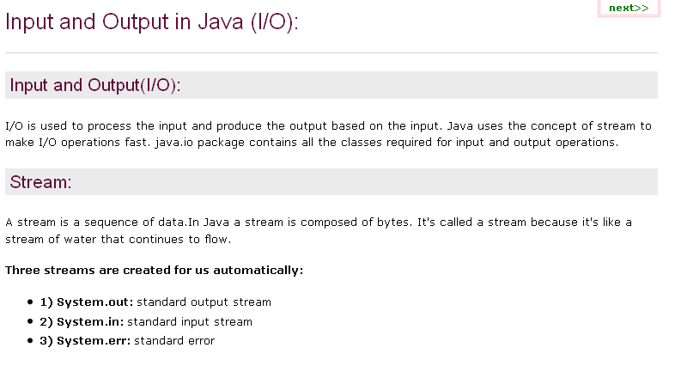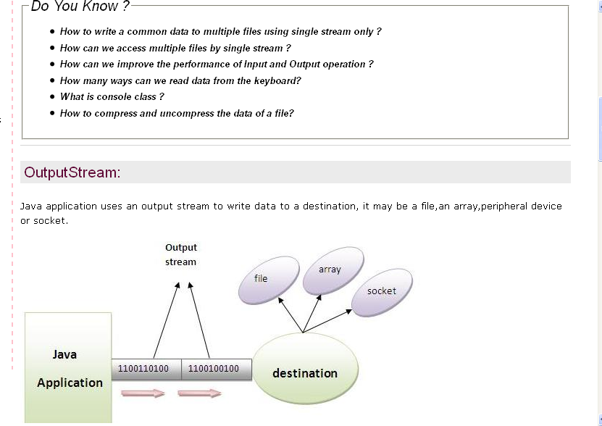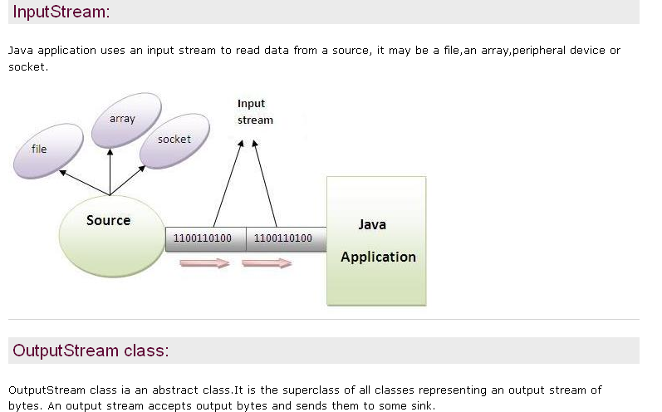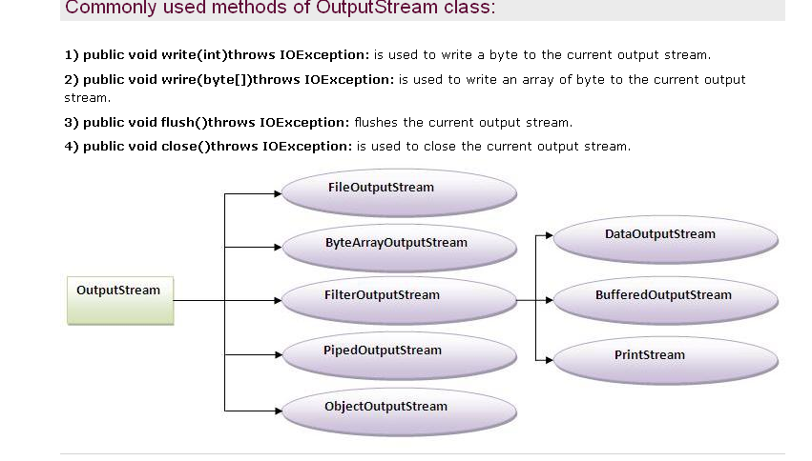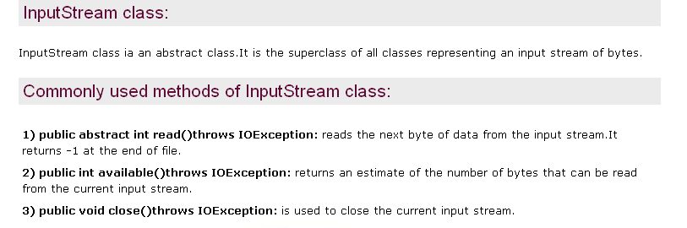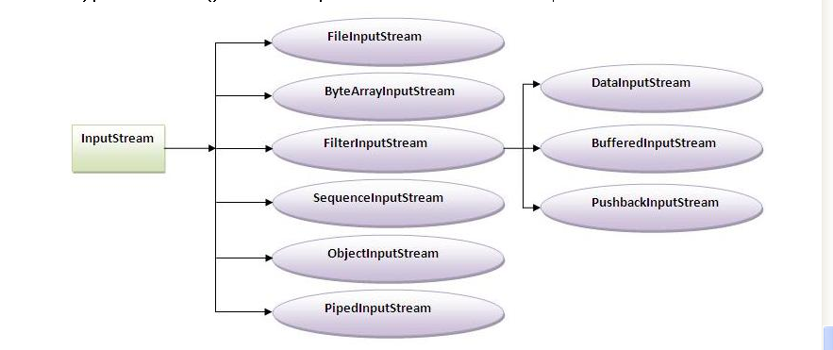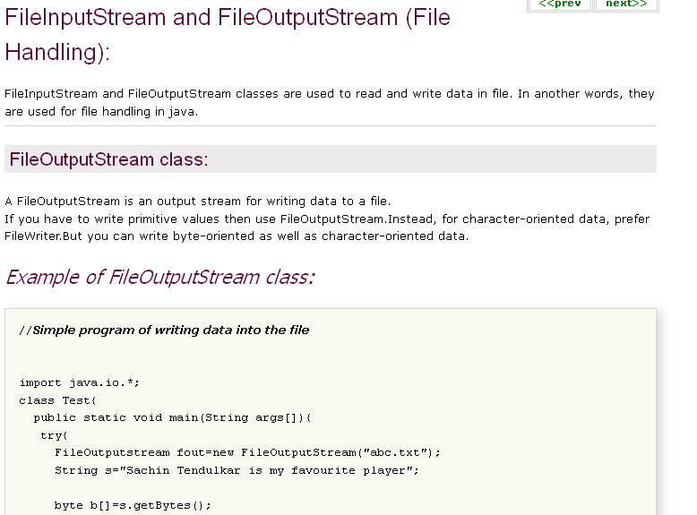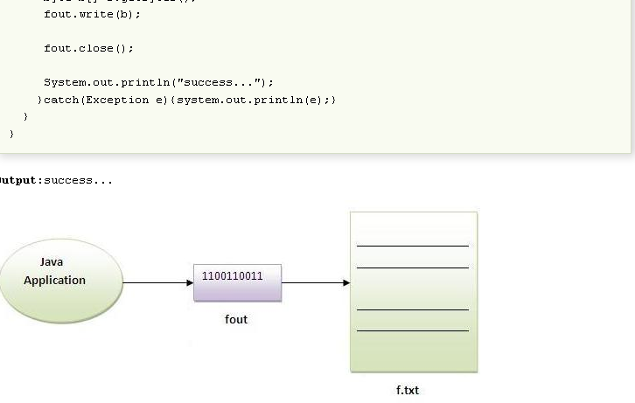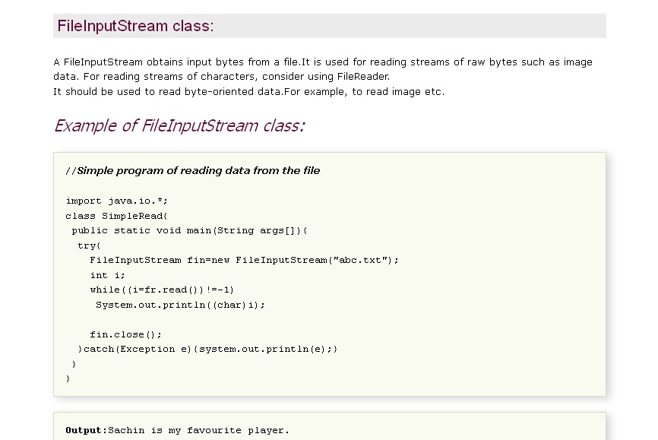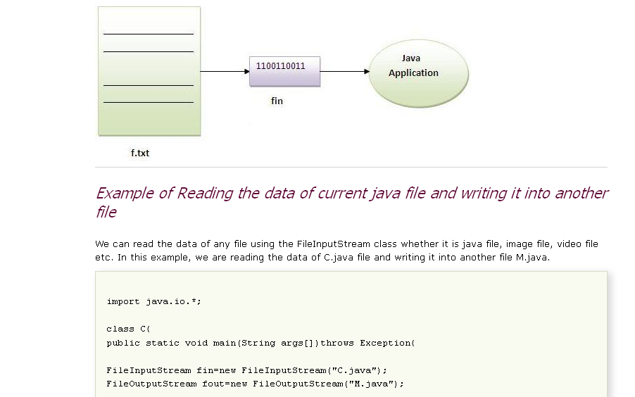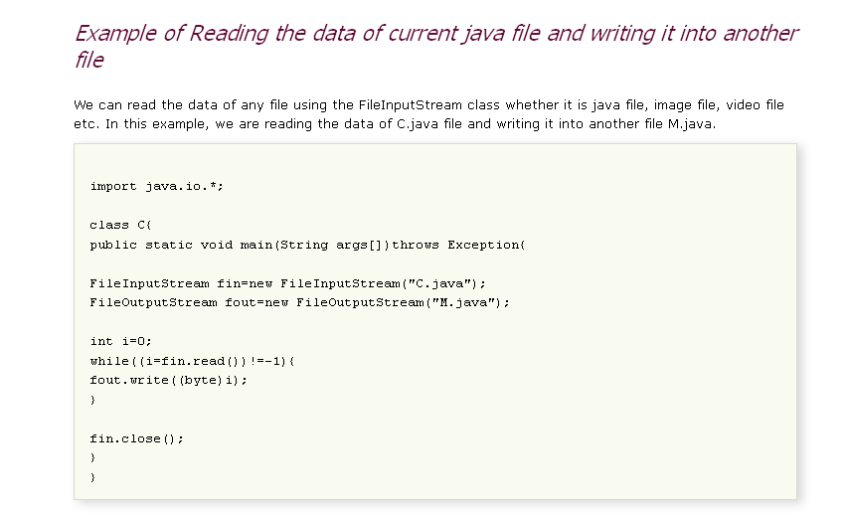
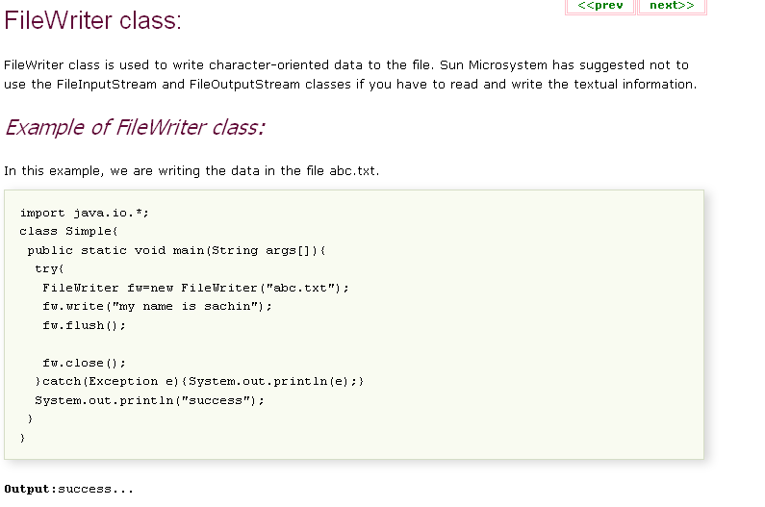

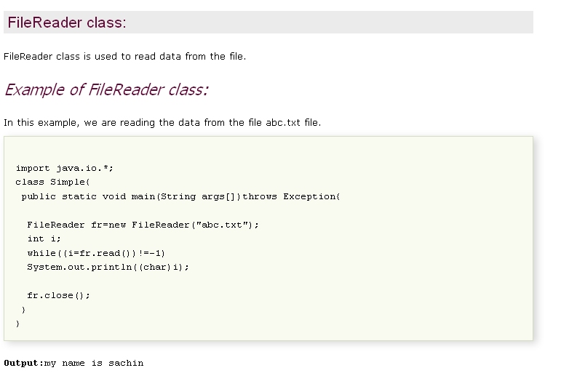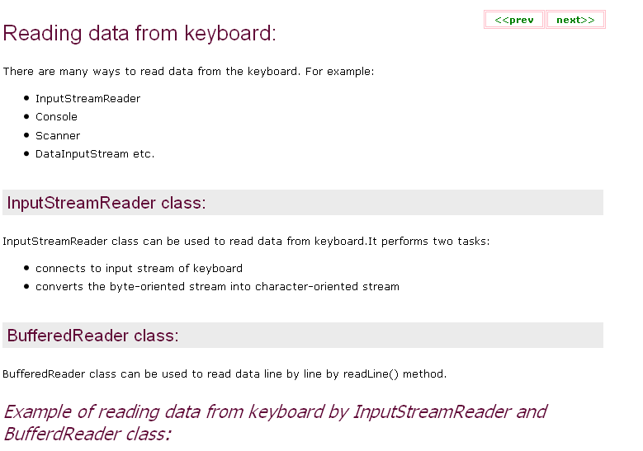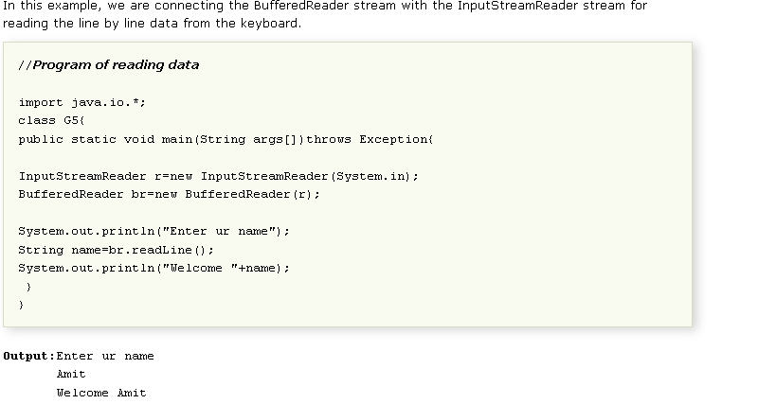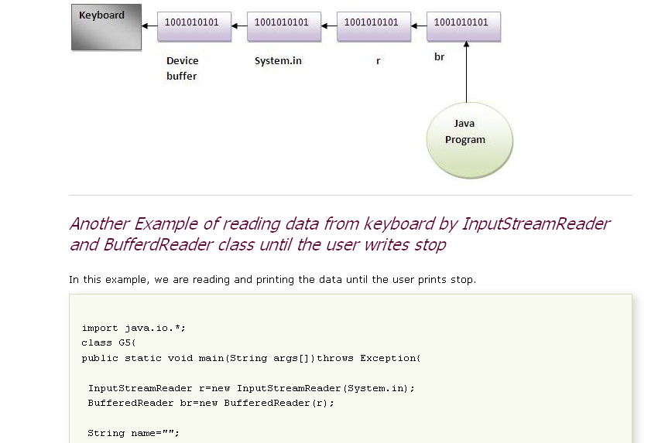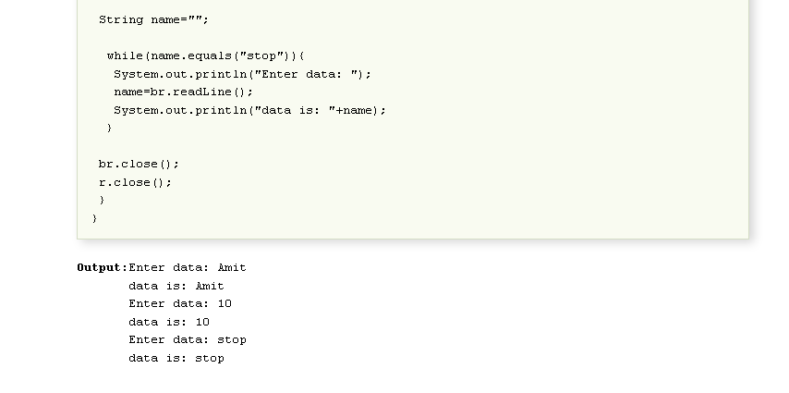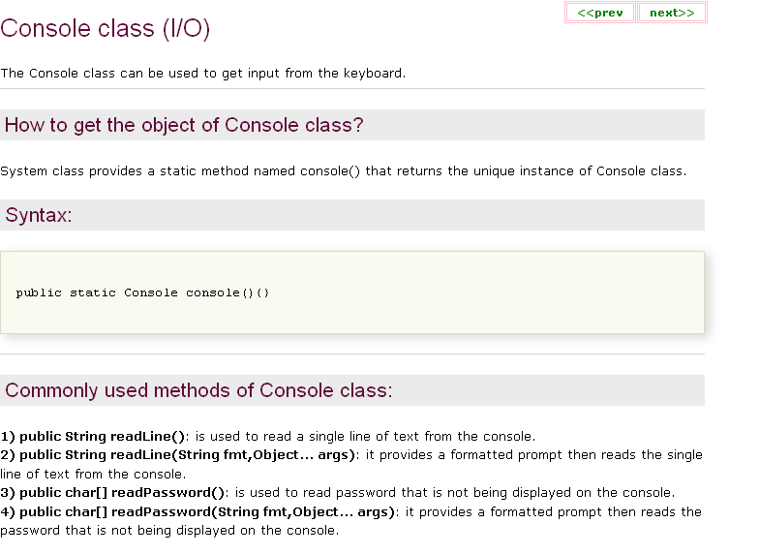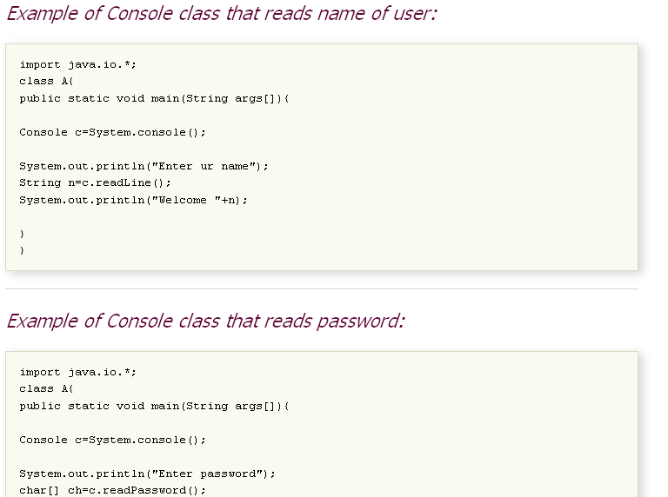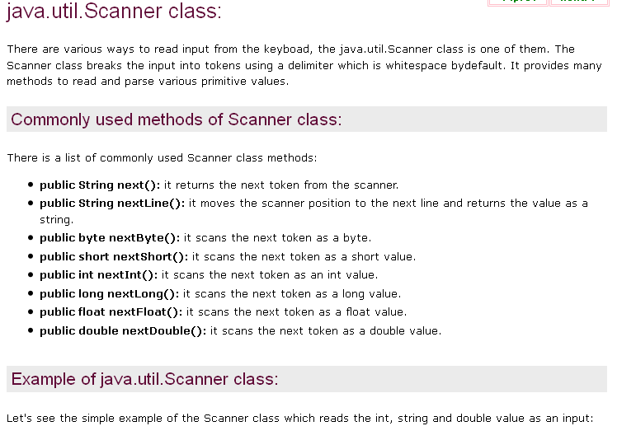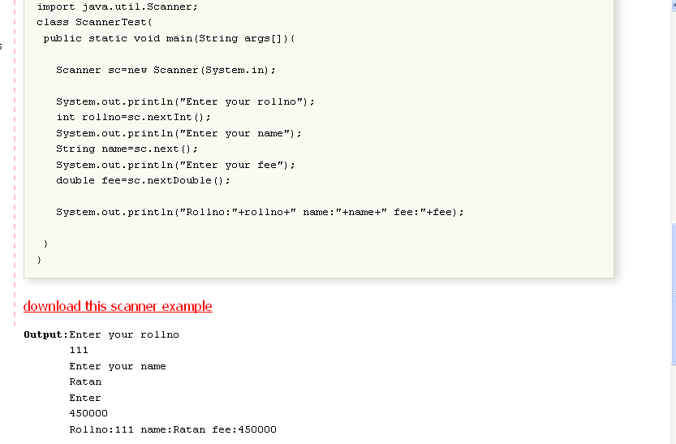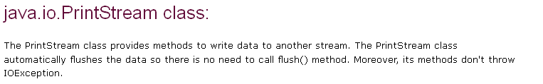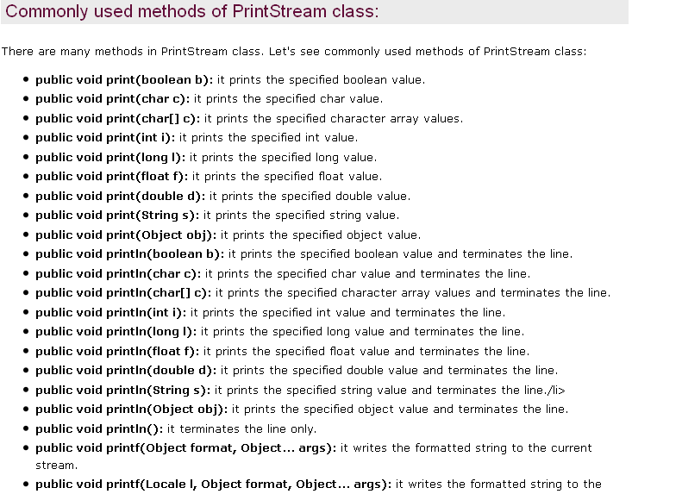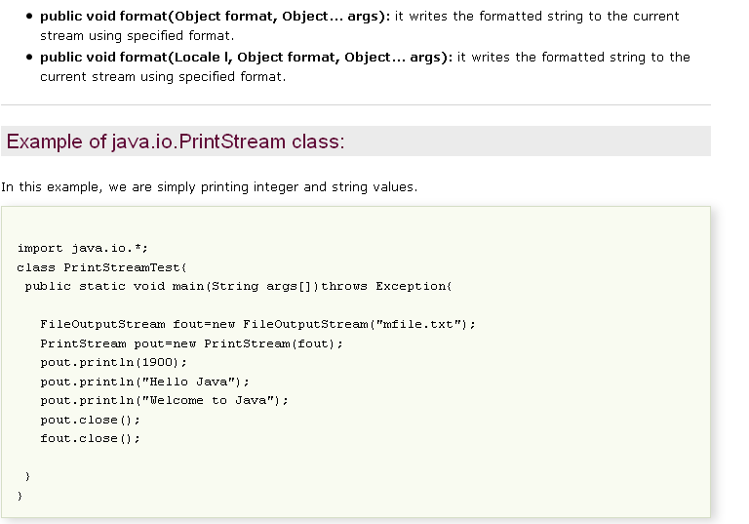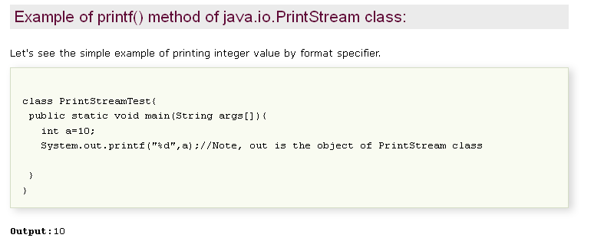Java file PrintWriter
This section demonstrates you the use of class PrintWriter.
PrintWriter prints formatted representations of objects to a text-output stream. In other words, you can say it enables to write formatted data to a writer. It implements all of the print methods found in PrintStream and does not contain methods for writing bytes. For instance, writing int, long and other primitive data formatted as text.
It has a wide selection of constructors that enable you to connect it to a File, an Output Stream, or a Writer. It enables us to access the printXXX methods.

java.io
Class PrintWriter
java.lang.Object
java.io.Writer
java.io.PrintWriter
Field Summary
protected Writer | out  The underlying character-output stream of this PrintWriter.

Fields inherited from class java.io.Writer
lock

Constructor Summary
PrintWriter(File file)
Creates a new PrintWriter, without automatic line flushing, with the specified file.
PrintWriter(File file, String csn)
Creates a new PrintWriter, without automatic line flushing, with the specified file and charset.
PrintWriter(OutputStream out)
Creates a new PrintWriter, without automatic line flushing, from an existing OutputStream.
PrintWriter(OutputStream out, boolean autoFlush)
Creates a new PrintWriter from an existing OutputStream.
PrintWriter(String fileName)
Creates a new PrintWriter, without automatic line flushing, with the specified file name.
PrintWriter(String fileName, String csn)
Creates a new PrintWriter, without automatic line flushing, with the specified file name and charset.
PrintWriter(Writer out)
Creates a new PrintWriter, without automatic line flushing.
PrintWriter(Writer out, boolean autoFlush)
Creates a new PrintWriter.

Method Summary
PrintWriter | append(char c)  Appends the specified character to this writer.
PrintWriter | append(CharSequence csq)  Appends the specified character sequence to this writer.
PrintWriter | append(CharSequence csq, int start, int end)  Appends a subsequence of the specified character sequence to this writer.
boolean | checkError()  Flushes the stream if it's not closed and checks its error state.
protected void | clearError()  Clears the error state of this stream.
void | close()  Closes the stream and releases any system resources associated with it.
void | flush()  Flushes the stream.
PrintWriter | format(Locale l, String format, Object... args)  Writes a formatted string to this writer using the specified format string and arguments.
PrintWriter | format(String format, Object... args)  Writes a formatted string to this writer using the specified format string and arguments.
void | print(boolean b)  Prints a boolean value.
void | print(char c)  Prints a character.
void | print(char[] s)  Prints an array of characters.
void | print(double d)  Prints a double-precision floating-point number.
void | print(float f)  Prints a floating-point number.
void | print(int i)  Prints an integer.
void | print(long l)  Prints a long integer.
void | print(Object obj)  Prints an object.
void | print(String s)  Prints a string.
PrintWriter | printf(Locale l, String format, Object... args)  A convenience method to write a formatted string to this writer using the specified format string and arguments.
PrintWriter | printf(String format, Object... args)  A convenience method to write a formatted string to this writer using the specified format string and arguments.
void | println()  Terminates the current line by writing the line separator string.
void | println(boolean x)  Prints a boolean value and then terminates the line.
void | println(char x)  Prints a character and then terminates the line.
void | println(char[] x)  Prints an array of characters and then terminates the line.
void | println(double x)  Prints a double-precision floating-point number and then terminates the line.
void | println(float x)  Prints a floating-point number and then terminates the line.
void | println(int x)  Prints an integer and then terminates the line.
void | println(long x)  Prints a long integer and then terminates the line.
void | println(Object x)  Prints an Object and then terminates the line.
void | println(String x)  Prints a String and then terminates the line.
protected void | setError()  Indicates that an error has occurred.
void | write(char[] buf)  Writes an array of characters.
void | write(char[] buf, int off, int len)  Writes A Portion of an array of characters.
void | write(int c)  Writes a single character.
void | write(String s)  Writes a string.
void | write(String s, int off, int len)  Writes a portion of a string.

Methods inherited from class java.lang.Object
clone, equals, finalize, getClass, hashCode, notify, notifyAll, toString, wait, wait, wait

Java - DataInputStream

Advertisements

The DataInputStream is used in the context of DataOutputStream and can be used to read primitives.
Following is the constructor to create an InputStream:
InputStream in = DataInputStream(InputStream in);
Once you have DataInputStream object in hand then there is a list of helper methods which can be used to read the stream or to do other operations on the stream.
SN | Methods with Description
1 | public final int read(byte[] r, int off, int len)throws IOException  Reads up to len bytes of data from the input stream into an array of bytes. Returns the total number of bytes read into the buffer otherwise -1 if it is end of file.
2 | Public final int read(byte [] b)throws IOException  Reads some bytes from the inputstream an stores in to the byte array. Returns the total number of bytes read into the buffer otherwise -1 if it is end of file.
3 | (a) public final Boolean readBooolean()throws IOException,  (b) public final byte readByte()throws IOException,  (c) public final short readShort()throws IOException  (d) public final Int readInt()throws IOException  These methods will read the bytes from the contained InputStream. Returns the next two bytes of the InputStream as the specific primitive type.
4 | public String readLine() throws IOException  Reads the next line of text from the input stream. It reads successive bytes, converting each byte separately into a character, until it encounters a line terminator or end of file; the characters read are then returned as a String.

Example:
Following is the example to demonstrate DataInputStream and DataInputStream. This example reads 5 lines given in a file test.txt and convert those lines into capital letters and finally copies them into another file test1.txt.
import java.io.*;

public class Test{
public static void main(String args[])throws IOException{

DataInputStream d = new DataInputStream(new
FileInputStream("test.txt"));

DataOutputStream out = new DataOutputStream(new
FileOutputStream("test1.txt"));

String count;
while((count = d.readLine()) != null){
String u = count.toUpperCase();
System.out.println(u);
out.writeBytes(u + " ,");
}
d.close();
out.close();
}
}
Here is the sample run of the above program:
THIS IS TEST 1 ,
THIS IS TEST 2 ,
THIS IS TEST 3 ,
THIS IS TEST 4 ,
THIS IS TEST 5 ,

ava - DataOutputStream

Advertisements

The DataInputStream stream let you write the primitives to an output source.
Following is the constructor to create an DataOutputStream.
DataOutputStream out = DataOutputStream(OutputStream out);
Once you have DataOutputStream object in hand then there is a list of helper methods which can be used to write the stream or to do other operations on the stream.
SN | Methods with Description
1 | public final void write(byte[] w, int off, int len)throws IOException  Writes len bytes from the specified byte array starting at point off , to the underlying stream.
2 | Public final int write(byte [] b)throws IOException  Writes the current number of bytes written to this data output stream. Returns the total number of bytes write into the buffer.
3 | (a) public final void writeBooolean()throws IOException,  (b) public final void writeByte()throws IOException,  (c) public final void writeShort()throws IOException  (d) public final void writeInt()throws IOException  These methods will write the specific primitive type data into the output stream as bytes.
4 | Public void flush()throws IOException  Flushes the data output stream.
5 | public final void writeBytes(String s) throws IOException  Writes out the string to the underlying output stream as a sequence of bytes. Each character in the string is written out, in sequence, by discarding its high eight bits.

Example:
Following is the example to demonstrate DataInputStream and DataInputStream. This example reads 5 lines given in a file test.txt and convert those lines into capital letters and finally copies them into another file test1.txt.
import java.io.*;

public class Test{
public static void main(String args[])throws IOException{

DataInputStream d = new DataInputStream(new
FileInputStream("test.txt"));

DataOutputStream out = new DataOutputStream(new
FileOutputStream("test1.txt"));

String count;
while((count = d.readLine()) != null){
String u = count.toUpperCase();
System.out.println(u);
out.writeBytes(u + " ,");
}
d.close();
out.close();
}
}
Here is the sample run of the above program:
THIS IS TEST 1 ,
THIS IS TEST 2 ,
THIS IS TEST 3 ,
THIS IS TEST 4 ,
THIS IS TEST 5 ,
The StreamTokenizer class can tokenizer a Reader into tokens. For instance, in the string "Mary had a little lamb" each word is a separate token.
When you are parsing files or computer languages it is normal to break the input into tokens, before further processing them. This process is also called "lexing".
You move through the tokens in the underlying Reader by calling the nextToken() method in a loop. After each call to nextToken() the StreamTokenizer has several fields you can read to see what kind of token was read, it's value etc. These fields are:
ttype | The type of token read (word, number, end of line)
sval | The string value of the token, if the token was a string (word)
nval | The number value of the token, if the token was a number.
Here is a simple example:
StreamTokenizer tokenizer = new StreamTokenizer(
new StringReader("Mary had 1 little lamb..."));

while(tokenizer.nextToken() != StreamTokenizer.TT_EOF){

if(tokenizer.ttype == StreamTokenizer.TT_WORD) {
System.out.println(tokenizer.sval);
} else if(tokenizer.ttype == StreamTokenizer.TT_NUMBER) {
System.out.println(tokenizer.nval);
} else if(tokenizer.ttype == StreamTokenizer.TT_EOL) {
System.out.println();
}

}
The StreamTokenizer is capable of recognizing identifiers, numbers, quoted strings, and various comment styles. You can also specify what characters are to be interpreted as white space, comment begin, end etc. All these things are configured on the StreamTokenizer before you start parsing its contents. See the JavaDoc for more information about that.

java.io
Class StreamTokenizer
java.lang.Object
java.io.StreamTokenizer
Field Summary
double | nval  If the current token is a number, this field contains the value of that number.
String | sval  If the current token is a word token, this field contains a string giving the characters of the word token.
static int | TT_EOF  A constant indicating that the end of the stream has been read.
static int | TT_EOL  A constant indicating that the end of the line has been read.
static int | TT_NUMBER  A constant indicating that a number token has been read.
static int | TT_WORD  A constant indicating that a word token has been read.
int | ttype  After a call to the nextToken method, this field contains the type of the token just read.

Constructor Summary
StreamTokenizer(InputStream is)
Deprecated. As of JDK version 1.1, the preferred way to tokenize an input stream is to convert it into a character stream, for example:
Reader r = new BufferedReader(new InputStreamReader(is));
StreamTokenizer st = new StreamTokenizer(r);

StreamTokenizer(Reader r)
Create a tokenizer that parses the given character stream.

Method Summary
void | commentChar(int ch)  Specified that the character argument starts a single-line comment.
void | eolIsSignificant(boolean flag)  Determines whether or not ends of line are treated as tokens.
int | lineno()  Return the current line number.
void | lowerCaseMode(boolean fl)  Determines whether or not word token are automatically lowercased.
int | nextToken()  Parses the next token from the input stream of this tokenizer.
void | ordinaryChar(int ch)  Specifies that the character argument is "ordinary" in this tokenizer.
void | ordinaryChars(int low, int hi)  Specifies that all characters c in the range low <= c <= high are "ordinary" in this tokenizer.
void | parseNumbers()  Specifies that numbers should be parsed by this tokenizer.
void | pushBack()  Causes the next call to the nextToken method of this tokenizer to return the current value in the ttype field, and not to modify the value in the nval or sval field.
void | quoteChar(int ch)  Specifies that matching pairs of this character delimit string constants in this tokenizer.
void | resetSyntax()  Resets this tokenizer's syntax table so that all characters are "ordinary." See the ordinaryChar method for more information on a character being ordinary.
void | slashSlashComments(boolean flag)  Determines whether or not the tokenizer recognizes C++-style comments.
void | slashStarComments(boolean flag)  Determines whether or not the tokenizer recognizes C-style comments.
String | toString()  Returns the string representation of the current stream token and the line number it occurs on.
void | whitespaceChars(int low, int hi)  Specifies that all characters c in the range low <= c <= high are white space characters.
void | wordChars(int low, int hi)  Specifies that all characters c in the range low <= c <= high are word constituents.

Methods inherited from class java.lang.Object
clone, equals, finalize, getClass, hashCode, notify, notifyAll, wait, wait, wait

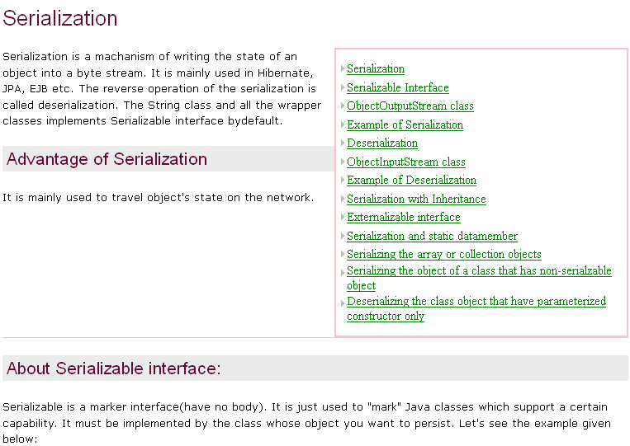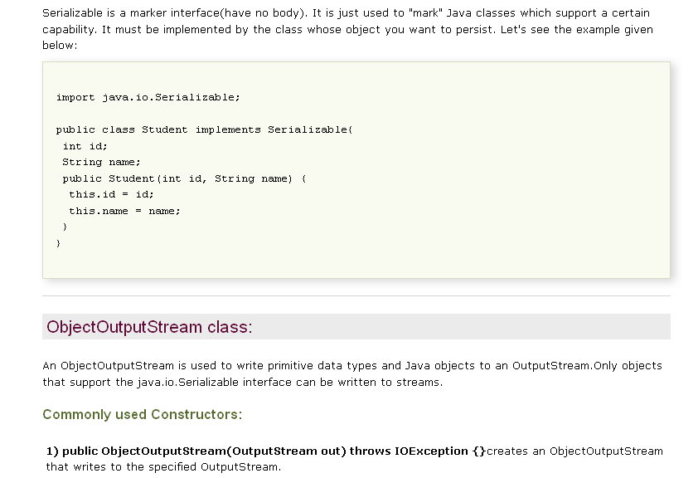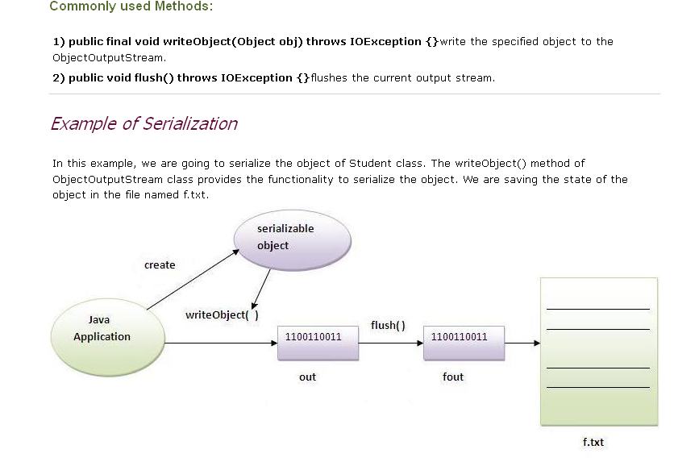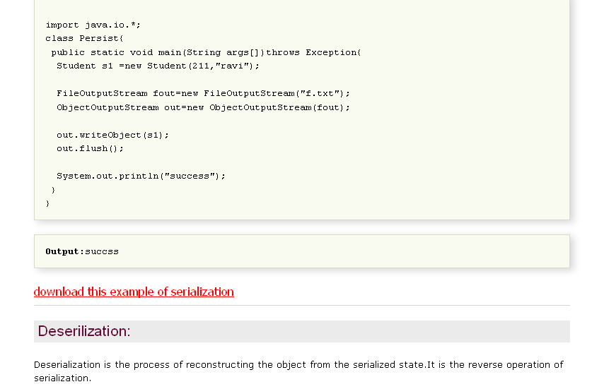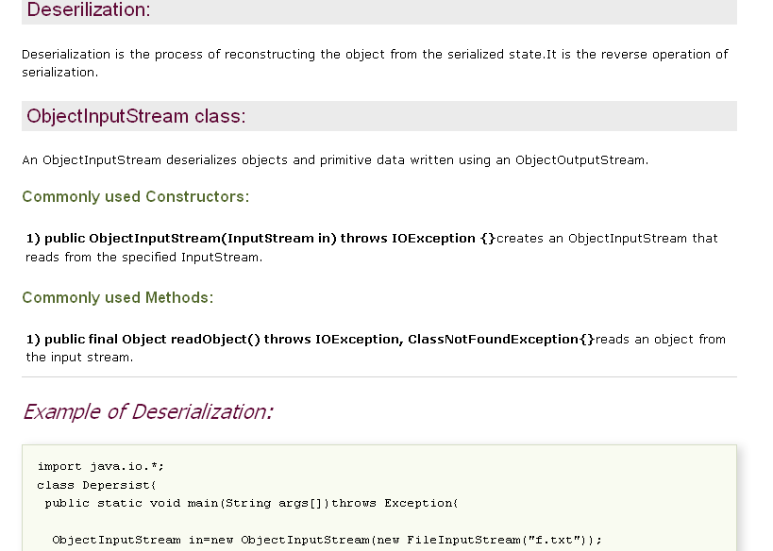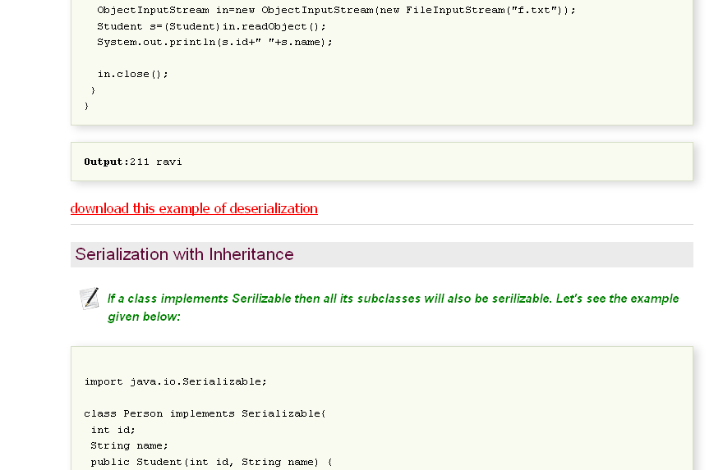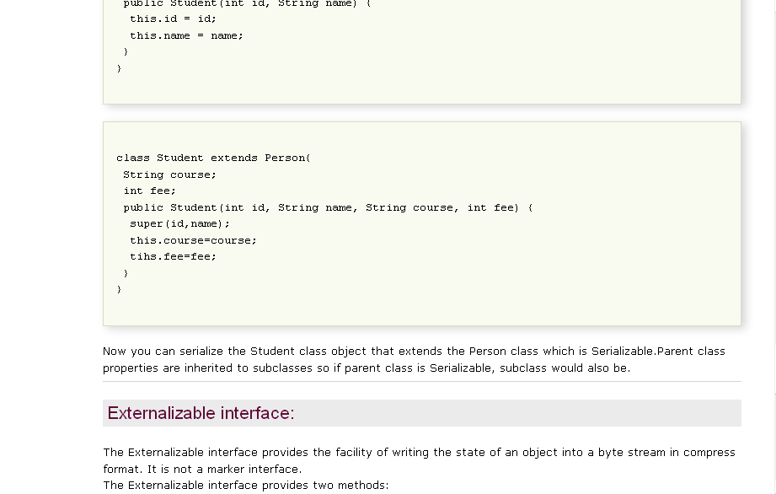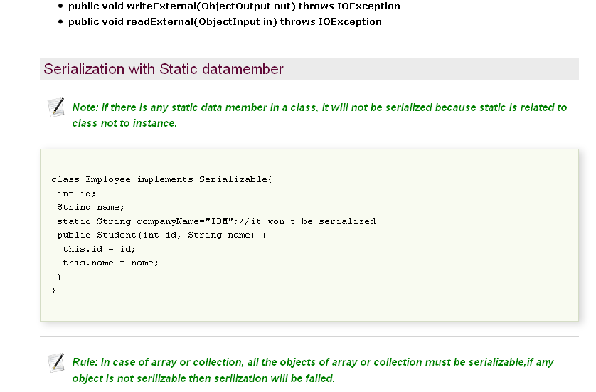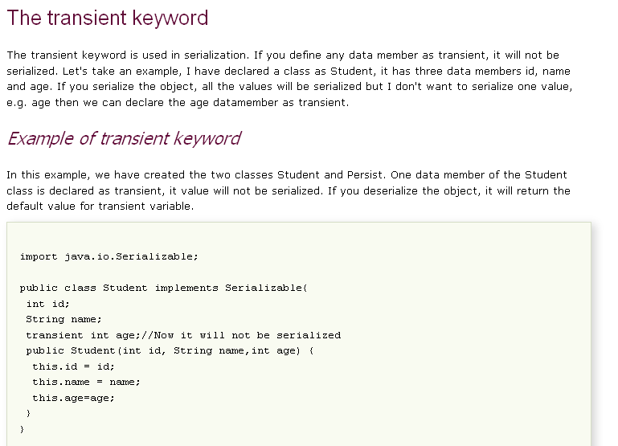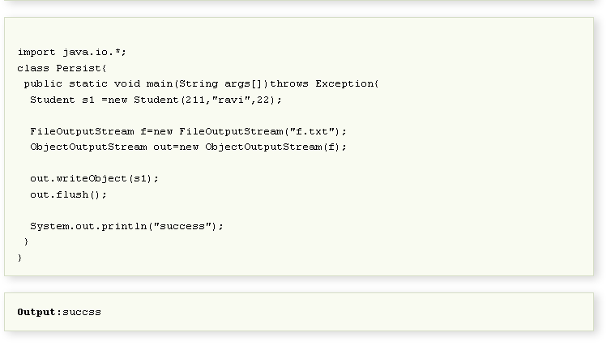Transient Keyword Example
Look into the following example to understand the purpose of transient keyword:
1  2  3  4  5  6  7  8  9  10  11  12  13  14  15  16  17  18  19  20  21  22  23  24  25  26  27  28  29  30  31  32  33  34  35  36  37  38  39  40  41  42  43  44  45  46  47  48  49  50  51  52 | package javabeat.samples;  import java.io.FileInputStream;  import java.io.FileOutputStream;  import java.io.IOException;  import java.io.ObjectInputStream;  import java.io.ObjectOutputStream;  import java.io.Serializable;  class NameStore implements Serializable{  private String firstName;  private transient String middleName;  private String lastName;  public NameStore (String fName,  String mName,  String lName){  this.firstName = fName;  this.middleName = mName;  this.lastName = lName;  }  public String toString(){  StringBuffer sb = new StringBuffer(40);  sb.append("First Name : ");  sb.append(this.firstName);  sb.append("Middle Name : ");  sb.append(this.middleName);  sb.append("Last Name : ");  sb.append(this.lastName);  return sb.toString();  }  }  public class TransientExample{  public static void main(String args[]) throws Exception {  NameStore nameStore = new NameStore("Steve",  "Middle","Jobs");  ObjectOutputStream o = new ObjectOutputStream  (new FileOutputStream("nameStore"));  // writing to object  o.writeObject(nameStore);  o.close();  // reading from object  ObjectInputStream in =new ObjectInputStream(  new FileInputStream("nameStore"));  NameStore nameStore1 = (NameStore)in.readObject();  System.out.println(nameStore1);  }  }  // output will be :  First Name : Steve  Middle Name : null  Last Name : Jobs

