JDBC&JTA:- package --→
java.sql.* package is used for the basic jdbc connections.
javax.sql.* package is used for the advance jdbc. Advance is connection pooling, rowsets...ect. he javax.sql packages will be included in the Java 1.4 platform, currently in beta.

What is JDBC? How do you connect to a database?
JDBC stands for Java Database Connectivity, which is a standard Java API for database-independent connectivity between the Java programming language and a wide range of databases.
The JDBC library includes APIs for each of the tasks commonly associated with database usage:
- Making a connection to a database
- Creating SQL or MySQL statements
- Executing that SQL or MySQL queries in the database
- Viewing & Modifying the resulting records
Fundamentally, JDBC is a specification that provides a complete set of interfaces that allows for portable access to an underlying database. Java can be used to write different types of executables, such as:
- Java Applications
- Java Applets
- Java Servlets
- Java ServerPages (JSPs)
- Enterprise JavaBeans (EJBs)
All of these different executables are able to use a JDBC driver to access a database and take advantage of the stored data. JDBC provides the same capabilities as ODBC, allowing Java programs to contain database-independent code.
java.sql | Provides the API for accessing and processing data stored in a data source (usually a relational database) using the JavaTM programming language.

Package java.sql
Provides the API for accessing and processing data stored in a data source (usually a relational database) using the JavaTM programming language.
See:
Description
Interface Summary
Array | The mapping in the Java programming language for the SQL type ARRAY.
Blob | The representation (mapping) in the JavaTM programming language of an SQL BLOB value.
CallableStatement | The interface used to execute SQL stored procedures.
Clob | The mapping in the JavaTM programming language for the SQL CLOB type.
Connection | A connection (session) with a specific database.
DatabaseMetaData | Comprehensive information about the database as a whole.
Driver | The interface that every driver class must implement.
ParameterMetaData | An object that can be used to get information about the types and properties of the parameters in a PreparedStatement object.
PreparedStatement | An object that represents a precompiled SQL statement.
Ref | The mapping in the Java programming language of an SQL REF value, which is a reference to an SQL structured type value in the database.
ResultSet | A table of data representing a database result set, which is usually generated by executing a statement that queries the database.
ResultSetMetaData | An object that can be used to get information about the types and properties of the columns in a ResultSet object.
Savepoint | The representation of a savepoint, which is a point within the current transaction that can be referenced from the Connection.rollback method.
SQLData | The interface used for the custom mapping of an SQL user-defined type (UDT) to a class in the Java programming language.
SQLInput | An input stream that contains a stream of values representing an instance of an SQL structured type or an SQL distinct type.
SQLOutput | The output stream for writing the attributes of a user-defined type back to the database.
Statement | The object used for executing a static SQL statement and returning the results it produces.
Struct | The standard mapping in the Java programming language for an SQL structured type.

Class Summary
Date | A thin wrapper around a millisecond value that allows JDBC to identify this as an SQL DATE value.
DriverManager | The basic service for managing a set of JDBC drivers.  NOTE: The DataSource interface, new in the JDBC 2.0 API, provides another way to connect to a data source.
DriverPropertyInfo | Driver properties for making a connection.
SQLPermission | The permission for which the SecurityManager will check when code that is running in an applet calls the DriverManager.setLogWriter method or the DriverManager.setLogStream (deprecated) method.
Time | A thin wrapper around the java.util.Date class that allows the JDBC API to identify this as an SQL TIME value.
Timestamp | A thin wrapper around java.util.Date that allows the JDBC API to identify this as an SQL TIMESTAMP value.
Types | The class that defines the constants that are used to identify generic SQL types, called JDBC types.

Exception Summary
BatchUpdateException | An exception thrown when an error occurs during a batch update operation.
DataTruncation | An exception that reports a DataTruncation warning (on reads) or throws a DataTruncation exception (on writes) when JDBC unexpectedly truncates a data value.
SQLException | An exception that provides information on a database access error or other errors.
SQLWarning | An exception that provides information on database access warnings.
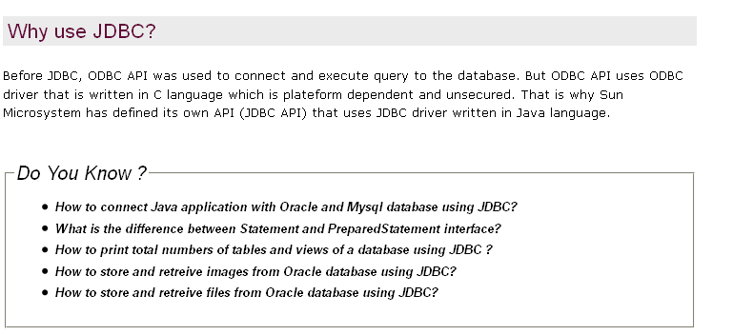
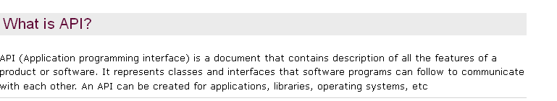
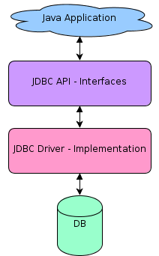

JDBC Architecture:
The JDBC API supports both two-tier and three-tier processing models for database access but in general JDBC Architecture consists of two layers:
- JDBC API: This provides the application-to-JDBC Manager connection.
- JDBC Driver API: This supports the JDBC Manager-to-Driver Connection.
The JDBC API uses a driver manager and database-specific drivers to provide transparent connectivity to heterogeneous databases.
The JDBC driver manager ensures that the correct driver is used to access each data source. The driver manager is capable of supporting multiple concurrent drivers connected to multiple heterogeneous databases.
Following is the architectural diagram, which shows the location of the driver manager with respect to the JDBC drivers and the Java application:
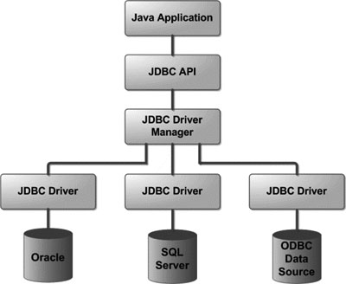

Common JDBC Components:
The JDBC API provides the following interfaces and classes:
- DriverManager: This class manages a list of database drivers. Matches connection requests from the java application with the proper database driver using communication subprotocol. The first driver that recognizes a certain subprotocol under JDBC will be used to establish a database Connection.
- Driver: This interface handles the communications with the database server. You will interact directly with Driver objects very rarely. Instead, you use DriverManager objects, which manages objects of this type. It also abstracts the details associated with working with Driver objects
- Connection : This interface with all methods for contacting a database. The connection object represents communication context, i.e., all communication with database is through connection object only.
- Statement : You use objects created from this interface to submit the SQL statements to the database. Some derived interfaces accept parameters in addition to executing stored procedures.
- ResultSet: These objects hold data retrieved from a database after you execute an SQL query using Statement objects. It acts as an iterator to allow you to move through its data.
- SQLException: This class handles any errors that occur in a database application.
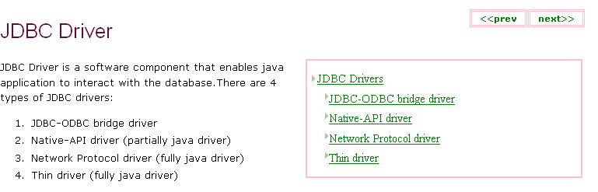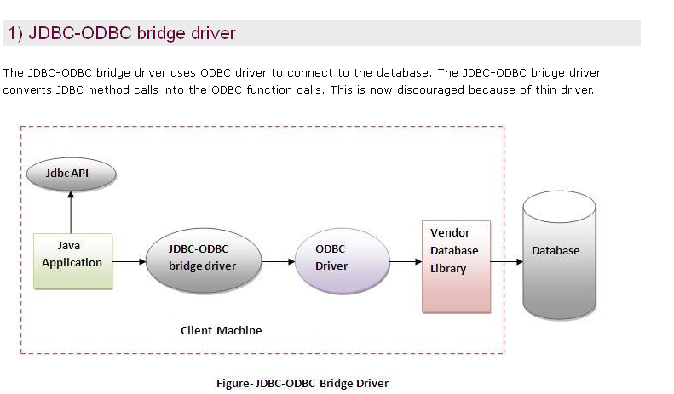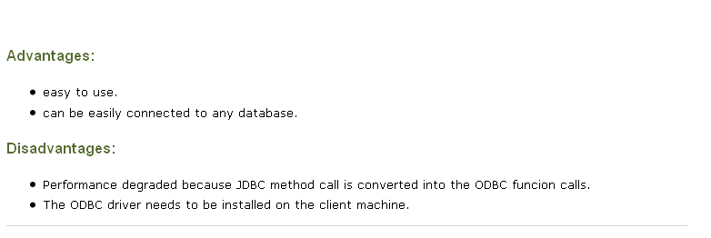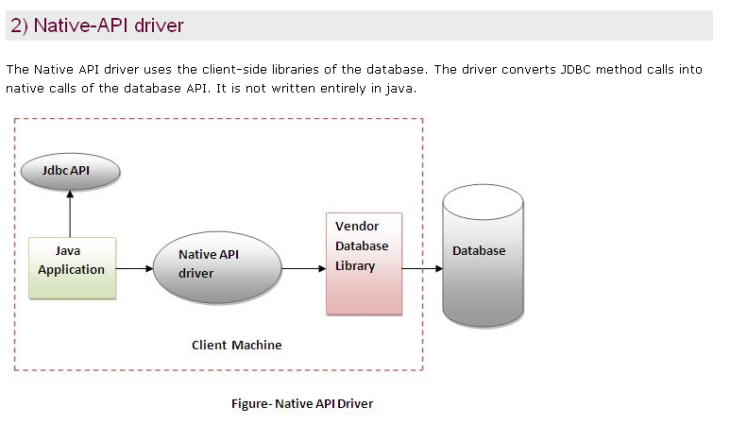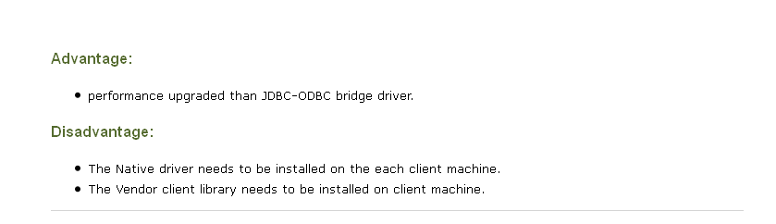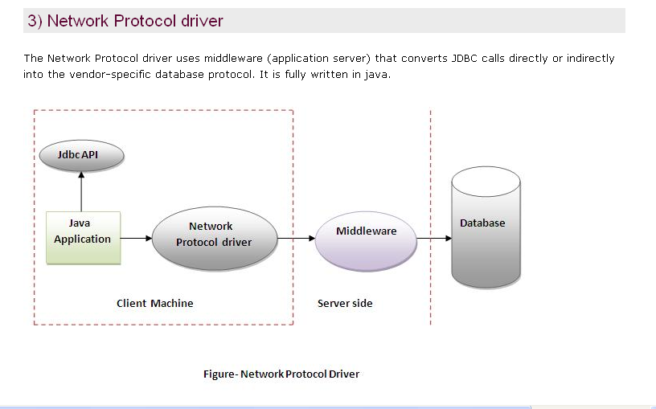All Java / Net-Protocol Driver – pure-java driver that calls the server-side
Type 3 drivers are pure Java drivers that use a proprietary network protocol to communicate with JDBC middleware on the server. The middleware then translates the network protocol to database-specific function calls. Type 3 drivers are the most flexible JDBC solution because they do not require native database libraries on the client and can connect to many different databases on the back end. Type 3 drivers can be deployed over the Internet without client installation. (See Figure 4.)
Java-------> JDBC statements------> SQL statements ------> databases.middleware.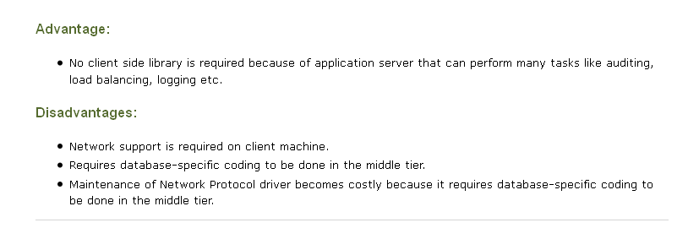
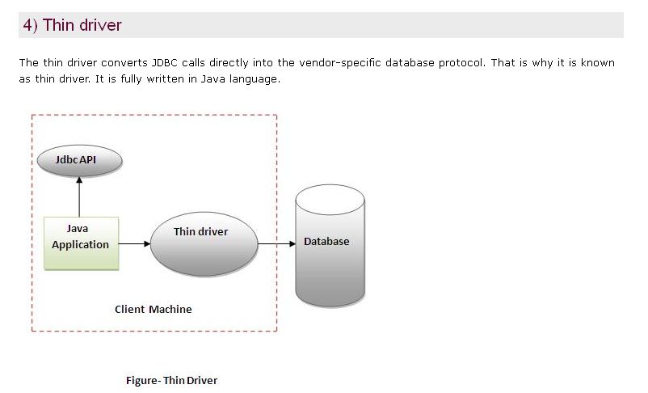
Type 4 Java to Database Protocol. Type 4 drivers are pure Java drivers that implement a proprietary database protocol (like Oracle's SQL*Net) to communicate directly with the database. Like Type 3 drivers, they do not require native database libraries and can be deployed over the Internet without client installation. One drawback to Type 4 drivers is that they are database specific. Unlike Type 3 drivers, if your back-end database changes, you may save to purchase and deploy a new Type 4 driver (some Type 4 drivers are available free of charge from the database manufacturer). However, because Type drivers communicate directly with the database engine rather than through middleware or a native library, they are usually the fastest JDBC drivers available. This driver directly converts the java statements to SQL statements.
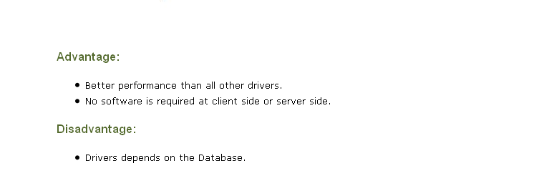

JDBC Versions
1). The JDBC 1.0 API.
2). The JDBC 1.2 API.
3). The JDBC 2.0 Optional Package API.
4). The JDBC 2.1 core API.
5) The JDBC 3.0 API.
6) The JDBC 4.0 API.
Features of JDBC 1.0 API
The JDBC 1.0 API was the first officially JDBC API launched consists of the following java classes and interfaces that you can open connections to particular databases.
This version includes a completely redesigned administration console with an enhanced graphical interface to manage and monitor distributed virtual databases.
Features of JDBC 1.2 API
1). It supports Updatabale ResultSets.
2). The DatabaseMetaData code has been refactored to provide more transparency with regard to the underlying database engine.
3) New pass through schedulers for increased performance.
Features of The JDBC 2.0 Optional Pacakage API
1). The use of DataSource interface for making a connection.
2). Use of JNDI to specify and obtain database connections.
3). It allows us to use Pooled connections, that is we can reuse the connections.
4). In this version the distrbuted transactions is possible.
5). It provides a way of handling and passing data using Rowset technology.
Features of the JDBC 2.1 core API.
1). Scroll forward and backward in a result set or has the ability to move to a specific row.
2). Instead of using SQL commands, we can make updates to a database tables using methods in the Java programming language
3). We can use multiple SQL statements in a a database as a unit, or batch.
4). It uses the SQL3 datatypes as column values. SQL3 types are Blob, Clob, Array, Structured type, Ref.
5). Increased support for storing persistent objects in the java programming language.
6). Supports for time zones in Date, Time, and Timestamp values.
7). Full precision for java.math.BigDecimal values.
Features of JDBC 3.0 API
1). Reusabilty of prepared statements by connection pools.
2). In this version there is number of properties defined for the ConnectionPoolDataSource. These properties can be used to describe how the PooledConnection objects created by DataSource objects should be pooled.
3) A new concept has been added to this API is of savepoints.
4). Retrieval of parameter metadata.
5). It has added a means of retrieving values from columns containing automatically generated values.
6). Added a new data type i.e. java.sql.BOOLEAN.
7). Passing parameters to CallableStatement.
8). The data in the Blob and Clob can be altered.
9). DatabaseMetaData API has been added.
Features of JDBC 4.0 :
1). Auto- loading of JDBC driver class.
2). Connection management enhancements.
3.) Support for RowId SAL type.
4). SQL exception handling enhancements.
5). DataSet implementation of SQl using Annotations.
6). SQL XML support

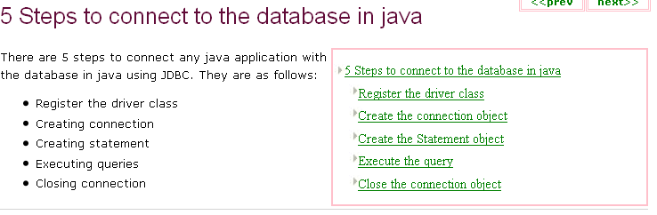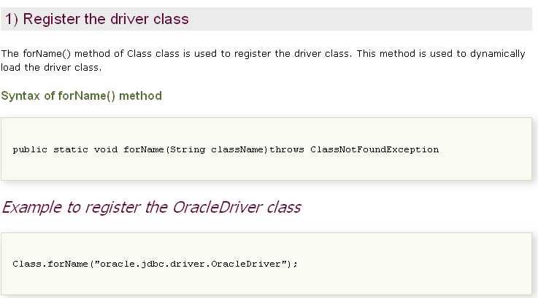
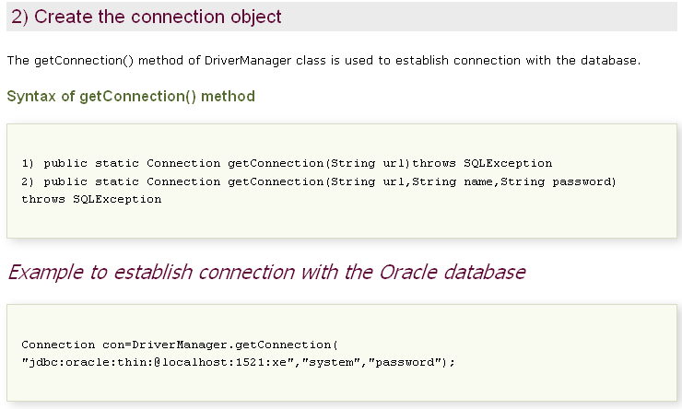
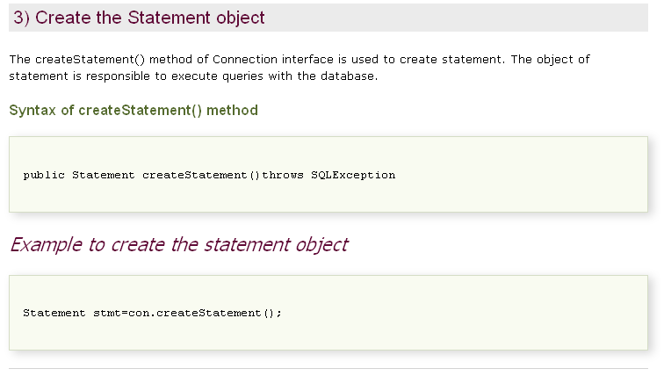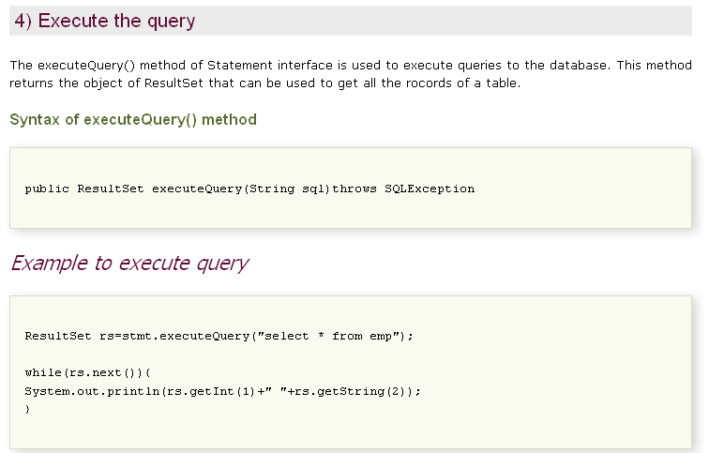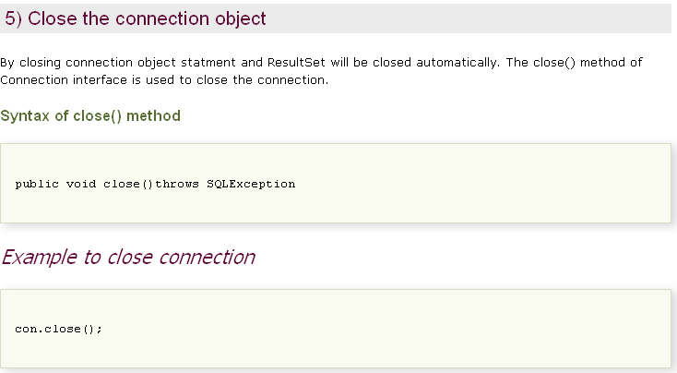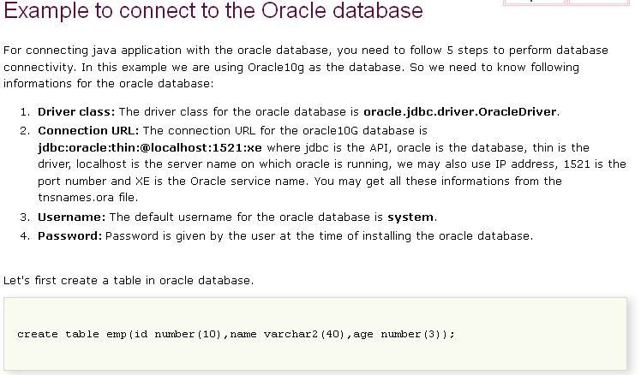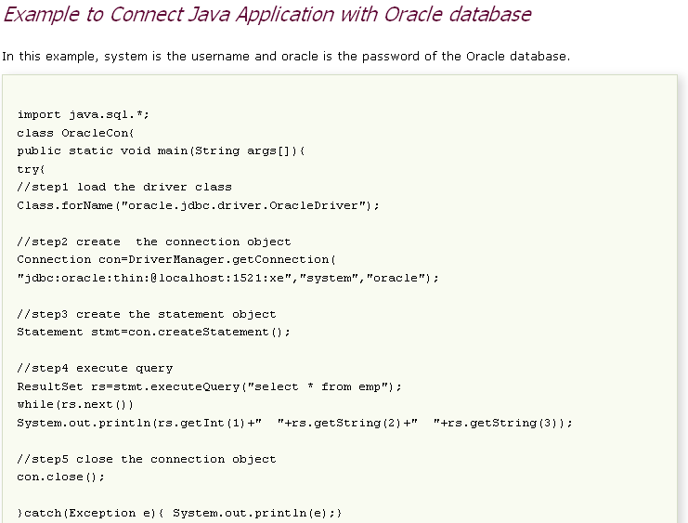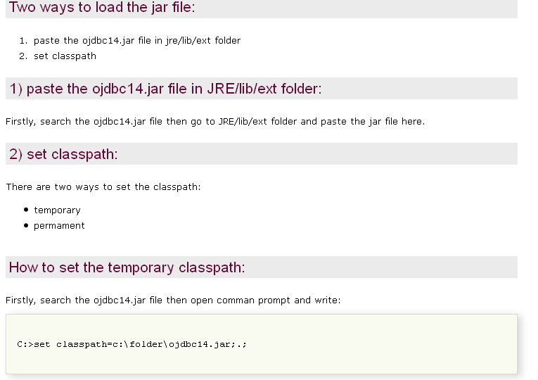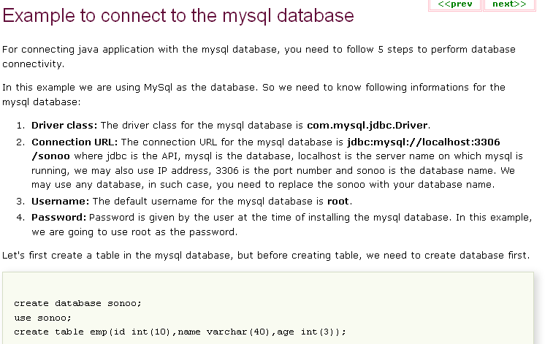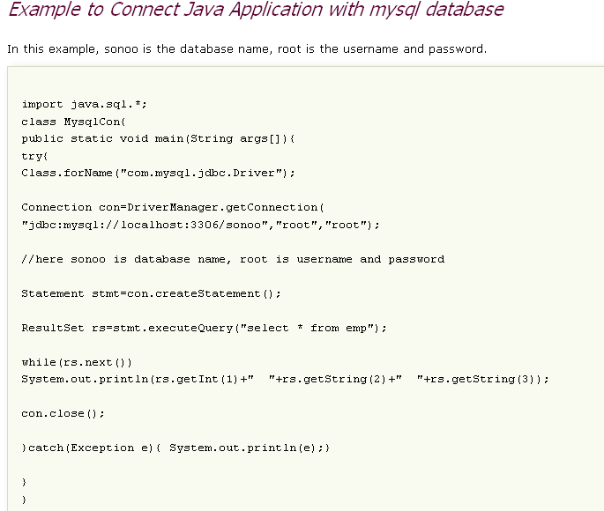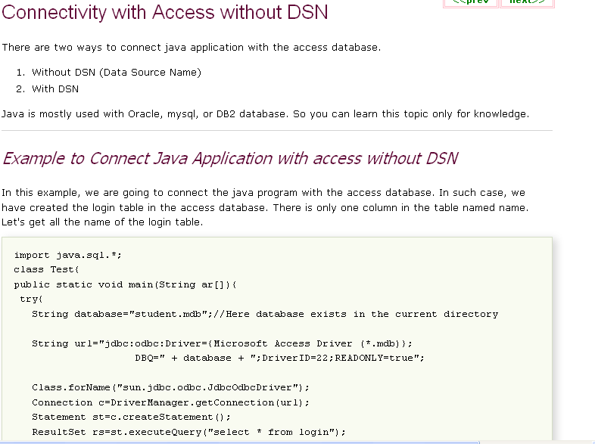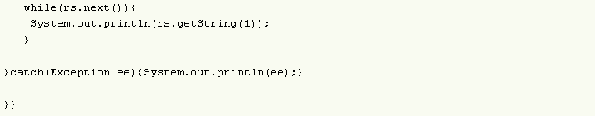
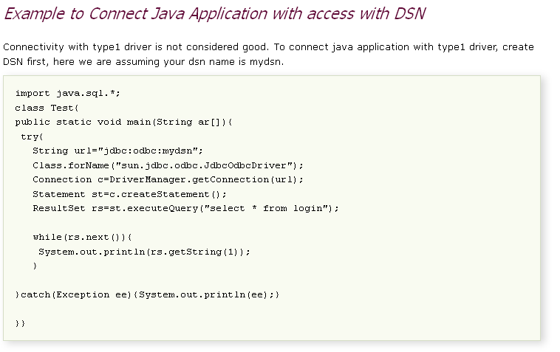
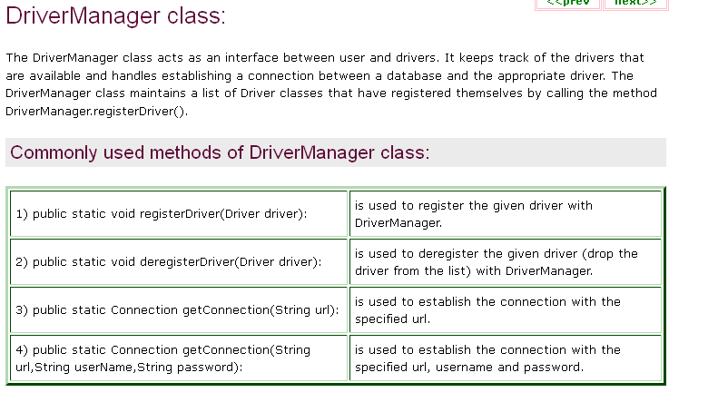

Approach (II) - DriverManager.registerDriver():
The second approach you can use to register a driver is to use the static DriverManager.registerDriver() method.
You should use the registerDriver() method if you are using a non-JDK compliant JVM, such as the one provided by Microsoft.
The following example uses registerDriver() to register the Oracle driver:
try {
Driver myDriver = new oracle.jdbc.driver.OracleDriver();
DriverManager.registerDriver( myDriver );
}
catch(ClassNotFoundException ex) {
System.out.println("Error: unable to load driver class!");
System.exit(1);
}

java.sql
Class DriverManager
java.lang.Object
java.sql.DriverManager
Driver, Connection

Method Summary
static void | deregisterDriver(Driver driver)  Drops a driver from the DriverManager's list.
static Connection | getConnection(String url)  Attempts to establish a connection to the given database URL.
static Connection | getConnection(String url, Properties info)  Attempts to establish a connection to the given database URL.
static Connection | getConnection(String url, String user, String password)  Attempts to establish a connection to the given database URL.
static Driver | getDriver(String url)  Attempts to locate a driver that understands the given URL.
static Enumeration<Driver> | getDrivers()  Retrieves an Enumeration with all of the currently loaded JDBC drivers to which the current caller has access.
static int | getLoginTimeout()  Gets the maximum time in seconds that a driver can wait when attempting to log in to a database.
static PrintStream | getLogStream()  Deprecated.
static PrintWriter | getLogWriter()  Retrieves the log writer.
static void | println(String message)  Prints a message to the current JDBC log stream.
static void | registerDriver(Driver driver)  Registers the given driver with the DriverManager.
static void | setLoginTimeout(int seconds)  Sets the maximum time in seconds that a driver will wait while attempting to connect to a database.
static void | setLogStream(PrintStream out)  Deprecated.
static void | setLogWriter(PrintWriter out)  Sets the logging/tracing PrintWriter object that is used by the DriverManager and all drivers.

Methods inherited from class java.lang.Object
clone, equals, finalize, getClass, hashCode, notify, notifyAll, toString, wait, wait, wait

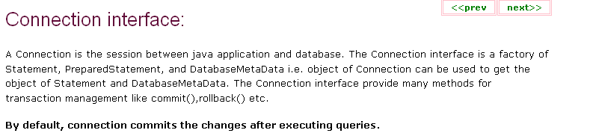

java.sql
Interface Connection
public interface Connection
A connection (session) with a specific database. SQL statements are executed and results are returned within the context of a connection.
A Connection object's database is able to provide information describing its tables, its supported SQL grammar, its stored procedures, the capabilities of this connection, and so on. This information is obtained with the getMetaData method.
Note: By default a Connection object is in auto-commit mode, which means that it automatically commits changes after executing each statement. If auto-commit mode has been disabled, the method commit must be called explicitly in order to commit changes; otherwise, database changes will not be saved.
Field Summary
static int | TRANSACTION_NONE  A constant indicating that transactions are not supported.
static int | TRANSACTION_READ_COMMITTED  A constant indicating that dirty reads are prevented; non-repeatable reads and phantom reads can occur.
static int | TRANSACTION_READ_UNCOMMITTED  A constant indicating that dirty reads, non-repeatable reads and phantom reads can occur.
static int | TRANSACTION_REPEATABLE_READ  A constant indicating that dirty reads and non-repeatable reads are prevented; phantom reads can occur.
static int | TRANSACTION_SERIALIZABLE  A constant indicating that dirty reads, non-repeatable reads and phantom reads are prevented.

Method Summary
void | clearWarnings()  Clears all warnings reported for this Connection object.
void | close()  Releases this Connection object's database and JDBC resources immediately instead of waiting for them to be automatically released.
void | commit()  Makes all changes made since the previous commit/rollback permanent and releases any database locks currently held by this Connection object.
Statement | createStatement()  Creates a Statement object for sending SQL statements to the database.
Statement | createStatement(int resultSetType, int resultSetConcurrency)  Creates a Statement object that will generate ResultSet objects with the given type and concurrency.
Statement | createStatement(int resultSetType, int resultSetConcurrency, int resultSetHoldability)  Creates a Statement object that will generate ResultSet objects with the given type, concurrency, and holdability.
boolean | getAutoCommit()  Retrieves the current auto-commit mode for this Connection object.
String | getCatalog()  Retrieves this Connection object's current catalog name.
int | getHoldability()  Retrieves the current holdability of ResultSet objects created using this Connection object.
DatabaseMetaData | getMetaData()  Retrieves a DatabaseMetaData object that contains metadata about the database to which this Connection object represents a connection.
int | getTransactionIsolation()  Retrieves this Connection object's current transaction isolation level.
Map<String,Class<?>> | getTypeMap()  Retrieves the Map object associated with this Connection object.
SQLWarning | getWarnings()  Retrieves the first warning reported by calls on this Connection object.
boolean | isClosed()  Retrieves whether this Connection object has been closed.
boolean | isReadOnly()  Retrieves whether this Connection object is in read-only mode.
String | nativeSQL(String sql)  Converts the given SQL statement into the system's native SQL grammar.
CallableStatement | prepareCall(String sql)  Creates a CallableStatement object for calling database stored procedures.
CallableStatement | prepareCall(String sql, int resultSetType, int resultSetConcurrency)  Creates a CallableStatement object that will generate ResultSet objects with the given type and concurrency.
CallableStatement | prepareCall(String sql, int resultSetType, int resultSetConcurrency, int resultSetHoldability)  Creates a CallableStatement object that will generate ResultSet objects with the given type and concurrency.
PreparedStatement | prepareStatement(String sql)  Creates a PreparedStatement object for sending parameterized SQL statements to the database.
PreparedStatement | prepareStatement(String sql, int autoGeneratedKeys)  Creates a default PreparedStatement object that has the capability to retrieve auto-generated keys.
PreparedStatement | prepareStatement(String sql, int[] columnIndexes)  Creates a default PreparedStatement object capable of returning the auto-generated keys designated by the given array.
PreparedStatement | prepareStatement(String sql, int resultSetType, int resultSetConcurrency)  Creates a PreparedStatement object that will generate ResultSet objects with the given type and concurrency.
PreparedStatement | prepareStatement(String sql, int resultSetType, int resultSetConcurrency, int resultSetHoldability)  Creates a PreparedStatement object that will generate ResultSet objects with the given type, concurrency, and holdability.
PreparedStatement | prepareStatement(String sql, String[] columnNames)  Creates a default PreparedStatement object capable of returning the auto-generated keys designated by the given array.
void | releaseSavepoint(Savepoint savepoint)  Removes the given Savepoint object from the current transaction.
void | rollback()  Undoes all changes made in the current transaction and releases any database locks currently held by this Connection object.
void | rollback(Savepoint savepoint)  Undoes all changes made after the given Savepoint object was set.
void | setAutoCommit(boolean autoCommit)  Sets this connection's auto-commit mode to the given state.
void | setCatalog(String catalog)  Sets the given catalog name in order to select a subspace of this Connection object's database in which to work.
void | setHoldability(int holdability)  Changes the holdability of ResultSet objects created using this Connection object to the given holdability.
void | setReadOnly(boolean readOnly)  Puts this connection in read-only mode as a hint to the driver to enable database optimizations.
Savepoint | setSavepoint()  Creates an unnamed savepoint in the current transaction and returns the new Savepoint object that represents it.
Savepoint | setSavepoint(String name)  Creates a savepoint with the given name in the current transaction and returns the new Savepoint object that represents it.
void | setTransactionIsolation(int level)  Attempts to change the transaction isolation level for this Connection object to the one given.
void | setTypeMap(Map<String,Class<?>> map)  Installs the given TypeMap object as the type map for this Connection object.

JDBC – Statements
Once a connection is obtained we can interact with the database. The JDBC Statement, CallableStatement, and PreparedStatement interfaces define the methods and properties that enable you to send SQL or PL/SQL commands and receive data from your database.
They also define methods that help bridge data type differences between Java and SQL data types used in a database.
Following table provides a summary of each interface's purpose to understand how do you decide which interface to use?
Interfaces | Recommended Use
Statement | Use for general-purpose access to your database. Useful when you are using static SQL statements at runtime. The Statement interface cannot accept parameters.
PreparedStatement | Use when you plan to use the SQL statements many times. The PreparedStatement interface accepts input parameters at runtime.
CallableStatement | Use when you want to access database stored procedures. The CallableStatement interface can also accept runtime input parameters.

The Statement Objects:

Creating Statement Object:
Before you can use a Statement object to execute a SQL statement, you need to create one using the Connection object's createStatement( ) method, as in the following example:
Statement stmt = null;
try {
stmt = conn.createStatement( );
. . .
}
catch (SQLException e) {
. . .
}
finally {
. . .
}
Once you've created a Statement object, you can then use it to execute a SQL statement with one of its three execute methods.
- boolean execute(String SQL) : Returns a boolean value of true if a ResultSet object can be retrieved; otherwise, it returns false. Use this method to execute SQL DDL statements or when you need to use truly dynamic SQL.
- int executeUpdate(String SQL) : Returns the numbers of rows affected by the execution of the SQL statement. Use this method to execute SQL statements for which you expect to get a number of rows affected - for example, an INSERT, UPDATE, or DELETE statement.
- ResultSet executeQuery(String SQL) : Returns a ResultSet object. Use this method when you expect to get a result set, as you would with a SELECT statement.

Closing Statement Obeject:
Just as you close a Connection object to save database resources, for the same reason you should also close the Statement object.
A simple call to the close() method will do the job. If you close the Connection object first it will close the Statement object as well. However, you should always explicitly close the Statement object to ensure proper cleanup.
Statement stmt = null;
try {
stmt = conn.createStatement( );
. . .
}
catch (SQLException e) {
. . .
}
finally {
stmt.close();
}
For a better understanding, I would suggest to study Statement - Example Code.

java.sql
Interface Statement
All Known Subinterfaces:
CallableStatement, PreparedStatement
Field Summary
static int | CLOSE_ALL_RESULTS  The constant indicating that all ResultSet objects that have previously been kept open should be closed when calling getMoreResults.
static int | CLOSE_CURRENT_RESULT  The constant indicating that the current ResultSet object should be closed when calling getMoreResults.
static int | EXECUTE_FAILED  The constant indicating that an error occured while executing a batch statement.
static int | KEEP_CURRENT_RESULT  The constant indicating that the current ResultSet object should not be closed when calling getMoreResults.
static int | NO_GENERATED_KEYS  The constant indicating that generated keys should not be made available for retrieval.
static int | RETURN_GENERATED_KEYS  The constant indicating that generated keys should be made available for retrieval.
static int | SUCCESS_NO_INFO  The constant indicating that a batch statement executed successfully but that no count of the number of rows it affected is available.

Method Summary
void | addBatch(String sql)  Adds the given SQL command to the current list of commmands for this Statement object.
void | cancel()  Cancels this Statement object if both the DBMS and driver support aborting an SQL statement.
void | clearBatch()  Empties this Statement object's current list of SQL commands.
void | clearWarnings()  Clears all the warnings reported on this Statement object.
void | close()  Releases this Statement object's database and JDBC resources immediately instead of waiting for this to happen when it is automatically closed.
boolean | execute(String sql)  Executes the given SQL statement, which may return multiple results.
boolean | execute(String sql, int autoGeneratedKeys)  Executes the given SQL statement, which may return multiple results, and signals the driver that any auto-generated keys should be made available for retrieval.
boolean | execute(String sql, int[] columnIndexes)  Executes the given SQL statement, which may return multiple results, and signals the driver that the auto-generated keys indicated in the given array should be made available for retrieval.
boolean | execute(String sql, String[] columnNames)  Executes the given SQL statement, which may return multiple results, and signals the driver that the auto-generated keys indicated in the given array should be made available for retrieval.
int[] | executeBatch()  Submits a batch of commands to the database for execution and if all commands execute successfully, returns an array of update counts.
ResultSet | executeQuery(String sql)  Executes the given SQL statement, which returns a single ResultSet object.
int | executeUpdate(String sql)  Executes the given SQL statement, which may be an INSERT, UPDATE, or DELETE statement or an SQL statement that returns nothing, such as an SQL DDL statement.
int | executeUpdate(String sql, int autoGeneratedKeys)  Executes the given SQL statement and signals the driver with the given flag about whether the auto-generated keys produced by this Statement object should be made available for retrieval.
int | executeUpdate(String sql, int[] columnIndexes)  Executes the given SQL statement and signals the driver that the auto-generated keys indicated in the given array should be made available for retrieval.
int | executeUpdate(String sql, String[] columnNames)  Executes the given SQL statement and signals the driver that the auto-generated keys indicated in the given array should be made available for retrieval.
Connection | getConnection()  Retrieves the Connection object that produced this Statement object.
int | getFetchDirection()  Retrieves the direction for fetching rows from database tables that is the default for result sets generated from this Statement object.
int | getFetchSize()  Retrieves the number of result set rows that is the default fetch size for ResultSet objects generated from this Statement object.
ResultSet | getGeneratedKeys()  Retrieves any auto-generated keys created as a result of executing this Statement object.
int | getMaxFieldSize()  Retrieves the maximum number of bytes that can be returned for character and binary column values in a ResultSet object produced by this Statement object.
int | getMaxRows()  Retrieves the maximum number of rows that a ResultSet object produced by this Statement object can contain.
boolean | getMoreResults()  Moves to this Statement object's next result, returns true if it is a ResultSet object, and implicitly closes any current ResultSet object(s) obtained with the method getResultSet.
boolean | getMoreResults(int current)  Moves to this Statement object's next result, deals with any current ResultSet object(s) according to the instructions specified by the given flag, and returns true if the next result is a ResultSet object.
int | getQueryTimeout()  Retrieves the number of seconds the driver will wait for a Statement object to execute.
ResultSet | getResultSet()  Retrieves the current result as a ResultSet object.
int | getResultSetConcurrency()  Retrieves the result set concurrency for ResultSet objects generated by this Statement object.
int | getResultSetHoldability()  Retrieves the result set holdability for ResultSet objects generated by this Statement object.
int | getResultSetType()  Retrieves the result set type for ResultSet objects generated by this Statement object.
int | getUpdateCount()  Retrieves the current result as an update count; if the result is a ResultSet object or there are no more results, -1 is returned.
SQLWarning | getWarnings()  Retrieves the first warning reported by calls on this Statement object.
boolean | isClosed()  Retrieves whether this Statement object has been closed.
boolean | isPoolable()  Returns a value indicating whether the Statement is poolable or not.
void | setCursorName(String name)  Sets the SQL cursor name to the given String, which will be used by subsequent Statement object execute methods.
void | setEscapeProcessing(boolean enable)  Sets escape processing on or off.
void | setFetchDirection(int direction)  Gives the driver a hint as to the direction in which rows will be processed in ResultSet objects created using this Statement object.
void | setFetchSize(int rows)  Gives the JDBC driver a hint as to the number of rows that should be fetched from the database when more rows are needed for ResultSet objects genrated by this Statement.
void | setMaxFieldSize(int max)  Sets the limit for the maximum number of bytes that can be returned for character and binary column values in a ResultSet object produced by this Statement object.
void | setMaxRows(int max)  Sets the limit for the maximum number of rows that any ResultSet object generated by this Statement object can contain to the given number.
void | setPoolable(boolean poolable)  Requests that a Statement be pooled or not pooled.
void | setQueryTimeout(int seconds)  Sets the number of seconds the driver will wait for a Statement object to execute to the given number of seconds.

Methods inherited from interface java.sql.Wrapper
isWrapperFor, unwrap

The PreparedStatement Objects:
The PreparedStatement interface extends the Statement interface which gives you added functionality with a couple of advantages over a generic Statement object.
This statement gives you the flexibility of supplying arguments dynamically.

Creating PreparedStatement Object:
PreparedStatement pstmt = null;
try {
String SQL = "Update Employees SET age = ? WHERE id = ?";
pstmt = conn.prepareStatement(SQL);
. . .
}
catch (SQLException e) {
. . .
}
finally {
. . .
}
All parameters in JDBC are represented by the ? symbol, which is known as the parameter marker. You must supply values for every parameter before executing the SQL statement.
The setXXX() methods bind values to the parameters, where XXX represents the Java data type of the value you wish to bind to the input parameter. If you forget to supply the values, you will receive an SQLException.
Each parameter marker is referred to by its ordinal position. The first marker represents position 1, the next position 2, and so forth. This method differs from that of Java array indices, which start at 0.
All of the Statement object's methods for interacting with the database (a) execute(), (b) executeQuery(), and (c) executeUpdate() also work with the PreparedStatement object. However, the methods are modified to use SQL statements that can take input the parameters.

Closing PreparedStatement Obeject:
Just as you close a Statement object, for the same reason you should also close the PreparedStatement object.
A simple call to the close() method will do the job. If you close the Connection object first it will close the PreparedStatement object as well. However, you should always explicitly close the PreparedStatement object to ensure proper cleanup.
PreparedStatement pstmt = null;
try {
String SQL = "Update Employees SET age = ? WHERE id = ?";
pstmt = conn.prepareStatement(SQL);
. . .
}
catch (SQLException e) {
. . .
}
finally {
pstmt.close();
}

java.sql
Interface PreparedStatement
All Superinterfaces:
Statement, Wrapper
All Known Subinterfaces:
CallableStatement
Field Summary

Fields inherited from interface java.sql.Statement
CLOSE_ALL_RESULTS, CLOSE_CURRENT_RESULT, EXECUTE_FAILED, KEEP_CURRENT_RESULT, NO_GENERATED_KEYS, RETURN_GENERATED_KEYS, SUCCESS_NO_INFO

Method Summary
void | addBatch()  Adds a set of parameters to this PreparedStatement object's batch of commands.
void | clearParameters()  Clears the current parameter values immediately.
boolean | execute()  Executes the SQL statement in this PreparedStatement object, which may be any kind of SQL statement.
ResultSet | executeQuery()  Executes the SQL query in this PreparedStatement object and returns the ResultSet object generated by the query.
int | executeUpdate()  Executes the SQL statement in this PreparedStatement object, which must be an SQL Data Manipulation Language (DML) statement, such as INSERT, UPDATE or DELETE; or an SQL statement that returns nothing, such as a DDL statement.
ResultSetMetaData | getMetaData()  Retrieves a ResultSetMetaData object that contains information about the columns of the ResultSet object that will be returned when this PreparedStatement object is executed.
ParameterMetaData | getParameterMetaData()  Retrieves the number, types and properties of this PreparedStatement object's parameters.
void | setArray(int parameterIndex, Array x)  Sets the designated parameter to the given java.sql.Array object.
void | setAsciiStream(int parameterIndex, InputStream x)  Sets the designated parameter to the given input stream.
void | setAsciiStream(int parameterIndex, InputStream x, int length)  Sets the designated parameter to the given input stream, which will have the specified number of bytes.
void | setAsciiStream(int parameterIndex, InputStream x, long length)  Sets the designated parameter to the given input stream, which will have the specified number of bytes.
void | setBigDecimal(int parameterIndex, BigDecimal x)  Sets the designated parameter to the given java.math.BigDecimal value.
void | setBinaryStream(int parameterIndex, InputStream x)  Sets the designated parameter to the given input stream.
void | setBinaryStream(int parameterIndex, InputStream x, int length)  Sets the designated parameter to the given input stream, which will have the specified number of bytes.
void | setBinaryStream(int parameterIndex, InputStream x, long length)  Sets the designated parameter to the given input stream, which will have the specified number of bytes.
void | setBlob(int parameterIndex, Blob x)  Sets the designated parameter to the given java.sql.Blob object.
void | setBlob(int parameterIndex, InputStream inputStream)  Sets the designated parameter to a InputStream object.
void | setBlob(int parameterIndex, InputStream inputStream, long length)  Sets the designated parameter to a InputStream object.
void | setBoolean(int parameterIndex, boolean x)  Sets the designated parameter to the given Java boolean value.
void | setByte(int parameterIndex, byte x)  Sets the designated parameter to the given Java byte value.
void | setBytes(int parameterIndex, byte[] x)  Sets the designated parameter to the given Java array of bytes.
void | setCharacterStream(int parameterIndex, Reader reader)  Sets the designated parameter to the given Reader object.
void | setCharacterStream(int parameterIndex, Reader reader, int length)  Sets the designated parameter to the given Reader object, which is the given number of characters long.
void | setCharacterStream(int parameterIndex, Reader reader, long length)  Sets the designated parameter to the given Reader object, which is the given number of characters long.
void | setClob(int parameterIndex, Clob x)  Sets the designated parameter to the given java.sql.Clob object.
void | setClob(int parameterIndex, Reader reader)  Sets the designated parameter to a Reader object.
void | setClob(int parameterIndex, Reader reader, long length)  Sets the designated parameter to a Reader object.
void | setDate(int parameterIndex, Date x)  Sets the designated parameter to the given java.sql.Date value using the default time zone of the virtual machine that is running the application.
void | setDate(int parameterIndex, Date x, Calendar cal)  Sets the designated parameter to the given java.sql.Date value, using the given Calendar object.
void | setDouble(int parameterIndex, double x)  Sets the designated parameter to the given Java double value.
void | setFloat(int parameterIndex, float x)  Sets the designated parameter to the given Java float value.
void | setInt(int parameterIndex, int x)  Sets the designated parameter to the given Java int value.
void | setLong(int parameterIndex, long x)  Sets the designated parameter to the given Java long value.
void | setNCharacterStream(int parameterIndex, Reader value)  Sets the designated parameter to a Reader object.
void | setNCharacterStream(int parameterIndex, Reader value, long length)  Sets the designated parameter to a Reader object.
void | setNClob(int parameterIndex, NClob value)  Sets the designated parameter to a java.sql.NClob object.
void | setNClob(int parameterIndex, Reader reader)  Sets the designated parameter to a Reader object.
void | setNClob(int parameterIndex, Reader reader, long length)  Sets the designated parameter to a Reader object.
void | setNString(int parameterIndex, String value)  Sets the designated paramter to the given String object.
void | setNull(int parameterIndex, int sqlType)  Sets the designated parameter to SQL NULL.
void | setNull(int parameterIndex, int sqlType, String typeName)  Sets the designated parameter to SQL NULL.
void | setObject(int parameterIndex, Object x)  Sets the value of the designated parameter using the given object.
void | setObject(int parameterIndex, Object x, int targetSqlType)  Sets the value of the designated parameter with the given object.
void | setObject(int parameterIndex, Object x, int targetSqlType, int scaleOrLength)  Sets the value of the designated parameter with the given object.
void | setRef(int parameterIndex, Ref x)  Sets the designated parameter to the given REF(<structured-type>) value.
void | setRowId(int parameterIndex, RowId x)  Sets the designated parameter to the given java.sql.RowId object.
void | setShort(int parameterIndex, short x)  Sets the designated parameter to the given Java short value.
void | setSQLXML(int parameterIndex, SQLXML xmlObject)  Sets the designated parameter to the given java.sql.SQLXML object.
void | setString(int parameterIndex, String x)  Sets the designated parameter to the given Java String value.
void | setTime(int parameterIndex, Time x)  Sets the designated parameter to the given java.sql.Time value.
void | setTime(int parameterIndex, Time x, Calendar cal)  Sets the designated parameter to the given java.sql.Time value, using the given Calendar object.
void | setTimestamp(int parameterIndex, Timestamp x)  Sets the designated parameter to the given java.sql.Timestamp value.
void | setTimestamp(int parameterIndex, Timestamp x, Calendar cal)  Sets the designated parameter to the given java.sql.Timestamp value, using the given Calendar object.
void | setUnicodeStream(int parameterIndex, InputStream x, int length)  Deprecated.
void | setURL(int parameterIndex, URL x)  Sets the designated parameter to the given java.net.URL value.

Methods inherited from interface java.sql.Statement
addBatch, cancel, clearBatch, clearWarnings, close, execute, execute, execute, execute, executeBatch, executeQuery, executeUpdate, executeUpdate, executeUpdate, executeUpdate, getConnection, getFetchDirection, getFetchSize, getGeneratedKeys, getMaxFieldSize, getMaxRows, getMoreResults, getMoreResults, getQueryTimeout, getResultSet, getResultSetConcurrency, getResultSetHoldability, getResultSetType, getUpdateCount, getWarnings, isClosed, isPoolable, setCursorName, setEscapeProcessing, setFetchDirection, setFetchSize, setMaxFieldSize, setMaxRows, setPoolable, setQueryTimeout

Methods inherited from interface java.sql.Wrapper
isWrapperFor, unwrap

The CallableStatement Objects:
Just as a Connection object creates the Statement and PreparedStatement objects, it also creates the CallableStatement object which would be used to execute a call to a database stored procedure.

Creating CallableStatement Object:
Suppose, you need to execute the following Oracle stored procedure:
CREATE OR REPLACE PROCEDURE getEmpName
(EMP_ID IN NUMBER, EMP_FIRST OUT VARCHAR) AS
BEGIN
SELECT first INTO EMP_FIRST
FROM Employees
WHERE ID = EMP_ID;
END;
NOTE: Above stored procedure has been written for Oracle, but we are working with MySQL database so let us write same stored procedure for MySQL as follows to create it in EMP database:
DELIMITER $$

DROP PROCEDURE IF EXISTS `EMP`.`getEmpName` $$
CREATE PROCEDURE `EMP`.`getEmpName`
(IN EMP_ID INT, OUT EMP_FIRST VARCHAR(255))
BEGIN
SELECT first INTO EMP_FIRST
FROM Employees
WHERE ID = EMP_ID;
END $$

DELIMITER ;
Three types of parameters exist: IN, OUT, and INOUT. The PreparedStatement object only uses the IN parameter. The CallableStatement object can use all three.
Here are the definitions of each:
Parameter | Description
IN | A parameter whose value is unknown when the SQL statement is created. You bind values to IN parameters with the setXXX() methods.
OUT | A parameter whose value is supplied by the SQL statement it returns. You retrieve values from theOUT parameters with the getXXX() methods.
INOUT | A parameter that provides both input and output values. You bind variables with the setXXX() methods and retrieve values with the getXXX() methods.
The following code snippet shows how to employ the Connection.prepareCall() method to instantiate a CallableStatement object based on the preceding stored procedure:
CallableStatement cstmt = null;
try {
String SQL = "{call getEmpName (?, ?)}";
cstmt = conn.prepareCall (SQL);
. . .
}
catch (SQLException e) {
. . .
}
finally {
. . .
}
The String variable SQL represents the stored procedure, with parameter placeholders.
Using CallableStatement objects is much like using PreparedStatement objects. You must bind values to all parameters before executing the statement, or you will receive an SQLException.
If you have IN parameters, just follow the same rules and techniques that apply to a PreparedStatement object; use the setXXX() method that corresponds to the Java data type you are binding.
When you use OUT and INOUT parameters you must employ an additional CallableStatement method, registerOutParameter(). The registerOutParameter() method binds the JDBC data type to the data type the stored procedure is expected to return.
Once you call your stored procedure, you retrieve the value from the OUT parameter with the appropriate getXXX() method. This method casts the retrieved value of SQL type to a Java data type.

Closing CallableStatement Obeject:
Just as you close other Statement object, for the same reason you should also close the CallableStatement object.
A simple call to the close() method will do the job. If you close the Connection object first it will close the CallableStatement object as well. However, you should always explicitly close the CallableStatement object to ensure proper cleanup.
CallableStatement cstmt = null;
try {
String SQL = "{call getEmpName (?, ?)}";
cstmt = conn.prepareCall (SQL);
. . .
}
catch (SQLException e) {
. . .
}
finally {
cstmt.close();
}

java.sql
Interface CallableStatement
All Superinterfaces:
PreparedStatement, Statement, Wrapper
Field Summary

Fields inherited from interface java.sql.Statement
CLOSE_ALL_RESULTS, CLOSE_CURRENT_RESULT, EXECUTE_FAILED, KEEP_CURRENT_RESULT, NO_GENERATED_KEYS, RETURN_GENERATED_KEYS, SUCCESS_NO_INFO

Method Summary
Array | getArray(int parameterIndex)  Retrieves the value of the designated JDBC ARRAY parameter as an Array object in the Java programming language.
Array | getArray(String parameterName)  Retrieves the value of a JDBC ARRAY parameter as an Array object in the Java programming language.
BigDecimal | getBigDecimal(int parameterIndex)  Retrieves the value of the designated JDBC NUMERIC parameter as a java.math.BigDecimal object with as many digits to the right of the decimal point as the value contains.
BigDecimal | getBigDecimal(int parameterIndex, int scale)  Deprecated. use getBigDecimal(int parameterIndex) or getBigDecimal(String parameterName)
BigDecimal | getBigDecimal(String parameterName)  Retrieves the value of a JDBC NUMERIC parameter as a java.math.BigDecimal object with as many digits to the right of the decimal point as the value contains.
Blob | getBlob(int parameterIndex)  Retrieves the value of the designated JDBC BLOB parameter as a Blob object in the Java programming language.
Blob | getBlob(String parameterName)  Retrieves the value of a JDBC BLOB parameter as a Blob object in the Java programming language.
boolean | getBoolean(int parameterIndex)  Retrieves the value of the designated JDBC BIT or BOOLEAN parameter as a boolean in the Java programming language.
boolean | getBoolean(String parameterName)  Retrieves the value of a JDBC BIT or BOOLEAN parameter as a boolean in the Java programming language.
byte | getByte(int parameterIndex)  Retrieves the value of the designated JDBC TINYINT parameter as a byte in the Java programming language.
byte | getByte(String parameterName)  Retrieves the value of a JDBC TINYINT parameter as a byte in the Java programming language.
byte[] | getBytes(int parameterIndex)  Retrieves the value of the designated JDBC BINARY or VARBINARY parameter as an array of byte values in the Java programming language.
byte[] | getBytes(String parameterName)  Retrieves the value of a JDBC BINARY or VARBINARY parameter as an array of byte values in the Java programming language.
Reader | getCharacterStream(int parameterIndex)  Retrieves the value of the designated parameter as a java.io.Reader object in the Java programming language.
Reader | getCharacterStream(String parameterName)  Retrieves the value of the designated parameter as a java.io.Reader object in the Java programming language.
Clob | getClob(int parameterIndex)  Retrieves the value of the designated JDBC CLOB parameter as a java.sql.Clob object in the Java programming language.
Clob | getClob(String parameterName)  Retrieves the value of a JDBC CLOB parameter as a java.sql.Clob object in the Java programming language.
Date | getDate(int parameterIndex)  Retrieves the value of the designated JDBC DATE parameter as a java.sql.Date object.
Date | getDate(int parameterIndex, Calendar cal)  Retrieves the value of the designated JDBC DATE parameter as a java.sql.Date object, using the given Calendar object to construct the date.
Date | getDate(String parameterName)  Retrieves the value of a JDBC DATE parameter as a java.sql.Date object.
Date | getDate(String parameterName, Calendar cal)  Retrieves the value of a JDBC DATE parameter as a java.sql.Date object, using the given Calendar object to construct the date.
double | getDouble(int parameterIndex)  Retrieves the value of the designated JDBC DOUBLE parameter as a double in the Java programming language.
double | getDouble(String parameterName)  Retrieves the value of a JDBC DOUBLE parameter as a double in the Java programming language.
float | getFloat(int parameterIndex)  Retrieves the value of the designated JDBC FLOAT parameter as a float in the Java programming language.
float | getFloat(String parameterName)  Retrieves the value of a JDBC FLOAT parameter as a float in the Java programming language.
int | getInt(int parameterIndex)  Retrieves the value of the designated JDBC INTEGER parameter as an int in the Java programming language.
int | getInt(String parameterName)  Retrieves the value of a JDBC INTEGER parameter as an int in the Java programming language.
long | getLong(int parameterIndex)  Retrieves the value of the designated JDBC BIGINT parameter as a long in the Java programming language.
long | getLong(String parameterName)  Retrieves the value of a JDBC BIGINT parameter as a long in the Java programming language.
Reader | getNCharacterStream(int parameterIndex)  Retrieves the value of the designated parameter as a java.io.Reader object in the Java programming language.
Reader | getNCharacterStream(String parameterName)  Retrieves the value of the designated parameter as a java.io.Reader object in the Java programming language.
NClob | getNClob(int parameterIndex)  Retrieves the value of the designated JDBC NCLOB parameter as a java.sql.NClob object in the Java programming language.
NClob | getNClob(String parameterName)  Retrieves the value of a JDBC NCLOB parameter as a java.sql.NClob object in the Java programming language.
String | getNString(int parameterIndex)  Retrieves the value of the designated NCHAR, NVARCHAR or LONGNVARCHAR parameter as a String in the Java programming language.
String | getNString(String parameterName)  Retrieves the value of the designated NCHAR, NVARCHAR or LONGNVARCHAR parameter as a String in the Java programming language.
Object | getObject(int parameterIndex)  Retrieves the value of the designated parameter as an Object in the Java programming language.
Object | getObject(int parameterIndex, Map<String,Class<?>> map)  Returns an object representing the value of OUT parameter parameterIndex and uses map for the custom mapping of the parameter value.
Object | getObject(String parameterName)  Retrieves the value of a parameter as an Object in the Java programming language.
Object | getObject(String parameterName, Map<String,Class<?>> map)  Returns an object representing the value of OUT parameter parameterName and uses map for the custom mapping of the parameter value.
Ref | getRef(int parameterIndex)  Retrieves the value of the designated JDBC REF(<structured-type>) parameter as a Ref object in the Java programming language.
Ref | getRef(String parameterName)  Retrieves the value of a JDBC REF(<structured-type>) parameter as a Ref object in the Java programming language.
RowId | getRowId(int parameterIndex)  Retrieves the value of the designated JDBC ROWID parameter as a java.sql.RowId object.
RowId | getRowId(String parameterName)  Retrieves the value of the designated JDBC ROWID parameter as a java.sql.RowId object.
short | getShort(int parameterIndex)  Retrieves the value of the designated JDBC SMALLINT parameter as a short in the Java programming language.
short | getShort(String parameterName)  Retrieves the value of a JDBC SMALLINT parameter as a short in the Java programming language.
SQLXML | getSQLXML(int parameterIndex)  Retrieves the value of the designated SQL XML parameter as a java.sql.SQLXML object in the Java programming language.
SQLXML | getSQLXML(String parameterName)  Retrieves the value of the designated SQL XML parameter as a java.sql.SQLXML object in the Java programming language.
String | getString(int parameterIndex)  Retrieves the value of the designated JDBC CHAR, VARCHAR, or LONGVARCHAR parameter as a String in the Java programming language.
String | getString(String parameterName)  Retrieves the value of a JDBC CHAR, VARCHAR, or LONGVARCHAR parameter as a String in the Java programming language.
Time | getTime(int parameterIndex)  Retrieves the value of the designated JDBC TIME parameter as a java.sql.Time object.
Time | getTime(int parameterIndex, Calendar cal)  Retrieves the value of the designated JDBC TIME parameter as a java.sql.Time object, using the given Calendar object to construct the time.
Time | getTime(String parameterName)  Retrieves the value of a JDBC TIME parameter as a java.sql.Time object.
Time | getTime(String parameterName, Calendar cal)  Retrieves the value of a JDBC TIME parameter as a java.sql.Time object, using the given Calendar object to construct the time.
Timestamp | getTimestamp(int parameterIndex)  Retrieves the value of the designated JDBC TIMESTAMP parameter as a java.sql.Timestamp object.
Timestamp | getTimestamp(int parameterIndex, Calendar cal)  Retrieves the value of the designated JDBC TIMESTAMP parameter as a java.sql.Timestamp object, using the given Calendar object to construct the Timestamp object.
Timestamp | getTimestamp(String parameterName)  Retrieves the value of a JDBC TIMESTAMP parameter as a java.sql.Timestamp object.
Timestamp | getTimestamp(String parameterName, Calendar cal)  Retrieves the value of a JDBC TIMESTAMP parameter as a java.sql.Timestamp object, using the given Calendar object to construct the Timestamp object.
URL | getURL(int parameterIndex)  Retrieves the value of the designated JDBC DATALINK parameter as a java.net.URL object.
URL | getURL(String parameterName)  Retrieves the value of a JDBC DATALINK parameter as a java.net.URL object.
void | registerOutParameter(int parameterIndex, int sqlType)  Registers the OUT parameter in ordinal position parameterIndex to the JDBC type sqlType.
void | registerOutParameter(int parameterIndex, int sqlType, int scale)  Registers the parameter in ordinal position parameterIndex to be of JDBC type sqlType.
void | registerOutParameter(int parameterIndex, int sqlType, String typeName)  Registers the designated output parameter.
void | registerOutParameter(String parameterName, int sqlType)  Registers the OUT parameter named parameterName to the JDBC type sqlType.
void | registerOutParameter(String parameterName, int sqlType, int scale)  Registers the parameter named parameterName to be of JDBC type sqlType.
void | registerOutParameter(String parameterName, int sqlType, String typeName)  Registers the designated output parameter.
void | setAsciiStream(String parameterName, InputStream x)  Sets the designated parameter to the given input stream.
void | setAsciiStream(String parameterName, InputStream x, int length)  Sets the designated parameter to the given input stream, which will have the specified number of bytes.
void | setAsciiStream(String parameterName, InputStream x, long length)  Sets the designated parameter to the given input stream, which will have the specified number of bytes.
void | setBigDecimal(String parameterName, BigDecimal x)  Sets the designated parameter to the given java.math.BigDecimal value.
void | setBinaryStream(String parameterName, InputStream x)  Sets the designated parameter to the given input stream.
void | setBinaryStream(String parameterName, InputStream x, int length)  Sets the designated parameter to the given input stream, which will have the specified number of bytes.
void | setBinaryStream(String parameterName, InputStream x, long length)  Sets the designated parameter to the given input stream, which will have the specified number of bytes.
void | setBlob(String parameterName, Blob x)  Sets the designated parameter to the given java.sql.Blob object.
void | setBlob(String parameterName, InputStream inputStream)  Sets the designated parameter to a InputStream object.
void | setBlob(String parameterName, InputStream inputStream, long length)  Sets the designated parameter to a InputStream object.
void | setBoolean(String parameterName, boolean x)  Sets the designated parameter to the given Java boolean value.
void | setByte(String parameterName, byte x)  Sets the designated parameter to the given Java byte value.
void | setBytes(String parameterName, byte[] x)  Sets the designated parameter to the given Java array of bytes.
void | setCharacterStream(String parameterName, Reader reader)  Sets the designated parameter to the given Reader object.
void | setCharacterStream(String parameterName, Reader reader, int length)  Sets the designated parameter to the given Reader object, which is the given number of characters long.
void | setCharacterStream(String parameterName, Reader reader, long length)  Sets the designated parameter to the given Reader object, which is the given number of characters long.
void | setClob(String parameterName, Clob x)  Sets the designated parameter to the given java.sql.Clob object.
void | setClob(String parameterName, Reader reader)  Sets the designated parameter to a Reader object.
void | setClob(String parameterName, Reader reader, long length)  Sets the designated parameter to a Reader object.
void | setDate(String parameterName, Date x)  Sets the designated parameter to the given java.sql.Date value using the default time zone of the virtual machine that is running the application.
void | setDate(String parameterName, Date x, Calendar cal)  Sets the designated parameter to the given java.sql.Date value, using the given Calendar object.
void | setDouble(String parameterName, double x)  Sets the designated parameter to the given Java double value.
void | setFloat(String parameterName, float x)  Sets the designated parameter to the given Java float value.
void | setInt(String parameterName, int x)  Sets the designated parameter to the given Java int value.
void | setLong(String parameterName, long x)  Sets the designated parameter to the given Java long value.
void | setNCharacterStream(String parameterName, Reader value)  Sets the designated parameter to a Reader object.
void | setNCharacterStream(String parameterName, Reader value, long length)  Sets the designated parameter to a Reader object.
void | setNClob(String parameterName, NClob value)  Sets the designated parameter to a java.sql.NClob object.
void | setNClob(String parameterName, Reader reader)  Sets the designated parameter to a Reader object.
void | setNClob(String parameterName, Reader reader, long length)  Sets the designated parameter to a Reader object.
void | setNString(String parameterName, String value)  Sets the designated parameter to the given String object.
void | setNull(String parameterName, int sqlType)  Sets the designated parameter to SQL NULL.
void | setNull(String parameterName, int sqlType, String typeName)  Sets the designated parameter to SQL NULL.
void | setObject(String parameterName, Object x)  Sets the value of the designated parameter with the given object.
void | setObject(String parameterName, Object x, int targetSqlType)  Sets the value of the designated parameter with the given object.
void | setObject(String parameterName, Object x, int targetSqlType, int scale)  Sets the value of the designated parameter with the given object.
void | setRowId(String parameterName, RowId x)  Sets the designated parameter to the given java.sql.RowId object.
void | setShort(String parameterName, short x)  Sets the designated parameter to the given Java short value.
void | setSQLXML(String parameterName, SQLXML xmlObject)  Sets the designated parameter to the given java.sql.SQLXML object.
void | setString(String parameterName, String x)  Sets the designated parameter to the given Java String value.
void | setTime(String parameterName, Time x)  Sets the designated parameter to the given java.sql.Time value.
void | setTime(String parameterName, Time x, Calendar cal)  Sets the designated parameter to the given java.sql.Time value, using the given Calendar object.
void | setTimestamp(String parameterName, Timestamp x)  Sets the designated parameter to the given java.sql.Timestamp value.
void | setTimestamp(String parameterName, Timestamp x, Calendar cal)  Sets the designated parameter to the given java.sql.Timestamp value, using the given Calendar object.
void | setURL(String parameterName, URL val)  Sets the designated parameter to the given java.net.URL object.
boolean | wasNull()  Retrieves whether the last OUT parameter read had the value of SQL NULL.

Methods inherited from interface java.sql.PreparedStatement
addBatch, clearParameters, execute, executeQuery, executeUpdate, getMetaData, getParameterMetaData, setArray, setAsciiStream, setAsciiStream, setAsciiStream, setBigDecimal, setBinaryStream, setBinaryStream, setBinaryStream, setBlob, setBlob, setBlob, setBoolean, setByte, setBytes, setCharacterStream, setCharacterStream, setCharacterStream, setClob, setClob, setClob, setDate, setDate, setDouble, setFloat, setInt, setLong, setNCharacterStream, setNCharacterStream, setNClob, setNClob, setNClob, setNString, setNull, setNull, setObject, setObject, setObject, setRef, setRowId, setShort, setSQLXML, setString, setTime, setTime, setTimestamp, setTimestamp, setUnicodeStream, setURL

Methods inherited from interface java.sql.Statement
addBatch, cancel, clearBatch, clearWarnings, close, execute, execute, execute, execute, executeBatch, executeQuery, executeUpdate, executeUpdate, executeUpdate, executeUpdate, getConnection, getFetchDirection, getFetchSize, getGeneratedKeys, getMaxFieldSize, getMaxRows, getMoreResults, getMoreResults, getQueryTimeout, getResultSet, getResultSetConcurrency, getResultSetHoldability, getResultSetType, getUpdateCount, getWarnings, isClosed, isPoolable, setCursorName, setEscapeProcessing, setFetchDirection, setFetchSize, setMaxFieldSize, setMaxRows, setPoolable, setQueryTimeout

Methods inherited from interface java.sql.Wrapper
isWrapperFor, unwrap

JDBC - Result Sets

→The java.sql.ResultSet interface represents the result set of a database query.

→The SQL statements that read data from a database query return the data in a result set. The SELECT statement is the standard way to select rows from a database and view them in a result set.
A ResultSet object maintains a cursor that points to the current row in the result set. The term "result set" refers to the row and column data contained in a ResultSet object.
The methods of the ResultSet interface can be broken down into three categories:
- Navigational methods: used to move the cursor around.
- Get methods: used to view the data in the columns of the current row being pointed to by the cursor.
- Update methods: used to update the data in the columns of the current row. The updates can then be updated in the underlying database as well.
The cursor is movable based on the properties of the ResultSet. These properties are designated when the corresponding Statement that generated the ResultSet is created.
JDBC provides following connection methods to create statements with desired ResultSet:
- createStatement(int RSType, int RSConcurrency);
- prepareStatement(String SQL, int RSType, int RSConcurrency);
- prepareCall(String sql, int RSType, int RSConcurrency);
The first argument indicate the type of a ResultSet object and the second argument is one of two ResultSet constants for specifying whether a result set is read-only or updatable.
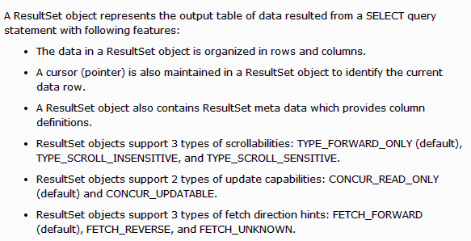

Type of ResultSet:
The possible RSType are given below, If you do not specify any ResultSet type, you will automatically get one that is TYPE_FORWARD_ONLY.
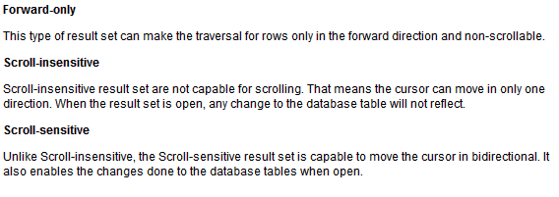
Type | Description
ResultSet.TYPE_FORWARD_ONLY | The cursor can only move forward in the result set.
ResultSet.TYPE_SCROLL_INSENSITIVE | The cursor can scroll forwards and backwards, and the result set is not sensitive to changes made by others to the database that occur after the result set was created.
ResultSet.TYPE_SCROLL_SENSITIVE. | The cursor can scroll forwards and backwards, and the result set is sensitive to changes made by others to the database that occur after the result set was created.

Concurrency of ResultSet:
The possible RSConcurrency are given below, If you do not specify any Concurrency type, you will automatically get one that is CONCUR_READ_ONLY.
Concurrency | Description
ResultSet.CONCUR_READ_ONLY | Creates a read-only result set. This is the default
ResultSet.CONCUR_UPDATABLE | Creates an updateable result set.
Our all the examples written so far can be written as follows which initializes a Statement object to create a forward-only, read only ResultSet object:
try {
Statement stmt = conn.createStatement(
ResultSet.TYPE_FORWARD_ONLY,
ResultSet.CONCUR_READ_ONLY);
}
catch(Exception ex) {
....
}
finally {
....
}

Navigating a Result Set:
There are several methods in the ResultSet interface that involve moving the cursor, including:
S.N. | Methods & Description
1 | public void beforeFirst() throws SQLException  Moves the cursor to just before the first row
2 | public void afterLast() throws SQLException  Moves the cursor to just after the last row
3 | public boolean first() throws SQLException  Moves the cursor to the first row
4 | public void last() throws SQLException  Moves the cursor to the last row.
5 | public boolean absolute(int row) throws SQLException  Moves the cursor to the specified row
6 | public boolean relative(int row) throws SQLException  Moves the cursor the given number of rows forward or backwards from where it currently is pointing.
7 | public boolean previous() throws SQLException  Moves the cursor to the previous row. This method returns false if the previous row is off the result set
8 | public boolean next() throws SQLException  Moves the cursor to the next row. This method returns false if there are no more rows in the result set
9 | public int getRow() throws SQLException  Returns the row number that the cursor is pointing to.
10 | public void moveToInsertRow() throws SQLException  Moves the cursor to a special row in the result set that can be used to insert a new row into the database. The current cursor location is remembered.
11 | public void moveToCurrentRow() throws SQLException  Moves the cursor back to the current row if the cursor is currently at the insert row; otherwise, this method does nothing
For a better understanding, I would suggest to study Navigate - Example Code.

Viewing a Result Set:
The ResultSet interface contains dozens of methods for getting the data of the current row.
There is a get method for each of the possible data types, and each get method has two versions:
- One that takes in a column name.
- One that takes in a column index.
For example, if the column you are interested in viewing contains an int, you need to use one of the getInt() methods of ResultSet:
S.N. | Methods & Description
1 | public int getInt(String columnName) throws SQLException  Returns the int in the current row in the column named columnName
2 | public int getInt(int columnIndex) throws SQLException  Returns the int in the current row in the specified column index. The column index starts at 1, meaning the first column of a row is 1, the second column of a row is 2, and so on.
Similarly there are get methods in the ResultSet interface for each of the eight Java primitive types, as well as common types such as java.lang.String, java.lang.Object, and java.net.URL
There are also methods for getting SQL data types java.sql.Date, java.sql.Time, java.sql.TimeStamp, java.sql.Clob, and java.sql.Blob. Check the documentation for more information about using these SQL data types.
For a better understanding, I would suggest to study Viewing - Example Code.

Updating a Result Set:
The ResultSet interface contains a collection of update methods for updating the data of a result set.
As with the get methods, there are two update methods for each data type:
- One that takes in a column name.
- One that takes in a column index.
For example, to update a String column of the current row of a result set, you would use one of the following updateString() methods:
S.N. | Methods & Description
1 | public void updateString(int columnIndex, String s) throws SQLException  Changes the String in the specified column to the value of s.
2 | public void updateString(String columnName, String s) throws SQLException  Similar to the previous method, except that the column is specified by its name instead of its index.
There are update methods for the eight primitive data types, as well as String, Object, URL, and the SQL data types in the java.sql package.
Updating a row in the result set changes the columns of the current row in the ResultSet object, but not in the underlying database. To update your changes to the row in the database, you need to invoke one of the following methods.
S.N. | Methods & Description
1 | public void updateRow()  Updates the current row by updating the corresponding row in the database.
2 | public void deleteRow()  Deletes the current row from the database
3 | public void refreshRow()  Refreshes the data in the result set to reflect any recent changes in the database.
4 | public void cancelRowUpdates()  Cancels any updates made on the current row.
5 | public void insertRow()  Inserts a row into the database. This method can only be invoked when the cursor is pointing to the insert row.
For a better understanding, I would suggest to study Updating - Example Code.
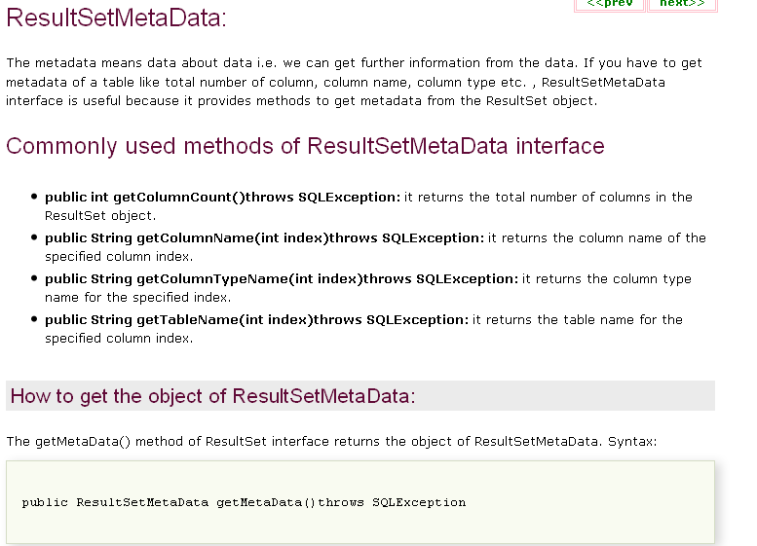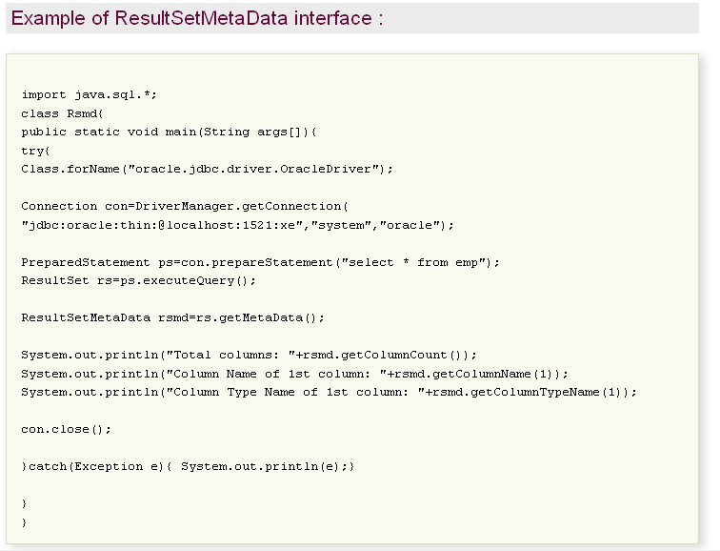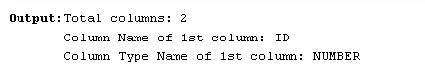
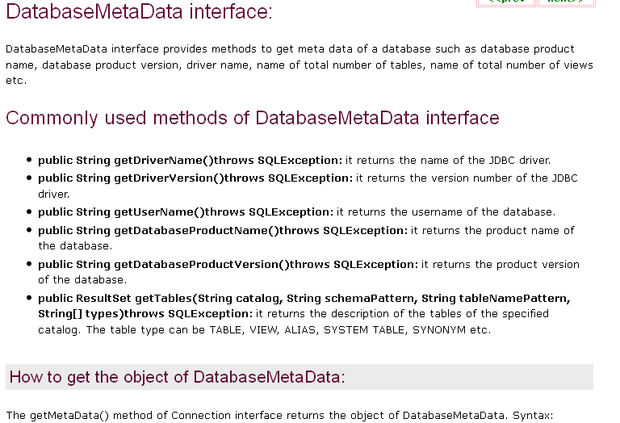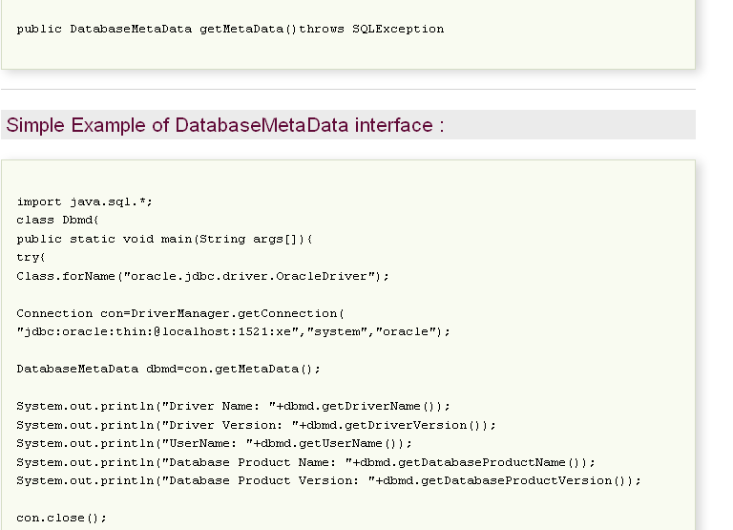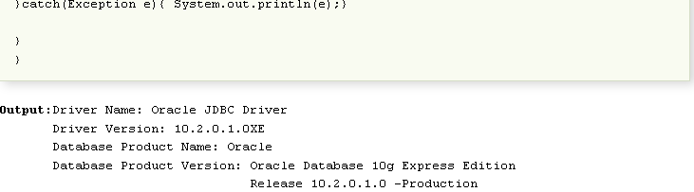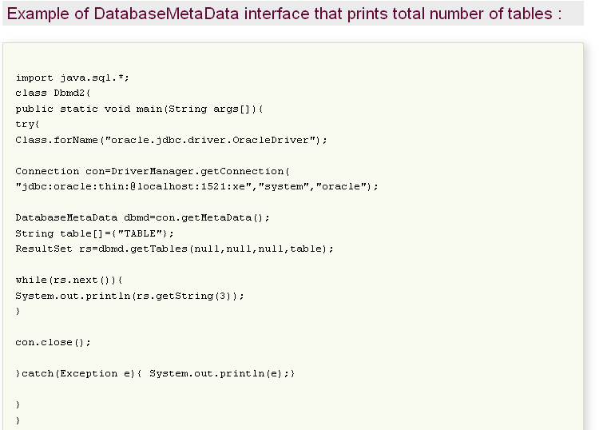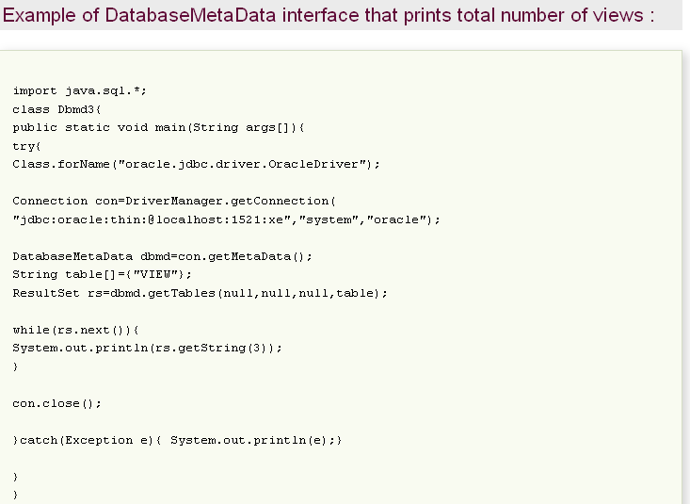

Package javax.sql
javax.sql.* package is used for the advance jdbc. Advance is connection pooling, rowsets...ect.
Provides the API for server side data source access and processing from the JavaTM programming language.
Interface Summary
CommonDataSource | Interface that defines the methods which are common between DataSource, XADataSource and ConnectionPoolDataSource.
ConnectionEventListener | An object that registers to be notified of events generated by a PooledConnection object.
ConnectionPoolDataSource | A factory for PooledConnection objects.
DataSource | A factory for connections to the physical data source that this DataSource object represents.
PooledConnection | An object that provides hooks for connection pool management.
RowSet | The interface that adds support to the JDBC API for the JavaBeansTM component model.
RowSetInternal | The interface that a RowSet object implements in order to present itself to a RowSetReader or RowSetWriter object.
RowSetListener | An interface that must be implemented by a component that wants to be notified when a significant event happens in the life of a RowSet object.
RowSetMetaData | An object that contains information about the columns in a RowSet object.
RowSetReader | The facility that a disconnected RowSet object calls on to populate itself with rows of data.
RowSetWriter | An object that implements the RowSetWriter interface, called a writer.
StatementEventListener | An object that registers to be notified of events that occur on PreparedStatements that are in the Statement pool.
XAConnection | An object that provides support for distributed transactions.
XADataSource | A factory for XAConnection objects that is used internally.

Class Summary
ConnectionEvent | An Event object that provides information about the source of a connection-related event.
RowSetEvent | An Event object generated when an event occurs to a RowSet object.
StatementEvent | A StatementEvent is sent to all StatementEventListeners which were registered with a PooledConnection.

DataSource:-
DataSource interface as an alternative to the DriverManager for establishing the connection. A DataSource object is the representation of database or the data source in the Java programming language. DataSouce object is mostly preferred over the DriverManager for establishing a connection to the database.
DataSource object can be thought as a factory for making connections to the particular database that the DataSource instance represents.
DataSource has a set of properties that identify and describe the real world data source that it represents. The properties include information about the location of the database server, the network protocol use to communicate with the server the name of the database and so on.
DataSource object works with JNDI (Java Naming and Directory interface) naming service so application can use the JNDI API to access the DataSource object.
In short we can say that the DataSource interface is implemented to provide three kinds of connections:
1). Basic DataSource class
This class is provided by the driver vendor. It is used for portability and easy maintence.
2). To provide connection pooling.
It is provided by the application server vendor or driver vendor. It works with ConnectionPoolDataSource class provided by a driver vendor. Its advantage is portability, easy maintenence and increased performance.
3). To provide distributed transactions
This class works with an XADataSource class, which is provided by the driver vendor. Its advantages are easy maintenence, portability and ability to participate in distributed transactions.
Data Source properties file example :
db.properties file
blocking=true
maxFree=10
loggingSQLWarning=true
min=10
$class=atg.service.jdbc.MonitoredDataSource
loggingSQLDebug=false
loggingSQLInfo=false
dataSource=DBXADataSource
max=20
maxIdleAge=1800
loggingSQLError=true
-------------------------------------------------
DBXADataSource.properties file
$class=atg.service.jdbc.FakeXADataSource
driver=oracle.jdbc.driver.OracleDriver
URL=jdbc:oracle:thin:@url:1545:testdb
user=sa
password=sa
readOnly=false
needsSeparateUserInfo=true

javax.sql
Interface DataSource
All Superinterfaces:
CommonDataSource, Wrapper
Method Summary
Connection | getConnection()  Attempts to establish a connection with the data source that this DataSource object represents.
Connection | getConnection(String username, String password)  Attempts to establish a connection with the data source that this DataSource object represents.

Methods inherited from interface javax.sql.CommonDataSource
getLoginTimeout, getLogWriter, setLoginTimeout, setLogWriter

Methods inherited from interface java.sql.Wrapper
isWrapperFor, unwrap

javax.sql
Interface RowSet
All Superinterfaces:
ResultSet, Wrapper
All Known Subinterfaces:
CachedRowSet, FilteredRowSet, JdbcRowSet, JoinRowSet, SyncResolver, WebRowSet

public interface RowSet
extends ResultSet
The interface that adds support to the JDBC API for the JavaBeansTM component model. A rowset, which can be used as a JavaBeans component in a visual Bean development environment, can be created and configured at design time and executed at run time.
The RowSet interface provides a set of JavaBeans properties that allow a RowSet instance to be configured to connect to a JDBC data source and read some data from the data source. A group of setter methods (setInt, setBytes, setString, and so on) provide a way to pass input parameters to a rowset's command property. This command is the SQL query the rowset uses when it gets its data from a relational database, which is generally the case.
The RowSet interface supports JavaBeans events, allowing other components in an application to be notified when an event occurs on a rowset, such as a change in its value.
The RowSet interface is unique in that it is intended to be implemented using the rest of the JDBC API. In other words, a RowSet implementation is a layer of software that executes "on top" of a JDBC driver. Implementations of the RowSet interface can be provided by anyone, including JDBC driver vendors who want to provide a RowSet implementation as part of their JDBC products.
A RowSet object may make a connection with a data source and maintain that connection throughout its life cycle, in which case it is called a connected rowset. A rowset may also make a connection with a data source, get data from it, and then close the connection. Such a rowset is called a disconnected rowset. A disconnected rowset may make changes to its data while it is disconnected and then send the changes back to the original source of the data, but it must reestablish a connection to do so.
A disconnected rowset may have a reader (a RowSetReader object) and a writer (a RowSetWriter object) associated with it. The reader may be implemented in many different ways to populate a rowset with data, including getting data from a non-relational data source. The writer can also be implemented in many different ways to propagate changes made to the rowset's data back to the underlying data source.
Rowsets are easy to use. The RowSet interface extends the standard java.sql.ResultSet interface. The RowSetMetaData interface extends the java.sql.ResultSetMetaData interface. Thus, developers familiar with the JDBC API will have to learn a minimal number of new APIs to use rowsets. In addition, third-party software tools that work with JDBC ResultSet objects will also easily be made to work with rowsets.
Since:
1.4

Field Summary

Fields inherited from interface java.sql.ResultSet
CLOSE_CURSORS_AT_COMMIT, CONCUR_READ_ONLY, CONCUR_UPDATABLE, FETCH_FORWARD, FETCH_REVERSE, FETCH_UNKNOWN, HOLD_CURSORS_OVER_COMMIT, TYPE_FORWARD_ONLY, TYPE_SCROLL_INSENSITIVE, TYPE_SCROLL_SENSITIVE

Method Summary
void | addRowSetListener(RowSetListener listener)  Registers the given listener so that it will be notified of events that occur on this RowSet object.
void | clearParameters()  Clears the parameters set for this RowSet object's command.
void | execute()  Fills this RowSet object with data.
String | getCommand()  Retrieves this RowSet object's command property.
String | getDataSourceName()  Retrieves the logical name that identifies the data source for this RowSet object.
boolean | getEscapeProcessing()  Retrieves whether escape processing is enabled for this RowSet object.
int | getMaxFieldSize()  Retrieves the maximum number of bytes that may be returned for certain column values.
int | getMaxRows()  Retrieves the maximum number of rows that this RowSet object can contain.
String | getPassword()  Retrieves the password used to create a database connection.
int | getQueryTimeout()  Retrieves the maximum number of seconds the driver will wait for a statement to execute.
int | getTransactionIsolation()  Retrieves the transaction isolation level set for this RowSet object.
Map<String,Class<?>> | getTypeMap()  Retrieves the Map object associated with this RowSet object, which specifies the custom mapping of SQL user-defined types, if any.
String | getUrl()  Retrieves the url property this RowSet object will use to create a connection if it uses the DriverManager instead of a DataSource object to establish the connection.
String | getUsername()  Retrieves the username used to create a database connection for this RowSet object.
boolean | isReadOnly()  Retrieves whether this RowSet object is read-only.
void | removeRowSetListener(RowSetListener listener)  Removes the specified listener from the list of components that will be notified when an event occurs on this RowSet object.
void | setArray(int i, Array x)  Sets the designated parameter in this RowSet object's command with the given Array value.
void | setAsciiStream(int parameterIndex, InputStream x)  Sets the designated parameter in this RowSet object's command to the given input stream.
void | setAsciiStream(int parameterIndex, InputStream x, int length)  Sets the designated parameter in this RowSet object's command to the given java.io.InputStream value.
void | setAsciiStream(String parameterName, InputStream x)  Sets the designated parameter to the given input stream.
void | setAsciiStream(String parameterName, InputStream x, int length)  Sets the designated parameter to the given input stream, which will have the specified number of bytes.
void | setBigDecimal(int parameterIndex, BigDecimal x)  Sets the designated parameter in this RowSet object's command to the given java.math.BigDeciaml value.
void | setBigDecimal(String parameterName, BigDecimal x)  Sets the designated parameter to the given java.math.BigDecimal value.
void | setBinaryStream(int parameterIndex, InputStream x)  Sets the designated parameter in this RowSet object's command to the given input stream.
void | setBinaryStream(int parameterIndex, InputStream x, int length)  Sets the designated parameter in this RowSet object's command to the given java.io.InputStream value.
void | setBinaryStream(String parameterName, InputStream x)  Sets the designated parameter to the given input stream.
void | setBinaryStream(String parameterName, InputStream x, int length)  Sets the designated parameter to the given input stream, which will have the specified number of bytes.
void | setBlob(int i, Blob x)  Sets the designated parameter in this RowSet object's command with the given Blob value.
void | setBlob(int parameterIndex, InputStream inputStream)  Sets the designated parameter to a InputStream object.
void | setBlob(int parameterIndex, InputStream inputStream, long length)  Sets the designated parameter to a InputStream object.
void | setBlob(String parameterName, Blob x)  Sets the designated parameter to the given java.sql.Blob object.
void | setBlob(String parameterName, InputStream inputStream)  Sets the designated parameter to a InputStream object.
void | setBlob(String parameterName, InputStream inputStream, long length)  Sets the designated parameter to a InputStream object.
void | setBoolean(int parameterIndex, boolean x)  Sets the designated parameter in this RowSet object's command to the given Java boolean value.
void | setBoolean(String parameterName, boolean x)  Sets the designated parameter to the given Java boolean value.
void | setByte(int parameterIndex, byte x)  Sets the designated parameter in this RowSet object's command to the given Java byte value.
void | setByte(String parameterName, byte x)  Sets the designated parameter to the given Java byte value.
void | setBytes(int parameterIndex, byte[] x)  Sets the designated parameter in this RowSet object's command to the given Java array of byte values.
void | setBytes(String parameterName, byte[] x)  Sets the designated parameter to the given Java array of bytes.
void | setCharacterStream(int parameterIndex, Reader reader)  Sets the designated parameter in this RowSet object's command to the given Reader object.
void | setCharacterStream(int parameterIndex, Reader reader, int length)  Sets the designated parameter in this RowSet object's command to the given java.io.Reader value.
void | setCharacterStream(String parameterName, Reader reader)  Sets the designated parameter to the given Reader object.
void | setCharacterStream(String parameterName, Reader reader, int length)  Sets the designated parameter to the given Reader object, which is the given number of characters long.
void | setClob(int i, Clob x)  Sets the designated parameter in this RowSet object's command with the given Clob value.
void | setClob(int parameterIndex, Reader reader)  Sets the designated parameter to a Reader object.
void | setClob(int parameterIndex, Reader reader, long length)  Sets the designated parameter to a Reader object.
void | setClob(String parameterName, Clob x)  Sets the designated parameter to the given java.sql.Clob object.
void | setClob(String parameterName, Reader reader)  Sets the designated parameter to a Reader object.
void | setClob(String parameterName, Reader reader, long length)  Sets the designated parameter to a Reader object.
void | setCommand(String cmd)  Sets this RowSet object's command property to the given SQL query.
void | setConcurrency(int concurrency)  Sets the concurrency of this RowSet object to the given concurrency level.
void | setDataSourceName(String name)  Sets the data source name property for this RowSet object to the given String.
void | setDate(int parameterIndex, Date x)  Sets the designated parameter in this RowSet object's command to the given java.sql.Date value.
void | setDate(int parameterIndex, Date x, Calendar cal)  Sets the designated parameter in this RowSet object's command with the given java.sql.Date value.
void | setDate(String parameterName, Date x)  Sets the designated parameter to the given java.sql.Date value using the default time zone of the virtual machine that is running the application.
void | setDate(String parameterName, Date x, Calendar cal)  Sets the designated parameter to the given java.sql.Date value, using the given Calendar object.
void | setDouble(int parameterIndex, double x)  Sets the designated parameter in this RowSet object's command to the given Java double value.
void | setDouble(String parameterName, double x)  Sets the designated parameter to the given Java double value.
void | setEscapeProcessing(boolean enable)  Sets escape processing for this RowSet object on or off.
void | setFloat(int parameterIndex, float x)  Sets the designated parameter in this RowSet object's command to the given Java float value.
void | setFloat(String parameterName, float x)  Sets the designated parameter to the given Java float value.
void | setInt(int parameterIndex, int x)  Sets the designated parameter in this RowSet object's command to the given Java int value.
void | setInt(String parameterName, int x)  Sets the designated parameter to the given Java int value.
void | setLong(int parameterIndex, long x)  Sets the designated parameter in this RowSet object's command to the given Java long value.
void | setLong(String parameterName, long x)  Sets the designated parameter to the given Java long value.
void | setMaxFieldSize(int max)  Sets the maximum number of bytes that can be returned for a column value to the given number of bytes.
void | setMaxRows(int max)  Sets the maximum number of rows that this RowSet object can contain to the specified number.
void | setNCharacterStream(int parameterIndex, Reader value)  Sets the designated parameter in this RowSet object's command to a Reader object.
void | setNCharacterStream(int parameterIndex, Reader value, long length)  Sets the designated parameter to a Reader object.
void | setNCharacterStream(String parameterName, Reader value)  Sets the designated parameter to a Reader object.
void | setNCharacterStream(String parameterName, Reader value, long length)  Sets the designated parameter to a Reader object.
void | setNClob(int parameterIndex, NClob value)  Sets the designated parameter to a java.sql.NClob object.
void | setNClob(int parameterIndex, Reader reader)  Sets the designated parameter to a Reader object.
void | setNClob(int parameterIndex, Reader reader, long length)  Sets the designated parameter to a Reader object.
void | setNClob(String parameterName, NClob value)  Sets the designated parameter to a java.sql.NClob object.
void | setNClob(String parameterName, Reader reader)  Sets the designated parameter to a Reader object.
void | setNClob(String parameterName, Reader reader, long length)  Sets the designated parameter to a Reader object.
void | setNString(int parameterIndex, String value)  Sets the designated paramter to the given String object.
void | setNString(String parameterName, String value)  Sets the designated paramter to the given String object.
void | setNull(int parameterIndex, int sqlType)  Sets the designated parameter in this RowSet object's SQL command to SQL NULL.
void | setNull(int paramIndex, int sqlType, String typeName)  Sets the designated parameter in this RowSet object's SQL command to SQL NULL.
void | setNull(String parameterName, int sqlType)  Sets the designated parameter to SQL NULL.
void | setNull(String parameterName, int sqlType, String typeName)  Sets the designated parameter to SQL NULL.
void | setObject(int parameterIndex, Object x)  Sets the designated parameter in this RowSet object's command with a Java Object.
void | setObject(int parameterIndex, Object x, int targetSqlType)  Sets the designated parameter in this RowSet object's command with a Java Object.
void | setObject(int parameterIndex, Object x, int targetSqlType, int scaleOrLength)  Sets the designated parameter in this RowSet object's command with the given Java Object.
void | setObject(String parameterName, Object x)  Sets the value of the designated parameter with the given object.
void | setObject(String parameterName, Object x, int targetSqlType)  Sets the value of the designated parameter with the given object.
void | setObject(String parameterName, Object x, int targetSqlType, int scale)  Sets the value of the designated parameter with the given object.
void | setPassword(String password)  Sets the database password for this RowSet object to the given String.
void | setQueryTimeout(int seconds)  Sets the maximum time the driver will wait for a statement to execute to the given number of seconds.
void | setReadOnly(boolean value)  Sets whether this RowSet object is read-only to the given boolean.
void | setRef(int i, Ref x)  Sets the designated parameter in this RowSet object's command with the given Ref value.
void | setRowId(int parameterIndex, RowId x)  Sets the designated parameter to the given java.sql.RowId object.
void | setRowId(String parameterName, RowId x)  Sets the designated parameter to the given java.sql.RowId object.
void | setShort(int parameterIndex, short x)  Sets the designated parameter in this RowSet object's command to the given Java short value.
void | setShort(String parameterName, short x)  Sets the designated parameter to the given Java short value.
void | setSQLXML(int parameterIndex, SQLXML xmlObject)  Sets the designated parameter to the given java.sql.SQLXML object.
void | setSQLXML(String parameterName, SQLXML xmlObject)  Sets the designated parameter to the given java.sql.SQLXML object.
void | setString(int parameterIndex, String x)  Sets the designated parameter in this RowSet object's command to the given Java String value.
void | setString(String parameterName, String x)  Sets the designated parameter to the given Java String value.
void | setTime(int parameterIndex, Time x)  Sets the designated parameter in this RowSet object's command to the given java.sql.Time value.
void | setTime(int parameterIndex, Time x, Calendar cal)  Sets the designated parameter in this RowSet object's command with the given java.sql.Time value.
void | setTime(String parameterName, Time x)  Sets the designated parameter to the given java.sql.Time value.
void | setTime(String parameterName, Time x, Calendar cal)  Sets the designated parameter to the given java.sql.Time value, using the given Calendar object.
void | setTimestamp(int parameterIndex, Timestamp x)  Sets the designated parameter in this RowSet object's command to the given java.sql.Timestamp value.
void | setTimestamp(int parameterIndex, Timestamp x, Calendar cal)  Sets the designated parameter in this RowSet object's command with the given java.sql.Timestamp value.
void | setTimestamp(String parameterName, Timestamp x)  Sets the designated parameter to the given java.sql.Timestamp value.
void | setTimestamp(String parameterName, Timestamp x, Calendar cal)  Sets the designated parameter to the given java.sql.Timestamp value, using the given Calendar object.
void | setTransactionIsolation(int level)  Sets the transaction isolation level for this RowSet obejct.
void | setType(int type)  Sets the type of this RowSet object to the given type.
void | setTypeMap(Map<String,Class<?>> map)  Installs the given java.util.Map object as the default type map for this RowSet object.
void | setURL(int parameterIndex, URL x)  Sets the designated parameter to the given java.net.URL value.
void | setUrl(String url)  Sets the URL this RowSet object will use when it uses the DriverManager to create a connection.
void | setUsername(String name)  Sets the username property for this RowSet object to the given String.

Methods inherited from interface java.sql.ResultSet
absolute, afterLast, beforeFirst, cancelRowUpdates, clearWarnings, close, deleteRow, findColumn, first, getArray, getArray, getAsciiStream, getAsciiStream, getBigDecimal, getBigDecimal, getBigDecimal, getBigDecimal, getBinaryStream, getBinaryStream, getBlob, getBlob, getBoolean, getBoolean, getByte, getByte, getBytes, getBytes, getCharacterStream, getCharacterStream, getClob, getClob, getConcurrency, getCursorName, getDate, getDate, getDate, getDate, getDouble, getDouble, getFetchDirection, getFetchSize, getFloat, getFloat, getHoldability, getInt, getInt, getLong, getLong, getMetaData, getNCharacterStream, getNCharacterStream, getNClob, getNClob, getNString, getNString, getObject, getObject, getObject, getObject, getRef, getRef, getRow, getRowId, getRowId, getShort, getShort, getSQLXML, getSQLXML, getStatement, getString, getString, getTime, getTime, getTime, getTime, getTimestamp, getTimestamp, getTimestamp, getTimestamp, getType, getUnicodeStream, getUnicodeStream, getURL, getURL, getWarnings, insertRow, isAfterLast, isBeforeFirst, isClosed, isFirst, isLast, last, moveToCurrentRow, moveToInsertRow, next, previous, refreshRow, relative, rowDeleted, rowInserted, rowUpdated, setFetchDirection, setFetchSize, updateArray, updateArray, updateAsciiStream, updateAsciiStream, updateAsciiStream, updateAsciiStream, updateAsciiStream, updateAsciiStream, updateBigDecimal, updateBigDecimal, updateBinaryStream, updateBinaryStream, updateBinaryStream, updateBinaryStream, updateBinaryStream, updateBinaryStream, updateBlob, updateBlob, updateBlob, updateBlob, updateBlob, updateBlob, updateBoolean, updateBoolean, updateByte, updateByte, updateBytes, updateBytes, updateCharacterStream, updateCharacterStream, updateCharacterStream, updateCharacterStream, updateCharacterStream, updateCharacterStream, updateClob, updateClob, updateClob, updateClob, updateClob, updateClob, updateDate, updateDate, updateDouble, updateDouble, updateFloat, updateFloat, updateInt, updateInt, updateLong, updateLong, updateNCharacterStream, updateNCharacterStream, updateNCharacterStream, updateNCharacterStream, updateNClob, updateNClob, updateNClob, updateNClob, updateNClob, updateNClob, updateNString, updateNString, updateNull, updateNull, updateObject, updateObject, updateObject, updateObject, updateRef, updateRef, updateRow, updateRowId, updateRowId, updateShort, updateShort, updateSQLXML, updateSQLXML, updateString, updateString, updateTime, updateTime, updateTimestamp, updateTimestamp, wasNull

Methods inherited from interface java.sql.Wrapper
isWrapperFor, unwrap
An Example of Row Set Event listener is given below, To run this example at first create a database name student and create a table also named student
CREATE TABLE student (
RollNo int(9) PRIMARY KEY NOT NULL,
Name tinytext NOT NULL,
Course varchar(25) NOT NULL,
Address text
);
Then insert the value into it as
NSERT INTO student VALUES(1, 'Ram', 'B.Tech', 'Delhi') ;
NSERT INTO student VALUES(2, 'Syam', 'M.Tech', 'Mumbai') ;
JDBCRowSetExample.java
package roseindia.net;
import java.sql.Connection;
import java.sql.DriverManager;
import java.sql.ResultSet;
import java.sql.Statement;
import javax.sql.RowSetEvent;
import javax.sql.RowSetListener;
import javax.sql.rowset.JdbcRowSet;
import com.sun.rowset.JdbcRowSetImpl;
public class JDBCRowSetExample {
public static void main(String[] args) throws Exception {
Connection connection = getMySqlConnection();
System.out.println("Connection Done");
Statement statement = connection.createStatement();
JdbcRowSet jdbcRowSet;
jdbcRowSet = new JdbcRowSetImpl(connection);
jdbcRowSet.setType(ResultSet.TYPE_SCROLL_INSENSITIVE);
String queryString = "SELECT * FROM student";
jdbcRowSet.setCommand(queryString);
jdbcRowSet.execute();
jdbcRowSet.addRowSetListener(new ExampleListener());
while (jdbcRowSet.next()) {
// Generating cursor Moved event
System.out.println("Roll No- " + jdbcRowSet.getString(1));
System.out.println("name- " + jdbcRowSet.getString(2));
}
connection.close();
}
// My Sql connection method
public static Connection getMySqlConnection() throws Exception {
String driver = "com.mysql.jdbc.Driver";
String url = "jdbc:mysql://localhost:3306/student";
String username = "root";
String password = "root";
Class.forName(driver);
Connection connection = DriverManager.getConnection(url, username,
password);
return connection;
}
}
class ExampleListener implements RowSetListener {
@Override
public void cursorMoved(RowSetEvent event) {
// TODO Auto-generated method stub
System.out.println("Cursor Moved Listener");
System.out.println(event.toString());
}
@Override
public void rowChanged(RowSetEvent event) {
// TODO Auto-generated method stub
System.out.println("Cursor Changed Listener");
System.out.println(event.toString());
}
@Override
public void rowSetChanged(RowSetEvent event) {
// TODO Auto-generated method stub
System.out.println("RowSet changed Listener");
System.out.println(event.toString());
}
}
When you run this application it will display message as shown below:
Connection Done
Cursor Moved Listener
javax.sql.RowSetEvent[source=com.sun.rowset.JdbcRowSetImpl@85af80]
Roll No- 1
name- vnay
Cursor Moved Listener
javax.sql.RowSetEvent[source=com.sun.rowset.JdbcRowSetImpl@85af80]
Roll No- 2
name- John
Cursor Moved Listener
javax.sql.RowSetEvent[source=com.sun.rowset.JdbcRowSetImpl@85af80]

javax.sql.rowset
Interface CachedRowSet
All Superinterfaces:
Joinable, ResultSet, RowSet, Wrapper
All Known Subinterfaces:
FilteredRowSet, JoinRowSet, WebRowSet
A CachedRowSet object is a container for rows of data that caches its rows in memory, which makes it possible to operate without always being connected to its data source. Further, it is a JavaBeansTM component and is scrollable, updatable, and serializable. A CachedRowSet object typically contains rows from a result set, but it can also contain rows from any file with a tabular format, such as a spread sheet. The reference implementation supports getting data only from a ResultSet object, but developers can extend the SyncProvider implementations to provide access to other tabular data sources.
An application can modify the data in a CachedRowSet object, and those modifications can then be propagated back to the source of the data.
A CachedRowSet object is a disconnected rowset, which means that it makes use of a connection to its data source only briefly. It connects to its data source while it is reading data to populate itself with rows and again while it is propagating changes back to its underlying data source. The rest of the time, a CachedRowSet object is disconnected, including while its data is being modified. Being disconnected makes a RowSet object much leaner and therefore much easier to pass to another component. For example, a disconnected RowSet object can be serialized and passed over the wire to a thin client such as a personal digital assistant (PDA).
Field Summary
static boolean | COMMIT_ON_ACCEPT_CHANGES  Causes the CachedRowSet object's SyncProvider to commit the changes when acceptChanges() is called.

Fields inherited from interface java.sql.ResultSet
CLOSE_CURSORS_AT_COMMIT, CONCUR_READ_ONLY, CONCUR_UPDATABLE, FETCH_FORWARD, FETCH_REVERSE, FETCH_UNKNOWN, HOLD_CURSORS_OVER_COMMIT, TYPE_FORWARD_ONLY, TYPE_SCROLL_INSENSITIVE, TYPE_SCROLL_SENSITIVE

Method Summary
void | acceptChanges()  Propagates row update, insert and delete changes made to this CachedRowSet object to the underlying data source.
void | acceptChanges(Connection con)  Propagates all row update, insert and delete changes to the data source backing this CachedRowSet object using the specified Connection object to establish a connection to the data source.
boolean | columnUpdated(int idx)  Indicates whether the designated column in the current row of this CachedRowSet object has been updated.
boolean | columnUpdated(String columnName)  Indicates whether the designated column in the current row of this CachedRowSet object has been updated.
void | commit()  Each CachedRowSet object's SyncProvider contains a Connection object from the ResultSet or JDBC properties passed to it's constructors.
CachedRowSet | createCopy()  Creates a RowSet object that is a deep copy of the data in this CachedRowSet object.
CachedRowSet | createCopyNoConstraints()  Creates a CachedRowSet object that is a deep copy of this CachedRowSet object's data but is independent of it.
CachedRowSet | createCopySchema()  Creates a CachedRowSet object that is an empty copy of this CachedRowSet object.
RowSet | createShared()  Returns a new RowSet object backed by the same data as that of this CachedRowSet object.
void | execute(Connection conn)  Populates this CachedRowSet object with data, using the given connection to produce the result set from which the data will be read.
int[] | getKeyColumns()  Returns an array containing one or more column numbers indicating the columns that form a key that uniquely identifies a row in this CachedRowSet object.
ResultSet | getOriginal()  Returns a ResultSet object containing the original value of this CachedRowSet object.
ResultSet | getOriginalRow()  Returns a ResultSet object containing the original value for the current row only of this CachedRowSet object.
int | getPageSize()  Returns the page-size for the CachedRowSet object
RowSetWarning | getRowSetWarnings()  Retrieves the first warning reported by calls on this RowSet object.
boolean | getShowDeleted()  Retrieves a boolean indicating whether rows marked for deletion appear in the set of current rows.
SyncProvider | getSyncProvider()  Retrieves the SyncProvider implementation for this CachedRowSet object.
String | getTableName()  Returns an identifier for the object (table) that was used to create this CachedRowSet object.
boolean | nextPage()  Increments the current page of the CachedRowSet.
void | populate(ResultSet data)  Populates this CachedRowSet object with data from the given ResultSet object.
void | populate(ResultSet rs, int startRow)  Populates this CachedRowSet object with data from the given ResultSet object.
boolean | previousPage()  Decrements the current page of the CachedRowSet.
void | release()  Releases the current contents of this CachedRowSet object and sends a rowSetChanged event to all registered listeners.
void | restoreOriginal()  Restores this CachedRowSet object to its original value, that is, its value before the last set of changes.
void | rollback()  Each CachedRowSet object's SyncProvider contains a Connection object from the original ResultSet or JDBC properties passed to it.
void | rollback(Savepoint s)  Each CachedRowSet object's SyncProvider contains a Connection object from the original ResultSet or JDBC properties passed to it.
void | rowSetPopulated(RowSetEvent event, int numRows)  Notifies registered listeners that a RowSet object in the given RowSetEvent object has populated a number of additional rows.
void | setKeyColumns(int[] keys)  Sets this CachedRowSet object's keyCols field with the given array of column numbers, which forms a key for uniquely identifying a row in this CachedRowSet object.
void | setMetaData(RowSetMetaData md)  Sets the metadata for this CachedRowSet object with the given RowSetMetaData object.
void | setOriginalRow()  Sets the current row in this CachedRowSet object as the original row.
void | setPageSize(int size)  Sets the CachedRowSet object's page-size.
void | setShowDeleted(boolean b)  Sets the property showDeleted to the given boolean value, which determines whether rows marked for deletion appear in the set of current rows.
void | setSyncProvider(String provider)  Sets the SyncProvider objec for this CachedRowSet object to the one specified.
void | setTableName(String tabName)  Sets the identifier for the table from which this CachedRowSet object was derived to the given table name.
int | size()  Returns the number of rows in this CachedRowSet object.
Collection<?> | toCollection()  Converts this CachedRowSet object to a Collection object that contains all of this CachedRowSet object's data.
Collection<?> | toCollection(int column)  Converts the designated column in this CachedRowSet object to a Collection object.
Collection<?> | toCollection(String column)  Converts the designated column in this CachedRowSet object to a Collection object.
void | undoDelete()  Cancels the deletion of the current row and notifies listeners that a row has changed.
void | undoInsert()  Immediately removes the current row from this CachedRowSet object if the row has been inserted, and also notifies listeners that a row has changed.
void | undoUpdate()  Immediately reverses the last update operation if the row has been modified.

javax.sql.rowset
Interface JdbcRowSet
All Superinterfaces:
Joinable, ResultSet, RowSet, Wrapper
wrapper around a ResultSet object that makes it possible to use the result set as a JavaBeansTM component. Thus, a JdbcRowSet object can be one of the Beans that a tool makes available for composing an application. Because a JdbcRowSet is a connected rowset, that is, it continually maintains its connection to a database using a JDBC technology-enabled driver, it also effectively makes the driver a JavaBeans component.
Because it is always connected to its database, an instance of JdbcRowSet can simply take calls invoked on it and in turn call them on its ResultSet object. As a consequence, a result set can, for example, be a component in a Swing application.
Another advantage of a JdbcRowSet object is that it can be used to make a ResultSet object scrollable and updatable. All RowSet objects are by default scrollable and updatable. If the driver and database being used do not support scrolling and/or updating of result sets, an application can populate a JdbcRowSet object with the data of a ResultSet object and then operate on the JdbcRowSet object as if it were the ResultSet object.
Method Summary
void | commit()  Each JdbcRowSet contains a Connection object from the ResultSet or JDBC properties passed to it's constructors.
boolean | getAutoCommit()  Each JdbcRowSet contains a Connection object from the original ResultSet or JDBC properties passed to it.
RowSetWarning | getRowSetWarnings()  Retrieves the first warning reported by calls on this JdbcRowSet object.
boolean | getShowDeleted()  Retrieves a boolean indicating whether rows marked for deletion appear in the set of current rows.
void | rollback()  Each JdbcRowSet contains a Connection object from the original ResultSet or JDBC properties passed to it.
void | rollback(Savepoint s)  Each JdbcRowSet contains a Connection object from the original ResultSet or JDBC properties passed to it.
void | setAutoCommit(boolean autoCommit)  Each JdbcRowSet contains a Connection object from the original ResultSet or JDBC properties passed to it.
void | setShowDeleted(boolean b)  Sets the property showDeleted to the given boolean value.

javax.sql.rowset
Interface FilteredRowSet
All Superinterfaces:
CachedRowSet, Joinable, ResultSet, RowSet, WebRowSet, Wrapper

public interface FilteredRowSet
extends WebRowSet
A JDBC FilteredRowSet standard implementation implements the RowSet interfaces and extends the CachedRowSetTM class. The CachedRowSet class provides a set of protected cursor manipulation methods, which a FilteredRowSet implementation can override to supply filtering support.
Method Summary
Predicate | getFilter()  Retrieves the active filter for this FilteredRowSet object.
void | setFilter(Predicate p)  Applies the given Predicate object to this FilteredRowSet object.

Batch in JDBC
"A batch is a group of one or more SQL (Structured Query Language) statements sent in one go to the SQL Server from an application for execution. The SQL Server parse the SQL statements in a single executable unit, called an SQL statement statement execution plan. The statements in the execution plan are then executed by the server in one go."
In Java, JDBC support batch processing using java.sql.Statement and java.sql.PreparesStatement inrerfaces. We can submit multiple DML(Data Manupulation Language) statements to the database server in one call from java application using java.sql package. Only insert, update and delete statements are allowed in batch processing in java. It minimize the number of hits (calls) to database server from java applications.
We can create batch by calling addBatch("Insert or Update or Delete sql statement") method from Statement or PreparesStatement interface. After adding all the statements, call executeBatch() to execute batch. The return type is arry type of int. The values in the itn array indicates how many are affected by the SQL statement in database server.
Syntax : SQL statements to batch -
- stmt.addBatch("insert into emp values('a001','ram','noida',1000)");
- stmt.addBatch("insert into emp values('a002','shayam','pune',2000)");
- stmt.addBatch("insert into emp values('a003','raman','kolkata',3000)");
- stmt.addBatch("insert into emp values('a004','suman','mumbai',4000)");
Execute batch in database server -
int i[] = st.executeBatch();
Follwoing is the source code to demostrates the batch processing using JDBC -
Here I am inserting multiple records in Student table using batch -
01 package jdbc;
02
03 import java.sql.Connection;
04 import java.sql.DriverManager;
05 import java.sql.ResultSet;
06 import java.sql.Statement;
07
08 public class BatchDemo1 {
09 Connection con;
10 Statement stmt;
11
12 public BatchDemo1() {
13 try {
14 Class.forName("com.mysql.jdbc.Driver");
15 con = DriverManager
16 .getConnection("jdbc:mysql://localhost/test?user=root&password=root");
17 } catch (Exception e) {
18 System.out.println("Error in connection" + e);
19 }
20 }
21
22 // Create table in database server
23 public void createTable() {
24 try {
25 String sql1 = "drop table if exists Student";
26 String sql = "create table Student(rollNo int primary key, Name varchar(30), Dob varchar(20), Course varchar(20))";
27
28 // drop the table if exists
29 stmt = con.createStatement();
30 stmt.executeUpdate(sql1);
31
32 // execute SQl statement to execute create table statement
33 stmt = con.createStatement();
34 int i = stmt.executeUpdate(sql);
35 System.out.println("Table created");
36 } catch (Exception e) {
37 e.printStackTrace();
38 }
39 }
40
41 public void batchProcess() {
42 try {
43 stmt.addBatch("insert into Student values(1,'Ram Kumar','10-02-1990','BTech')");
44 stmt.addBatch("insert into Student values(2,'Shayam Kumar','15-05-1992','BTech')");
45 stmt.addBatch("insert into Student values(3,'Ritu Kumari','4-07-1989','MCA')");
46 stmt.addBatch("insert into Student values(4,'Suman Saurabh','12-12-1995','MCA')");
47 stmt.addBatch("insert into Student values(5,'Suresh Sharma','10-11-1991','BTech')");
48 int i[] = stmt.executeBatch();
49 for (int j : i) {
50 if (j != 0)
51 System.out.println("Executed successfully");
52 else
53 System.out.println("Not Executed successfully");
54 }
55 } catch (Exception e) {
56 e.printStackTrace();
57 }
58 }
59
60 public void showRecords() {
61 try {
62 stmt = con.createStatement();
63 ResultSet res = stmt.executeQuery("select * from Student");
64 while (res.next()) {
65 System.out.print(res.getString(1));
66 System.out.print("\t" + res.getString(2));
67 System.out.print("\t" + res.getString(3));
68 System.out.println("\t" + res.getString(4));
69 }
70
71 } catch (Exception e) {
72 System.out.println("Error in fetching data" + e);
73 }
74 }
75
76 public static void main(String[] args) {
77 BatchDemo1 obj = new BatchDemo1();
78 obj.createTable();
79 obj.batchProcess();
80 obj.showRecords();
81 }
82 }
Downlo
What is JDBC Connection Pool?
The database connection is expensive object and it requires a lot of effort to connect to the database and get a connection object. You can then use the same connection object to execute a number of SQL statements. In a high traffic website or web application, getting a new connection from the database for each user request is a huge work and it makes the website slow. There is another mechanism to store a number of connection in a pool and then get the connection from the pool to process user request. One the request is processed you can return the connection to the pool. Thus the Connection Pooling is the mechanism of storing a number of live database connection in resource pool.

JDBC Connection Pool
Posted on: April 3, 2006 at 12:00 AM
The JDBC Connection Pool tutorial discusses about the Connection Pooling in Java.

JDBC Connection Pool
In this section we will learn about JDBC Connection Pool and see how to use Apache DBCP for creating the database connection pool. We will also see some examples of executing SQL statements against database. Your application will give you improved performance if you use the JDBC Connection pooling.
What is JDBC Connection Pool?
The database connection is expensive object and it requires a lot of effort to connect to the database and get a connection object. You can then use the same connection object to execute a number of SQL statements. In a high traffic website or web application, getting a new connection from the database for each user request is a huge work and it makes the website slow. There is another mechanism to store a number of connection in a pool and then get the connection from the pool to process user request. One the request is processed you can return the connection to the pool. Thus the Connection Pooling is the mechanism of storing a number of live database connection in resource pool.
You can make your own code for JDBC connection pooling but instead of writing the code from scratch you can use Apache DBCP. Read Apache DBCP Tutorial for more information on using it for making database connection and executing the SQL statements
Benefits of JDBC Connection Pooling
Here are the benefits of JDBC Connection Pooling:
- Improved Application performance
- Improved response time of the application
- No over head of establishing database connection and closing of the connection
Weblogic-jdbc-connectionPool:-

Understanding WebLogic Database Access
By Jeff Heaton
Entity beans provide a convenient interface between your program and the database. These beans hold data that must eventually be stored in some permanent form, most commonly a relational database. J2EE has two types of entity beans: bean-managed persistence (BMP) beans and container-managed persistence (CMP) beans. BMP entity beans open connections directly to the database, whereas CMP entity beans rely on the server (container) for interacting with the database.
The purpose of an entity bean is to allow Java data to move between memory and permanent storage, such as a database. When entity beans write their data to a database, you need to understand the basics of connecting a database to WebLogic. A basic familiarity with SQL and relational databases is assumed.
You can use nearly any sort of database with WebLogic. The examples in this article use the ODBC-JDBC bridge driver. Open Database Connectivity (ODBC) is a common standard on the Microsoft platform. Java Database Connectivity (JDBC) is the Java database standard. Using the ODBC-JDBC bridge allows you to use ODBC drivers from Java. Everything that you need to use the ODBC-JDBC bridge is already built into Java.
If you're using a database such as Oracle, DB2, MySQL, or SQL Server, you should use the appropriate driver. This will give better performance than the ODBC-JDBC bridge.
Regardless of which database you use, you must set up the appropriate tables. In SQL, a table is a database construct that holds individual rows. For example, if you were keeping an address book, the address book is the table with individual names stored in rows.
Listing 1 shows the SQL code necessary to create an example database.
Listing 1: Script to Create the Example Database
CREATE TABLE T_STUDENT (
F_ID INTEGER NOT NULL PRIMARY KEY,
F_FIRST VARCHAR(40),
F_LAST VARCHAR(40))
CREATE TABLE T_DEPARTMENT (
F_ID INTEGER NOT NULL PRIMARY KEY,
F_NAME VARCHAR(40))
CREATE TABLE T_COURSE (
F_ID INTEGER NOT NULL PRIMARY KEY,
F_NAME VARCHAR(40),
F_CREDIT INTEGER,
F_DEPARTMENT_ID INTEGER NOT NULL)
The SQL in Listing 1 should be generic enough to work with most databases. Note that each table name is prefixed with T_ and each field name is prefixed with F_. This notation ensures that a table or field name does not accidentally use a reserved word. This is important when designing for multiple databases, in which the collection of reserved words is different from database to database.
As you can see from Listing 1, each table is made up of several fields. For example, T_DEPARTMENT holds F_ID and F_NAME as fields. Every row in the T_DEPARTMENT table will hold these two values.

Creating the connection pool
WebLogic communicates with the database through a connection pool. The connection pool enables WebLogic to use a fixed number of connections to databases rather than incur the overhead of constantly creating and disposing of connections. Because of this, you must establish a data connection pool that accesses your database. To do so, follow these steps:
1. Start Administrative Console.
For more information on this step.
2. On the left side of the screen, click the Services folder, and then click the JDBC folder.
On this page, you can choose connection pools and choose to create a connection pool.
3. Type a name for the connection pool.
To follow along with the example, type SchoolPool for the connection pool name. This name needs to be given to the data source you create in the next section.
4. Choose your database type.
Your database type should match the database you're using. To follow along with the example, choose Other.
5. Set the driver class name and URL to whatever is appropriate for your database.
The driver class name and URL in Figure 1 are for an ODBC DSN named school.
6. Add this pool to your server.
To do so, click the Targets tab. Select your server, and then click the right arrow button to assign it.
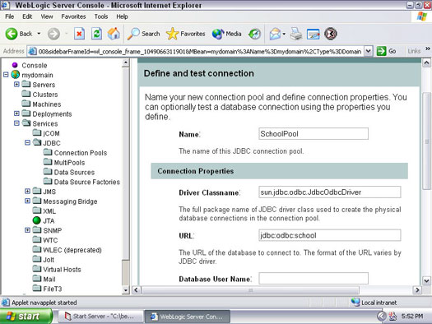
Figure 1: Create a connection pool.

Creating the data source
After you create a connection pool, you must attach it to a data source. It is through this data source that WebLogic can access your database. To create a data source, follow these steps:
1. In Administrative Console, click the Services folder and then click the data source you want to use.
If you choose the JDBC data source, the screen shown in Figure 2 appears.
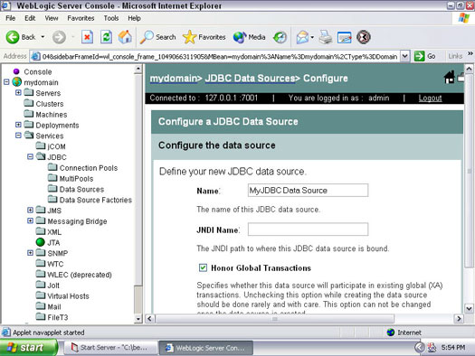
Figure 2: Create a data source.
2. Type a name for your data source.
You can choose any name you want; the name is for your reference only.
3. Type a JNDI name.
To follow along with the example, type jdbc/SchoolDataSource for the JNDI name.
4. Type a pool name.
This is the name you typed in Step 3 in the preceding section. To follow along with the example, type SchoolPool for the pool name.
5. Add this data source to your server.
To do so, click the Targets tab. Select your server, and then click the right arrow button to assign it.
Now that you've set up the database connection, you're ready to use beans that interact with that database.

