JSP

→Java Server Pages or JSP for short is Sun's solution for developing dynamic web sites.
→ JavaServer Pages (JSP) is a technology for developing web pages that support dynamic content which helps developers insert java code in HTML pages by making use of special JSP tags, most of which start with <% and end with %>.
→
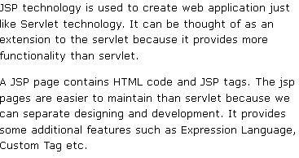
→ SP provide excellent server side scripting support for creating database driven web applications. JSP enable the developers to directly insert java code into jsp file, this makes the development process very simple and its maintenance also becomes very easy. JSP pages are efficient, it loads into the web servers memory on receiving the request very first time and the subsequent calls are served within a very short period of time.

→ Why Use JSP?
JavaServer Pages often serve the same purpose as programs implemented using the Common Gateway Interface (CGI). But JSP offer several advantages in comparison with the CGI.
- Performance is significantly better because JSP allows embedding Dynamic Elements in HTML Pages itself instead of having a separate CGI files.
- JSP are always compiled before it's processed by the server unlike CGI/Perl which requires the server to load an interpreter and the target script each time the page is requested.
- JavaServer Pages are built on top of the Java Servlets API, so like Servlets, JSP also has access to all the powerful Enterprise Java APIs, including JDBC, JNDI, EJB, JAXP etc.
- JSP pages can be used in combination with servlets that handle the business logic, the model supported by Java servlet template engines.
Finally, JSP is an integral part of J2EE, a complete platform for enterprise class applications. This means that JSP can play a part in the simplest applications to the most complex and demanding.
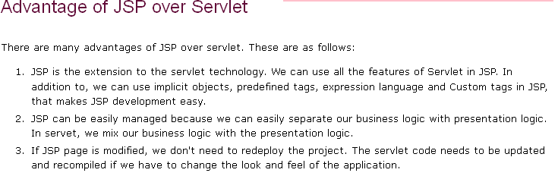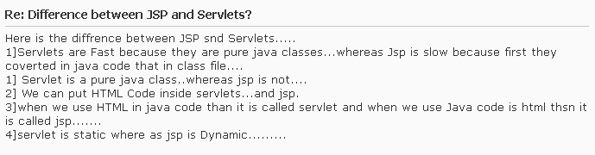

Advantages of JSP:
Following is the list of other advantages of using JSP over other technologies:
- vs. Active Server Pages (ASP): The advantages of JSP are twofold. First, the dynamic part is written in Java, not Visual Basic or other MS specific language, so it is more powerful and easier to use. Second, it is portable to other operating systems and non-Microsoft Web servers.
- vs. Pure Servlets: It is more convenient to write (and to modify!) regular HTML than to have plenty of println statements that generate the HTML.
- vs. Server-Side Includes (SSI): SSI is really only intended for simple inclusions, not for "real" programs that use form data, make database connections, and the like.
- vs. JavaScript: JavaScript can generate HTML dynamically on the client but can hardly interact with the web server to perform complex tasks like database access and image processing etc.
- vs. Static HTML: Regular HTML, of course, cannot contain dynamic information.

In this article we will list some of the differences between Servlet and JSP
Servlet | JSP
A servlet is a server-side program | JSP is an interface on top of Servlets
Executes inside a Web server, such as Tomcat | A JSP program is compiled into a Java servlet before execution
Receives HTTP requests from users and provides HTTP responses | Easier to write than servlets as it is similar to HTML.
Written in Java, with a few additional APIs specific to this kind of processing | Can make use of Javabeans also
In MVC architecture Servlet acts as controller. | In MVC architecture JSP acts as view.
Servlet advantages include:  - Performance-get loaded upon first request and remains in memory idenfinately.  - Simplicity- Run inside controlled server environment. No specific client software is needed:web broser is enough  - Session Management-overcomes HTTP’s stateless nature  <li>Java Technology-network access,Database connectivity, j2ee integration | JSP Provides an extensive infrastructure for:  - Tracking sessions.  - Managing cookies.  - Reading and sending HTML headers.  - Parsing and decoding HTML form data.  - JSP is Efficient: Every request for a JSP is handled by a simple Java thread  - JSP is Scalable: Easy integration with other backend services  - Seperation of roles: Developers, Content Authors/Graphic Designers/Web Masters

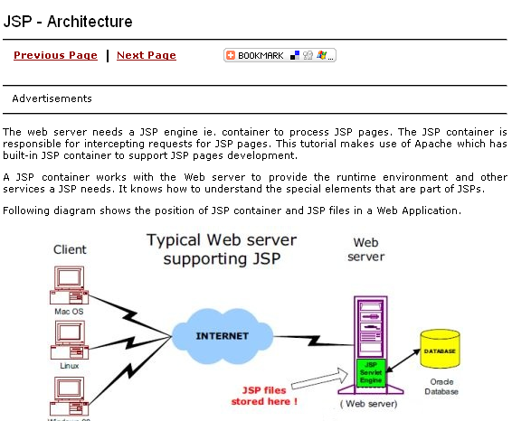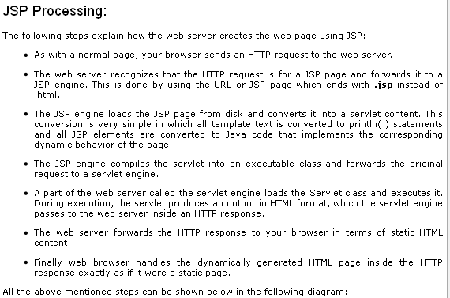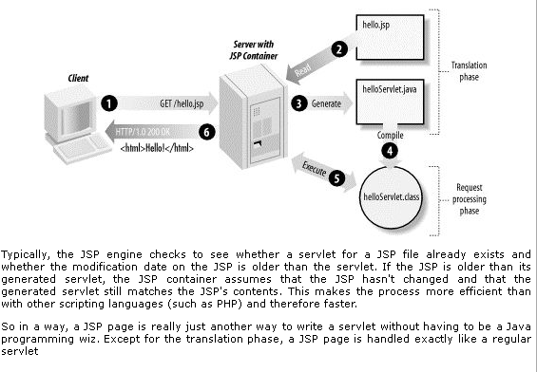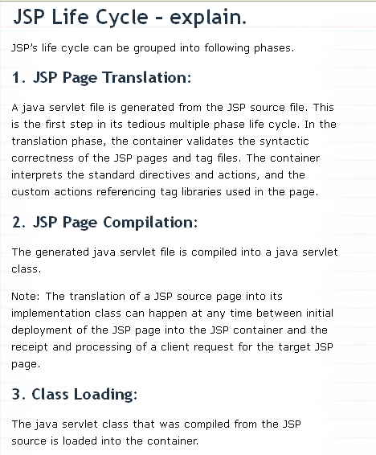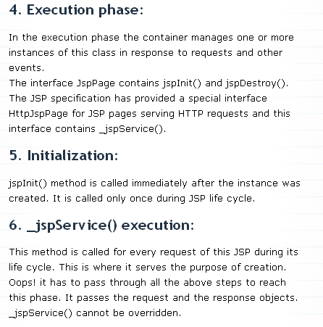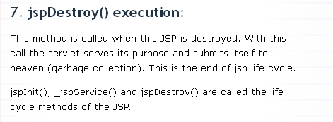
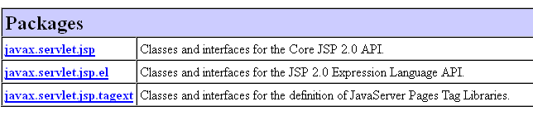

Javax.servlet.jsp:-
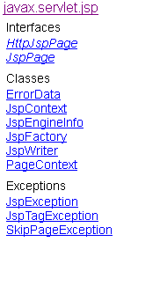
Javax.servlet.jsp.el:-
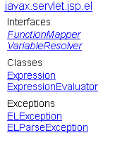

javax.servlet.jsp.tagext
Interfaces
BodyTag
DynamicAttributes
IterationTag
JspTag
SimpleTag
Tag
TryCatchFinally

Classes
BodyContent
BodyTagSupport
FunctionInfo
JspFragment
PageData
SimpleTagSupport
TagAdapter
TagAttributeInfo
TagData
TagExtraInfo
TagFileInfo
TagInfo
TagLibraryInfo
TagLibraryValidator
TagSupport
TagVariableInfo
ValidationMessage
VariableInfo

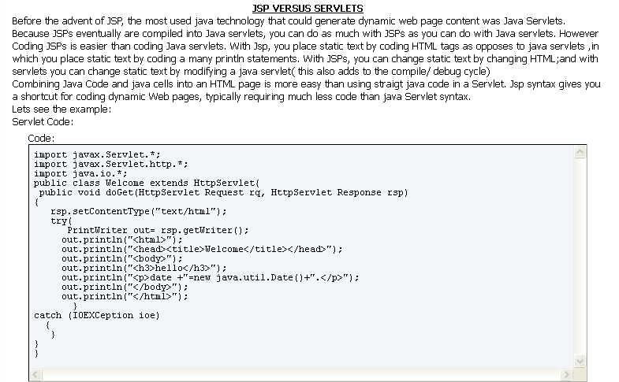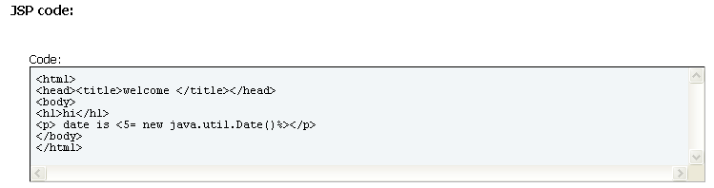

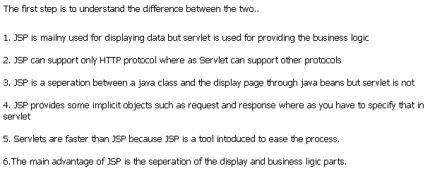

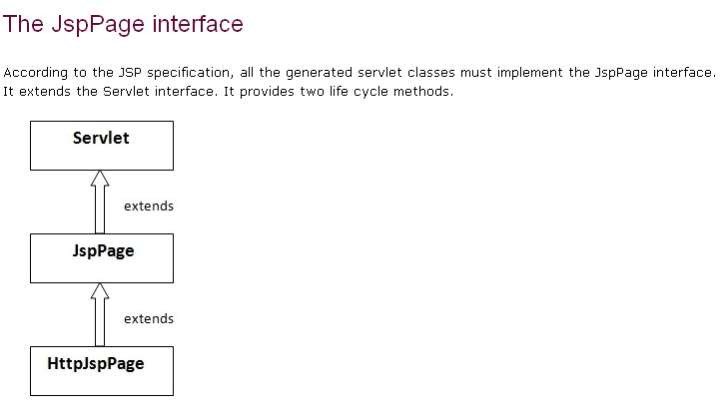

javax.servlet.jsp
Interface JspPage
All Superinterfaces:
javax.servlet.Servlet
All Known Subinterfaces:
HttpJspPage

public interface JspPage extends javax.servlet.Servlet

Method Summary
void | jspDestroy()  The jspDestroy() method is invoked when the JSP page is about to be destroyed.
void | jspInit()  The jspInit() method is invoked when the JSP page is initialized.

Methods inherited from interface javax.servlet.Servlet
destroy, getServletConfig, getServletInfo, init, service

javax.servlet.jsp
Interface HttpJspPage
All Superinterfaces:
JspPage, javax.servlet.Servlet

public interface HttpJspPage extends JspPage

Method Summary
void | _jspService(javax.servlet.http.HttpServletRequest request, javax.servlet.http.HttpServletResponse response)  The _jspService()method corresponds to the body of the JSP page.

Methods inherited from interface javax.servlet.jsp.JspPage
jspDestroy, jspInit

Methods inherited from interface javax.servlet.Servlet
destroy, getServletConfig, getServletInfo, init, service

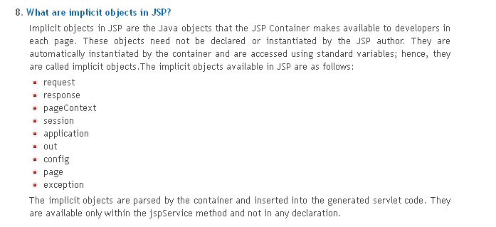
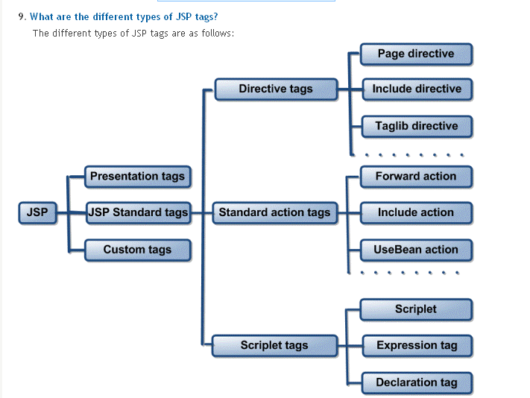
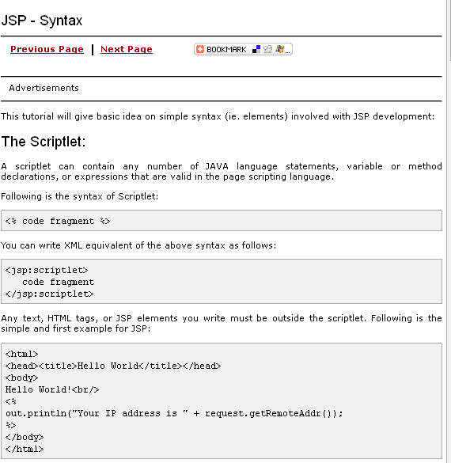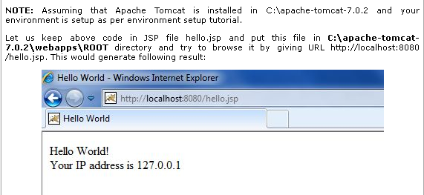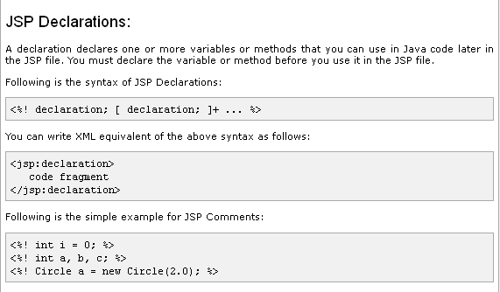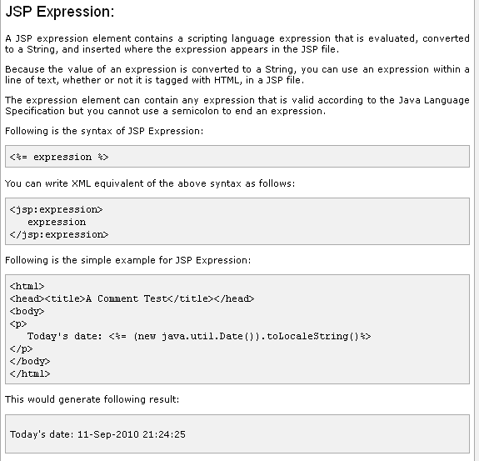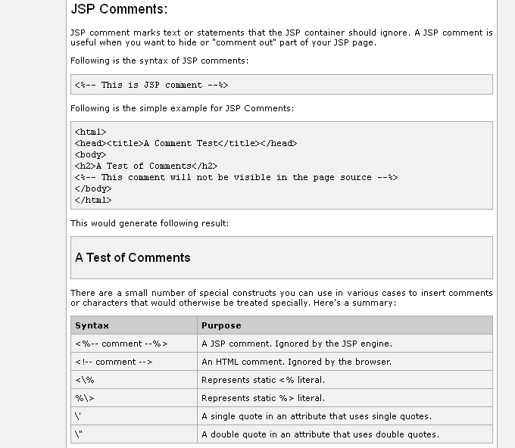

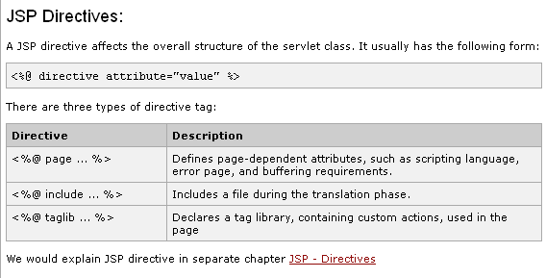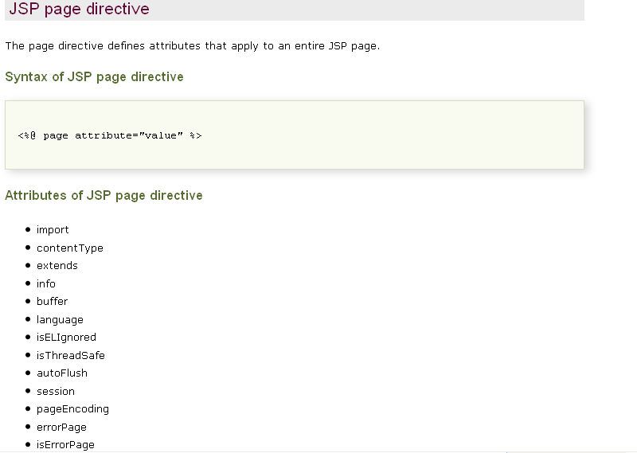
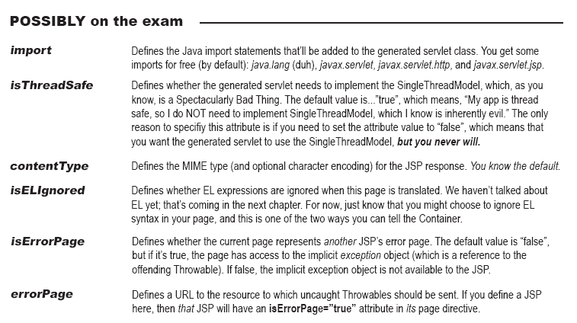
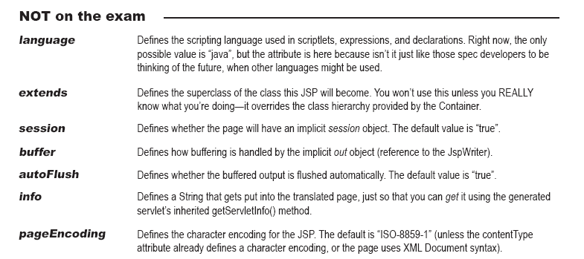
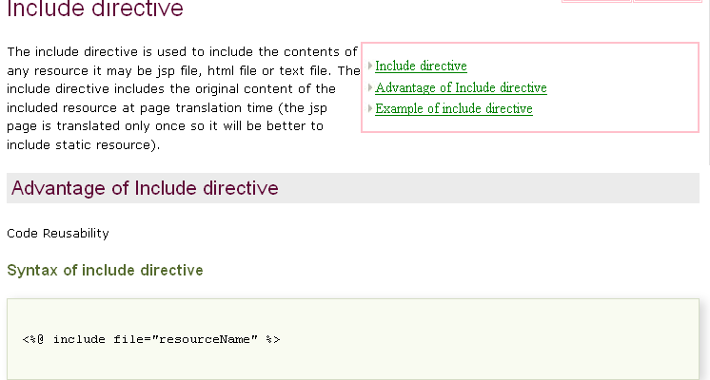
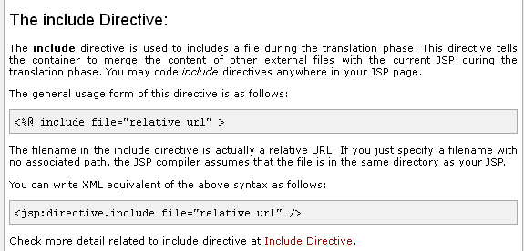
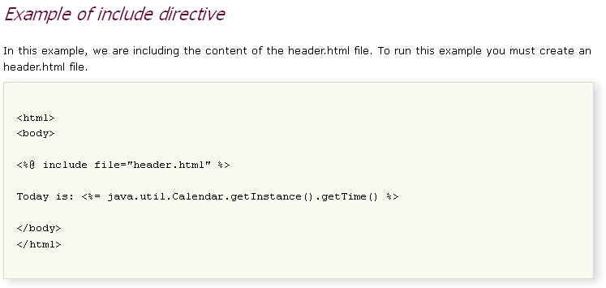
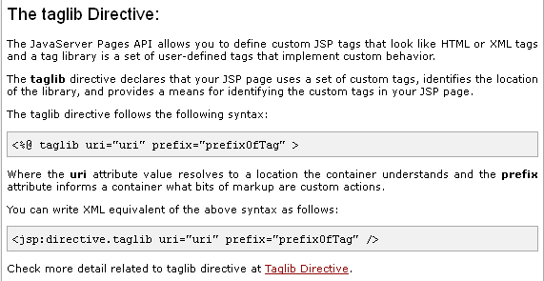
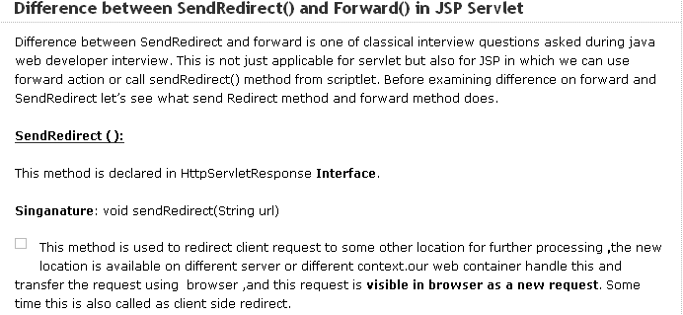
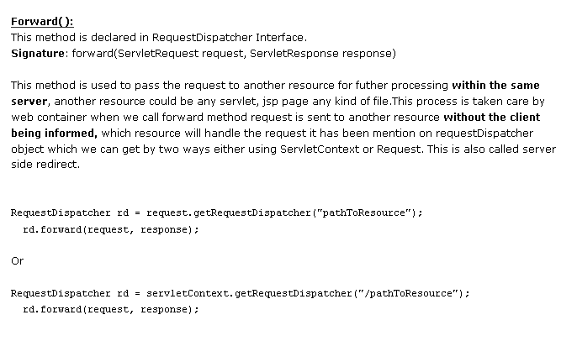
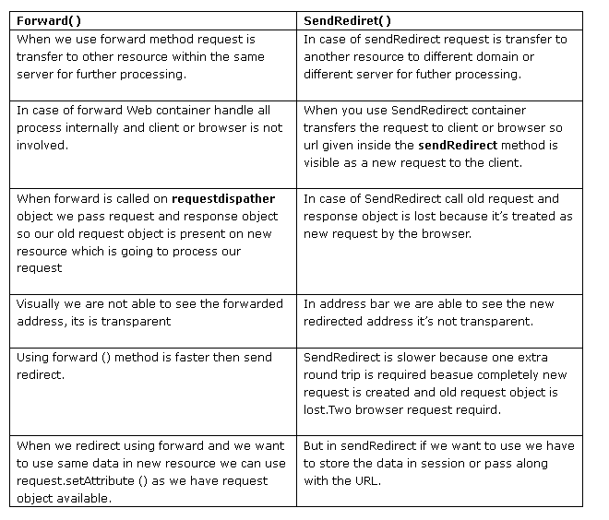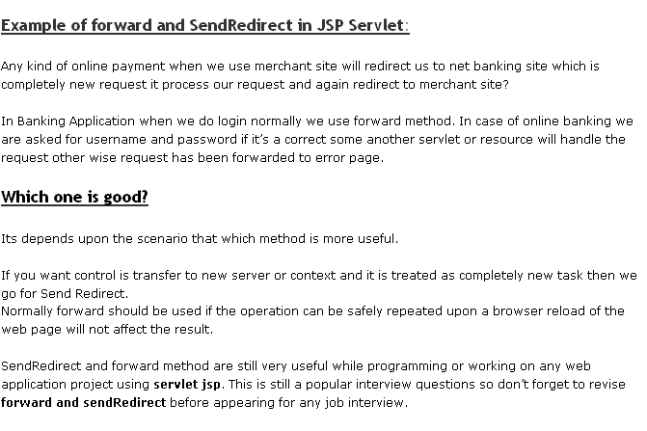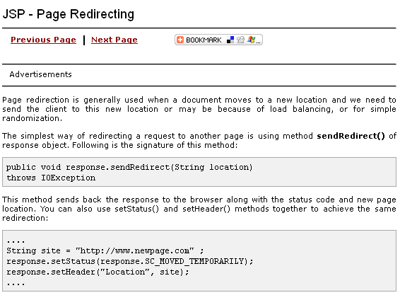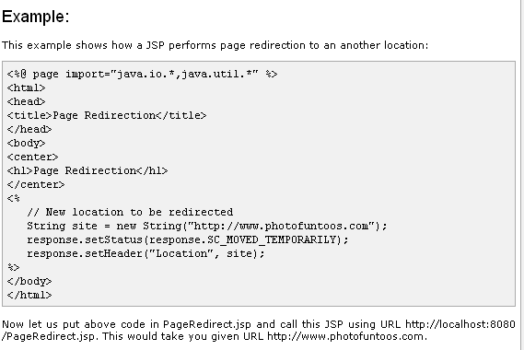
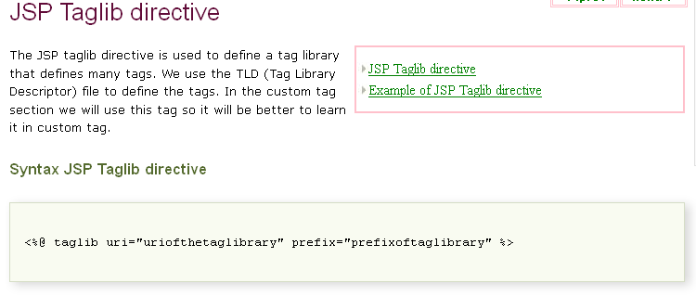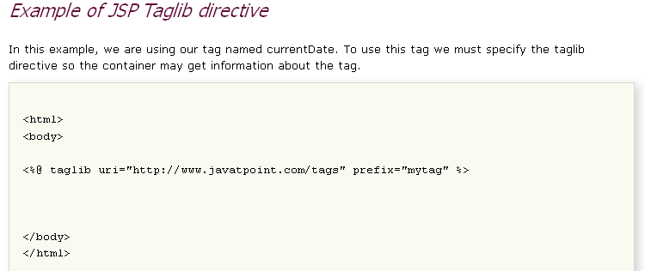

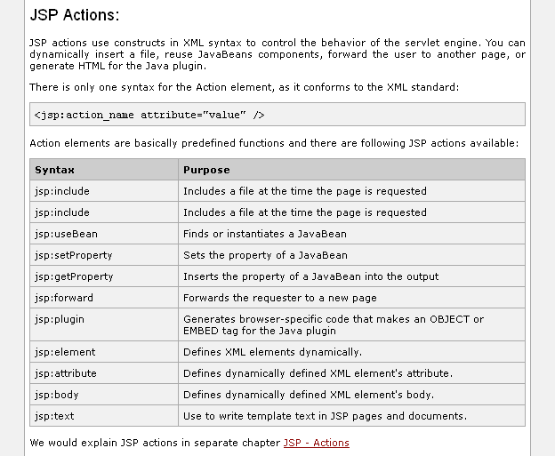
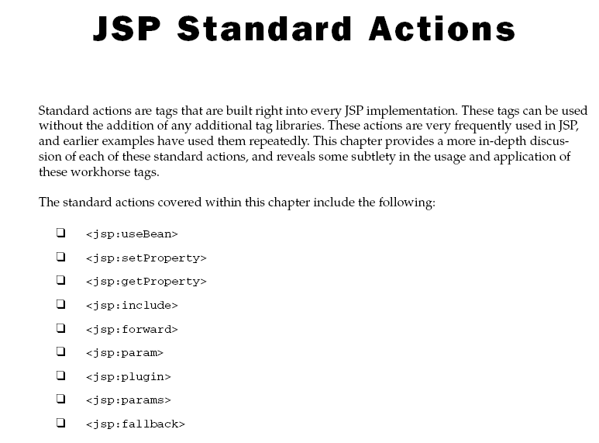
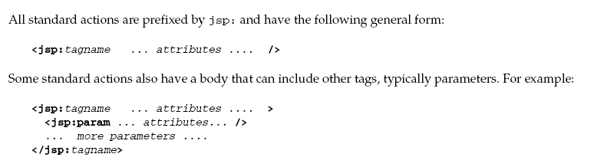
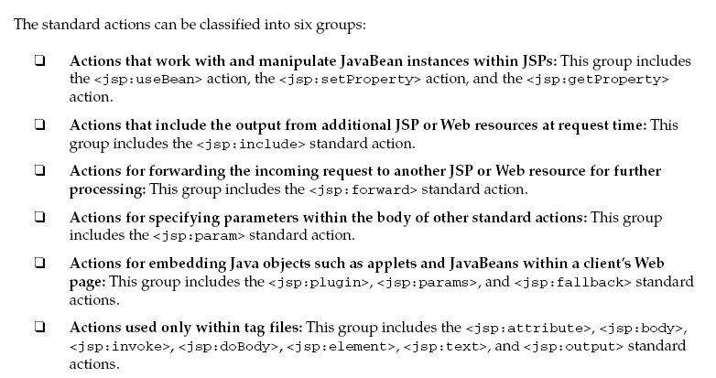
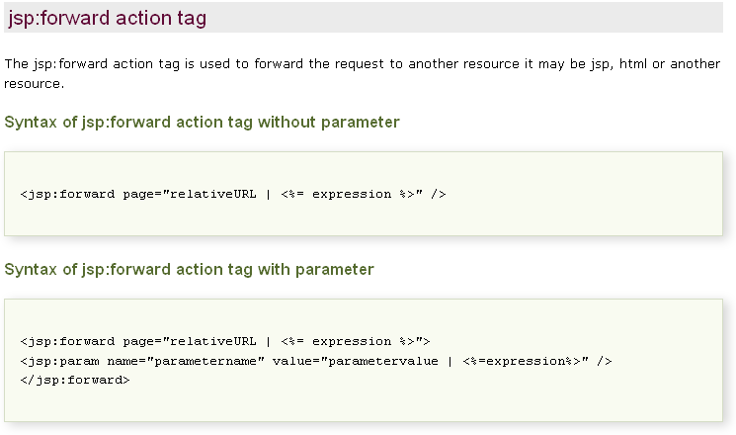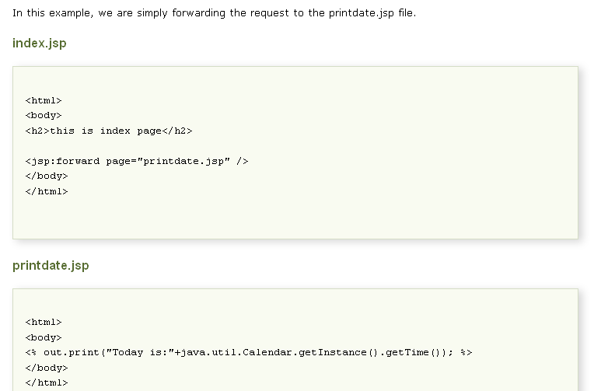
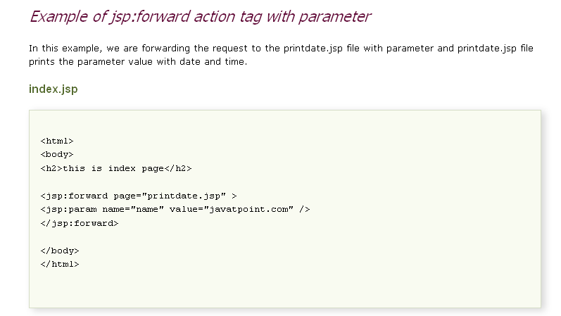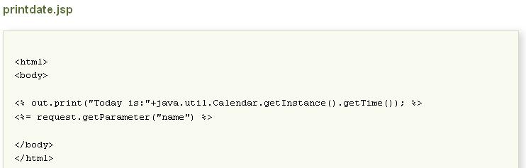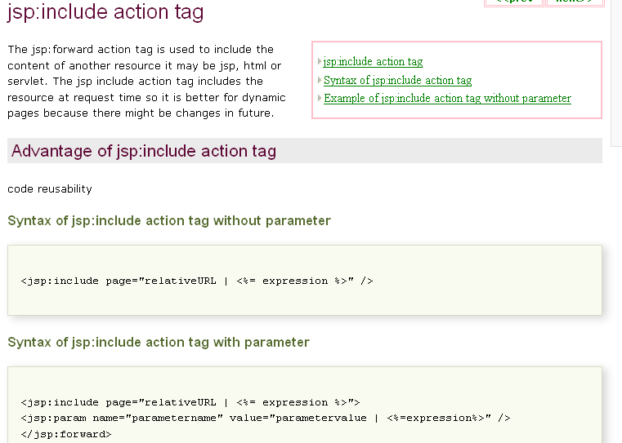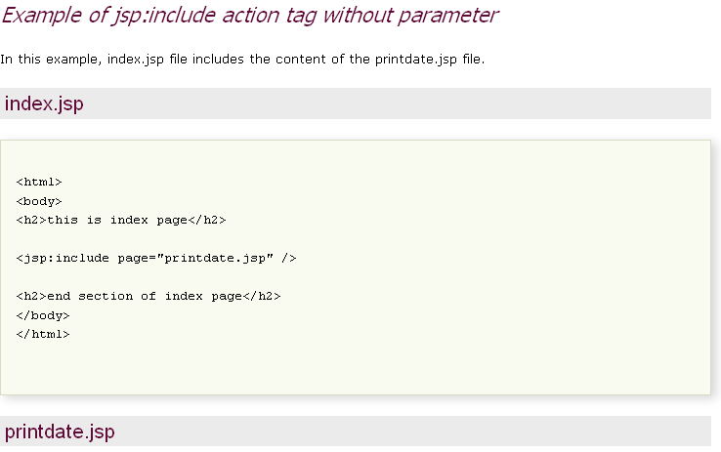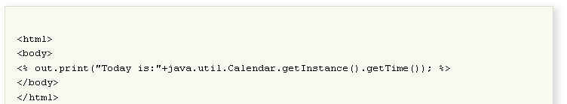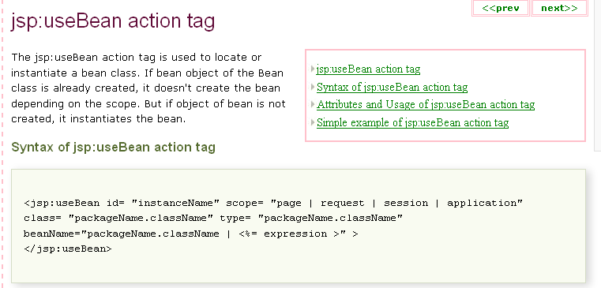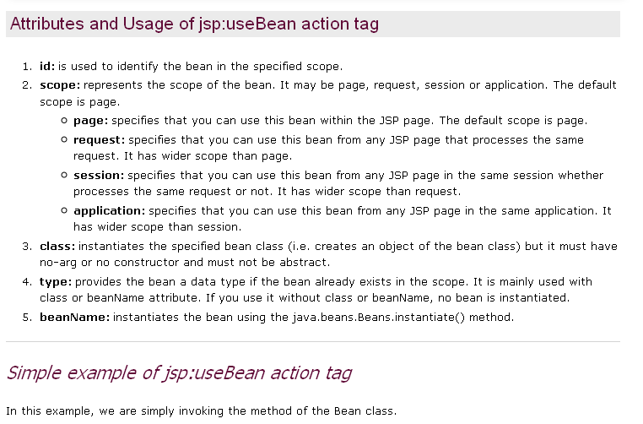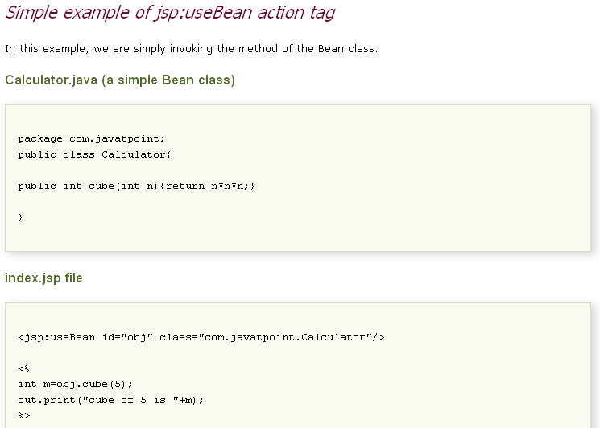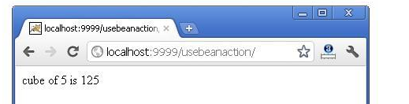
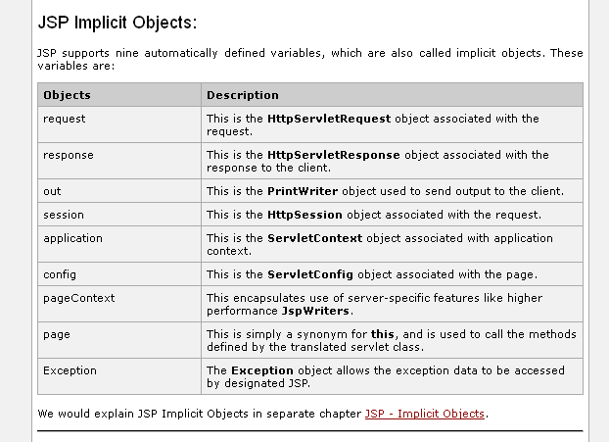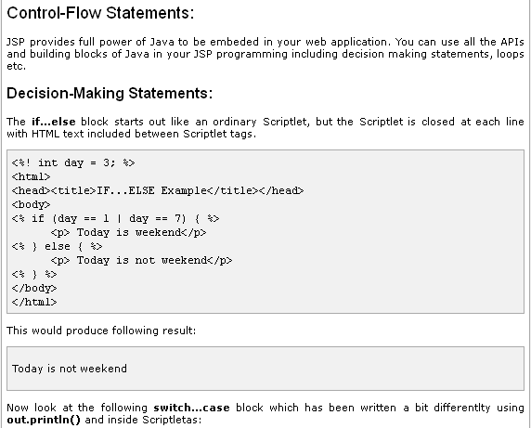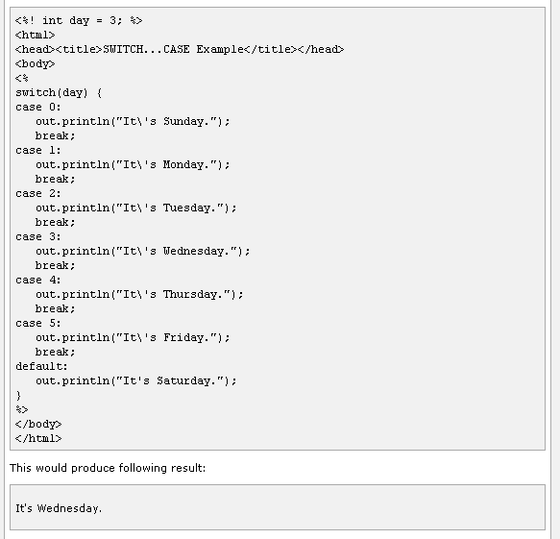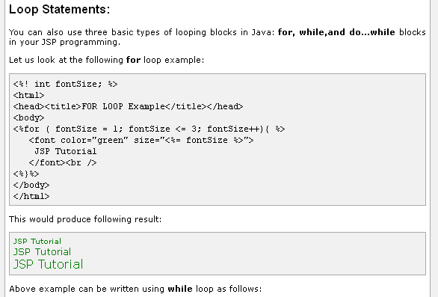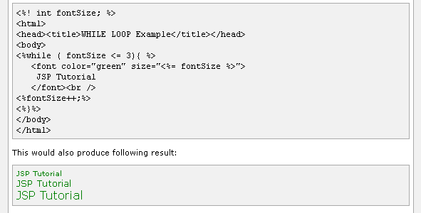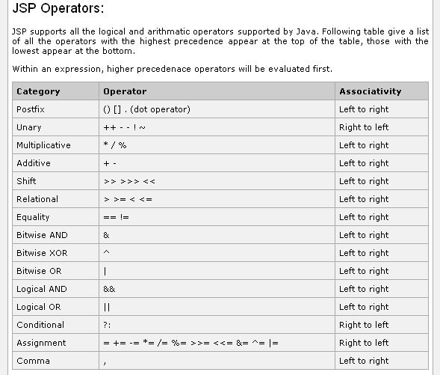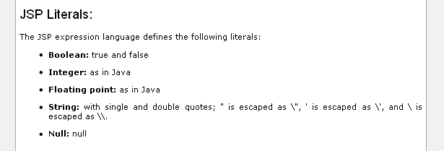

Exception Handling in JSP Pages
Overview
In this article we will learn how exceptional events can occur in a JSP page and how to catch these exceptional events to display a more useful message to the user.
What are Exceptions ?
Exceptions mean exceptional events and as we all know exceptional events can occur anywhere in a program e.g. you are trying to connect to a database and the database server is down, now you wouldn't have expected this to happen ;).
How to catch Exceptions ?
You can catch exceptions in a JSP page like you would do in other Java classes. Simply put the code which can throw an exception/s between a try..catch block.
<%
try {
// Code which can throw can exception
} catch(Exception e) {
// Exception handler code here
}
%>
There is yet another useful way of catching exceptions in JSP pages. You can specify error page in the 'page' directive. Then if any exception is thrown, the control will be transferred to that error page where you can display a useful message to the user about what happened and also inform your sysadmin about this exception depending obviously on how important it may be.
In this article we will explore this error page method of exception handling in JSP pages.
Building Demo Pages
To demonstrate the run-time exception handling feature of JSP pages, we will build three pages.
- Form.html - Display a Form to the user to enter his or her age.
- FormHandler.jsp - A JSP Page which receives this value and prints it on the user screen.
- ExceptionHandler.jsp - An exception handler JSP page which is actually an error page to which control will be passed when an exception is thrown.
i. Form.html
Create a new Form.html page. Copy the following code and paste it into the Form.html page :
<html>
<head>
<style>
body, input { font-family:Tahoma; font-size:8pt; }
</style>
</head>
<body>

<!-- HTML Form -->
<form action="FormHandler.jsp" method="post">
Enter your age ( in years ) :
<input type="text" name="age" />
<input type="submit" value="Submit" />
</form>

</body>
</html>
Explanation
Form.html page simply displays a single input field Form to the user to enter his age in years. The name of input field where user will enter his/her age is "age". We will use this input field name "age" in the FormHandler.jsp page to receive it's value.
ii. FormHandler.jsp
Create new FormHandler.jsp page. Copy and paste the following code in it :
<%@ page errorPage="ExceptionHandler.jsp" %>
<html>
<head>
<style>
body, p { font-family:Tahoma; font-size:10pt; }
</style>
</head>
<body>

<%-- Form Handler Code --%>
<%
int age;

age = Integer.parseInt(request.getParameter("age"));
%>

<%-- Displaying User Age --%>
<p>Your age is : <%= age %> years.</p>

<p><a href="Form.html">Back</a>.</p>

</body>
</html>
Explanation
Code above is rather simple. Notice the first line, the page directive. It specifies an errorPage ExceptionHandler.jsp, our exception handler JSP page.
<%@ page errorPage="ExceptionHandler.jsp" %>
Then we declare an int variable "age". Then using the static method of Integer class we parse the entered value using Integer.parseInt() method. The value is retrieved using request.getParameter() method. The argument to request.getParameter() is the name of Form field whose value we want to retrieve.
<%
int age;

age = Integer.parseInt(request.getParameter("age"));
%>
If all goes well and user entered an int ( e.g. 12345 ) value in the input field then we display that value back to the user.
<p>Your age is : <%= age %> years.</p>
Now things can go wrong and exceptional events can occur. For example, if user didn't enter a value and what if user entered his name ( e.g. "Faisal Khan"), of String type instead of an integer ?.
These things will be handled by the ExceptionHandler.jsp JSP page.
iii. ExceptionHandler.jsp
Create a new ExceptionHandler.jsp page. Copy and paste the following code in it :
<%@ page isErrorPage="true" import="java.io.*" %>
<html>
<head>
<title>Exceptional Even Occurred!</title>
<style>
body, p { font-family:Tahoma; font-size:10pt; padding-left:30; }
pre { font-size:8pt; }
</style>
</head>
<body>

<%-- Exception Handler --%>
<font color="red">
<%= exception.toString() %><br>
</font>

<%
out.println("<!--");
StringWriter sw = new StringWriter();
PrintWriter pw = new PrintWriter(sw);
exception.printStackTrace(pw);
out.print(sw);
sw.close();
pw.close();
out.println("-->");
%>

</body>
</html>
Explanation
To make a JSP page exception handler ( i.e. errorPage ), you have to specify isErrorPage attribute in the page directive at the top and set it's value to true.
<%@ page isErrorPage="true" %>
When a JSP page has been declared an errorPage, it is made available an object with name of "exception" of type java.lang.Throwable. We use different methods of this exception object to display useful information to the user.
<font color="red">
<%= exception.toString() %><br>
</font>
We can put the stack trace information for debugging inside HTML <!-- --> comment tags. So that user only sees a useful message and the sysadmin, developers can see the whole story.
<%
out.println("<!--");
StringWriter sw = new StringWriter();
PrintWriter pw = new PrintWriter(sw);
exception.printStackTrace(pw);
out.print(sw);
sw.close();
pw.close();
out.println("-->");
%>
To use the PrintWriter and StringWriter classes you'll have to import java.io.* package in your JSP page by changing the page directive at the top to :
<%@ page isErrorPage="true" import="java.io.*" %>
Running the Demo Pages
Place Form.html, FormHandler.jsp and ExceptionHandler.jsp pages in a place where your application server ( e.g. Tomcat, Orion etc ) can find them. Never put your JSP pages in the /WEB-INF/ folder.
I placed these three pages in the /web/jsp/ folder so the path to these pages on my system will be http://localhost:8080/web/jsp/Form.html and so on. Notice that on my system application server is running on 8080 port. You should change the port number to the one where your application server is running.
Enter your age e.g. 24, in the input field and press the submit button. You should see FormHandler.jsp page giving you a response like following :
Your age is : 24 years.
Now try again. This time don't enter any value or simply enter a non-integer value e.g. your name, and press the submit button. Now instead of FormHandler.jsp page showing you your age, the control will be internally passed to ExceptionHandler.jsp page which will show an exception message in red color :
java.lang.NumberFormatException:
To see the complete stack trace view the source of the page. On Internet Explorer, click View -> Source. On the source page you will see complete exception stack trace written.
Although our demo application worked and you learned about specifying error pages e.g. ExceptionHandler.jsp, in your normal JSP pages e.g. FormHandler.jsp, there is still a catch. The exception message that was given to the user i.e. java.lang.NumberFormatException, is not very useful, is it? To give a more useful message keep reading.
Improved FormHandler.jsp page
Remove the FormHandler code in FormHandler.jsp page and add the following one :
<%
int age;

try {
age = Integer.parseInt(request.getParameter("age"));
} catch (NumberFormatException e) {
throw new JspException("Please enter a valid integer value!");
}
%>
Explanation
This time we catch the NumberFormatException locally and throw a new JspException with our own exception message. JspException is a JSP special exception class which extends java.lang.Exception. So all we had to do is to give our own message to the JspException class. Now lets see what will happen this time.
We will just have to edit one single line in ExceptionHandler.jsp for it to work.
Improved ExceptionHandler.jsp
Simply change the exception handler code with this one :
<font color="red">
<%= exception.getMessage() %><br>
</font>
That's it. Now view the Form.html page again and don't enter any value and press the submit button. This time you will not see "java.lang.NumberFormatException", rather the message will be :
Please enter a valid integer value!
And like before you can see the complete stack trace by viewing the source for the FormHandler.jsp page in your browser.
Summary
In this article we learned about exception handling feature of JSP pages. We learned that to make a JSP an error page, we have to set the isErrorPage attribute in the page directive at the top to true. Now this JSP page will be an error page and it will be made available as java.lang.Throwable object with name "exception". We can use methods of "exception" object e.g. exception.getMessage(), exception.toString(), exception.printStackTrace(), to display useful information to the user.
To make exceptions from other JSP pages to go to the error page above, we have to set the errorPage attribute in the page directive at the top to the location of our JSP error page e.g. errorPage="ExceptionHandler.jsp".
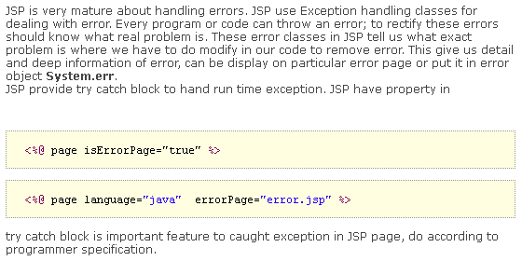

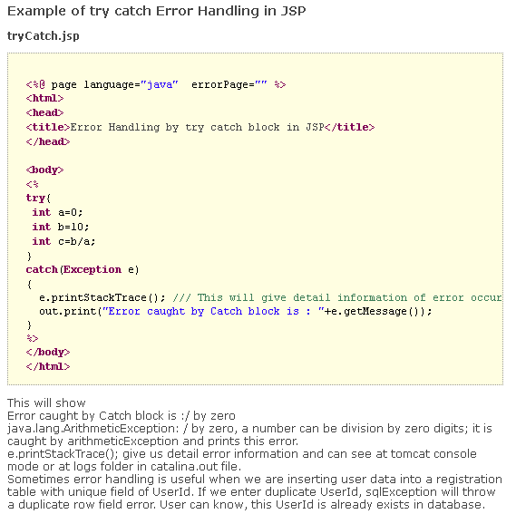
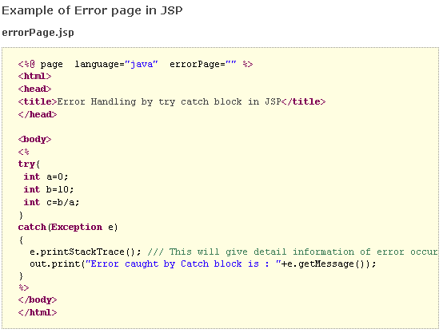
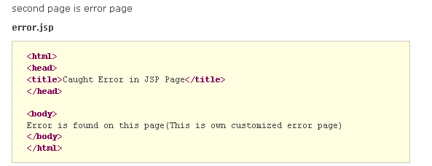

javax.servlet.jsp
Class JspException
java.lang.Object
java.lang.Throwable
java.lang.Exception
javax.servlet.jsp.JspException
All Implemented Interfaces:
java.io.Serializable
Direct Known Subclasses:
JspTagException, SkipPageException

public class JspException extends java.lang.Exception

Constructor Summary
JspException()
Construct a JspException.
JspException(java.lang.String msg)
Constructs a new JSP exception with the specified message.
JspException(java.lang.String message, java.lang.Throwable rootCause)
Constructs a new JSP exception when the JSP needs to throw an exception and include a message about the "root cause" exception that interfered with its normal operation, including a description message.
JspException(java.lang.Throwable rootCause)
Constructs a new JSP exception when the JSP needs to throw an exception and include a message about the "root cause" exception that interfered with its normal operation.

Method Summary
java.lang.Throwable | getRootCause()  Returns the exception that caused this JSP exception.

Methods inherited from class java.lang.Throwable
fillInStackTrace, getCause, getLocalizedMessage, getMessage, getStackTrace, initCause, printStackTrace, printStackTrace, printStackTrace, setStackTrace, toString

Methods inherited from class java.lang.Object
clone, equals, finalize, getClass, hashCode, notify, notifyAll, wait, wait, wait

