References Sites:
https://java2blog.com/introduction-to-complexity-of-algorithm/

Algorithm

Introduction to complexity of algorithm

How will you calculate complexity of algorithm” is very common question in interview.How will you compare two algorithm?
How running time get affected when input size is quite large?
So these are some question which is frequently asked in interview.
IN this post,We will have basic introduction on complexity of algorithm and also to big o notation.

What is an algorithm?
An algorithm is step by step instructions to solve given problem.
Lets take a simple example.You want to write an algorithm for listening particular song.
1) Search for song on computer.
2) Is song available?
i.If Yes,Then listen that song.
ii.If no,download that song and then listen that song.
So we are solving a problem by step by step procedure.This step by step instructions is called Algorithm.

Why do you need to evaluate an algorithm?
You need to evaluate an algorithm so that you can find most optimize algorithm for solving given problem and also considering various factors and constraints.
For example:
You want to go from city A to City B.Then there are various choices available i.e. by flight,bus or train.So you need to choose among different options depending on your budget and urgency.

Counting number of instructions:
Number of instructions can be different for different programming languages.
Lets count number of instruction for searching a element in a array.
1  2  3  4  5  6  7  8  9 | int n=array.length  for (int i = 0; i < n; i++) {  if(array[i]==elementToBeSearched)  return true;  }  return false;
Let’s assume our processor takes one instruction for each of the operation:
- For assigning a value to a variable
- For comparting two values
- Multiply or addition
- Return statement
In Worst case:
If element which we want to search is last element in sorted array then it will be worst case here.
So :
1  2  3  4  5 | if(array[i]==elementToBeSearched) ,i++ and i<n <b>will be executed n times</b>  int n=array.length,i=0,return true or false <strong>will be executed one time.  </strong>

Why do you need to evaluate an algorithm?
You need to evaluate an algorithm so that you can find most optimize algorithm for solving given problem and also considering various factors and constraints.
For example:
You want to go from city A to City B.Then there are various choices available i.e. by flight,bus or train.So you need to choose among different options depending on your budget and urgency.

Counting number of instructions:
Number of instructions can be different for different programming languages.
Lets count number of instruction for searching a element in a array.
1  2  3  4  5  6  7  8  9 | int n=array.length  for (int i = 0; i < n; i++) {  if(array[i]==elementToBeSearched)  return true;  }  return false;
Let’s assume our processor takes one instruction for each of the operation:
- For assigning a value to a variable
- For comparting two values
- Multiply or addition
- Return statement
In Worst case:
If element which we want to search is last element in sorted array then it will be worst case here.
So :
1  2  3  4  5 | if(array[i]==elementToBeSearched) ,i++ and i<n <b>will be executed n times</b>  int n=array.length,i=0,return true or false <strong>will be executed one time.  </strong>
Hence f(n)=3n+3

Asymptotic behaviour :
Here We will see how f(n) performs with larger value of n.Now in above function, we have two parts i.e. 3n and 3. Here you can note two points:
- As n grows larger, we can ignore constant 3 as it will be always 3 irrespective of value of n. It makes sense as you can consider 3 as initialization constant and different language may take different time for initialization.So other function remains f(n)=3n.
- We can ignore constant multiplier as different programming language may compile the code differently. For example array look up may take different number of instructions in different languages. So what we are left with is f(n)=n

How will you compare algorithms?
You can compare algorithms by its rate of growth with input size n
Lets take a example.For solving same problem, you have two functions:
f(n) =4n^2 +2n+4 and f(n) =4n+4
For f(n) =4n^22 +2n+4
so here
f(1)=4+2+4
f(2)=16+4+4
f(3)=36+6+4
f(4)=64+8+4
….
As you can see here contribution of n^22 increasing with increasing value of n.So for very large value of n,contribution of n^2 will be 99% of value on f(n).So here we can ignore low order terms as they are relatively insignificant as described above.In this f(n),we can ignore 2n and 4.so
n^2+2n+4 ——–>n^2
For f(n) =4n+4
so here
f(1)=4+4
f(2)=8+4
f(3)=12+4
f(4)=16+4
….
As you can see here contribution of n increasing with increasing value of n.So for very large value of n,contribution of n will be 99% of value on f(n).So here we can ignore low order terms as they are relatively insignificant.In this f(n),we can ignore 4 and also 4 as constant multiplier as seen above so
4n+4 ——–>nSo here n is highest rate of growth.
Point to be noted :
We are dropping all the terms which are growing slowly and keep one which grows fastest.

Big O Notation:
This notation is used for theoretical measure of execution of an algorithm. It gives tight upper bound of a given function. Generally it is represented as f(n)=O(g(n)) and it reads as “f of n is big o of g of n”.
Formal definition:
f(n) = O(g(n)) means there are positive constants c and n0, such that 0 ≤ f(n) ≤ cg(n) for all n ≥ n0. The values of c and n0 must not be depend on n.

When you say O(g(n)) , It means it will never be worst than g(n). Having said that it means O(g(n)) includes smaller or same order of growth as g(n).
So O(n) includes O(n),O(logn) and O(1).
So O(g(n)) is a good way to show complexity of algorithm.
Lets take some example and calculate value for c and n0.
1. f(n)=4n+3
Writing in a form of f(n)<=c*g(n) with f(n)=4n+3 and g(n)=5n
4n+3<=5n for n0=3 and c=5.
or 4n+3<=6n for n0=2 and c=6
Writing in a form of f(n)<=c*g(n) with f(n)=4n+3 and g(n)=6n
so there can be multiple values for n0 and c for which f(n)<=c g(n) will get satisfied.
2. f(n)=4n^2+2n+4
Writing in a form of f(n)<=c*g(n) with f(n)=4n^2 +2n+4 and g(n)=5n^2
4n^2 +2n+4<=5n^2 for n0=4 and c=5

Rules of thumb for calculating complexity of algorithm:
Simple programs can be analyzed using counting number of loops or iterations.
Consecutive statements:
We need to add time complexity of consecutive statements.
1  2  3  4 | int m=0; // executed in constant time c1  m=m+1; // executed in constant time c2
f(n)=c1+c2;
So O(f(n))=1
Calculating complexity of a simple loop:
Time complexity of a loop can be determined by running time of statements inside loop multiplied by total number of iterations.
1  2  3  4  5  6  7 | int m=0; // executed in constant time c1  // executed n times  for (int i = 0; i < n; i++) {  m=m+1; // executed in constant time c2  }
f(n)=c2*n+c1;
So O(n)=n

Calculating complexity of a nested loop:
It is product of iterations of each loop.
1  2  3  4  5  6  7  8  9  10  11 | int m=0; executed in constant time c1  // Outer loop will be executed n times  for (int i = 0; i < n; i++) {  // Inner loop will be executed n times  for(int j = 0; j < n; j++)  {  m=m+1; executed in constant time c2  }  }
f(n)=c2*n*n + c1
So O(f(n))=n^2

If and else:
When you have if and else statement, then time complexity is calculated with whichever of them is larger.
1  2  3  4  5  6  7  8  9  10  11  12  13  14 | int countOfEven=0;//executed in constant time c1  int countOfOdd=0; //executed in constant time c2  int k=0; //executed in constant time c3  //loop will be executed n times  for (int i = 0; i < n; i++) {  if(i%2==0) //executed in constant time c4  { countOfEven++; //executed in constant time c5  k=k+1; //executed in constant time c6  }  else  countOfOdd++; //executed in constant time c7  }
f(n)=c1+c2+c3+(c4+c5+c6)*n
So o(f(n))=n

Logarithmic complexity
Lets understand logarithmic complexity with the help of example.You might know about binary search.When you want to find a value in sorted array, we use binary search.
1  2  3  4  5  6  7  8  9  10  11  12  13  14  15  16  17 | public int binarySearch(int[] sorted, int first, int last, int elementToBeSearched) {  int iteration=0;  while (first < last) {  iteration++;  System.out.println("i"+iteration);  int mid = (first + last) / 2; // Compute mid point.  System.out.println(mid);  if (elementToBeSearched < sorted[mid]) { last = mid; // repeat search in first half. } else if (elementToBeSearched > sorted[mid]) {  first = mid + 1; // Repeat search in last half.  } else {  return mid; // Found it. return position  }  }  return -1; // Failed to find element  }
Now let’s assume our soreted array is:
1  2  3 | int[] sortedArray={12,56,74,96,112,114,123,567};
and we want to search for 74 in above array. Below diagram will explain how binary search will work here.

When you observe closely, in each of the iteration you are cutting scope of array to the half. In every iteration, we are overriding value of first or last depending on soretedArray[mid].
So for
0th iteration : n
1th iteration: n/2
2nd iteration n/4
3rd iteration n/8.
Generalizing above equation:
For ith iteration : n/2i
So iteration will end , when we have 1 element left i.e. for any i, which will be our last iteration:
1=n/2i;
2i=n;
after taking log
i= log(n);
so it concludes that number of iteration requires to do binary search is log(n) so complexity of binary search is log(n)
It makes sense as in our example, we have n as 8 . It took 3 iterations(8->4->2->1) and 3 is log(8).
So If we are dividing input size by k in each iteration,then its complexity will be O(logk(n)) that is log(n) base k.
Lets take an example:
1  2  3  4  5  6  7 | int m=0;  // executed log(n) times  for (int i = 0; i < n; i=i*2) {  m=m+1;  }
Complexity of above code will be O(log(n)).

Exercise:
Lets do some exercise and find complexity of given code:
1.
1  2  3  4  5  6 | int m=0;  for (int i = 0; i < n; i++) {  m=m+1;  }
Ans:
1  2  3  4  5  6  7 | int m=0;  // Executed n times  for (int i = 0; i < n; i++) {  m=m+1;  }
Complexity will be O(n)
2.
1  2  3  4  5  6  7  8  9  10  11 | int m=0;  for (int i = 0; i < n; i++) {  m=m+1;  }  for (int i = 0; i < n; i++) {  for(int j = 0; j < n; j++)  m=m+1;  }  }
Ans:
1  2  3  4  5  6  7  8  9  10  11  12  13 |  | int m=0;  // Executed n times  for (int i = 0; i < n; i++) {  m=m+1;  }  // outer loop executed n times  for (int i = 0; i < n; i++) {  // inner loop executed n times  for(int j = 0; j < n; j++)  m=m+1;  }
1  2  3 | }
Complexity will be :n+n*n —>O(n^2)
3.
1  2  3  4  5  6  7  8  9  10  11  12  13 | int m=0;  // outer loop executed n times  for (int i = 0; i < n; i++) {  // middle loop executed n/2 times  for(int j = n/2; j < n; j++)  for(int k=0;k*k < n; k++ )  m=m+1;  }  }  }
Ans:
1  2  3  4  5  6  7  8  9  10  11  12  13  14 | int m=0;  // outer loop executed n times  for (int i = 0; i < n; i++) {  // middle loop executed n/2 times  for(int j = n/2; j < n; j++)  // inner loop executed log(n) times  for(int k=0;k*k < n; k++ )  m=m+1;  }  }  }
Complexity will be n*n/2*log(n)–> n^2log(n)
4.
1  2  3  4  5  6  7  8  9  10 | int m=0;  for (int i = n/2; i < n; i++) {  for(int j = n/2; j < n; j++)  for(int k=0;k < n; k++ )  m=m+1;  }
Ans:
1  2  3  4  5  6  7  8  9  10  11  12 | int m=0;  // outer loop executed n/2 times  for (int i = n/2; i < n; i++) {  // middle loop executed n/2 times  for(int j = n/2; j < n; j++)  // inner loop executed n times  for(int k=0;k < n; k++ )  m=m+1;  }
Complexity will be n/2*n/2*n –> n^3

Table of Contents

Java Sorting Algorithms

1. Bubble sort

2. Insertion sort

3. Selection sort

4. Heap sort

5. Quick Sort

6. Merge sort

7. Shell Sort

8. Counting Sort

9. Bucket Sort

10. Radix sort

Github Source code:

Join Our News Letter – Stay Updated

1. Bubble sort
Time Complexity:
Best case: O(n)
Average case: O(n^2)
Worst case: O(n^2)

Bubble sort algorithm:
Bubble sort works by iterating first element to last element, comparing two adjacent elements and swapping them if they are not in correct order. Each iteration places next larger value to its correct place.

Why bubble sort is called bubble sort or sinking sort(From wikipedia):
Bubble sort can be done in ascending order or descending order.
Reason for being called Sinking sort:
The larger values might be regarded as heavier and therefore be seen to progressively sink to the bottom of the list
Reason for being called Bubble sort:
The smaller values might be regarded as lighter and therefore be seen to progressively bubble up to the top of the list
package com.test.sort.algorithm;

public class BubleSortExample {
static void intBubSort(int[] sortArray) {
for(int i=0;i<sortArray.length-1;i++)
{
for (int j=0;j<sortArray.length-1-i;j++)
{
if(sortArray[j]>sortArray[j+1])
{
int temp =sortArray[j+1];
sortArray[j+1]=sortArray[j];
sortArray[j] = temp;
}
}
}
}

static void dispay(int[] sortedArray) {
for(int i=0;i<=sortedArray.length-1;i++) {
System.out.println(sortedArray[i]);
}
}

public static void main(String[] args) {
// TODO Auto-generated method stub

int[] intArray= {2,10,55,6,27};
intBubSort(intArray);
dispay(intArray);
}

}

Insertion sort in java:
Insertion sort works by comparing values at index with all its prior elements.We place value at the index where there are no lesser value to the elements. So when you reach last element,we get a sorted array.
Lets see how it works:
Lets say you have array as {100,20,15,30,5,75}
- 1. Compare 20 with 100,as 20 is less than 100, our array will become {100,100,15,30,5,75}. We have reached to 0th index, we will place 20 to 0th index {20,100,15,30,5,75}
- 2. Compare 15 with 100, as it is less,our array will become {20,100,100,30,5,75}. Now compare 20 with 15, it is again less, our array will become {20,20,100,30,5,75}. As we have reached start of array again. Place 15 at 0th index.our array will become {15,20,100,30,5,75}
- 3. Compare 30 with 100, as it is less,our array will become {15,20,100,100,5,75}.Now compare 30 with 20 again, it is more, so we will stop here, As we reached at index where 30 is greater than 15 and 20. so we will put 30 at this index. our array will become {15,20,30,100,5,75}
- 4. Compare 5 with 100, as it is less, our array will become {15,20,30,100,100,75}. Now compare 30 with 5 again,it is less,our array will become {15,20,30,30,100,75}. Similarly 20 with 5, it is less,our array will become {15,20,20,30,100,75}.Compare 15 with 5 , it is less,our array will become {15,15,20,30,100,75}.As we have reached start of array again. Place 5 at 0th index.our array will become {5,15,20,30,100,75}
- 5. Compare 75 with 100, it is less,so our array will become {5,15,20,30,100,100}.Now compare 30 with 75 again, it is more, so we will stop here, As we reached at index where 75 is greater than 5,15,20 and 30. so we will put 75 at this index. our array will become {5,15,20,30,75,100}
- 6. Finally we got sorted array.

Insertion sort in java example:
I have printed intermediate steps to understand it better:
1  2  3  4  5  6  7  8  9  10  11  12  13  14  15  16  17  18  19  20  21  22  23  24  25  26  27  28  29  30  31  32  33  34  35  36  37  38  39  40  41 | ublic class InsertionSortMain {  /*  * @author: Arpit Mandliya  */  public static void main(String args[])  {  int arr[]={100,20,15,30,5,75};  insertionSort(arr);  }  public static int[] insertionSort(int arr[])  {  for (int i = 1; i < arr.length; i++)  {  int valueToSort = arr[i];  int j;  // If we get smaller value than valueToSort then , we stop at that index.  for ( j = i; j > 0 && arr[j - 1] > valueToSort; j--) {  arr[j] = arr[j - 1];  }  // We will put valueToSort at that index  arr[j] = valueToSort;  System.out.print("Iteration "+(i)+": ");  printArray(arr);  }  return arr;  }  public static void printArray(int arr[])  {  for (int i = 0; i <arr.length; i++) {  System.out.print(arr[i]+" ");  }  System.out.println();  }  }
When you run above program, you will get following output:
1  2  3  4  5  6  7 | Iteration 1: 20 100 15 30 5 75  Iteration 2: 15 20 100 30 5 75  Iteration 3: 15 20 30 100 5 75  Iteration 4: 5 15 20 30 100 75  Iteration 5: 5 15 20 30 75 100
We are iterating from first element to last element.You may notice that each iteration places current element at its right place where all its prior element are less than current element.

Complexity:
Best case: O(n)
Average case: O(nˆ2)
Worst case: O(nˆ2)
To understand more about complexity,please go through complexity of algorithm.
That’s all about insertion sort in java.
public class InsertionSortingExample {

public static void insertionSortImperative(int[] input) {
for (int i = 1; i < input.length; i++) {
int key = input[i];
int j = i - 1;
while (j >= 0 && input[j] > key) {
input[j + 1] = input[j];
j = j - 1;
}
input[j + 1] = key;
}
}
static void dispay(int[] sortedArray) {
for(int i=0;i<=sortedArray.length-1;i++) {
System.out.println(sortedArray[i]);
}
}

public static void main(String[] args) {
// TODO Auto-generated method stub

int[] intArray= {1,2,10,55,99,6,27};
insertionSortImperative(intArray);
dispay(intArray);
}

}

Selection Sort
Selection sort is a sorting mechanism that begins by finding the smallest element in the array and swapping it with the first.
Then the second-smallest element is found and swapped with the second, and so on until the array is sorted.
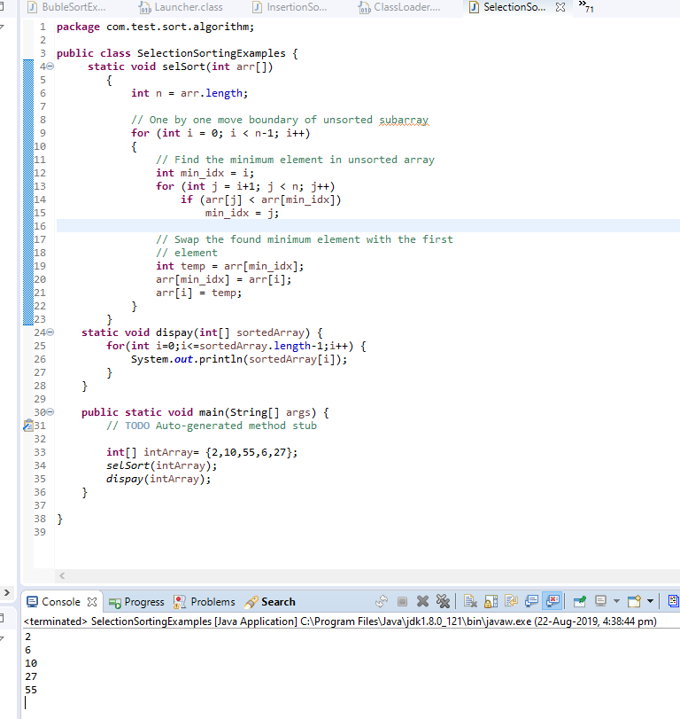
// Java program for implementation of Selection Sort
class SelectionSort
{
void sort(int arr[])
{
int n = arr.length;

// One by one move boundary of unsorted subarray
for (int i = 0; i < n-1; i++)
{
// Find the minimum element in unsorted array
int min_idx = i;
for (int j = i+1; j < n; j++)
if (arr[j] < arr[min_idx])
min_idx = j;

// Swap the found minimum element with the first
// element
int temp = arr[min_idx];
arr[min_idx] = arr[i];
arr[i] = temp;
}
}

// Prints the array
void printArray(int arr[])
{
int n = arr.length;
for (int i=0; i<n; ++i)
System.out.print(arr[i]+" ");
System.out.println();
}

// Driver code to test above
public static void main(String args[])
{
SelectionSort ob = new SelectionSort();
int arr[] = {64,25,12,22,11};
ob.sort(arr);
System.out.println("Sorted array");
ob.printArray(arr);
}
}
/* This code is contributed by Rajat Mishra*/
Output:
Sorted array:
11 12 22 25 64
Time Complexity: O(n²) as there are two nested loops.
Auxiliary Space: O(1)
The good thing about selection sort is it never makes more than O(n) swaps and can be useful when memory write is a costly operation.

Heap sort in java

What is heap?
A heap is a tree with some special properties, so value of node should be greater than or equal to(less than or equal to in case of min heap) children of the node and tree should be complete binary tree.

Binary heaps
Binary heaps are those heaps which can have up to 2 children. We will use binary heaps in our next few sections.

Understanding complete binary tree:
Complete binary tree is a binary tree whose leaves are at h or h-1 level where h is height of the tree.
Index of left child= 2*(index of its parent)+1
Index of right child= 2*(index of its parent)+2
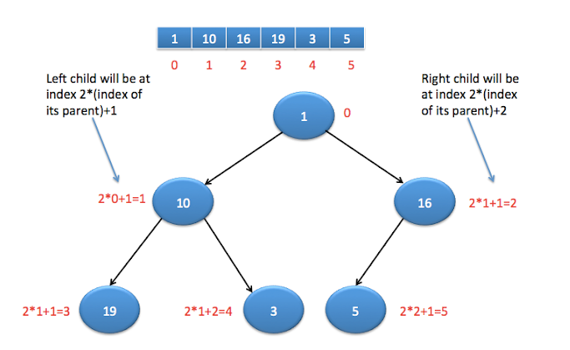

Types of heaps
There are two types of heap.
- Max heap
- Min heap
Max heap : It is binary heap where value of node is greater than left and right child of the node.
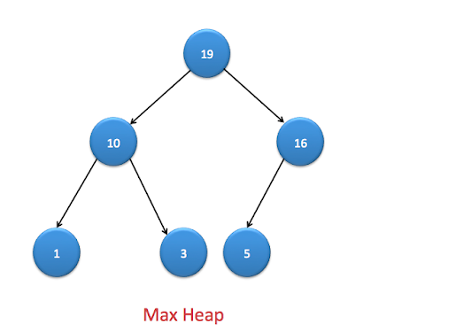
Min heap : It is binary heap where value of node is lesser than left and right child of the node.
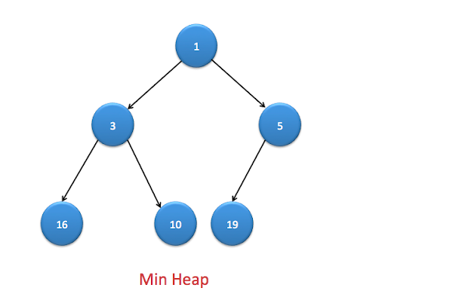

Heapifying an element:
Once we create a heap , it may not satisfy heap property. In order to make it heap again, we need to adjust locations of the heap and this process is known as heapifying the elements.
In order to create a max heap, we will compare current element with its children and find the maximum, if current element is not maximum then exchange it with maximum of left or right child.
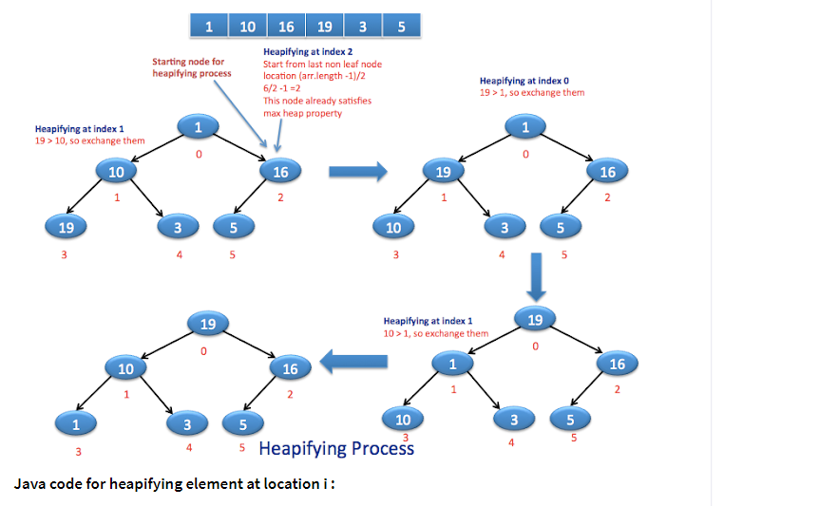
Java code for heapifying element at location i :

public static void heapify(int[] arr, int i,int size) {
int left = 2*i+1;
int right = 2*i+2;
int max;
if(left <= size && arr[left] > arr[i]){
max=left;
} else {
max=i;
}
if(right <= size && arr[right] > arr[max]) {
max=right;
}
// If max is not current node, exchange it with max of left and right child
if(max!=i) {
exchange(arr,i, max);
heapify(arr, max,size);
}
}

Steps for heap sort:
- Represent array as complete binary tree.
  - Left child will be at 2*i+1 th location
  - Right child will be at 2*i+2 th location.
- Build a heap.
  - All the leaf nodes already satisfy heap property, so we don’t need to heapify them.
  - Last leaf node will be present at (n-1)th location, so parent of it will be at (n-1)/2 th location, hence (n-1)/2 will be location of last non leaf node.
  - Iterate over non leaf nodes and heapify the elements.
- After building a heap, max element will be at root of the heap. We will exchange it with (n-1)th location, so largest element will be at proper place and remove it from the heap by reducing size of n.
- When you exchange largest element, it may disturb max heap property, so you need to again heapify it.
- Once you do above steps until no elements left in heap, you will get sorted array in the end.

Java code for heap sort:
1  2  3  4  5  6  7  8  9  10  11  12  13  14  15  16  17  18  19  20  21  22  23  24  25  26  27  28  29  30  31  32  33  34  35  36  37  38  39  40  41  42  43  44  45  46  47  48  49  50  51  52  53  54  55  56  57  58  59  60  61  62  63  64  65  66 | package org.arpit.java2blog;  import java.util.*;  public class HeapSortMain {  public static void buildheap(int []arr) {  /*  * As last non leaf node will be at (arr.length-1)/2  * so we will start from this location for heapifying the elements  * */  for(int i=(arr.length-1)/2; i>=0; i--){  heapify(arr,i,arr.length-1);  }  }  public static void heapify(int[] arr, int i,int size) {  int left = 2*i+1;  int right = 2*i+2;  int max;  if(left <= size && arr[left] > arr[i]){  max=left;  } else {  max=i;  }  if(right <= size && arr[right] > arr[max]) {  max=right;  }  // If max is not current node, exchange it with max of left and right child  if(max!=i) {  exchange(arr,i, max);  heapify(arr, max,size);  }  }  public static void exchange(int[] arr,int i, int j) {  int t = arr[i];  arr[i] = arr[j];  arr[j] = t;  }  public static int[] heapSort(int[] arr) {  buildheap(arr);  int sizeOfHeap=arr.length-1;  for(int i=sizeOfHeap; i>0; i--) {  exchange(arr,0, i);  sizeOfHeap=sizeOfHeap-1;  heapify(arr, 0,sizeOfHeap);  }  return arr;  }  public static void main(String[] args) {  int[] arr={1,10,16,19,3,5};  System.out.println("Before Heap Sort : ");  System.out.println(Arrays.toString(arr));  arr=heapSort(arr);  System.out.println("=====================");  System.out.println("After Heap Sort : ");  System.out.println(Arrays.toString(arr));  }  }
When you run above program, you will get below output:
1  2  3  4  5  6  7 | Before Heap Sort :  [1, 10, 16, 19, 3, 5]  =====================  After Heap Sort :  [1, 3, 5, 10, 16, 19]

Quick Sort in java
which is using divide and conquer algorithm.
In quick sort, we first choose a pivot and divide into two sublists,one will contain elements lower than pivot and other will have elements greater than pivot.

Quick sort Algorithm:
Lets say array is arr[]
- Choose a pivot, it is generally mid element of the list.
- Initialise two index variable , left=0 and right=arr.length-1
- Increment left variable until you get element higher than pivot.
- Decrement right variable until you get element lesser than pivot
- swap arr[left] and arr[right]
- Recursively sort sublists(sublist with less than pivot, sublist greater than pivot) using above algorithm.
- In the end , you will get sorted array.
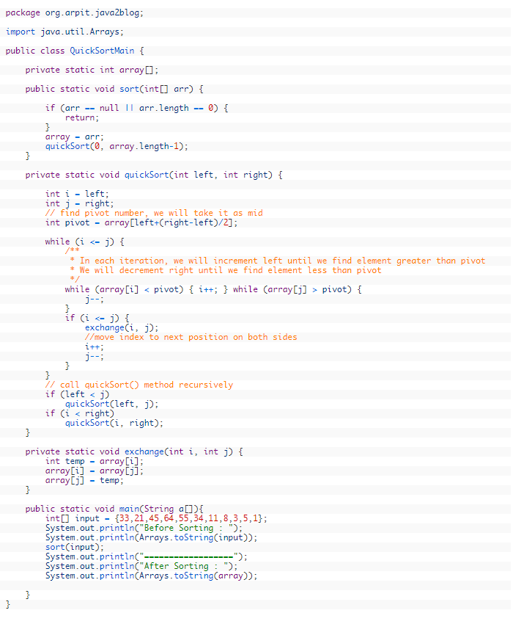
package com.test.sort.algorithm;

import java.util.Arrays;

public class QuickSortMain {

private static int array[];

public static void sort(int[] arr) {
if (arr == null || arr.length == 0) {
return;
}
array = arr;
quickSort(0, array.length - 1);
}
private static void quickSort(int left, int right) {

int i = left;
int j = right;
// find pivot number, we will take it as mid
int pivot = array[left + (right - left) / 2];
while (i <= j) {
/**
* In each iteration, we will increment left until we find element greater than
* pivot We will decrement right until we find element less than pivot
*/
while (array[i] < pivot) {
i++;
}
while (array[j] > pivot) {
j--;
}
if (i <= j) {
exchange(i, j);
// move index to next position on both sides
i++;
j--;
}
}
// call quickSort() method recursively
if (left < j)
quickSort(left, j);
if (i < right)
quickSort(i, right);
}
private static void exchange(int i, int j) {
int temp = array[i];
array[i] = array[j];
array[j] = temp;
}
public static void main(String a[]) {
int[] input = { 33, 21, 45, 64, 55, 34, 11, 8, 3, 5, 1 };
System.out.println("Before Sorting : ");
System.out.println(Arrays.toString(input));
sort(input);
System.out.println("==================");
System.out.println("After Sorting : ");
System.out.println(Arrays.toString(array));

}
}

Merge Sort
Like QuickSort, Merge Sort is a Divide and Conquer algorithm. It divides input array in two halves, calls itself for the two halves and then merges the two sorted halves.The merge() function is used for merging two halves. The merge(arr, l, m, r) is key process that assumes that arr[l..m] and arr[m+1..r] are sorted and merges the two sorted sub-arrays into one. See following C implementation for details.
MergeSort(arr[], l, r)
If r > l
1. Find the middle point to divide the array into two halves:
middle m = (l+r)/2
2. Call mergeSort for first half:
Call mergeSort(arr, l, m)
3. Call mergeSort for second half:
Call mergeSort(arr, m+1, r)
4. Merge the two halves sorted in step 2 and 3:
Call merge(arr, l, m, r)
The following diagram from wikipedia shows the complete merge sort process for an example array {38, 27, 43, 3, 9, 82, 10}. If we take a closer look at the diagram, we can see that the array is recursively divided in two halves till the size becomes 1. Once the size becomes 1, the merge processes comes into action and starts merging arrays back till the complete array is merged.
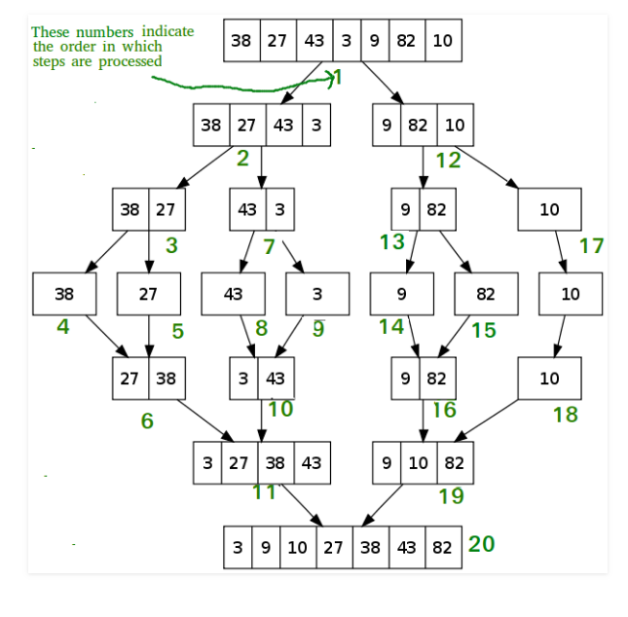

public class MergeSortMain {

/*
* @author: Arpit Mandliya
*/
static int arr[]={100,20,15,30,5,75,40};

public static void main(String args[])
{
// Print array before merge sort
System.out.println("Array before sorting:");
printArray(arr,0,arr.length-1);
System.out.println("-----------------------------");

mergeSort(0,arr.length-1);

System.out.println("-----------------------------");

// Print array after sorting
System.out.println("Array After sorting:");
printArray(arr,0,arr.length-1);

}

// Recursive algorithm for merge sort
public static void mergeSort(int start,int end)
{
int mid=(start+end)/2;
if(start<end)
{
// Sort left half
mergeSort(start,mid);
// Sort right half
mergeSort(mid+1,end);
// Merge left and right half
merge(start,mid,end);
}

}

private static void merge(int start, int mid, int end) {
// Initializing temp array and index
int[] tempArray=new int[arr.length];
int tempArrayIndex=start;

System.out.print("Before Merging: ");
printArray(arr,start,end);

int startIndex=start;
int midIndex=mid+1;

// It will iterate until smaller list reaches to the end
while(startIndex<=mid && midIndex<=end)
{
if(arr[startIndex]< arr[midIndex])
{
tempArray[tempArrayIndex++]=arr[startIndex++];
}
else
{
tempArray[tempArrayIndex++]=arr[midIndex++];
}
}

// Copy remaining elements
while(startIndex<=mid)
{
tempArray[tempArrayIndex++]=arr[startIndex++];
}
while(midIndex<=end)
{
tempArray[tempArrayIndex++]=arr[midIndex++];
}

// Copy tempArray to actual array after sorting
for (int i = start; i <=end; i++) {
arr[i]=tempArray[i];
}

System.out.print("After merging: ");
printArray(tempArray,start,end);
System.out.println();
}

public static void printArray(int arr[],int start,int end)
{
for (int i = start; i <=end; i++) {
System.out.print(arr[i]+" ");
}
System.out.println();
}
}

100 20 15 30 5 75 40
-----------------------------
Before Merging: 100 20
After merging: 20 100

Before Merging: 15 30
After merging: 15 30

Before Merging: 20 100 15 30
After merging: 15 20 30 100

Before Merging: 5 75
After merging: 5 75

Before Merging: 5 75 40
After merging: 5 40 75

Before Merging: 15 20 30 100 5 40 75
After merging: 5 15 20 30 40 75 100

-----------------------------
Array After sorting:
5 15 20 30 40 75 100

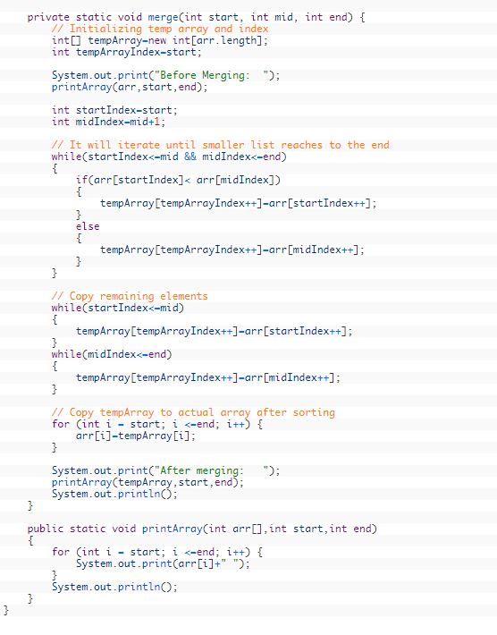
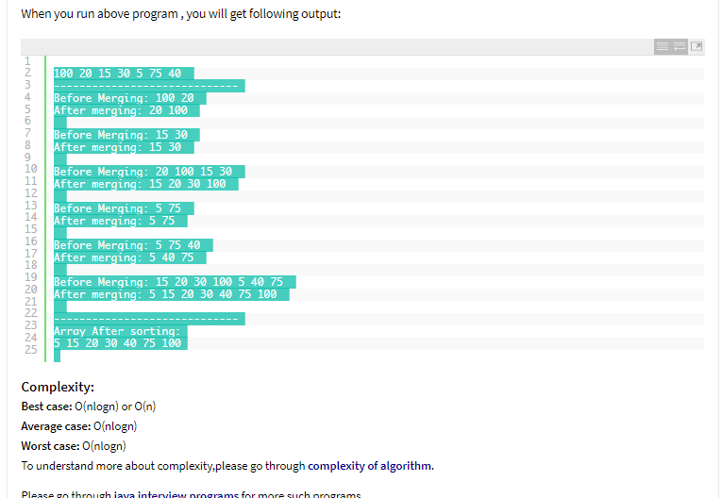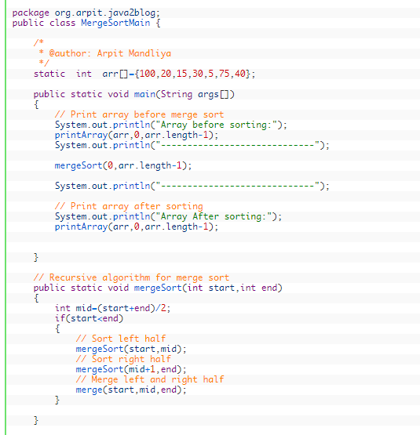

Shell sort
Shell sort is in place comparison based sorting algorithm. It is generalization of insertion sort. It was invented by Donald shell.
It allows to sort elements which are far apart. In case of insertion sort, comparison happens between only adjacent elements but in shell sort, it avoid comparing adjacent elements until last steps. Last step of shell sort is ultimately insertion sort.
In short, it improves insertion sort by comparison and exchange elements that are far away.
Shell sort uses a sequence that can be referred as increment sequence. Shell sort makes multiple passes over array and sort number of equally sized array using insertion sort.
Time complexity:
Best case: O(n)
Average case: Depends on gaps
Worst case : o(nlog2n)

Java program to implement shell sort:
1  2  3  4  5  6  7  8  9  10  11  12  13  14  15  16  17  18  19  20  21  22  23  24  25  26  27  28  29  30  31  32  33  34  35  36  37  38  39  40  41  42  43  44  45  46 | package org.arpit.java2blog;  import java.util.Arrays;  public class ShellSortMain {  public static void main(String[] args) {  int[] array = { 22, 53, 33, 12, 75, 65, 887, 125, 37, 977 };  System.out.println("Before Sorting : ");  System.out.println(Arrays.toString(array));  System.out.println("===================");  System.out.println("After Sorting : ");  array = shellsort(array);  System.out.println(Arrays.toString(array));  }  private static int[] shellsort(int[] array) {  // first part uses the Knuth's interval sequence  int h = 1;  while (h <= array.length / 3) {  h = 3 * h + 1; // h is equal to highest sequence of h<=length/3  // (1,4,13,40...)  }  // next part  while (h > 0) { // for array of length 10, h=4  // This step is similar to insertion sort below  for (int i = 0; i < array.length; i++) {  int temp = array[i];  int j;  for (j = i; j > h - 1 && array[j - h] >= temp; j = j - h) {  array[j] = array[j - h];  }  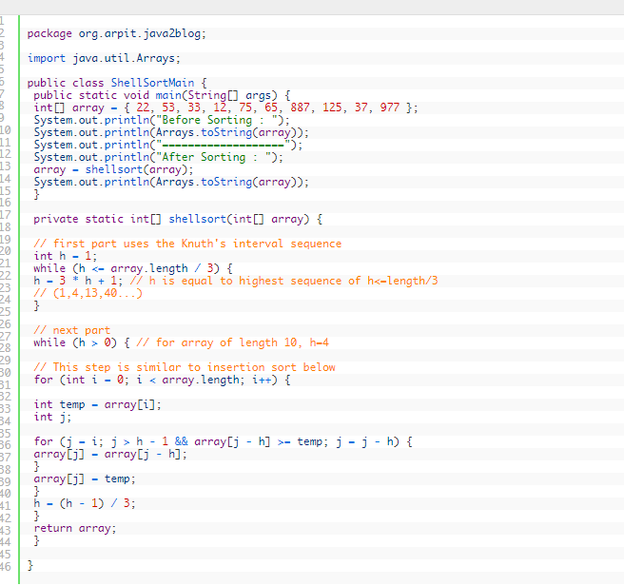  array[j] = temp;  }  h = (h - 1) / 3;  }  return array;  }  }
When you run above program, you will get below output:
1  2  3  4  5  6  7 | Before Sorting :  [22, 53, 33, 12, 75, 65, 887, 125, 37, 977]  ===================  After Sorting :  [12, 22, 33, 37, 53, 65, 75, 125, 887, 977]

Counting Sort

the frequencies of distinct elements of the array to be sorted is counted and stored in an auxiliary array, by mapping its value as an index of the auxiliary array.
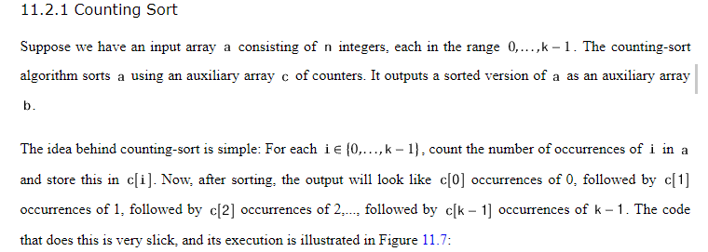
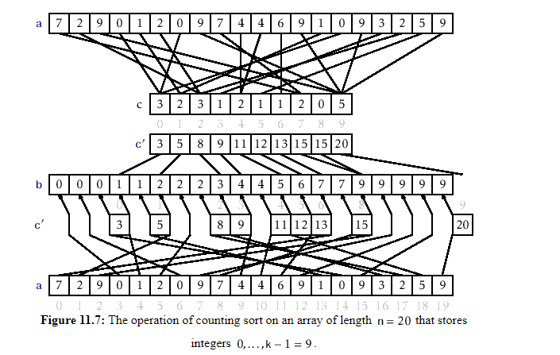
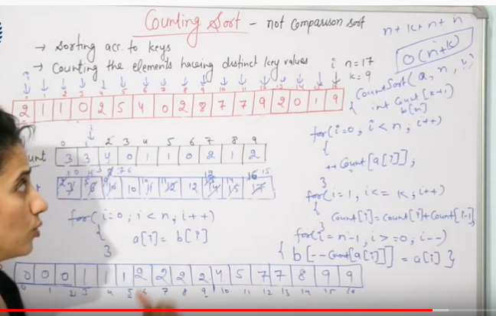
package com.sortalgorithm.test;

import java.util.Arrays;

public class CountSortingExample {
public static int[] theArray= {99,44,5,22,3,9,1};
@SuppressWarnings("null")
public static void countSort() {
int totNulElem=theArray.length;
System.out.println(" totNulElem --- "+totNulElem);
int maxElKey=findMaxValue(theArray);
System.out.println(" maxElKey --- "+maxElKey);
int[] countElmnt = new int[maxElKey+1];
int[] sortcountElmnt = new int[totNulElem];
//find count array elements
for(int i=0;i<totNulElem;i++) {
countElmnt[theArray[i]]=++countElmnt[theArray[i]];
}
//System.out.println(" Count sorted list is ---- After "+Arrays.toString(countElmnt));

for(int j=1;j<=maxElKey;j++) {
countElmnt[j]=countElmnt[j]+countElmnt[j-1];
}
//System.out.println(" Count sorted list is ---- After "+Arrays.toString(countElmnt));
for(int k=totNulElem-1;k>=0;k--) {
//int indexElmnt=--countElmnt[theArray[k]];
sortcountElmnt[--countElmnt[theArray[k]]]=theArray[k];
}
theArray=sortcountElmnt;
//System.out.println(" Count sorted list is ---- After "+Arrays.toString(theArray));
//System.out.println(" Count sorted list is ---- After "+Arrays.toString(countElmnt));
}

public static int findMaxValue(int[] collection) {
int highest = collection[0];
for (int index = 1; index < collection.length; index ++) {
if (collection[index] > highest) {
highest = collection [index];
}
}
return highest;
}
public static void main(String[] args) {
// TODO Auto-generated method stub
System.out.println(" Count sorted list is-- Before "+Arrays.toString(theArray));

countSort();
// TODO Auto-generated method stub
System.out.println(" Count sorted list is ---- After "+Arrays.toString(theArray));

}

}
Count sorted list is-- Before [99, 44, 5, 22, 3, 9, 1]
totNulElem --- 7
maxElKey --- 99
Count sorted list is ---- After [1, 3, 5, 9, 22, 44, 99]

Buket sorting
public class BuketSortingExample {

static int[] sort(int[] sequence, int maxValue)
{
// Bucket Sort
int[] Bucket = new int[maxValue + 1];
int[] sorted_sequence = new int[sequence.length];

for (int i = 0; i < sequence.length; i++)
Bucket[sequence[i]]++;

int outPos = 0;
for (int i = 0; i < Bucket.length; i++)
for (int j = 0; j < Bucket[i]; j++)
sorted_sequence[outPos++] = i;

return sorted_sequence;
}

static void printSequence(int[] sorted_sequence)
{
for (int i = 0; i < sorted_sequence.length; i++)
System.out.print(sorted_sequence[i] + " ");
}

static int maxValue(int[] sequence)
{
int maxValue = 0;
for (int i = 0; i < sequence.length; i++)
if (sequence[i] > maxValue)
maxValue = sequence[i];
return maxValue;
}

public static void main(String args[])
{
System.out
.println("Sorting of randomly generated numbers using BUCKET SORT");
Random random = new Random();
int N = 20;
int[] sequence = new int[N];

for (int i = 0; i < N; i++)
sequence[i] = Math.abs(random.nextInt(100));

int maxValue = maxValue(sequence);

System.out.println("\nOriginal Sequence: ");
printSequence(sequence);

System.out.println("\nSorted Sequence: ");
printSequence(sort(sequence, maxValue));
}
}

Radix sort
The Radix sort, like counting sort and bucket sort, is an integer based algorithm (I mean the values of the input array are assumed to be integers). ... Time Complexity of radix sort in the best case, average case and worst case is O(k*n) where k is the length of the longest number and n is the size of the input array.
