Java Collections FrameWork:-

Collections:- Framework This ^{framework} is provided in the java.util package.
Collection:- is a Java Interface.
- A collection represents a group of objects, known as its elements.
- Objects can be stored, retrieved, and manipulated as elements of collections
- Collections can be used in various scenarios like Storing phone numbers, Employee names database etc.
A Collections Framework mainly contains the following 3 parts
A Collections Framework is defined by a set of interfaces, concrete class implementations for most of the interfaces and a set of standard utility methods and algorithms. In addition, the framework also provides several abstract implementations, which are designed to make it easier for you to create new and different implementations for handling collections of data.
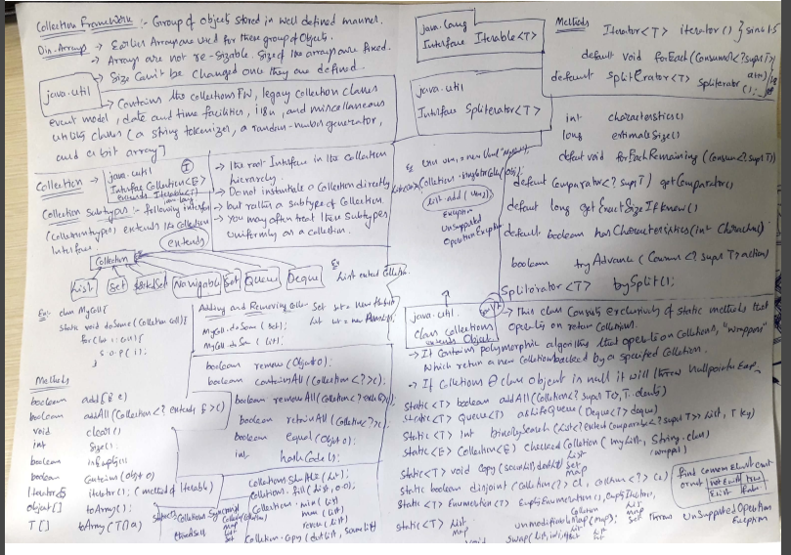

Core Collection Interfaces
The 6 core Interfaces used in the Collection framework are:
- Collection
- Set
- List
- Iterator (Not a part of the Collections Framework)
- SortedSet
- Map
- SortedMap

Collections Hierarchy:-
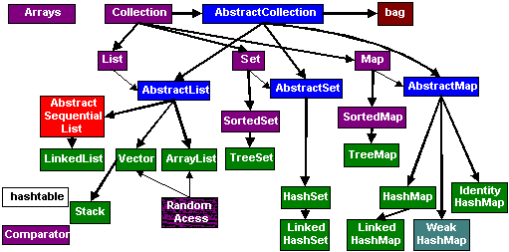

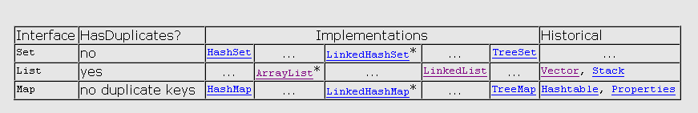Principal features of non-primary implementations :
- HashMap has slightly better performance than LinkedHashMap, but its iteration order is undefined
- HashSet has slightly better performance than LinkedHashSet, but its iteration order is undefined
- TreeSet is ordered and sorted, but slow
- TreeMap is ordered and sorted, but slow
- LinkedList has fast adding to the start of the list, and fast deletion from the interior via iteration
Iteration order for above implementations :
- HashSet - undefined
- HashMap - undefined
- LinkedHashSet - insertion order
- LinkedHashMap - insertion order of keys (by default), or 'access order'
- ArrayList - insertion order
- LinkedList - insertion order
- TreeSet - ascending order, according to Comparable / Comparator
- TreeMap - ascending order of keys, according to Comparable / Comparator

The Collection Interfaces:
The collections framework defines several interfaces. This section provides an overview of each interface:
SN | Interfaces with Description
1 | The Collection Interface  This enables you to work with groups of objects; it is at the top of the collections hierarchy.
2 | The List Interface  This extends Collection and an instance of List stores an ordered collection of elements.
3 | The Set  This extends Collection to handle sets, which must contain unique elements
4 | The SortedSet  This extends Set to handle sorted sets
5 | The Map  This maps unique keys to values.
6 | The Map.Entry  This describes an element (a key/value pair) in a map. This is an inner class of Map.
7 | The SortedMap  This extends Map so that the keys are maintained in ascending order.
8 | The Enumeration  This is legacy interface and defines the methods by which you can enumerate (obtain one at a time) the elements in a collection of objects. This legacy interface has been superceded by Iterator.

The Collection Interface:-
The Collection interface is the foundation upon which the collections framework is built. It declares the core methods that all collections will have. These methods are summarized in the following table.
Because all collections implement Collection, familiarity with its methods is necessary for a clear understanding of the framework. Several of these methods can throw an UnsupportedOperationException.
SN | Methods with Description
1 | boolean add(Object obj)  Adds obj to the invoking collection. Returns true if obj was added to the collection. Returns false if obj is already a member of the collection, or if the collection does not allow duplicates.
2 | boolean addAll(Collection c)  Adds all the elements of c to the invoking collection. Returns true if the operation succeeded (i.e., the elements were added). Otherwise, returns false.
3 | void clear( )  Removes all elements from the invoking collection.
4 | boolean contains(Object obj)  Returns true if obj is an element of the invoking collection. Otherwise, returns false.
5 | boolean containsAll(Collection c)  Returns true if the invoking collection contains all elements of c. Otherwise, returns false.
6 | boolean equals(Object obj)  Returns true if the invoking collection and obj are equal. Otherwise, returns false.
7 | int hashCode( )  Returns the hash code for the invoking collection.
8 | boolean isEmpty( )  Returns true if the invoking collection is empty. Otherwise, returns false.
9 | Iterator iterator( )  Returns an iterator for the invoking collection.
10 | boolean remove(Object obj)  Removes one instance of obj from the invoking collection. Returns true if the element was removed. Otherwise, returns false.
11 | boolean removeAll(Collection c)  Removes all elements of c from the invoking collection. Returns true if the collection changed (i.e., elements were removed). Otherwise, returns false.
12 | boolean retainAll(Collection c)  Removes all elements from the invoking collection except those in c. Returns true if the collection changed (i.e., elements were removed). Otherwise, returns false
13 | int size( )  Returns the number of elements held in the invoking collection.
14 | Object[ ] toArray( )  Returns an array that contains all the elements stored in the invoking collection. The array elements are copies of the collection elements.
15 | Object[ ] toArray(Object array[ ])  Returns an array containing only those collection elements whose type matches that of array.
Note:-Sorting a collection in Java is easy, just use Collections.sort(Collection) to sort your values. For example:
?
1  2  3  4  5  6  7  8  9  10  11  12  13  14  15  16  17  18  19  20  21 | package de.vogella.algorithms.sort.standardjava;  import java.util.ArrayList;  import java.util.Collections;  import java.util.List;  public class Simple {  public static void main(String[] args) {  List list = new ArrayList();  list.add(5);  list.add(4);  list.add(3);  list.add(7);  list.add(2);  list.add(1);  Collections.sort(list);  for (Integer integer : list) {  System.out.println(integer);  }  }  }

Java - The List Interface
The List interface extends Collection and declares the behavior of a collection that stores a sequence of elements. A List (sometimes called a sequence) is an ordered Collection that can contain duplicate elements.
- Elements can be inserted or accessed by their position in the list, using a zero-based index.
- A list may contain duplicate elements.
- In addition to the methods defined by Collection, List defines some of its own, which are summarized in the following below Table.
- Several of the list methods will throw an UnsupportedOperationException if the collection cannot be modified, and a ClassCastException is generated when one object is incompatible with another.
List implementations in the Java Collections API:
- java.util.ArrayList
- java.util.LinkedList
- java.util.Vector
- java.util.Stack

SN | Methods with Description
1 | void add(int index, Object obj)  Inserts obj into the invoking list at the index passed in index. Any preexisting elements at or beyond the point of insertion are shifted up. Thus, no elements are overwritten.
2 | boolean addAll(int index, Collection c)  Inserts all elements of c into the invoking list at the index passed in index. Any preexisting elements at or beyond the point of insertion are shifted up. Thus, no elements are overwritten. Returns true if the invoking list changes and returns false otherwise.
3 | Object get(int index)  Returns the object stored at the specified index within the invoking collection.
4 | int indexOf(Object obj)  Returns the index of the first instance of obj in the invoking list. If obj is not an element of the list, .1 is returned.
5 | int lastIndexOf(Object obj)  Returns the index of the last instance of obj in the invoking list. If obj is not an element of the list, .1 is returned.
6 | ListIterator listIterator( )  Returns an iterator to the start of the invoking list.
7 | ListIterator listIterator(int index)  Returns an iterator to the invoking list that begins at the specified index.
8 | Object remove(int index)  Removes the element at position index from the invoking list and returns the deleted element. The resulting list is compacted. That is, the indexes of subsequent elements are decremented by one
9 | Object set(int index, Object obj)  Assigns obj to the location specified by index within the invoking list.
10 | List subList(int start, int end)  Returns a list that includes elements from start to end.1 in the invoking list. Elements in the returned list are also referenced by the invoking object.

Before seeing differences between Vector and ArrayList, let's see some similarities between these two and why we can use ArrayList in place of Vector on certain scenario.

1) Vector and ArrayList are index based and backed up by an array internally.
2) Both ArrayList and Vector maintains the insertion order of element. Means you can assume that you will get the object in the order you have inserted if you iterate over ArrayList or Vector.
3) Both Iterator and ListIterator returned by ArrayList and Vector are fail-fast.
4) ArrayList and Vector also allows null and duplicates.

Vector vs ArrayList in Java
Now let's see some key difference between Vector and ArrayList in Java, this will decide when is the right time to use Vector over ArrayList and vice-versa. Differences are based upon properties like synchronization, thread safety, speed, performance , navigation and Iteration over List etc.

1) Synchronization and thread-safety
First and foremost difference between Vector and ArrayList is that Vector is synchronized and ArrayList is not, what it means is that all the method which structurally modifies Vector e.g. add () or remove () are synchronized which makes it thread-safe and allows it to be used safely in a multi-threaded and concurrent environment. On the other hand ArrayList methods are not synchronized thus not suitable for use in multi-threaded environment. This is also a popular interview question on thread, where people ask why ArrayList can not be shared between multiple threads.

2) Speed and Performance
ArrayList is way faster than Vector. Since Vector is synchronized and thread-safe it pays price of synchronization which makes it little slow. On the other hand ArrayList is not synchronized and fast which makes it obvious choice in a single-threaded access environment. You can also use ArrayList in a multi-threaded environment if multiple threads are only reading values from ArrayList or you can create read only ArrayList as well.

3) Capacity
Whenever Vector crossed the threshold specified it increases itself by value specified in capacityIncrement field while you can increase size of ArrayList by calling ensureCapacity () method.

4) Enumeration and Iterator
Vector can return enumeration of items it hold by calling elements () method which is not fail-fast as opposed to Iterator and ListIterator returned by ArrayList. I have discussed this point in detail on my post What is difference between Iterator and Enumeration, you can also look there.

5) Legacy
Another point worth to remember is Vector is one of those classes which comes with JDK 1.0 and initially not part of Collection framework but in later version it's been re-factored to implement List interface so that it could become part of collection framework

After considering these points about both Vector and ArrayList , my conclusion is use ArrayList wherever possible and avoids use of Vector until you have no choice. Think for CopyOnWriteArrayList over Vector, if you have multiple readers and few writers because it can provide thread-safety without impacting performance too much.
Read more: http://javarevisited.blogspot.com/2011/09/difference-vector-vs-arraylist-in-java.html#ixzz28gq4S2Xh
Q)How to make ArrayList as Thread-save in collections frame work
List Collections.synchronizedList(List) method to synchronize ArrayList
Example:-
public class Race implements RaceListener {
private Thread[] racers;
/* private ArrayList finishingOrder;
//Make an ArrayList to hold RaceCar objects to determine winners
finishingOrder = Collections.synchronizedCollection(new ArrayList(numberOfRaceCars)); */
private List finishingOrder;
//Make an ArrayList to hold RaceCar objects to determine winners
finishingOrder = Collections.synchronizedList(new ArrayList(numberOfRaceCars)
//Fill array with RaceCar objects
for(int i=0; i<numberOfRaceCars; i++) {
racers[i] = new RaceCar(laps, inputs[i]);
//Add this as a RaceListener to each RaceCar
((RaceCar) racers[i]).addRaceListener(this);
}
//Implement the one method in the RaceListener interface
public void addFinisher(RaceCar finisher) {
finishingOrder.add(finisher);
}

ArrayList:-

java.util
Class ArrayList<E>
java.lang.Object
java.util.AbstractCollection<E>
java.util.AbstractList<E>
java.util.ArrayList<E>

1. ArrayList in Java is most frequently used collection class after HashMap in Java.
2. Java ArrayList represents an automatic re-sizable array and used in place of array. Since we can not modify size of an array after creating it, we prefer to use ArrayList in Java which re-size itself automatically once it gets full. ArrayList in Java implements List interface and allow null.
3. Java ArrayList also maintains insertion order of elements and allows duplicates opposite to any Set implementation which doesn't allow duplicates.
4. ArrayList supports both Iterator and ListIterator for iteration but it’s recommended to use ListIterator as it allows the programmer to traverse the list in either direction, modify the list during iteration, and obtain the Iterator's current position in the list. But while using ListIterator you need to be little careful because ListIterator has no current element; its cursor position always lies between the element that would be returned by a call to previous () and the element that would be returned by a call to next ().
5. rrayList has been modified in Java5 (Tiger) to support Generics which makes Java ArrayList even more powerful because of enhanced type-safety. Before Java5 since there was no generics no type checking at compile time which means there is chance of storing different type of element in an ArrayList which is meant for something and ultimately results in ClassCastException during runtime.
Field Summary

Fields inherited from class java.util.AbstractList
modCount

Constructor Summary
ArrayList()
Constructs an empty list with an initial capacity of ten.
ArrayList(Collection<? extends E> c)
Constructs a list containing the elements of the specified collection, in the order they are returned by the collection's iterator.
ArrayList(int initialCapacity)
Constructs an empty list with the specified initial capacity.

Method Summary
boolean | add(E e)  Appends the specified element to the end of this list.
void | add(int index, E element)  Inserts the specified element at the specified position in this list.
boolean | addAll(Collection<? extends E> c)  Appends all of the elements in the specified collection to the end of this list, in the order that they are returned by the specified collection's Iterator.
boolean | addAll(int index, Collection<? extends E> c)  Inserts all of the elements in the specified collection into this list, starting at the specified position.
void | clear()  Removes all of the elements from this list.
Object | clone()  Returns a shallow copy of this ArrayList instance.
boolean | contains(Object o)  Returns true if this list contains the specified element.
void | ensureCapacity(int minCapacity)  Increases the capacity of this ArrayList instance, if necessary, to ensure that it can hold at least the number of elements specified by the minimum capacity argument.
E | get(int index)  Returns the element at the specified position in this list.
int | indexOf(Object o)  Returns the index of the first occurrence of the specified element in this list, or -1 if this list does not contain the element.
boolean | isEmpty()  Returns true if this list contains no elements.
int | lastIndexOf(Object o)  Returns the index of the last occurrence of the specified element in this list, or -1 if this list does not contain the element.
E | remove(int index)  Removes the element at the specified position in this list.
boolean | remove(Object o)  Removes the first occurrence of the specified element from this list, if it is present.
protected void | removeRange(int fromIndex, int toIndex)  Removes from this list all of the elements whose index is between fromIndex, inclusive, and toIndex, exclusive.
E | set(int index, E element)  Replaces the element at the specified position in this list with the specified element.
int | size()  Returns the number of elements in this list.
Object[] | toArray()  Returns an array containing all of the elements in this list in proper sequence (from first to last element).
 | toArray(T[] a)  Returns an array containing all of the elements in this list in proper sequence (from first to last element); the runtime type of the returned array is that of the specified array.
  <T> T[]
void | trimToSize()  Trims the capacity of this ArrayList instance to be the list's current size.

Methods inherited from class java.util.AbstractList
equals, hashCode, iterator, listIterator, listIterator, subList

Methods inherited from class java.util.AbstractCollection
containsAll, removeAll, retainAll, toString

Methods inherited from class java.lang.Object
finalize, getClass, notify, notifyAll, wait, wait, wait

Methods inherited from interface java.util.List
containsAll, equals, hashCode, iterator, listIterator, listIterator, removeAll, retainAll, subList

LinkedList:-
  - Linked Lists are an alternative to ArrayLists that Computer Scientists have come up with. While an ArrayList uses an array internally to store the data, a LinkedList uses nodes to hold the elements.
  - These nodes then point to each other, thus leading to the name "Linked" List.
- There are three types of Linked Lists:
  - singly-linked lists
  - doubly-linked lists
  - circularly-linked lists
1.Singly-linkedLists:- Singly-linked lists work by having each node pointing to the next node, with the tail node (or end node) pointing to nothing (or a null reference).
2.doubly-linkedlists:-
- Doubly-linked lists expand upon the singly-linked list, with each node pointing to the previous node as well as the next node
- In doubly-linked lists, both the head node (first node) and the tail node point to nothing
3.cirularly-linedLists:-
Circularly-linked lists expand upon the singly-linked list differently than the doubly-linked list; instead of having the tail node pointing to nothing, it "circles" back around, pointing to the head element as the name suggests.

LinkedList
The LinkedList is implemented using nodes linked to each other. Each node contains a previous node link, next node link, and value, which contains the actual data. When new data is inserted, a node is inserted and the links of the surrounding nodes are updated accordingly. When one is removed, the same happens – The surrounding nodes are changing their links and the deleted node is garbage collected. This, as well, gives strengths and weaknesses:
- Fast manipulation As you’d expect, adding and removing new data anywhere in the list is instantanious. Change two links, and you have a new value anywhere you want it.
- No random access Even though the get(int) is still there, it now just iterates the list until it reaches the index you specified. It has some optimizations in order to do that, but that’s basically it.

java.util
Class LinkedList<E>
java.lang.Object
java.util.AbstractCollection<E>
java.util.AbstractList<E>
java.util.AbstractSequentialList<E>
java.util.LinkedList<E>
Field Summary

Fields inherited from class java.util.AbstractList
modCount

Constructor Summary
LinkedList()
Constructs an empty list.
LinkedList(Collection<? extends E> c)
Constructs a list containing the elements of the specified collection, in the order they are returned by the collection's iterator.

Method Summary
boolean | add(E e)  Appends the specified element to the end of this list.
void | add(int index, E element)  Inserts the specified element at the specified position in this list.
boolean | addAll(Collection<? extends E> c)  Appends all of the elements in the specified collection to the end of this list, in the order that they are returned by the specified collection's iterator.
boolean | addAll(int index, Collection<? extends E> c)  Inserts all of the elements in the specified collection into this list, starting at the specified position.
void | addFirst(E e)  Inserts the specified element at the beginning of this list.
void | addLast(E e)  Appends the specified element to the end of this list.
void | clear()  Removes all of the elements from this list.
Object | clone()  Returns a shallow copy of this LinkedList.
boolean | contains(Object o)  Returns true if this list contains the specified element.
Iterator<E> | descendingIterator()  Returns an iterator over the elements in this deque in reverse sequential order.
E | element()  Retrieves, but does not remove, the head (first element) of this list.
E | get(int index)  Returns the element at the specified position in this list.
E | getFirst()  Returns the first element in this list.
E | getLast()  Returns the last element in this list.
int | indexOf(Object o)  Returns the index of the first occurrence of the specified element in this list, or -1 if this list does not contain the element.
int | lastIndexOf(Object o)  Returns the index of the last occurrence of the specified element in this list, or -1 if this list does not contain the element.
ListIterator<E> | listIterator(int index)  Returns a list-iterator of the elements in this list (in proper sequence), starting at the specified position in the list.
boolean | offer(E e)  Adds the specified element as the tail (last element) of this list.
boolean | offerFirst(E e)  Inserts the specified element at the front of this list.
boolean | offerLast(E e)  Inserts the specified element at the end of this list.
E | peek()  Retrieves, but does not remove, the head (first element) of this list.
E | peekFirst()  Retrieves, but does not remove, the first element of this list, or returns null if this list is empty.
E | peekLast()  Retrieves, but does not remove, the last element of this list, or returns null if this list is empty.
E | poll()  Retrieves and removes the head (first element) of this list
E | pollFirst()  Retrieves and removes the first element of this list, or returns null if this list is empty.
E | pollLast()  Retrieves and removes the last element of this list, or returns null if this list is empty.
E | pop()  Pops an element from the stack represented by this list.
void | push(E e)  Pushes an element onto the stack represented by this list.
E | remove()  Retrieves and removes the head (first element) of this list.
E | remove(int index)  Removes the element at the specified position in this list.
boolean | remove(Object o)  Removes the first occurrence of the specified element from this list, if it is present.
E | removeFirst()  Removes and returns the first element from this list.
boolean | removeFirstOccurrence(Object o)  Removes the first occurrence of the specified element in this list (when traversing the list from head to tail).
E | removeLast()  Removes and returns the last element from this list.
boolean | removeLastOccurrence(Object o)  Removes the last occurrence of the specified element in this list (when traversing the list from head to tail).
E | set(int index, E element)  Replaces the element at the specified position in this list with the specified element.
int | size()  Returns the number of elements in this list.
Object[] | toArray()  Returns an array containing all of the elements in this list in proper sequence (from first to last element).
 | toArray(T[] a)  Returns an array containing all of the elements in this list in proper sequence (from first to last element); the runtime type of the returned array is that of the specified array.
  <T> T[]

Vecotr:-
- class Vector provides the capabilities of array-(like data structures )that can resize themselves dynamically.
- Like ArrayList but with two differences:
Vector is synchronized, and it contains many legacy methods that are not part of the collections framework.
With the release of Java 2, Vector was reengineered to extend AbstractList and implement the List interface, so it now is fully compatible with collections.
Here are the Vector constructors:
Vector( )
Vector(int size)
Vector(int size, int incr)
Vector(Collection c)
→ All vectors start with an initial capacity. After this initial capacity is reached, the next time that you attempt to store an object in the vector, the vector automatically allocates space for that object plus extra room for additional objects.
→By allocating more than just the required memory, the vector reduces the number of allocations that must take place. This reduction is important, because allocations are costly in terms of time. The amount of extra space allocated during each reallocation is determined by the increment that you specify when you create the vector. If you don't specify an increment, the vector's size is doubled by each allocation cycle.

Vector defines these protected data members:
int capacityIncrement-The increment value is stored in capacityIncrement.
int elementCount; The number of elements currently in the vector is stored in elementCount.
Object elementData[ ]; he array that holds the vector is stored in elementData.

SN | Methods with Description
1 | void add(int index, Object element)  Inserts the specified element at the specified position in this Vector.
2 | boolean add(Object o)  Appends the specified element to the end of this Vector.
3 | boolean addAll(Collection c)  Appends all of the elements in the specified Collection to the end of this Vector, in the order that they are returned by the specified Collection's Iterator.
4 | boolean addAll(int index, Collection c)  Inserts all of the elements in in the specified Collection into this Vector at the specified position.
5 | void addElement(Object obj)  Adds the specified component to the end of this vector, increasing its size by one.
6 | int capacity()  Returns the current capacity of this vector.
7 | void clear()  Removes all of the elements from this Vector.
8 | Object clone()  Returns a clone of this vector.
9 | boolean contains(Object elem)  Tests if the specified object is a component in this vector.
10 | boolean containsAll(Collection c)  Returns true if this Vector contains all of the elements in the specified Collection.
11 | void copyInto(Object[] anArray)  Copies the components of this vector into the specified array.
12 | Object elementAt(int index)  Returns the component at the specified index.
13 | Enumeration elements()  Returns an enumeration of the components of this vector.
14 | void ensureCapacity(int minCapacity)  Increases the capacity of this vector, if necessary, to ensure that it can hold at least the number of components specified by the minimum capacity argument.
15 | boolean equals(Object o)  Compares the specified Object with this Vector for equality.
16 | Object firstElement()  Returns the first component (the item at index 0) of this vector.
17 | Object get(int index)  Returns the element at the specified position in this Vector.
18 | int hashCode()  Returns the hash code value for this Vector.
19 | int indexOf(Object elem)  Searches for the first occurence of the given argument, testing for equality using the equals method.
20 | int indexOf(Object elem, int index)  Searches for the first occurence of the given argument, beginning the search at index, and testing for equality using the equals method.
21 | void insertElementAt(Object obj, int index)  Inserts the specified object as a component in this vector at the specified index.
22 | boolean isEmpty()  Tests if this vector has no components.
23 | Object lastElement()  Returns the last component of the vector.
24 | int lastIndexOf(Object elem)  Returns the index of the last occurrence of the specified object in this vector.
25 | int lastIndexOf(Object elem, int index)  Searches backwards for the specified object, starting from the specified index, and returns an index to it.
26 | Object remove(int index)  Removes the element at the specified position in this Vector.
27 | boolean remove(Object o)  Removes the first occurrence of the specified element in this Vector If the Vector does not contain the element, it is unchanged.
28 | boolean removeAll(Collection c)  Removes from this Vector all of its elements that are contained in the specified Collection.
29 | void removeAllElements()  Removes all components from this vector and sets its size to zero.
30 | boolean removeElement(Object obj)  Removes the first (lowest-indexed) occurrence of the argument from this vector.
31 | void removeElementAt(int index)  removeElementAt(int index)
32 | protected void removeRange(int fromIndex, int toIndex)  Removes from this List all of the elements whose index is between fromIndex, inclusive and toIndex, exclusive.
33 | boolean retainAll(Collection c)  Retains only the elements in this Vector that are contained in the specified Collection.
34 | Object set(int index, Object element)  Replaces the element at the specified position in this Vector with the specified element.
35 | void setElementAt(Object obj, int index)  Sets the component at the specified index of this vector to be the specified object.
36 | void setSize(int newSize)  Sets the size of this vector.
37 | int size()  Returns the number of components in this vector.
38 | List subList(int fromIndex, int toIndex)  Returns a view of the portion of this List between fromIndex, inclusive, and toIndex, exclusive.
39 | Object[] toArray()  Returns an array containing all of the elements in this Vector in the correct order.
40 | Object[] toArray(Object[] a)  Returns an array containing all of the elements in this Vector in the correct order; the runtime type of the returned array is that of the specified array.
41 | String toString()  Returns a string representation of this Vector, containing the String representation of each element.
42 | void trimToSize()  Trims the capacity of this vector to be the vector's current size.

Queue Fundamentals
interface Queue was introduced with JDK 1.5 and is part of collections framework as Queue extends Collection interface. Queue stores elements in such way it returns the first one added. Queue follows the style of FIFO (first in, first out, remember stack follows LIFO, last in, first out). The first element in the queue is known as head and the last one is known as tail. New elements are added to the tail.
Since Queue is an interface you need to instantiate a concrete implementation of the interface in order to use it. You can choose between the following Queue implementations in the Java Collections API:
- java.util.LinkedList
- java.util.PriorityQueue
LinkedList is a pretty standard queue implementation.
PriorityQueue stores its elements internally according to their natural order (if they implement Comparable), or according to a Comparator passed to the PriorityQueue.
java.util

Interface Queue<E>
- Type Parameters:
E - the type of elements held in this collection
All Superinterfaces:
Collection<E>, Iterable<E>
All Known Subinterfaces:
BlockingDeque<E>, BlockingQueue<E>, Deque<E>, TransferQueue<E>
All Known Implementing Classes:
AbstractQueue, ArrayBlockingQueue, ArrayDeque, ConcurrentLinkedDeque, ConcurrentLinkedQueue, DelayQueue, LinkedBlockingDeque, LinkedBlockingQueue, LinkedList, LinkedTransferQueue, PriorityBlockingQueue, PriorityQueue, SynchronousQueue

Method Summary
Methods
Modifier and Type | Method and Description
boolean | add(E e)  Inserts the specified element into this queue if it is possible to do so immediately without violating capacity restrictions, returning true upon success and throwing an IllegalStateException if no space is currently available.
E | element()  Retrieves, but does not remove, the head of this queue.
boolean | offer(E e)  Inserts the specified element into this queue if it is possible to do so immediately without violating capacity restrictions.
E | peek()  Retrieves, but does not remove, the head of this queue, or returns null if this queue is empty.
E | poll()  Retrieves and removes the head of this queue, or returns null if this queue is empty.
E | remove()  Retrieves and removes the head of this queue.

Methods inherited from interface java.util.Collection
addAll, clear, contains, containsAll, equals, hashCode, isEmpty, iterator, remove, removeAll, retainAll, size, toArray, toArray

Stack:-
→Stack is a subclass of Vector that implements a standard last-in, first-out stack.
→A Stack is like a bucket in which you can put elements one-by-one in sequence and retrieve elements from the bucket according to the sequence of the last entered element
→Stack is a collection of data and follows the LIFO (Last in, first out) rule that mean you can insert the elements one-by-one in sequence and the last inserted element can be retrieved at once from the bucket.
→Elements are inserted and retrieved to/from the stack through the push() and pop() method.

Class java.util.Stack
java.lang.Object
|
+----java.util.Vector
|
+----java.util.Stack


Stack()


empty()
Returns true if the stack is empty.
peek()
Peeks at the top of the stack.
pop()
Pops an item off the stack.
push(Object)
Pushes an item onto the stack.
search(Object)
Sees if an object is on the stack.


Stack
public Stack()


push
public Object push(Object item)
Pushes an item onto the stack.
Parameters:
item - the item to be pushed on.
pop
public Object pop()
Pops an item off the stack.
Throws: EmptyStackException
If the stack is empty.
peek
public Object peek()
Peeks at the top of the stack.
Throws: EmptyStackException
If the stack is empty.
empty
public boolean empty()
Returns true if the stack is empty.
search
public int search(Object o)
Sees if an object is on the stack.
Parameters:
o - the desired object
Returns:
the distance from the top, or -1 if it is not found.

Set:- A Set is a Collection that cannot contain duplicate elements
→The Set interface contains only methods inherited from Collection and adds the restriction that duplicate elements are prohibited.

java.util
Interface Set<E>

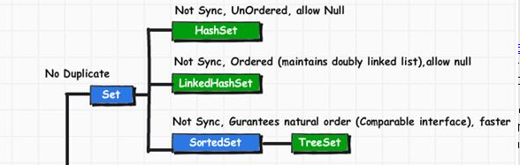
Method Summary
boolean | add(E o)  Adds the specified element to this set if it is not already present (optional operation).
boolean | addAll(Collection<? extends E> c)  Adds all of the elements in the specified collection to this set if they're not already present (optional operation).
void | clear()  Removes all of the elements from this set (optional operation).
boolean | contains(Object o)  Returns true if this set contains the specified element.
boolean | containsAll(Collection<?> c)  Returns true if this set contains all of the elements of the specified collection.
boolean | equals(Object o)  Compares the specified object with this set for equality.
int | hashCode()  Returns the hash code value for this set.
boolean | isEmpty()  Returns true if this set contains no elements.
Iterator<E> | iterator()  Returns an iterator over the elements in this set.
boolean | remove(Object o)  Removes the specified element from this set if it is present (optional operation).
boolean | removeAll(Collection<?> c)  Removes from this set all of its elements that are contained in the specified collection (optional operation).
boolean | retainAll(Collection<?> c)  Retains only the elements in this set that are contained in the specified collection (optional operation).
int | size()  Returns the number of elements in this set (its cardinality).
Object[] | toArray()  Returns an array containing all of the elements in this set.
 | toArray(T[] a)  Returns an array containing all of the elements in this set; the runtime type of the returned array is that of the specified array.
  <T> T[]

- java.util.HashSet
- java.util.LinkedHashSet
SortedSet→java.util.TreeSet
HashSet:-
HashSet implements the Set interface. HashSet uses hash table, at the background, for storage of elements; uses a mechanism called hashing. No guarantee of returning the elements in the same order when called different times or insertion order. HashSet permits null element. But the set should contain only one null value as duplicates are not permitted. The methods of HashSet are not synchronized. But a synchronized version of HashSet can be obtained..
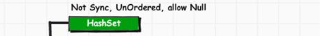

java.util
Class HashSet<E>
java.lang.Object
java.util.AbstractCollection<E>
java.util.AbstractSet<E>
java.util.HashSet<E>
Constructor Summary
HashSet()
Constructs a new, empty set; the backing HashMap instance has default initial capacity (16) and load factor (0.75).
HashSet(Collection<? extends E> c)
Constructs a new set containing the elements in the specified collection.
HashSet(int initialCapacity)
Constructs a new, empty set; the backing HashMap instance has the specified initial capacity and default load factor (0.75).
HashSet(int initialCapacity, float loadFactor)
Constructs a new, empty set; the backing HashMap instance has the specified initial capacity and the specified load factor.

Method Summary
boolean | add(E e)  Adds the specified element to this set if it is not already present.
void | clear()  Removes all of the elements from this set.
Object | clone()  Returns a shallow copy of this HashSet instance: the elements themselves are not cloned.
boolean | contains(Object o)  Returns true if this set contains the specified element.
boolean | isEmpty()  Returns true if this set contains no elements.
Iterator<E> | iterator()  Returns an iterator over the elements in this set.
boolean | remove(Object o)  Removes the specified element from this set if it is present.
int | size()  Returns the number of elements in this set (its cardinality).

Methods inherited from class java.util.AbstractSet
equals, hashCode, removeAll

Methods inherited from class java.util.AbstractCollection
addAll, containsAll, retainAll, toArray, toArray, toString

Methods inherited from class java.lang.Object
finalize, getClass, notify, notifyAll, wait, wait, wait

Methods inherited from interface java.util.Set
addAll, containsAll, equals, hashCode, removeAll, retainAll, toArray, toArray

Hashing in java?

Object comparison – hashCode() & equals()
hashCode() is a method of Object class. Hash code is an integer representation of an object by JVM. Hash code is system generated and JVM takes the address of the object as the basis (seed) to generate the hash code. Hash codes generated need not be the same for different times of execution. Internally, the objects are stored in Hashtable format. The equals() method, as we know earlier, compares two strings or characters. For comparison, the JVM uses their hash codes only. This way of comparison is very faster than comparing each character in the two strings. This hash code format cannot be used by the programmer in coding.
About equals() method()
equals() is a method of Object class. This method is not designed to exactly compare the properties of two objects; but designed, to know whether two references refer the same object or not. Many classes override this method for their convenience. String() and System classes has overridden this method to know two objects are same or not.
Following program shows the usage of hashCode() and equals() methods.
1  2  3  4  5  6  7  8  9  10  11  12  13  14  15  16  17  18  19  20  21  22  23  24  25  26  27  28 | public class Test  {  public static void main(String args[])  {  Test t1 = new Test();  Test t2 = new Test();  System.out.println(t1.getClass());  int a = t1.hashCode();  int b = t2.hashCode();  System.out.println("t1 object hash code: " + a);  System.out.println("t2 object hash code: " + b);  if(t1.equals(t2))  System.out.println("t1 and t2 refers the same");  else  System.out.println("t1 and t2 does not refer the same");  Test t3, t4;  t3 = t1;  t4 = t1;  if(t3.equals(t4))  System.out.println("t3 and t4 refers the same");  else  System.out.println("t3 and t4 does not refer the same");  }  }
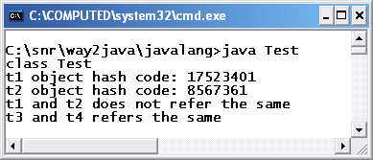
getClass() method of Object class returns the class for which object t1 belongs. hashCode() method returns the hash code of the object t1. equals() method for t1 and t2 returned false and for t3 and t4 returned true as t3 and t4 refer the same t1 object. Comparing objects with hashcode is known as hashing.
About Hashing and Hashcode
Comparing two strings letter by letter in a for loop is a time taking process. To make faster, the JVM converts each string into an integer number called hashcode. Different strings with different sequence of characters have different hashcodes. Comparison with integer numbers gives maximum performance. Usage of hashcode numbers for comparison, searching of duplicate elements and identification is faster.
Hashing is process of converting a string or object into a 32-bit hashcode integer number. Two objects are said to be equal if their hashcodes are same. hashCode() is used in combination with equals() method. When compared, hashing is done automatically by the JVM. Hashing, in data structures, is done implicitly in the basic operations with add(), contains(), remove() and size() etc. Hashing is more useful to compare the sets of large content.

How hashing works
Purely as an example to help us grasp the concept, let's suppose that we want to map a list of string keys to string values (for example, map a list of countries to their capital cities). So let's say we want to store the data in Table 1 in the map.
Table 1: Example data to put in a map
Key | Value
Cuba | Havana
England | London
France | Paris
Spain | Madrid
Switzerland | Berne
And let's suppose that our hash function is to simply take the length of the string. For simplicity, we'll have two arrays: one for our keys and one for the values. So to put an item in the hash table, we compute its hash code (in this case, simply count the number of characters), then put the key and value in the arrays at the corresponding index. For example, Cuba has a hash code (length) of 4. So we store Cuba in the 4th position in the keys array, and Havana in the 4th index of the values array etc. And we end up with the following:
Position  (hash code = key length) | Keys array | Values array
1
2
3
4 | Cuba | Havana
5 | Spain | Madrid
6 | France | Paris
7 | England | London
8
9
10
11 | Switzerland | Berne
Now, in this specific example things work quite well. Our array needs to be big enough to accommodate the longest string, but in this case that's only 11 slots. And we do waste a bit of space because, for example, there's no 1-letter keys in our data, nor keys between 8 and 10 letters. But in this case, the waste isn't so bad either. And taking the length of a string is nice and fast, so so is the process of finding the value associated with a given key (certainly faster than doing up to five string comparisons)¹.
We can also easily see that this method wouldn't work for storing arbitrary strings. If one of our string keys was a thousand characters in length but the rest were small, we'd waste the majority of the space in the arrays. More seriously, this model can't deal with collisions: that is, what to do when there is more than one key with the same hash code (in this case, one than more string of a given length). For example, if our keys were random words of English, taking the string length would be fairly useless. Granted, the word psuedoantidisestablishmentarianistically would probably get its own place in the array. But on the other hand, we'd be left with thousands of, say, 6-letter words all competing for the same slot in the array.

Java.util.LinkedHashSet:-
java.lang.Object
java.util.AbstractCollection<E>
java.util.AbstractSet<E>
java.util.HashSet<E>
java.util.LinkedHashSet<E>
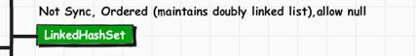
This class extends HashSet, but adds no members of its own.
LinkedHashSet maintains a linked list of the entries in the set, in the order in which they were inserted. This allows insertion-order iteration over the set.
That is, when cycling through a LinkedHashSet using an iterator, the elements will be returned in the order in which they were inserted.
The hash code is then used as the index at which the data associated with the key is stored. The transformation of the key into its hash code is performed automatically.
The LinkedHashSet class supports four constructors. The first form constructs a default hash set:
LinkedHashSet( )
The following constructor form initializes the hash set by using the elements of c.
LinkedHashSet(Collection c)
The following constructor form initializes the capacity of the hash set to capacity.
The capacity grows automatically as elements are added to the Hash.
LinkedHashSet(int capacity)
The fourth form initializes both the capacity and the fill ratio (also called load capacity) of the hash set from its arguments:
LinkedHashSet(int capacity, float fillRatio)

Example:
The following program illustrates several of the methods supported by LinkedHashSet:
import java.util.*;

class HashSetDemo {
public static void main(String args[]) {
// create a hash set
LinkedHashSet hs = new LinkedHashSet();
// add elements to the hash set
hs.add("B");
hs.add("A");
hs.add("D");
hs.add("E");
hs.add("C");
hs.add("F");
System.out.println(hs);
}
}
This would produce following result:
[B, A, D, E, C, F]

Constructor Summary
LinkedHashSet()
Constructs a new, empty linked hash set with the default initial capacity (16) and load factor (0.75).
LinkedHashSet(Collection<? extends E> c)
Constructs a new linked hash set with the same elements as the specified collection.
LinkedHashSet(int initialCapacity)
Constructs a new, empty linked hash set with the specified initial capacity and the default load factor (0.75).
LinkedHashSet(int initialCapacity, float loadFactor)
Constructs a new, empty linked hash set with the specified initial capacity and load factor.

Method Summary

Methods inherited from class java.util.HashSet
add, clear, clone, contains, isEmpty, iterator, remove, size

Methods inherited from class java.util.AbstractSet
equals, hashCode, removeAll

Methods inherited from class java.util.AbstractCollection
addAll, containsAll, retainAll, toArray, toArray, toString

Methods inherited from class java.lang.Object
finalize, getClass, notify, notifyAll, wait, wait, wait

Methods inherited from interface java.util.Set
add, addAll, clear, contains, containsAll, equals, hashCode, isEmpty, iterator, remove, removeAll, retainAll, size, toArray, toArray

TreeSet:-
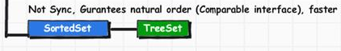

TreeSet in java
1. TreeSet in java guarantees sorted set of elements which are arranged in ascending order.
2. TreeSet in java provides log(n) time for basic operations such as add, remove and contains.
3. TreeSet in java is not synchronized , we need to synchronize it externally using Collections.synchronizedSortedSet.

java.util
Class TreeSet<E>
java.lang.Object
java.util.AbstractCollection<E>
java.util.AbstractSet<E>
java.util.TreeSet<E>
Constructor Summary
TreeSet()
Constructs a new, empty tree set, sorted according to the natural ordering of its elements.
TreeSet(Collection<? extends E> c)
Constructs a new tree set containing the elements in the specified collection, sorted according to the natural ordering of its elements.
TreeSet(Comparator<? super E> comparator)
Constructs a new, empty tree set, sorted according to the specified comparator.
TreeSet(SortedSet<E> s)
Constructs a new tree set containing the same elements and using the same ordering as the specified sorted set.

Method Summary
boolean | add(E e)  Adds the specified element to this set if it is not already present.
boolean | addAll(Collection<? extends E> c)  Adds all of the elements in the specified collection to this set.
E | ceiling(E e)  Returns the least element in this set greater than or equal to the given element, or null if there is no such element.
void | clear()  Removes all of the elements from this set.
Object | clone()  Returns a shallow copy of this TreeSet instance.
Comparator<? super E> | comparator()  Returns the comparator used to order the elements in this set, or null if this set uses the natural ordering of its elements.
boolean | contains(Object o)  Returns true if this set contains the specified element.
Iterator<E> | descendingIterator()  Returns an iterator over the elements in this set in descending order.
NavigableSet<E> | descendingSet()  Returns a reverse order view of the elements contained in this set.
E | first()  Returns the first (lowest) element currently in this set.
E | floor(E e)  Returns the greatest element in this set less than or equal to the given element, or null if there is no such element.
SortedSet<E> | headSet(E toElement)  Returns a view of the portion of this set whose elements are strictly less than toElement.
NavigableSet<E> | headSet(E toElement, boolean inclusive)  Returns a view of the portion of this set whose elements are less than (or equal to, if inclusive is true) toElement.
E | higher(E e)  Returns the least element in this set strictly greater than the given element, or null if there is no such element.
boolean | isEmpty()  Returns true if this set contains no elements.
Iterator<E> | iterator()  Returns an iterator over the elements in this set in ascending order.
E | last()  Returns the last (highest) element currently in this set.
E | lower(E e)  Returns the greatest element in this set strictly less than the given element, or null if there is no such element.
E | pollFirst()  Retrieves and removes the first (lowest) element, or returns null if this set is empty.
E | pollLast()  Retrieves and removes the last (highest) element, or returns null if this set is empty.
boolean | remove(Object o)  Removes the specified element from this set if it is present.
int | size()  Returns the number of elements in this set (its cardinality).
NavigableSet<E> | subSet(E fromElement, boolean fromInclusive, E toElement, boolean toInclusive)  Returns a view of the portion of this set whose elements range from fromElement to toElement.
SortedSet<E> | subSet(E fromElement, E toElement)  Returns a view of the portion of this set whose elements range from fromElement, inclusive, to toElement, exclusive.
SortedSet<E> | tailSet(E fromElement)  Returns a view of the portion of this set whose elements are greater than or equal to fromElement.
NavigableSet<E> | tailSet(E fromElement, boolean inclusive)  Returns a view of the portion of this set whose elements are greater than (or equal to, if inclusive is true) fromElement.

Methods inherited from class java.util.AbstractSet
equals, hashCode, removeAll

Methods inherited from class java.util.AbstractCollection
containsAll, retainAll, toArray, toArray, toString

Methods inherited from class java.lang.Object
finalize, getClass, notify, notifyAll, wait, wait, wait

Methods inherited from interface java.util.Set
containsAll, equals, hashCode, removeAll, retainAll, toArray, toArray

TreeSet provides an implementation of the Set interface that uses a tree for storage. Objects are stored in sorted, ascending order. Access and retrieval times are quite fast, which makes TreeSet an excellent choice when storing large amounts of sorted information that must be found quickly.
The following constructors are defined:
TreeSet( )
TreeSet(Collection c)
TreeSet(Comparator comp)
TreeSet(SortedSet ss)
The first form constructs an empty tree set that will be sorted in ascending order according to the natural order of its elements. The second form builds a tree set that contains the elements of c. The third form constructs an empty tree set that will be sorted according to the comparator specified by comp. (Comparators are described later in this chapter.) The fourth form builds a tree set that contains the elements of ss.
Here is an example that demonstrates a TreeSet:
// Demonstrate TreeSet.
import java.util.*;
class TreeSetDemo {
public static void main(String args[]) {
// Create a tree set
TreeSet ts = new TreeSet();
// Add elements to the tree set
ts.add("C");
ts.add("A");
ts.add("B");
ts.add("E");
ts.add("F");
ts.add("D");
System.out.println(ts);
}
}
The output from this program is shown here:
[A, B, C, D, E, F]
As explained, because TreeSet stores its elements in a tree, they are automatically arranged in sorted order, as the output confirms.

Difference between ArrayList and Vector

By : Ankush Gorav | May 28, 2012 | 5 Comments

This is one of the most famous questions which interviewers consider in an interview. Before we actually see the differences, let me give you a brief description of both.
ArrayList is the implementation of List Interface. The Following table summaries the chanrateristics of ArrayList.
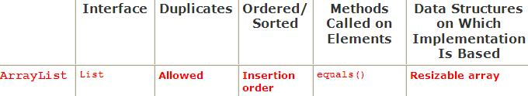
It is not synchronized ( so, this is not thread-safe).
ArrayList class is implemented using Array internally as data structure and can be dynamically resizable. By default, ArrayList increases by half of its size when its size is increased.
Vector is the implementation of List Interface. The Following table summaries the chanrateristics of Vector.
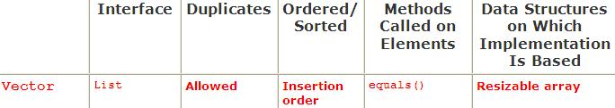
It is synchronized ( so, this is thread-safe).
Vector class is implemented using Array internally as data structure and can be dynamically resizable. By default, Vector doubles the size of its array when its size is increased

ArrayList Vs Vector
ArrayList is not synchronized. So, all the methods of ArrayList are not thread-safe. It should not be used in a multi-threaded environment.
Vector is synchronized. So, all the methods of Vector are thread-safe. It can be used in a multi-threaded environment.
ArrayList is faster (since it is not synchronized).
Vector is slow (since it is synchronized).
ArrayList increases by half of its size when its size is increased.
Vector doubles the size of its array when its size is increased.

Which one you should choose – Vector or ArrayList?
The only main difference which I have found between the two is – Vector is synchronized and ArrayList is not. And, since synchronization is a costly operation to perform (in terms of performance), Vector is slower than ArrayList. So, you should use Vector only when there is a need of thread-safe operations.

Java.util.Map
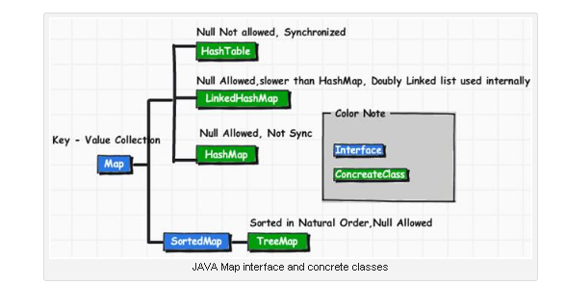
Map interface is part of java.util package. Map interface can add key and value put(key, value) pair elements. This Map permits null value. Map is interface. Key and value of Map can get by Set Interface and Map interface through Iterator interface.

Working Experience in this is :-
Test1:- it allows only one null key and data values ex:- mymap.put("","rajesh");mymap.put("","fff"); out put is:- {=rajesh}
Test2:-it not allows null key and null values ex:- mymap.put("","");
mymap.put("",""); out put is:- {=}
Test3:-it wont allows two null key and value keys ex:- mymap.put("","rrr");
mymap.put("","dddd"); out put :- {=dddd}

Nested Class Summary
static interface | Map.Entry<K,V>  A map entry (key-value pair).

Method Summary
void | clear()  Removes all of the mappings from this map (optional operation).
boolean | containsKey(Object key)  Returns true if this map contains a mapping for the specified key.
boolean | containsValue(Object value)  Returns true if this map maps one or more keys to the specified value.
Set<Map.Entry<K,V>> | entrySet()  Returns a Set view of the mappings contained in this map.
boolean | equals(Object o)  Compares the specified object with this map for equality.
V | get(Object key)  Returns the value to which the specified key is mapped, or null if this map contains no mapping for the key.
int | hashCode()  Returns the hash code value for this map.
boolean | isEmpty()  Returns true if this map contains no key-value mappings.
Set<K> | keySet()  Returns a Set view of the keys contained in this map.
V | put(K key, V value)  Associates the specified value with the specified key in this map (optional operation).
void | putAll(Map<? extends K,? extends V> m)  Copies all of the mappings from the specified map to this map (optional operation).
V | remove(Object key)  Removes the mapping for a key from this map if it is present (optional operation).
int | size()  Returns the number of key-value mappings in this map.
Collection<V> | values()  Returns a Collection view of the values contained in this map.

HashMap:-

Java HashMap
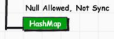
- The java HashMap class does not guarantee that the order will remain constant over time.
- This implementation provides constant-time performance for the basic operations (get and put), assuming the hash function disperses the elements properly among the buckets.
- The HashMap implementation is not synchronized. If multiple threads access this map concurrently, and at least one of the threads modifies the map structurally, it must be synchronized externally.
To prevent unsynchronized access to the Map: Map m = Collections.synchronizedMap(new HashMap(…));

java.util
Class HashMap<K,V>
java.lang.Object
java.util.AbstractMap<K,V>
java.util.HashMap<K,V>
Nested Class Summary

Nested classes/interfaces inherited from class java.util.AbstractMap
AbstractMap.SimpleEntry<K,V>, AbstractMap.SimpleImmutableEntry<K,V>

Constructor Summary
HashMap()
Constructs an empty HashMap with the default initial capacity (16) and the default load factor (0.75).
HashMap(int initialCapacity)
Constructs an empty HashMap with the specified initial capacity and the default load factor (0.75).
HashMap(int initialCapacity, float loadFactor)
Constructs an empty HashMap with the specified initial capacity and load factor.
HashMap(Map<? extends K,? extends V> m)
Constructs a new HashMap with the same mappings as the specified Map.
retain
Method Summary
void | clear()  Removes all of the mappings from this map.
Object | clone()  Returns a shallow copy of this HashMap instance: the keys and values themselves are not cloned.
boolean | containsKey(Object key)  Returns true if this map contains a mapping for the specified key.
boolean | containsValue(Object value)  Returns true if this map maps one or more keys to the specified value.
Set<Map.Entry<K,V>> | entrySet()  Returns a Set view of the mappings contained in this map.
V | get(Object key)  Returns the value to which the specified key is mapped, or null if this map contains no mapping for the key.
boolean | isEmpty()  Returns true if this map contains no key-value mappings.
Set<K> | keySet()  Returns a Set view of the keys contained in this map.
V | put(K key, V value)  Associates the specified value with the specified key in this map.
void | putAll(Map<? extends K,? extends V> m)  Copies all of the mappings from the specified map to this map.
V | remove(Object key)  Removes the mapping for the specified key from this map if present.
int | size()  Returns the number of key-value mappings in this map.
Collection<V> | values()  Returns a Collection view of the values contained in this map.

Methods inherited from class java.util.AbstractMap
equals, hashCode, toString

Methods inherited from class java.lang.Object
finalize, getClass, notify, notifyAll, wait, wait, wait

Methods inherited from interface java.util.Map
equals, hashCode

LinkedHashMap:-
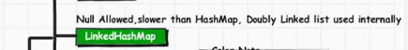
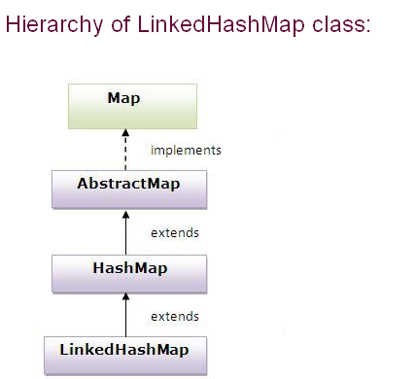
Note:-1)It will not allows null key but allows null values.
2)it wont allows duplicate keys…if we try to giv it takes only first inserted values only
Ex:- LinkedHashMap Lhm = new LinkedHashMap();
Lhm.put(0, "Ankit");
Lhm.put(0, "Ram");
Lhm.put(0, "Arun");
Lhm.put(4, "Anand");
Lhm.put(1, "Gyan");
Out put is :- The Entries of LinkedHashMap are : {0=Arun, 4=Anand, 1=Gyan}
The Class LinkedHashMap is an extension of HashMap with specific feature of retaining the insertion order in the order, in which they were inserted. Also if one inserts the key again into the LinkedHashMap the original orders is retained.
This allows insertion-order iteration over the map. That is, when iterating a LinkedHashMap, the elements will be returned in the order in which they were inserted.
You can also create a LinkedHashMap that returns its elements in the order in which they were last accessed.

java.util
Class LinkedHashMap<K,V>
java.lang.Object
java.util.AbstractMap<K,V>
java.util.HashMap<K,V>
java.util.LinkedHashMap<K,V>
Type Parameters:
K - the type of keys maintained by this map
V - the type of mapped values
All Implemented Interfaces:
Serializable, Cloneable, Map<K,V>
Nested Class Summary

Nested classes/interfaces inherited from class java.util.AbstractMap
AbstractMap.SimpleEntry<K,V>, AbstractMap.SimpleImmutableEntry<K,V>

Constructor Summary
LinkedHashMap()
Constructs an empty insertion-ordered LinkedHashMap instance with the default initial capacity (16) and load factor (0.75).
LinkedHashMap(int initialCapacity)
Constructs an empty insertion-ordered LinkedHashMap instance with the specified initial capacity and a default load factor (0.75).
LinkedHashMap(int initialCapacity, float loadFactor)
Constructs an empty insertion-ordered LinkedHashMap instance with the specified initial capacity and load factor.
LinkedHashMap(int initialCapacity, float loadFactor, boolean accessOrder)
Constructs an empty LinkedHashMap instance with the specified initial capacity, load factor and ordering mode.
LinkedHashMap(Map<? extends K,? extends V> m)
Constructs an insertion-ordered LinkedHashMap instance with the same mappings as the specified map.

Method Summary
void | clear()  Removes all of the mappings from this map.
boolean | containsValue(Object value)  Returns true if this map maps one or more keys to the specified value.
V | get(Object key)  Returns the value to which the specified key is mapped, or null if this map contains no mapping for the key.
protected boolean | removeEldestEntry(Map.Entry<K,V> eldest)  Returns true if this map should remove its eldest entry.

Methods inherited from class java.util.HashMap
clone, containsKey, entrySet, isEmpty, keySet, put, putAll, remove, size, values

Methods inherited from class java.util.AbstractMap
equals, hashCode, toString

Methods inherited from class java.lang.Object
finalize, getClass, notify, notifyAll, wait, wait, wait

Methods inherited from interface java.util.Map
containsKey, entrySet, equals, hashCode, isEmpty, keySet, put, putAll, remove, size, values

HashTable:-
The Hashtable class implements a hash table, which maps keys to values. You can store any non-null object as a key or as a value.
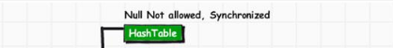
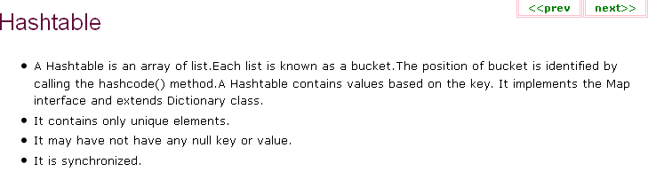
→To successfully store and retrieve objects from a hash table, the objects used as keys must implement the hashCode() method and the equals() method.
→HashTable is synchronized.
→Iterator in the HashMap is fail-safe while the enumerator for the Hashtable isn’t.
→Hashtable doesn’t allow nulls

java.util
Class Hashtable<K,V>
java.lang.Object
java.util.Dictionary<K,V>
java.util.Hashtable<K,V>
All Implemented Interfaces:
Serializable, Cloneable, Map<K,V>
Direct Known Subclasses:
Properties, UIDefaults
Constructor Summary
Hashtable()
Constructs a new, empty hashtable with a default initial capacity (11) and load factor (0.75).
Hashtable(int initialCapacity)
Constructs a new, empty hashtable with the specified initial capacity and default load factor (0.75).
Hashtable(int initialCapacity, float loadFactor)
Constructs a new, empty hashtable with the specified initial capacity and the specified load factor.
Hashtable(Map<? extends K,? extends V> t)
Constructs a new hashtable with the same mappings as the given Map.

Method Summary
void | clear()  Clears this hashtable so that it contains no keys.
Object | clone()  Creates a shallow copy of this hashtable.
boolean | contains(Object value)  Tests if some key maps into the specified value in this hashtable.
boolean | containsKey(Object key)  Tests if the specified object is a key in this hashtable.
boolean | containsValue(Object value)  Returns true if this hashtable maps one or more keys to this value.
Enumeration<V> | elements()  Returns an enumeration of the values in this hashtable.
Set<Map.Entry<K,V>> | entrySet()  Returns a Set view of the mappings contained in this map.
boolean | equals(Object o)  Compares the specified Object with this Map for equality, as per the definition in the Map interface.
V | get(Object key)  Returns the value to which the specified key is mapped, or null if this map contains no mapping for the key.
int | hashCode()  Returns the hash code value for this Map as per the definition in the Map interface.
boolean | isEmpty()  Tests if this hashtable maps no keys to values.
Enumeration<K> | keys()  Returns an enumeration of the keys in this hashtable.
Set<K> | keySet()  Returns a Set view of the keys contained in this map.
V | put(K key, V value)  Maps the specified key to the specified value in this hashtable.
void | putAll(Map<? extends K,? extends V> t)  Copies all of the mappings from the specified map to this hashtable.
protected void | rehash()  Increases the capacity of and internally reorganizes this hashtable, in order to accommodate and access its entries more efficiently.
V | remove(Object key)  Removes the key (and its corresponding value) from this hashtable.
int | size()  Returns the number of keys in this hashtable.
String | toString()  Returns a string representation of this Hashtable object in the form of a set of entries, enclosed in braces and separated by the ASCII characters ", " (comma and space).
Collection<V> | values()  Returns a Collection view of the values contained in this map.

Methods inherited from class java.lang.Object
finalize, getClass, notify, notifyAll, wait, wait, wait

Java.util. Dictionary:-

java.util
Class Dictionary<K,V>
java.lang.Object
java.util.Dictionary<K,V>
Direct Known Subclasses:
Hashtable
Constructor Summary
Dictionary()
Sole constructor.

Method Summary
abstract Enumeration<V> | elements()  Returns an enumeration of the values in this dictionary.
abstract V | get(Object key)  Returns the value to which the key is mapped in this dictionary.
abstract boolean | isEmpty()  Tests if this dictionary maps no keys to value.
abstract Enumeration<K> | keys()  Returns an enumeration of the keys in this dictionary.
abstract V | put(K key, V value)  Maps the specified key to the specified value in this dictionary.
abstract V | remove(Object key)  Removes the key (and its corresponding value) from this dictionary.
abstract int | size()  Returns the number of entries (distinct keys) in this dictionary.

Methods inherited from class java.lang.Object
clone, equals, finalize, getClass, hashCode, notify, notifyAll, toString, wait, wait, wait

What are the differences between HashMap and Hashtable?
Posted about 723 days ago | 4 comments
Lets see what are the differences we can see in HashMap and Hashtable.
1. Synchronization :
Hashtables are synchronized , it means at one point of time only one thread can modify a Hashtable. i.e any thread before performing an update on a hashtable will be acquiring a lock on the object while others will wait for lock to be released.
Hashmap is not synchronized , but we can make it synchronized.
2. Fail-safe:
Iterator of HashMap is fail-safe but the enumerator for the Hashtable is not fail-safe. Lets see what exactly fail-safe is. If an iterator has been created on a collection object and some other thread tries to modify this object , a concurrent modification exception will be thrown. So fail safe is like ability of system to fail but it wont produce some catastrophic results.
3. null values
Hashtable doesn’t allow null but Hashmap allows null values.

Java - The Properties Class

Properties is a subclass of Hashtable. It is used to maintain lists of values in which the key is a String and the value is also a String.
The Properties class is used by many other Java classes. For example, it is the type of object returned by System.getProperties( ) when obtaining environmental values.
Properties defines the following instance variable. This variable holds a default property list associated with a Properties object.
java.util

Class Properties
- java.lang.Object

  - java.util.Dictionary<K,V>

    - java.util.Hashtable<Object,Object>

      - java.util.Properties
- All Implemented Interfaces:
Serializable, Cloneable, Map<Object,Object>
Direct Known Subclasses:
Provider
- native2ascii tool for Solaris, native2ascii tool for Windows, Serialized Form

Field Summary
Fields
Modifier and Type | Field and Description
protected Properties | defaults  A property list that contains default values for any keys not found in this property list.

Constructor Summary
Constructors
Constructor and Description
Properties()
Creates an empty property list with no default values.
Properties(Properties defaults)
Creates an empty property list with the specified defaults.

Method Summary
Methods
Modifier and Type | Method and Description
String | getProperty(String key)  Searches for the property with the specified key in this property list.
String | getProperty(String key, String defaultValue)  Searches for the property with the specified key in this property list.
void | list(PrintStream out)  Prints this property list out to the specified output stream.
void | list(PrintWriter out)  Prints this property list out to the specified output stream.
void | load(InputStream inStream)  Reads a property list (key and element pairs) from the input byte stream.
void | load(Reader reader)  Reads a property list (key and element pairs) from the input character stream in a simple line-oriented format.
void | loadFromXML(InputStream in)  Loads all of the properties represented by the XML document on the specified input stream into this properties table.
Enumeration<?> | propertyNames()  Returns an enumeration of all the keys in this property list, including distinct keys in the default property list if a key of the same name has not already been found from the main properties list.
void | save(OutputStream out, String comments)  Deprecated.  This method does not throw an IOException if an I/O error occurs while saving the property list. The preferred way to save a properties list is via the store(OutputStream out, String comments) method or the storeToXML(OutputStream os, String comment) method.
Object | setProperty(String key, String value)  Calls the Hashtable method put.
void | store(OutputStream out, String comments)  Writes this property list (key and element pairs) in this Properties table to the output stream in a format suitable for loading into a Properties table using the load(InputStream) method.
void | store(Writer writer, String comments)  Writes this property list (key and element pairs) in this Properties table to the output character stream in a format suitable for using the load(Reader) method.
void | storeToXML(OutputStream os, String comment)  Emits an XML document representing all of the properties contained in this table.
void | storeToXML(OutputStream os, String comment, String encoding)  Emits an XML document representing all of the properties contained in this table, using the specified encoding.
Set<String> | stringPropertyNames()  Returns a set of keys in this property list where the key and its corresponding value are strings, including distinct keys in the default property list if a key of the same name has not already been found from the main properties list.

Methods inherited from class java.util.Hashtable
clear, clone, contains, containsKey, containsValue, elements, entrySet, equals, get, hashCode, isEmpty, keys, keySet, put, putAll, rehash, remove, size, toString, values

Java.util.TreeMap:-
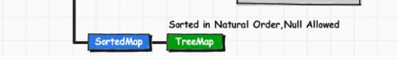
The TreeMap class implements the SortedMap interface by using a tree. A TreeMap provides an efficient means of storing key/value pairs in sorted order, and allows rapid retrieval.
The TreeMap class guarantees that the map will be in ascending key order, sorted according to the natural order for the key's class, or by the comparator provided at creation time, depending on which constructor is used.
The following constructors are defined in TreeMap class.
?
1  2  3  4 | TreeMap( )  TreeMap(Comparator comp)  TreeMap(Map m)  TreeMap(SortedMap sm)
The first constructs an empty tree map that will be sorted by using the natural order of its keys. The second constructs an empty tree-based map that will be sorted by using the Comparator comp. The third form initializes a tree map with the entries from m, which will be sorted by using the natural order of the keys. The fourth form initializes a tree map with the entries from SortedMap, which will be sorted in the same order as SortedMap.
The TreeMap is not synchronized, so if you have resource tree map that can be manipulate by more than one thread use the Collections utility class to get synchronized map using below code.
?
1 | Map m = Collections.synchronizedMap(new TreeMap(...));

java.util
Class TreeMap<K,V>
java.lang.Object
java.util.AbstractMap<K,V>
java.util.TreeMap<K,V>
Type Parameters:
K - the type of keys maintained by this map
V - the type of mapped values
All Implemented Interfaces:
Serializable, Cloneable, Map<K,V>, NavigableMap<K,V>, SortedMap<K,V>
Nested Class Summary

Nested classes/interfaces inherited from class java.util.AbstractMap
AbstractMap.SimpleEntry<K,V>, AbstractMap.SimpleImmutableEntry<K,V>

Constructor Summary
TreeMap()
Constructs a new, empty tree map, using the natural ordering of its keys.
TreeMap(Comparator<? super K> comparator)
Constructs a new, empty tree map, ordered according to the given comparator.
TreeMap(Map<? extends K,? extends V> m)
Constructs a new tree map containing the same mappings as the given map, ordered according to the natural ordering of its keys.
TreeMap(SortedMap<K,? extends V> m)
Constructs a new tree map containing the same mappings and using the same ordering as the specified sorted map.

Method Summary
Map.Entry<K,V> | ceilingEntry(K key)  Returns a key-value mapping associated with the least key greater than or equal to the given key, or null if there is no such key.
K | ceilingKey(K key)  Returns the least key greater than or equal to the given key, or null if there is no such key.
void | clear()  Removes all of the mappings from this map.
Object | clone()  Returns a shallow copy of this TreeMap instance.
Comparator<? super K> | comparator()  Returns the comparator used to order the keys in this map, or null if this map uses the natural ordering of its keys.
boolean | containsKey(Object key)  Returns true if this map contains a mapping for the specified key.
boolean | containsValue(Object value)  Returns true if this map maps one or more keys to the specified value.
NavigableSet<K> | descendingKeySet()  Returns a reverse order NavigableSet view of the keys contained in this map.
NavigableMap<K,V> | descendingMap()  Returns a reverse order view of the mappings contained in this map.
Set<Map.Entry<K,V>> | entrySet()  Returns a Set view of the mappings contained in this map.
Map.Entry<K,V> | firstEntry()  Returns a key-value mapping associated with the least key in this map, or null if the map is empty.
K | firstKey()  Returns the first (lowest) key currently in this map.
Map.Entry<K,V> | floorEntry(K key)  Returns a key-value mapping associated with the greatest key less than or equal to the given key, or null if there is no such key.
K | floorKey(K key)  Returns the greatest key less than or equal to the given key, or null if there is no such key.
V | get(Object key)  Returns the value to which the specified key is mapped, or null if this map contains no mapping for the key.
SortedMap<K,V> | headMap(K toKey)  Returns a view of the portion of this map whose keys are strictly less than toKey.
NavigableMap<K,V> | headMap(K toKey, boolean inclusive)  Returns a view of the portion of this map whose keys are less than (or equal to, if inclusive is true) toKey.
Map.Entry<K,V> | higherEntry(K key)  Returns a key-value mapping associated with the least key strictly greater than the given key, or null if there is no such key.
K | higherKey(K key)  Returns the least key strictly greater than the given key, or null if there is no such key.
Set<K> | keySet()  Returns a Set view of the keys contained in this map.
Map.Entry<K,V> | lastEntry()  Returns a key-value mapping associated with the greatest key in this map, or null if the map is empty.
K | lastKey()  Returns the last (highest) key currently in this map.
Map.Entry<K,V> | lowerEntry(K key)  Returns a key-value mapping associated with the greatest key strictly less than the given key, or null if there is no such key.
K | lowerKey(K key)  Returns the greatest key strictly less than the given key, or null if there is no such key.
NavigableSet<K> | navigableKeySet()  Returns a NavigableSet view of the keys contained in this map.
Map.Entry<K,V> | pollFirstEntry()  Removes and returns a key-value mapping associated with the least key in this map, or null if the map is empty.
Map.Entry<K,V> | pollLastEntry()  Removes and returns a key-value mapping associated with the greatest key in this map, or null if the map is empty.
V | put(K key, V value)  Associates the specified value with the specified key in this map.
void | putAll(Map<? extends K,? extends V> map)  Copies all of the mappings from the specified map to this map.
V | remove(Object key)  Removes the mapping for this key from this TreeMap if present.
int | size()  Returns the number of key-value mappings in this map.
NavigableMap<K,V> | subMap(K fromKey, boolean fromInclusive, K toKey, boolean toInclusive)  Returns a view of the portion of this map whose keys range from fromKey to toKey.
SortedMap<K,V> | subMap(K fromKey, K toKey)  Returns a view of the portion of this map whose keys range from fromKey, inclusive, to toKey, exclusive.
SortedMap<K,V> | tailMap(K fromKey)  Returns a view of the portion of this map whose keys are greater than or equal to fromKey.
NavigableMap<K,V> | tailMap(K fromKey, boolean inclusive)  Returns a view of the portion of this map whose keys are greater than (or equal to, if inclusive is true) fromKey.
Collection<V> | values()  Returns a Collection view of the values contained in this map.

Methods inherited from class java.util.AbstractMap
equals, hashCode, isEmpty, toString

Methods inherited from class java.lang.Object
finalize, getClass, notify, notifyAll, wait, wait, wait

Methods inherited from interface java.util.Map
equals, hashCode, isEmpty

JAVA—Iterators:-
→Which are objects that allow going over all the elements of a collection in sequence?
The collection-Iterators :-
  - Iterator
  - ListIterator
  - Enumeration
  - For-each-loop.

Iterator
- Java Iterator is an interface in the collection framework
- It traverses through all the elements of the collection.
- It works like enumeration.
- It has methods hasNext() and next().
- List, Set interface has iterator() methods .
- Iterator defines three methods, one of which is optional.

java.util Interface Iterator<E>
All Known Subinterfaces:
ListIterator<E>, XMLEventReader
All Known Implementing Classes:
BeanContextSupport.BCSIterator, EventReaderDelegate, Scanner
public interface Iterator<E>
Since:
1.2

An iterator over a collection. Iterator takes the place of Enumeration in the Java collections framework. Iterators differ from enumerations in two ways:
- Iterators allow the caller to remove elements from the underlying collection during the iteration with well-defined semantics.
- Method names have been improved.

Result | Method | Description
b = | it.hasNext() | true if there are more elements for the iterator.
obj = | it.next() | Returns the next object. If a generic list is being accessed, the iterator will return something of the list's type. Pre-generic Java iterators always returned type Object, so a downcast was usually required.
 | it.remove() | Removes the most recent element that was returned by next. Not all collections support delete. An UnsupportedOperationException will be thrown if the collection does not support remove().

Important point about Iterator in Java:
1) Iterator in Java support generics so always use Generic version of Iterator rather than using Iterator with raw type.

2) If you want to remove objects from Collection than don't use for-each loop instead use Iterator's remove() method to avoid any ConcurrentModificationException.

3) Iterating over collection using Iterator is subject to ConcurrentModificationException if Collection is modified after Iteration started, but this only happens in case of fail-fast Iterators.

4) There are two types of Iterators in Java, fail-fast and fail-safe, check difference between fail-safe and fail-fast Iterator for more details.

5) List collection type also supports ListIterator which has add() method to add elements in collection while Iterating. There are some more differences between Iterator and ListIterator like bidirectional traversing, which we have discussed above. Also why ListIterator has add() method is a popular Java Collection Interview question.
Read more: http://javarevisited.blogspot.com/2011/10/java-iterator-tutorial-example-list.html#ixzz29S1m09Sl

What is List Iterator in Java?
ListIterator in Java is an Iterator which allows user to traverse Collection like ArrayList and HashSet in both direction by using method previous() and next (). You can obtain ListIterator from all List implementation including ArrayList and LinkedList. ListIterator doesn’t keep current index and its current position is determined by call to next() or previous() based on direction of traversing

ListIterator is implemented only by the classes that implement the List interface (ArrayList, LinkedList, and Vector). ListIterator provides the following.
Result | Method | Description
Forward iteration
b = | it.hasNext() | true if there is a next element in the collection.
obj = | it.next() | Returns the next object.
Backward iteration
b = | it.hasPrevious() | true if there is a previous element.
obj = | it.previous() | Returns the previous element.
Getting the index of an element
i = | it.nextIndex() | Returns index of element that would be returned by subsequent call to next().
i = | it.previousIndex() | Returns index of element that would be returned by subsequent call to previous().
Optional modification methods. UnsupportedOperationException thrown if unsupported.
 | it.add(obj) | Inserts obj in collection before the next element to be returned by next() and after an element that would be returned by previous().
 | it.set() | Replaces the most recent element that was returned by next or previous().
 | it.remove() | Removes the most recent element that was returned by next() or previous().

ENUMERTATION:-

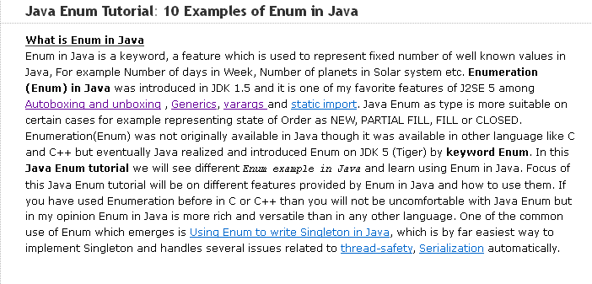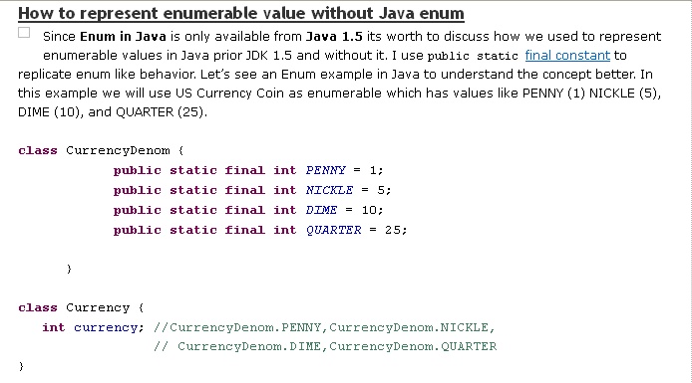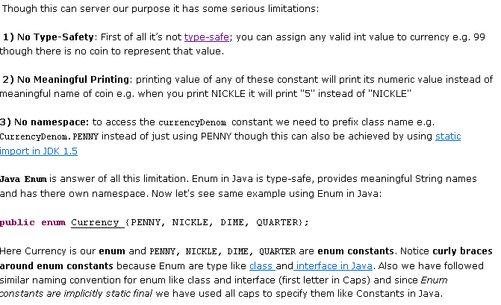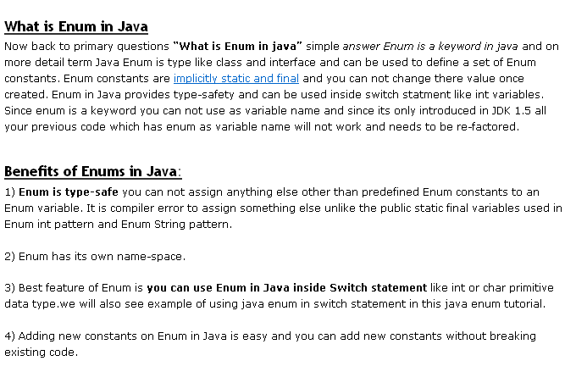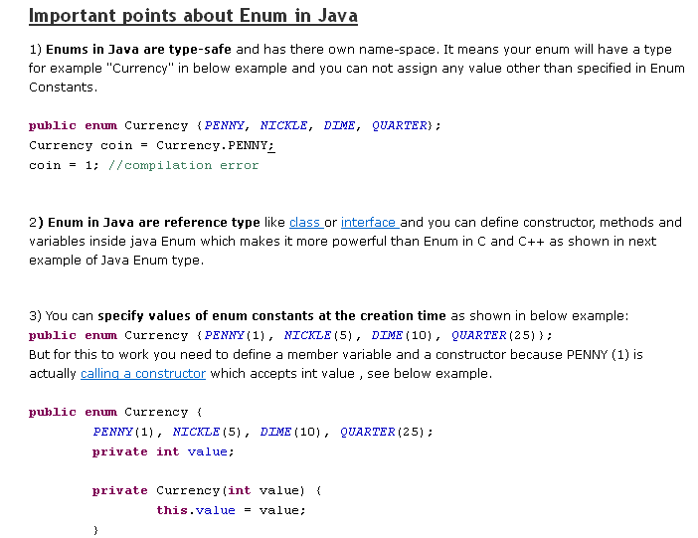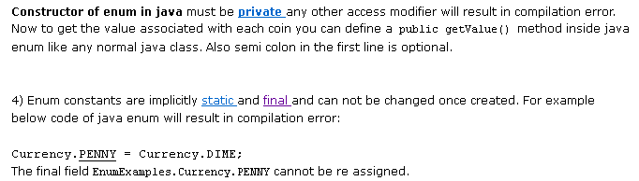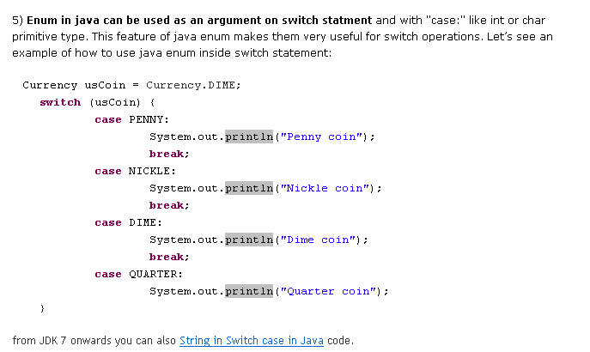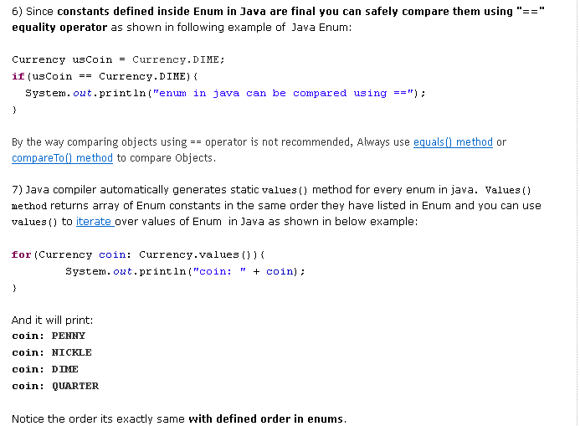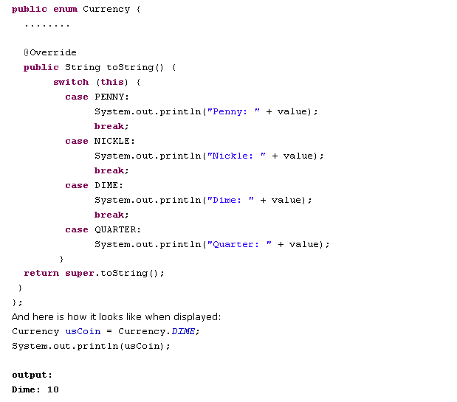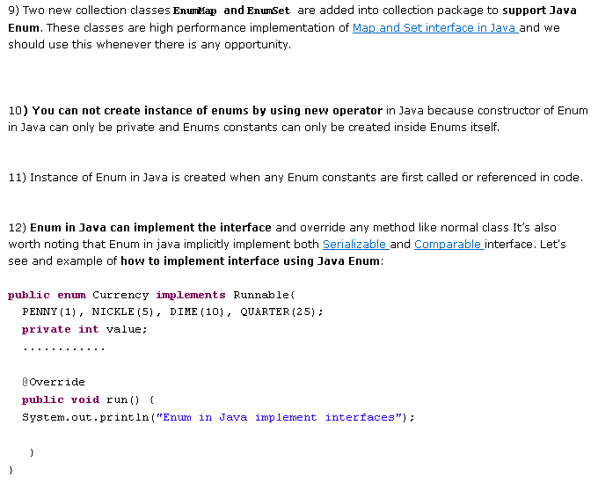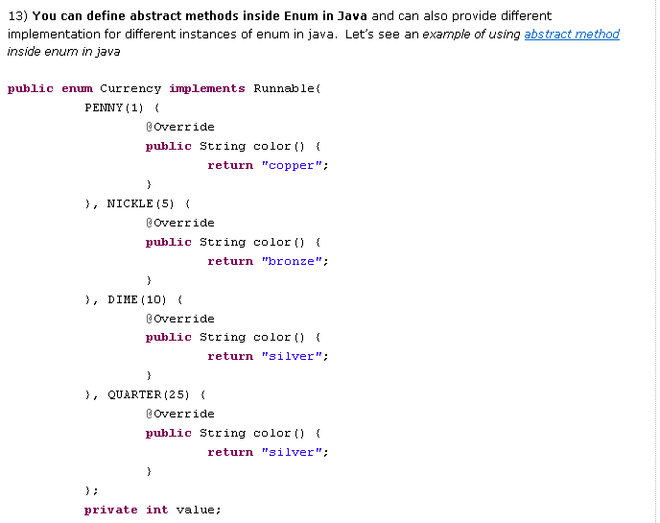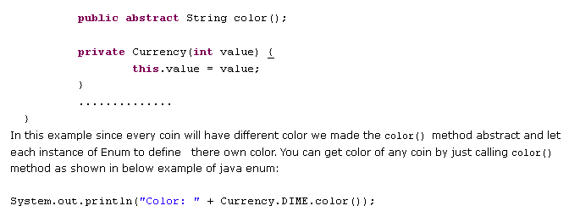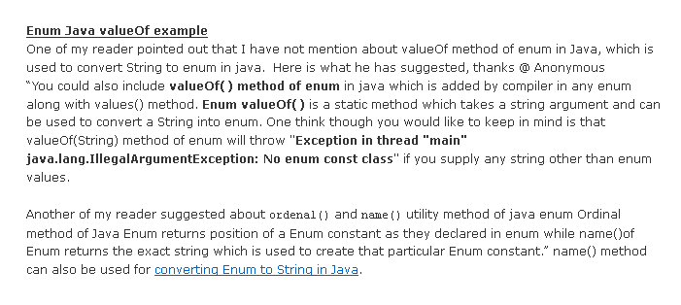java.util
Interface Enumeration<E>
All Known Subinterfaces:
NamingEnumeration<T>
All Known Implementing Classes:
StringTokenizer
public interface Enumeration<E>
Method Summary
boolean | hasMoreElements()  Tests if this enumeration contains more elements.
E | nextElement()  Returns the next element of this enumeration if this enumeration object has at least one more element to provide.

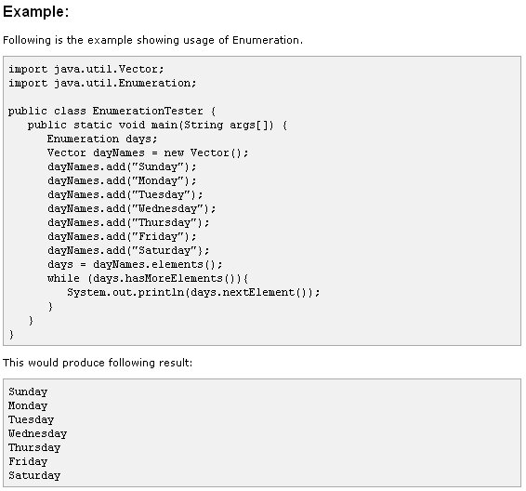
For-each-loop:-
→Java 1.5 provides many new features including a new way of iterating over a collection of elements. This new feature is known as for-each loop that can be considered as enhanced for loop.
→This new syntactical construct has been designed to simplify iteration over a collection of elements.
→For-each construct is used with generics elegantly that takes care of type safety also.
The syntax of for-each loop is shown here:
for(type vaiable : collection){ Statements; }
and
for (type vaiable: array) { Statements; }
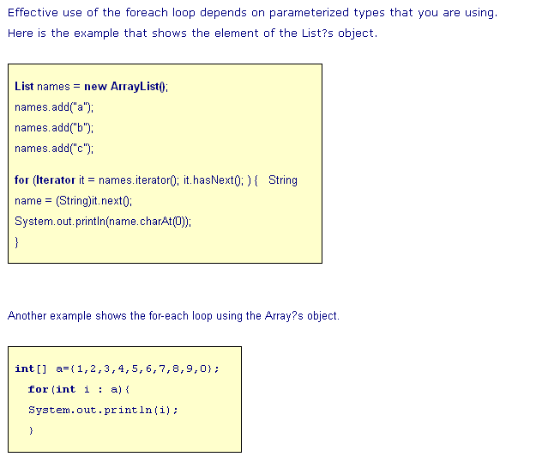

2) Enhanced For loop
We will cover the usage of Enhanced for-loop in this section. This is also referred to as for-each loop. The following code shows how to iterate over the elements in a Collection using the traditional Iterator interface.
ForEachTest.java
1  2  3  4  5  6  7  8  9  10  11  12  13  14  15  16  17  18 | package foreach;  import java.util.*;  public class ForEachTest  {  public static void main(String[] args)  {  List<Integer> numbers = new ArrayList<Integer>();  numbers.add(1);numbers.add(2);numbers.add(3);  Iterator<Integer> numbersIterator = null;  for(numbersIterator = numbers.iterator(); numbersIterator.hasNext();)  {  System.out.println(numbersIterator.next());;  }  }  }
Though the goal of the above program is traversing over the elements in the list collection, we are depending on the Iterator API to achieve this. A replacement to the Iterator is the usage of Enhanced for-loop, through which it is possible to have a short and a neat code like this,
1  2  3  4 | for(Integer number : numbers)  {  System.out.println(number);  }
Let us see how the above syntax is used to traverse over the collection. The expression before the symbol ':' is a declaration statement which declares an Integer object called number for holding the individual element from the collection. The expression that follows after the symbol must be a Collection type whose elements can be iterated. Precisely, this type must implement an interface called java.util.Iterable which has a single method called iterator(). During compile-time, the compiler translates the above code which looks very similar to the following,
1  2  3  4  5  6 | Iterator<Integer> intIterator = numbers.iterator();  for(;intIterator.hasNext();)  {  System.out.println(intIterator.next());  }
Even it is possible to apply this new syntax for type Arrays. So, the following code is perfectly legal and it compiles fine.
1  2  3  4  5  6 | int [] numbers = {10, 20, 30, 40, 50};  for(int num : numbers)  {  System.out.println(num);  }
The enhanced for-loop is just a convenience from the programmer’s point of view for iterating over the Collection. But the usage of this loop has some dis-advantages. The first one out of the two is that step-value cannot be incremented. For example, it is not possible to traverse the first element and then the thirth element and so on. And the second dis-advantage is that backward traversal is not possible.

java.util
Class ConcurrentModificationException

→This situation can come in case of multithreaded as well as single threaded environment.

→This exception may be thrown by methods that have detected concurrent modification of an object when such modification is not permissible.

→Java Collection classes are fail-fast which means that if the Collection will be changed while some thread is traversing over it using iterator, the iterator.next() will throw
Lets see the scenario with an example:
1  2  3  4  5  6  7  8  9  10  11  12  13  14  15  16  17  18  19  20  21  22  23  24  25  26  27  28  29  30  31  32  33  34  35  36  37 | import java.util.*;  public class IteratorExample {  public static void main(String args[]){  List<String> myList = new ArrayList<String>();  myList.add("1");  myList.add("2");  myList.add("3");  myList.add("4");  myList.add("5");  Iterator<String> it = myList.iterator();  while(it.hasNext()){  String value = it.next();  System.out.println("List Value:"+value);  if(value.equals("3")) myList.remove(value);  }  Map<String,String> myMap = new HashMap<String,String>();  myMap.put("1", "1");  myMap.put("2", "2");  myMap.put("3", "3");  Iterator<String> it1 = myMap.keySet().iterator();  while(it1.hasNext()){  String key = it1.next();  System.out.println("Map Value:"+myMap.get(key));  if(key.equals("2")){  myMap.put("1","4");  //myMap.put("4", "4");  }  }  }  }
Output is:
1  2  3  4  5  6  7 | List Value:1  List Value:2  List Value:3  Exception in thread "main" java.util.ConcurrentModificationException  at java.util.AbstractList$Itr.checkForComodification(AbstractList.java:372)  at java.util.AbstractList$Itr.next(AbstractList.java:343)  at com.journaldev.java.IteratorExample.main(IteratorExample.java:27)
From the output stack trace, its clear that the exception is coming when we call iterator next() function. If you are wondering how Iterator checks for the modification, its implementation is present in AbstractList class where an int variable modCount is defined that provides the number of times list size has been changed. This value is used in every next() call to check for any modifications in a function checkForComodification().
Now comment the list part and run the program again.
Output will be:
1  2  3 | Map Value:3  Map Value:2  Map Value:4
Since we are updating the existing key value in the myMap, its size has not been changed and we are not getting ConcurrentModificationException. Note that the output may differ in your system because HashMap keyset is not ordered like list. If you will uncomment the statement where I am adding a new key-value in the HashMap, it will cause ConcurrentModificationException.

To Avoid ConcurrentModificationException in multi-threaded environment:
1. You can convert the list to an array and then iterate on the array. This approach works well for small or medium size list but if the list is large then it will affect the performance a lot.
2. You can lock the list while iterating by putting it in a synchronized block. This approach is not recommended because it will cease the benefits of multithreading.
3. If you are using JDK1.5 or higher then you can use ConcurrentHashMap and CopyOnWriteArrayList classes. It is the recommended approach.

To Avoid ConcurrentModificationException in single-threaded environment:
You can use the iterator remove() function to remove the object from underlying collection object. But in this case you can remove the same object and not any other object from the list.
Let us run an example using Concurrent Collection classes:
1  2  3  4  5  6  7  8  9  10  11  12  13  14  15  16  17  18  19  20  21  22  23  24  25  26  27  28  29  30  31  32  33  34  35  36  37  38  39  40  41  42  43  44  45  46  47  48  49  50  51  52 | package com.journaldev.java;  import java.util.Iterator;  import java.util.List;  import java.util.Map;  import java.util.concurrent.ConcurrentHashMap;  import java.util.concurrent.CopyOnWriteArrayList;  public class ThreadSafeIteratorExample {  public static void main(String[] args) {  List<String> myList = new CopyOnWriteArrayList<String>();  myList.add("1");  myList.add("2");  myList.add("3");  myList.add("4");  myList.add("5");  Iterator<String> it = myList.iterator();  while(it.hasNext()){  String value = it.next();  System.out.println("List Value:"+value);  if(value.equals("3")){  myList.remove("4");  myList.add("6");  myList.add("7");  }  }  System.out.println("List Size:"+myList.size());  Map<String,String> myMap = new ConcurrentHashMap<String,String>();  myMap.put("1", "1");  myMap.put("2", "2");  myMap.put("3", "3");  Iterator<String> it1 = myMap.keySet().iterator();  while(it1.hasNext()){  String key = it1.next();  System.out.println("Map Value:"+myMap.get(key));  if(key.equals("1")){  myMap.remove("3");  myMap.put("4", "4");  myMap.put("5", "5");  }  }  System.out.println("Map Size:"+myMap.size());  }  }
Output is:
1  2  3  4  5  6  7  8  9  10  11 | List Value:1  List Value:2  List Value:3  List Value:4  List Value:5  List Size:6  Map Value:1  Map Value:null  Map Value:4  Map Value:2  Map Size:4
From the above example its clear that:
1. concurrent Collection classes can be modified avoiding ConcurrentModificationException
2. In case of CopyOnWriteArrayList, iterator doesn’t accomodate the changes in the list and works on the original list.
3. In case of ConcurrentHashMap, the behavior is not always the same.
For condition:
1  2 | if(key.equals("1")){  myMap.remove("3");
Output is:
1  2  3  4  5 | Map Value:1  Map Value:null  Map Value:4  Map Value:2  Map Size:4
It is taking the new object added with key “4″ but not the next added object with key “5″.
Now if I change the condition to
1  2 | if(key.equals("3")){  myMap.remove("2");
Output is:
1  2  3  4 | Map Value:1  Map Value:3  Map Value:null  Map Size:4
In this case its not considering the new added objects.
So if you are using ConcurrentHashMap then avoid adding new objects as it can be processed depending on the keyset. Note that the same program can print different values in your system because HashMap keyset is not in any order.
Extra Toppings:
If you are working on single-threaded environment and want your code to take care of the extra added objects in the list then you can do so using following code and avoiding iterator.
1  2  3  4  5  6  7  8 | for(int i = 0; i<myList.size(); i++){  System.out.println(myList.get(i));  if(myList.get(i).equals("3")){  myList.remove(i);  i--;  myList.add("6");  }  }

java.util
Class StringTokenizer
java.lang.Object
java.util.StringTokenizer
All Implemented Interfaces:
Enumeration<Object>
Constructor Summary
StringTokenizer(String str)
Constructs a string tokenizer for the specified string.
StringTokenizer(String str, String delim)
Constructs a string tokenizer for the specified string.
StringTokenizer(String str, String delim, boolean returnDelims)
Constructs a string tokenizer for the specified string.

Method Summary
int | countTokens()  Calculates the number of times that this tokenizer's nextToken method can be called before it generates an exception.
boolean | hasMoreElements()  Returns the same value as the hasMoreTokens method.
boolean | hasMoreTokens()  Tests if there are more tokens available from this tokenizer's string.
Object | nextElement()  Returns the same value as the nextToken method, except that its declared return value is Object rather than String.
String | nextToken()  Returns the next token from this string tokenizer.
String | nextToken(String delim)  Returns the next token in this string tokenizer's string.

Methods inherited from class java.lang.Object
clone, equals, finalize, getClass, hashCode, notify, notifyAll, toString, wait, wait, wait

Collections and Maps in Java

C. Petitpierre, 6 August 2002

Sun documentation
This brief survey of the collections and the maps offered by Java, has been made to provide a synthetic view of these elements. It should allow you to select the classes that implement the services you look for, by compare the available objects and their operations in synoptic tables. All the statements presented here have not been tested, and there may well be errors that occur at compile or run time. I would appreciate if you communicate them to me.
Note 1: This presentation is not complete, the official documentation must be referred to for the details and the complete set of operations
Note 2: Ealier versions of Java contained collections in the form of array (int x[]), Dictionary (obsolete, superseded by Map), Hashtable (extends Dictionary) and Vector (superseded by List, which has shorter method names).
Note 3: All the former and the new classes are defined in java.util.*;
- Interfaces
All availables interfaces.
- Corresponding Implementations
The various implementations that match the interfaces.
- Main Characteristics of the Collections and Maps
What are the main differences between the different aggregations ?
- Storing Objects in a Collection or a Map
The main methods that define the operation offered by the aggregations.
- Retrieving and Managing Objects in a Collection or a Map
Storing operations.
- Transformations
How can an aggregation be transformed to another one.
- Walking Through a Collection
Operations that allow a program to scan the stored elements.
- Sorting a Collection or a Map
The sorting possibilities offered by the tree objects.

Interfaces
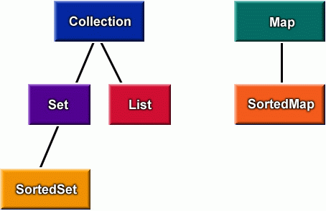
The symbols shown in the figure above define interfaces. They can only be used as attribute definition, not as instantiation class names:
Collection xx = null;
xx = new Collection ( ); // error !
Set yy = null;
SortedSet zz = null;
The figure also provides the directions of the dependencies.
xx = yy;
xx = zz;
yy = xx; // error !

Corresponding Implementations
 |  | Implementations
 |  | Hash Table | Resizable Array | Balanced Tree | Linked List
Interfaces | Collection | HashSet | ArrayList | TreeSet | LinkedList
Interfaces | Set | HashSet |  | TreeSet
Interfaces | SortedSet |  |  | TreeSet
Interfaces | List |  | ArrayList |  | LinkedList
Interfaces | Map | HashMap |  | TreeMap
Interfaces | SortedMap |  |  | TreeMap
The table above defines the implementations that correspond to the interfaces shown in the previous figure. An object defined by an interface must be instantiated by means of a class lying on the same line as the interface :
Collection xx1 = new HashSet ( ); // HashSet on the same line as Collection
Collection xx2 = new ArrayList ( );
SortedSet yy = new TreeSet ( );
Of course each collection can also be instantiated under its proper class:
ArrayList al = new ArrayList ( );

Main Characteristics of the Collections and Maps
All collections are used in a very similar way. What changes is the way in which the elements are stored in the collection:
ordered, with duplicates, with an access based on a key...
Moreover, some accesses may be more efficient in a collection or another one:
an ArrayList is created with an extra capacity, it must not be reallocated each time it grows
a LinkedList and an ArrayList can be used to create a fifo (list.add() / list.remove(0))
a TreeMap and a TreeSet are ordered (and thus need comparators)
a Set and a Map cannot contain duplicates
a Map contains pairs of (key;object). the elements are ordered and can be accessed by the key
the elements of some collections can be addressed by index
the collections can be walked through sequentially (iterator)
to walk through a Map, a collection must first be extracted
(see details below).

Storing Objects in a Collection or a Map
The basic methods to insert objects into a collection are given below:
HashSet, TreeSet | set.add(object); | add somewhere, in the order of the elements
LinkedList | list.add(object);  list.add(index, object); | adds at the end  adds at index and shifts the previous  elements from index towards the end
ArrayList | list.add(object)  list.add(index, object);  list.set(index,object); | adds at the end  adds at index and shifts the previous elements  overwrite the value at index
The basic methods to insert objects into a map are indicated below:
HashMap  TreeMap | map.put(key,value); | both key and value are Objects  in the tree maps, keys are put in order of the keys
Note: the aggregations that store the objects in an ordered manner (TreeSet and TreeMap) must know how to compare the inserted objects (respectively keys). There are two ways to do that:
• have the objects (respectively keys) that are inserted in the tree aggregation implement Comparable
• provide a Comparator in the parameters of the instantiation of the aggregation
An example.

Retrieving and Managing Objects in a Collection or a Map
Some methods are known by all aggregations:
clear( ); size( ); remove (object);
Some of the methods defined in a collection are given below:
LinkedList | obj = c.get(index); | obj = c.remove(index); | bool = c.contains(obj); | objArr = c.toArray( );
ArrayList | obj = c.get(index); | obj = c.remove(index); | bool = c.contains(obj); | objArr = c.toArray( );
HashSet | - | see 1 inch above | bool = c.contains(obj); | objArr = c.toArray( );
TreeSet | - | see 1 inch above | bool = c.contains(obj); | objArr = c.toArray( );
Some of the methods defined in a map are defined below (Object obj, key;) :
HashMap  TreeMap | obj = m.get (key); | obj = m.remove (key); | bool = m.containsKey (key);  bool = m.containsValue( key); | collection = m.values( );  set = m.keySet( );
The operations of the last column return collections of elements. These collections can be used to walk through the trees.

Transformations
Passing from one aggregation type to another one can be used to sort the elements, eliminate the duplicates, create an array, and so on.
A collection of any type can be transformed to another one:
Set set = new HashSet ( );
.... fill in the set ....
SortedSet ss = new TreeSet ( set );
Parameter available for the instantiation:
LinkedList | ( ) | (Collection)
ArrayList | ( ) | (Collection) | (initialCapacity)
HashSet | ( ) | (Collection) | (initialCapacity) | (initialCapacity, loadFactor)
HashMap | ( ) | (Map) | (initialCapacity) | (initialCapacity, loadFactor)
TreeSet | ( ) | (Collection) | (Comparator) | (SortedSet)
TreeMap | ( ) | (Map) | (Comparator) | (SortedMap)
The maps return collections containing only the objects (keys are dropped)
Collection col = tm.values();
which can used as parameter in the instantiation of a collection.
A collection can be transformed into an array with:
Object [] obj = collection.toArray();

Walking Through a Collection
It is possible to walk through the elements of a collection (but not through the elements of a map). Walking through the elements of a collection is done in the following way:
for (Iterator it=coll.iterator(); it.hasNext( ); ) {
Object anObject = it.next( );
System.out.println( anObject );
}
There is no statement in the last position between the parentheses of the for loop. The first time next() is called, it returns the first object.

Sorting a Collection or a Map
The first way for sorting an aggregation is to recreate a new collection or map with an implicit ordering:
TreeSet setA = new TreeSet ( list);
TreeSet setB = new TreeSet ( comparator );
setB.addAll ( list );
TreeMap tm = new TreeMap ( comparator );
tm.putAll (hashMap);
An example.
The class Collections offers static methods to sort collections, as well as various other methods (see SUN's doc):
Collections.sort (list, comparator);

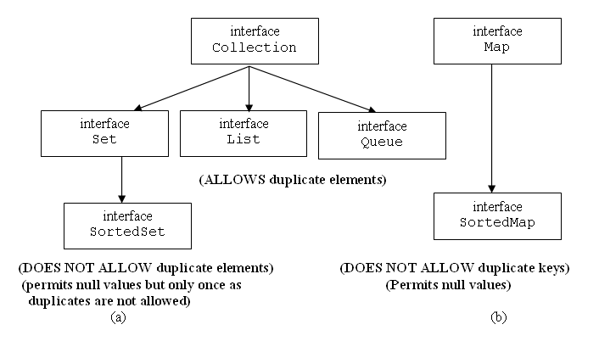
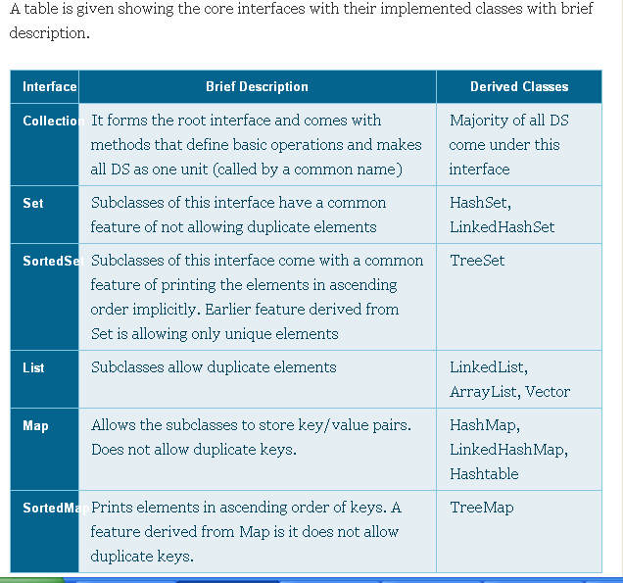
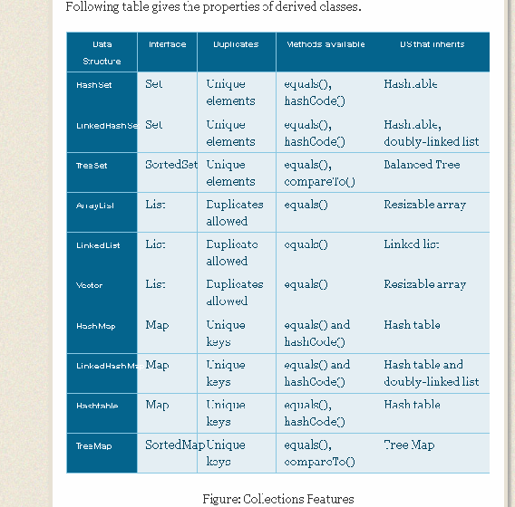

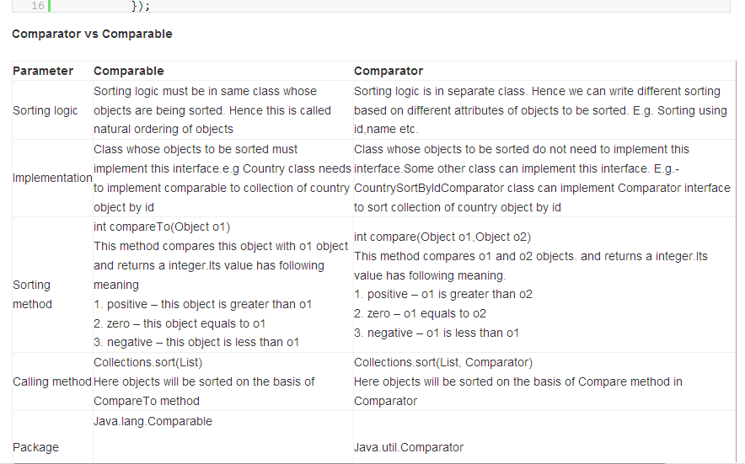

Interview Questions and Answers on Collections Framework.

What is collection framework and in which package it has,what are those
Collections:- Framework This ^{framework} is provided in the java.util package.
Collection:- is a Java Interface.
- A collection represents a group of similar objects, known as its elements.
- Objects can be stored, retrieved, and manipulated as elements of collections
- Collections can be used in various scenarios like Storing phone numbers, Employee names database etc.
A Collections Framework mainly contains the following 3 parts
A Collections Framework is defined by a set of interfaces, concrete class implementations for most of the interfaces and a set of standard utility methods and algorithms. In addition, the framework also provides several abstract implementations, which are designed to make it easier for you to create new and different implementations for handling collections of data.
public interface Collection<E>
extends Iterable<E>

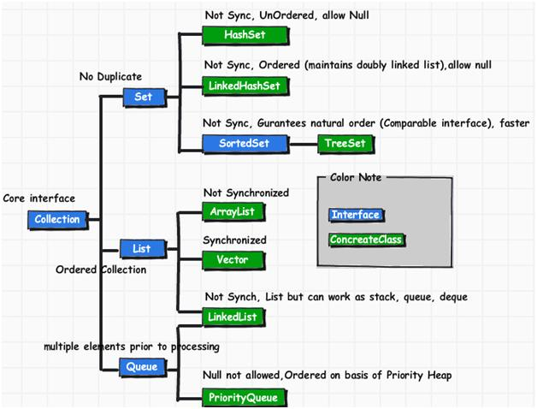
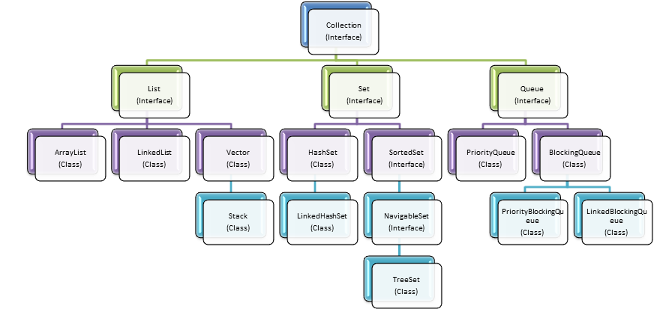
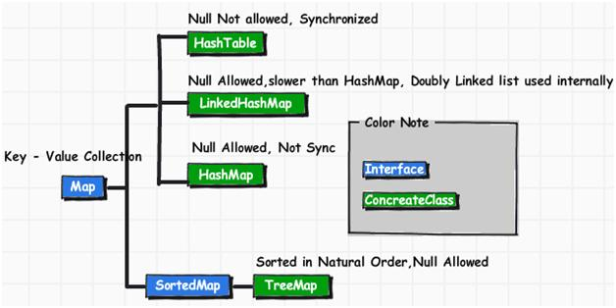

What are Collection related features in Java 8?
- Java Stream API for collection classes for supporting sequential as well as parallel processing
- Iterable interface is extended with forEach() default method that we can use to iterate over a collection. It is very helpful when used with lambda expressions because it’s argument Consumer is a function interface.
- Miscellaneous Collection API improvements such as forEachRemaining(Consumer action) method in Iteratorinterface, Map replaceAll(), compute(), merge() methods.

What is the benefit of Generics in Collections Framework?
Java 1.5 came with Generics and all collection interfaces and implementations use it heavily. Generics allow us to provide the type of Object that a collection can contain, so if you try to add any element of other type it throws compile time error.
This avoids ClassCastException at Runtime because you will get the error at compilation. Also Generics make code clean since we don’t need to use casting and instanceof operator.

4.Why Collection doesn’t extend Cloneable and Serializable interfaces?
Collection is an interface that specifies a group of objects known as elements. The details of how the group of elements is maintained is left up to the concrete implementations of Collection. For example, some Collection implementations like List allow duplicate elements whereas other implementations like Set don't. A lot of the Collection implementations have a public clonemethod. However, it does't really make sense to include it in all implementations of Collection. This is because Collection is an abstract representation. What matters is the implementation. The semantics and the implications of either cloning or serializing come into play when dealing with the actual implementation; that is, the concrete implementation should decide how it should be cloned or serialized, or even if it can be cloned or serialized. In some cases, depending on what the actual backing-implementation is, cloning and serialization may not make much sense. So mandating cloning and serialization in all implementations is actually less flexible and more restrictive. The specific implementation should make the decision as to whether it can be cloned or serialized.
