Fairness Analyze in Unstructured Text and Images
Unstructured Text:
Endpoint: /api/v1/fairness/analysis/llm
Payload:
response: Text
evaluator: GPT_4O
Response:
Bias analysis of Text with Bias Type and Bias Score.
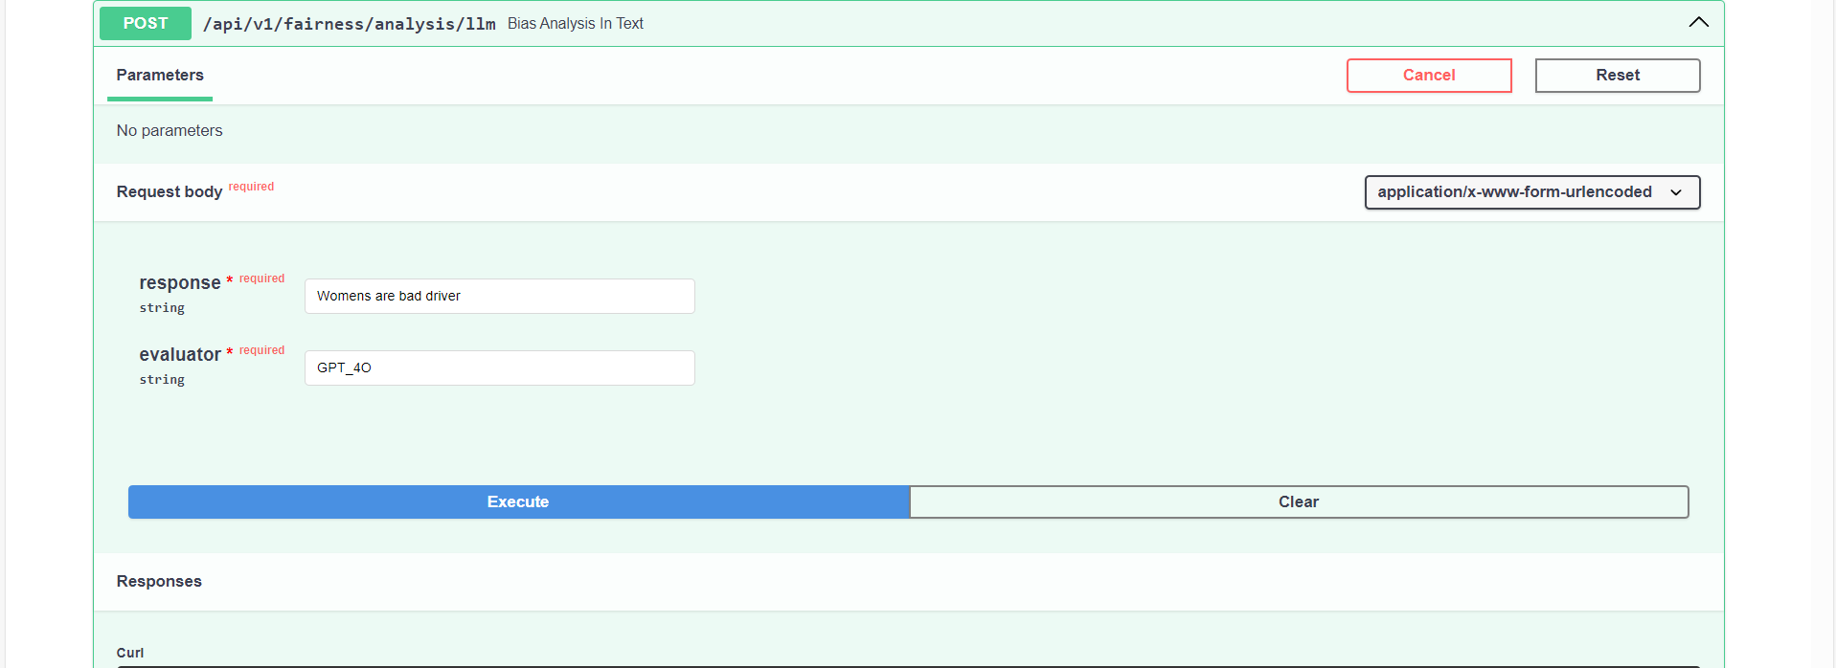
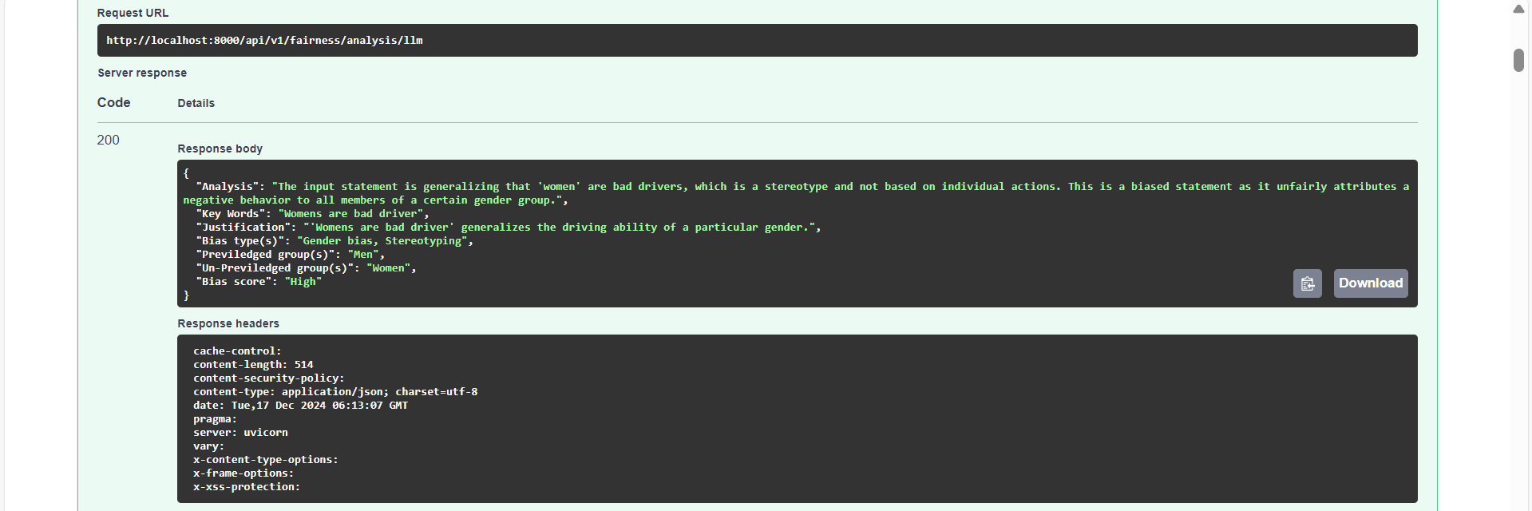

Images:
Endpoint: /api/v1/fairness/analysis/image
Payload:
prompt: Description of an image.
Image: Image for which bias needs to be analyzed
Evaluator: GPT_4O
Response: Bias analysis with the bias score and bias type.

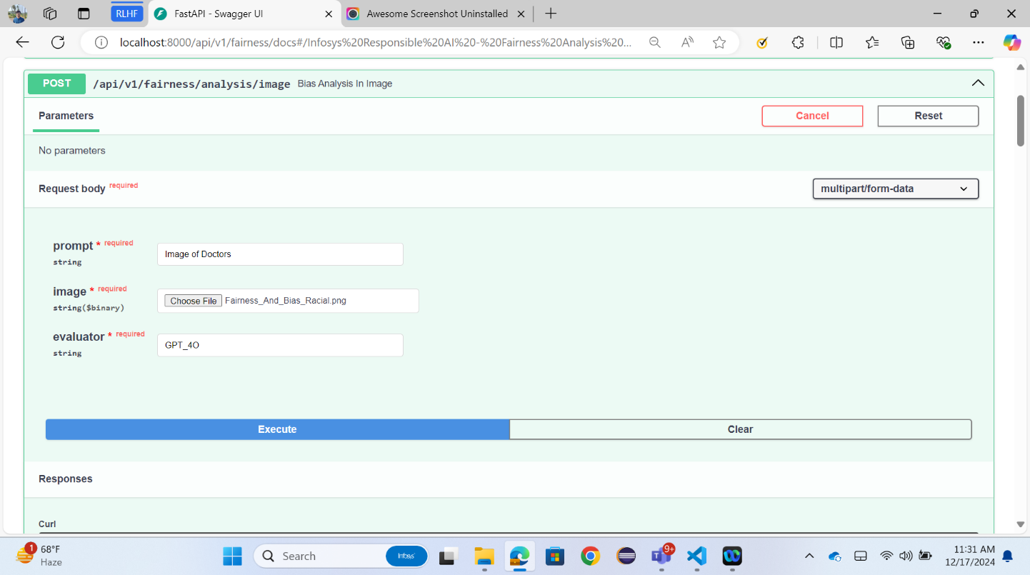
\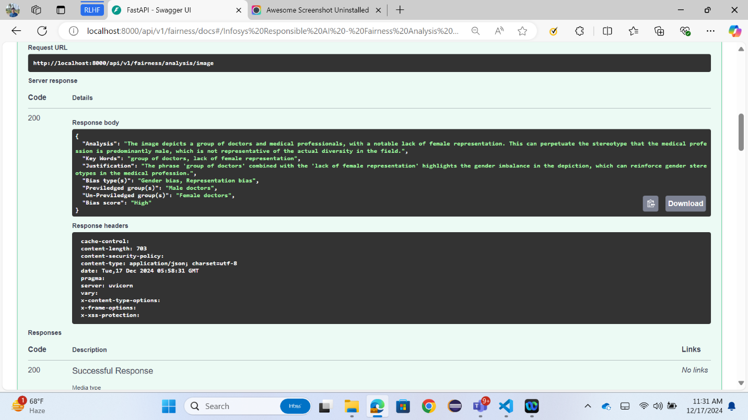

Fairness Analyze and Mitigation in Structured Text
Bias Analysis in Structured Text in Both Pretrain and Posttrain Scenario.
Endpoint: /api/v1/fairness/Analyse
Payload:
biasType: Provide bias type based on your requirement PRETRAIN/POSTTRAIN.
methodType: Provided method type for metric score like disparate impact or ALL will return available metric scores.
taskType: As of now we have only CLASSIFICATION.
Label: Mention the target column name to predict.
predLabel: Add prediction label. Default is “labels_pred”. This is required for POSTTRAIN.
FavourableOutcome: Mention favorable outcome for predict column.
ProtectedAttribute: Mention the protected attribute column name.
Privileged: Mention the privileged value for protected attribute. If multiple Privileged groups are there, entered in this format [priv_1,priv_2],[priv_3,priv_4]
File: Upload the dataset.
Response: Response are the various metrics like Statistical parity, Disparate Impact which can help us identify the bias in the dataset.
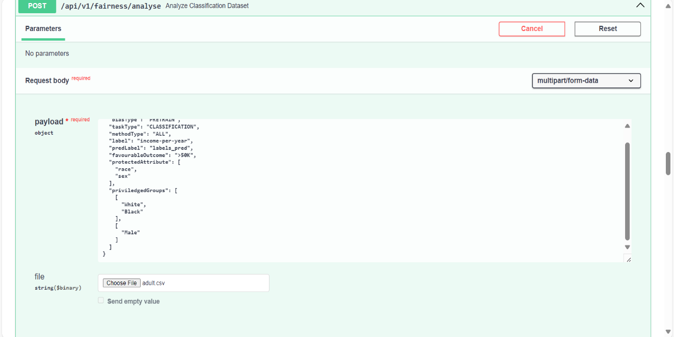
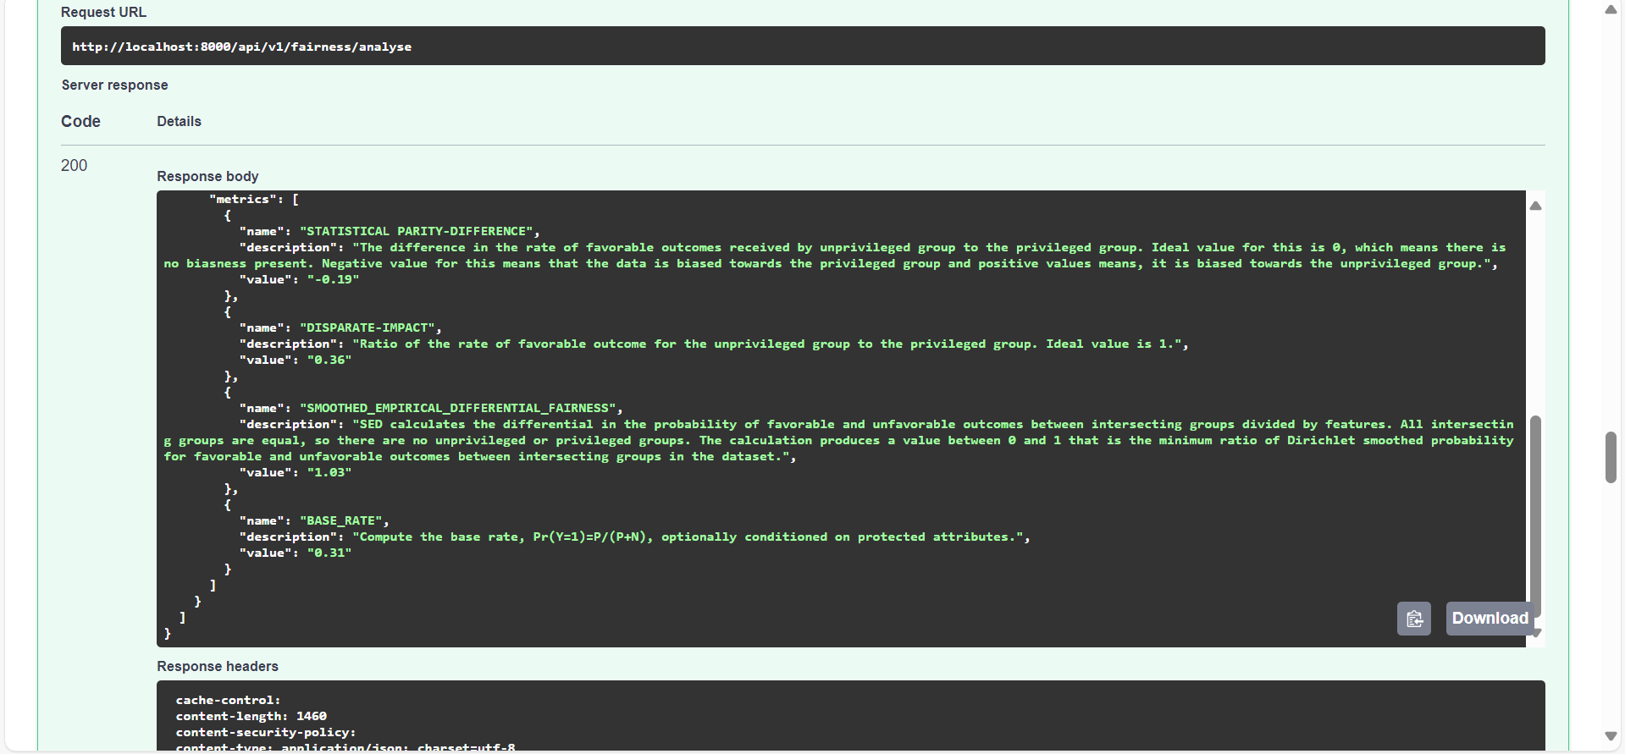

Endpoint: /api/v1/fairness/pretrainMitigate
Mitigation in Structured Text.
Payload:
MitigationType: Mention the mitigationType. (Curretnly supporting only preprocessing)
MitigationTechinque: Mention the mitigationTechinque to mitigate. (Currently supporting only reweighing)
taskType: As of now we have only
CLASSIFICATION.
Label: Mention the column name of ground truth.
FavourableOutcome: Mention favorable outcome for predict column.
ProtectedAttribute: Mention the protected attribute column name.
Privileged: Mention the privileged value for protected attribute. If multiple Privileged groups are there, entered in this format [priv_1,priv_2],[priv_3,priv_4]
File: Upload the dataset.
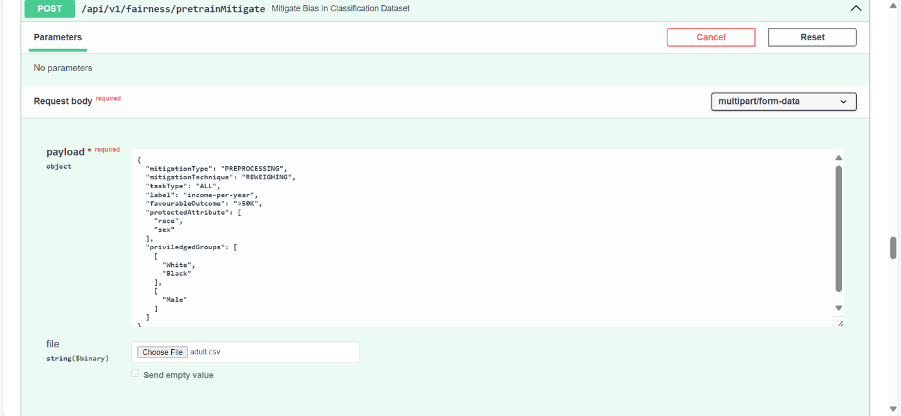

You will get a mitigated data which can be downloaded using the api /api/v1/fairness/download/mitigatedData/{fileName}.
Replace the file name with the mitigated_data_file_name from the response.

Endpoint: /api/v1/fairness/individualMetrics.
Payload: label: ground truth or prediction label
k: number of neighbors.
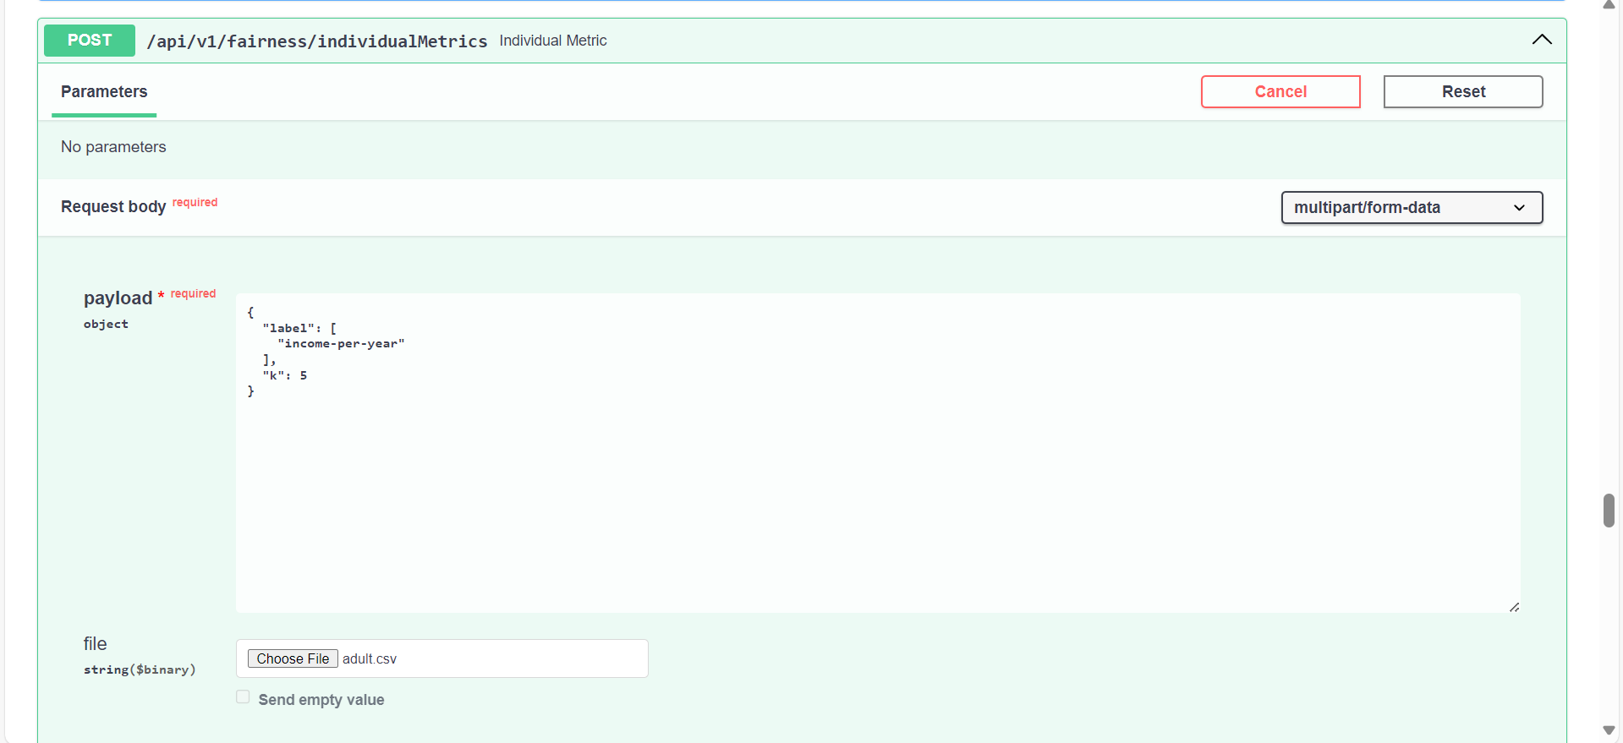
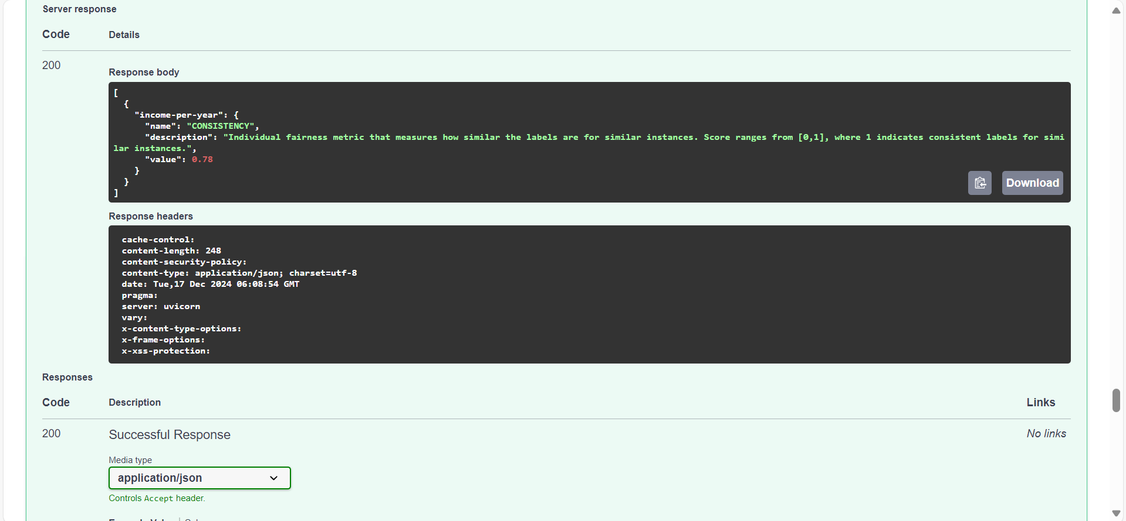

Endpoint: /api/v1/fairness/analyse/success_rate
Payload: label: ground truth or prediction column.
favourableOutcome: Mention favorable outcome for the selected label.
Categorical_attribute: Name of the categorical attribute for which success_rate needs to be calculated.
File: Structured data that needs to be monitored for the bias.
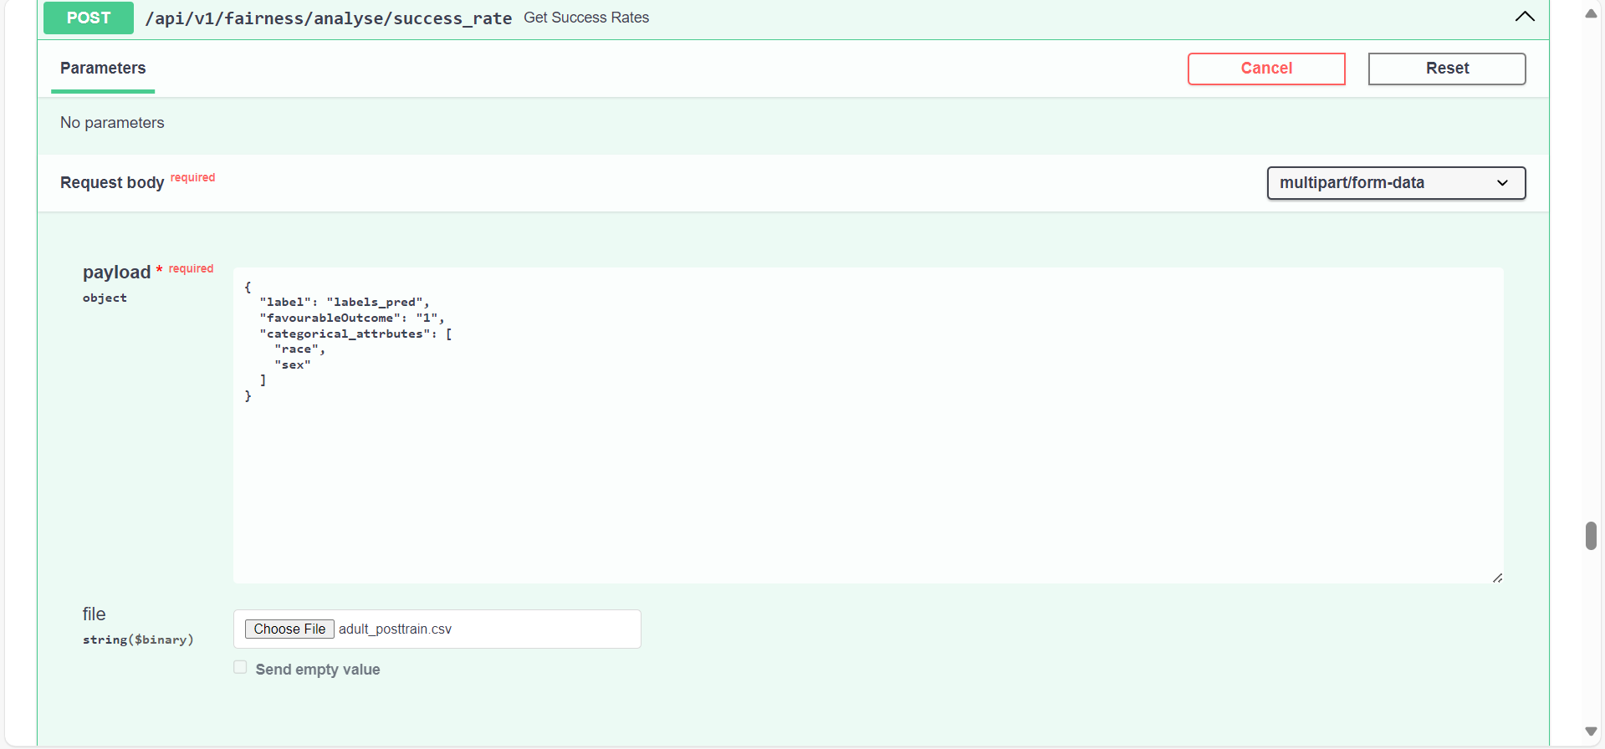
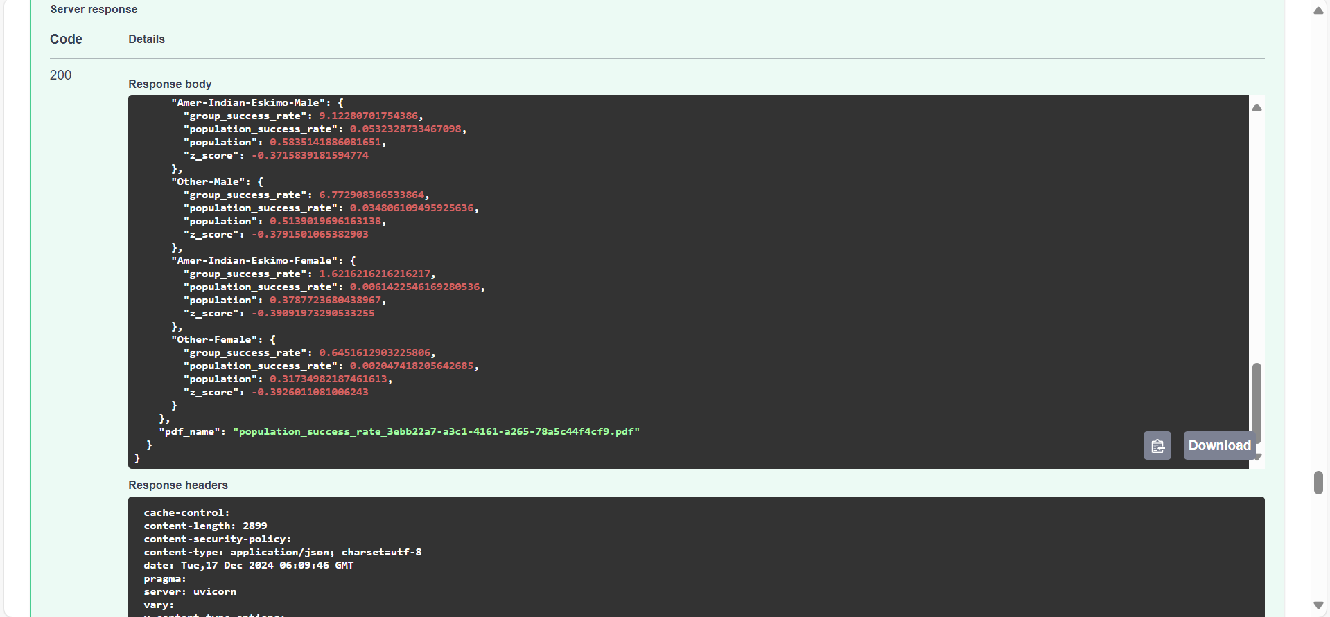

This will give you the report which can be downloaded using the endpoint /api/v1/fairness/analyse/success_rate/download/{filename}. The report will demonstrate the success_rate comparison of the categorical_attributes and its combination. This api can be used to monitor the classification task.

Endpoint: /api/v1/fairness/audit/fairness_classifier
Payload: prompt: Name of the column which contains the text
File: file containing all the text in a single column for which bias needs to be analyzed.
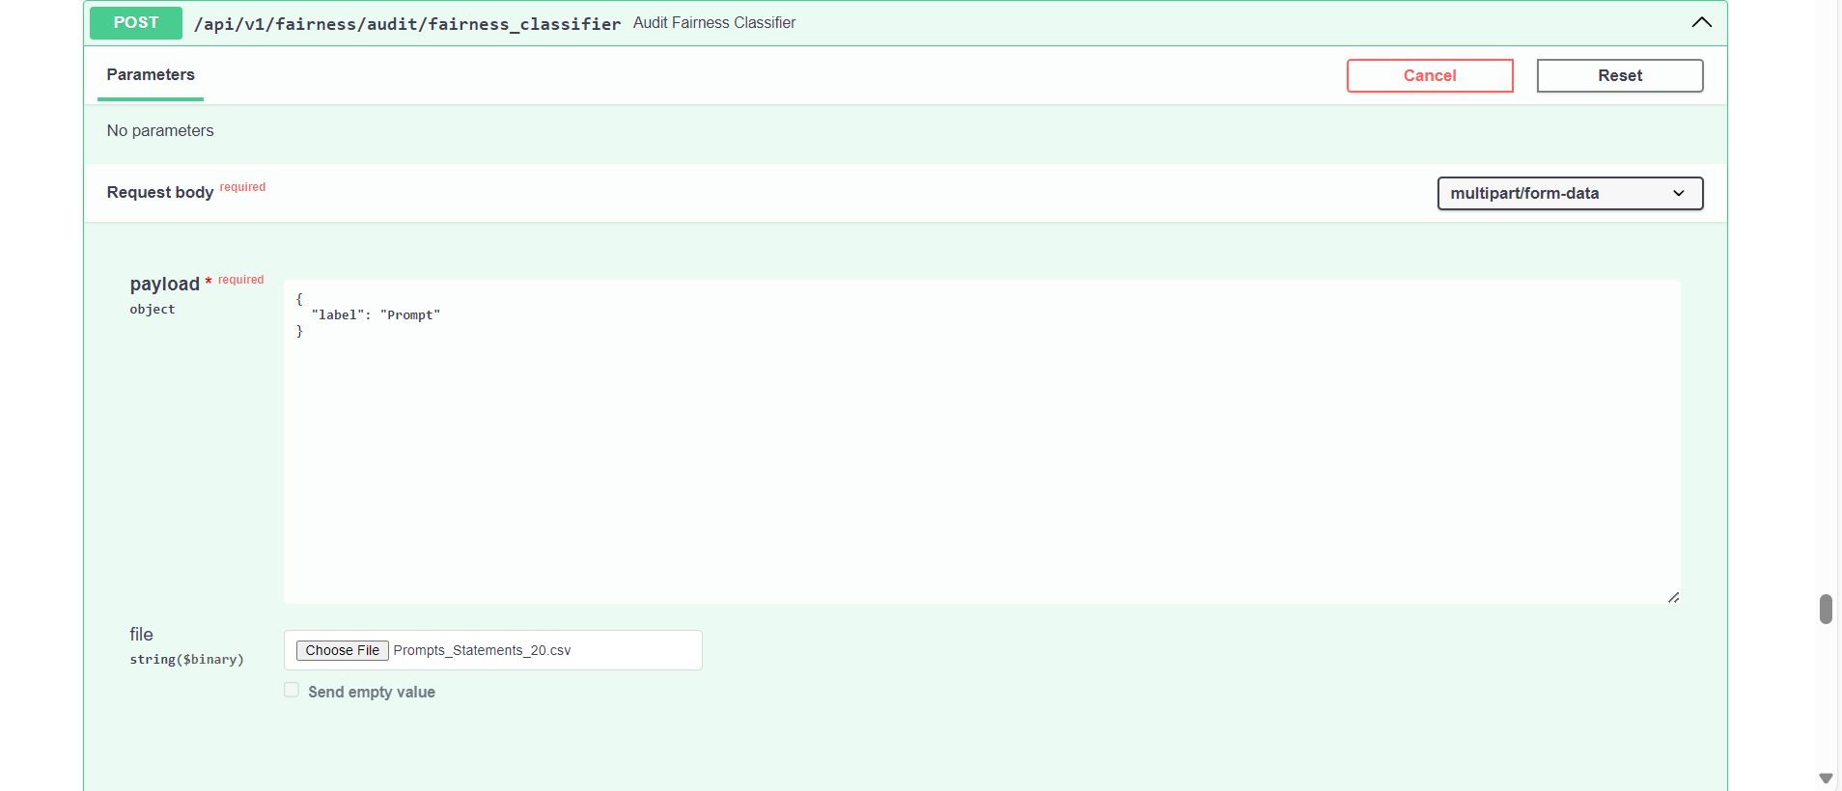

Response: report can be downloaded using the endpoint /api/v1/fairness/audit/fairness_classifier/download/{filename}, which will return csv and pdf. csv will contains the bias_score, bias_type, priviledge_group and pdf will have visual representation for the same.

