Parts of a tool: Raider PhysLab
Every tool uses the same layout, shown here with Sound. Some tools add or leave out a part.

Guided mode
Every tool opens here. Students see one step at a time, then answer predictions one at a time.
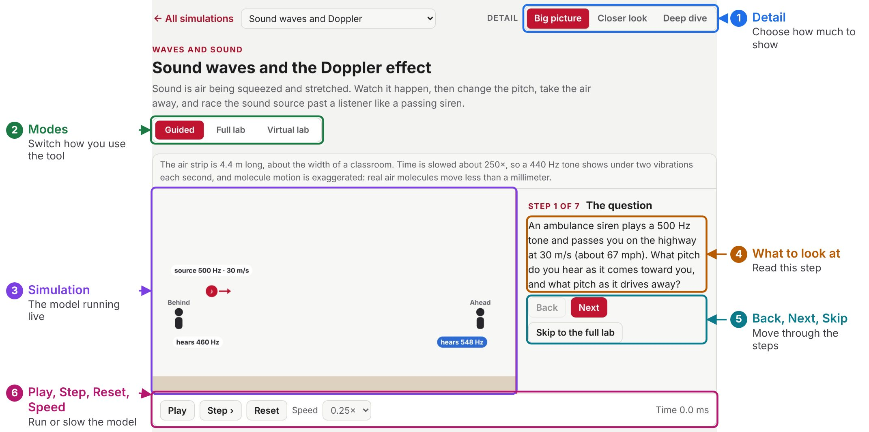
1. Detail. Changes how many names, controls and how much math students see. Any student can choose any level. | 4. Step text. Explains this step. Step 1 is always the tool's real-world question.
2. Mode buttons. Switch between Guided, Full lab and any other modes this tool has. | 5. Back, Next and Skip to the full lab. Move through the steps, or leave the walkthrough and open every control.
3. Simulation. The model running live. Guided mode dims the parts that are not being explained. | 6. Play, Step, Reset and Speed. Play or pause the model, step it forward a moment at a time, start over, or slow it down.

Full lab: the bench
Students change the variables and watch the model respond.
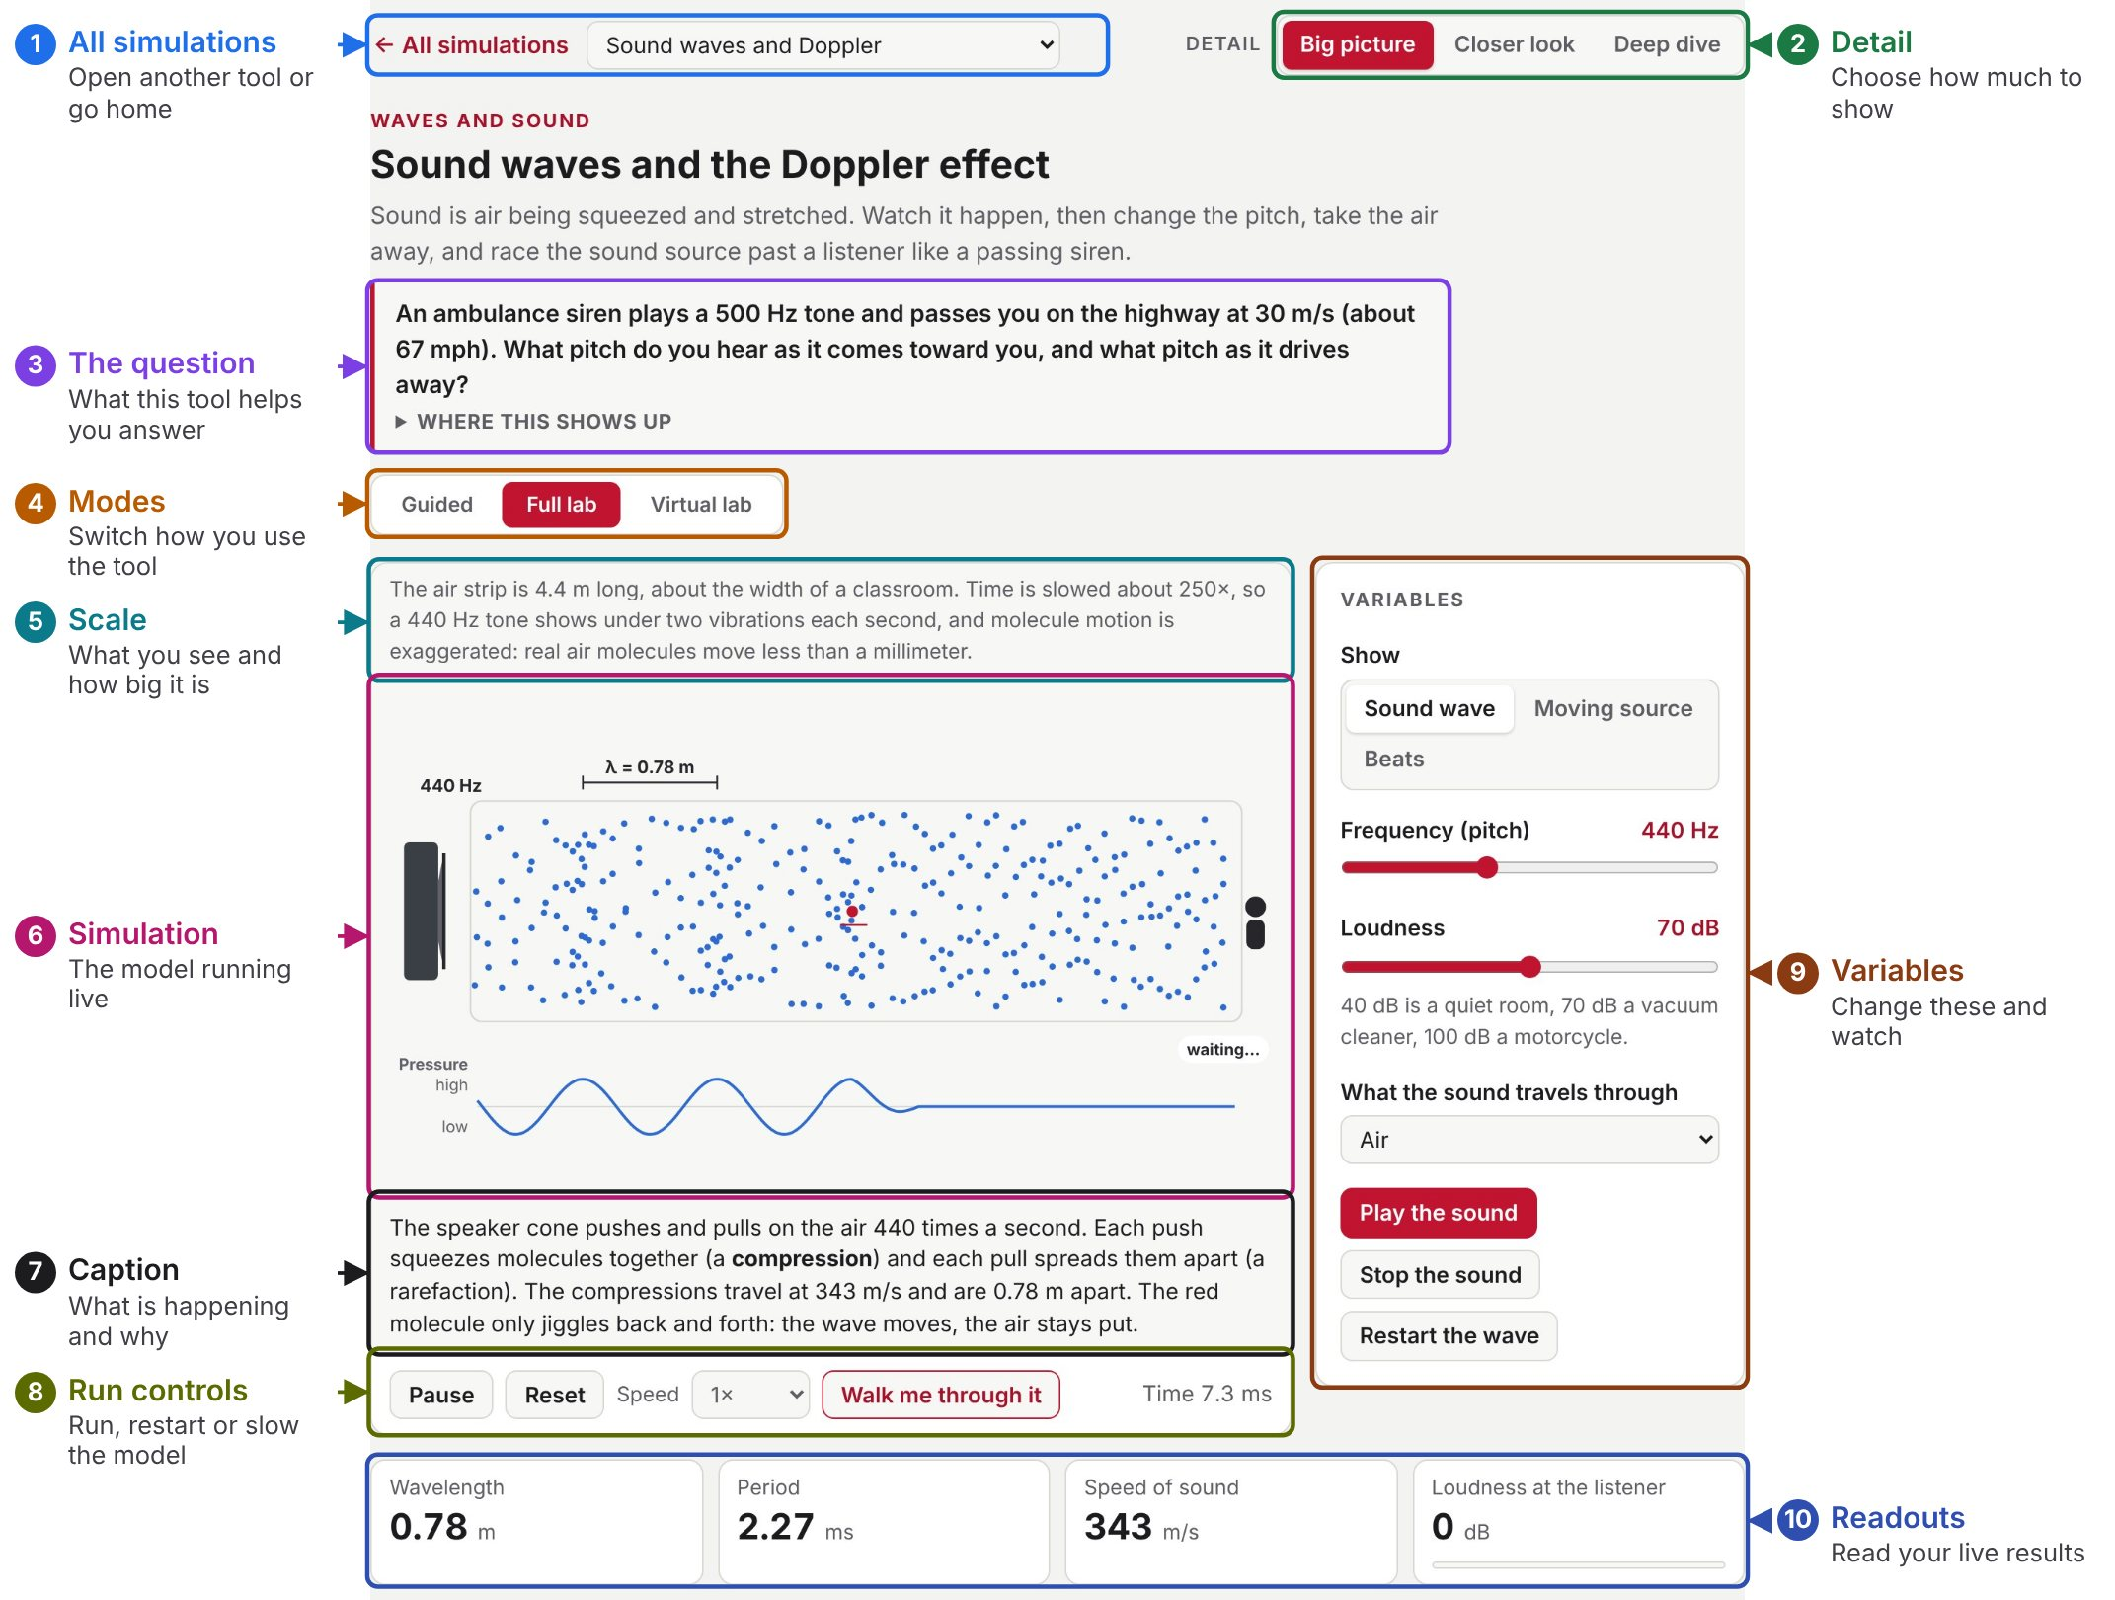
1. All simulations and tool menu. Go back to the home page or jump straight to another tool. | 6. Simulation. The model running live. Students watch this respond when a variable changes.
2. Detail. Changes how many names, controls and how much math students see. | 7. Live caption. Explains what is happening right now, and why. It changes with the variables.
3. The question. The real-world question this tool answers. Where this shows up opens real uses of the idea. | 8. Pause, Reset, Speed and Walk me through it. Pause or restart the model, slow it down to 0.1×, or open the guided tour. When paused, Step moves it forward a moment at a time.
4. Mode buttons. Switch between Guided, Full lab and any other modes this tool has. | 9. Variables. The sliders and switches students change. The model responds right away.
5. Scale line. Says what students are looking at and how big it really is. | 10. Readouts. The live numbers from the model, with units. Students read their results here.

Full lab: data and support
Below the bench, students test predictions, collect data and check the model.
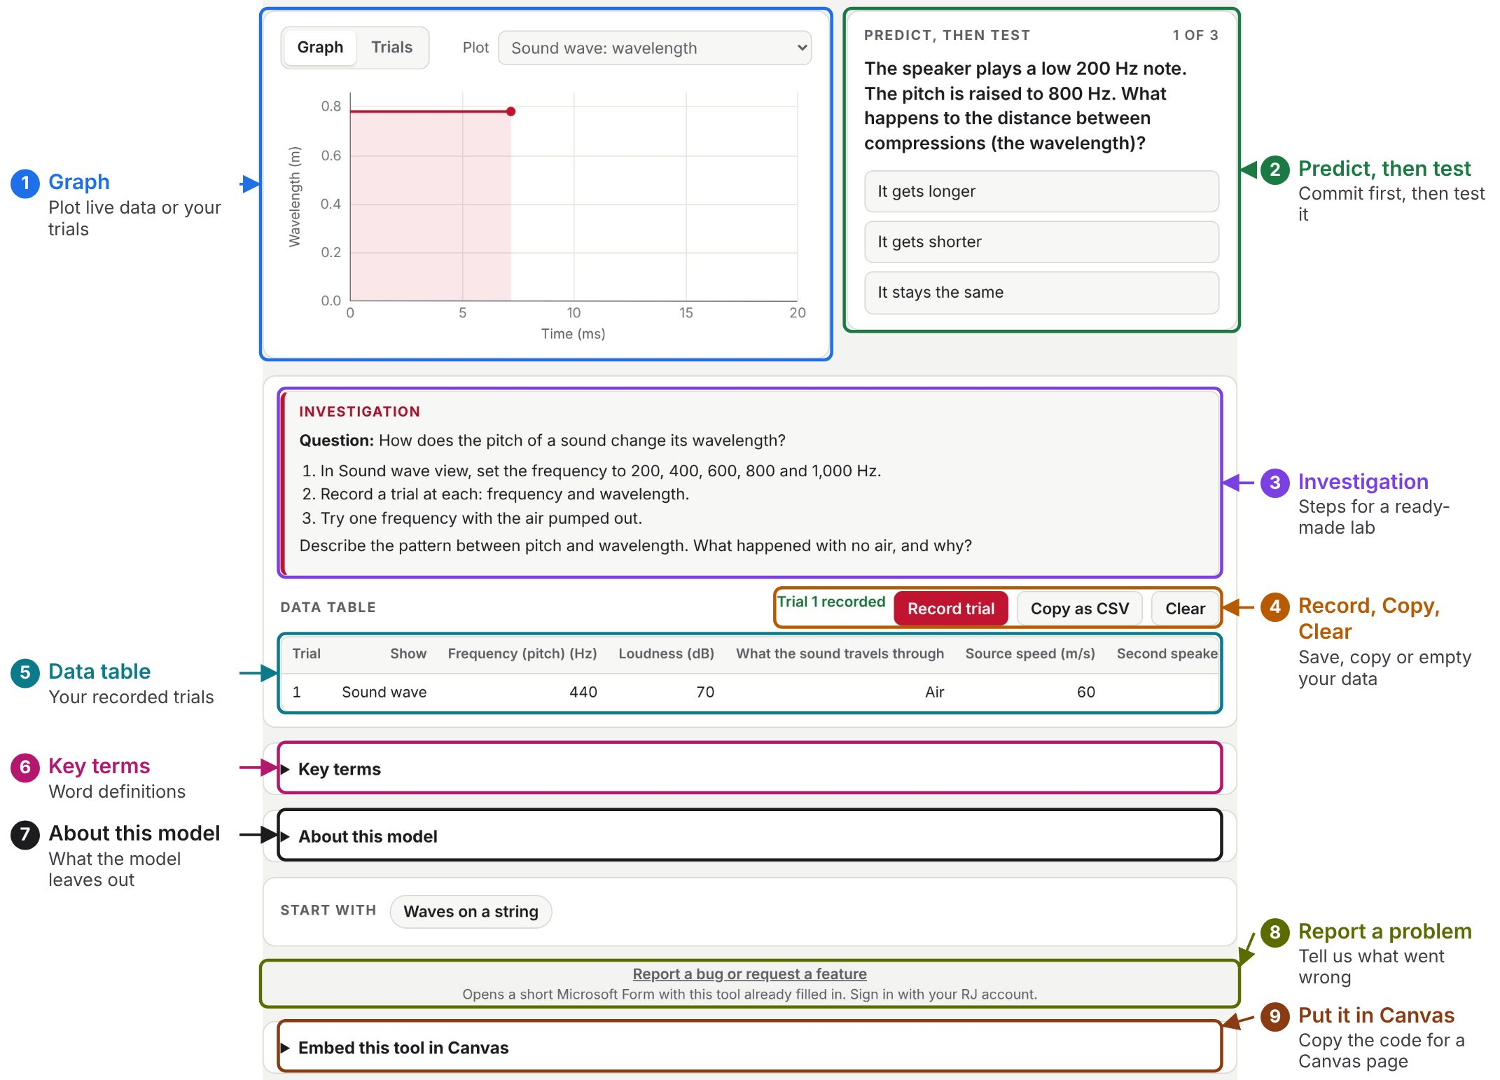
1. Graph and Plot. Graph shows the live plot, and Plot chooses which reading it shows. Trials plots your recorded trials, using the x and y you choose. | 6. Key terms. Definitions of the words used in this tool.
2. Predict, then test. Students choose a prediction, then the tool runs the test and explains the result. | 7. About this model. What the model calculates and what it simplifies.
3. Investigation. A ready-made lab: the question, what to change and record, and what to explain. | 8. Report a bug or request a feature. Opens a short Microsoft Form with this tool already filled in.
4. Record trial, Copy as CSV and Clear. Record trial saves the current settings and readings as a row. Copy as CSV copies the table for Excel or Desmos. Clear empties it. | 9. Embed this tool in Canvas. Creates the code or link for a Canvas page, with pictures of each step.
5. Data table. Every recorded trial. It stays in this browser on this device.

