COIT13229

Applied Distributed Systems

Assignment 1 – Java Client/Server Application

Reese Gunardi – 12109627

Screenshots

Home page:

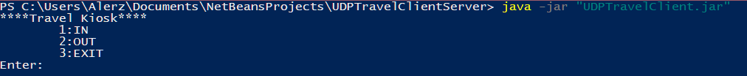

Successful login:

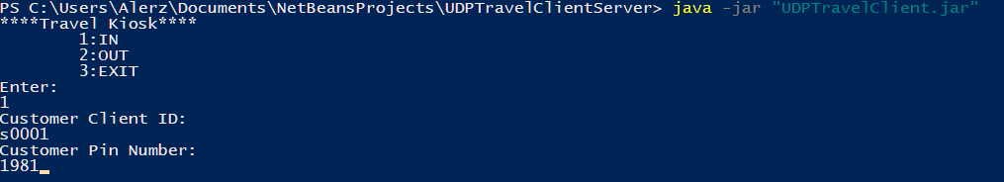

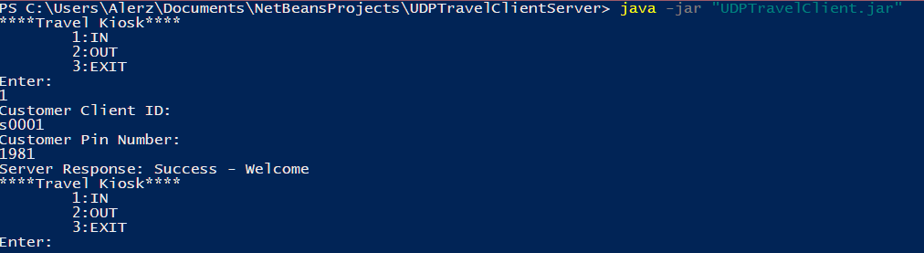

Successful Logout:

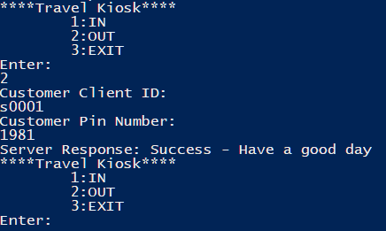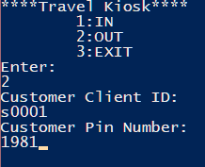

Console Output on Successful Logout:

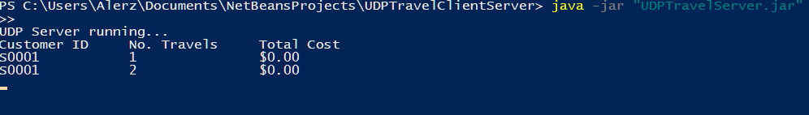

Incorrect Client ID:

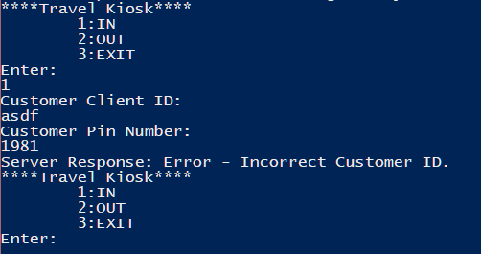

Incorrect Pin Number:

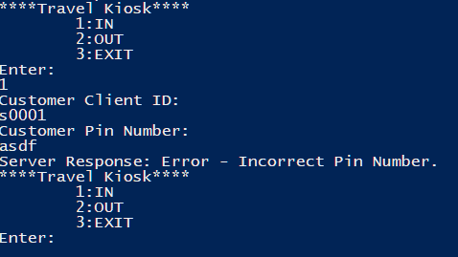

Customer already signed in:

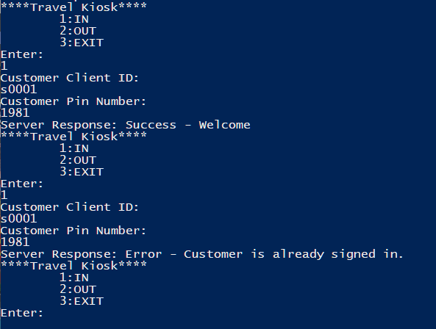  
Customer already signed out:

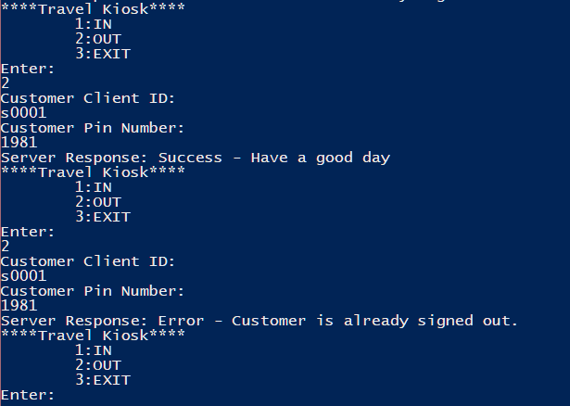

Server loads text file, displays output, handles multiple clients & calculates cost:

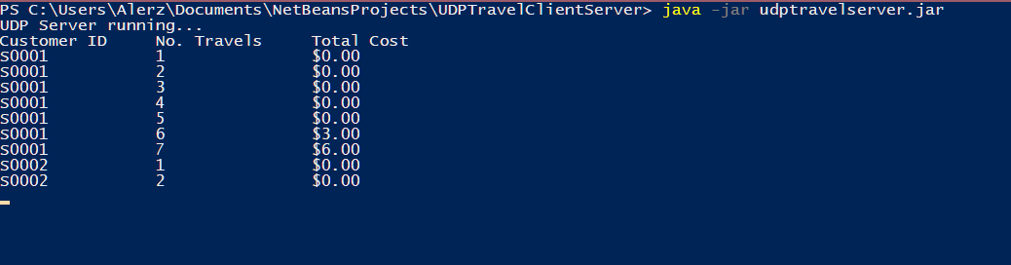

Server saves customer class to binary, scheduled through TimerTask:

