Why Buses Bunch
The Relationship Between Passenger Demand and Bus Bunching on CapMetro Rapid Route 801, July–December 2021
ELE IDSA Project 1 · GEC2B
Instructor: Ezron John D. Cabrera
Prepared by
Rence Marquez
Khalil Badal
Elijah
October 2026

1. Introduction

Background
- Data source: Capital Metropolitan Transportation Authority (CapMetro), Austin, Texas — APC Raw July 2021 – December 2021, Texas Open Data Portal (ID im6q-3pc9), free and public.
- Collection: automatic passenger counters (APC) use door sensors to log boardings and alightings; GPS and an onboard clock record the time and stop for each event. One row = one bus at one stop.
- Study subset: Route 801 (CapMetro Rapid), southbound, July 1 – December 30, 2021 — 229,421 stop events, 29 stops, 183 service days. Scheduled every 10 minutes on weekdays 7:00–18:00.
- Bus bunching: buses lose their even spacing and arrive in pairs, followed by a long gap. A late bus finds more riders waiting, dwells longer, and falls further behind; the bus behind it catches up. Some riders wait far longer than scheduled; some buses are crowded while others run nearly empty.

Motivation
- Bunching degrades reliability and equity on high-frequency routes without any change to the schedule or fleet.
- The Route 801 APC dataset is large (229,421 records), real, free, and stop-level — it enables direct measurement of bunching rather than estimation.
- The six-month window captures seasonal variation, commuting patterns, and holiday disruptions.

Objectives and Hypotheses
This study examines how passenger demand relates to bus bunching on Route 801. Three hypotheses are tested:
- H1: Buses with a longer gap behind the bus ahead (headway) carry more passengers.
- H2: The more people board and alight, the longer the bus stays at the stop (dwell time).
- H3: Headways become more irregular further along the route (bunching builds up).

2. Methodology

Data acquisition
- Source: Capital Metropolitan Transportation Authority (CapMetro), APC Raw July 2021 – December 2021, Texas Open Data Portal (dataset im6q-3pc9), free public download.
- How the data is produced: automatic passenger counters (APC) on CapMetro buses. Door sensors count passengers getting on and off, and the bus's GPS and clock record when and where each stop happens. Each row is one stop event: one bus stopping at one stop.
- Raw size: 9,197,694 rows × 47 columns, covering every CapMetro route. All values are stored as text.
- Study subset: Route 801 (CapMetro Rapid), southbound, July 1 – December 30, 2021: 229,421 stop events, 29 stops, 143 buses, 183 service days.

Parameters used to segregate the data
Parameter | Values used | Purpose
Route | 801 | Study route
Direction | Southbound (code 6) | One direction of travel
Period | Jul 1 – Dec 30, 2021 | Full dataset coverage
Day type | Weekday / weekend | Compare demand patterns
Analysis window | Weekdays, 7:00–17:59 | Hours when buses are scheduled every 10 minutes, so the planned headway is constant
Hour of day | 0–23 | Demand by time of day
Stop order | 1 (first stop) to 29 (last stop) | Position along the route
Headway group | 0–5, 5–10, 10–15, 15–20, 20+ min | Compare buses that are close together vs far apart

Key variables
- Headway: time since the previous bus at the same stop.
- Passenger load: passengers on board after the stop (max_load).
- Boardings / alightings: ons / offs.
- Dwell time: seconds from door open to door close.

Data cleaning
Filtering. A record is kept only if it passes all six rules:
Step | Rule | Records left
Raw dataset | — | 9,197,694
1 | Route 801 | 547,616
2 | Bus serving its assigned route | 524,728
3–4 | No error flags (record or trip) | 480,452
5 | Valid stop ID (not 0) | 455,654
6 | Southbound only | 229,421

Other cleaning steps
- Type conversion: text is converted to numbers and dates.
- Duplicates: 7 duplicate records (same trip, same stop) are removed.
- Terminal stops: stops 1 and 29 are the ends of the route, where buses wait between trips. Their "dwell times" are layovers (median 10–13 minutes), so the 17,659 terminal records are excluded from the dwell and headway analysis (see the figure below).
- Invalid values:
- Boardings or alightings above 40 at a single stop (33 values, above the 99.99th percentile) are counter errors.
- Dwell times above 10 minutes at non-terminal stops (381 values) are not passenger service.
- Both are marked as missing.
- Imputation: the missing values are filled with the median of the same stop and hour. The median is used because these variables are strongly skewed. In total 414 values were imputed, less than 0.2% of records.
- Headway check: some scheduled trips are missing from the APC data, so two recorded buses can be 20 minutes apart only because the bus between them wasn't recorded. A headway is therefore kept only when the two buses were scheduled exactly 10 minutes apart. This leaves 51,437 valid headways in the analysis window.
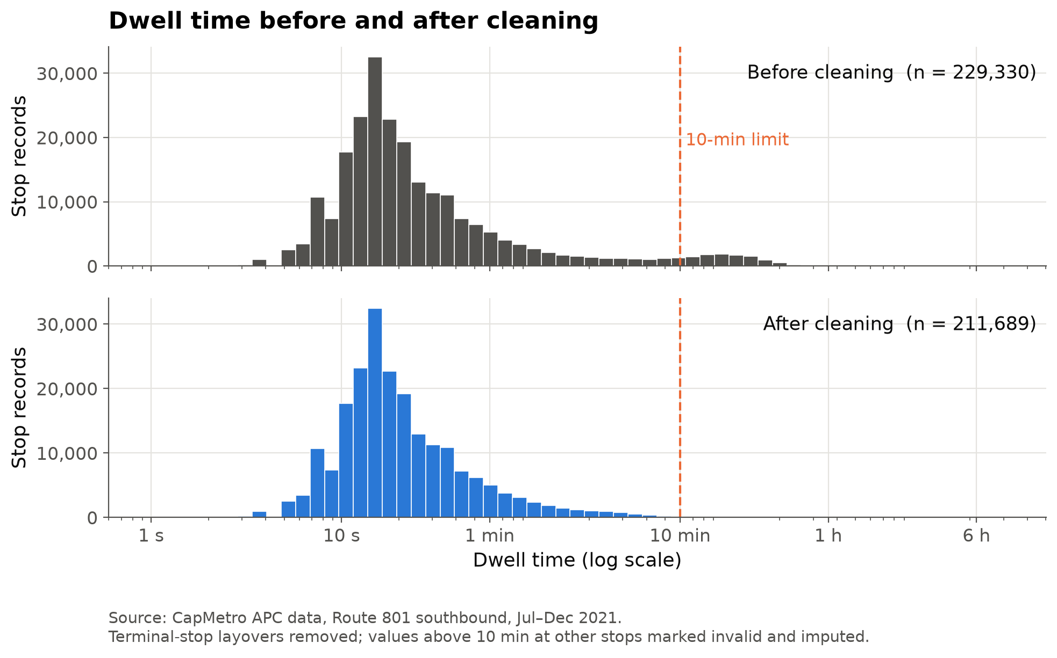
Figure 1. Dwell time before and after cleaning

Tools
Python (pandas, NumPy, Matplotlib, SciPy, statsmodels). The full pipeline is in src/prepare_data.py.

3. Results and Discussion

3.1 Ridership Patterns

Boardings by hour of day
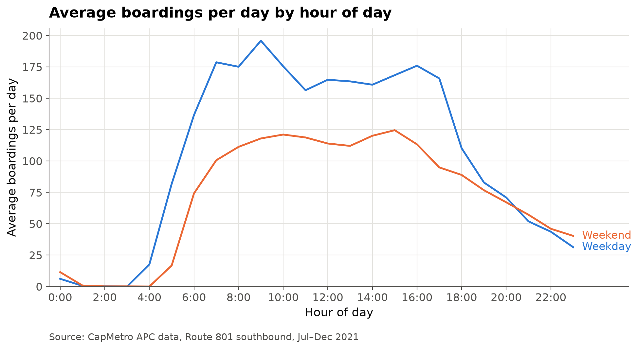
Figure 2. Boardings by hour of day, weekdays vs weekends
- Weekday demand peaks at 9:00 with 195.9 average boardings, then stays high through the afternoon with a second peak at 16:00 (175.9), matching the morning and afternoon commute.
- Weekend demand is lower and flatter, peaking at 15:00 with 124.6 average boardings, about 36% below the weekday morning peak.
- Average total boardings per weekday (2,514) are 45% higher than on weekends (1,728), which suggests Route 801 is mainly a commuter service.
- Both day types have almost no ridership between 1:00 and 4:00, with a sharp weekday ramp-up from 5:00.

Boardings per service day
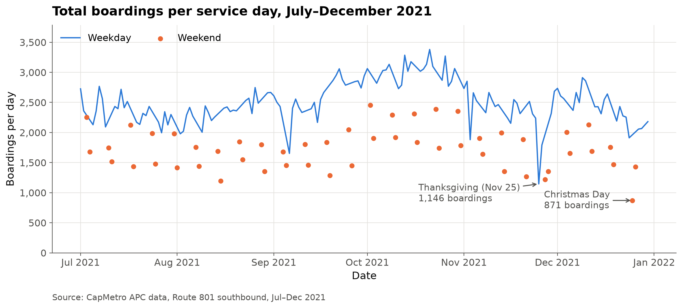
Figure 3. Total boardings per day, July–December 2021
- Average boardings per service day over the study period: 2,291 (weekdays 2,514, weekends 1,728).
- Weekday ridership is highest in October (average 3,025 per weekday) and lowest in July, August and November (about 2,350). The October rise may reflect students and office workers returning in the fall, but the data alone can't confirm that.
- The clearest holiday dip is Thanksgiving (Nov 25, 2021): 1,146 boardings, less than half the weekday average and 3.8 standard deviations below it.
- Weekend ridership (orange dots) stays below weekday ridership throughout. The lowest day is Christmas Day (Dec 25) with 871 boardings.

Headway distribution (analysis window)
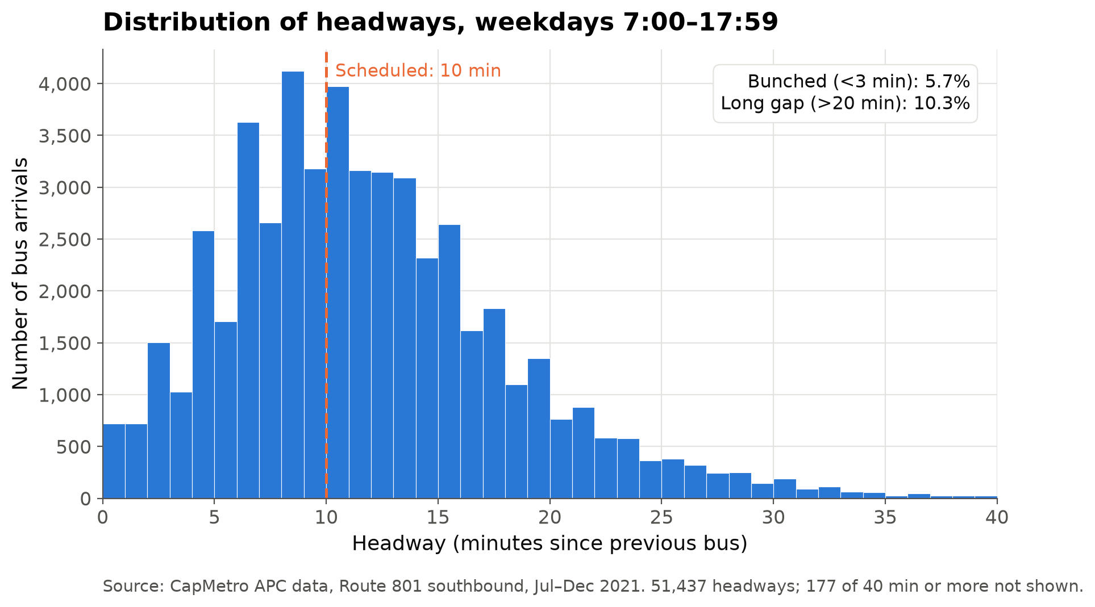
Figure 4. Distribution of headways, weekdays 7:00–17:59
- Of the 51,437 valid headways in the analysis window (weekdays 7:00–17:59), the median is 11.0 minutes, just above the scheduled 10 minutes.
- The distribution has a long right tail: 10.3% of headways exceed 20 minutes (long gaps) and 5.7% are under 3 minutes (bunched buses).
- The most common headway is 8–9 minutes, followed by 10–11 minutes, so many buses do run close to schedule, but when spacing breaks down the gaps are large.
- Together, roughly 1 in 6 bus arrivals is either bunched or a long gap.

3.2 Where and When Passengers Board
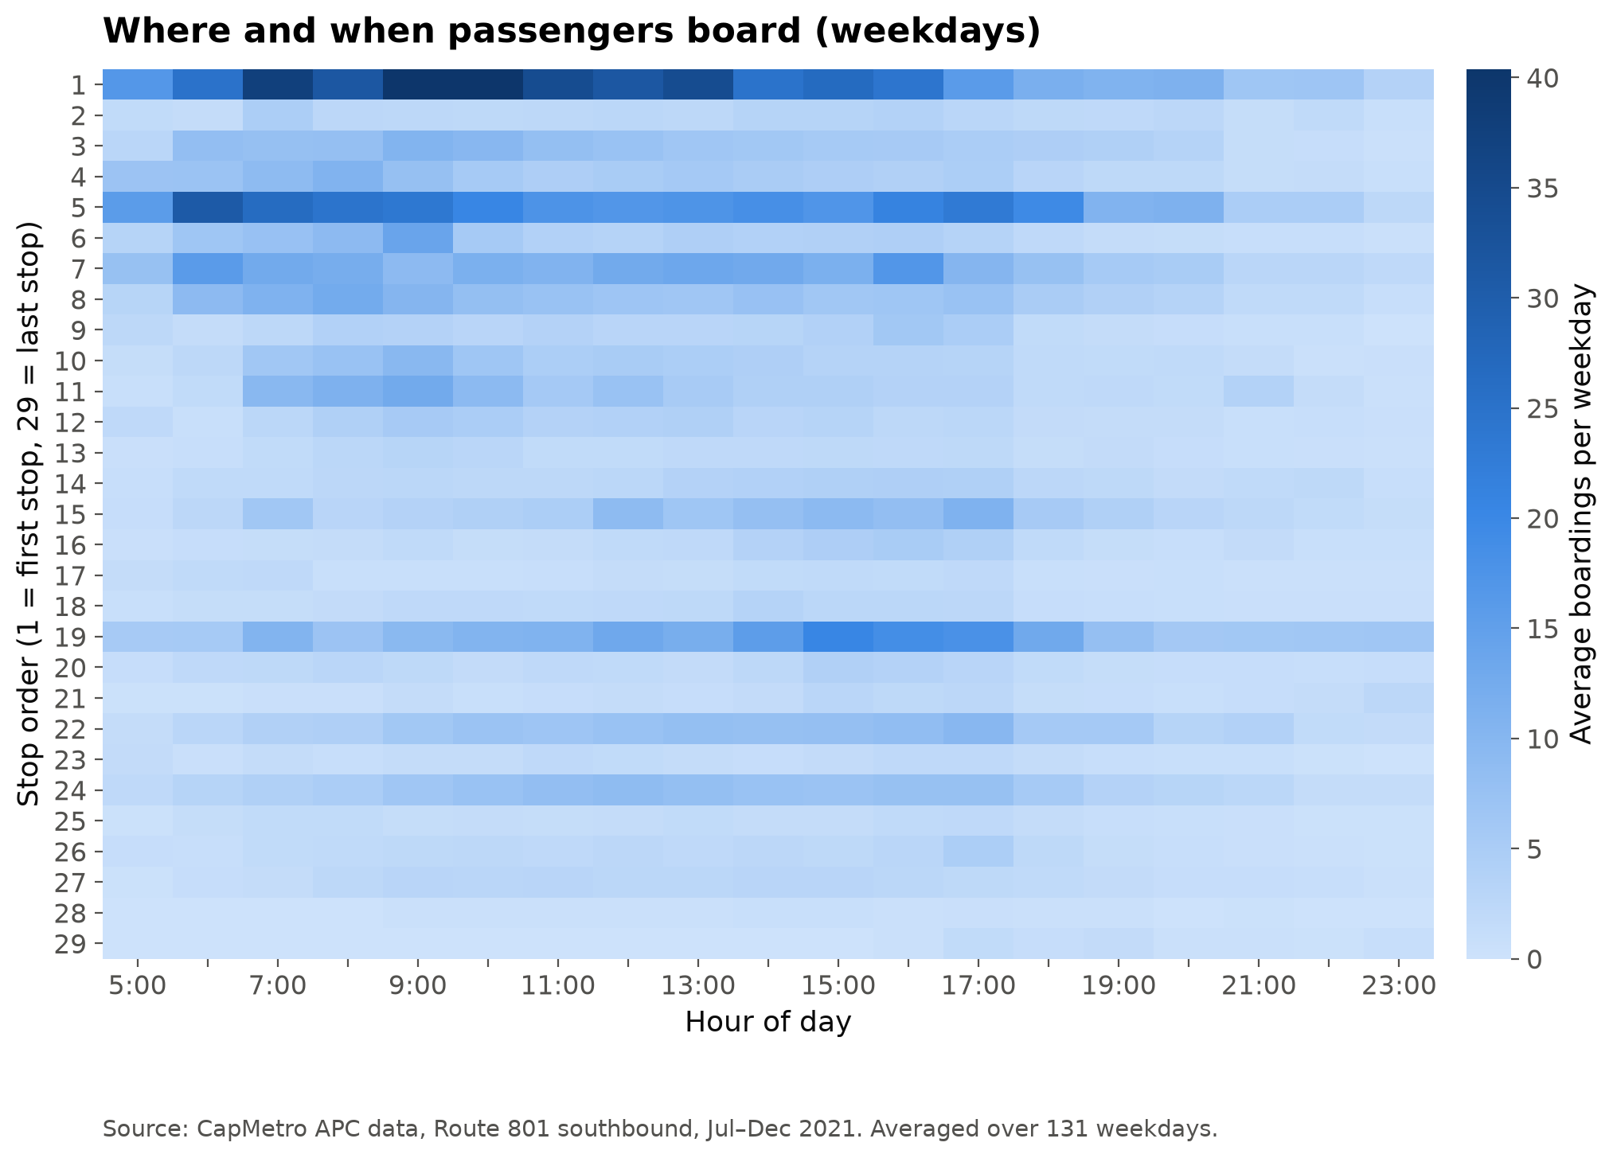
Figure 5. Average weekday boardings by stop and hour
- Boardings are concentrated at a few stops. Stop 1 (the first stop) is the busiest, with up to about 40 boardings per weekday in a single hour around 7:00–10:00. Stops 5 and 19 are the next busiest. Over a whole weekday, stop 1 averages about 442 boardings, stop 5 about 329 and stop 19 about 204.
- Stop 5 is busiest in the morning (6:00–9:00). Stop 19 is busiest in the afternoon (15:00–17:00), which suggests commuters travelling out in the morning and back in the afternoon.
- Apart from stops 22 and 24, the stops after stop 20 have few boardings at any hour, because passengers are mostly getting off near the end of the route.
- Demand is uneven across both stops and hours. A bus reaching a busy stop at a busy hour has many more people to serve, and the hypothesis results test whether that is tied to bunching.

3.3 Hypothesis Results
All tests use the analysis window (weekdays 07:00–17:59, buses scheduled every 10 minutes): 126,070 stop events over 131 service days. Every test uses a significance level of alpha = 0.05.

H1 — Buses with a longer headway carry more passengers
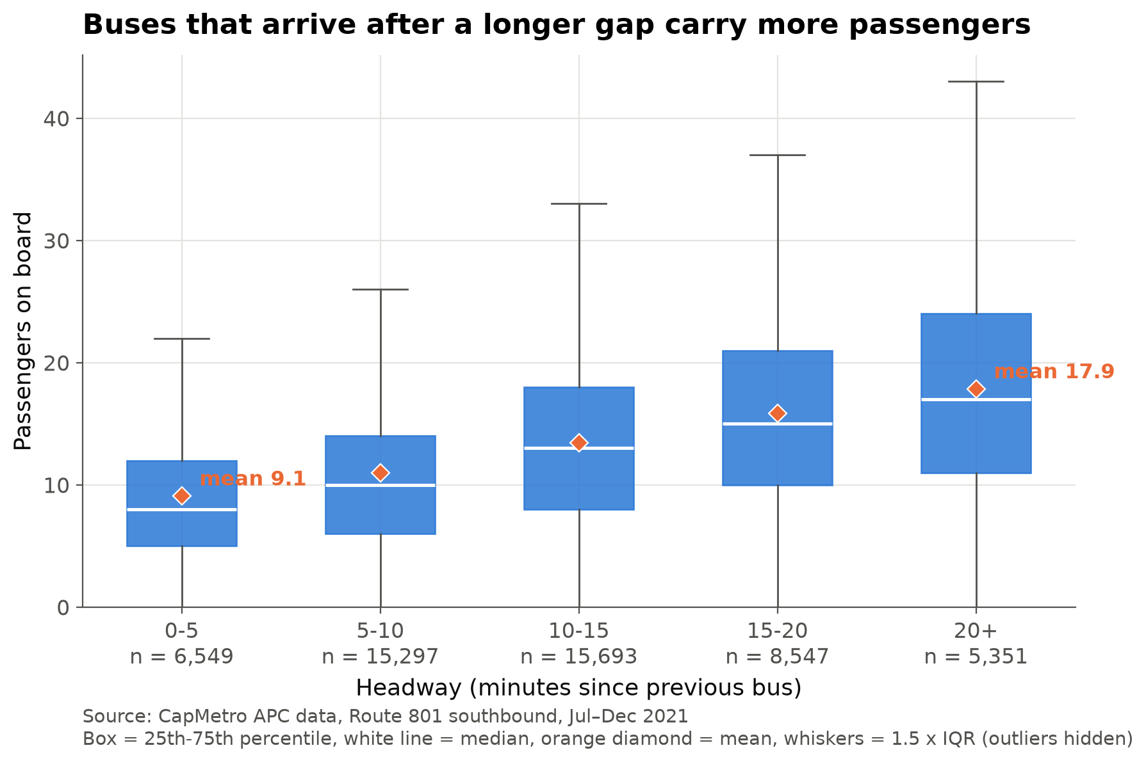
Figure 6. H1: Passengers on board by headway group
- Mean load climbs with every headway group: 9.1 passengers at 0–5 min (n = 6,549), 11.0 at 5–10, 13.4 at 10–15, 15.8 at 15–20 and 17.9 at 20+ min (n = 5,351) — roughly double the load for a bus that is 20+ minutes behind the one ahead.
- The medians move the same way (8 → 17 passengers), so the pattern is not driven by a few crowded buses.
- Spearman correlation: rho = 0.349, p < 0.001 (n = 51,437 valid headways) — a moderate positive association.
- Kruskal-Wallis: H = 5,883.4, df = 4, p < 0.001. Both tests are below alpha = 0.05, so we reject H0: load does depend on the headway.

H2 — More boardings and alightings mean longer dwell time
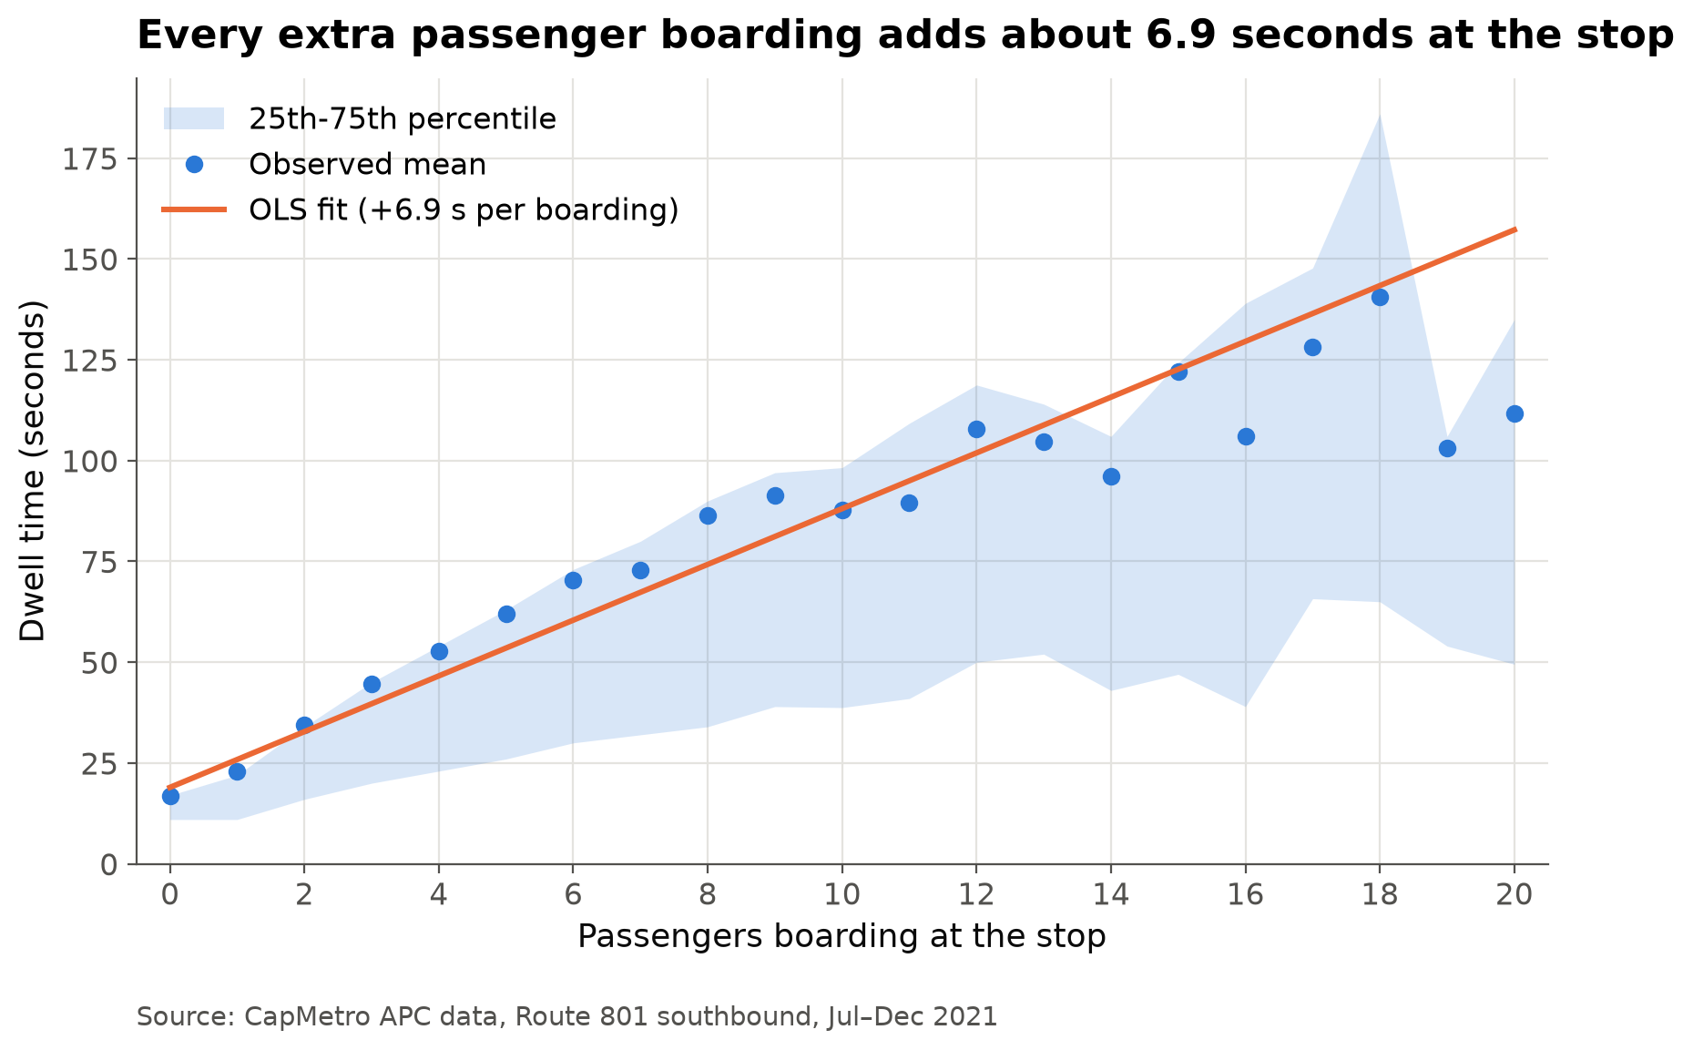
Figure 7. H2: Dwell time vs passengers boarding
- OLS on 116,697 non-terminal stop events: dwell_time = 12.79 + 6.91 × ons + 3.65 × offs (seconds). Each extra boarding adds about 6.9 s (95% CI 6.81–7.02) and each alighting about 3.7 s (95% CI 3.54–3.76) — boarding costs about 1.9× as much time as alighting, which fits the fact that boarding passengers queue at the front door to pay while alighting passengers simply step off.
- Both coefficients are significant (p < 0.001 each; F(2, 116694) = 12,777, p < 0.001), so we reject H0. R² = 0.180: boardings and alightings explain 18% of the variation in dwell time, the rest comes from traffic, wheelchair ramps and driver behaviour.
- Observed mean dwell rises from 16.9 s with no boardings to 111.8 s at 20 boardings, and the 25th–75th band widens with it, so busy stops are both slower and less predictable.
- The straight fit runs above the observed means past ~15 boardings (fitted 157 s vs observed 112 s at 20), i.e. the real relationship flattens a little when many passengers board at once.

H3 — Headways become more irregular along the route
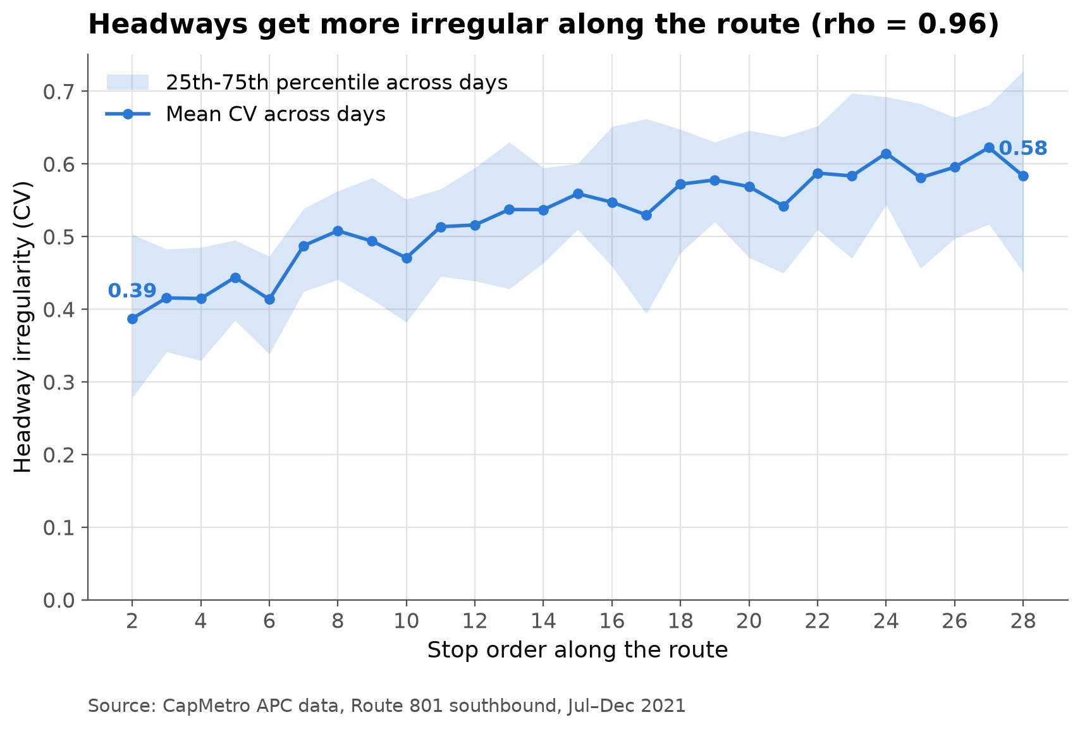
Figure 8. H3: Headway irregularity along the route
- Irregularity is measured as the coefficient of variation (CV = std / mean of the headways) for each service day and stop, using 3,382 day × stop cells with at least 3 valid headways over 128 service days.
- Mean CV rises almost monotonically from 0.387 at stop 2 to 0.583 at stop 28 (+51%), peaking at 0.622 at stop 27. The 25th–75th band also widens, so bad days get worse further down the line.
- Spearman correlation between stop order and mean CV: rho = 0.955, p = 9.3 × 10⁻¹⁵ (n = 27 stops) — a very strong, near-linear increase.
- p < alpha = 0.05, so we reject H0: buses do not keep their 10-minute spacing along the route, they drift apart and bunch up.

Discussion
The three results form one self-reinforcing cycle
- H2 → H1: a bus that meets more passengers stays longer at each stop (+6.9 s per boarding), so it falls further behind schedule.
- H1 → H2: falling behind opens a bigger gap to the bus ahead, and a bigger gap means more passengers waiting — load rises from 9.1 to 17.9 as the headway grows past 20 minutes — which lengthens the dwell again.
- → H3: each turn of the loop amplifies the previous one, so the spacing between buses gets more uneven the further along the route they go (CV 0.39 → 0.58), while the bus behind, with a short headway, finds empty stops and catches up. That is bus bunching.
- The cycle is consistent with the demand pattern shown in the boardings heatmap: the delay starts at the few very busy stops early in the route and then grows downstream.
Limitations
- These are associations, not proof of cause. The tests show the variables move together; they cannot by themselves prove that demand causes bunching.
- One route, one direction, one period: Route 801 southbound, July–December 2021, weekdays 07:00–17:59 only. The results need not hold for other routes, the northbound direction, weekends or off-peak hours.
- APC counting errors: automatic counters miscount at crowded doors; extreme values (above 40 boardings, dwell above 10 min) were removed and imputed during cleaning, but smaller errors remain.
- Missing trips: some scheduled trips are not in the APC data. Only headways between buses scheduled exactly 10 minutes apart were kept (51,437 of them), so a part of the real variation is excluded.
- 2021 is a recovery year: ridership was still affected by COVID-19, so absolute passenger counts are lower than in a normal year, even if the relationships hold.

4. Conclusion
- Data: CapMetro APC records (Texas Open Data Portal, dataset im6q-3pc9) for Route 801 Rapid, southbound, 1 July – 30 December 2021 — 229,421 stop events at 29 stops from 9.2 million raw rows; the analysis window is weekdays 07:00–17:59, when buses are scheduled every 10 minutes (126,070 events, 131 service days).
- Cleaning: six filtering rules (route, assigned route, no error flags, valid stop, southbound), 7 duplicates dropped, 17,659 terminal records excluded because their "dwell" is layover time, impossible values (ons/offs above 40, dwell above 10 min) replaced by the stop-and-hour median — under 0.2% of records imputed — and only headways between buses scheduled exactly 10 minutes apart kept (51,437 valid headways).
- Demand is concentrated, not spread out: stop 1 is the busiest with about 442 boardings per weekday (up to ~40 in a single hour, 07:00–10:00), followed by stop 5 (~329, peaking 06:00–09:00) and stop 19 (~204, peaking 15:00–17:00); stops after 20 are mostly alighting stops.
- Ridership follows the commute: weekdays average 2,514 boardings vs 1,728 on weekends (+45%), peaking at 9:00 and 16:00; the median headway is 11.0 min against a 10-min schedule, with 5.7% of arrivals bunched (<3 min) and 10.3% long gaps (>20 min).
- All three hypotheses are supported (alpha = 0.05):
- H1 — demand follows the gap: mean load rises from 9.1 passengers after a 0–5 min headway to 17.9 after 20+ min (Spearman rho = 0.349; Kruskal-Wallis H = 5,883.4, df = 4; both p < 0.001).
- H2 — passengers cost time: every boarding adds about 6.9 s and every alighting about 3.7 s of dwell time (OLS, n = 116,697, R² = 0.180, p < 0.001); mean dwell goes from 16.9 s with no boardings to 111.8 s at 20 boardings.
- H3 — bunching grows along the route: mean headway irregularity rises from CV 0.39 at stop 2 to 0.58 at stop 28 (+51%, peak 0.62 at stop 27; Spearman rho = 0.955, p < 0.001).
- Overall: the three results close a self-reinforcing loop — more passengers → longer dwell → the bus falls behind → a bigger gap → still more passengers — so Route 801 does not keep its 10-minute spacing, and the unevenness is worst at the end of the route; the evidence is strong association, not proof of cause.
- Recommendation: break the loop early rather than late — apply holding control at a mid-route timing point (hold a bus that is running close behind the one ahead) and speed up boarding at the three heavy stops (1, 5 and 19) through all-door boarding or off-board fare payment, since boarding time is the single largest controllable term in the dwell model.

