Ward conversation screen — UX design

1. Purpose
This document defines the visual and interaction design for the ward conversation screen — the screen on which the student spends most of the scenario.
It covers three frames, one per escalation stage. It does not cover the entry screen, the two outcome screens, or the exit pathway; those are listed in section 10 as outstanding deliverables.

2. Design approach

2.1 The constraint
Sandra’s dialogue is generated by the AI at runtime. Her exact wording is therefore not a design surface. She is prohibited from breaking character, teaching, or reassuring the student.

Levers selected
Two levers were chosen, and deliberately only two, so that the change between stage 2 and stage 3 remains legible rather than saturating at stage 2.
- Proximity - Sandra grows across the three stages, ending cropped by the frame edge.
- Spatial isolation - the surrounding ward is progressively removed: location label and equipment at stage 2, Mr Chen at stage 3.

3. Callout legend
Numbering is consistent across all three frames.
# | Region | Requirement served
1 | Scene area | FR-04 — ward environment: Sandra, Mr Chen, IV context, equipment
2 | Sandra | FR-05 — AI-controlled NPC; the escalation lever acts on this element
3 | Dialogue block | FR-05 — AI-generated wording, not fixed by design
4 | Typed input and send | FR-06 — typed text as the minimum interaction method
5 | Exit affordance | FR-17, BR-09 — student-initiated exit from the scenario
6 | Instruction line | NFR-05 — establishes how to respond; stage 1 only

4. Stage 1 — dismissive
The opening state, following Sandra’s request to administer Mr Chen’s IV Augmentin. The full ward is visible, and Sandra is at her smallest. The instructional line appears here only; it establishes the interaction model at the point the student first needs it and is removed thereafter so that the interface is not seen to reassure the student mid-escalation.
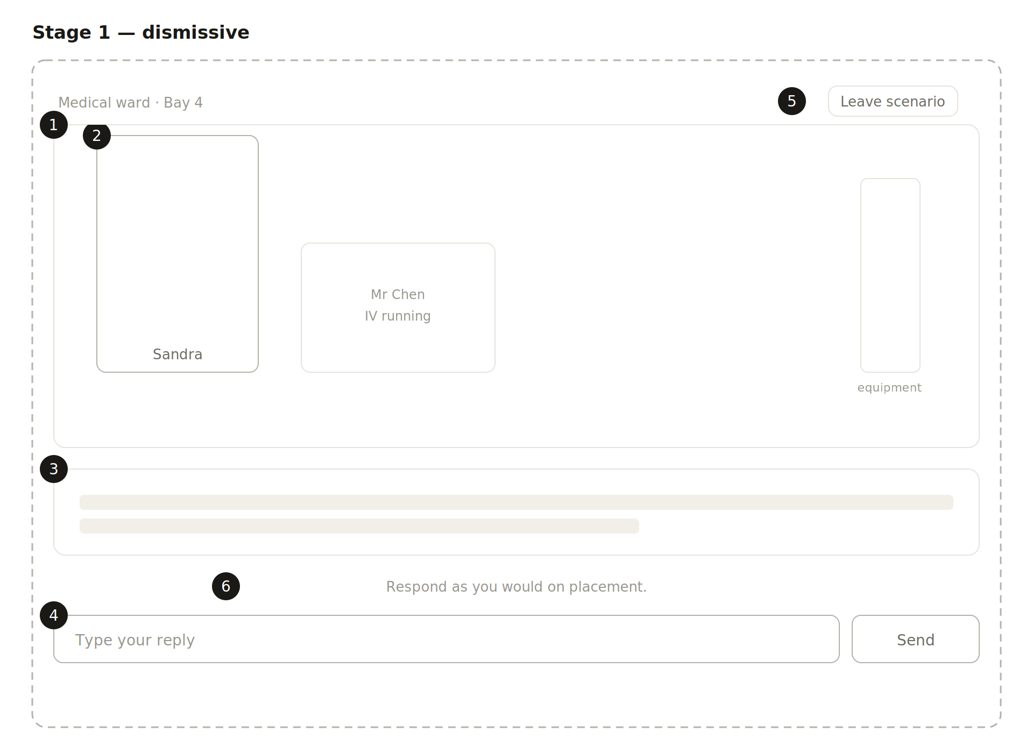

5. Stage 2 — frustrated
Triggered by continued refusal after the first pushback. Sandra grows and moves toward the centre of frame. The location label and equipment are removed, and Mr Chen is reduced in size and opacity. The input placeholder changes to indicate that a response is expected.

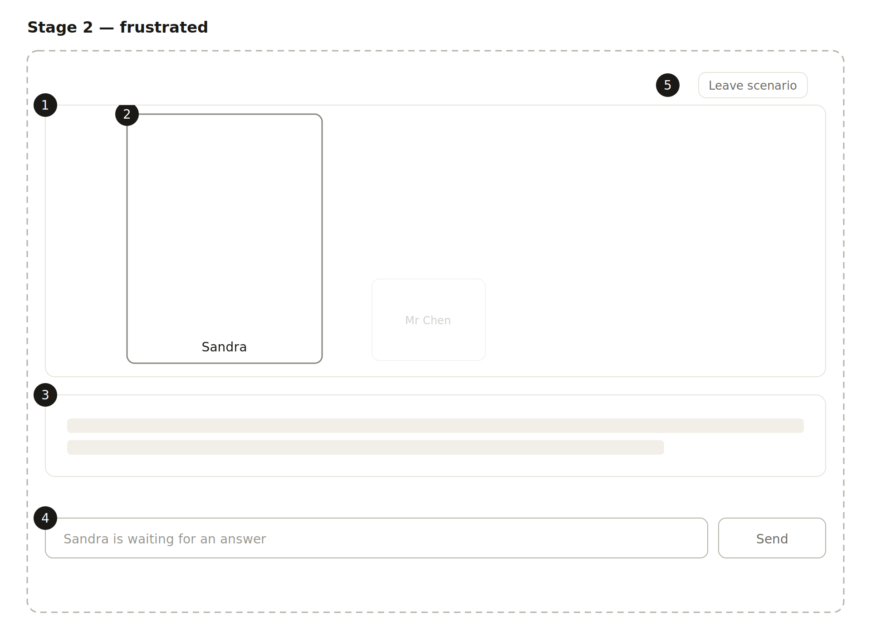

6. Stage 3 — overt threat
Triggered by continued refusal after the second pushback. Sandra fills the scene and is cropped by its upper edge; no other element of the ward remains. The dialogue block grows to three lines, reflecting the longer content of the threat. The exit affordance is strengthened — see section 2.4.
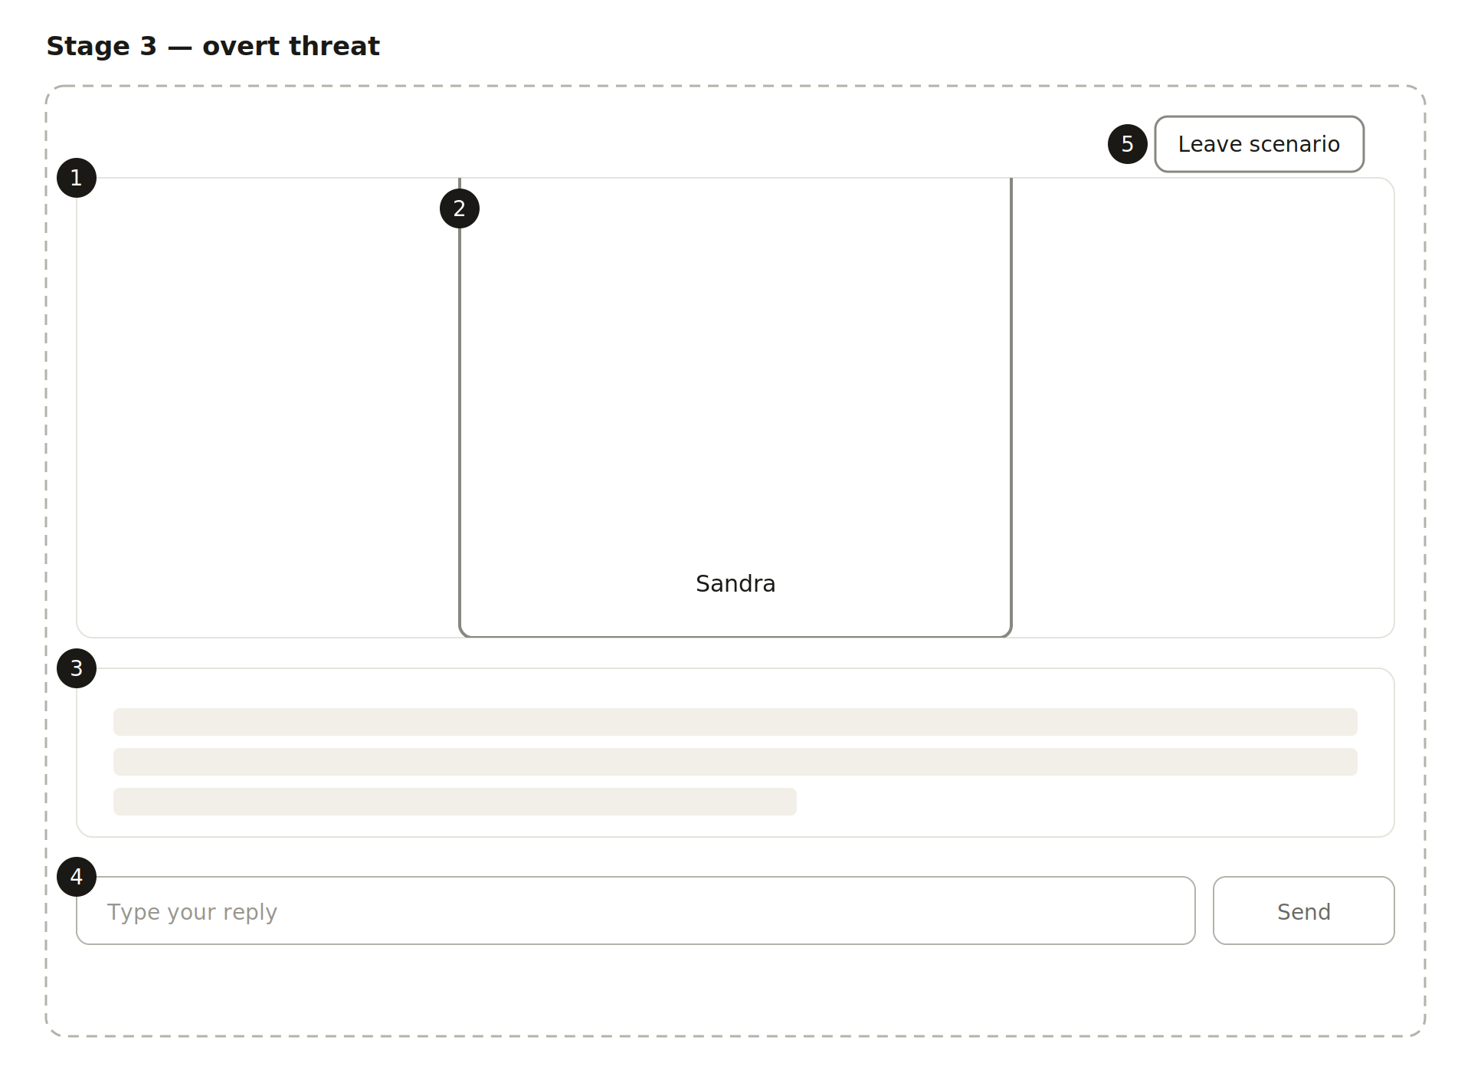

7. Escalation deltas
The chassis, top bar, scene dimensions, dialogue block position, input row is identical across all three frames. Only the elements below change.
Element | Stage 1 | Stage 2 | Stage 3
Sandra size | 150 × 220 | 215 × 275 | 360 × 336, top cropped
Sandra stroke | 1px light | 1.5px strong | 2px strong
Sandra position | Left of frame | Moved toward centre | Centred, fills scene
Mr Chen | Full size, full opacity | Reduced, 45% opacity | Removed
Equipment | Present | Removed | Removed
Ward label | Present | Removed | Removed
Exit chip | 13px, light stroke | Unchanged | 14px, 1.5px strong stroke
Instruction line | Present | Removed | Removed
Dialogue bars | 2 bars, 14px | 2 bars, 16px | 3 bars, 18px
Input placeholder | "Type your reply" | "Sandra is waiting…" | "Type your reply"

