VISIONGUARD AWAKE
Real-Time Driver Drowsiness and Yawn Monitoring System
Bring Your Own Project (BYOP)
Computer Vision Course
VIT Bhopal University

Student Name | __________________
Registration Number | __________________
Department | CSE (AI & ML)
Date | __________________

Abstract
Road accidents caused by fatigue are a serious safety issue. VisionGuard Awake is a lightweight computer vision prototype that uses a webcam, OpenCV, and MediaPipe FaceMesh to monitor a driver’s face in real time and detect two common visual signs of fatigue: prolonged eye closure and repeated yawning. The system computes eye and mouth geometry, applies temporal decision rules, and raises an alert when risk patterns are detected. It also stores event logs and snapshots for later review. This project demonstrates a practical application of computer vision using accessible tools and a real-world use case that is clearly different from document-scanning systems.

1. Problem Statement
Drowsy driving reduces reaction time, lowers concentration, and can lead to microsleep episodes. In many cases, fatigue symptoms become visible on the face before a dangerous event occurs.
This project addresses the following question: Can a webcam-based computer vision system detect signs of driver drowsiness such as prolonged eye closure and repeated yawning in real time and alert the user?

2. Why This Problem Matters
The chosen problem has direct real-world value because it is related to road safety and human awareness.
It is also well aligned with the course because it uses live image capture, face analysis, landmark interpretation, geometric feature extraction, and rule-based visual decision making.

3. Project Objectives
- Build a real-time face-based monitoring system using a standard webcam
- Detect prolonged eye closure using facial landmarks and Eye Aspect Ratio (EAR)
- Detect yawning using mouth landmarks and Mouth Aspect Ratio (MAR)
- Generate visible and audible alerts when fatigue symptoms appear
- Log important events and save snapshots for review
- Organize the code in a clean, modular, reusable structure

4. System Pipeline
The solution follows a simple but effective vision pipeline. Frames are captured from a webcam, facial landmarks are extracted using MediaPipe FaceMesh, the eye and mouth regions are converted into geometric ratios, and a temporal logic layer determines whether an alert should be triggered.
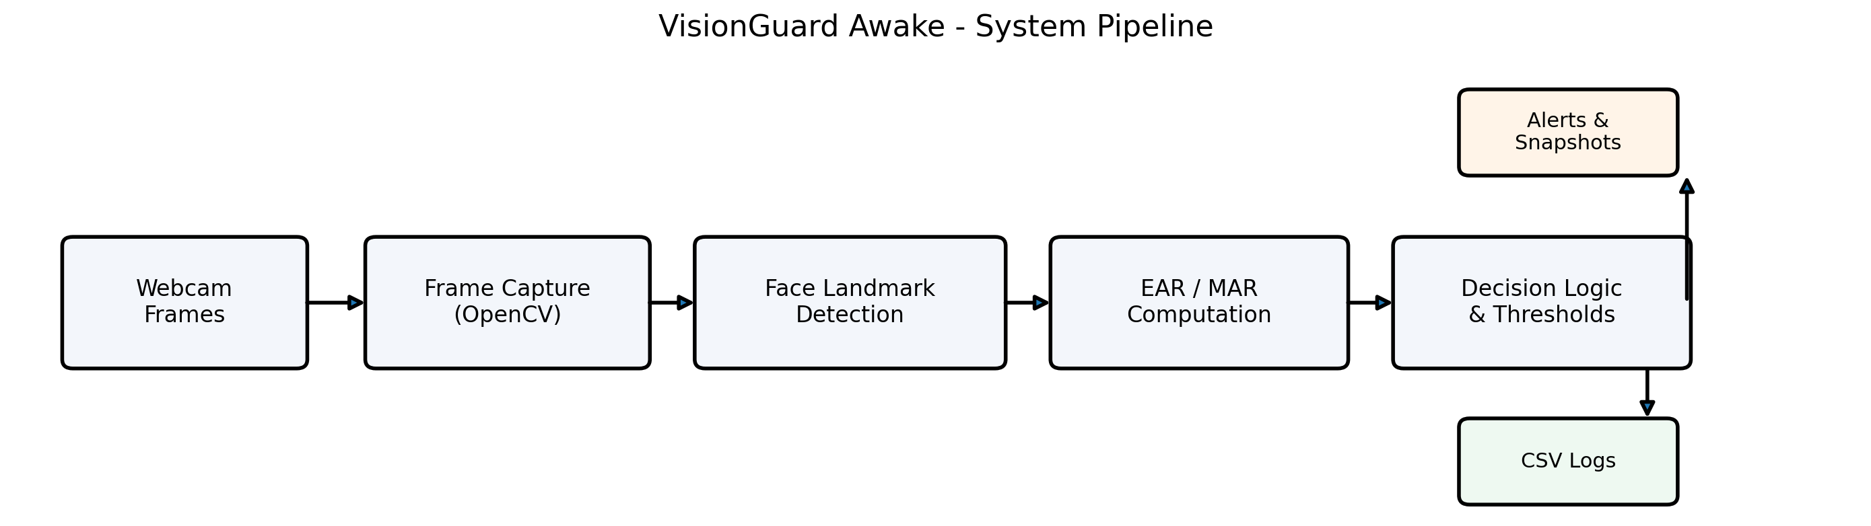
Figure 1. High-level workflow of VisionGuard Awake.

5. Core Methodology

5.1 Face Landmark Detection
MediaPipe FaceMesh is used to detect detailed facial landmarks in real time. This avoids the need to train a custom facial model and keeps the system lightweight enough for ordinary laptops.

5.2 Eye Aspect Ratio (EAR)
EAR is computed from selected eye landmarks. When the eye is open, the vertical distances between the eyelids remain noticeable. When the eye closes, those vertical distances shrink while the horizontal eye width stays comparatively stable, causing the ratio to decrease.

5.3 Mouth Aspect Ratio (MAR)
MAR is computed using mouth width and mouth opening. A large MAR sustained across several frames is treated as a yawn event candidate. Repeated yawns inside a rolling time window are interpreted as a sign of fatigue.

5.4 Temporal Logic
Single-frame decisions are unreliable because natural blinking, speaking, or head movement can mimic fatigue. To reduce false alarms, the system checks for consecutive low-EAR frames and repeated yawns across time.

6. Technologies Used
Component | Tool | Purpose
Programming | Python | Main implementation language
Vision processing | OpenCV | Webcam capture, drawing, display
Face analysis | MediaPipe FaceMesh | Real-time facial landmark detection
Numerical support | NumPy | Lightweight numeric operations
Logging | CSV | Store detected warning events

7. Key Design Decisions
A landmark-geometry approach was selected instead of training a deep learning classifier from scratch because it is interpretable, faster to implement, and suitable for real-time execution on standard hardware.
Thresholds and runtime parameters were centralized in a configuration file so that the system can be tuned for different users and webcam conditions.
CSV logging and snapshot storage were added to make the prototype feel closer to a practical monitoring system rather than a one-screen demo.

8. Challenges Faced
Threshold sensitivity was one of the main challenges because people differ in facial structure, blinking style, and speaking behavior.
Low light, occlusion, glasses, and side-face angles can reduce landmark quality and introduce false positives.
Another challenge was balancing responsiveness with stability. A very aggressive system gives more false alarms, while a very conservative system may react too late.

9. Results and Observations
The final prototype completes the full pipeline of webcam capture, landmark extraction, EAR/MAR computation, temporal reasoning, and event recording.
Evaluation for this project is qualitative and functional rather than benchmark-based. The success criterion is whether the system reacts meaningfully to visible simulated fatigue cues in a live webcam setting.

10. Limitations
- The system assumes a clearly visible single face.
- Performance depends on webcam quality and lighting conditions.
- It uses manually chosen thresholds rather than personalized learned models.
- It is a prototype and not a certified automotive safety solution.

11. Future Improvements
- Head pose estimation for nodding detection
- Gaze or distraction monitoring
- Mobile or embedded deployment
- Personalized threshold calibration
- A learned fatigue score combining multiple facial cues

12. Learning Outcomes
This project strengthened my understanding of live frame processing, face landmark analysis, feature engineering, temporal logic, and practical system design in computer vision.
It also showed that meaningful vision systems do not always require heavy model training; sometimes a careful classical pipeline is the right engineering choice.

13. Conclusion
VisionGuard Awake is a practical, purposeful, and well-scoped BYOP project. It applies core computer vision ideas to a real safety problem and produces a complete prototype with clear inputs, outputs, and documentation. The project is distinct from document-scanning applications and is easy to demonstrate during evaluation.

