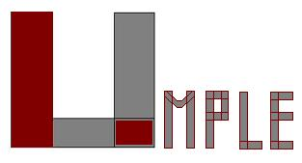

Uottawa

**The Model-Oriented**

**Programming Technology**

***A new way to program. A new way to design. A new way to learn.***

Works with Java, C++, PhP

**Add UML model concepts to code**

**or**

**Add code to UML**

**Create UML textually**

**or**

**Program from a diagram**

|  |
| --- |
| Generate state-of-the-art code for |
| * State machines |
| * Associations with referential integrity |
| * Concurrency |
| * Patterns |

Raise software productivity

* Build systems quickly from models
* Reduce code volume
* Generate documentation

|  |
| --- |
| Improve software quality |
| * Umple is written in itself |
| * Four levels of testing |

Teach and learn modeling faster

* Students ‘get’ modeling finally
* Demonstrated to improve grades

|  |
| --- |
| Adopt modeling incrementally into |
| existing code: *umplification* |

Key websites:

UmpleOnline: <http://try.umple.org>

Open source code: <http://code.umple.org>

User manual: <http://manual.umple.org>

|  |
| --- |
| Umple = |
| UML Programming Language |
| + Ample |
| + Simple |

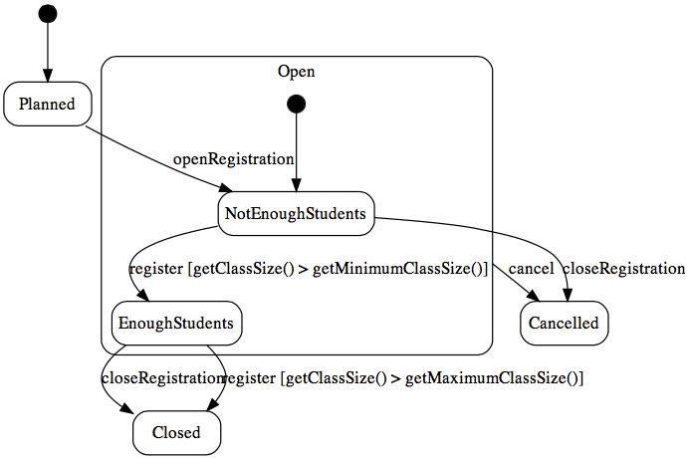

Sample

state diagram generated by Umple

Sample

class diagram for editing the Umple below

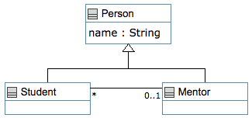

Sample Umple textual model + code

|  |  |
| --- | --- |
| 1 | class Person { |
| 2 | name; // Attribute, string by default |
| 3 | String toString () { |
| 4 | return(getName()); |
| 5 | } |
| 6 | } |
| 7 |  |
| 8 | class Student { |
| 9 | isA Person; |
| 10 | } |
| 11 |  |
| 12 | class Mentor { |
| 13 | isA Person; |
| 14 | } |
| 15 |  |
| 16 | association { |
| 17 | 0..1 Mentor -- * Student; |
| 18 | } |