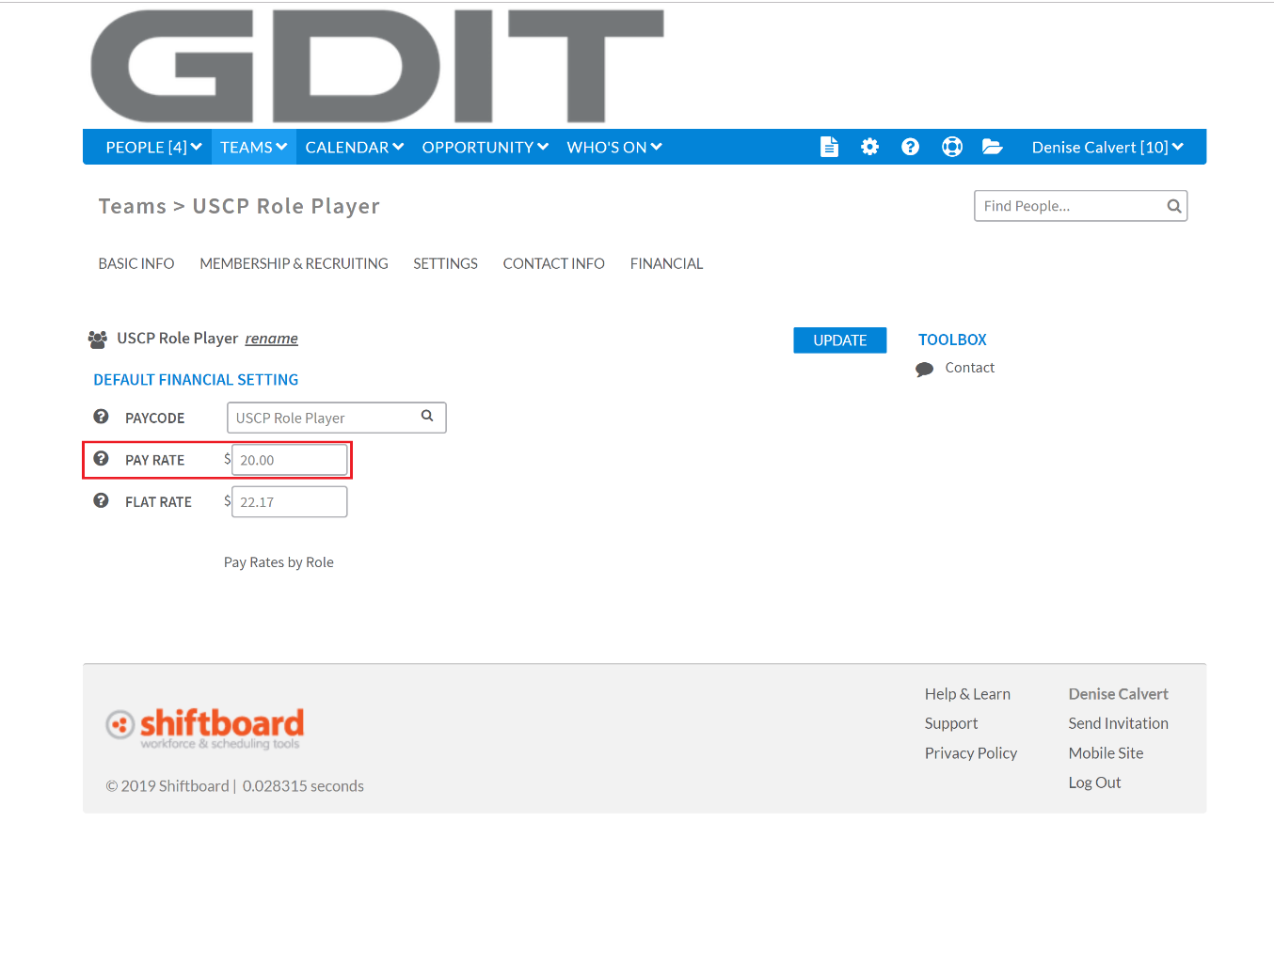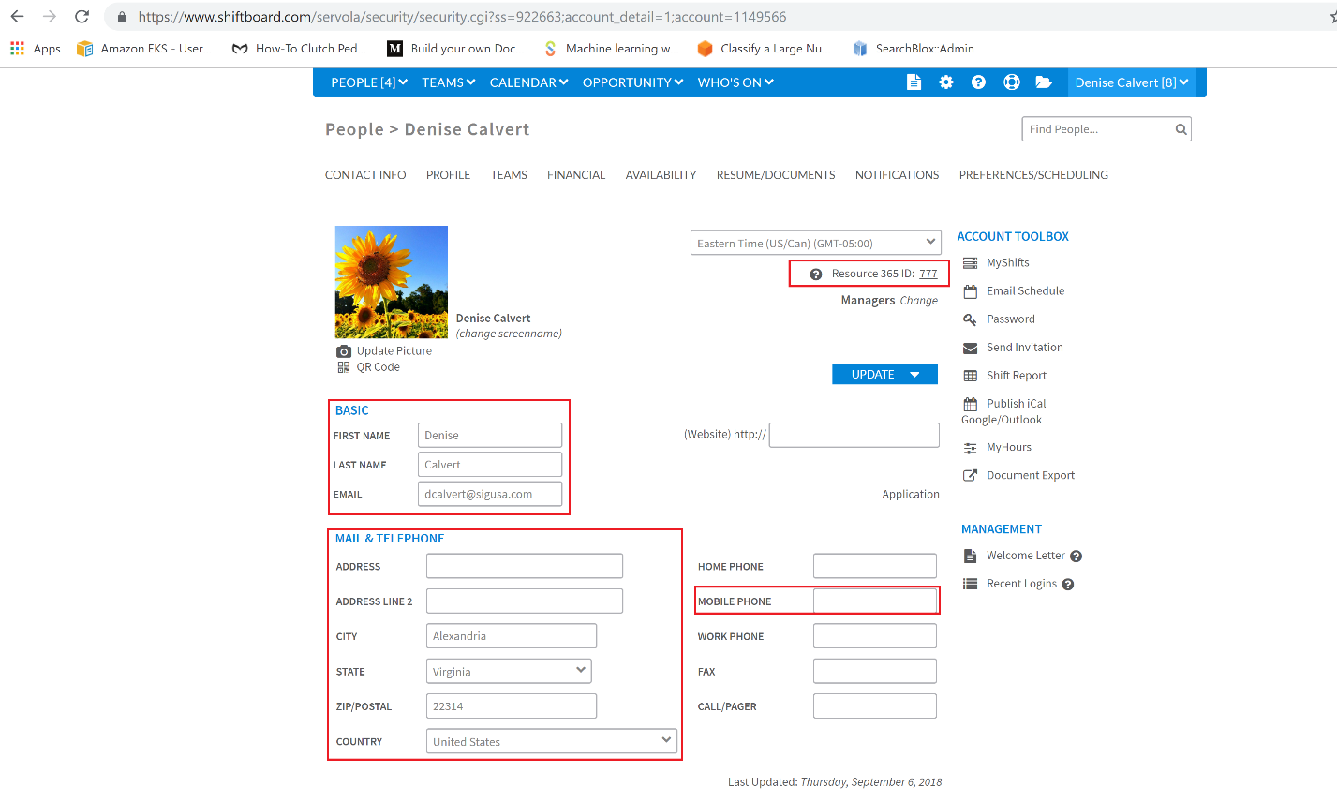

Teams Pay Rate

PO- the shiftboard field name is (external ID)

Pay rate

Required personal information for invoice

User Profile Example

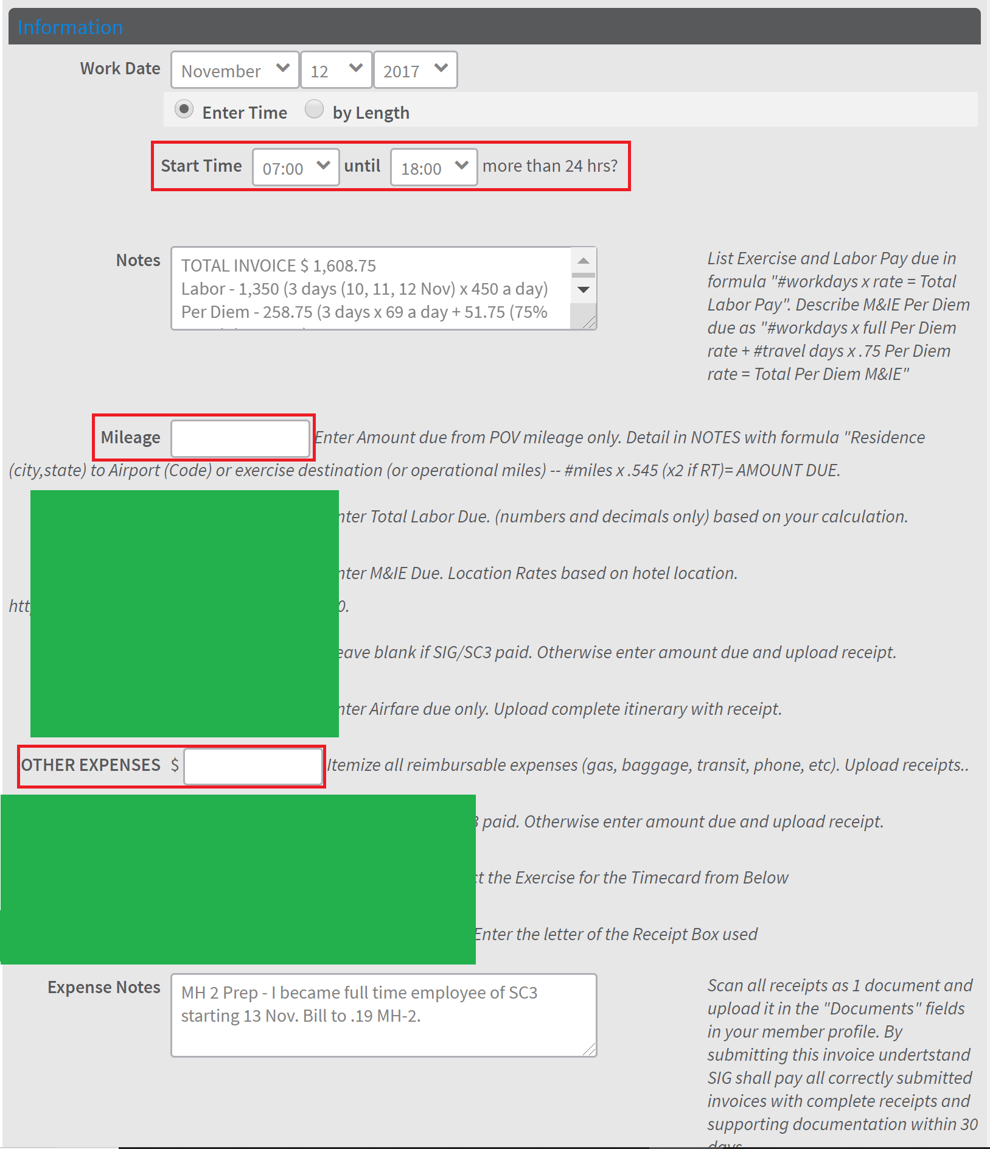

This is where miles go

This is the ODC field

Timecard Example

**RED: Mandatory**

**GREEN: No relevance**

Invoice Example

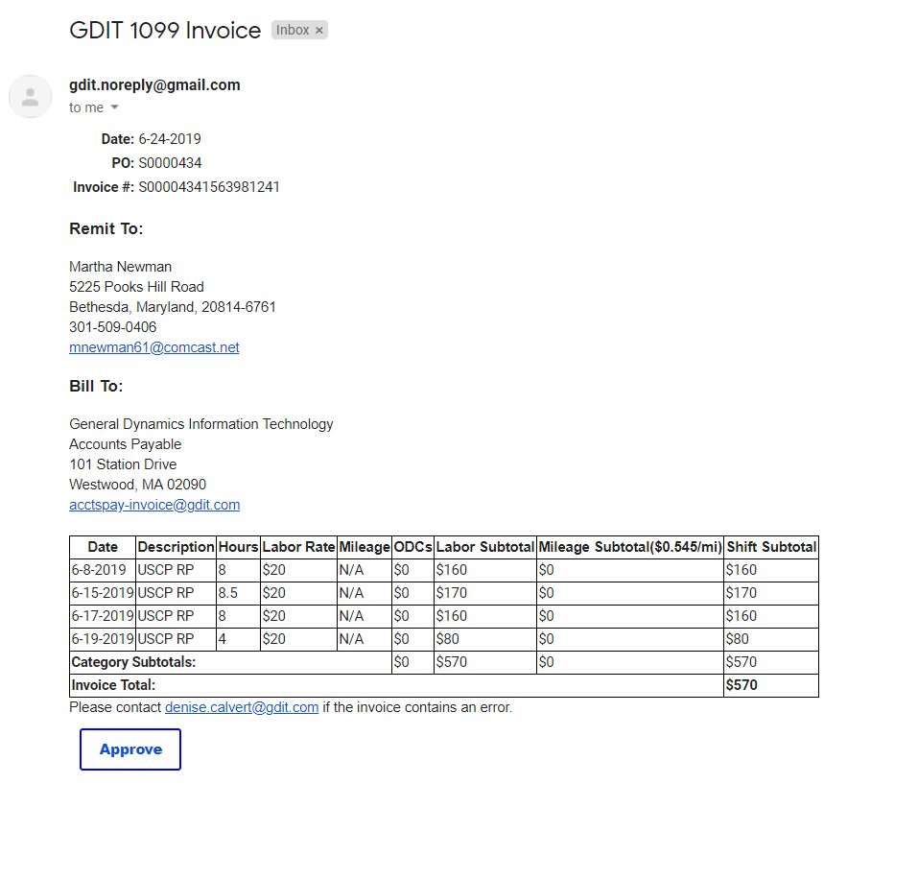

All of the 1099s required information for invoice validity

PO grabbed from the external id tag on the user profile

User Guide

1.The **red fields** are the 1099s basic mandatory information that is required for the remit to part of the invoice, without this the invoice would be valid and not comply with regulations.

2.The **PO** is the most important part and should always be checked that it is present otherwise the invoice is invalid as well

3. Make sure that the **payrate** is filled in otherwise the timecard will be full of zeros and calculate the money due as zero

4. On the timecard use the Start Time box to put in the hours, hours worked is currently getting grabbed from the shift

5. **Mileage** on the timecard is entered in as miles not the calculated amount the calculated amount as was previously done, this makes it easier for the 1099s to check that the correct miles have been entered, the program will do the calculate from a provided rate and display the rate and final amount on the invoice.

7. **ODCs (Other Expenses)** The program will be looking at the other expenses field for all ODCs so the final ODC total should be placed into that field, the green fields

6. If you are using the green outlined fields for clarity add up all of them and put the total into the other expenses field only. This is the field that the program is looking at for ODCs, if it is left blank the program will make it zero and it will not be added to the timecard.