Lab Assignment – 3
NAME : LUNAGARIYA RAJVI
ENROLLMENT NO : 24SOECE11019
DIV : CE-A
ROLL_NO : 11

1 : Draw a real picture for class and object. Differentiate class and object in terms of diagram only. Perform following tasks.
Task 1: Create a class
Task 2: Add few data members as private
Task 3: Add few methods as public to work on defined data members Task 4: Create a Demo class with main method.
Task 5: Create at least two objects of a class defined in Task 1 into main method and call all methods using that object.
Task 6: Write comment for each important portion of code like data members’ declaration, methods, some important logic etc.
Task 7: Summarize above solution in your own few words to visualize the solution to the end user.
using System; using System.Collections.Generic; using System.Linq; using System.Text; using System.Threading.Tasks;

namespace TUTORIAL_3

{ class Student
{
private int enroll; private string name; private string branch;

public void AcceptData(int e, string n, string b)
{
enroll = e; name = n;
branch = b;
}

public void DisplayData()
{
Console.WriteLine("---------Student Details--------");
Console.WriteLine("Enrollment No : " + enroll);
Console.WriteLine("Name : " + name);
Console.WriteLine("Branch : " + branch);
}
class T3Q1
{
public static void Main(string[] args)
{
Console.WriteLine("Name : rajvi lunagariya");
Console.WriteLine("Enrollment No : 24SOECE11019 ");

Student s1 = new Student(); Student s2 = new Student();

s1.AcceptData(101, "Drashti", "Computer Science");
Console.WriteLine("Details of Student 1"); s1.DisplayData();

s2.AcceptData(102, "Shreeya", "Computer Science");
Console.WriteLine("Details of Student 2"); s2.DisplayData();
}
}
}
}

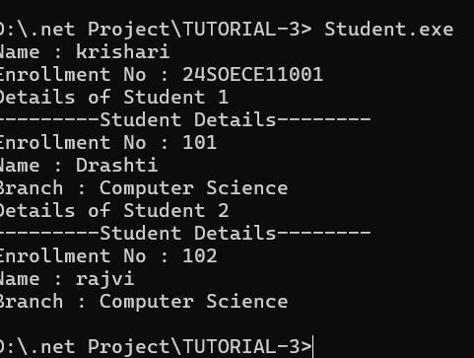

2 : Define a class Clock with three private integer data members hour, min and sec. Define a no argument constructor to initialize time value to 12:00:00. Define a three argument constructor to initialize the time. Define a methods to
- Increment time to next second.
- Display the time value.
- Return the hour (int getHour())
- Return the minute (int getMinute())
- Return the seconds (int getSeconds())
using System; using System.Collections.Generic; using System.Linq; using System.Text; using System.Threading.Tasks;
namespace TUTORIAL_3

{ class clock

{
private int hour; private int min; private int sec;

//no argument constructor public clock()
{ hour = 12; min = 0; sec = 0;
}

//parameterized constructor public clock(int h, int m, int s)
{
hour = h;
min = m; sec = s;
}

public void IncrementTime()
{ sec++;

if (sec == 60)
{ sec = 0; min++;

if (min == 60)
{ min = 0; hour++;

if (hour == 24) hour = 0;
}
}
}

public void Display()
{
Console.WriteLine("{0:D2}:{1:D2}:{2:D2}", hour, min, sec);
}

public int GetHour()
{ return hour;
}

public int GetMinutes()
{
return min;

}

public int GetSecond()
{ return sec;
}
}

class T3Q2
{
static void Main()
{
Console.WriteLine("Name : rajvi lunagariya");
Console.WriteLine("Enrollment No : 24SOECE11019 ");
clock c = new clock();
Console.WriteLine("Current Time:");
c.Display();

c.IncrementTime();

Console.WriteLine("After increment:");

c.Display();

Console.Read();
}
}
}

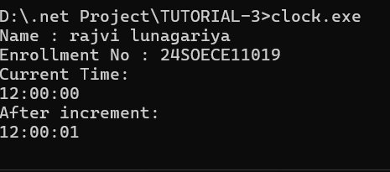

3 : Define a Student class with appropriate data members, property, constructors, methos etc. Define another class called TestStudent within the same .cs file. Also create an object of student class and demonstrate the use of student class.
using System;
using System.Collections.Generic; using System.Linq; using System.Text; using System.Threading.Tasks;

namespace TUTORIAL_3

{ class Student
{
public int Id; public string Name;
public int id
{
get { return Id; }
set { Id = value; }
} public string name { get { return Name; }
set { Name = value; }

} public Student()
{
Id = 1;
Name = "unknown";
} public Student(int i, string n)
{
Id = i;
Name = n;
}
public void display()
{

Console.WriteLine("Id: " + Id);
Console.WriteLine("Name: " + Name);
}
}

class class5
{

static void Main(string[] args)

{
Console.WriteLine("Name : rajvi lunagariya");
Console.WriteLine("Enrollment No : 24SOECE11019 ");

Student s = new Student(101,"shreeya"); s.display();
}

} }

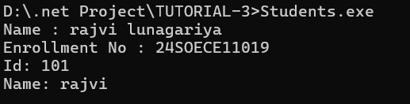

4 : Use above program classes and create objects for 5 students and demonstrate the use student class.
using ConsoleApp1; using System;
using System.Collections.Generic; using System.Linq; using System.Text; using System.Threading.Tasks;
namespace TUTORIAL_3

{
public class Student2
{
public int Id; public string Name;
public int id
{

get { return Id; } // read value of id set { Id = value; } // write value of id
}

public string name
{
get { return name; } // read value of id set { Name = value; } // write value of id
}

//Parameterized Constructure

public Student2()
{
Id = 1;
Name = "Unknown";
}

//Static Method
public Student2(int i, string n)
{
Id = i;
Name = n;
}
public void Display()
{

Console.WriteLine("Id : " + Id);
Console.WriteLine("Name : " + Name);
}
} }

class Class3
{ static void Main(string[] args)
{
Console.WriteLine("Name : rajvi lunagariya");
Console.WriteLine("Enrollment No : 24SOECE11019 ");

Student2 s1 = new Student2(101, "Drashti"); Student2 s2 = new Student2(102, "Shreeya"); Student2 s3 = new Student2(103, "Krishna"); Student2 s4 = new Student2(104, "Jinal"); Student2 s5 = new Student2(105, "Jaldhara");

s1.Display(); s2.Display(); s3.Display(); s4.Display(); s5.Display();

Console.ReadLine();
}
}

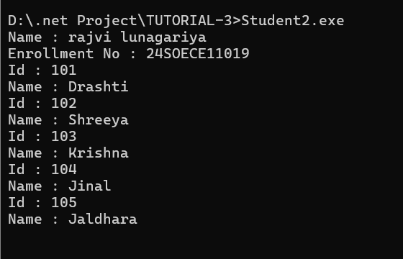

5 : Rearrange the given code to get the desired output.
using System;

namespace TUTORIAL_3

{

class Product

{ int pcode; string pname; string mname;

public Product(int pcd, String pnm, String mnm)

{
pcode = pcd; pname = pnm; mname = mnm;

}
public void Display()
{

Console.WriteLine("Name : rajvi lunagariya");
Console.WriteLine("Enrollment No : 24SOECE11019 ");
Console.WriteLine("product code is := " + pcode);
Console.WriteLine("product name is := " + pname);
Console.WriteLine("manufacturer name is := " + mname);

}
}

public class Class4

{

public static void Main(string[] args)

{
Console.WriteLine("Name : rajvi lunagariya");
Console.WriteLine("Enrollment No : 24SOECE11019 "); int n = args.Length;

if (args.Length < 3)
{

Console.WriteLine("Syntax Error"); return;
}

int pcd = Convert.ToInt32(args[0]); string pnm = args[1]; string mnm = args[2];
Product p = new Product(pcd, pnm, mnm);

p.Display();

Console.Read();

}
}
}

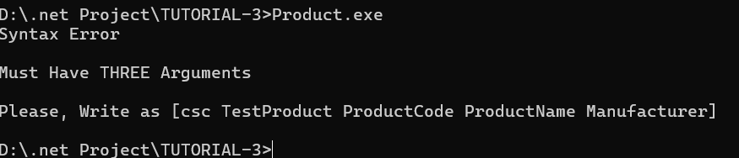

6 : Complete the following code that will generate the given output:
using System;

namespace TUTORIAL_3

{

class Line

{

private double length; // Length of a line
public Line()
{

//………………………………Missing statement-1……………………………….//

Console.WriteLine("Object is being creating value length = 10");

//………………………………Missing statement-2……………………………….// length = 10;
}
public void setLength(double len)

{

//………………………………Missing statement-3……………………………….// length = len;
}

public double getLength()

{

//………………………………Missing statement-4……………………………….// return length;
}
}

class Class6

{
static void Main(string[] args)

{
Console.WriteLine("Name : rajvi lunagariya");
Console.WriteLine("Enrollment No : 24SOECE11019 ");

Line line = new Line();

// set line length

Console.WriteLine("Length of line : {0}", line.getLength());

// set line length line.setLength(6);
Console.WriteLine("Length of line : {0}", line.getLength());

Console.ReadKey();

}
}
}

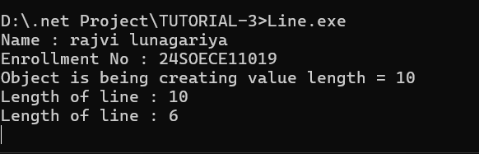

7 : Define EnrolmentNo and Name properties for the Student class and demonstrate use of these properties along with required data members, methods and constructors.
(Classes, Objects and Constructors)
using ConsoleApp1; using System; using System.Collections.Generic; using System.Linq; using System.Text; using System.Threading.Tasks;
namespace TUTORIAL_3

{

class StudentDetails
{ private int enroll; private string name;

//Property Data Member

public int e
{
get { return enroll; }
set { enroll = value; }
}
public string n
{
get { return name; } set { name = value; }
}

//Empty Constructure

public StudentDetails()
{
}
public StudentDetails(int e, string n)
{ enroll = e;
name = n;
}
public void Display()
{
Console.WriteLine("Name : rajvi lunagariya");
Console.WriteLine("Enrollment No : 24SOECE11019 "); }
} }

class Class7
{ static void Main(string[] args)
{
Console.WriteLine("Name : shreeya vekariya");
Console.WriteLine("Enrollment No : 24SOECE11050 ");

StudentDetails s = new StudentDetails(); Console.WriteLine("Enter Enrollment Number : ");
s.e = Convert.ToInt32(Console.ReadLine());

Console.WriteLine("Enter Name : "); s.n = Console.ReadLine();

s.Display(); Console.ReadLine();
} }

8. A program to accept and display student details using a class, objects, constructors, and methods.
using ConsoleApp1; using System;
using System.Collections.Generic; using System.Linq; using System.Text; using System.Threading.Tasks;
namespace TUTORIAL_3

{

class StudentDetails1
{
private int enroll; private string name; private string course;

public StudentDetails1(int e, string n, string c)
{
enroll = e; name = n;
course = c;
}
public void Display()
{
Console.WriteLine("Enrollment No : " + enroll);
Console.WriteLine("Name : " + name);
Console.WriteLine("Course : " + course);
}
} }

class Class8
{
static void Main()
{
Console.WriteLine("Name : rajvi lunagariya");
Console.WriteLine("Enrollment No : 24SOECE11019 ");

Console.WriteLine("Enter Enrollment Number : "); int e = Convert.ToInt32(Console.ReadLine());

Console.WriteLine("Enter Name : "); string n = Console.ReadLine();

Console.WriteLine("Enter Course : "); string c = Console.ReadLine();

StudentDetails1 s = new StudentDetails1(e, n, c);

s.Display(); Console.ReadLine();
} }

9. A program to create a clock, display the current time, and increment it by one second.
using System;
using System.Collections.Generic; using System.Linq; using System.Text; using System.Threading.Tasks;

namespace TUTORIAL_3

{

class clock1

{
private int hour; private int min; private int sec;

//no argument constructor
public clock1()
{
hour = 12; min = 0; sec = 0;

} //parameterized constructor
public clock1(int h, int m, int s)
{ hour = h; min = m; sec = s;
}

public void IncrementTime()
{ sec++;

if (sec == 60)
{ sec = 0; min++;

if (min == 60)
{ min = 0; hour++;

if (hour == 24) hour = 0;
}
}
}

public void Display()
{
Console.WriteLine("{0:D2}:{1:D2}:{2:D2}", hour, min, sec);
}

}

class Class9
{
static void Main()
{
Console.WriteLine("Name : rajvi lunagariya");
Console.WriteLine("Enrollment No : 24SOECE11019 ");
clock1 c = new clock1();
Console.WriteLine("Current Time:"); c.Display();

c.IncrementTime();
Console.WriteLine("After increment:"); c.Display();

Console.Read();
}
} }

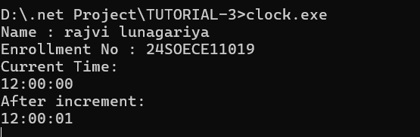

10. A program to accept employee details and calculate the net salary using constructors and methods.
using System;
using System.Collections.Generic; using System.Linq; using System.Security.AccessControl; using System.Text; using System.Threading.Tasks;

namespace TUTORIAL_3
{

class EmployeeDetails
{
private int empid; private string empName; private double basicSalary; private double netsalary;

public EmployeeDetails(int id, string name, double salary)
{
empid = id; empName = name; basicSalary = salary;
}

public void CalculateSalary()

{

double hra = basicSalary * 0.20; // Assuming 20% HRA double da = basicSalary * 0.10; // Assuming 10% DA

netsalary = basicSalary + hra + da; // Assuming 10% deduction for taxes
}

public void DisplayEmployeeDetails()
{

Console.WriteLine("----Employee Details------");
Console.WriteLine("Employee id is:" + empid);
Console.WriteLine("Employee name is:" + empName);
Console.WriteLine("Employee basic salary is:" + basicSalary);
Console.WriteLine("Employee net salary is:" + netsalary);
}
}

class Class10
{
public static void Main(string[] args)

{

Console.WriteLine("Name : rajvi lunagariya");
Console.WriteLine("Enrollment No : 24SOECE11019 ");

Console.Write("enter Employee id:"); int id = Convert.ToInt32(Console.ReadLine());

Console.Write("enter name:"); string name = Console.ReadLine(); Console.Write("enter salary:");
double salary = Convert.ToDouble(Console.ReadLine());

EmployeeDetails emp = new EmployeeDetails(id, name, salary); emp.CalculateSalary(); emp.DisplayEmployeeDetails();

Console.ReadLine();

}
} }

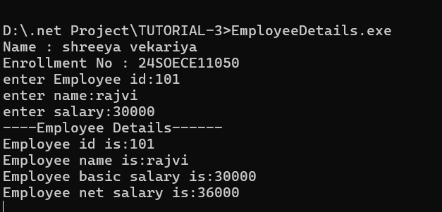

11. A program to create multiple bank accounts and perform deposit, withdrawal, and balance enquiry operations.

using System;
using System.Collections.Generic; using System.Linq; using System.Text; using System.Threading.Tasks;

namespace TUTORIAL_3
{

class BankAccount
{
private string accountNo; private string accountHolder; private double balance;
public BankAccount(string accNo, string Holder, double amount)
{
accountNo = accNo; accountHolder = Holder;
balance = amount;
}
public void Deposit(double amount)
{

balance += amount;
Console.WriteLine("amount deposited successfully.");

}
public void Withdraw(double amount)
{
if (amount <= balance)
{
balance -= amount;
Console.WriteLine("amount withdrawn successfully.");
} else
{
Console.WriteLine("Invalid withdrawal amount.");
}
}

public void BalancsEnquiry()
{
Console.WriteLine("Account Number: " + accountNo);
Console.WriteLine("Account Holder Name:" + accountHolder);
Console.WriteLine("Balance balance :" + balance);
}
}

class Class11
{
static void Main(string[] args)
{

BankAccount acc1 = new BankAccount("1001", "rajvi lunagariya", 10000);
BankAccount acc2 = new BankAccount("1002", "mahi vekariya", 15000);

Console.WriteLine("Account 1 Transactions:");

acc1.Deposit(2000); acc1.Withdraw(3000); acc1.BalancsEnquiry();

Console.WriteLine("========================");

Console.WriteLine("Account 2 Transactions:");

acc2.Deposit(5000); acc2.Withdraw(2000); acc2.BalancsEnquiry(); Console.ReadLine();
}
}
}

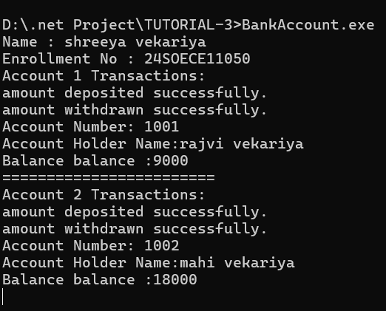

12. A program to accept and display a student's enrollment number and name using properties.
using System;
using System.Collections.Generic; using System.Linq; using System.Text; using System.Threading.Tasks;

namespace TUTORIAL_3

{ class studentDetails
{

public int enroll_no { get; set; } public string name { get; set; }
}

class Class12
{

public static void Main(string[] args)
{
Console.WriteLine("Name : rajvi lunagariya");
Console.WriteLine("Enrollment No : 24SOECE11019 ");

studentDetails studentDetails = new studentDetails();

Console.Write("Enter Enrollment Number : ");
studentDetails.enroll_no = Convert.ToInt32(Console.ReadLine());

Console.Write("Enter Name : "); studentDetails.name = Console.ReadLine();

Console.WriteLine("=========Student Details:===========");

Console.WriteLine("Enrollment Number: " + studentDetails.enroll_no);
Console.WriteLine("Name: " + studentDetails.name);

Console.ReadLine();
}
}
}

13. A program to store product details using properties and display the bill amount.
(Access Specifiers)
using System;
using System.Collections.Generic; using System.Linq; using System.Text; using System.Threading.Tasks;

namespace TUTORIAL_3
{
class pd
{
public int prodid { get; set; } public string name { get; set; } public double price { get; set; } public int quantity { get; set; }

public double CalculateBill()
{
return price * quantity;
}
}

class Class13
{
public static void Main(string[] args)
{
Console.WriteLine("Name : rajvi lunagariya");
Console.WriteLine("Enrollment No : 24SOECE11019 ");

pd product = new pd();
Console.Write("Enter Product ID: ");
product.prodid = Convert.ToInt32(Console.ReadLine());

Console.Write("Enter Product Name: "); product.name = Console.ReadLine();

Console.Write("Enter Product Price: ");
product.price = Convert.ToDouble(Console.ReadLine());

Console.Write("Enter Product Quantity: ");
product.quantity = Convert.ToInt32(Console.ReadLine());
double totalBill = product.CalculateBill();
Console.WriteLine("=========Product Details:===========");
Console.WriteLine("Product ID: " + product.prodid);
Console.WriteLine("Product Name: " + product.name);
Console.WriteLine("Product Price: " + product.price);
Console.WriteLine("Product Quantity: " + product.quantity);
Console.WriteLine("Total Bill Amount: " + totalBill);

Console.ReadLine();
}
} }

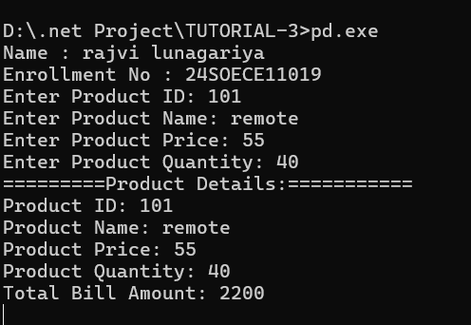

14. A program to restrict direct access to employee salary while allowing controlled access through public methods.

using System;
using System.Collections.Generic; using System.Linq; using System.Text; using System.Threading.Tasks;

namespace TUTORIAL_3
{
internal class Employee
{

private double salary; //public method set salary

public void SetSalary(double amount)
{
salary = amount;
}

public double GetSalary()
{
return salary;
}
}

class Class14
{
public static void Main(string[] args)
{
Console.WriteLine("Name : rajvi lunagariya");
Console.WriteLine("Enrollment No : 24SOECE11019 ");

Employee emp = new Employee();

Console.Write("Enter Employee Salary: "); double amount = Convert.ToDouble(Console.ReadLine());
emp.SetSalary(amount);

Console.WriteLine("Employee Salary: " + emp.GetSalary());

Console.ReadLine();
}
}

}

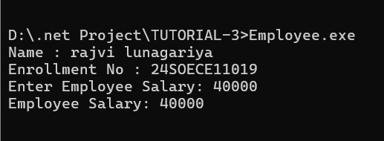

(Inheritance)

15.A program to inherit personal information into a student class and display complete details.

using System;
using System.Collections.Generic; using System.Linq; using System.Text; using System.Threading.Tasks;

namespace TUTORIAL_3
{ internal class Person
{ public int age { get; set; }
public string gender { get; set; }

public void DisplayPersonDetails()
{
Console.WriteLine("------------person details----------");
Console.WriteLine("Age of person : " + age);
Console.WriteLine("Gender of person : " + gender);
}
}

//childe class

class Student1 : Person
{
public int enroll_no { get; set; }
public string name { get; set; }

public void DisplayStudentDetails()
{
Console.WriteLine("------------student details----------");
Console.WriteLine("Enrollment number of student : " + enroll_no);
Console.WriteLine("Name of student : " + name);
}
}

class Class15
{
public static void Main(string[] args)
{

Student1 s = new Student1();

Console.WriteLine("Name : rajvi lunagariya");
Console.WriteLine("Enrollment No : 24SOECE11019 ");

Console.Write("Enter Student Age: ");

s.age = Convert.ToInt32(Console.ReadLine());

Console.Write("Enter Student Gender: "); s.gender = Console.ReadLine();

Console.Write("Enter Student Enrollment Number: "); s.enroll_no = Convert.ToInt32(Console.ReadLine());

Console.Write("Enter Student Name: "); s.name = Console.ReadLine();

s.DisplayPersonDetails();

s.DisplayStudentDetails(); Console.ReadLine();
}
} }

16. A Program to inherit employee details and calculate salary for different employee categories.
using System;
using System.Collections.Generic; using System.Linq; using System.Text; using System.Threading.Tasks;

namespace TUTORIAL_3

{
internal class Employee1
{
public int EmployeeId { get; set; }
public string Name { get; set; }

public double BasicSalary { get; set; }

}

class PermanentEmployee : Employee1
{

public void CalculateSalary()
{

double hra = BasicSalary * 0.20; double da = BasicSalary * 0.10; double netSalary = BasicSalary + hra + da;

Console.WriteLine("Permanent Employee Salary:");

Console.WriteLine("----------------------------------------");
Console.WriteLine("Employee ID: " + EmployeeId);
Console.WriteLine("Employee Name: " + Name);
Console.WriteLine("Basic Salary: " + BasicSalary);

Console.WriteLine("HRA: " + hra); Console.WriteLine("DA: " + da);
Console.WriteLine("Net Salary: " + netSalary);
}
}

class ContractEmployee : Employee1
{

public void CalculateSalary()
{

double netSalary = BasicSalary;
Console.WriteLine("Contract Employee Salary:");
Console.WriteLine("----------------------------------------");
Console.WriteLine("Employee ID: " + EmployeeId);
Console.WriteLine("Employee Name: " + Name);
Console.WriteLine("Net Salary: " + netSalary);
}
}

class Class16
{
public static void Main(string[] args)
{

PermanentEmployee p = new PermanentEmployee();

p.EmployeeId = 101;
p.Name = "shreeya";
p.BasicSalary = 500000;

p.CalculateSalary();

ContractEmployee c = new ContractEmployee();

c.EmployeeId = 102;
c.Name = "Mahi";
c.BasicSalary = 300000;

c.CalculateSalary();

}

} }

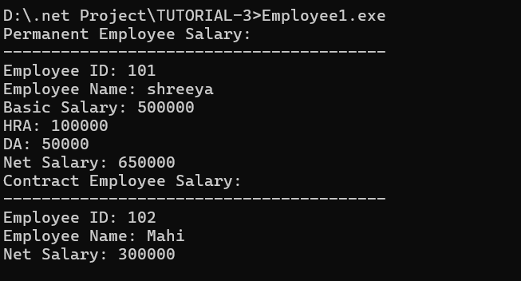

(Method Overriding)

17. A program to calculate the area of different shapes using method overriding.
using System;
using System.Collections.Generic; using System.Linq; using System.Text; using System.Threading.Tasks;
namespace TUTORIAL_3

{
internal class Shape

//virtual will allow the method to be overridden in derived classes //override keyword weitten in the child class method //virtual keyword written in the parent class method
{

public virtual void CalculateArea()
{
Console.WriteLine("Calculating area of shape:");
}
}

class Circle : Shape
{
public override void CalculateArea()
{ double radius = 5;
double area = Math.PI * radius * radius;

Console.WriteLine("Calculating area of circle :" + area.ToString("0.00"));
}
}

class Rectangle : Shape
{
public override void CalculateArea()
{
double length = 10; double width = 5;
double area = length * width;
Console.WriteLine("Calculating area of rectangle:" + area);
}
}

class Triangle : Shape
{
public override void CalculateArea()
{
double b = 10; double h = 5; double area = 0.5 * b * h;
Console.WriteLine("Calculating area of triangle:" + area);
}
}

class Class17
{
public static void Main(string[] args)
{
Console.WriteLine("Name : rajvi lunagariya");
Console.WriteLine("Enrollment No : 24SOECE11019 ");

Shape shape;

shape = new Circle(); shape.CalculateArea();

shape = new Rectangle(); shape.CalculateArea();

shape = new Triangle(); shape.CalculateArea();

Console.ReadLine();
}
} }

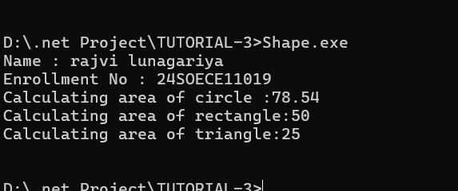

18. A program to generate salary slips for permanent and contract employees using overridden methods.

(Keywords)
using System;
using System.Collections.Generic; using System.Linq; using System.Text; using System.Threading.Tasks;

namespace TUTORIAL_3
{
internal class Employee2
{
public string Name { get; set; }
public double Salary { get; set; }

public virtual void GenerateSalarySlip()
{

Console.WriteLine("Employee Salary Slip");
}
}

class PermanentEmployee2 : Employee2
{
public override void GenerateSalarySlip()
{
double hra = Salary * 0.20; double da = Salary * 0.10; double netSalary = Salary + hra + da;

Console.WriteLine("Permanent Employee Salary Slip:");
Console.WriteLine("----------------------------------------");
Console.WriteLine("Employee Name: " + Name);
Console.WriteLine("Basic Salary: " + Salary);

Console.WriteLine("HRA: " + hra); Console.WriteLine("DA: " + da);
Console.WriteLine("Net Salary: " + netSalary);
}
}

class ContractEmployee2 : Employee2
{
public override void GenerateSalarySlip()
{
double netSalary = Salary;
Console.WriteLine("Contract Employee Salary Slip:");
Console.WriteLine("----------------------------------------");
Console.WriteLine("Employee Name: " + Name);
Console.WriteLine("Net Salary: " + Salary);
}
}

class Class18
{
static void Main(string[] args)
{

Console.WriteLine("Name : rajvi lunagariya");
Console.WriteLine("Enrollment No : 24SOECE11019 ");

emp.Name = "shreeya"; emp.Salary = 30000;

emp.GenerateSalarySlip();

Console.WriteLine();
ContractEmployee2 c = new ContractEmployee2(); c.Name = "mitu";
c.Salary = 30000;

c.GenerateSalarySlip();

Console.Read();
}
} }

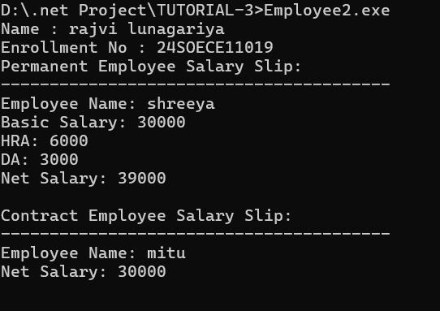

19. A program to count the total number of students created using objects. (static) using System; using System.Collections.Generic; using System.Linq; using System.Text; using System.Threading.Tasks;

namespace TUTORIAL_3

{ class student

{
static int count = 0;

public student()
{
count++;
}
public static void Display()
{
Console.WriteLine("Total number of students: " + count);
}

}

class Class19
{
static void Main(string[] args)
{
Console.WriteLine("Name : rajvi lunagariya");
Console.WriteLine("Enrollment No : 24SOECE11019 ");
student s1 = new student(); student s2 = new student(); student s3 = new student(); student s4 = new student(); student s5 = new student();

student.Display();
}
} }

20. A program to initialize object data using the current object reference. (this)

using System;
using System.Collections.Generic; using System.Linq;
using System.Text; using System.Threading.Tasks;

namespace TUTORIAL_3
{
internal class person1
{ private int age; private string name;

public person(string name, int age)

{
this.age = age;
this.name = name;
}
public void Display()
{
Console.WriteLine("Name: " + name);
Console.WriteLine("Age: " + age);
}
}

class Class20
{
static void Main(string[] args)
{
Console.WriteLine("Name : rajvi lunagariya");
Console.WriteLine("Enrollment No : 24SOECE11019 ");

person p1 = new person("shreeya", 20);

p1.Display();

}
} }
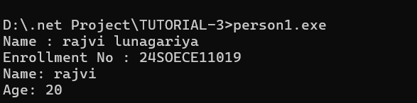

21. A program to initialize inherited data using the base class constructor. (base) using System;
using System.Collections.Generic; using System.Linq; using System.Text; using System.Threading.Tasks;

namespace TUTORIAL_3
{
internal class Employee3
{

protected string designation; protected double salary;

public Employee3(string designation, double salary)
{
this.designation = designation;
this.salary = salary;
}
}

class Department : Employee3 {

private string dept_name;
public Department(string designation, double salary, string dept_name) : base(designation, salary)
{
this.dept_name = dept_name;

}
public void Display()
{

Console.WriteLine("Employee Designation: " + designation);
Console.WriteLine("Employee Salary: " + salary);
Console.WriteLine("Department Name: " + dept_name);
} }

class Class21
{
static void Main(string[] args)
{
Console.WriteLine("Name : rajvi lunagariya");
Console.WriteLine("Enrollment No : 24SOECE11019 "); Department d = new Department("software engineering", 50000, "backend"); d.Display();
}
} }

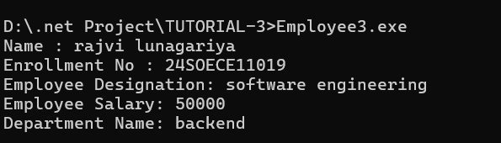

22. A program to display user information by hiding a base class method in the derived class. (new)
using System;
using System.Collections.Generic; using System.Linq; using System.Text; using System.Threading.Tasks;

namespace TUTORIAL_3
{
internal class Employee4
{
public void EmpStatus()
{
Console.WriteLine("Employee working");
}
}

class Department1 : Employee4
{

//new keyword hide method
public new void EmpStatus()
{
Console.WriteLine("Employee is not working");
}
}

class Class22
{

public static void Main(string[] args)
{
Console.WriteLine("Name : rajvi lunagariya");
Console.WriteLine("Enrollment No : 24SOECE11019 ");

d.EmpStatus();
}
} }

Department1 d = new Department1();
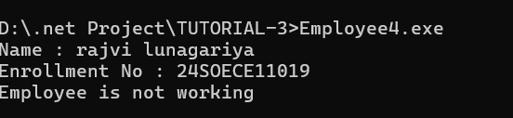

23. A program to calculate interest for different account types using an abstract class. (abstract)

// using an abstract class.

using System;
// Abstract base class

//An abstract class cannot be used to create objects directly.
//It is designed to be a base/parent class for other classes. abstract class Account
{
// Store account amount protected double amount;

// Constructor to set amount
public Account(double amount)
{
this.amount = amount;
}

// Abstract method
public abstract void CalculateInterest(); }

// Saving Account class
class SavingAccount : Account
{
// Constructor
public SavingAccount(double amount) : base(amount) { }

// Calculate saving account interest
public override void CalculateInterest()
{
Console.WriteLine("Saving Account Interest = " + (amount * 4 / 100));
} }

// Current Account class
class CurrentAccount : Account
{
// Constructor
public CurrentAccount(double amount) : base(amount) { }

// Calculate current account interest
public override void CalculateInterest()
{
Console.WriteLine("Current Account Interest = " + (amount * 2 / 100));
}
}

class Class25
{ public static void Main()
{

Console.WriteLine("Name : rajvi lunagariya");
Console.WriteLine("Enrollment No : 24SOECE11019 ");

// Create Saving Account object
SavingAccount a = new SavingAccount(10000);

// Calculate saving account interest a.CalculateInterest(); // Create Current Account object
CurrentAccount b = new CurrentAccount(10000);

// Calculate current account interest b.CalculateInterest();

Console.Read();
} }

24. A program to display student results using a sealed class to prevent further inheritance. (sealed)
using System;
using System.Collections.Generic; using System.Linq; using System.Text; using System.Threading.Tasks;
namespace TUTORIAL_3
{ internal class University
{
private string school_name; private string department_name;

public University(string school_name, string department_name)
{
this.school_name = school_name; this.department_name = department_name;
}
public void Display()
{
Console.WriteLine("School Name: " + school_name);
Console.WriteLine("Department Name: " + department_name);
}
}

class Class23
{

public static void Main(string[] args)
{
Console.WriteLine("Name : rajvi lunagariya");
Console.WriteLine("Enrollment No : 24SOECE11019 "); University u = new University("RK University", "Computer Engineering"); u.Display();
}
} }
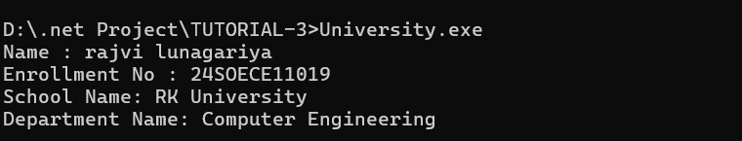

25. A program to validate and modify a password using different string operations.

using System;
using System.Collections.Generic; using System.Linq; using System.Text; using System.Threading.Tasks;

namespace TUTORIAL_3

{ class Class24
{ static void Main()
{
Console.WriteLine("Name : rajvi lunagariya");
Console.WriteLine("Enrollment No : 24SOECE11019 ");

Console.WriteLine("enter password:"); string password = Console.ReadLine();

password = password.Trim();

Console.WriteLine("Password Details");
Console.WriteLine("-------------------------");

Console.WriteLine("Password Length: " + password.Length);
if (password.Length < 8)
{
Console.WriteLine("Password is too short. It should be at least 8 characters long.");
} else
{
Console.WriteLine("Password length is valid.");

if (password.Contains("@") || password.Contains("#") ||
password.Contains("$"))
{
Console.WriteLine("special character : Available.");
} else {
Console.WriteLine("special character : not Available.");
}

Console.WriteLine("Uppercase password: " + password.ToUpper());

Console.WriteLine("Lowercase password: " + password.ToLower());

string modifiedPassword = password.Replace("@", "#");

Console.WriteLine("Modified Password: " + modifiedPassword);
}

Console.ReadLine();
}
} }

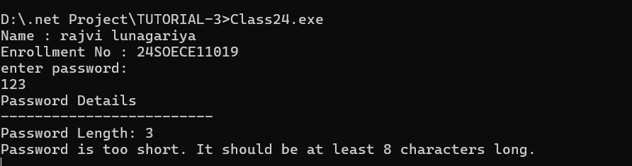

26. A program to format a customer's name using string functions such as trimming, replacing, inserting, and converting case.

using System;

namespace TUTORIAL_3

{ class Class26
{
static void Main()
{

Console.WriteLine("Name : rajvi lunagariya");
Console.WriteLine("Enrollment No : 24SOECE11019 ");

Console.Write("Enter Customer Name: ");

string name = Console.ReadLine();

Console.WriteLine("String Operations");
Console.WriteLine("-------------------------");
// Remove spaces from beginning and end name = name.Trim(); Console.WriteLine("After Trim : " + name);

// Convert name to uppercase
Console.WriteLine("Uppercase Name : " + name.ToUpper());

// Convert name to lowercase
Console.WriteLine("Lowercase Name : " + name.ToLower());

// Replace spaces with underscore string replacedName = name.Replace(" ", "_");

Console.WriteLine("After Replace : " + replacedName);

// Insert "Mr. " at the beginning string formattedName = name.Insert(0, "Mr. ");

Console.WriteLine("After Insert : " + formattedName);

// Display length
Console.WriteLine("Name Length : " + name.Length);

Console.Read();
}
} }

