Lab Assignment – 1

- Create an ASP.Net page that shows the use of Ad Rotator

.aspx file
<%@ Page Language="C#" AutoEventWireup="true" CodeBehind="demo1.aspx.cs" Inherits="Assignments.demo1" %>

<!DOCTYPE html>

<html xmlns="http://www.w3.org/1999/xhtml">
<head runat="server">
<title>AdRotator Demo</title>
</head>
<body>

<form id="form1" runat="server">

<h2>LUNAGARIYA RAJVI </h2>
<h2>ASP.NET AdRotator Control</h2>

<asp:Image
ID="Image1"
runat="server"
ImageUrl="~/Images/img2.jpg.png"
Width="400"
Height="250" />

</form>

</body>
</html>

.aspx.cs file

using System;

namespace assigments
{
public partial class aasigment1_que1 : System.Web.UI.Page
{
protected void Page_Load(object sender, EventArgs e)
{
}
}
}

Xml file

Output :

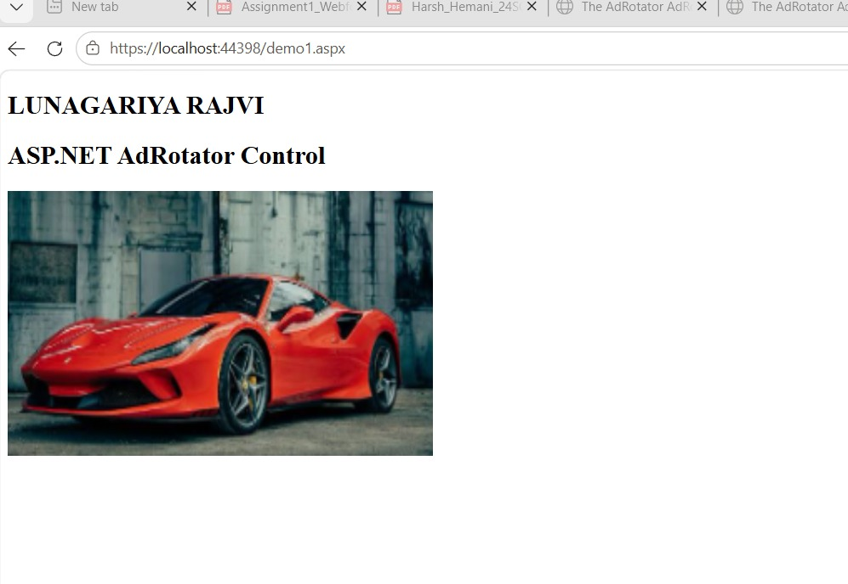

2.Create an ASP.Net page that shows current day and also display selected date.

.aspx file

<%@ Page Language="C#" AutoEventWireup="true"
CodeFile="aasigement2_que2.aspx.cs"
Inherits="aasiiments.aasigement2_que2" %>
<!DOCTYPE html>

<html xmlns="http://www.w3.org/1999/xhtml">
<head runat="server">
<title></title>
</head>
<body>
<form id="form1" runat="server">
<div>
<h2> Name : rajvi lunagariya</h2>
CALENDAR CONTROL DEMO<br />
<br />
Today is:
<asp:Label ID="lblToday" runat="server"></asp:Label>
<br /><br />
<asp:Calendar ID="Calendar1" runat="server" OnSelectionChanged="Calendar1_SelectionChanged"></asp:Calendar>
<br />
Selected Date: <asp:Label ID="lblSelected" runat="server"></asp:Label>
</div>
</form>
</body>
</html>

Aspx.cs file

using System;
using System.Web.UI;

namespace aasiiments
{
public partial class aasigement2_que2 : Page
{
protected void Page_Load(object sender, EventArgs e)
{
if (!IsPostBack)
{
lblToday.Text = DateTime.Now.ToString("dddd, dd/MM/yyyy");
}
}

protected void Calendar1_SelectionChanged(object sender, EventArgs e)
{
lblSelected.Text = Calendar1.SelectedDate.ToString("dd/MM/yyyy");
}
}
}

Output ::

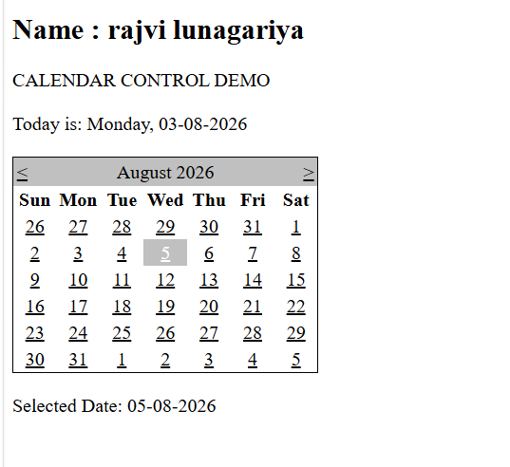

- Demonstrate the use of File Upload control.

Aspx file

<%@ Page Language="C#" AutoEventWireup="true" CodeFile="aasigement1_que3.aspx.cs" Inherits="aasiiments.aasigement1_que3" %>

<!DOCTYPE html>

<html xmlns="http://www.w3.org/1999/xhtml">
<head runat="server">
<title></title>
</head>
<body>
<form id="form1" runat="server">
<div><h2>Name : rajvi lunagariya </h2><br></div>
<asp:FileUpload ID="FileUpload1" runat="server" /> <br /><br />

<asp:Button runat="server" OnClick="Button1_Click" Text="submit" />
<asp:Label ID="Label1" runat="server" Text="Label"></asp:Label>
</form>
</body>
</html>

Aspx.cs file :

using System;
using System.Web.UI;
using System.Web.UI.WebControls;

namespace aasiiments
{
public partial class aasigement1_que3 : Page
{
protected void Page_Load(object sender, EventArgs e)
{
}

protected void Button1_Click(object sender, EventArgs e)
{
if (FileUpload1.HasFile)
{
string fileName = FileUpload1.FileName;
string filePath = Server.MapPath("~/Image/") + fileName;

FileUpload1.SaveAs(filePath);
Label1.Text = "File uploaded successfully!";
}
else
{
Label1.Text = "Please select a file to upload.";
}
}
}
}

Output :

